**Life Expectancy and GDP**

1. Introduction
   1. Goals
2. Research and visualization
   1. life expectancy trends
   2. Trends in GDP for each country
   3. Average GDP of countries
   4. Average life expectancy of countries
   5. GDP VS Life Expectancy
3. Conclusions

## **Introduction**

This analysis delves into the interplay between economic development and health across six countries from 2000 to 2015.

We leverage data from the World Health Organization and World Bank, focusing on two key indicators: Gross Domestic Product (GDP) and life expectancy.

GDP reflects the overall economic output of a country, while life expectancy gauges the average lifespan of its citizens. Understanding their relationship illuminates a country's health and economic well-being.

### **1.2 Goals**

Goal is to identify the relationship between GDP and life expectancy of these countries.

1. Track life expectancy trends for each country over the analyzed period (2000-2015).
2. Explore trends in GDP for each country.
3. Calculate minimum, maximum and average GDP across all countries.
4. Calculate minimum, maximum, and average life expectancy for each country.
5. Investigate the correlation between GDP and life expectancy for each country and across all countries.

## **Analysis**

### **life expectancy trends**

While life expectancy is rising steadily across the globe, Germany stands out with its citizens living longer lives. Despite significant progress, Zimbabwe's life expectancy continues to lag behind, with residents facing a ten-year deficit compared to other nations. However, Zimbabwe is experiencing a remarkable surge in life expectancy, narrowing the gap and offering a brighter outlook for the future.

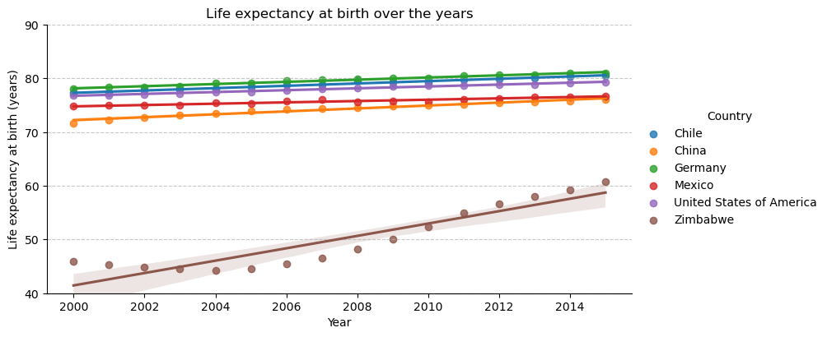

### **Trends in GDP for each country**

The United States maintains a significant GDP lead over most other countries, and its consistent growth further widens that gap. Germany held the second-place GDP ranking until 2007, when China's astonishing economic growth propelled it past Germany. Now, China stands as the only country approaching the U.S., with their GDPs potentially converging in the coming years.

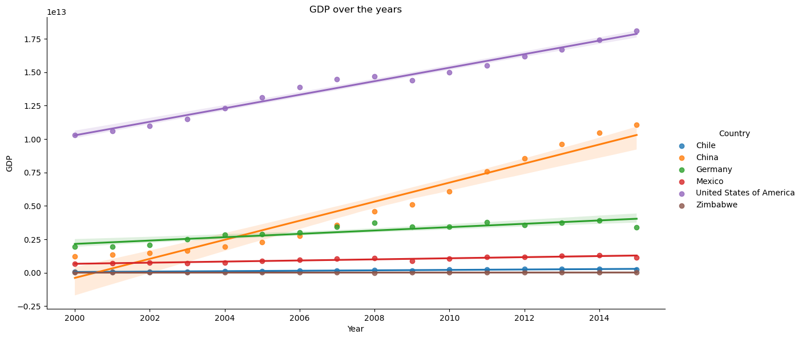

### **Average GDP of countries**

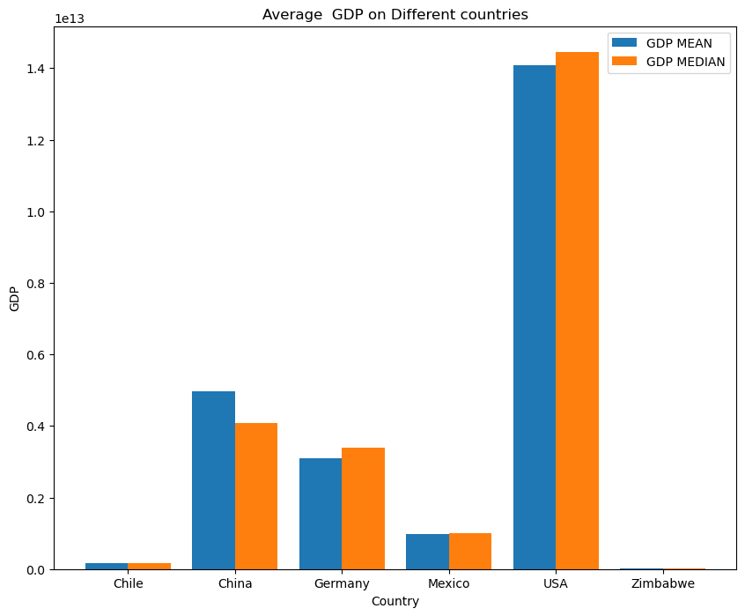

The U.S. is like a financial giant compared to other countries. Their average income is a whopping 1.4 trillion compared to China's 0.6 trillion. It's a big difference!

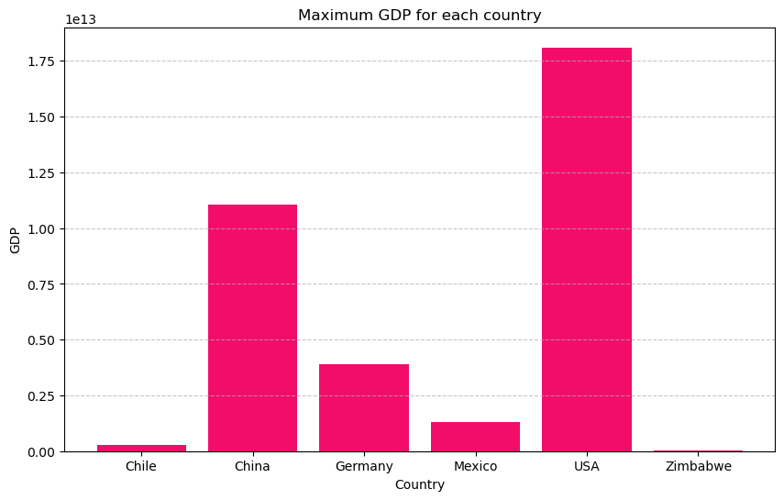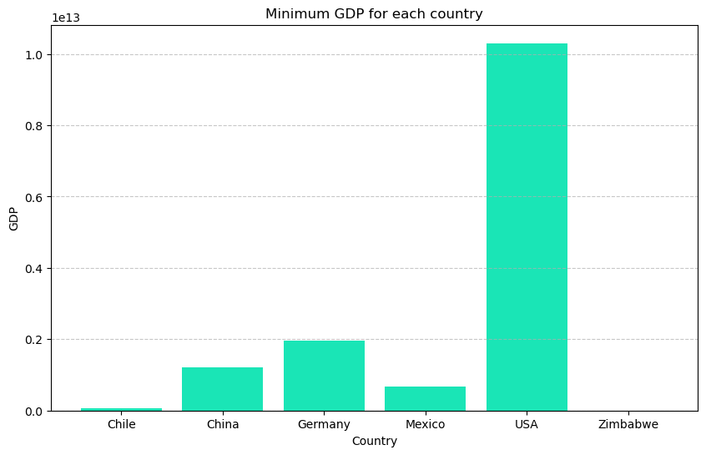

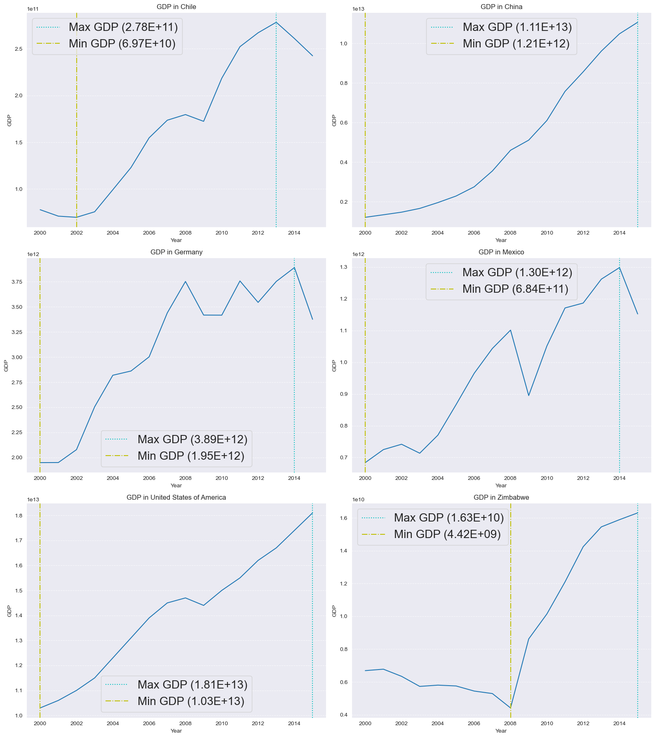

Check out the fascinating highs and lows of each country's GDP in these plots. More excitingly, global GDP is on a steady upward curve, with the US and China in the driver's seat.

### **Average life expectancy of countries**

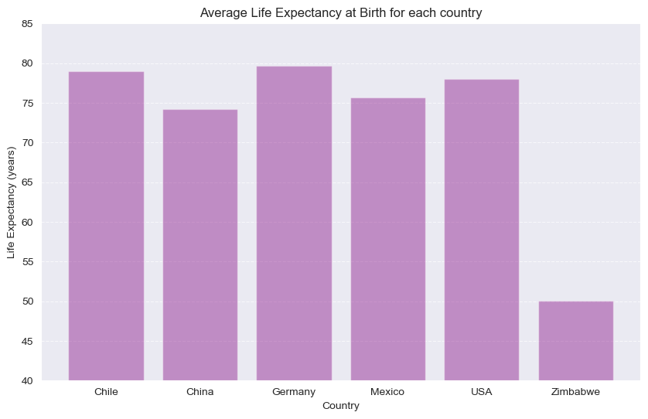

Most countries can expect average life spans between 70 and 80 years. Zimbabwe, however, has a notably lower average around 50 years old.

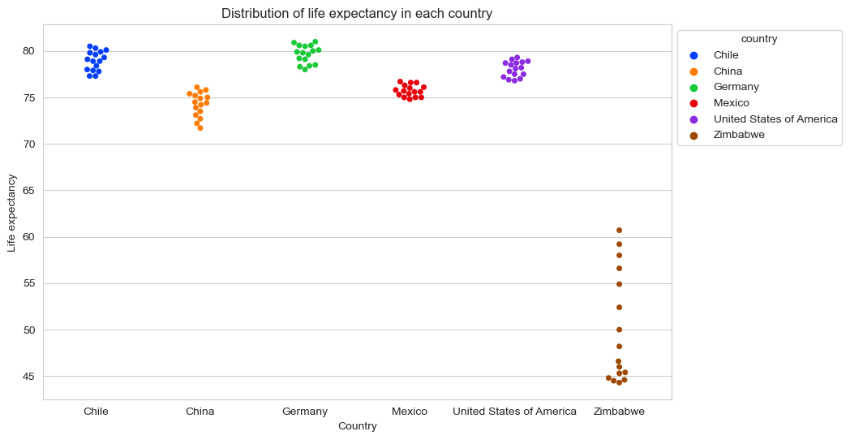

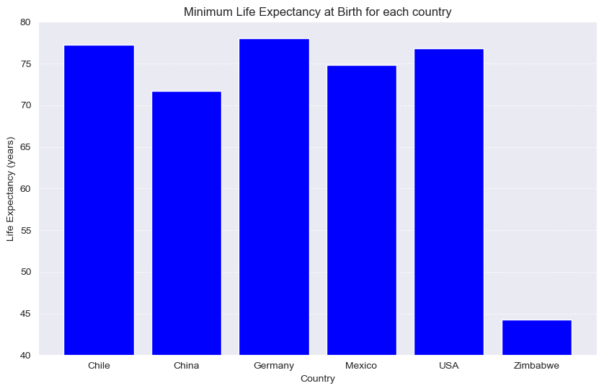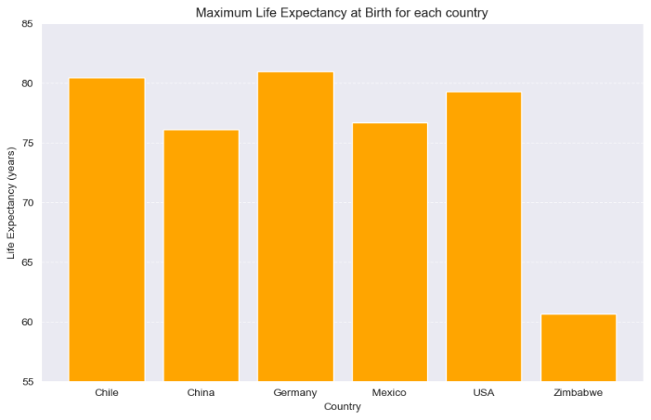

These interactive plots invite us to explore the captivating tapestry of global life expectancy. Delving deeper, we can discover the range of average lifespans, and even uncover the intriguing minimum and maximum values for each country.

### **2.5 GDP VS Life Expectancy**

Plot below displays the varying correlations in the relationship between life expectancy and GDP for these countries.

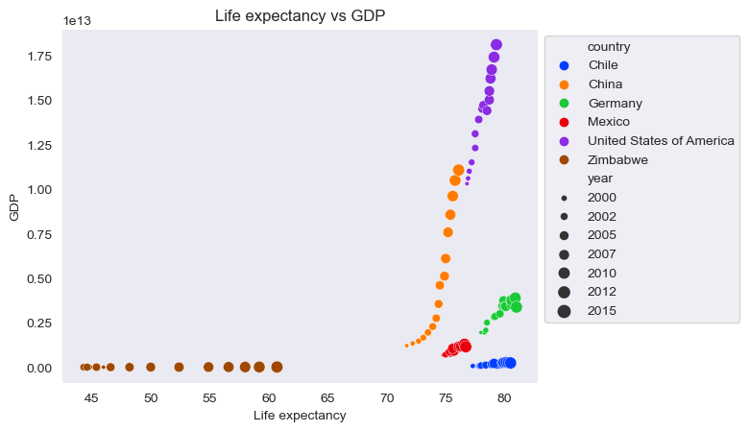

### However, we are unable to see the details of some countries, so we will look at the correlation of each country individually.

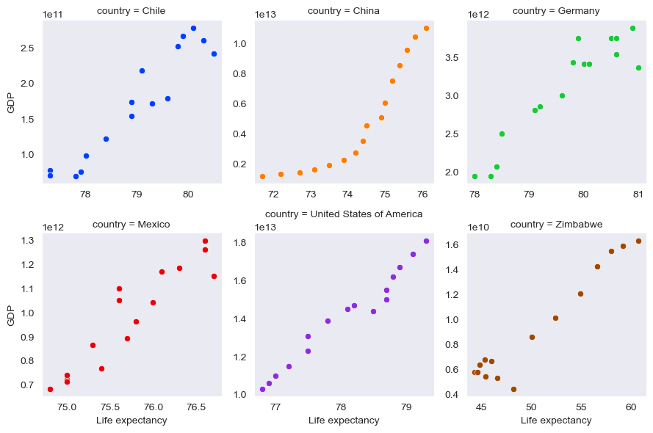

Most countries show a positive relationship between life expectancy and GDP. But China is truly astonishing, with its booming economy leading to an exponential increase in life expectancy. This means that wealthier nations generally have healthier populations, with China exemplifying this link in a remarkable way.

## **Conclusions**

* **Economic Prosperity and Longer Lives:**
  + Across most analyzed countries, higher GDPs were linked to longer life expectancies, highlighting the positive impact of economic development on health.
* **Life Expectancy Trends:**
  + Generally rising: All countries saw life expectancy increases, demonstrating global progress.
  + Variations and extremes: Zimbabwe faced the lowest average (44.3 years), while Germany boasted the highest peak (81 years).
  + Average lifespan: Across these countries, the average life expectancy reached 72.79 years.
* **Economic Growth Patterns:**
  + Overall progress: All countries experienced GDP growth during the analyzed period.
  + Financial leaders: The US and China led the way, with the US holding the highest GDP (18.1 trillion dollars) and China demonstrating impressive growth.
  + Average wealth: The average GDP across these countries stood at around 3.9 trillion dollars.
* **Notable Observations from the Data:**
  + 2008 turning point: Around 2008, GDP growth trends shifted, with China being least affected and Mexico experiencing the largest decline.
  + Zimbabwe's surge: After 2008, Zimbabwe saw a notable increase in GDP.
  + Life expectancy outlier: Chile had a high life expectancy despite a lower GDP compared to other countries.
  + China's unique trajectory: In the GDP-life expectancy relationship, China stood out with an exponential growth trend.
* **Final Takeaway:**
  + While disparities exist and further research is needed, this analysis reveals a clear connection between economic advancement and healthier lives. China's remarkable progress underlines the transformative potential of economic growth in shaping positive health outcomes.