**FoodWheel**

1. Introduction
   1. What we solved
2. Analyze and visualization
   1. Foodwheel cuisines
   2. Order Price Over Time
   3. Customer orders
   4. Neighborhoods that have the most restaurants
3. Conclusions

## **Introduction**

With a crucial board meeting on the horizon, FoodWheel's leadership seeks a recipe for continued growth. Diving into their culinary data, I've uncovered insights that could shape their next course—from the most popular cuisines to untapped neighborhoods ripe for expansion. This analysis reveals the hidden ingredients behind FoodWheel's success, equipping them to make data-driven decisions that satisfy their appetite for growth.

### **1.2 What we solved**

1. What cuisines does FoodWheel offer?
2. How has the average order amount changed over time?
3. How much has each customer on FoodWheel spent over the past six months?
4. Which areas should the company search for more restaurants to partner with?

## **Analysis**

### **Foodwheel cuisines**

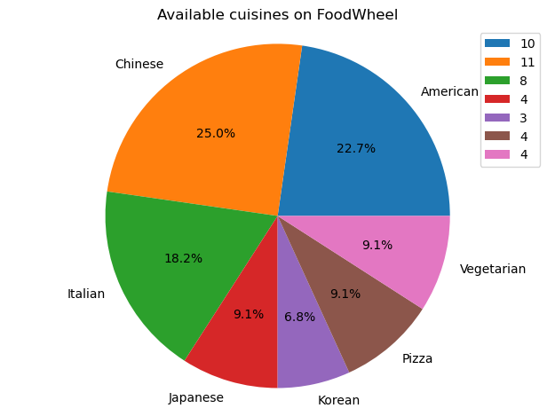

Among FoodWheel's offerings, Chinese cuisine reigns supreme, accounting for 25% of available options. American and Italian cuisines follow closely behind with 22.7% and 18.2% respectively. With other cuisines dipping below 10%, Korean cuisine brings up the rear at 6.8%.

### **Order Price Over Time**

* How has the average order amount changed over time?
* What does this say about the trajectory of the company?

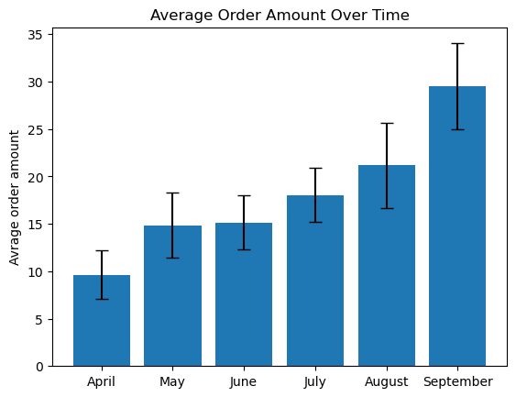

FoodWheel's average order amounts consistently climbed between April and September, with a notable jump from 10 to 30. As illustrated in the chart above, this upward trend suggests growing customer engagement and potential for further revenue growth.

### **Customer orders**

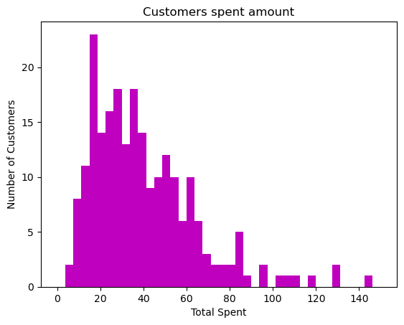

While most customers' food budget lies between $10 and $65, their interest extends to options in the $20-$40 range. However, some high-rollers show potential spending reach up to $142.

Though most orders fall within $10-$65, FoodWheel shouldn't overlook the potential for high-value customers.

### **Neighborhoods that have the most restaurants**

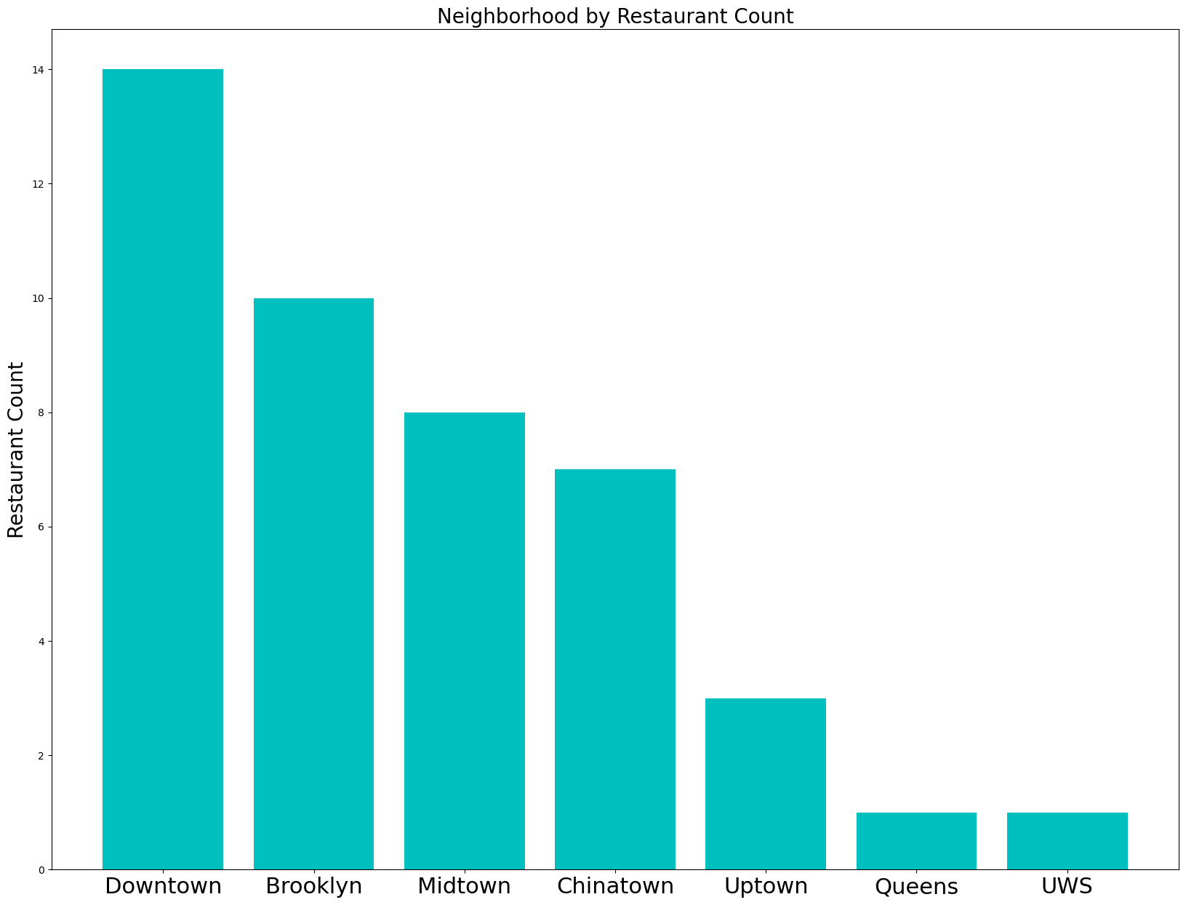

While Downtown and Brooklyn boast high concentrations of restaurants (14 and 10 respectively), Queens and Upper West Side, with only one restaurant each, present untapped potential for FoodWheel's expansion. Queens' large population and diverse demographics suggest catering to specific cuisines or partnering with local favorites. Upper West Side, with its trendy vibe, might benefit from introducing fast-casual options. Further analysis of user preferences in these areas can further refine these recommendations and unlock significant growth opportunities for FoodWheel.

## **Conclusions**

* Culinary Focus: Chinese cuisine dominates FoodWheel's landscape, offering a lucrative starting point for targeted promotions and marketing campaigns. Expanding options in popular categories like American and Italian can also tap into existing customer preferences.
* Growing Orders: The consistent rise in average order amounts presents a positive trend. Further analysis can identify factors driving this growth and capitalize on potential for increased revenue.
* Customer Insights: Understanding the range of customer spending interests, from everyday meals to occasional splurges, allows FoodWheel to tailor offerings and promotions to different segments.
* Expansion Potential: Queens and Upper West Side emerge as untapped markets with significant populations and diverse needs. Prioritizing partnerships or specific cuisines in these areas can unlock substantial growth opportunities.