**Certificate of PARTICIPATION**



This is to certify that

HEAD (PHYSICAL

EDUCATION)

MANAGER

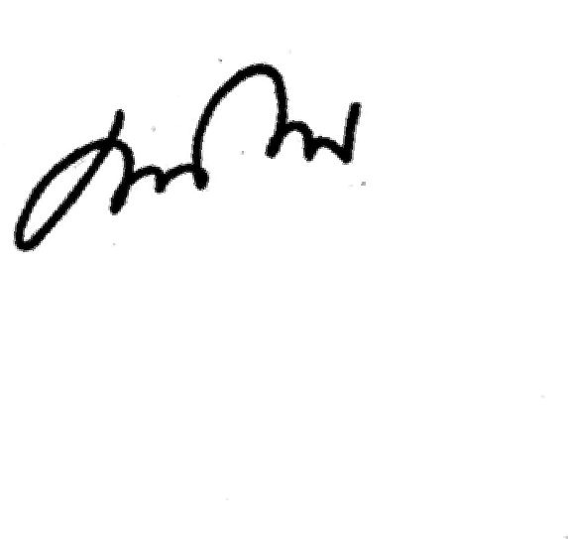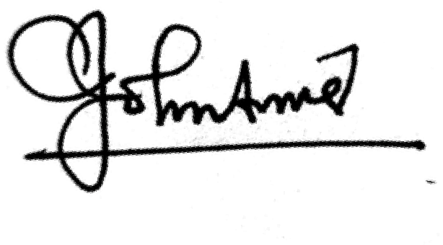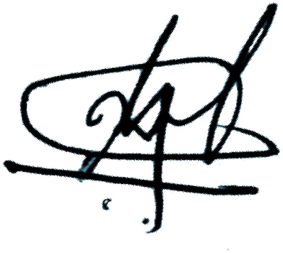

PRINCIPAL

Name

of CLASS has participated in 100MSPRINTANDJUMP competition conducted as part of The Annual Sports Meet 2023-24.