**TITLE XYZ**

Monthly Report

October 2020

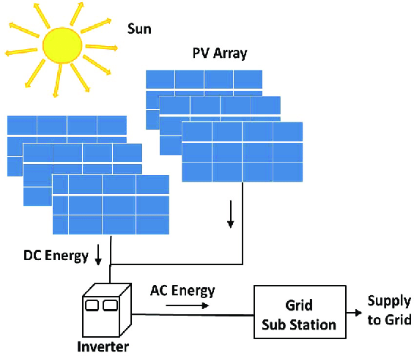

**Table of contents**

**Daily operation and maintenance log**

**Site visits log**

1. XYZ-related
2. ABC-related

**Additional information**

1. Preventive maintenance actual vs plan
2. Any other information for the month

**Appendix 1 – Module layout**

**Appendix 2 – Single line diagram**

**Appendix 3 – Spare parts list**

*Report issued on {Current_Date}*

*By Mr XY Zee*

*________________________*

*Signature*

**General information**

1. Name plate
2. Other information

**Executive summary**

**Key highlights for the month**

1. Health, safety and security
2. Plant performance
3. Plant operations
4. Plant maintenance
5. Technical issues with action plan
6. Open issues follow-up table
7. Other highlights if any

**Event logs**

1. Preventive maintenance log
2. Corrective maintenance log
3. Replacement and spare parts in / out log
4. Downtime due to grid log
5. Downtime due to power producer log
6. Downtime due to client / other 3rd parties log
7. Force Majeure event log

**Energy production figures**

**Performance Ratios (PR) and availability**

**Inverter efficiency**

**Asset performance from COD to date**

**General information**

1. **Name plate**

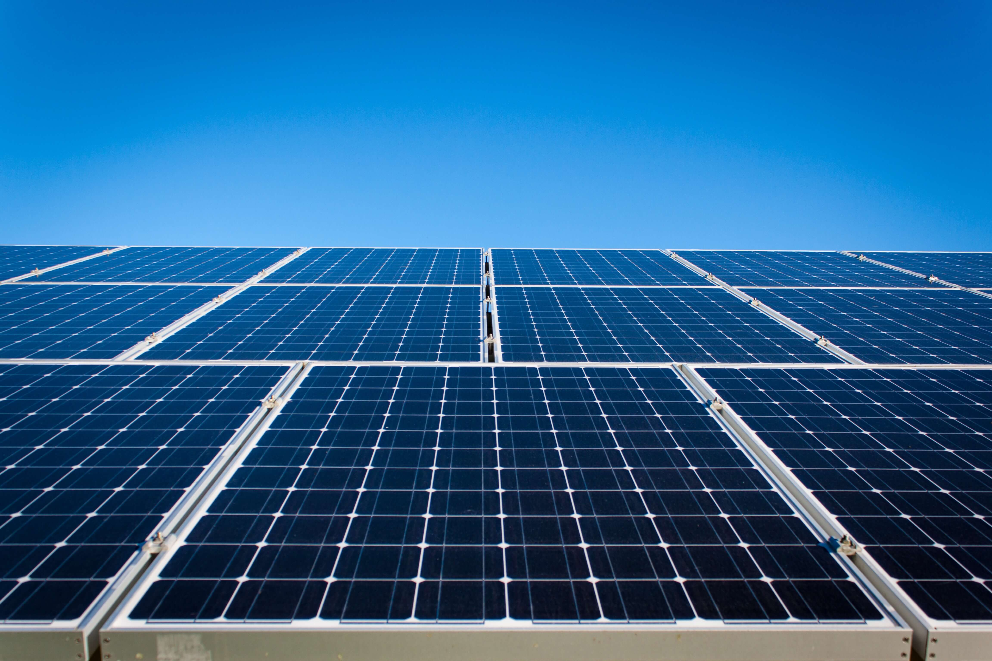

1. **Other information**

* Landlord : XYZ
* Owner : Solar Rooftop RST 1 Co., Ltd. (fully owned by ABC)
* PV module supplier : ABAB
* Inverter supplier : XYZ
* Monitoring system : CONT7890 Energy
* EPC contractor : CONT123
* O&M contractor : CONT123
* Capacity : 888 kWpeak
* Total area : 3452 m2
* PV module quantity : 8888
* PV module details : ABC (300 Wpeak)
* PV module area : 7777 m2
* PV module tilt : 10ᵒ and 20ᵒ
* Inverter quantity : 123
* Inverter details : MAT789 CL25000E (25 kW)
* Pyranometer quantity : 1
* Pyrometer details : asdf
* Total energy production : 3,198,848 kWh (as of 31-Oct-2020)

**Executive summary**

Energy production in October is 62,536 kWh, below forecast by 13% due to down time client. Gross PR is 66.2% [Net PR is 76.2%, below forecast by 1.9%.] Availability level is 97.7% (CONT7890 and Internet had to be reset after plant shutdown). Radiation is 13% below forecast.

Energy production and Performance Ratios for the month

Performance summary for the month

**Key highlights for the period**

1. **Health, safety and security**

* Staff, contractors and visitors must wear personal protective equipment while visiting the site.

1. **Plant performance**

* Energy production for the month is 62,536 kWh due to:
* 5 days of down time client (triggered by zero export control);
* Gross PR is 66.2%
* Net PR is 76.2%
* Clipping affects the Net PR
* Energy production figure adjusted to down time client is 71,647 kWh

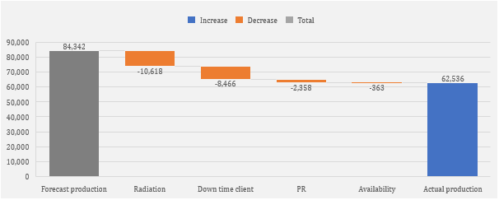

1. **Plant operations**

* Inverter issue (fan issue) for inverter 9 which required replacement.
* CONT7890/ internet issue after plant shutdown which required reset.

1. **Other highlights if any**

* None.

**Events log**

1. **Preventive maintenance log**

|  |  |  |  |  |
| --- | --- | --- | --- | --- |
| Date | Equipment or item | Scheduled event | Action | Status |
| 27-Oct 2020 | Overall plant | Monthly site walk-through and visual inspection | ASDF performed the walk-through and inspection | OK |

1. **Corrective maintenance log**

|  |  |  |  |  |
| --- | --- | --- | --- | --- |
| Date | Equipment or item | Failure event | Action | Status |
| 8-Oct 2020 | Inverter | Fan alarm | Replace Inv 9 fan | OK |
| 8-Oct 2020 | Inverter | Fan alarm | Reset Inv 6 | OK |
| 9-Oct 2020 | Array | Check array | Check array | OK |
| 12-Oct 2020 | CONT7890 | Data transmission error | Reset communications box | OK |
| 14-Oct 2020 | CONT7890 | Data transmission error | Reset communications box, Inverter cleaning | OK |
| 15-Oct 2020 | CONT7890, Inverter | Data transmission error | Reset communications box, Inverter fan alarm reset | OK |
| 16-Oct 2020 | Inverter | Fan alarm | Clean Inv 13 fan | OK |
| 19-Oct 2020 | Inverter | Inv alarm | Re-start Inv 14 due to error reading/ SIT789 black out | OK |

1. **Replacement and spare parts in / out log**

|  |  |  |  |  |  |  |
| --- | --- | --- | --- | --- | --- | --- |
| Date failed | Date replaced | Equipment or item | Part # | Failure reason | In/Out | Stock |
| None | - | - | - | - | - | - |

1. **Downtime due to grid log**

|  |  |  |  |  |  |
| --- | --- | --- | --- | --- | --- |
| Date | From time | To time | Downtime | Comment | Ref. if any |
| None | - | - | - | - | - |
| Total downtime for the period | | | 0 min |  |  |

1. **Downtime due to power producer log**

|  |  |  |  |  |  |
| --- | --- | --- | --- | --- | --- |
| Date | From time | To time | Downtime | Comment | Ref. if any |
| None | - | - | - | - | - |
| Total downtime for the period | | | 0 min |  |  |

1. **Downtime due to landlord / other 3rd parties log**

|  |  |  |  |  |  |
| --- | --- | --- | --- | --- | --- |
| Date | From time | To time | Downtime | Comment | Ref. if any |
| 3-Oct | 8.00 AM | 6.15 PM | Full | Downtime due to no / low consumption | - |
| 4-Oct | 8.00 AM | 6.15 PM | Full | Downtime due to no / low consumption | - |
| 10-Oct | 8.00 AM | 6.15 PM | Full | Downtime due to no / low consumption | - |
| 11-Oct | 8.00 AM | 6.15 PM | Full | Downtime due to no / low consumption | - |
| 13-Oct | 8.00 AM | 6.15 PM | Full | Downtime due to no / low consumption | - |
| Total downtime for the period | | | 5 days |  |  |

1. **Force Majeure event log**

|  |  |  |  |  |  |
| --- | --- | --- | --- | --- | --- |
| Date | From time | To time | Downtime | Comment | Ref. if any |
| None | - | - | - | - | - |
| Total downtime for the period | | | 0 min |  |  |

**Energy production figures**

1. **Daily and for the month**

Daily energy production and radiation yield

|  |  |  |  |  |  |  |  |
| --- | --- | --- | --- | --- | --- | --- | --- |
| Date | Energy produced (in kWh) | Radiation (in Wh/m2) | Gross PR (in %) | Net PR (in %) | Availability (in %) | Module Temp. (in °C) | Down time client |
| 1st | 4226 | 7,000 | 75.9% | 75.9% | 100.0% | 36.9 |  |
| 2nd | 3,128 | 5,181 | 75.9% | 75.9% | 100.0% | 36.4 |  |
| 3rd | 1,838 | 5,391 | 42.9% | 78.0% | 100.0% | 36.9 | down time client |
| 4th | 25 | 4,951 | 0.6% | 74.9% | 99.2% | 37.0 | down time client |
| 5th | 3104 | 5,015 | 77.9% | 78.0% | 99.8% | 36.9 |  |
| 6th | 2,790 | 4,547 | 77.2% | 77.2% | 100.0% | 36.4 |  |
| 7th | 2719 | 4,386 | 78.0% | 78.0% | 100.0% | 36.2 |  |
| 8th | 899 | 1,368 | 82.6% | 82.6% | 100.0% | 34.7 |  |
| 9th | 1171 | 1,761 | 83.6% | 83.6% | 100.0% | 35.1 |  |
| 10th | 449 | 1,611 | 35.1% | 60.8% | 85.1% | 34.8 | down time client |
| 11th | 36 | 3,303 | 1.4% | 74.9% | 100.0% | 35.8 | down time client |
| 12th | 2,472 | 3,687 | 84.3% | 84.3% | 99.7% | 37.3 |  |
| 13th | 97 | 1,412 | 8.6% | 78.1% | 96.0% | 34.6 | down time client |
| 14th | 2,861 | 4,680 | 76.9% | 76.9% | 99.2% | 34.3 |  |
| 15th | 3698 | 4,506 | 77.3% | 77.3% | 99.6% | 36.3 |  |
| 16th | 1,174 | 1,823 | 81.0% | 81.0% | 100.0% | 35.1 |  |
| 17th | 759 | 1,146 | 83.3% | 83.3% | 100.0% | 34.7 |  |
| 18th | 1,022 | 1,548 | 83.0% | 85.1% | 100.0% | 34.9 |  |
| 19th | 792 | 1,800 | 55.3% | 57.8% | 82.5% | 35.5 |  |
| 20th | 1,779 | 2,872 | 77.9% | 77.9% | 100.0% | 36.0 |  |
| 21st | 2255 | 3,705 | 76.6% | 76.6% | 100.0% | 36.3 |  |
| 22nd | 3,200 | 5,265 | 76.5% | 76.6% | 100.0% | 36.6 |  |
| 23rd | 3330 | 5,413 | 77.4% | 77.4% | 100.0% | 36.3 |  |
| 24th | 3,877 | 6,428 | 75.9% | 76.1% | 100.0% | 35.6 |  |
| 25th | 171 | 6,025 | 3.6% | 10.1% | 68.2% | 36.7 |  |
| 26th | 3,310 | 5,479 | 76.0% | 76.0% | 99.8% | 37.0 |  |
| 27th | 1800 | 2,875 | 78.8% | 78.8% | 100.0% | 36.1 |  |
| 28th | 2,326 | 3,691 | 79.3% | 79.3% | 100.0% | 36.1 |  |
| 29th | 1571 | 2,491 | 79.3% | 79.3% | 99.2% | 35.4 |  |
| 30th | 3,221 | 5,213 | 77.7% | 77.7% | 100.0% | 36.4 |  |
| 31st | 2,436 | 4,304 | 71.2% | 75.9% | 100.0% | 36.2 |  |
| **TOT** | **62,536** | **118,878** | **-** | **-** | **-** | **-** | **-** |
| AVE | 2,003 | 3,819 | 66.2% | 76.2% | 97.7% | 35.9 | - |

**Performance Ratio (PR) and availability**

1. **Daily and for the month**

Daily Performance Ratios (Gross PR and Net PR)

Monthly Performance Ratio = 66.2% Gross and 76.2% Net

Daily availability

Monthly availability = 97.7%

Comments:

* Gross PR is 66.2% with 5 days of down time client.
* Net PR is 76.2% due to clipping, which reduces the Net PR.

**Inverter efficiency**

Daily efficiency

Monthly efficiency = 68.1%

Radar diagram “PR by inverter”

**Comparative analysis for energy production, radiation, PR and temperature**



**Daily operation and maintenance log**

|  |  |  |  |  |
| --- | --- | --- | --- | --- |
| Date | Event | Action | Comment | Status |
| 1st |  |  |  |  |
| 2nd |  |  |  |  |
| 3rd |  |  |  |  |
| 4th |  |  |  |  |
| 5th |  |  |  |  |
| 6th |  |  |  |  |
| 7th |  |  |  |  |
| 8th | Corr. Maintenance | CONT123 plant visit | Inv 9 change fan, Reset Inv 6 | OK |
| 9th | Corr. Maintenance | CONT123 plant visit | Check array | OK |
| 10th |  |  |  |  |
| 11th |  |  |  |  |
| 12th | Corr. Maintenance | CONT123 plant visit | Check internet and reset CONT7890 | OK |
| 13th |  |  |  |  |
| 14th | Corr. Maintenance | CONT123 plant visit | Check internet and reset CONT7890, Inverter cleaning | OK |
| 15th | Corr. Maintenance | CONT123 plant visit | Check internet and reset CONT7890 | OK |
| 16th | Corr. Maintenance | CONT123 plant visit | Inv 13 clean fan | OK |
| 17th |  |  |  |  |
| 18th |  |  |  |  |
| 19th | Corr. Maintenance | CONT123 plant visit | Re-start Inv 14 due to error reading/ SIT789 black out | OK |
| 20th |  |  |  |  |
| 21st |  |  |  |  |
| 22nd |  |  |  |  |
| 23rd |  |  |  |  |
| 24th |  |  |  |  |
| 25th |  |  |  |  |
| 26th |  |  |  |  |
| 27th | Prev. maintenance | Monthly site walk-through and visual inspection | Refer to monthly visit report issued by ASDF Asset Management team | OK |
| 28th |  |  |  |  |
| 29th |  |  |  |  |
| 30th |  |  |  |  |
| 31st |  |  |  |  |

**Third parties site visit log**

1. **XYZ-related**

|  |  |  |  |  |
| --- | --- | --- | --- | --- |
| Date | Full name of visitors | Company | Area visited | Reason |
| None | - | - | - | - |

1. **ABC-related**

|  |  |  |  |  |
| --- | --- | --- | --- | --- |
| Date | Full name of visitors | Company | Area visited | Reason |
| 8-Oct 2020 | MrFGH | CONT123 | Inverter room | Corrective maintenance |
| 8-Oct 2020 | MrFGH | CONT123 | Inverter room | Corrective maintenance |
| 9-Oct 2020 | MrRSTUV | CONT123 | Inverter room | Preventive maintenance |
| 12-Oct 2020 | MrFGH | CONT123 | Inverter room | Corrective maintenance |
| 14-Oct 2020 | MrFGH | CONT123 | Inverter room | Corrective maintenance |
| 15-Oct 2020 | MrFGH | CONT123 | Inverter room | Corrective maintenance |
| 16-Oct 2020 | MrFGH | CONT123 | Inverter room | Corrective maintenance |
| 19-Oct 2020 | MrFGH | CONT123 | Inverter room | Corrective maintenance |
| 27-Oct 2020 | MrRSTUV | CONT123 | Inverter room | Preventive maintenance |

**Additional period-related information**

1. **Preventive maintenance actual VS plan**

|  |  |  |  |  |  |  |  |  |  |  |  |  |  |  |  |
| --- | --- | --- | --- | --- | --- | --- | --- | --- | --- | --- | --- | --- | --- | --- | --- |
| **Action** | **Frequency** | **Sep-19** | **Oct-19** | **Nov-19** | **Dec-19** | **Jan-20** | **Feb-20** | **Mar-20** | **Apr-20** | **May-20** | **Jun-20** | **Jul-20** | **Aug-20** | **Sep-20** | **Oct-20** |
| **General** |  |  |  |  |  |  |  |  |  |  |  |  |  |  |  |
| Check monitoring data | Day | ✓✓ | ✓✓ | ✓✓ | ✓✓ | ✓✓ | ✓✓ | ✓✓ | ✓✓ | ✓✓ | ✓✓ | ✓✓ | ✓✓ | ✓✓ | ✓✓ |
| Site walk through | Month | ✓ | ✓ | ✓ | ✓ | ✓ | ✓ | ✓ | ✓ | ✓ | ✓ | ✓ | ✓ | ✓ | ✓ |
| **Inverter area** |  |  |  |  |  |  |  |  |  |  |  |  |  |  |  |
| Visual inspection | Month | ✓ | ✓ | ✓ | ✓ | ✓ | ✓ | ✓ | ✓ | ✓ | ✓ | ✓ | ✓ | ✓ | ✓ |
| Clean inverter building | Semester |  |  |  |  |  |  |  |  |  |  |  |  |  |  |
| Check building's lighting | Semester |  |  |  |  |  |  |  |  |  |  |  |  |  |  |
| Clear fence from any object | Semester |  |  |  |  |  |  |  |  |  |  |  |  |  |  |
| Check fence, doors, access status | Semester |  |  |  |  |  |  |  |  |  |  |  |  |  |  |
| Check ventilation system | Semester |  |  |  |  |  |  |  |  |  |  |  |  |  |  |
| Clean filters | Semester |  |  |  |  |  |  |  |  |  |  |  |  |  |  |
| Change filters | Year |  |  |  |  |  |  |  |  |  |  |  |  |  |  |
| Check protection and fuses | Semester |  |  |  |  |  |  |  |  |  |  |  |  |  |  |
| Check cables and connections | Semester |  |  |  |  |  |  |  |  |  |  |  |  |  |  |
| Check and test display | Semester |  |  |  |  |  |  |  |  |  |  |  |  |  |  |
| Check and test fans | Semester |  |  |  |  |  |  |  |  |  |  |  |  |  |  |
| Thermo-scan | Semester |  |  |  |  |  |  |  |  |  |  |  |  |  |  |
| Insulation test | Semester |  |  |  |  |  |  |  |  |  |  |  |  |  |  |
| Grounding test | Semester |  |  |  |  |  |  |  |  |  |  |  |  |  |  |
| Firmware update | Semester |  |  |  |  |  |  |  |  |  |  |  |  |  |  |
| Check and test remote control | Semester |  |  |  |  |  |  |  |  |  |  |  |  |  |  |
| **Module area** |  |  |  |  |  |  |  |  |  |  |  |  |  |  |  |
| Visual inspection | Month | ✓ | ✓ | ✓ | ✓ | ✓ | ✓ | ✓ | ✓ | ✓ | ✓ | ✓ | ✓ | ✓ | ✓ |
| Clean modules | Semester |  |  |  |  | ✓ |  |  | ✓ |  |  |  |  |  |  |
| Check clips and screws | Semester |  |  |  |  |  |  |  |  |  |  |  |  |  |  |
| Check cables | Semester |  |  |  |  |  |  |  |  |  |  |  |  |  |  |
| Check interconnections | Semester |  |  |  |  |  |  |  |  |  |  |  |  |  |  |
| IV measurements 25 units | Semester |  |  |  |  |  |  |  |  |  |  |  |  |  |  |
| Structural strength test | Semester |  |  |  |  |  |  |  |  |  |  |  |  |  |  |
| **Monitoring system** |  |  |  |  |  |  |  |  |  |  |  |  |  |  |  |
| Visual inspection of cabinet | Month | ✓ | ✓ | ✓ | ✓ | ✓ | ✓ | ✓ | ✓ | ✓ | ✓ | ✓ | ✓ | ✓ | ✓ |
| Check ventilation of cabinet | Semester |  |  |  |  |  |  |  |  |  |  |  |  |  |  |
| Check battery status | Semester |  |  |  |  |  |  |  |  |  |  |  |  |  |  |
| Change batteries | 3 years |  |  |  |  |  |  |  |  |  |  |  |  |  |  |
| Check and tighten connections | Semester |  |  |  |  |  |  |  |  |  |  |  |  |  |  |
| Clean sensors | Semester |  |  |  |  |  |  |  |  |  |  |  |  |  |  |
| Check silicate of pyranometer | Semester |  |  |  |  |  |  |  |  |  |  |  |  |  |  |
| Check position of sensors | Semester |  |  |  |  |  |  |  |  |  |  |  |  |  |  |
| Clean cabinets | Semester |  |  |  |  |  |  |  |  |  |  |  |  |  |  |
| **MDB** |  |  |  |  |  |  |  |  |  |  |  |  |  |  |  |
| Clean cabinets | Semester |  |  |  |  |  |  |  |  |  |  |  |  |  |  |
| Check connections | Semester |  |  |  |  |  |  |  |  |  |  |  |  |  |  |
| Picture power meters | Semester |  |  |  |  |  |  |  |  |  |  |  |  |  |  |
| Test breakers | Semester |  |  |  |  |  |  |  |  |  |  |  |  |  |  |

Colour code: ✓ Completed ✓ Work in progress ✓ Overdue

1. **Any other period-related information**

* None.

**Appendix 1 – Module layout**

