## Spectroscopic Information near N=14 and N=16

### Physics Justification

Recent advances in *ab initio* calculations have resulted in the ability to calculate the properties of nuclei with mass greater than 20, providing precise estimations of properties of nuclei like 48Ca [HAG15], and employing properly constrained two- and three-nucleon interactions from effective field theory [EKS15]. These advances allow us to compute nuclear observables for both stable nuclei, and nuclei close to or beyond the driplines, without parameter fitting [HAG16]. Furthermore, recent developments in many-body theory allow us to compute effective Hamiltonians which can be used in a nuclear structure context [BOG14,JAN14,JAN15]. Experimental results on nuclei close to the driplines thus provide unique inputs to our basic understanding of correlations in nuclear systems near the limits of stability.

There is little known about nuclei one to two protons away from the potentially doubly magic 22O and the doubly magic 24O. In the case of 22O, much has been studied experimentally with respect to neutron degrees of freedom, with the primary aim being identifying whether or not the N=14 subshell gap is magic [THI00,STA04,BEC06]. The experimental data, however, is lacking for nuclei that vary by one proton from 22O. For example, since 21N was first observed in 1970 [ART70] only two experiments have been performed to identify excited states of this nucleus [SOH08,ELE10]. In the case of Ref. [SOH08] five excited states were observed by two step fragmentation and were given tentative spin-parity assignments. Similarly, excited states have been measured in 23F three times [ORR89,AZA02,MIC06]. Most recently a series of four reactions were used to populate excited states, including single and multi-nucleon knockout, proton transfer, and inelastic scattering [MIC06]. These measurements resulted in an analysis of the angular distributions of charged particles from the (4He,t) transfer reaction which led to the determination of spectroscopic factors for two of the observed states. For both 23F and 21N, there are no firm spin-parity assignments, and spectroscopic factors are either unknown (21N) or unconfirmed (23F). A more thorough study of the excited states in 23F and 21N, including firm spin-parity assignments and measurements of spectroscopic factors, would provide data that is crucial for better understanding the evolution of neutron rich nuclei as a function of proton number.

Approaching the neutron dripline with 24O, the experimental data becomes more scarce. Although 25F was also first observed in 1970 [ART70] and several gamma rays were observed in the early 2000’s [BEL01,AZA02,ELE04], the first detailed spectroscopy of excited states in 25F was not published until 2014 [VAJ14]. In Ref [VAJ14] seven gamma-rays are identified corresponding to five excited states. The states are given tentative spin-parity assignments, but due to the nature of the fragmentation reaction employed, no spectroscopic information was determined. Many of the excited states in the 25F, as well as the other nuclei of interest, decay by emitting high energy (~3 MeV) gamma rays. GRETINA affords a unique opportunity to perform high resolution gamma ray spectroscopy that is not possible with other instruments. Figure 1 displays the current best precision gamma ray spectrum for 25F, taken from Ref. [VAJ14].

Performing single proton knockout reactions with beams of radioactive 24,26Ne and 22O will provide a critical means to further develop the current understanding of the structure of neutron rich isotopes near N=14 and N=16. By probing the largely mysterious proton shell structure in this region in a systematic way, as a function of changing isospin, we will gain valuable, currently unknown, knowledge on the structure of the excited states of 23F, 21N, and 25F, as well as information concerning the ground state configuration of the potentially doubly magic 22O, as shown in Figure 2. The measurements of these nuclei will also provide an excellent proving ground for modern theoretical models.

### Goals of the proposed experiment

The primary goal of this experiment is to measure the spectroscopic factors and spin-parities of single particle states in 23F, 21N, and 25F near the N=14 and N=16 magic numbers. By measuring proton knockout from radioactive 24,26Ne we will be able to determine the spectroscopic factors of the low lying states in 23,25F. This information is crucial to the further development of effective Hamiltonian shell-model calculations aiming to correctly describe the behavior of the oxygen, and near oxygen isotopes as they approach the dripline, as well as increasing our understanding of the proton degrees of freedom as a function of changing isospin.

In addition to the knockout from Ne, a proton knockout reaction will also be performed using a radioactive 22O beam, with the aim of this reaction being to understand the underlying structure of 22O. This measurement will further allow us to characterize the nature of the ground state of the potentially doubly magic 22O isotope, while simultaneously identifying excited states in 21N. Since a proton knockout reaction will be used we will be able to make spin-parity assignments and determine spectroscopic factors to these states. The excited states populated in 21N will be able to be studied using both *ab initio* methods and using effective Hamiltonian shell-model calculations, providing a neutron rich benchmark for comparing these calculations.

### Experimental Details

### We propose to perform one-proton knockout reactions using radioactive 24,26Ne and 22O beams, on a 281 mg/cm2 thick 9Be target. The target will be placed at the pivot location of the S800 spectrograph, and will be surrounded by the GRETINA detector setup (see Figure 3). The knockout residues will be detected on an event by event basis in the S800 spectrograph, while de-excitation γ-rays are detected in coincidence with GRETINA. The proposal involves three secondary beams, all of which are produced from a 48Ca primary beam, being delivered to the S3 vault. The rate estimates for the radioactive 26Ne and 22O beams are based on yield measurements performed for NSCL Experiments 07502, 08029 and are scaled using LISE++ calculations with the EPAX31.a parameterization. The rate estimates for the radioactive 24Ne beam is estimated through LISE++ calculations, also using the EPAX3.1a parameterization. For the radioactive 22O beams the primary 9Be target will be 1128 mg/cm2 while the aluminum wedge used will be 1000 mg/cm2. The combination of thick primary target and wedge were chosen such that the knockout residues will be at a low enough energy to be detectable by the S800. The estimated beam rate for 22O is 111 pps/pnA, with the momentum acceptance for the A1900 set to 3%. With the full primary beam intensity of 80 pnA the result is an absolute 22O beam rate of 8.8x103 pps.

### The radioactive 24,26Ne beams will be produced using primary 9Be targets with thicknesses of 770 mg/cm2 and 1222 mg/cm2 and an Al wedge degrader of thicknesses of 400 mg/cm2 and 510 mg/cm2 respectively. The estimated absolute beam rate for the 24Ne is 3.8x105 pps, while the estimated absolute beam rate for the 26Ne beam is 4.2x104 pps. The momentum acceptances for the A1900 will be 1% for both of these beams.

### A summary of the beams requested on target, as well as their absolute beam rates, and the time needed to develop and take measurements with each beam is displayed in Table 1. Also in Table 1 the sensitivity, in millibarns, of the measurement and the requested time on target is shown with the desired number of counts to achieve this sensitivity. All calculations performed in Table 1 utilized an efficiency of 8% for GRETINA and 100% for the S800. It should be noted that due to the similarity in the magnetic rigidity settings for the A1900, the time required to retune between the oxygen and neon isotopes is reduced from 3 hours to 0 hours; this is the reason for the reduction in the time required to change the beam after the first beam is produced. In addition, the change time is composed of 6 hours to develop the secondary beam, and 4 hours to tune the S800 to the correct setting. After the primary S800 tuning the subsequent tuning time required will be 1 hour (as advised by Daniel Bazin). Taking these factors into consideration, the total requested beam time for the entire measurement is 97 hours.

### Supplemental Information (Figures, Tables, References, etc., including one figure that depicts the layout of the experimental apparatus)

## **References:**

## [HAG15] G. Hagen et al., Nature Physics Advanced Online Pub., 1-5 (2015).

## [EKS15] A. Ekstrom et al., Phys. Rev. C 91, 051301(R) (2015).

## [HAG16] G. Hagen et al., Phys. Scripta, in press (2016).

## [BOG14] S.k. Bogner et al., Phys. Rev. Lett. 113, 142501 (2014).

## [JAN14] G.R. Jansen et al., Phys. Rev. Lett. 113, 142502 (2014).

## [JAN15] G.R. Jansen et al., ArXiv Preprint, 1511.00757 (2015).

## [THI00] P.G. Thirolf et al., Phys. Lett. B 485, 16-22 (2000).

## [STA04] M. Stanoiu et al., Phys. Rev. C 69, 034312 (2004).

## [BEC06] E. Becheva et al., Phys. Rev. Lett. 96, 012501 (2006).

## [ART70] A.G. Artukh et al., Phys. Lett. 32B, 43-44 (1970).

## [SOH08] D. Sohler et al., Phys. Rev. C 77, 044303 (2008).

## [ELE10] Z. Elekes et al., Phys. Rev. C 82, 027305 (2010).

## [ORR89] N.A. Orr et al., Nucl. Phys. A 491, 457-467 (1989).

## [AZA02] F. Azaiez, Nucl. Phys. A 704, 37c-49c (2002).

## [MIC06] S. Michimasa et al., Phys. Lett. B 638, 146-152 (2006).

## [BEL01] M. Belleguic et al., Nucl. Phys. A 682, 136c-142c (2001).

## [AZA02] F. Azaiez et al., Euro. Phys. Journal A 15, 93-97 (2002).

## [ELE04] Z. Elekes et al., Phys. Lett. B 599, 17-22 (2004).

## [VAJ14] Zs. Vajta et al., Phys. Rev. C 89, 054323 (2014).

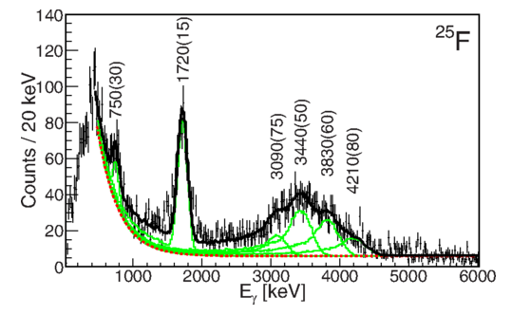

**Figure 1:** Gamma ray spectrum taken from Vajta et al. [VAJ14]. From the spectrum, it is clear that there are at least four gamma rays present exceeding 3 MeV. The high resolution capability of the GRETINA HPGe crystals, compared to the BaF2 used to obtain the displayed spectrum, provide a unique opportunity to measure these gamma rays.

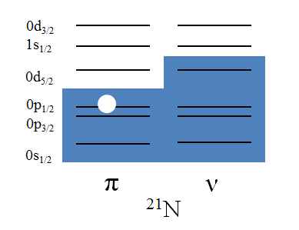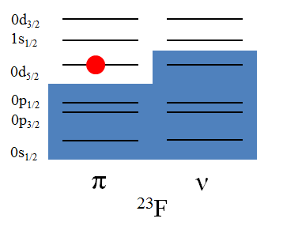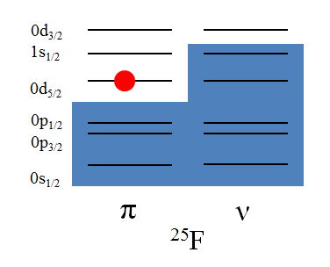

**Figure 2:** Possible proton states above and below the Fermi levels of 21N,23F and 25F. A schematic single-particle picture has been adopted. The nucleus 21N is represented as a one-proton state removed from 22O.

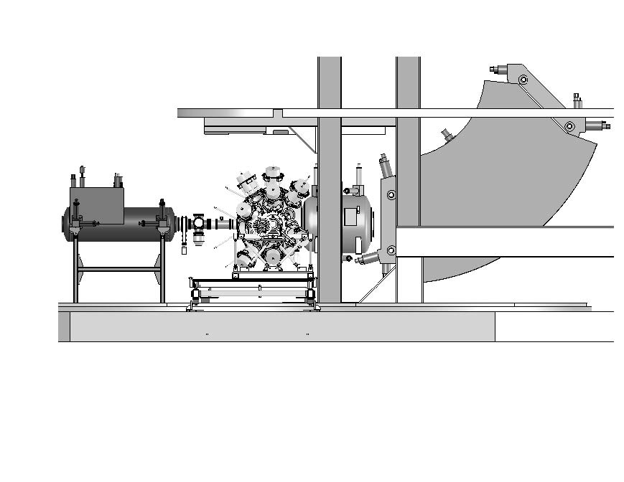

Figure 3: GRETINA setup surrounding the target position of the S800 spectrograph. Four GRETINA detectors will occupy the most forward positions at 58o and the remaining five will be located at 90o adjacent to each other.

|  |  |  |  |  |  |  |  |
| --- | --- | --- | --- | --- | --- | --- | --- |
| Beam | Beam Rate [pps] | A1900 D4 Magnetic Rigidity [Tm] | σ sensitivity [mb] | Counts in Peak | Measurement Time [hrs] | Change Time [hrs] | Total Time  [hrs] |
| 22O | 8800 | 3.65 | 0.1 | 300 | 61 | 10 | 71 |
| 26Ne | 42000 | 3.5 | 0.1 | 300 | 10 | 7 | 17 |
| 24Ne | 380000 | 3.6 | 0.1 | 300 | 2 | 7 | 9 |
| -- | -- | -- | -- | -- | -- | -- | 97 |

**Table 1:** The estimated beam rates for the secondary beams are shown, as well as the magnetic rigidity calculated for the final magnet (D4) in the A1900. The desired cross section sensitivities are shown, and the resulting required number of counts, and time needed on target to obtain these sensitivities are displayed. The time required to change beams is shown, and the total time required for the experiment is displayed in the final row and column.

## Status of Previous Experiments

Results from, or status of analysis of, previous experiments at the CCF listed by experiment number. Please indicate publications, invited talks, Ph.D.s awarded, Master’s degrees awarded, undergraduate theses completed.

## Educational Impact of Proposed Experiment

If the experiment will be part of a thesis project, please include the total number of years the student has been in graduate school, what other experiments the student has participated in at the NSCL and elsewhere (explicitly identify the experiments done as part of thesis work), and what part the proposed measurement plays in the complete thesis project.