Keiser Window Explain(from chatgpt)

The Kaiser window is a useful function in signal processing for designing filters and for windowing in Fourier analysis. Below is a simple C program that demonstrates how to apply a Kaiser window to a WAV signal. The program will read the WAV file, apply the Kaiser window to the samples, and write the output to a new WAV file.

**Required Libraries**

Make sure you have the following libraries or add them to your project:

* <math.h>: For mathematical functions like cos, sinh, and PI.
* <stdio.h> and <stdlib.h>: For file handling and memory management.

### Kaiser Window Formula

The Kaiser window function w(n)w(n)w(n) is defined as:



Where:

* I0I_0I0​ is the modified zeroth-order Bessel function of the first kind.
* β\betaβ is the shape parameter.
* NNN is the window length.
* n is the sample index

**Compilation and Execution**

1. Save the code in a file named kaiser_window.c.
2. Compile the program using a C compiler, such as GCC:

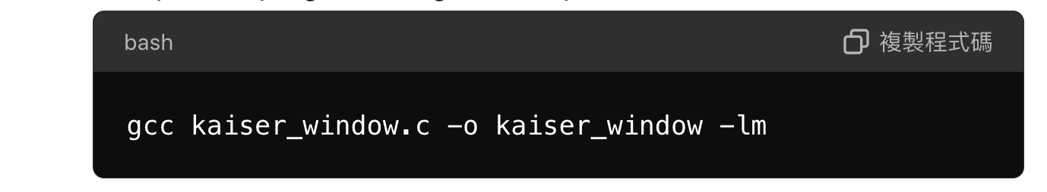

The -lm flag links the math library, which is required for mathematical functions like sqrt and cos.

1. Run the program:

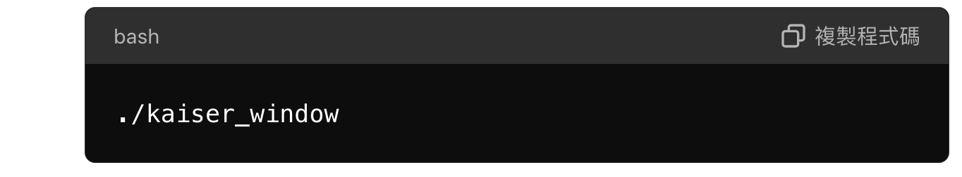

### Explanation:

* **Bessel Function Calculation**: The besselI0 function computes the zeroth-order modified Bessel function, which is a critical part of the Kaiser window function.
* **Applying the Kaiser Window**: The apply_kaiser_window function multiplies each sample in the signal by the corresponding Kaiser window value.
* **File Handling**: The program includes simplified functions to read and write WAV files. Note that these functions assume a very basic WAV file format and may not work with all WAV files.

You can adjust the beta parameter to change the window shape. Higher values of beta result in a wider main lobe and more attenuation in the sidelobes.