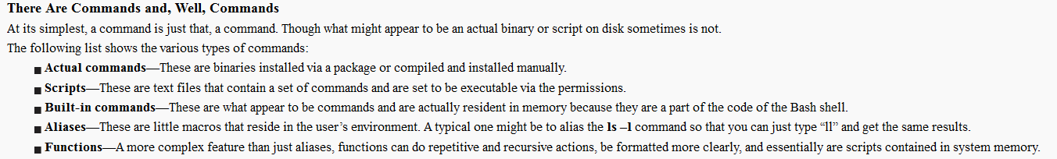

[root@localhost ~]# which pwd

/usr/bin/pwd

[root@localhost ~]# type pwd

pwd is a shell builtin

man pwd

pwd –-help

info pwd

which: show the full path of shell command

type

**type**

The type command is a shell builtin that displays the kind of command the shell will execute, given a particular command name. It works like this:

type *command*

where “command” is the name of the command you want to examine. Here are some examples:

[me@linuxbox me]$ type type  
type is a shell builtin

[me@linuxbox me]$ type ls  
ls is aliased to `ls --color=tty'

[me@linuxbox me]$ type cp  
cp is /bin/cp

Here we see the results for three different commands. Notice that the one for ls (taken from a Fedora system) and how the ls command is actually an alias for the ls command with the “-- color=tty” option added. Now we know why the output from ls is displayed in color!