**Global unicast addresses** [**^**](https://4sysops.com/archives/ipv6-tutorial-part-5-address-types-and-global-unicast-addresses/#Content-bal-title)

A global unicast address is simply what we call a public IP address in IPv4—that is, an IP address that is routed across the whole Internet. You can make out a global unicast address easily: The first three bits are set to 001. Thus, the address prefix of a global IPv6 address is 2000::/3 because 0010000000000000 is 2000 in hex. However, in the future, the IANA (Internet Assigned Numbers Authority) might delegate currently unassigned portions of the IPv6 address space. Hence, 2000::/3 won’t always be the prefix for global unicast addresses.

[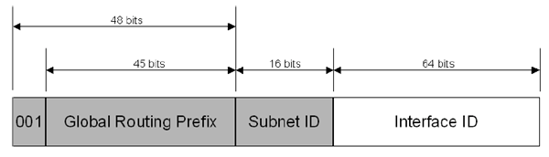](https://4sysops.com/wp-content/uploads/2011/03/IPv6.tutorial.Global.unicast.address.png)

(Note: The diagram is from Microsoft’s “[Introduction to IP Version 6](http://www.microsoft.com/windowsserver2003/technologies/ipv6/introipv6.mspx).”)

The next 45 bits are the so-called global routing prefix. This is the part that is assigned to organizations. The following 16 bits are for the subnet ID, which you can use for hierarchical addressing in your network. The last 64 bits indicate the interface ID, which is the part of the IPv6 address that must be unique within a subnet. You know what this means, right? You can have 65,536 (=216subnets), and each subnet can have 18446744073709551616 (=264) computers. I hope you have an efficient OS deployment too

With IPv6, how many bits have been used for the interface identifier of an unicast address?

(Specify the number using digits only.)

**Correct Answer:**64