**If you're upgrading to Ubuntu 15.04 or later**, fcitx will be installed. If IBus is running OK and you want to keep it, you're all set. If not, I suggest you try fcitx.

If fcitx does not show up in the Language Support panel, you'll need to go into Terminal and run *im-config*. When the configuration list comes up, click "OK" and then you'll be asked "Do you want to explicitly select the user configuration?" Click "OK", select fcitx, and click "OK". Exit terminal, and logout/login.

After logging in, skip down this page to where I show how to [make sure you have the fcitx menu](http://www.pinyinjoe.com/linux/ubuntu-12-chinese-setup.htm#keyboard-menu) <--- by clicking this jump link.

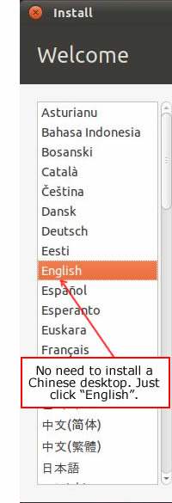**If you're doing a clean installation,** at the Welcome sreen you will be asked to pick a display language, as shown on the right here. --->

*It is not necessary to use a Chinese language desktop if you don't want to,* because Chinese input methods are available in any locale. You can select "English" or another language now, and use Chinese menus later if you wish.

**After installation, add language support:**

After the installation is complete and you have logged in, you will find more than one way to get into the Language Support control panel.

The "old" way is to click the menu at the upper right of the screen, and select System Settings:

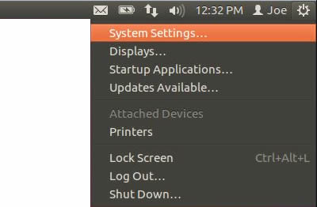

That will bring up the System Settings panel, where you'll find Language Support:

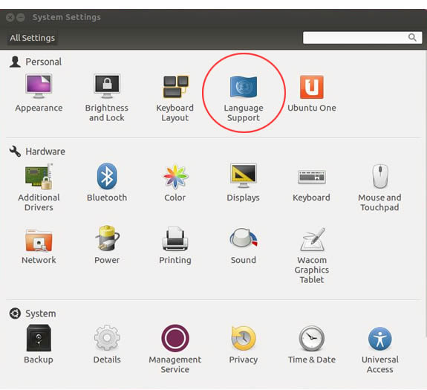

The new way is to tap the Super key (the Ubuntu/Windows key on your keyboard) or click the Dash icon at the upper left of your screen, and type "Language" into the search box:

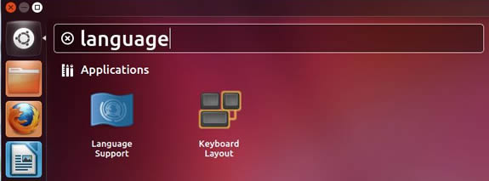

Double-click the Language Support icon to open that panel.

Then click the "Install / Remove Languages..." button:

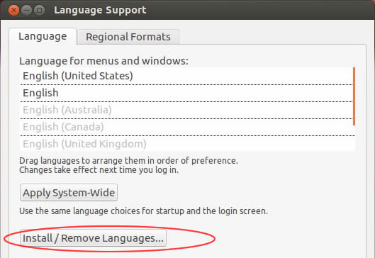

I've cropped out the "Keyboard input method system" menu because in some cases you need to install languages first to ensure all input method frameworks are available.

After you click the Install/Remove Languages button, the Installed Languages panel will appear. Scroll to and select the languages you want to install, then click the "Apply Changes" button:

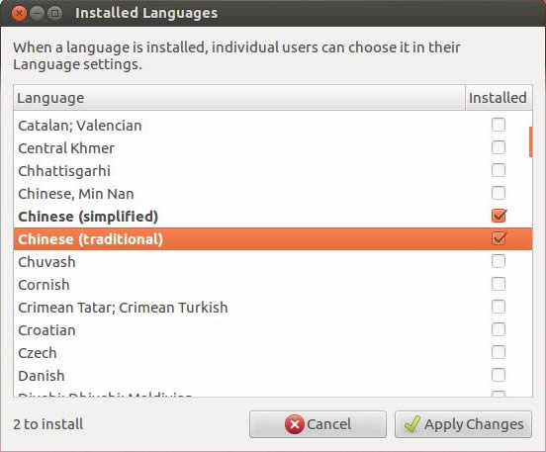

After the file installation process is complete, log out and log back in:

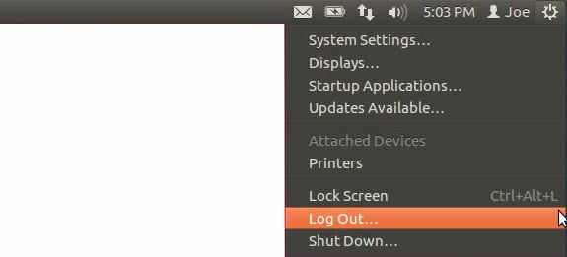

Then return to the Language Support panel:

Ubuntu language support panel title bar

Beginning in Ubuntu 15 you'll have the choice of fcitx in the "Keyboard input method system" menu. I suggest you use fcitx, as [Ibus has had problems lately](http://www.pinyinjoe.com/faq/ubuntu-1404-chinese-ime-problems-faq.htm). (If fcitx is not there, go back and install the Chinese language(s) as shown above, and be sure to log out and log in. If you don't log out and in, the menu usually will not change.)

In Ubuntu 10 through 14, select IBus unless you have a very specific need for one of the alternatives. (For info on adding the old SCIM framework to this menu, see the [input methods page](http://www.pinyinjoe.com/linux/ubuntu-10-chinese-input-pinyin-chewing.htm).) You can also add fcitx to these releases too, as explained near the end of my [14.xx bugs FAQ](http://www.pinyinjoe.com/faq/ubuntu-1404-chinese-ime-problems-faq.htm).

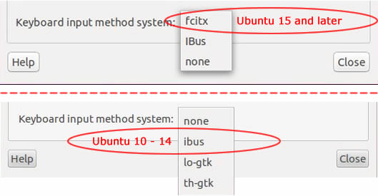

After selecting a keyboard input method system, log out and log back in again. Yes, again.



In Ubuntu 15 or later with fcitx selected, you should see the fcitx keyboard icon on the top panel. If you see the IBus "En" language icon instead, try the command line fix below.

kcitx penguinThe fcitx penguin may put in an appearance in place of that keyboard icon at some point. Do not be alarmed. He's just showing you his calligraphy brush.

fcitx keyboard icon in the Ubuntu top panel

In 13.10 - 14.10 you'll see an IBus language icon:

Ubuntu 1310 input method menu icon

In 10.04 - 13.04 you'll see the IBus keyboard icon:

Ubuntu input method keyboard menu icon

If the icon is not there, or if you see the wrong one, go back to the Language panel to recheck your settings, log out / log in, or if that doesn't work then restart. If it still refuses to appear, open Terminal and run:

*im-config*

Then click through the dialogs to select fcitx, or IBus, or whatever you need. **Logout and login again.** You should see the keyboard icon now. (In older systems, you can also try *im-switch -s fcitx* or *im-switch -s ibus* as appropriate.)

Once you have installed everything above. Go to the terminal and type “im-config”, follow the instructions and set fcitx as your default input method.

Then you should see a keyboard appear in the top right status bar in the screen.

Click on the that keyboard and choose “Configure”.

In the “Input method” tab, click on the plus sign to add a new input method.

Untick “Only show current language”, then find “Unikey” and add it.

Go back to the keyboard again, click on it and choose input method (with a arrow “>”  like this), then choose “Unikey”.

Now you should be able to type in Vietnamese!

Note that if you don’t any effect of your changes, you have to log out then log in Ubuntu to enable them.