# Exercises: Functions

This document defines the homework assignments from the [“PHP Basics“ Course @ Software University](https://softuni.bg/courses/php-basics/). Please submit as homework a single zip / rar / 7z archive holding the solutions (source code) of all below described problems.

## Inside Volume

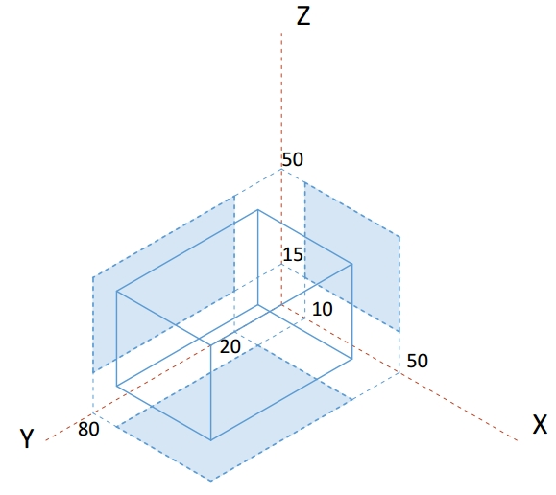Write a function that determines whether a point is inside the volume, defined by the box, shown on the right.

The **input** comes as a string representing the coordinates that needs to be split and parsed as numbers. Each set of 3 elements are the x, y and z coordinates of a point.

The **output** should be printed to the console on a new line for each point. Print inside if the point lies inside the volume and outisde otherwise.

### Examples

|  |  |
| --- | --- |
| **Input** | **Output** |
| 8, 20, 22 | outside |
| 13.1, 50, 31.5,  50, 80, 50,  -5, 18, 43 | inside  inside  outside |

### Hints

This task is very similar to previous assignments where a point might lie inside an area in 2D space, with just an extra dimension added. If we look at a classic conditional statement, which checks whether a point is inside a rectangle:

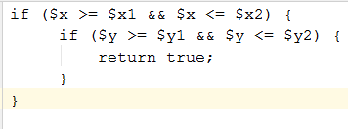

It checks whether a coordinate is greater than the minimum and at the same time less than the maximum bounding value for both axes (x and y). All we have to do is to include an additional check for a coordinate to be within the vertical limits of the volume (z-axis):

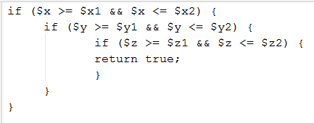

We can then wrap this whole statement in a function and as we process each set of coordinates, pass them to see if they are inside the volume and print the correct message to the console. Since the volume is the same every time, we can hardcode the values, but it’s generally good practice to pass them as function arguments, so that the function may work with any arbitrary volume. Later in the course we’ll learn how to shorten this with the use of objects.

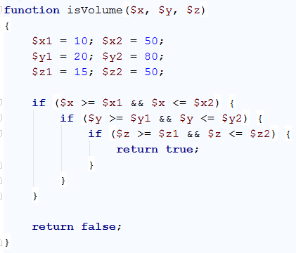

We can extract the sets of coordinates with a loop that skips 3 elements at a time and assigns them to temporary variables:

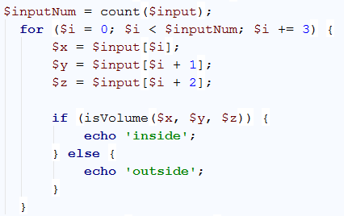

We know from the problem description that the input array will contain sets to three coordinates. Starting at 0, the current element (denoted by index ***i*** inside the loop) is the x-coordinate, the element after the current (***i + 1***) is the y-coordinate, and the element two indices after the current (***i + 2***) is the z-coordinate. At the end of the cycle, the index is increased by 3 and we can obtain the coordinates of the next point, using the same arithmetic (instead of 0, 1 and 2 we will get 3, 4 and 5) and so on, until there are no more elements in the array. The three coordinates are passed into our function and we get a Boolean value as a result. If it’s true, we print inside for the current point and otherwise we print outside.

## Road Radar

Write a function that determines whether a driver is within the speed limit. You will receive his speed and the area where he’s driving. Each area has a different limit: on the **motorway** the limit is **130** km/h, on the **interstate** the limit is **90**, inside a **city** the limit is **50** and within a **residential** area the limit is **20** km/h. If the driver is within the limits, your function prints nothing. If he’s over the limit however, your function prints the severity of the infraction. For speeds up to **20** km/hover the limit, he’s speeding; for speeds up to **40** over the limit, the infraction is **excessive speeding** and for anything else, **reckless driving**.

The **input** comes in two rows. On the first row you will receive the current speed as a string and needs to be parsed as a number. On the second row you will be given the second element which is the area.

The **output** should be printed to the console. Note in certain cases there will be no output.

### Examples

|  |  |
| --- | --- |
| **Input** | **Output** |
| 40  city |  |
| 20  residential | speeding |
| 120  interstate | excessive speeding |
| 200  motorway | reckless driving |

### Hints

We can divide the task in two functions – one that determines what the current speed limit is, depending on zone, and another which tells us if an infraction is being made, depending on current speed and current limit. Determining the limit is achieved with a **switch** statement on the input:

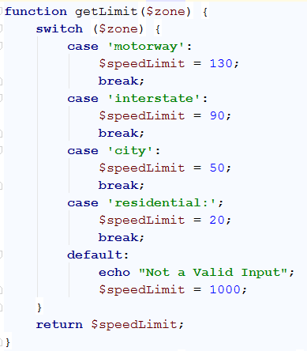

This function takes a string as an argument and returns a number, depending on what that string is. We can take this directly from the input, pass it to this function and save the return value in a variable. In our second function, we pass the current speed and the limit, which we just saved.

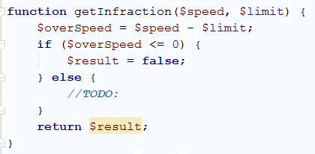

We calculate the difference between the current speed and the limit – if it’s negative or zero, this means the driver is within the rules and we return false, and in any other case, return the infraction as a string and store the result of the operation in a variable.

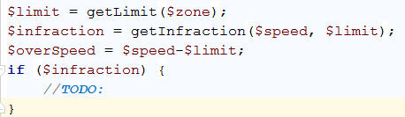

We can use the fact that PHP functions can return different data types and directly use the result we stored in a conditional statement – if it’s **false** (no infraction), do nothing, if it’s **truthy** (non-empty string in this case), print the value store in the variable.

## *Template format

Write a program that receives data about a quiz and prints it formatted as an XML document. The data comes as pairs of question-answer entries. The format of the document should be as follows:

|  |
| --- |
| **XML** |
| <?xml version="1.0" encoding="UTF-8"?>  <quiz>  <question>  {question text}  </question>  <answer>  {answer text}  </answer>  </quiz> |

The **input** comes as a string in which the questions and answers will be separated by “, “.

The **output** should be printed on the console.

### Examples

|  |
| --- |
| **Input** |
| Who was the forty-second president of the U.S.A.?, William Jefferson Clinton |
| **Output** |
| <?xml version="1.0" encoding="UTF-8"?>  <quiz>  <question>  Who was the forty-second president of the U.S.A.?  </question>  <answer>  William Jefferson Clinton  </answer>  </quiz> |

|  |
| --- |
| **Input** |
| Dry ice is a frozen form of which gas?, Carbon Dioxide, What is the brightest star in the night sky?, Sirius |
| **Output** |
| <?xml version="1.0" encoding="UTF-8"?>  <quiz>  <question>  Dry ice is a frozen form of which gas?  </question>  <answer>  Carbon Dioxide  </answer>  <question>  What is the brightest star in the night sky?  </question>  <answer>  Sirius  </answer>  </quiz> |

## Cooking by Numbers

Write a program that receives a number and a list of five operations. Perform the operations in sequence by starting with the input number and using the result of every operation as starting point for the next. Print the result of every operation in order. The operations can be one of the following:

* chop – divide the number by two
* dice – square root of number
* spice – add 1 to number
* bake – multiply number by 3
* fillet – subtract 20% from number

The **input** comes in 2 lines. On the first line you will receive your starting point and must be parsed to a number. On the second line you will receive 5 commands separated by “, “ each one will be the name of the operation to be performed.

The **output** should be printed on the console.

### Examples

|  |  |
| --- | --- |
| **Input** | **Output** |
| 32  chop, chop, chop, chop, chop | 16 8 4 2 1 |

|  |  |
| --- | --- |
| **Input** | **Output** |
| 9, dice, spice, chop, bake, fillet | 3  4  2  6  4.8 |

## Modify Average

Write a program that modifies a number until the average value of all of its digits is **higher than 5**. In order to modify the number, your program should append a **9** to the end of the number, when the average value of all of its digits is **higher than 5** the program should stop appending. If the number’s average value of all of its digits is already **higher than 5**, no appending should be done.

The **input** is a single number received as a string.

The **output** should consist of a single number - the final modified number which has an average value of all of its digits **higher than 5**. The **output** should be printed on the console.

### Constraints

* **The input number will consist of no more than 6 digits.**
* **The input will be a valid number (there will be no leading zeroes).**

### Examples

|  |  |
| --- | --- |
| **Input** | **Output** |
| 101 | 1019999 |
| 5835 | 5835 |

## Validity Checker

Write a program that receives two points in the format **x1, y1, x2, y2** and checks if the distances between each point and the start of the cartesian coordinate system (0, 0) and between the points themselves is **valid**. A distance between two points is considered **valid**, if it is an **integer value**. In case a distance is valid write "**{x1, y1} to {x2, y2} is valid"**, in case the distance is invalid write **"{x1, y1} to {x2, y2} is invalid"**.

The order of comparisons should always be first **{x1, y1}** to **{0, 0}**, then **{x2, y2}** to **{0, 0}** and finally **{x1, y1}** to **{x2, y2}**.

The **input** consists of one string in which the coordinates are separated by “, “(look at the examples).

For each comparison print on the **output** either "**{x1, y1} to {x2, y2} is valid"** if the distance between them is valid, or **"{x1, y1} to {x2, y2} is invalid"**- if it’s invalid.

### Examples

|  |  |
| --- | --- |
| **Input** | **Output** |
| 3, 0, 0, 4 | {3, 0} to {0, 0} is valid  {0, 4} to {0, 0} is valid  {3, 0} to {0, 4} is valid |
| 2, 1, 1, 1 | {2, 1} to {0, 0} is invalid  {1, 1} to {0, 0} is invalid  {2, 1} to {1, 1} is valid |

## Treasure Locator

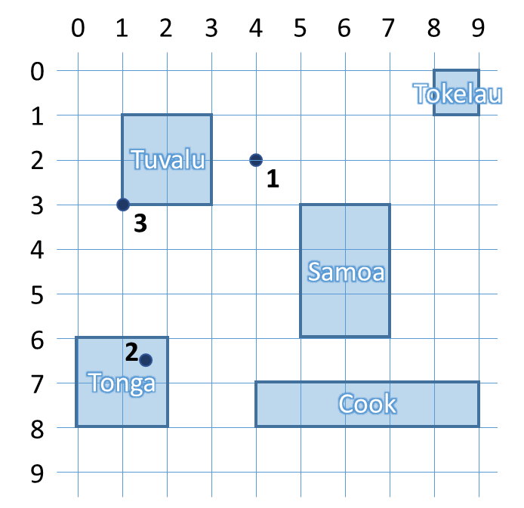You will be given a series of coordinates, leading to a buried treasure. Use the map to the right to write a program that locates on which island it is. After you find where all the treasure chests are, compose a list and print it on the console. If a chest is not on any of the islands, print “On the bottom of the ocean” to inform your treasure-hunting team to bring diving gear. If the location is on the shore (border) of the island, it’s still considered to lie inside.

The **input** comes as a string of variable number of elements separated by “, “ that must be parsed to numbers. Each pair is the coordinates to a buried treasure chest.

The **output** is a list of the locations of every treasure chest, either the name of an island or “On the bottom of the ocean”, printed on the console.

### Examples

|  |  |
| --- | --- |
| **Input** | **Output** |
| 4, 2, 1.5, 6.5, 1, 3 | On the bottom of the ocean  Tonga  Tuvalu |
| 6, 4 | Samoa |

## Trip Length

You will be given the coordinates of 3 points on a 2D plane. Write a program that finds the two shortest segments that connect them (without going back to the starting point). When determining the listing order, use the order with the lowest numerical value (see the figure in the hints for more information).

The **input** comes as a string with 6 elements separated by “, “ that must be parsed to numbers. The order is **x1, y1, x2, y2, x3, y3**.

The **output** is the return value of your program as a string, representing the order in which the three points must be visited and the final distance between them. See the examples for more info.

### Examples

|  |  |
| --- | --- |
| **Input** | **Output** |
| 0, 0, 2, 0, 4, 0 | 1->2->3: 4 |

|  |  |
| --- | --- |
| **Input** | **Output** |
| 5, 1, 1, 1, 5, 4 | 2->1->3: 7 |

|  |  |
| --- | --- |
| **Input** | **Output** |
| -1, -2, 3.5, 0, 0, 2 | 1->3->2: 8.154234499766936 |

### Hints

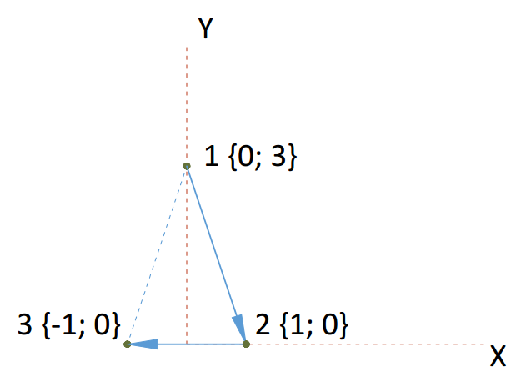You can find the horizontal and vertical offset between two points by calculating the difference between their coordinates. Use Pythagoras’ theorem to find the distance.

If more than one shortest paths exist, choose the one with lowest numerical value. For instance, in the figure on the right, 1🡪2🡪3 is the same distance as 3🡪2🡪1, but we chose to start at 1, since it’s lower than 3. When choosing the second point, we encounter the same issue – 1🡪3🡪2 would be the same as 1🡪2🡪3, but we chose to visit 2 first, because it’s lower than 3.

## **Radio Crystals

It’s time to put your skills to work for the war effort – creating management software for a radio transmitter factory. Radios require a finely tuned quartz crystal in order to operate at the correct frequency. The resource used to produce them is quartz ore that comes in big chunks and needs to undergo several processes, before it reaches the desired properties.

You need to write a program that monitors the current thickness of the crystal and recommends the next procedure that will bring it closer to the desired frequency. To reduce waste and the time it takes to make each crystal your program needs to complete the process with the least number of operations. Each operation takes the same amount of time, but since they are done at different parts of the factory, the crystals have to be transported and thoroughly washed every time an operation different from the previous must be performed, so this must also be taken into account. When determining the order, always attempt to start from the operation that removes the largest amount of material.

The different operations you can perform are the following:

* Cut – cuts the crystal in 4
* Lap – removes 20% of the crystal’s thickness
* Grind – removes 20 microns of thickness
* Etch – removes 2 microns of thickness
* X-ray – increases the thickness of the crystal by 1 micron; this operation can only be done once!
* Transporting and washing – removes any imperfections smaller than 1 micron (round down the number); do this after every batch of operations that remove material

At the beginning of your program, you will receive a number representing the desired final thickness and a series of numbers, representing the thickness of crystal ore in microns. Process each chunk and print to the console the order of operations and number of times they need to be repeated to bring them to the desired thickness.

The **input** comes as a string with a variable number of elements separated by “, “ that must be parsed to numbers. The first number is the target thickness and all following numbers are the thickness of different chunks of quartz ore.

The **output** is the order of operation and how many times they are repeated, every operation on a new line. See the examples for more information.

### Examples

|  |  |
| --- | --- |
| **Input** | **Output** |
| 1375, 50000 | Processing chunk 50000 microns  Cut x2  Transporting and washing  Lap x3  Transporting and washing  Grind x11  Transporting and washing  Etch x3  Transporting and washing  X-ray x1  Finished crystal 1375 microns |

#### Explanation

The operation that would remove the most material is always cutting – it removes three quarters of the chunk. Starting from 50000, if we perform it twice, we bring the chunk down to 3125. If we cut again, the chunk will be 781.25, which is less than the desired thickness, so we move to the next operation, but we first round down the number (transporting & washing). Next, we lap the chunk – after three operations, the crystal reaches 1600 microns. One more lapping would take it to 1280, so we move on to the next operation instead. We do the same check with grinding, and finally by etching 2 times, the crystal has reached 1376 microns, which is one more than desired. We don’t have an operation which only takes away 1 micron, so instead we etch once more to get to 1374, wash and then x-ray to add 1 micron, which brings us to the desired thickness.

|  |  |
| --- | --- |
| **Input** | **Output** |
| 1000, 4000, 8100 | Processing chunk 4000 microns  Cut x1  Transporting and washing  Finished crystal 1000 microns  Processing chunk 8100 microns  Cut x1  Transporting and washing  Lap x3  Transporting and washing  Grind x1  Transporting and washing  Etch x8  Transporting and washing  Finished crystal 1000 microns |

## **DNA Helix

Write a program that prints a DNA helix with length, specified by the user. The helix has a repeating structure, but the symbol in the chain follows the sequence ATCGTTAGGG. See the examples for more information.

The **input** comes as a single string element that must be parsed to a number. It represents the length of the required helix.

The **output** is the completed structure, printed on the console.

### Examples

|  |  |  |  |  |
| --- | --- | --- | --- | --- |
| **Input** | **Output** |  | **Input** | **Output** |
| 4 | **AT** *C--G* T----T *A--G* | 10 | **AT** *C--G* T----T *A--G* **GG** *A--T* C----G *T--T* **AG** *G--G* |