1. AddPhotos()~ kanw load tis default eikones sthn Program.defaultImages
2. Play button ~ reset ta panta kai timer1.start
3. Shuffle

* Dhmiourgoume random
* Add.ImagesList(defaultImages[random]) ~ mexri na gemisei o pinakas
* Program.imagesList = imagesList

Program.imageList(Static) imageList(non static) defaultImages

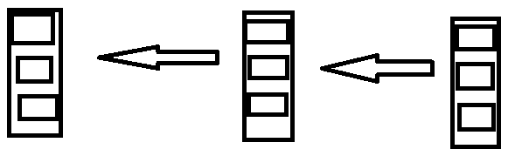

1. O timer1 meta apo 3 sec metatrepei tis eikones se hidden image

Timer1:

* otan energopoieite meta apo 3 sec ta metatrepei se hidden image
* auksanei thn metablhth time ~time+=1;
* Elengxei kathe 1 sec an to paixnidi exei teleiwsei

Timer2:

* Kanei update ola ta labels kathe 1 sec

Gameplay

1. Cast ton sender se picturebox ~box
2. Test(box)
   * Briskei pio picturebox thn kalese
   * Krataei to image location
   * Thn apokaluptei
   * Kanei return to imagelocation

Case1: First Match

* Apothikeuei pio picturebox einai
* Kanei to finding match = true ~ ara psaxnoyme gia to tairi tou
* Apothikeuoyme poia eikona exei
* To kanoume disable wste na mhn patiete 2h fora

Case2: Brikame to swsto deutero match

* Kanoyme reset to finding match = false ~ ara koitame gia prwto match pali
* Kanoyme ayto kai to 1o match disable wste na mhn ksanapatithoun

Case3: Einai lathos to deuteron match

* Deixnoyme thn lathos eikona gia 300 ms
* Kanoyme auto kai to prwto match pali hidden image
* Kanoyme to prwto match enable wste na mporoyme na to ksanapatisoume