

ASSIGNMENT
COURSE: MATHEMATICAL MODELS IN INFECTIOUS DISEASES
ATHANASACOPOULOS CHRISTOS
Student ID: 7450022400003

MAY 2025

QUESTION 1th:
The epidemic curve for the first 15 days of the pandemic is shown in the figure below.
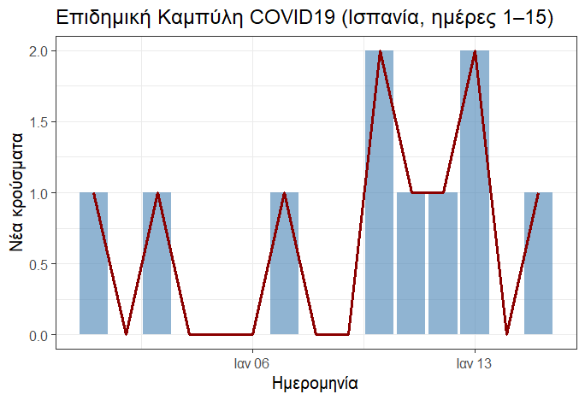
From the epidemic curve, we observe that in the first days up to approximately day 7th the cases range from 1 — likely imported travel-related — cases and sporadic. Subsequently, from day 8th onwards there is a doubling of cases signaling the beginning of the exponential phase of local transmission. Around day 10th and 11th a stabilization around 2 cases is also observed, suggesting an exponential growth trend. Zero cases in the initial phase may be due to sporadic case recording given that we were at the very beginning of the pandemic, as well as a possible weekend effect. Finally, it should be noted that although 2 cases is a very small absolute number, it represents a large proportional increase. In summary, we could say that in the first two weeks the epidemic starts with sporadic cases, followed by a doubling around day 8 where the exponential spread phase begins. This pattern would certainly have raised the alarm for the need for rapid intervention to limit disease transmission.
QUESTION 2th:
In this question we will estimate the effective reproduction number by applying the methodology of Cori et al. For the generation time T_{g} we used the study by Hiroshi Nishiura et al (Serial interval of novel coronavirus (COVID-19) infections)
https://pmc.ncbi.nlm.nih.gov/articles/PMC7128842/
from which we obtained a mean generation time of 4.7 days with a standard deviation of 2.9 days.
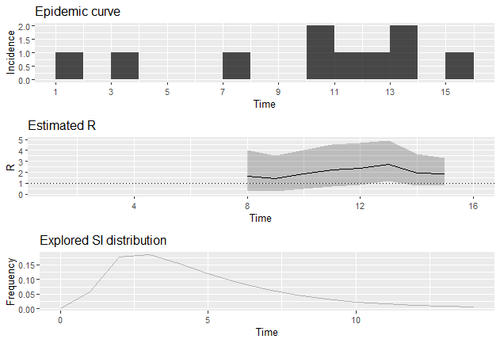
Results showed that in the first 2 weeks, Spain was in an exponential transmission phase with R_{t}>1 with a mean value of approximately 1.66, while the peak of transmission was in the 7-13 day window with R_{t}≈2.73. Nevertheless, as shown in the graph below, the R_{t} is accompanied by a wide confidence interval due to the fact that we are at a very early stage of the pandemic. The results are summarized in the graph below.

QUESTION 3th:
Parameter | Notation | Value
Total Population | Ν | 47332614
Susceptibles | S | N-E = 47332610
Infected (not Infectious) | Ε | 10
Infectious | Ι | 0
Recovered/Immune | R | 0
Basic Reproduction Number | R₀ | 1.66
Transition rate from Infectious  to Recovered | $$γ=\frac{1}{infectious period}$$ | $$\frac{1}{7}$$
Transmission rate | $$β=R_{0}∙γ$$ | 0.2371429
Transition rate from Exposed to  Infectious | $$σ=\frac{1}{latent period}$$ | $$\frac{1}{4}$$
- The parameters of the SEIR model at the onset of the pandemic based on the question data are summarized in the following table:
- Based on the model, the estimate for E is 2236.4 individuals and the graph is shown below:
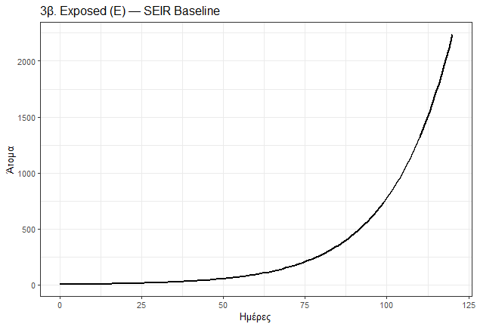

From the graph we observe that in the first approximately 4 days there is a small drop in the number of exposed but not yet infectious individuals, because some of those 10 individuals have transitioned to infectious. That is, we are in the latent period. From day 10th onwards, the number of infected individuals begins to increase, and from approximately day 50th their exponential growth begins. We observe that on day 50 we have 55 infectious, on day 80 we have 269, and on day 120 we have 2236, exactly illustrating this exponential rate. Finally, no peak appears within the 4 months and we expect exponential growth to continue if no epidemic control or vaccination intervention occurs.
- The estimate for the cumulative number of infected individuals over 4 months is 10,561 (Graph 1). Correspondingly, the percentage of the population infected in the first 4 months of the epidemic was 0.022% (Graph 2). The corresponding graphs are shown below:
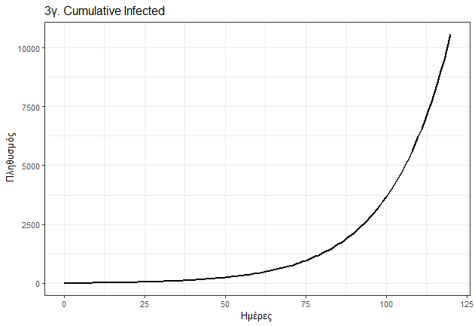
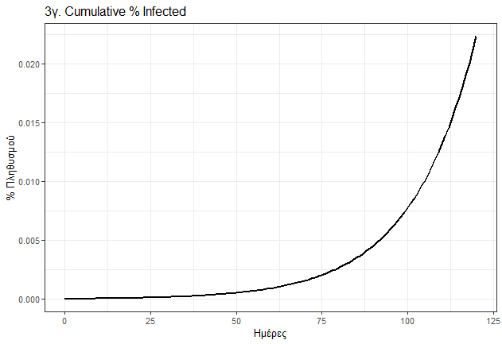

From the graphs we observe that the number of infected individuals initially shows a very small increase, whereas from day 50th onwards exponential growth begins.
- The final epidemic size based on our model is summarized in the following table:
Susceptibles | Exposed | Infectious | Recovered/Immune | Total Infected
15498631 47319816 | 0  2236.422348 | 0  2856.809639 | 31833983 7704.4885042 | 31833983 10561

So as shown in the table, if the epidemic had been left uncontrolled approximately 31.8 million people would have been infected, i.e., approximately 67% of the population, which is confirmed by R₀=1.66.
QUESTION 4th:
- To adapt the SEIR model to incorporate the implementation of social distancing measures, we needed to add a factor f=0.4 which gives us the 40% reduction in contacts that is activated from day $t_{SD}=30$ so that measures begin from the 2th month onwards. More specifically, the transmission rate β becomes:
$$β_{SD}=\left\{\begin{aligned}β, t≤30 \\ β\left(1-f\right), t>30\end{aligned}\right.$$
Where β is the value calculated in question 3th based on R₀. All other parameters remained unchanged ($σ=\frac{1}{4}, γ=\frac{1}{7}$) and we started again with E=10 and I=0. The simulation was run for 4 months (120 days) and a summary table is given below with the variable values at the start, day 30th and 120th day:
Day | Susceptibles (S) | Exposed (E) | Infectious (I) | Recovered/Immune (R) | Cumulative Infected (C)
0 | 47332604 | 10 | 0 | 0 | 0
30 | 47332519 | 19.181943 | 24.499423 | 51.0325257 | 75.531949
120 | 47332170 | 15.348221 | 26.928152 | 401.7835893 | 428.711741

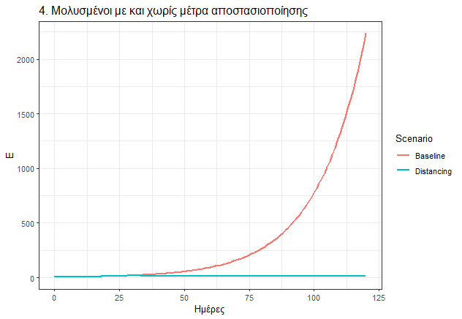
- The graph of Exposed (E) over the 4 months with social distancing measures compared to the corresponding estimate from the baseline scenario is shown below:

From the graph we observe that implementing social distancing measures with a 40% reduction in social contacts has a dramatic impact on the spread of the epidemic, reducing the exposed to nearly 0 (E(120)≈27) in contrast to the baseline scenario where exposed individuals numbered 2236 over 4 months. The measures make the E curve nearly flat after day 30th day, instead of the exponential growth shown by the baseline model. Correspondingly, it dramatically reduces both the infectious (≈402 vs vs 2857) and cumulative infections (≈402 vs vs 2857) as shown in the table above and in question 3b. This illustrates how critical timely intervention is for limiting the epidemic.ριορισμό (ή και εξάλειψη) της εκθετικής φάσης της επιδημίας.

QUESTION 5th:
- The social contact matrix is shown below:
$$\left(\begin{matrix}18 & 5 & 1 \\ 4 & 6 & 2 \\ 1 & 2 & 2\end{matrix}\right)$$
Where each element is of the form $c_{ij}$ from the i-th row and j-th column. More specifically, row 1th 2th and 3th rows give the contacts of the 0-17, 18-64 and 65+ age groups respectively, while the 1th , 2th and 3th columns respectively give the contacts of the 0-17, 18-64 and 65+ groups. For example, the element $c_{11}=18$ gives us the contacts of children 0-17 with other children.
The results of the pandemic simulation in the absence of measures over 4 months are shown in the summary table below (for time points day 0, day 60 and day 120), along with the corresponding graph of infectious individuals:
Day | Age Group | S | E | I | R | Total
0 | 0–17 | 9 466 518 | 5 | 0 | 0 | 9 466 523
 | 18–64 | 23 666 302 | 5 | 0 | 0 | 23 666 307
 | 65+ | 14 199 784 | 0 | 0 | 0 | 14 199 784
60 | 0–17 | 1 022 85 | 823 920 | 2 755 915 | 5 784 402 | 9 466 523
 | 18–64 | 4 276 920 | 4 147 117 | 6 771 841 | 8 470 429 | 23 666 307
 | 65+ | 8 045 177 | 1 861 725 | 2 188 207 | 2 104 674 | 14 199 784
120 | 0–17 | 2 370 | 7,7 | 1 011 | 9 463 134 | 9 466 523
 | 18–64 | 426 911 | 1 559,21 | 15 449,05 | 23 222 388 | 23 666 307
 | 65+ | 2 890 296 | 7 164,52 | 41 419 | 11 260 905 | 14 199 784
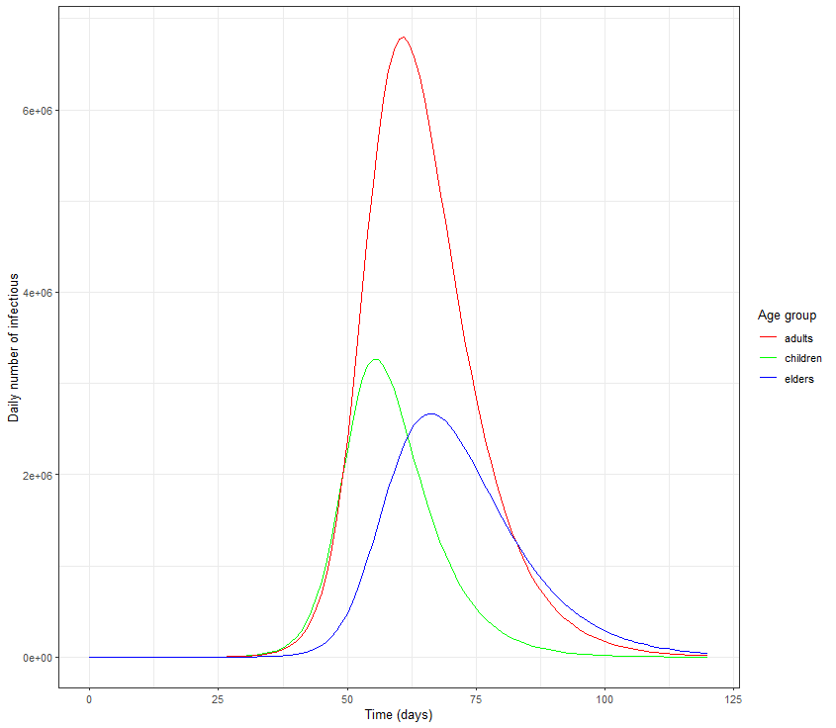

From the table above we observe a tremendous transmission in children, as the susceptibles at the endος του 4μήνου ανέρχονται μόλις σε 2370 από τους 9466518 (!). Φαίνεται ότι η συλλογική ανοσία επιτυγχάνεται πάρα πολύ γρήγορα για τα παιδιά και τους ενήλικες και λίγο πιο αργά για τους ηλικιωμένους. Αντίστοιχα, πολύ μεγάλο κύμα φαίνεται να υπάρχει και στους ενήλικες ενώ ακολουθούν οι ηλικιωμένοι. Από το γράφημα των μολυσματικών, αντίστοιχα, βλέπουμε την δυναμική εξάπλωση της πανδημίας και πως εν τέλει φαίνεται το βάρος της πανδημίας να μεταφέρεται εν τέλει στην ομάδα ατόμων with τα περισσότερα άτομα (ενήλικες 18-64).Ταυτόχρονα, παρατηρούμε ότι το υψηλότερο peak of the pandemic lies in the adult group, as they constitute the largest share of the population (50%). However, it is clear ξεκάθαρα ότι τα παιδιά φτάνουν πρώτα (χρονικά) στο peak (around day 60) precisely due to their very frequent contacts, followed by adults (day 65) and finally the elderly (day 70) οι ηλικιωμένοι λόγω των λιγότερων επαφών τους.
In summary, without epidemic control measures, the peak is reached within just 60 days for peak for the most socially active groups. These findings highlight how critical age structure and contact networks are in designing social distancing measures.signing social distancing measures.α επαφών στο σχεδιασμό μέτρων κοινωνικής αποστασιοποίησης.

QUESTION 6th:
For the period 01-Sep-2020 to 20-Jun-2021 (293 days), daily new cases “new cases” from the ECDC and removals were defined with a removals with lag 7-day lag corresponding to the mean infectious duration of COVID-19. The total population is approximately 47 million and initial conditions: $\left\{\begin{aligned}S_{0}=N-I_{0} \\ I_{0}=new_cases\left[1\right]\end{aligned}\right.$ .
The chain binomial SIR model was implemented in OpenBugs with likelihood:
$${new_cases}_{t}\sim Bin(S_{t-1},1-e^{-β\frac{I_{t-1}}{N}})$$
While S and I are updated discretely each day. The prior for parameter β was assumed to follow LogNormal(0,5)LogNormal(0,5) estimated via MCMC with 3 chains with 10500 iterations and 1000 burn-in. The MCMC diagnostics showed excellent convergence as shown below, with the blue, red and green chains nearly overlapping:

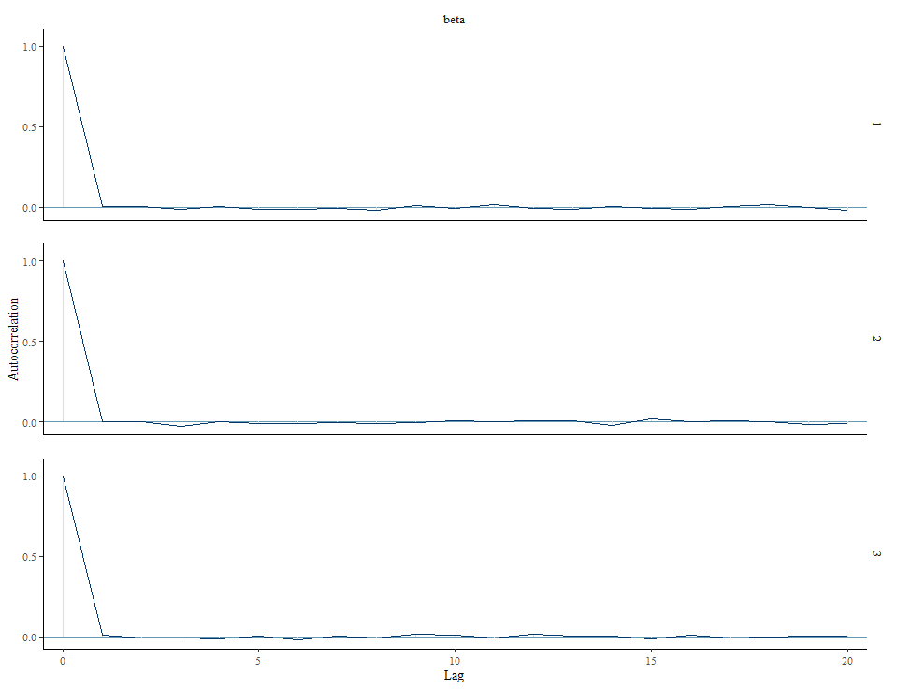

In the graph above we observe that after lag 1 the autocorrelation drops to nearly 0. The posterior estimate for $\hat{β}=0,1298$ with $95\%C.I.\left[0.1297,0.1299\right]$. Also, the
$\hat{R}=1.001≅1$ which also indicates very good chain mixing and convergence. Finally the Deviance $≅2.093∙{10}^{5}$ and the $DIC≅2.093∙{10}^{5} (pD≅1)$ confirm that this is a model with a single free parameter and very good predictive accuracy.
In summary, the chain-binomial SIR model fits our data for Spain extremely well with estimated transmission rate $β≅0,13$ per day and practically zero uncertainty.

QUESTION 7th:
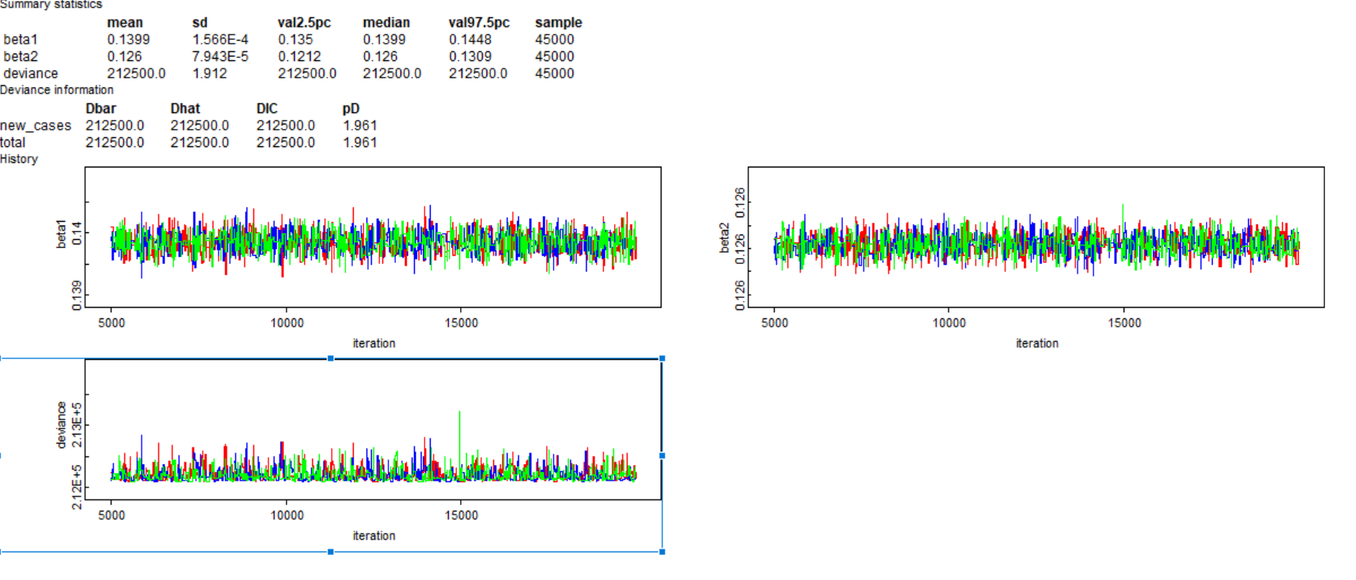
In this question we extended the chain-binomial SEIR model so that the transmission rate changes at a point we selected arbitrarily (day 60th. To avoid high autocorrelation we used thinning=10. The model was run for 20000 iterations and 5000 burn-in. The results obtained, as shown in the figure below, indicated very good convergence of our chains with $\hat{R}≅1$ .

As shown, our estimates for β were $\hat{β_{1}}=0,1399$ and 95% C.I C.I. [0.1350,0.1448] before the change point and $\hat{β_{2}}=0,126$ with 95% C.I with 95% C.I. [0.1212,0.1309] after the change-point. That is, there is approximately a 10% reduction in the transmission rate. Also, as shown in the graph below, after lag=lag=5 the autocorrelation tends toward 0, confirming the very good convergence of the chains. Finally the posterior appeared quite narrow.
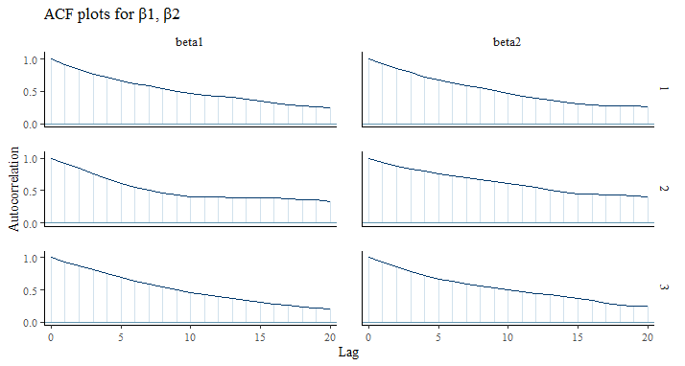

QUESTION 8th:
In this model the difference was that we also had a 3th change point (day 120th) and so our β values were: $\left\{\begin{aligned}β_{1} , t≤t_{cp1} \\ β_{2} ,t_{cp1}≤t≤t_{cp2} \\ β_{3} ,t>t_{cp2}\end{aligned}\right.$
As we ran the algorithm we again observed, as shown in the figure below, that the chains converged very well. καλά. Επίσης, η μείωση που φαίνεται στο DIC (210300 vs 212500 previously) indicates that the model with 3 change points performs better than the previous one.
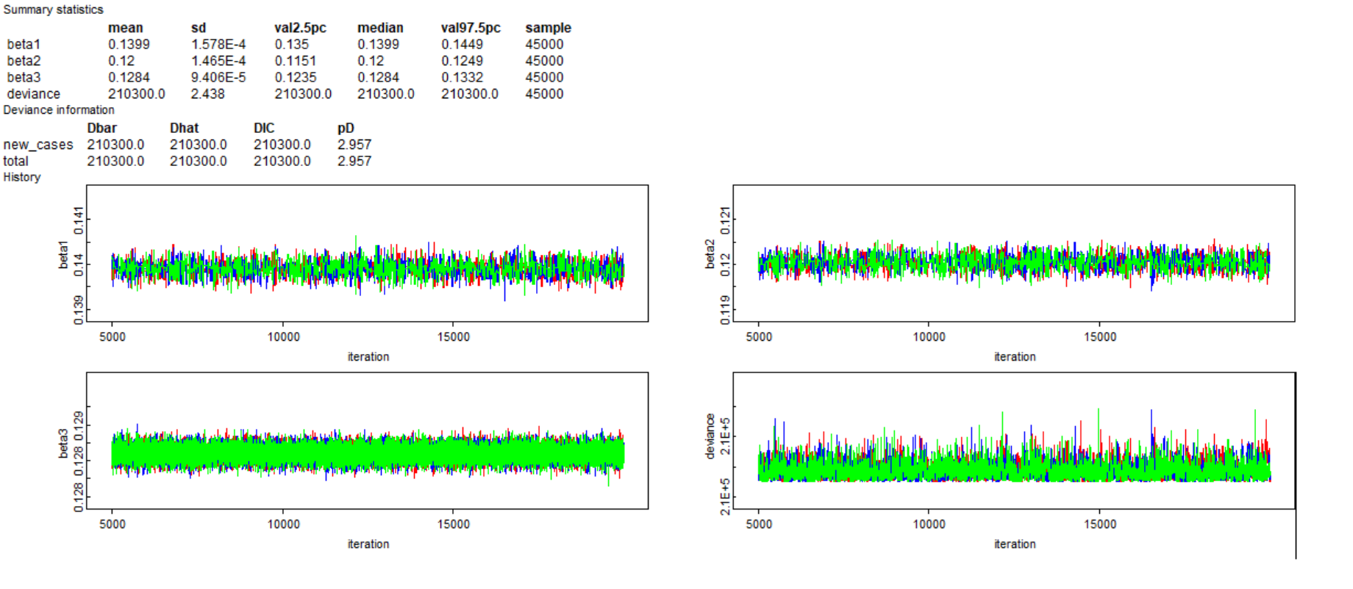

Our estimates for β were: $\left\{\begin{aligned}\hat{β_{1}}=0,1399 \\ \hat{β_{2}}=0,12 \\ \hat{β_{3}}=0,1284\end{aligned}\right.$ and as shown at change point 1th there is a reduction in the transmission rate and at change point 2th a small increase again, changes that likely reflect the presence of measures in the 1th case and some relaxation of them in the 2th.
The autocorrelations are shown below and appear to decrease smoothly for β₁, β₂ and very rapidly for β₃
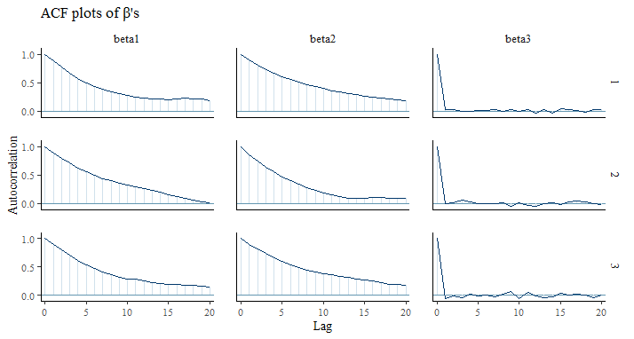

QUESTION 9th:
In this question we attempted to fit our model to a single change point where we estimate the time at which the transmission rate changes.λάζει ο ρυθμός μετάδοσης. Συντάχθηκαν δύο διαφορετικοί αλγόριθμοι για το ερώτημα αυτό. Ένας σε STAN with a continuous SIR model and one in OpenBugs essentially an extension of the previous models. Both algorithms encountered problems. The STAN algorithm is excessively slow during execution and for this reason the results below are those from OpenBugs. As shown below, the two chains appear to converge but the change point is immovable. This either means the algorithm did not search for other values of t or that it finds no other change point in our data. The estimated β values are 0.14 and 0.11 respectively.
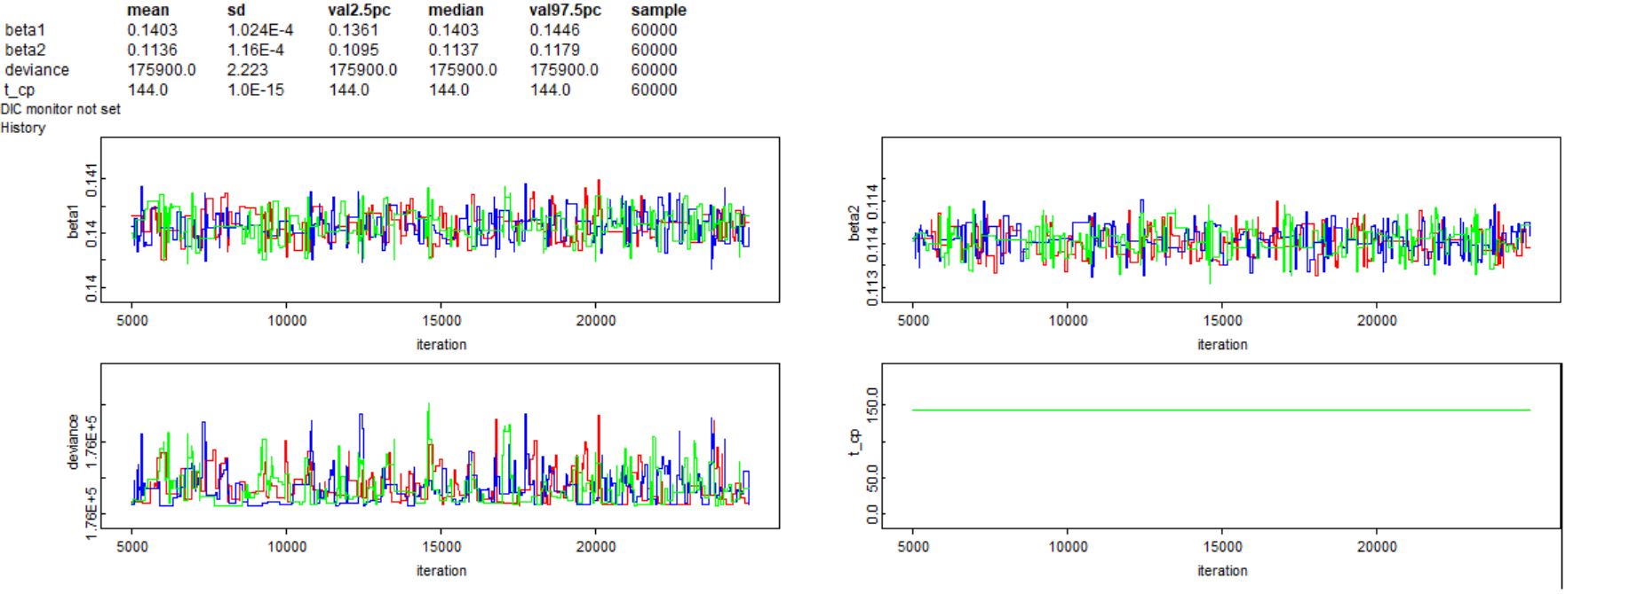
However, as shown in the graph below, there appear to be 3 transmission change points (November, February and May) with αποτέλεσμα να δείχνει ότι μάλλον ο αλγόριθμος απλά δεν έψαξε για αλλαγές στο t.
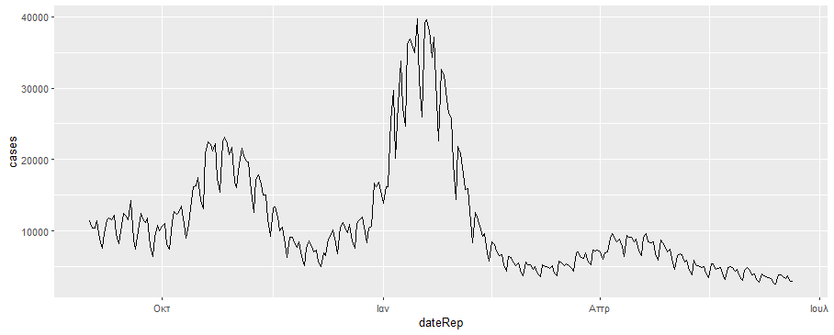

For this assignment, it should be noted that within the framework of classical SIR/SEIR models, “Removals”/ “Recovered” (R) correspond to individuals leaving the infectious compartment, either through recovery or death. Therefore, in the presentα ανάλυση δεν διαχωρίζουμε τις θνητότητες από τις αναρρώσεις, παρά μοντελοποιούμε μόνο τις συνολικές αφαιρέσεις (recoveries + deaths). Given that the case fatality rate of COVID-19 is relatively low compared to the total number of infections, this approach is considered adequate for capturing epidemic dynamics.demic dynamics.ραφή της επιδημικής δυναμικής.

