software development

Gantt Manager with java swing

Christos Fragkathoulas

ΑΝΑΦΟΡΑ

ΝΟΕΜΒΡΙΟΣ 2022

Report History

|  |  |  |
| --- | --- | --- |
| Date | Version | Description |
| 2022/10/20 | v.01 | Requirement specification and use cases |
| 2022/10/30 | v.02 | Initial class design |
| 2022/11/3 | v.03 | Fill OREOS matrix |
| 2022/11/5 | v.04 | Fill traceability matrix |
| 2022/11/10 | v.05 | Initial Design of parser, reporter |
| 2022/11/12 | v.06 | Initial Design dom |
| 2022/11/25 | v.06 | Final design of parser and reporter |
| 2022/11/27 | v.07 | Final design of dom |
| 2022/11/30 | v.08 | Design of backend |
| 2022/12/01 | v.09 | Implementation of tests |
| 2022/12/05 | v.1 | Report |

# – Use Cases

LoadFile

ID: UC 1

Description and Goal

The use case <<LoadFile>> loads a representation of a Gantt diagram from a single file.

Actors (esp. primary actor)

The user

Preconditions

The user has to login.

Basic Flow

1. The use case starts when the user chooses from menu <<LoadFile>>.
2. The system presents the files.
3. User choses a file.
4. The system loads the file and displays its contents.

Extensions / Variations

1. If there are not tsv file in the system, system’s state remains the same.

Post conditions

The system has loaded the file.

LoadTopLevelTasks

ID: UC 2

Description and Goal

The use case <<LoadTopLevelTasks>> loads and displays all top level tasks.

Actors (esp. primary actor)

The user.

Preconditions

The user has logged in and UC1 has been completed successfully.

Basic Flow

1. The use case start when the user selects from menu << LoadTopLevelTasks >>.

2. The system displays top level tasks.

Extensions / Variations

1. In case of there is no loaded file, UC2 ends.

Post conditions

The system has displayed all top level tasks.

LoadTasksByPrefix

ID: UC 3

Description and Goal

The use case <<LoadTasksByPrefix>> displays all tasks which of them starts with a prefix.

Actors (esp. primary actor)

The user.

Preconditions

The user has logged in and UC1 has been completed successfully.

Basic Flow

The use case start when user selects from menu << LoadTasksByPrefix >>.

1. The system displays all tasks which of them starts with a prefix.

Extensions / Variations

1. In case of there is no loaded file, UC3 ends.

2. In case of there are no tasks which of them start with a prefix, UC4 ends.

Post conditions

The system has displayed all tasks that start with a prefix.

LoadTaskById

ID: UC 4

Description and Goal

Th use case <<LoadTaskById>> displays task by id.

Actors (esp. primary actor)

The user.

Preconditions

The user has logged in and UC1 has been completed successfully.

Basic Flow

1. The use case start when user selects from menu << LoadTaskById >>.
2. The system displays the task that has this id.

Extensions / Variations

1. In case of there is no loaded file, UC4 ends.

2. In case of there are no task with this id, UC4 ends.

Post conditions

The system has displayed the task that has this id.

SaveReport

ID: UC 5

Description and Goal

The use case <<SaveReport>> save report to the system based on user’s selected format.

Actors (esp. primary actor)

The user.

Preconditions

The user has logged in and UC1 has been completed successfully.

Basic Flow

1. The use case start when user selects from menu << SaveReport >>.
2. The system displayed the available format options.
3. The users selects the preferred type of the format
4. In case of tab-delimited format:
   1. The system save the report into a tab-delimited file.
5. In case of markdown format:
   1. The system save the report into a markdown file.

6. In case of html format:

1. The system save the report into a html format file.

Extensions / Variations

1. In case of there is no space left in the system, it displays the message no space left
2. In case of there is no loaded file, UC5 ends.

Post conditions

The system saves a report in a specific format.

TerminateProgram

ID: UC 6

Description and Goal

The use case <<TerminateProgram>> terminates the program.

Actors (esp. primary actor)

The user.

Preconditions

-

Basic Flow

1. The use case starts when user selects from menu ‘TerminateProgram’.

2. The system displays the appropriate message.

3. If user choose ‘TerminateProgram’:

3.1. The system terminates program.

4. Else if user chooses “Cancel”:

4.1. The system returns to the home page of the program.

Extensions / Variations

-

Post conditions

The system terminates the program.

# Test cases

Tests designed are explained below.

## use cases via system tests

### **Use case UC1: load fiLE**

**Test cases**

|  |  |  |
| --- | --- | --- |
| *Description* | *ON* | *In case of the users starts the program.* |
|  | *RECEIVING* | *Request to load a unique file based on the path and the delimiter.* |
|  | *ENSURE* | That the system. |
|  | *OUTPUTS* | *A SimpleTableModel object with all tasks sorted.* |
|  | *SUCH THAT* | *To load the file.* |

|  |  |  |
| --- | --- | --- |
| ID | T1_V0_01 | HappyDayScenario for MainController.load() |
| Pre-cond. |  | Program running |
| Input |  | Path and delimiter |
| Output |  | *A SimpleTableModel containing: project name, column names, path and the tasks of the file* |
| Post-cond. |  | File has been loaded and the project name is the correct one |
| Method To test |  | MainController.load(filename, delimeter) |

|  |  |  |
| --- | --- | --- |
| ID | T1_V0_02 | HappyDayScenario for MainController.load() |
| Pre-cond. |  | Program running |
| Input |  | Path and delimiter |
| Output |  | *A SimpleTableModel containing: project name, column names, path and the tasks of the file* |
| Post-cond. |  | File has been loaded and the column names are correct |
| Method To test |  | MainController.load(filename, delimeter) |

|  |  |  |
| --- | --- | --- |
| ID | T1_V0_03 | NoTsvFileLoadedScenario for MainController.load() |
| Pre-cond. |  | Program running |
| Input |  | Any file but tsv |
| Output |  | *No output* |
| Post-cond. |  | State stays impact. The file has not been loaded |
| Method To test |  | MainController.load(filename, delimeter) |

### **USE CASE UC2: load TOP LEVEL TASKS**

**Test cases**

|  |  |  |
| --- | --- | --- |
| *Description* | *ON* | *In case of the users starts the program and a file has been loaded* |
|  | *RECEIVING* | *Request to load all top-level tasks.* |
|  | *ENSURE* | *That the system.* |
|  | *OUTPUTS* | *A SImpleTableModel containing all TopLevel tasks.* |
|  | *SUCH THAT* | *Top level tasks have been loaded.* |

|  |  |  |
| --- | --- | --- |
| ID | T2_V0_01 | HappyDayScenario for MainController. getTopLevelTasks () |
| Pre-cond. |  | Program runs and a tsv file with the right format has been loaded. |
| Input |  | No input. |
| Output |  | *A SimpleTableModel containing project name, column names, path and the top level tasks.* |
| Post-cond. |  | Top level tasks have been loaded. The sum of the top level tasks is correct. |
| Method To test |  | MainController. getTopLevelTasks () |

|  |  |  |
| --- | --- | --- |
| ID | T2_V0_02 | WrongFileFormatScenario for MainController. getTopLevelTasks () |
| Pre-cond. |  | Program runs and a tsv file with the false format has been loaded. |
| Input |  | No input. |
| Output |  | No output. |
| Post-cond. |  | State stays impact. No top level tasks to show |
| Method To test |  | MainController. getTopLevelTasks () |

### **USE CASE UC3: load tasks by prefix**

**Test cases**

|  |  |  |
| --- | --- | --- |
| *Description* | *ON* | *In case of the users starts the program and a file has been loaded* |
|  | *RECEIVING* | *Request to load tasks given a prefix* |
|  | *ENSURE* | *That the system* |
|  | *OUTPUTS* | *A SimpleTableModel object with attributes:path, column names, project name and tasks based on prefix sorted.* |
|  | *SUCH THAT* | Tasks based on prefix have been loaded |

|  |  |  |
| --- | --- | --- |
| ID | T3_V0_01 | HappyDayScenario for MainController. getΤaskByPrefix (prefix) |
| Pre-cond. |  | Program runs and a tsv file with the right format has been loaded. |
| Input |  | The prefix |
| Output |  | *A SimpleTableModel object with attributes:path, column names, project name and tasks based on prefix sorted .* |
| Post-cond. |  | Tasks based on prefix have been loaded |
| Method To test |  | MainController. getΤaskByPrefix (prefix) |

|  |  |  |
| --- | --- | --- |
| ID | T3_V0_02 | WrongFileFormatScenario for MainController. getΤaskByPrefix (prefix) |
| Pre-cond. |  | Program runs and a tsv file with the wrong format has been loaded. |
| Input |  | Any input |
| Output |  | No output |
| Post-cond. |  | State stays impact. No tasks to show based on any prefix |
| Method To test |  | MainController. getΤaskByPrefix (prefix) |

**Involved methods**

### **USE CASE UC4: Load tasks by id**

**Test cases**

|  |  |  |
| --- | --- | --- |
| *Description* | *ON* | *In case of the users starts the program and a file has been loaded* |
|  | *RECEIVING* | *Request to load task with this id* |
|  | *ENSURE* | *That the system* |
|  | *OUTPUTS* | *A SimpleTableModel containing a task with this id, path, column names and project name* |
|  | *SUCH THAT* | *Task based on this id has been loaded.* |

|  |  |  |
| --- | --- | --- |
| ID | T4_V0_01 | HappyDayScenario for MainController. getΤaskById (id) |
| Pre-cond. |  | Program runs and a tsv file with the right format has been loaded. |
| Input |  | Id |
| Output |  | *A SimpleTableModel column names containing path, project name and a task with this id* |
| Post-cond. |  | Task based on this id has been loaded |
| Method To test |  | MainController. getΤaskById (id) |

|  |  |  |
| --- | --- | --- |
| ID | T4_V0_02 | WrongFileFormatScenario for MainController. getΤaskById (id) |
| Pre-cond. |  | Program runs and a tsv file with the wrong format has been loaded. |
| Input |  | Any Id |
| Output |  | No output. |
| Post-cond. |  | State stays impact. No tasks to show based on any id |
| Method To test |  | MainController. getΤaskById (id) |

### **USE CASE UC5: save Report**

**Test cases**

|  |  |  |
| --- | --- | --- |
| *Description* | *ON* | *In case of the users starts the program and a file has been loaded* |
|  | *RECEIVING* | *Request to save a report with the tasks sorted* |
|  | *ENSURE* | *That the system* |
|  | *OUTPUTS* | *Number of tasks included in report* |
|  | *SUCH THAT* | *A report with the tasks has been saved* |

|  |  |  |
| --- | --- | --- |
| ID | T5_V0_01 | HappyDayScenario for MainController.createReport(Path,type) |
| Pre-cond. |  | Program runs and a tsv file with the right format has been loaded. |
| Input |  | Path, txt file type |
| Output |  | *Number of tasks included in report* |
| Post-cond. |  | A report with tasks sorted has been saved. The number of tasks included in the report is the correct one |
| Method To test |  | MainController.createReport(Path,type) |

|  |  |  |
| --- | --- | --- |
| ID | T5_V0_02 | HappyDayScenario for MainController.createReport(Path,type) |
| Pre-cond. |  | Program runs and a tsv file with the right format has been loaded. |
| Input |  | Path, md file type |
| Output |  | *Number of tasks included in report* |
| Post-cond. |  | A report with tasks sorted has been saved. The number of tasks included in the report is the correct one |
| Method To test |  | MainController.createReport(Path,type) |

|  |  |  |
| --- | --- | --- |
| ID | T5_V0_03 | HappyDayScenario for MainController.createReport(Path,type) |
| Pre-cond. |  | Program runs and a tsv file with the right format has been loaded. |
| Input |  | Path, html file type |
| Output |  | *Number of tasks included in report* |
| Post-cond. |  | A report with tasks sorted has been saved. The number of tasks included in the report is the correct one |
| Method To test |  | MainController.createReport(Path,type) |
| ID | T5_V0_04 | WrongFileFormatScenario for MainController.createReport(Path,type) |
| Pre-cond. |  | Program runs and a tsv file with the wrong format has been loaded. |
| Input |  | Path, txt file type |
| Output |  | No output. |
| Post-cond. |  | State stays impact. No tasks to make report. |
| Method To test |  | MainController.createReport(Path,type) |

|  |  |  |
| --- | --- | --- |
| ID | T5_V0_05 | WrongFileFormatScenario for MainController.createReport(Path,type) |
| Pre-cond. |  | Program runs and a tsv file has not been loaded. |
| Input |  | Path, md file type |
| Output |  | No output. |
| Post-cond. |  | State stays impact. No tasks to make report. |
| Method To test |  | MainController.createReport(Path,type) |

|  |  |  |
| --- | --- | --- |
| ID | T5_V0_06 | WrongFileFormatScenario for MainController.createReport(Path,type) |
| Pre-cond. |  | Program runs and a tsv file has not been loaded. |
| Input |  | Path, html file type |
| Output |  | No output. |
| Post-cond. |  | State stays impact. No tasks to make report. |
| Method To test |  | MainController.createReport(Path,type) |

## Traceability Matrix

Use cases to id’s Array 1:

|  |  |
| --- | --- |
| UC1 | LoadFile |
| UC2 | LoadTopLevelTasks |
| UC3 | LoadTasksByPrefix |
| UC4 | LoadTasksById |
| UC5 | SaveReports |
| UC6 | TerminateProgram |

Matrix 2 is the traceability matrix for our tests. The tests are described below.

|  |  |  |  |  |  |
| --- | --- | --- | --- | --- | --- |
|  | UC1 | UC2 | UC3 | UC4 | UC5 |
| T1_V0_01 | X |  |  |  |  |
| T1_V0_02 | X |  |  |  |  |
| T1_V0_03 |  |  |  |  |  |
| T2_V0_01 |  | X |  |  |  |
| T2_V0_02 |  | X |  |  |  |
| T3_V0_01 |  |  | X |  |  |
| T3_V0_02 |  |  | X |  |  |
| T4_V0_01 |  |  |  | X |  |
| T4_V0_02 |  |  |  | X |  |
| T5_V0_01 |  |  |  |  | X |
| T5_V0_02 |  |  |  |  | X |
| T5_V0_03 |  |  |  |  | X |
| T5_V0_04 |  |  |  |  | X |
| T5_V0_05 |  |  |  |  | X |
| T5_V0_06 |  |  |  |  | X |

Traceability matrix between use cases and tests

# Σχεδίαση Λογισμικού

## Διαγράμματα ΠΑΚΕΤΩΝ / υποσυστημάτων

UML diagram of the packages below:

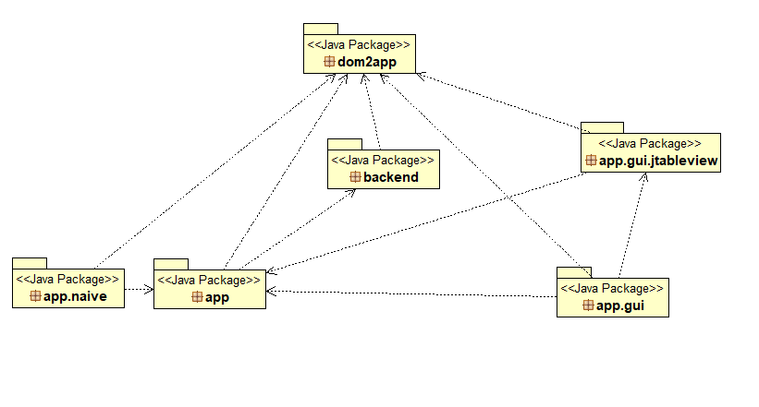

Description of the work packages below:

System Packages

|  |  |
| --- | --- |
| Dom2app | Contains an entity that represents the loaded files data and is accessible to all other operations of the system. |
| App | It is the middle man from gui to backend operations |
| App.gui | Front end part of the application |
| App.naive | A naïve client. A possible flow of events in the system. |
| App.gui.jtableview | Repressentation of the data contained in the entity of dom2app package |
| Backend | It’s the maestro of the backend operations |

## Class diagrams

**package** dom2app;

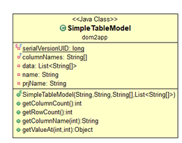

**package** app;

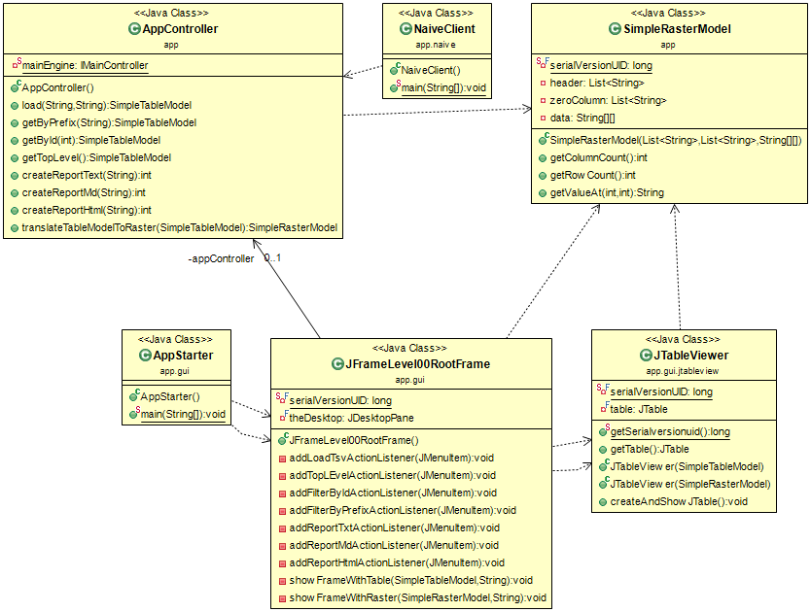

**package** dom;

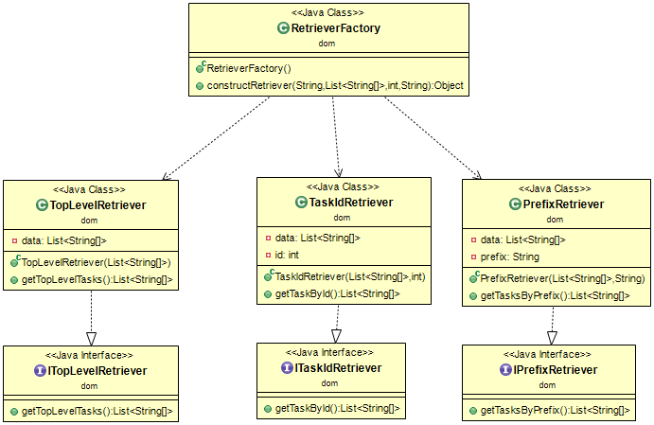

**package** backend;

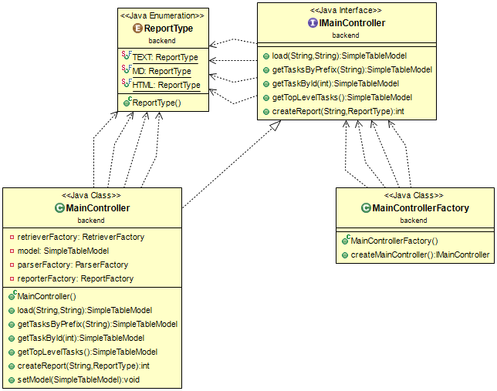

**package** parser;

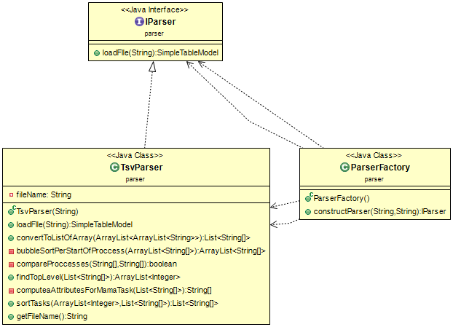

**package** reporter;

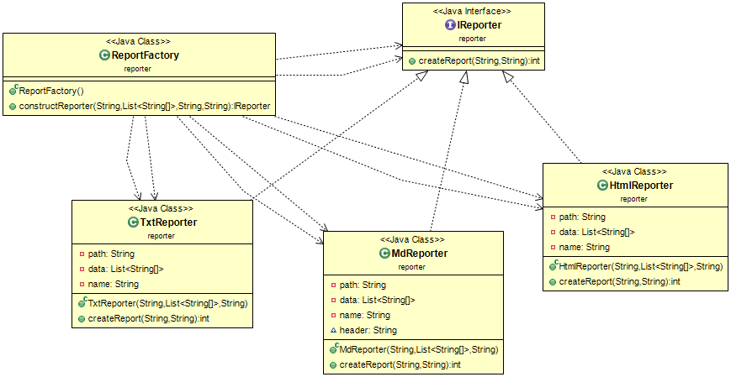

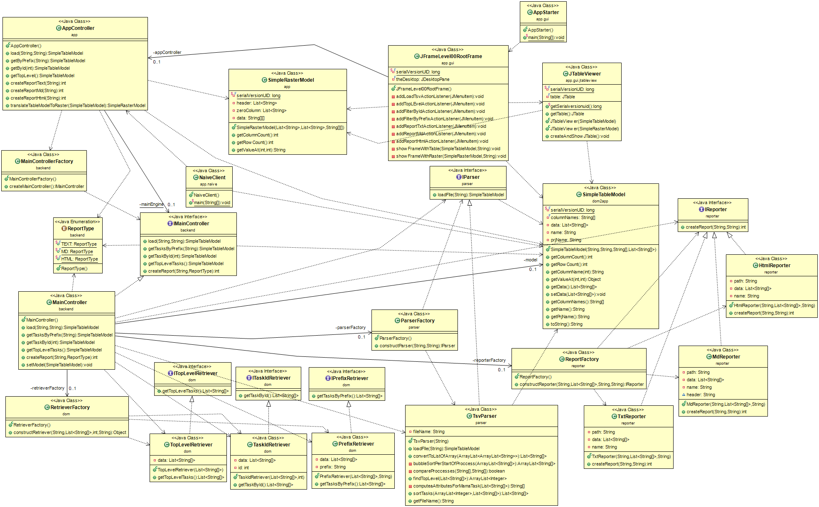All classes;

## Class Analysis and consistence to requirements

### Domain Classes

|  |  |
| --- | --- |
| Package dom2app | SimpleTableModel. The class that represents the input file. |

### Business Logic Classes

|  |  |
| --- | --- |
| Package backend | MainController, IMainController for the interface. MainControllerFactory for instance creation. ReportType for different types of report. |
| Package dom | TopLevelRetriever, TaskIdRetriever, PrefixRetriever and abstract classes ITopLevelRetriever, ITaskIdRetriever, IprefixRetriever. The  ParserFactory for instance creation. |
| Package parser | TsvParser and IParser for the interface.The ParserFactory for instance creation. |
| Package reporter | TxtReporter, MdReporter, HtmlReporter και IReporter The ReportFactory for instance creation. |
|  |  |

### Boundary classes

|  |  |
| --- | --- |
| Package app | AppStarter a client class for user interface  AppController, JTableViewer, JFrameLevel00RootFrame, SimpleRasterModel, are the handler/controller classes  NaiveClient a use example |

### requirements to methods

|  |  |  |
| --- | --- | --- |
| Use case | Back-end methods | Front-end methods |
| Load file | MainController. load () | AppController.load() |
| GetTasksByPrefix | MainController. getTasksByPrefix () | AppController.getTasksByPrefix () |
| GetTaskById | MainController. getTaskById () | AppController.getTaskById () |
| CreateReport | MainController. createReport () | AppController. createReport () |
| GetTopLevelTasks | MainController. getTopLevelTasks () | AppController.getTopLevelTasks() |