

DOCX Generation
Capabilities Showcase & Design System Guide

A comprehensive demonstration of every formatting capability
available through Claude’s docx-js code generation pipeline.

Version 2.0 • May 2026
Generated by Claude (Anthropic) • docx-js pipeline

Table of Contents

Design System
This section defines the foundational design tokens used throughout all generated documents. Every element – from headings to callout boxes – derives its visual identity from these tokens.

Color Palette
The palette is built around a professional blue primary with semantic colors for status indicators. All hex values are defined as constants and referenced by every component.
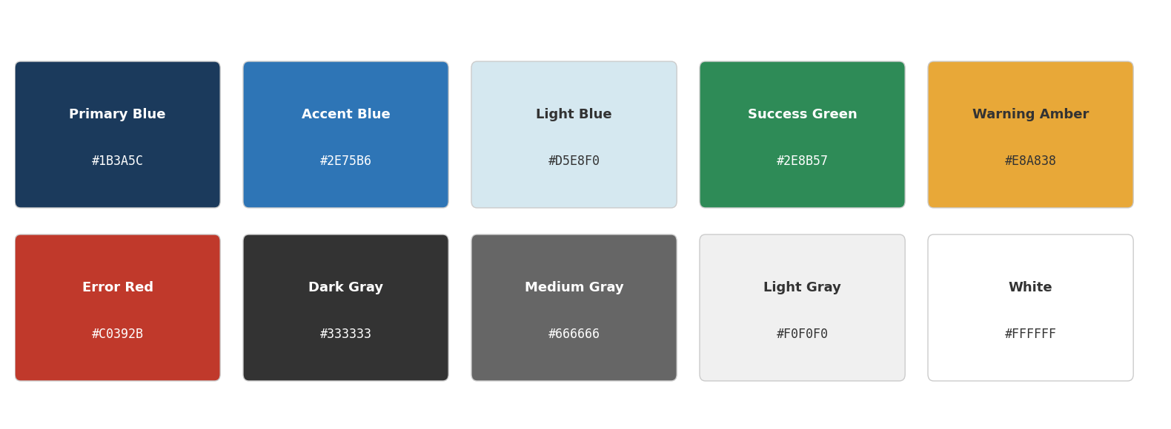
Figure 1 – Design System Color Palette (10 tokens)
 How it’s done
Colors are defined as a COLOR constant object. Every component references these tokens – never hardcoded hex values. The palette image is generated via matplotlib and embedded as ImageRun with type: "png".

Typography Scale
Font hierarchy uses Arial as the universal base for cross-platform compatibility (Word, LibreOffice, Google Docs). Code blocks use Courier New.
Style | Font | Size | Weight | Usage
Heading 1 | Arial | 16pt | Bold | Section titles, major divisions
Heading 2 | Arial | 14pt | Bold | Subsections
Heading 3 | Arial | 12pt | Bold | Sub-subsections, feature groups
Body | Arial | 11pt | Regular | Running text, descriptions
Caption | Arial | 9pt | Italic | Figure captions, table notes
Code | Courier New | 9pt | Regular | Code samples, API references
Table 1 – Typography Scale
 How it’s done
Styles are defined in the Document constructor under styles.paragraphStyles with exact built-in IDs ("Heading1", "Heading2") and outlineLevel for TOC support. Font defaults set in styles.default.document.run.
 Antipattern
Never use custom style IDs for headings (e.g. "MyHeading1") – TOC generation requires the exact built-in IDs. Also never set outlineLevel without matching heading ID.

Spacing & Rhythm
Consistent vertical rhythm is achieved through standardized spacing tokens:
- Heading 1: 240 DXA before + 240 after (approx. 12pt)
- Heading 2: 180 DXA before + 180 after (approx. 9pt)
- Body text: 120 DXA after (approx. 6pt)
- Callout boxes: 200 DXA before + 200 after
- Between sections: spacer(400) – ~20pt gap
 How it’s done
Spacing is set via paragraph.spacing: { before, after } in DXA units (1 pt = 20 DXA). The spacer() helper creates an empty paragraph with configurable spacing.

Typography & Character Formatting
This section showcases all available character-level formatting options.

Character Styles
Bold text Italic text Bold + Italic Underlined Strikethrough
Highlighted text Red colored text Blue accent text ALL CAPS text Small caps text
Normal then ^{superscript} and _{subscript} – useful for formulas like H₂O or E=mc²

 How it’s done
Each formatting option is a property on TextRun: bold, italics, underline: {}, strike, highlight, color, allCaps, smallCaps, superScript, subScript. Multiple can be combined.

Font Mixing
Arial (default) → Times New Roman → Georgia → Courier New (mono)
 How it’s done
Each TextRun can specify its own font property. For cross-platform safety, stick to web-safe fonts: Arial, Times New Roman, Georgia, Courier New, Verdana.

Paragraph Alignment & Indentation
◀ Left-aligned (default) – standard body text alignment
◆ Center-aligned – for titles, captions, images
Right-aligned – for dates, signatures ▶
Justified text distributes words evenly across the full line width. This creates clean left and right edges, commonly used in formal documents, reports, and publications where a polished appearance is paramount.
First-line indent (720 DXA = 0.5 inch). Common in academic and literary documents. Set via indent: { firstLine: value }.
Block indent (left: 720 DXA). Creates a visual quote block or secondary-level content. Used for excerpts and callouts.
 How it’s done
Paragraph alignment via AlignmentType.LEFT/CENTER/RIGHT/JUSTIFIED. Indentation via indent: { firstLine, left, right, hanging } in DXA units (1440 DXA = 1 inch).

Lists
Proper list formatting requires the numbering config – never use manual unicode bullet characters.

Bulleted List (Multi-level)
- Level 0 – Primary bullet (•)
- Another primary item with details
  - Level 1 – Secondary bullet (◦)
  - Level 1 continued
    - Level 2 – Tertiary bullet (▪)
- Back to level 0

Numbered List (Multi-level)
- First item with decimal numbering
- Second item
  - Sub-item with letter numbering (a, b, c)
  - Another sub-item
    - Roman numeral sub-sub-item (i, ii, iii)
- Third main item

Checklist
- Design tokens defined
- Typography scale configured
- Table styles created
- Charts embedded
- Headers & footers set up

 How it’s done
Lists use Document.numbering.config with named references ("bullets", "numbers"). Each level defines format (LevelFormat.BULLET/DECIMAL/LOWER_LETTER/LOWER_ROMAN), text pattern, and indent. Paragraphs reference via numbering: { reference, level }.
 Antipattern
Never use new TextRun("• Item") or unicode bullet characters. This breaks accessibility, breaks list continuation, and prevents Word from recognizing the list structure.

Tables
Tables are the most complex element in docx generation. They require careful width management for cross-platform compatibility.

Basic Table with Header
Feature | Word | LibreOffice | Google Docs
Bold/Italic/Underline | ✓ | ✓ | ✓
Table cell shading | ✓ | ✓ | ✓
Multi-level lists | ✓ | ✓ | ∼
Headers & Footers | ✓ | ✓ | ✓
Embedded images | ✓ | ✓ | ✓
Table of Contents | ✓ | ✓ | ✗
Footnotes | ✓ | ✓ | ∼
Multi-column layout | ✓ | ✓ | ✗
Landscape sections | ✓ | ✓ | ✗
Table 2 – Cross-Platform Compatibility Matrix (✓ = full, ∼ = partial, ✗ = none)

 How it’s done
Table requires width (DXA), columnWidths array (must sum to table width), and matching cell widths. ShadingType.CLEAR for fills (never SOLID). Alternating row colors via index check.
 Antipattern
Never use WidthType.PERCENTAGE – it breaks rendering in Google Docs. Never omit cell margins – text will touch cell borders. Never forget dual widths: both columnWidths AND cell width are required.

Table with Merged Cells
Merged Header (3 columns)
Category | Count | Coverage
Character formatting | 12 styles | 95%
Paragraph formatting | 8 options | 90%
Table features | 6 features | 88%
Table 3 – Merged Header Cells Demo
 How it’s done
Cell merging via columnSpan property. The merged cell’s width equals the sum of spanned column widths. Only the first cell in the merged range should be present in the row.

Images & Charts
Images are embedded directly into the document via ImageRun. Charts are pre-rendered as PNG via matplotlib and inserted as standard images.

Embedded Charts

Bar Chart
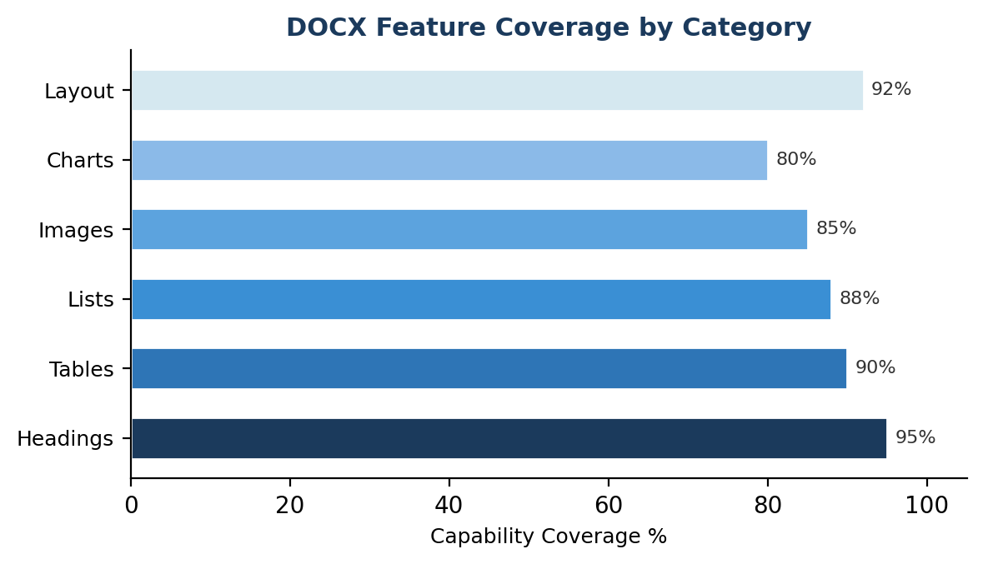
Figure 2 – Feature Coverage by Category (horizontal bar chart, matplotlib)

Line Chart with Dual Axis
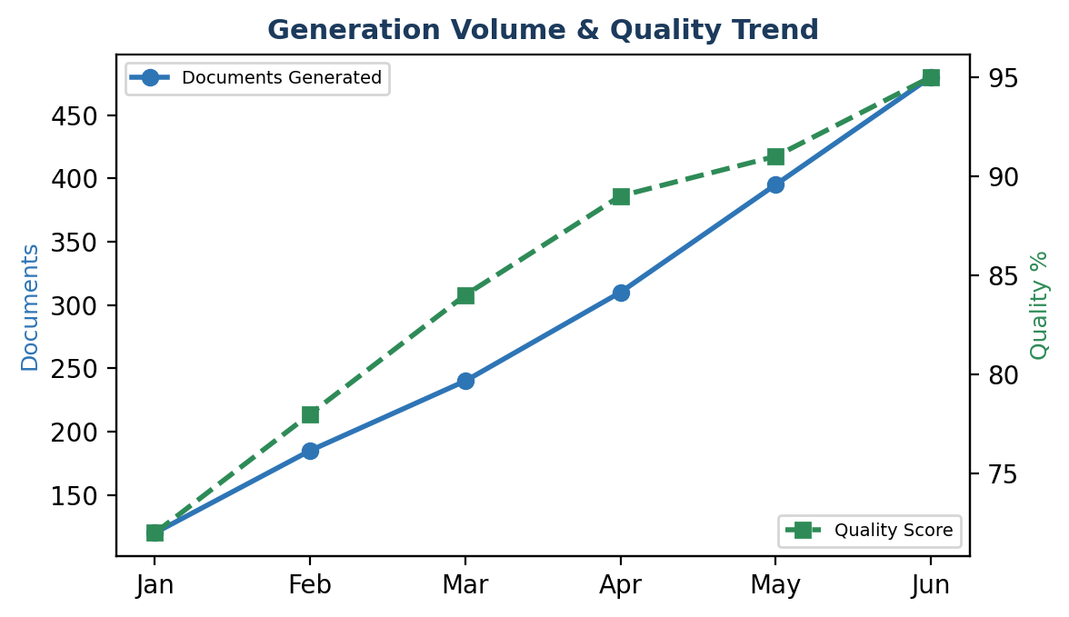
Figure 3 – Generation Volume & Quality Trend (dual Y-axis, matplotlib)

Pie Chart
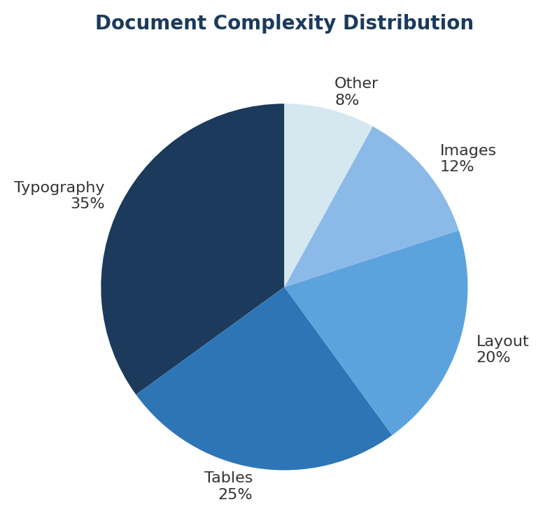
Figure 4 – Document Complexity Distribution (pie chart, matplotlib)
 How it’s done
Charts are generated as PNG files using matplotlib, then read via fs.readFileSync() and embedded with ImageRun({ type: "png", data: buffer, transformation: { width, height } }). The altText object requires title, description, and name fields.
 Antipattern
Never omit the type parameter on ImageRun – it produces invalid XML. Never omit altText – it’s required for accessibility. Avoid extremely large images (>2000px) as they bloat file size.

Inline Icons
Icons can be embedded inline with text:
 Info callout  Warning callout
 How it’s done
Inline icons are ImageRun elements placed alongside TextRun elements within the same Paragraph. Small transformation dimensions (16x16) keep them text-sized.

Callout Components
Reusable callout boxes serve as the document’s information architecture. Three variants are defined:

Info Callout
 Info / How it’s done
Blue left border (12pt, accent color), light blue background (EBF5FB), optional inline icon. Used for technical explanations and implementation notes.

Warning Callout
 Warning / Antipattern
Amber left border (12pt, warning color), warm yellow background (FFF8E1), triangle icon. Used for common mistakes and pitfalls to avoid.

Code Block
const doc = new Document({ sections: [{ children: [...] }] });
Packer.toBuffer(doc).then(buf => fs.writeFileSync('out.docx', buf));
 How it’s done
Code blocks use Courier New font, gray background (#F5F5F5), thin border. Implemented as Paragraph with shading and border properties. For multi-line code, use separate Paragraph elements (never \n).

Hyperlinks, Bookmarks & Footnotes

External Hyperlinks
Visit Anthropic Documentation for API reference.

Internal Bookmarks
Jump to Design System section.
 How it’s done
External: ExternalHyperlink with link URL. Internal: create Bookmark({ id, children }) at destination, reference with InternalHyperlink({ anchor: id }). Both use style: "Hyperlink" for blue underlined text.

Footnotes
Document generation uses docx-js library with Node.js runtime.
 How it’s done
Footnotes defined in Document constructor under footnotes: { 1: { children: [...] } }. Referenced inline via FootnoteReferenceRun(id). Automatically numbered and placed at page bottom.

Tab Stops
Left-aligned text Right-aligned on same line
Chapter 1 5
Chapter 2 18
 How it’s done
Tab stops: TabStopType.RIGHT with TabStopPosition.MAX for right-alignment on same line. Dot leaders via PositionalTab with PositionalTabLeader.DOT for TOC-like formatting.

Page Layout & Sections
Documents can mix page orientations, column layouts, and section breaks within a single file.

Page Breaks
Page breaks can be inline (new PageBreak() inside a Paragraph) or automatic (pageBreakBefore: true on a Paragraph). Section breaks allow orientation and margin changes mid-document.

Margins & Page Size
Property | US Letter | A4 | Unit
Width | 12,240 | 11,906 | DXA
Height | 15,840 | 16,838 | DXA
1 inch margin | 1,440 | 1,440 | DXA
Content width | 9,360 | 9,026 | DXA
Table 4 – Page Size Reference (1440 DXA = 1 inch = 72pt)
 How it’s done
Page size set in section properties: page.size.width / height. Margins via page.margin. All values in DXA (twentieths of a point). Content width = page width – left margin – right margin.
The next page demonstrates landscape orientation via a section break.

Landscape Orientation
This page uses landscape orientation via a section break. Ideal for wide tables and comparison matrices.

Feature | Word  Win | Word  Mac | Word  Web | Libre  Office | Google  Docs | Pages | WPS | OnlyO. | PDF
Typography | ✓ | ✓ | ✓ | ✓ | ✓ | ✓ | ✓ | ✓ | ✓
Tables | ✓ | ✓ | ✓ | ✓ | ✓ | ∼ | ✓ | ✓ | ✓
Merged cells | ✓ | ✓ | ✓ | ✓ | ✓ | ∼ | ✓ | ✓ | ✓
Images | ✓ | ✓ | ✓ | ✓ | ✓ | ✓ | ✓ | ✓ | ✓
TOC | ✓ | ✓ | ∼ | ✓ | ✗ | ∼ | ✓ | ✓ | ✗
Footnotes | ✓ | ✓ | ✓ | ✓ | ∼ | ∼ | ✓ | ✓ | ✓
Headers/Footers | ✓ | ✓ | ∼ | ✓ | ✓ | ✓ | ✓ | ✓ | ✓
Multi-column | ✓ | ✓ | ✗ | ✓ | ✗ | ∼ | ∼ | ✓ | ✗
Landscape | ✓ | ✓ | ✗ | ✓ | ✗ | ✓ | ✓ | ✓ | ✓
Hyperlinks | ✓ | ✓ | ✓ | ✓ | ✓ | ✓ | ✓ | ✓ | ✓
Table 5 – Full Cross-Platform Compatibility Matrix (landscape view)
 How it’s done
Landscape via section properties: page.size.orientation = PageOrientation.LANDSCAPE + type: SectionType.NEXT_PAGE. Pass portrait dimensions – docx-js swaps them internally. Content width becomes 15840 – 2×1440 = 12960 DXA.

Multi-Column Layout
This section uses a two-column layout with a vertical separator. Text flows naturally from the bottom of the left column to the top of the right column.

Multi-column layouts are ideal for newsletters, brochures, comparison documents, and any content that benefits from shorter line lengths. Research shows that 45–75 characters per line is optimal for readability.

Column configuration is set at the section level: column.count for number of columns, column.space for the gap between them (720 DXA = 0.5 inch), and column.separate for the vertical divider line.

For unequal columns, set equalWidth: false and define each Column with specific width and space values. This is useful for sidebar layouts where one column is narrow (e.g., navigation) and the other is wide (main content).

Force content to the next column with SectionType.NEXT_COLUMN. This acts as a column break, pushing subsequent content to the top of the next column – similar to a page break but within the same page.

Key limitation: headers, footers, and margins are shared across all columns within a section. Each column cannot have its own independent header or footer.

Appendix: API Quick Reference
Complete mapping of document features to docx-js API calls.

Feature | API | Notes
Bold | TextRun({ bold: true }) | Character-level property
Italic | TextRun({ italics: true }) | Character-level property
Color | TextRun({ color: "2E75B6" }) | 6-char hex, no # prefix
Font | TextRun({ font: "Arial" }) | Must be installed on viewer’s system
Size | TextRun({ size: 24 }) | Half-points: 24 = 12pt
Heading | heading: HeadingLevel.HEADING_1 | Paragraph-level; requires style ID
Alignment | alignment: AlignmentType.CENTER | LEFT, CENTER, RIGHT, JUSTIFIED
Indent | indent: { firstLine: 720 } | DXA; also left, right, hanging
Spacing | spacing: { before: 240, after: 120 } | DXA (20 DXA = 1pt)
Bullet list | numbering: { reference, level } | Needs numbering config in Document
Table | new Table({ width, columnWidths }) | DXA widths; dual width required
Cell shade | shading: { fill, type: CLEAR } | ShadingType.CLEAR only
Cell merge | columnSpan: n | First cell only; width = sum
Image | ImageRun({ type, data, ... }) | type required (png/jpg)
Page break | new PageBreak() | Must be inside Paragraph
Section | SectionType.NEXT_PAGE | Enables layout changes
Landscape | PageOrientation.LANDSCAPE | Pass portrait dimensions
Columns | column: { count: 2 } | Section-level property
Header | headers: { default: Header } | Per-section; first/odd/even
Footer | footers: { default: Footer } | PageNumber.CURRENT/TOTAL
TOC | new TableOfContents(...) | Needs HeadingLevel styles
Hyperlink | ExternalHyperlink({ link }) | style: "Hyperlink" on TextRun
Bookmark | new Bookmark({ id, children }) | For internal navigation
Footnote | FootnoteReferenceRun(id) | Defined in Document constructor
Tab stop | tabStops: [{ type, position }] | RIGHT + MAX for right-align
Dot leader | PositionalTabLeader.DOT | TOC-style dotted line
Border | border: { bottom: { style, size } } | On paragraph or cell
Shading | shading: { fill, type: CLEAR } | Paragraph or cell background
Table 6 – Complete API Quick Reference

End of Document
Generated by Claude · Anthropic · May 2026

docx-js: https://github.com/dolanmiu/docx – TypeScript library for creating .docx files
Node.js v18+ runtime required. Charts rendered via matplotlib (Python) pre-generation step.

