**A PRELIMENERY REPORT ON**

**Home Surveillance System with alert system using python**

SUBMITTED TO THE SAVITRIBAI PHULE PUNE UNIVERSITY, PUNE

IN THE PARTIAL FULFILLMENT OF THE REQUIREMENTS

FOR THE AWARD OF THE DEGREE \

OF

**BACHELOR OF TECHNOLOGY**

**(INFORMATION TECHNOLOGY)**

##### SUBMITTED BY

STUDENT NAME:- PRADIP WARE, ANKIT KHAIRNAR



**DEPARTMENT OF INFORMATION TECHNOLOGY**

## G H RAISONI INSTITUTE OF ENGINEERING AND TECHNOLGY

WAGHOLI, PUNE 412207

## SAVITRIBAI PHULE PUNE UNIVERSITY

## 2022-23



**CERTIFICATE**

This is to certify that the project report entitles

**Home Surveillance System**

Submitted by

STUDENT NAME: - PRADIP WARE, ANKIT KHAIRNAR Exam No :

is a bonafide student of this institute and the work has been carried out by her under the supervision of **Prof. Bhagyashree Wankar** and it is approved for the partial fulfillment of the requirement of Savitribai Phule Pune University, for the award of the degree of **Bachelor of Technology** (Information Technology).

**(Prof. Bhagyashree Wankar)** **(Prof. R. Y. Sable)**

Guide Head,

Department Department

Information Technology Information Technology

**(Dr. R. D. Kharadkar)**

Director,

G H Raisoni Institute of Engineering and Technology, Wagholi, Pune.

Place : Pune Date

**ACKNOWLEDGEMENT**

This research is conducted at G. H. Raisoni Institute of Engineering and Technology, Pune, We would like to thank Prof. Bhagyashree Wankar for her support for the research work. We would also like to thank Dr. Rachna Sable, HOD, Department of Computer Science and Information Technology for her consistent guidance, support and encouragement throughout the research work.

**ABSTRACT**

Home security includes both the security hardware placed on a property and individuals' personal security practices. Security hardware includes doors, locks, alarm systems, lighting, motion detectors, and security camera systems. Personal security involves practices like ensuring doors are locked, alarms are activated, owning a Dog, windows are closed, and extra keys are not hidden outside.

The detection and tracking of moving object in real-time based smart video surveillance is an emerging research area for security-surveillance that monitors normal or suspicious activities in various areas. It allows identification and detection of moving object by means of various computer vision techniques that focuses on the automatic smart video surveillance system . In reality, due to lack of several automation security reason, such smart surveillance systems are the need of the society. Such enormous demand enhances the growth of technological advancement for smart surveillance . This kind of smart automated system can reduce the ill intension of individual toward crime, minimizes theft cases monitor the real situation or activity for future identification and investigation etc .

1. **Introduction:**

**Home Surveillance system:**

With the increasing prevalence of crimes in urban and rural areas, homeowners are becoming more concerned about their safety and security. One way to enhance home security is to install a home surveillance system. Advances in technology have made it possible to develop cost-effective home surveillance systems that provide homeowners with remote monitoring capabilities and alert systems.

In this research paper, we present a home surveillance security system with an alert system using Python, Twilio, and IP Webcam. IP Webcam is a popular Android application that turns a mobile device into a webcam. Python is used to program the system, while Twilio provides cloud communication services that allow the system to send alerts to the user's phone.

Our home surveillance security system is designed to detect motion and send alerts to the user's phone via Twilio. The system uses a Raspberry Pi, a camera module, and IP Webcam. The Raspberry Pi captures images and videos, which are processed by OpenCV, a computer vision library for Python. IP Webcam streams live video to the Raspberry Pi, which is used for real-time monitoring.

The system is programmed using Python to detect motion in the captured images and videos. Once motion is detected, an alert is sent to the user's phone via Twilio. The alert message includes a link to the live video stream from IP Webcam, allowing the user to monitor their home in real-time.

In this paper, we provide a detailed description of the system architecture, the hardware and software components used, and the programming techniques employed. We also evaluate the effectiveness of the system in detecting intruders and compare it to other existing home surveillance systems.

The paper is organized as follows. In Section 2, we provide a literature review of existing home surveillance systems and highlight their advantages and limitations. In Section 3, we describe the system architecture and the hardware and software components used. In Section 4, we present the programming techniques employed and the algorithms used for motion detection. In Section 5, we evaluate the system's effectiveness in detecting intruders and compare it to other existing home surveillance systems. Finally, in Section 6, we conclude the paper and provide suggestions for future research.

In conclusion, our home surveillance security system with an alert system using Python, Twilio, and IP Webcam is a cost-effective and innovative solution for enhancing home security. The system's ability to detect motion, send alerts to the user's phone, and provide a live video stream from IP Webcam provides homeowners with peace of mind and security. The research paper provides a comprehensive description of the system's architecture, programming techniques, and effectiveness in detecting intruders.

* 1. **Basic Concept:**

The home surveillance security system with an alert system using Python, Twilio, and IP Webcam is designed to enhance the security of a household by detecting motion and sending alerts to the user's phone. The system uses a Raspberry Pi as the main component, which is connected to a camera module and programmed using Python to capture images and videos. The images and videos captured by the Raspberry Pi are then processed by OpenCV, a computer vision library for Python, to detect motion.

To provide live video streaming, the system also uses IP Webcam, an Android application that streams live video from a mobile device. IP Webcam is installed on a mobile device and connected to the same Wi-Fi network as the Raspberry Pi. The Raspberry Pi then accesses the live video stream from IP Webcam and displays it on a monitor.

Once motion is detected, an alert is sent to the user's phone via Twilio. Twilio provides a cloud communication platform that allows developers to send and receive messages, make phone calls, and more. Using Twilio, the system sends an SMS alert to the user's phone, notifying them of the detected motion. The alert message includes a link to the live video stream from IP Webcam, allowing the user to monitor their home in real-time.

The home surveillance security system is designed to be affordable and easy to use. The Raspberry Pi and camera module can be easily installed and programmed by individuals with basic programming knowledge. The system can be customized to meet the specific security needs of the user, with options to adjust the sensitivity of motion detection and customize the message sent by Twilio.

Overall, the home surveillance security system with an alert system using Python, Twilio, and IP Webcam is an innovative and cost-effective solution for enhancing home security. By using open-source software and affordable hardware components, the system can be easily replicated and customized to meet the specific needs of any household. The system's ability to detect motion, provide live video streaming, and send alerts to the user's phone provides homeowners with peace of mind and security.

* 1. **Application:**

The home surveillance security system with an alert system using Python, Twilio, and IP Webcam has several practical applications in enhancing home security. The system can be installed in a residential household to monitor and detect intruders, or in a business setting to monitor employee activity after hours.

The system can also be used to monitor pets or children at home, providing parents and pet owners with peace of mind while they are away. Additionally, the system can be used as a baby monitor, with the live video stream from IP Webcam providing real-time monitoring of the baby's room.

Another practical application of the system is in monitoring the home during vacation or travel. By setting up the system to send alerts to the user's phone, homeowners can be notified of any suspicious activity while they are away. The live video stream from IP Webcam also allows homeowners to monitor their home in real-time, providing an added layer of security.

The home surveillance security system with an alert system using Python, Twilio, and IP Webcam is also a cost-effective solution for enhancing security in rental properties or apartments. The system can be easily installed and removed, allowing renters to take the system with them when they move.

The system can also be used in conjunction with other security measures, such as door and window sensors, to create a comprehensive home security system. The use of open-source software and affordable hardware components also makes the system a viable option for individuals or households on a budget.

Overall, the home surveillance security system with an alert system using Python, Twilio, and IP Webcam has a wide range of practical applications in enhancing home security. The system is customizable to meet the specific needs of the user and can be easily installed and programmed by individuals with basic programming knowledge. The use of affordable hardware components and open-source software also makes the system an attractive option for individuals or households on a budget.

1. **Literature Survey:**
   1. **Related Work Done**

**A vision-based home security system using OpenCV on Ip Webcam 3**: . Home security system has established its importance and benefits numerous times by providing immediate monitoring of the house. This is because of the increasing home theft and burglary incidents that create an awareness among most of the house owners. CCTV-based security systems are not real-time because the alert comes to the owner after the incident occurred unless they are at home during the incident. To overcome this problem, many researchers are developing cost-effective custom-based security systems, which are affordable for everyone. Most of these systems use a Passive Infrared (PIR) motion sensor for motion detection. Although affordable, such a system still has many limitations. For example, false alarms triggered due to an abnormal condition such as rapid heating from sunlight exposure. In this work, a vision-based home security system using OpenCV on Ip Webcam 3 model B was developed to improve the effectiveness of motion detection. This system applied the Haar-Cascade algorithm coupled with background subtraction as well as considered the Histogram of Oriented Gradients (HOG) during the development stage. The developed prototype was tested under a few conditions to determine the accuracy of motion detection and compare the results with a system that uses a PIR motion sensor for motion detection. From the results obtained, the developed vision-based home security system using OpenCV has 100% of detection rate compared to the PIR motion sensor-based security system with 76% of the detection rate.

* **Remote Home Surveillance System:** —Home surveillance system is becoming one of the key factors of the home security systems. A fully remotely controlled surveillance of home is going to be the future. Everyone is worried about the security of the home when they are not at home; also they want to be sure that the children or old ones are safe. This paper presents a novel solution that makes the surveillance of home from anywhere with the help of internet. Remote home surveillance with the help of internet, mobile robot and an IP camera is presented. The utilization of various available apps on internet has been done. Using the Team Viewer, Arduino Uno, RF transmitters, PC, IP camera a unique way for the home surveillance system has been realized.
* **Implementation of Smart Home Assistance and Surveillance:** Smart home systems help one to control and assist using voice commands. It plays a vital role in assisting differently abled and elder people. It can also be operated remotely. In this paper, the implementation involves two methods, using Bluetooth and GSM technology. The former method uses a HC - 05 Bluetooth, which can be implemented when we are at home. A mobile application is developed and the Arduino Bluetooth is controlled which has the control over the house appliances. The latter method uses GSM technology. The project is implemented on ARM11 Ip Webcam microcontroller board. The software is developed in Python integrated development environment. The demonstration of the working prototype is done using a fan and bulb as a load. The proposed system is also used for surveillance of the home or office when we are in a remote location by alerting the user when there is any illegal intrusion into the house. Thus the proposed system ensures effective assistance along with security surveillance.

**2.2 Existing System (Modifications)**

presented an automated security system with surveillance. A PIR sensor and a camera were installed respectively to detect the presence of an intruder and capture his/her picture. The owner will be alerted through Short Message Service (SMS) using the GSM technology. At the heart of the system was an Atmega644p microcontroller, which receives and processes signals from the PIR sensor and decides whether it is necessary to send a notification message with the captured image over SMS. Suresh et al. proposed a home monitoring and security system where a PIR sensor and a temperature and humidity sensor are connected to an Arduino Uno microcontroller. The system intends to apply changes in both motion and temperature in a monitored room to improve the accuracy of the intrusion detection by reducing false detections based on line of sight that can be cut by any entity and not necessarily an intruder. If the temperature is above a set threshold and a change in motion is detected, an SMS message will then be sent to the owner’s mobile phone via GSM. An Arduino-based, low-cost, and multi-level home security system was proposed by Zaman et al. for developing countries. Their system consists of two parts, namely internal and external parts to make the system more effective. The internal part is controlled by an Arduino Mega microcontroller with GSM shield to detect intruder(s) and notify the owner through SMS or phone call. Each room was installed with PIR sensors and LED lights attached to the ceiling. When a PIR sensor is triggered, a signal is sent to the microcontroller, LED lights blink, respective lights of the affected room get turned on, an installed alarm starts to buzz for three seconds with intervals to alert the surrounding, and the GSM module sends an SMS notification to the owner. On the other hand, the external part is controlled by an Arduino Uno microcontroller that includes a fingerprint-based door lock and a webcam. Only users with authorized fingerprints saved in the sensor memory will be granted access.

1. **Problem Statement:**

Home security is a critical concern for homeowners, particularly in areas with high crime rates or where burglary is a common occurrence. Traditional home security systems can be expensive and require professional installation, making them unaffordable for many households.

Additionally, traditional home security systems often rely on sensors that can be easily bypassed by experienced burglars, leaving homeowners vulnerable to break-ins. This is particularly true in rental properties or apartments, where homeowners may not have the authority to install permanent security measures.

To address these issues, a cost-effective and easily installed home surveillance security system with an alert system using Python, Twilio, and IP Webcam is proposed. The system utilizes affordable hardware components and open-source software, making it accessible to households on a budget. Additionally, the system can be easily installed and programmed by individuals with basic programming knowledge, eliminating the need for professional installation.

The proposed system provides real-time monitoring of a home through live video streaming, allowing homeowners to monitor their home in real-time from their mobile devices. The system also uses motion detection technology to alert homeowners of any suspicious activity, sending an SMS alert to their phone via Twilio.

By addressing the issues of affordability, ease of installation, and vulnerability to bypassing, the proposed home surveillance security system with an alert system using Python, Twilio, and IP Webcam offers a practical and effective solution for enhancing home security. The system has the potential to be used in a wide range of settings, from residential households to rental properties, and can be customized to meet the specific needs of the user.

1. **Project Requirement:**

The development of the home surveillance security system with an alert system using Python, Twilio, and IP Webcam requires the following components and tools:

1. IP Webcam: The system utilizes the IP Webcam app, which is available for both Android and iOS devices, to stream live video from the camera to the user's mobile device.
2. Raspberry Pi: The Raspberry Pi is a small, affordable, and versatile computer that will serve as the central hub for the system.
3. Camera Module: The Raspberry Pi camera module will be used to capture live video footage.
4. Python: The system will be programmed using Python, an open-source programming language.
5. Motion Detection: The system will use motion detection technology to detect any suspicious activity within the camera's field of view.
6. Twilio API: The system will use Twilio's API to send SMS alerts to the user's phone in the event of suspicious activity.
7. Mobile Device: The user's mobile device will serve as the interface for the system, allowing them to view live video footage and receive SMS alerts.
8. Wi-Fi Connection: The system will require a stable Wi-Fi connection to ensure that the live video stream and SMS alerts are transmitted in real-time.
9. Power Source: The Raspberry Pi will require a power source to ensure that the system remains operational.
10. Housing and Mounting: The system components will require a housing and mounting solution to ensure that they are protected from the elements and properly positioned to capture live video footage.

Overall, the development of the home surveillance security system with an alert system using Python, Twilio, and IP Webcam requires a combination of hardware components and software tools, as well as the ability to program and configure the system using Python. The final system should be able to capture live video footage, detect motion, and send SMS alerts in real-time, providing homeowners with an effective and cost-efficient solution for enhancing home security.

1. **UML Diagrams:**

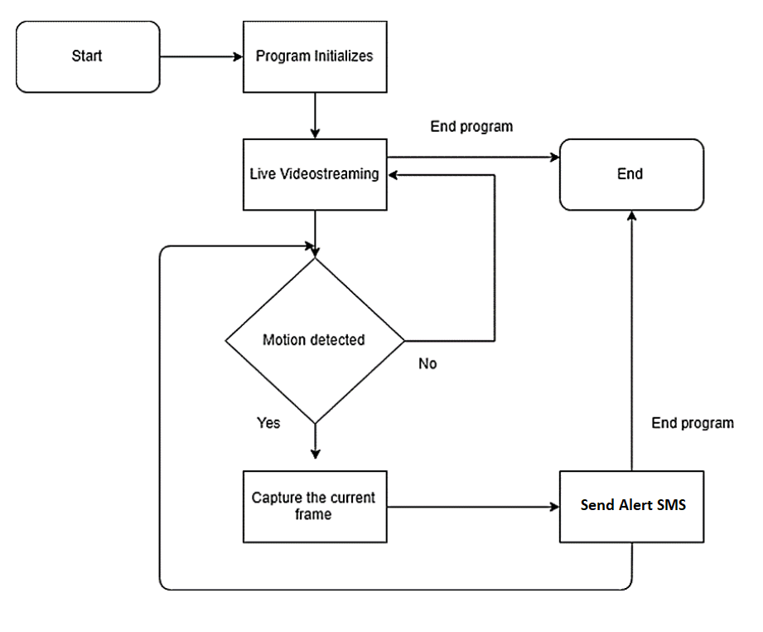

**5.2 Flow Chart**

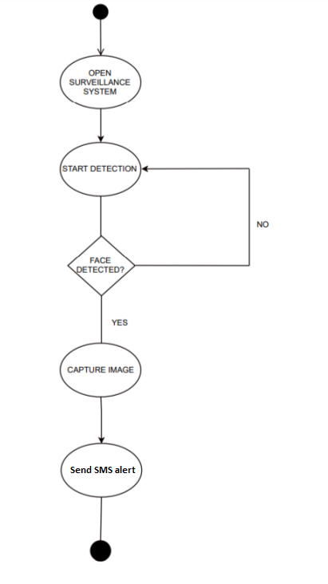

* 1. **Project Plan:**

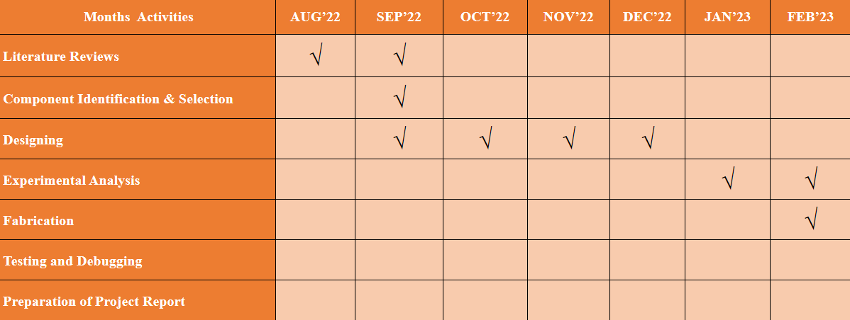

1. **Conclusion:**

the development of a home surveillance security system with an alert system using Python, Twilio, and IP Webcam can provide homeowners with an effective and cost-efficient solution for enhancing home security. The system utilizes readily available hardware components, such as the Raspberry Pi and camera module, and an open-source programming language, Python, to process live video footage and detect motion. The integration of Twilio's API allows for real-time SMS alerts to be sent to the user's mobile device in the event of suspicious activity. The system can be easily configured through the IP Webcam app, making it user-friendly and accessible.

Overall, this project demonstrates the feasibility of using modern technology to improve home security, and provides a platform for further development and customization. Future work can include the integration of additional sensors and machine learning algorithms for improved detection accuracy, and the implementation of a cloud-based storage solution for video footage. The system can also be expanded to include multiple cameras and integrated with smart home technologies for a comprehensive home security solution.

**7 References:**

1. Remote Home Surveillance System Sushant Kumar :Home surveillance system is becoming one of the key factors of the home security systems. (2016-2017)
2. Implementation of Smart Home Assistance and Surveillance V Anand kumar, V Nandala, M Kousalya, P Madhumitha, R Kamaleshwari, N Kalvi Selvi : Smart home systems help one to control and assist using voice commands. It plays a vital role in assisting differently abled and elder people. It can also be operated remotely (2021-2022).
3. Moving human detection and tracking from thermal video through intelligent surveillance system for smart applications Manoj Kumar 1 & Susmita Ray1 & Dileep Kumar Yadav (2020-2021)
4. Design and Implementation of Network Security Transmission System for Intelligent Home Video Surveillance Zhigang Ren, Hao Liu : With the concept of intelligent objects, intelligent home has a wide application prospect. This article in view of the smart home system (2018-2019)
5. Smart Surveillance System 1CR14CS011 Amrit Sinha 1CR14CS015 Ankur Singh 1CR14CS076 Manas Kashyap (2017-2018)
6. A vision-based home security system using OpenCV on Ip Webcam 3 Thinesh Prathaban1,b), Weilynn Thean2,c), Mohd Ilyas Sobirin Mohd Sazali2,a) (2019-2020)