Restored basic commands like C-a and C-e.
Installation
Method #1: Copy this dotm file to your Word’s startup folder.
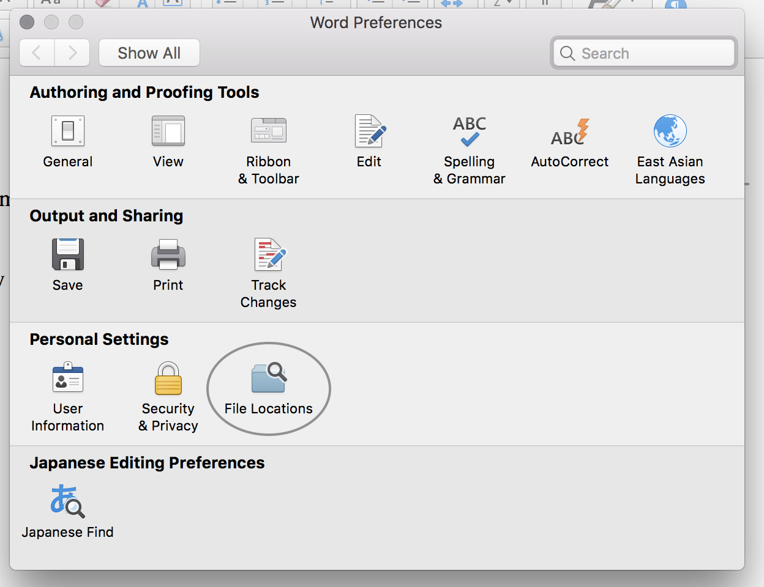
Figure 1 Location of the file path option.
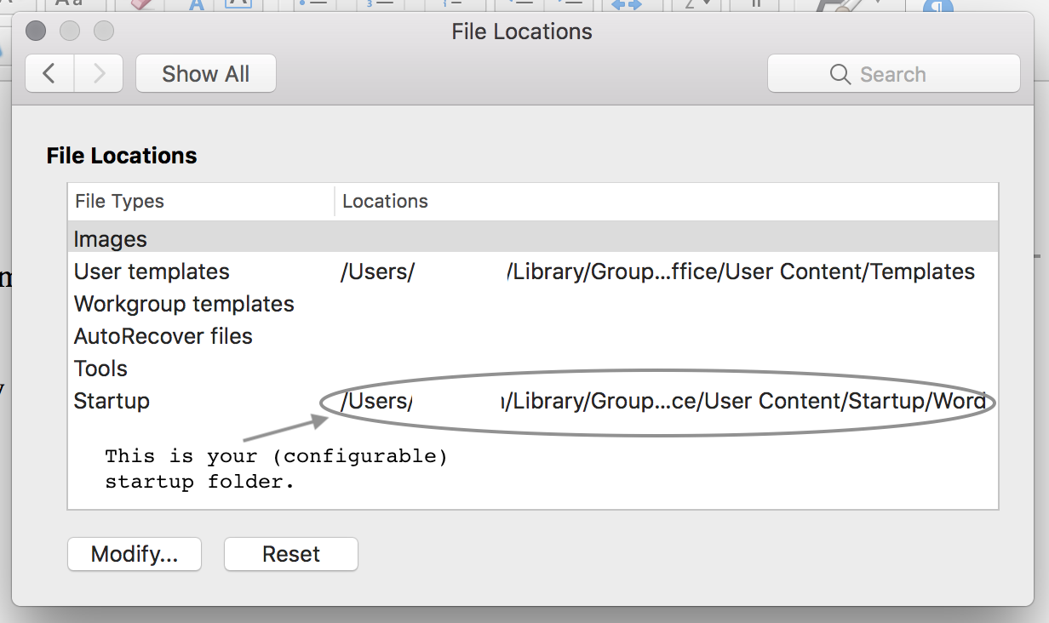
Figure 2 Startup path.
Method #2: Place this file to any location you like and add it via template options.
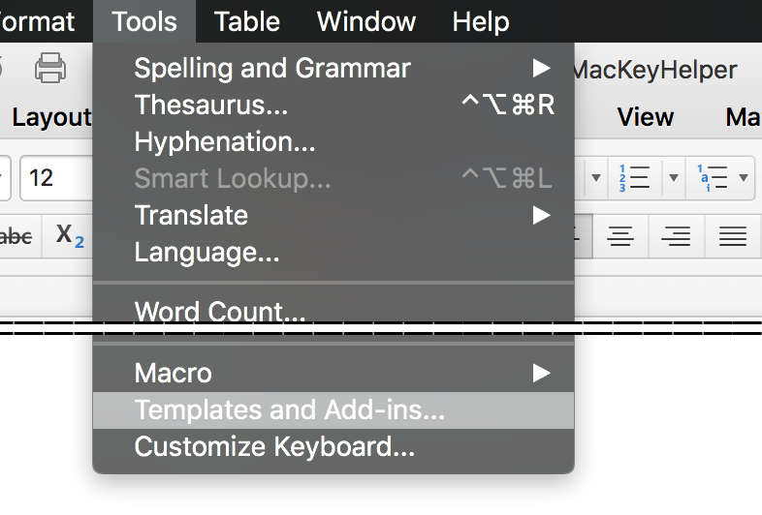
Figure 3 Find Templates and Macros option.
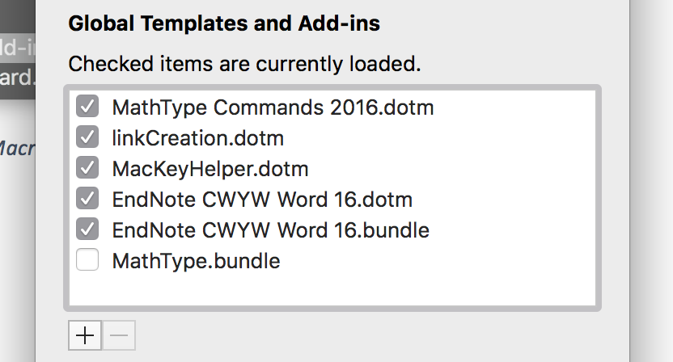
Figure 4 Add the macro file here.

恢复了 Mac 原生的基本 C-a C-e 等.
安装方法
方法1: 将本文件放置到 Word 的启动目录之下, 如 Figure 1 和 Figure 2 所示.
方法2: 将本文件放置到任意目录, 再在模板管理中添加, 如 Figure 3和Figure 4.

