Code use tutorial:

Data preparation:

- Folders of videos of different subjects, such as Taliban series videos:
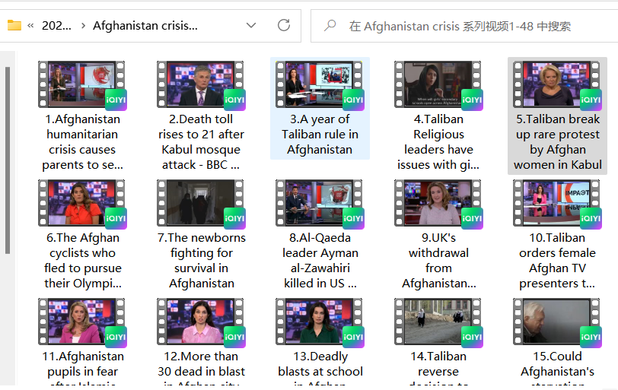
- Video information library:
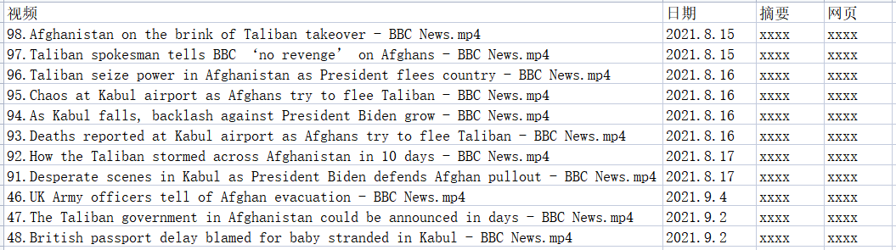

Environmental preparation:

1 Python environment construction (windows system)
1.1 Installing Anaconda
Download address:
https: //mirrors.tuna.tsinghua.edu.cn/anaconda/archive/ ?C=M&O=D

Most Windows 10/11 computers are 64-bit operating systems, choose the x86_64 version; If the computer has a 32-bit operating system, choose the x86 version.

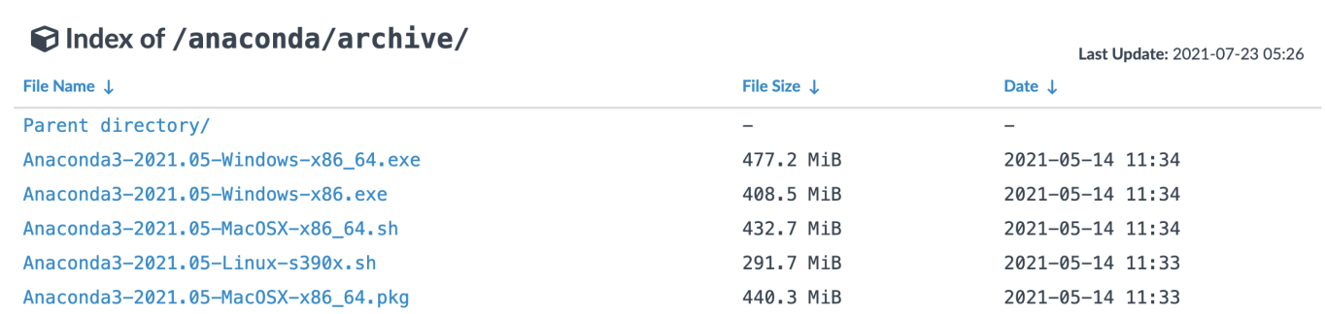

After the download is complete, double-click the installation program to enter the graphical interface. The default installation location is drive C. You are advised to change the installation location to drive D.

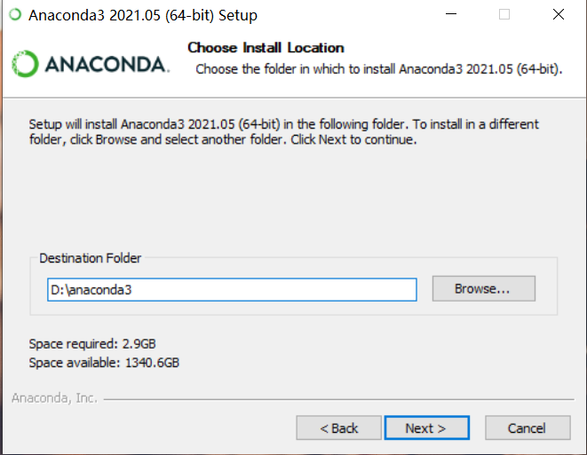

Check Conda for adding environment variables and ignore warnings.
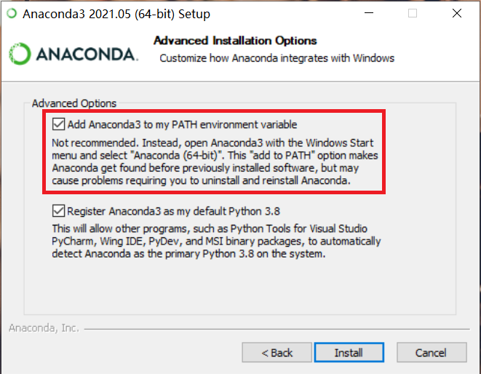
1.2 Open the terminal and create the Conda environment

Open the Anaconda Prompt Terminal: Windows Start Menu in the lower left -> Anaconda3 -> Anaconda Prompt Launch Console.
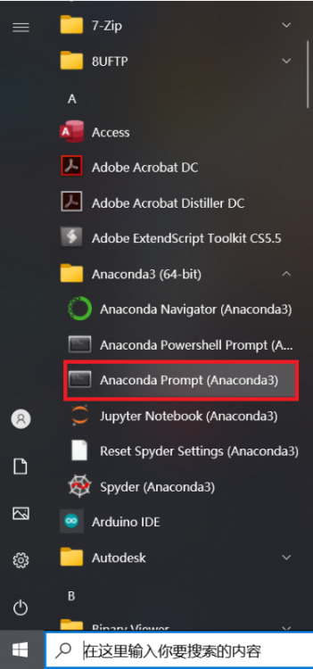

Create a new Conda environment with the following command:
conda create --name paddle_env python=3.8 --channel https://mirrors.tuna.tsinghua.edu.cn/anaconda/pkgs/free/

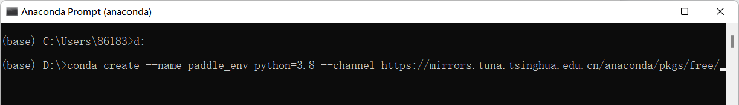

The above command will create an executable environment called paddle_env, python version 3.8, which will take a while, depending on the state of the network.
The command line will then output a prompt, type y and enter to continue the installation.

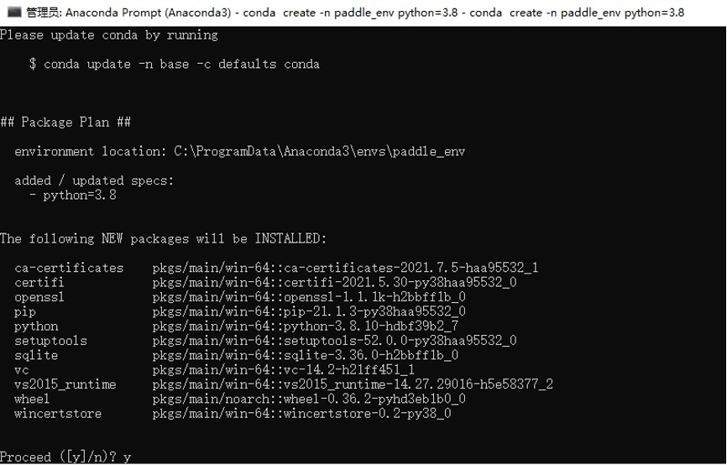

To activate the Conda environment you just created, enter the following command on the command line:
conda activate paddle_env
where python #Check whether the installation is successful, just appear the screen
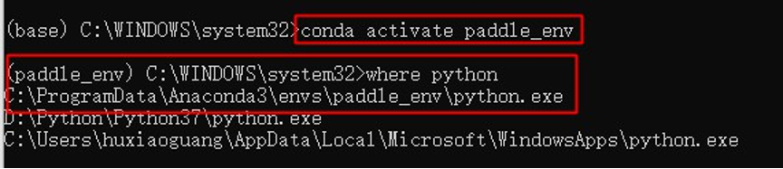
The above anaconda environment and python environment are installed.

2 Install Paddlepaddle and Paddleocr

2.1 Install Paddlepaddle：
python -m pip install paddlepaddle -i https://pypi.tuna.tsinghua.edu.cn/simple
pip install paddlepaddle -i https://mirror.baidu.com/pypi/simple

2.2 Install PaddleOCR Whl包
pip install "paddleocr>=2.0.1"

3 Install Whisper
Installation link reference:
https://blog.csdn.net/weixin_44011409/article/details/127507692?ops_request_misc=%257B%2522request%255Fid%2522%253A%2522167981660716800188528440%2522%252C%2522scm%2522%253A%252220140713.130102334.pc%255Fall.%2522%257D&request_id=167981660716800188528440&biz_id=0&utm_medium=distribute.pc_search_result.none-task-blog-2~all~first_rank_ecpm_v1~rank_v31_ecpm-1-127507692-null-null.142^v76^insert_down1,201^v4^add_ask,239^v2^insert_chatgpt&utm_term=whisper%E5%88%9D%E4%BD%93%E9%AA%8C&spm=1018.2226.3001.4187

4 Install nltk

5 Other installation packages install
Moviepy：pip install moviepy
If other libraries are not installed, use the pip install module name.
Run the code once all environments/modules have been configured successfully.

Tutorials to use:

NV2PRS.py (Bulk video -- > Style Library + Script template)
After opening the NV2PRS.py file:
Line 392, change the address, name of the generated script xlsx.
Scroll down to the end and you can see the main function area as follows:
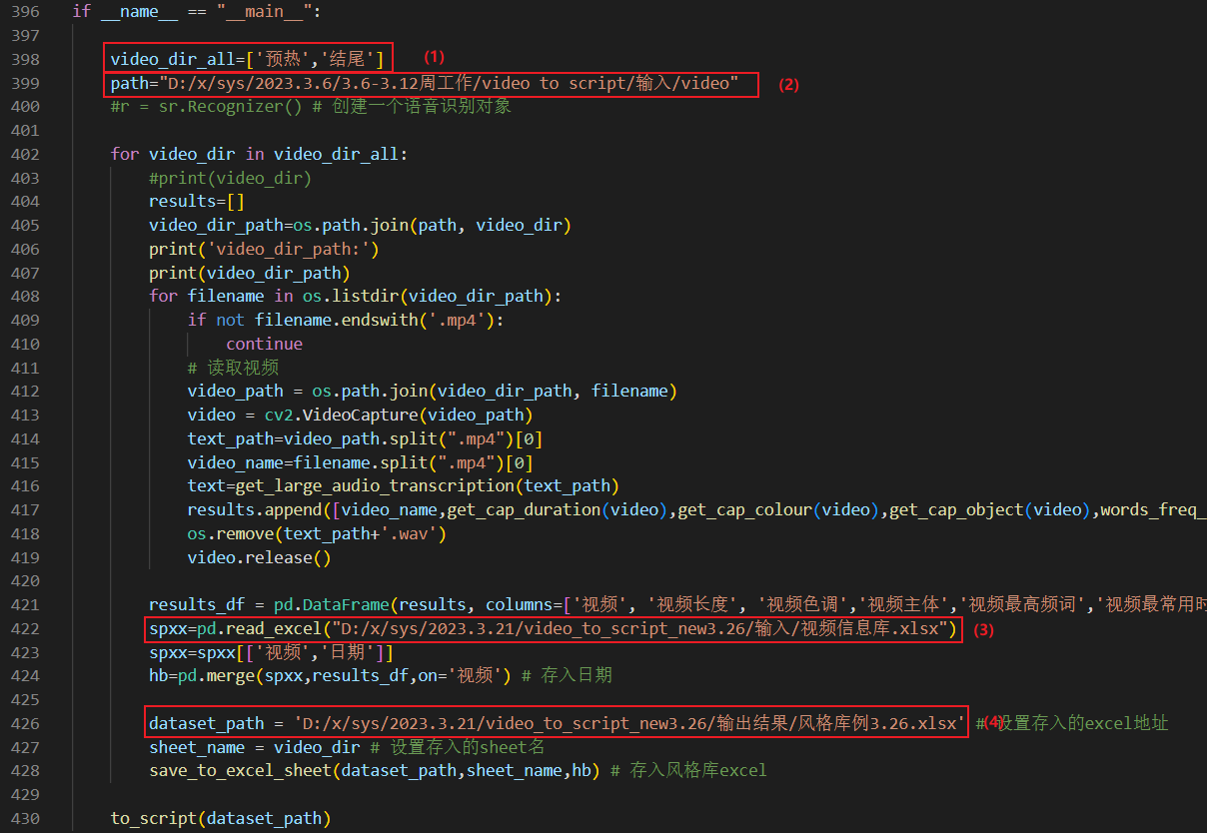

- Change according to the stage folder names under the video folder.
- The address where the video folder is provided.
- The address of the video information library provided.
- Change the address, name of the generated style library xlsx. After confirming that it is correct, run it.

