Project Management Plan

for

Theia: Indoor Navigation Assistance App
Preliminary Project Plan
Prepared by Felix Zheng, Ziming Fu, Tong Shen, Jinming Wang, Zirun Ye, Zijian Zhang
CPTS 484
9/14/25

Table of Contents
1. Overview 1
1.1. Project Purpose, Objectives, and Success Criteria 1
1.2. Project Deliverables 1
1.3. Assumptions, Dependencies, and Constraints 2
1.4. References 3
1.5. Definitions and Acronyms 3
2. Project Organization 4
2.1. Process Model 4
2.2. Organizational Structure 5
2.3. Roles and Responsibilities 6
3. Managerial Process Plans 7
3.1. Management objectives and priorities 7
3.2. Assumptions, dependencies, and constraints 7
3.3. Risk management 7
3.4. Monitoring and controlling mechanisms 8
4. Technical Process Plans 10
4.1. Methods, tools, and techniques 10
4.2. Software documentation 10
Revision History
Name | Date | Reason for Changes | Version
Project Management Plan for Theia: Indoor Navigation Assistance App | Sep 14 | initial draft | 1.0 draft 1

Overview

Project Purpose, Objectives, and Success Criteria
The purpose of the Theia project is to deliver a smartphone application that assists blind and visually impaired individuals with accurate, accessible, and reliable indoor navigation. The app addresses the business need of improving accessibility within buildings (classrooms, offices, labs, restrooms, lounges, etc.) by providing a system to support blind people navigating inside buildings. Our primary stakeholders are blind people who will be directly using this app to navigate indoors. Secondary stakeholders will be anyone who is involved with helping navigate blind people, this includes the following: caretakers of blind people, public servants (e.g. police), hospitality staff, etc. For phase 1 we need to identify specific quantitative and measurable business needs that the app is expected to meet as well as criteria to measure satisfaction of the previously mentioned needs according to the stakeholders.

This app is only intended for indoor navigation and is not intended to be a comprehensive app for navigation. The mode of this app will be voice-based interaction at release, although our system should be easily modifiable for future upgrades. It will also have emergency situation notification services, with the extent of it being automated notifications for emergency services. The third main use case of this will be for the building manager to update the building map in the event of construction or other events that will influence the routes’ availability.

Non-functional objectives we need to meet are categorized into usability objectives and performance objectives. Usability objectives will revolve around the success rate of users of our product in task success, audio eligibility, among others. Performance objectives will revolve around the app’s ability to function normally on a typical cellular phone.

Project dependencies of the Theia app are decomposed into a few categories: relationships with other projects, integration with other projects, feature dependencies, and shared designs/code/hardware. Relationship with other projects: we aim to meet institutional accessibility standards like those set with ADA and our app will integrate with “smart campus” building maps. Integration that we require with other projects include that with Wifi/bluetooth beacons inside those buildings which we need to pinpoint the user’s position. The biggest shared element of our app will be that of existing features in a cellular device where we will use the existing processing power, camera to detect obstacles, and other features that are all highly dependent on the cellular device.

Project Deliverables

Deliverable | Delivery Date | Delivery Method
Project Phase I: Preliminary Project Plan | Sep 14 | Canvas
Phase 1: Presentation | Oct 8 | Zoom
Phase 1: AS-IS/TO-BE scenarios | Oct 8 | Zoom/Canvas
Phase 1: WRS document | Oct 12 | Canvas
Phase 1: prototype (WRS) | Oct 12 | Canvas
Phase 1: User manual (WRS) | Oct 12 | Canvas
Project Phase I: Final Submission/Presentation | Oct 12 | Canvas
Project Phase II: Final Submission | Nov 2 | Canvas
Summary Report Submission | Dec 7 | Canvas

Assumptions, Dependencies, and Constraints

Features - Success Driver:
- AS-1: Blind users have access to a smartphone with standard sensors (accelerometer, gyroscope, camera, microphone).
- AS-2: Digital building maps or layouts are available for route planning.-
- AS-3: Ease of use is a priority for our end users
Quality - Success Driver:
- AS-4: The buildings have both wifi and Bluetooth beacons
- DE-1: Indoor positioning accuracy depends on external infrastructure (Bluetooth or Wi-Fi).
- DE-2: Emergency communication depends on network connectivity.

Schedule - Constraint:
- CO-2: Project Phase 1 due Oct 12
- CO-3: Phase 2 Due Nov 2
- CO-4: Final submission due Dec 7
Cost - Constraint:
- CO-1: Project budget limited to existing hardware/software resources (Bluetooth beacons, smartphones, free/open APIs).

Staff - Constraint:
- CO-5: Staff consists of 6 employees

References

“ArcGIS IPS.” Indoor Positioning System & Location Tracking (Indoor GPS), www.esri.com/en-us/arcgis/products/arcgis-ips/overview. Accessed 13 Sept. 2025.
“Web Content Accessibility Guidelines (WCAG) 2.1.” W3C, www.w3.org/TR/WCAG21/. Accessed 13 Sept. 2025.
“Guidance on Web Accessibility and the Ada.” ADA.Gov, 29 July 2025, www.ada.gov/resources/web-guidance/.
“Extensible Markup Language (XML) 1.0 (Fifth Edition).” W3C, www.w3.org/TR/xml/. Accessed 13 Sept. 2025.
Rossum, Guido van, et al. “PEP 8 – Style Guide for Python Code.” Python Enhancement Proposals (PEPs), PHI Learning Pvt. Ltd., 5 July 2001, peps.python.org/pep-0008/.
“Management by Objectives (MBO): Definition and Process [2025] • Asana.” Asana, Asana, 22 May 2025, asana.com/resources/management-by-objectives.

Definitions and Acronyms
Bluetooth beacon: Transmit Bluetooth signals to other Bluetooth enabled devices→ in our use case we will be using this to pinpoint location of smartphones

ADA: Americans with Disability Act
- US Government agency

IoT: Internet of Things
- Smart devices

SuS: System Usability Score

TPR: True Positive Rate
- True Positives /( False Negatives+ True Positives​)

Project Organization

Process Model
We will use Agile model
Why we choose Agile model
- User needs are unclear: The experience blind users experience when using the system (whether voice prompts are clear, routing is reasonable, and positioning is accurate) requires real-world testing and cannot be fully defined in one go.
- External software is relied on: As mentioned in DE-1, Indoor navigation may involve multiple technologies such as Bluetooth Beacons, WiFi, NFC, QR codes, and AI recognition, requiring ongoing testing.
- Quick feedback is crucial: As mentioned in AS-3, this app is to help accessibility so it needs to be easy to use. Blind users are a special group, and continuous user feedback is essential to ensure the system is truly usable.
Therefore, this project adopts the Agile development model, carries out development in an iterative manner using Scrum, and combines prototyping to gradually converge requirements and implementation.

We will divide this project into several sprints, each lasting several weeks. Each sprint will accomplish different goals, for example:
- Sprint 1: Implement basic room search and voice prompts.
- Sprint 2: Implement indoor path planning.
- Sprint 3: Implement bug fixes and user testing.

Organizational Structure
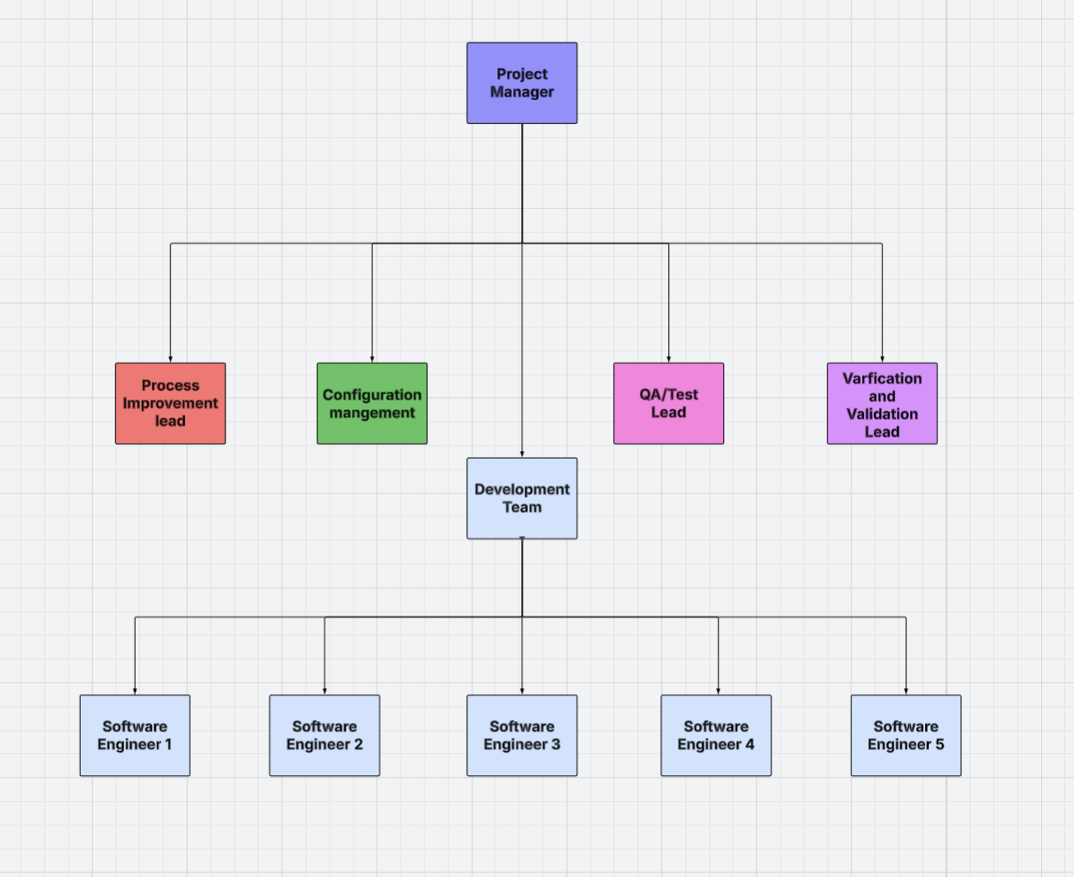
1. Project Manager:
This project adopts a layered and functional organizational structure. The top layer is managed by the Project Manager, responsible for overall management and external communications. The middle layer comprises four key support functions (process improvement, configuration management, quality assurance and testing, and verification and validation). The bottom layer is comprised of a team of software engineers, responsible for specific development tasks.

2. Management Layer
The Project Manager
Located at the highest level of the organizational structure, is responsible for overall project planning, resource coordination, and schedule control.
Serving as the primary external interface, they maintain communication with clients, advisors, and external stakeholders.
They liaise with the four key functional departments and ensure coordinated operations.

3. Engineering Support Layer
The four key functional leaders report directly to the Project Manager:
The Process Improvement Lead
Drives continuous improvement of team processes, leads iteration reviews, and proposes optimization solutions.

4. Configuration Management
Responsible for source code version control, branch management, builds, and releases.
Ensures the order and traceability of all development artifacts (code, documentation, and configuration).
Maintains a unified baseline environment when collaborating across teams.

5. QA/Test Lead
Develops test plans and test cases. Lead system-level testing, regression testing, and accessibility testing to ensure product quality standards are met.
Work closely with the development and verification teams to identify and track defects.
Verification and Validation (V&V) Lead
Responsible for verification (confirming that the system correctly implements specifications) and validation (confirming that the system meets actual user needs).
In this project, the focus is on confirming whether blind users can successfully complete indoor navigation tasks using voice and tactile feedback.

Roles and Responsibilities

Team member | Preliminary Plan | Slideshow | WRS document
Zijian Zhang | Section 4.1 and 4.2 | Scenario 3 and Organize the presentation | 1.4  2.1 DI1
Zirun Ye | Section 3.1 and 3.2 | Scenario 2 | 3.1, Section 4 scenario 1 and 2.
Felix Zheng | Section 1 | Summary + Comparisons | 1.1, 1.2, 1.3, 2.1.DI3, 2.1.DI4, User manual, 3.1.3.2-3.1.3.4
Ziming Fu | Section 3.3 and 3.4 | Analyze first priority scenario | Section 4 scenario 3 and 4
Tong Shen | Section 4.1 and 4.2 | Scenario 4 | 2.1 DI2, 2.2, and 2.3
Jinming Wang | Section 2 | Analyze First priority scenario | 3.2.1, 3.2.2,3.2.3(part)

Managerial Process Plans

Management objectives and priorities
The management objective of the team is to collaborate efficiently through fair task distribution and to meet deadlines by assigning roles according to each member’s strengths and areas for growth. To ensure a high-quality final product, the project will be broken down into smaller, manageable tasks, allowing all members to contribute efficiently, support one another, and complete work on time.

The management priorities are to maintain clear communication through weekly meetings and group chats on Discord, track deadlines, and assign roles using a shared Google File. Any ambiguities in requirements will be resolved collaboratively with all project stakeholders, either during team meetings or through the designated team liaison, Zijian Zhang. Additionally, the team will meet before each deadline to review and revise all deliverables to measure and ensure quality. The finalized product will then be submitted collectively by the team liaison.

Assumptions, dependencies, and constraints
The project’s completion depends on team members attending scheduled online meetings and contributing to the assigned tasks. The functionality of our application depends on Android Studio and the pre-mapping of the building.

Risk management

No. | Risk | Type | Likelihood | Description
1 | Bluetooth/WiFi access point missing or working poorly | Technical | Likely - High potential impact | Buildings might not have enough beacons installed for good positioning, or the beacons that exist might have weak or spotty signals in different parts of the building.
2 | Voice commands don't work well in loud places | Usability | Moderate - High potential impact | The app's voice features might not work properly in noisy areas like crowded hallways or cafeterias, which are exactly where blind users need help navigating.
3 | Building maps become outdated | Technical | Moderate - Medium potential impact | When buildings get renovated or furniture gets moved around, the app's maps won't match the real layout anymore, causing wrong directions.
4 | Phone battery dies too quickly | Technical | Likely - Medium potential impact | Running sensors, Bluetooth, GPS, and voice features all at once uses a lot of battery power, which could leave users stuck without navigation help.
5 | App doesn't meet accessibility requirements | Legal/Usability | Moderate - High potential impact | The app might not follow ADA or WCAG accessibility rules, making it hard for blind users to actually use or creating legal problems.
6 | Fall detection doesn't work right | Safety | Moderate - Critical impact | The system might call emergency services when someone didn't actually fall (false alarm) or miss real falls, which makes users lose trust in the app.

Monitoring and controlling mechanisms

No. | Risk | Monitoring and Controlling
1 | Bluetooth/WiFi access point missing or working poorly | - Check what access point setup already exists in buildings before launching  - Create backup ways to find position (step counting, QR codes at doorways)  - Map out where signals are strong and weak in each building
2 | Voice commands don't work well in loud places | - Test how well voice recognition works in different noise levels  - Add noise filtering and make volume adjust automatically  - Let users save their frequent destinations ahead of time
3 | Building maps become outdated | - Set up a system with building managers to tell us about changes  - Let users report when they find map problems  - Walk through buildings regularly to check if maps are still correct  - Show users when the map was last updated
4 | Phone battery dies too quickly | - Test how much battery the app uses during normal trips  - Add a battery-saving mode that checks sensors less often  - Warn users when battery is low
5 | App doesn't meet accessibility requirements | - Check the app against ADA and WCAG 2.1 rules regularly  - Have blind users test every version we make  - Get feedback from accessibility experts  - Keep documentation of accessibility features
6 | Fall detection doesn't work right | - Test the fall detection with different scenarios  - Ask users to confirm before calling emergency services  - Let users adjust how sensitive the fall detection is  - Keep track of false alarms and missed falls to improve the system

Technical Process Plans

Methods, tools, and techniques
The documentation follows the IEEE Standard for Software Project Documentation (IEEE 829). The drafting process includes initial authoring, peer review, supervisor approval, and version release. An iterative documentation method is adopted to ensure that the document evolves consistently with project updates.

The documentation is prepared using Microsoft Word and Overleaf (LaTeX) for technical sections. All versions are maintained in GitHub for version tracking. Grammarly and Word’s built-in spell checker are used for grammar and style verification.

Standardized formatting techniques are applied to maintain consistency across all sections.
The IEEE two-column format and a numbered heading system are used. References are managed through BibTeX. Document revisions are tracked using change-tracking mode to ensure transparency in edits.

Software documentation
Document | Template or Standard | Created By | Reviewed By | Target Date | Distribution
Work Reengineering Specification (WRS) | Course template | Canvas | Team | Aug 18 | GitHub
Project Plan | Course template | Tong Shen, Zirun Ye | Zijian Zhang | Sep 14 | GitHub
User Manual | Course template | Zijian Zhang | Jinming Wang | Nov 11 | GitHub
Test Plan | IEEE 829 | Jinming Wang | Zirun Ye | Nov 23 | GitHub
Final Report | Course template | Team | Team | Dec 7 | Github

