CptS 484: Software Requirements
WRS Evolution
Requirements Elicitation

10/12/2025

Revision History 1
[1] Introduction 3
1.1. Purpose 3
1.2. Scope 3
1.3. Objectives and Success Criteria 3
1.4. Definitions, Acronyms, and Abbreviations 4
[2] Issues with the Preliminary Definition Given 4
2.1. Domain Issues 4
2.2. Functional Requirements Issues 7
2.3. Non-Functional Requirements(NFR) Issues 10
[3] WRS 17
3.1. W 17
3.1.1. Problem 17
3.1.2. Goals 18
3.1.3. Improved Understanding of Domain, Stakeholders, Functional, and Non-Functional Objectives 19
3.1.3.1. Improved Domain 19
3.1.3.2. Stakeholders 20
3.1.3.3. Improved Functional Objectives 20
3.1.3.4. Improved Non-Functional Objectives 21
3.2. RS 22
3.2.1. Functional Requirements 22
3.2.2. Non-Functional Requirements 25
3.2.3. Specifications 28
[4] Prototype Interface Mock-ups 30
[5] User Manual 33
[6] References 33
6.1. Phase 1 Roles 33
6.2. Activities 34
Appendix I: Process Details 34

Revision History
Date | Version | Changes | Editor
2025/10/12 | 1.0 | Added W section | Zirun Ye
2025/10/12 | 1.1 | Added Non/Function requirements | Jinming Wang
2025/10/12 | 1.2 | Add 1.4 Definitions, etc | Zijian Zhang

Introduction

Purpose
The purpose of the Theia project is to deliver a smartphone application that assists blind and visually impaired individuals with accurate, accessible, and reliable indoor navigation. The app addresses the business need of improving accessibility within buildings (classrooms, offices, labs, restrooms, lounges, etc.) by providing a system to support blind people navigating inside buildings. Our primary stakeholders are blind people who will be directly using this app to navigate indoors. Secondary stakeholders will be anyone who is involved with helping navigate blind people, this includes the following: caretakers of blind people, public servants (e.g. police), hospitality staff, etc. For phase 1, we need to identify specific quantitative and measurable business needs that the app is expected to meet, as well as criteria to measure satisfaction of the previously mentioned needs according to the stakeholders.

Scope
This app is only intended for indoor navigation and is not intended to be a comprehensive app for navigation. The mode of this app will be voice-based interaction at release, although our system should be easily modifiable for future upgrades. It will serve 3 main functionalities:
- It will provide audio-based guidance to blind users inside a building
- It will have emergency contact(s) notification services in the event of the blind user requiring help with fall detection using the phone’s sensors.
- It will allow a building manager to update the building map in the event of construction or other events that will influence the routes’ availability.

Objectives and Success Criteria
1.3.a. Usability Objectives
- Integrated as a smartphone app
- Provide route directions in audio format
- Able to modify floor mappings
- Connectivity to phone services to call
- Route recalculations
1.3.b. Performance Objectives
- Reliably get from one room to another in a supported building
- Provide eligible audio directions in various conditions
- Low-latency positional updates

Definitions, Acronyms, and Abbreviations

Term | Definition
Theia | A smartphone-based indoor navigation system designed for blind and visually impaired users, offering audio and haptic feedback for safe and independent mobility.
Indoor Navigation | The process of determining and guiding a user’s position within a building, including rooms, corridors, and stairways.
Haptic Feedback | The use of vibration signals to convey navigation cues or warnings to users who cannot rely on visual feedback.
AI-based Visual Recognition | A machine vision component that detects environmental features, obstacles, or landmarks to enhance navigation accuracy.
Hybrid Mapping | A mapping technique combining static floor maps with real-time environmental sensing to improve turn accuracy and route correction.
Emergency Mode | The operational state in which Theia detects a fall or safety event and automatically alerts emergency contacts or authorities.
Accessibility | The design principle ensures that software is usable by individuals with varying physical abilities, such as blindness or limited mobility.
Bluetooth Beacons / Wi-Fi Triangulation | Indoor localization technologies are used to determine the user’s position when GPS is unavailable.
Stakeholder | Any individual or group affected by or involved in the development, use, or maintenance of Theia, including blind users, caretakers, and building managers.

Issues with the Preliminary Definition Given

Domain Issues
Domain Issue ID | Domain Issue Description
DI1 | PD_ID | PD1. Indoor Navigation Function for Blind and Visually Impaired Users
DI1 | The current domain definition for Theia lacks a clear technological and environmental scope. Indoor navigation for blind and visually impaired (B/VI) users can involve multiple hardware platforms and data sources (e.g., cameras, LiDAR, external beacons). Without a defined boundary, the system’s requirements may exceed the capabilities of a smartphone-based prototype. The issue concerns how to ensure that Theia provides reliable indoor navigation using only built-in smartphone sensors and voice interaction, while maintaining user safety and route accuracy within mapped indoor environments.
DI1 | Option 1 | Restrict Theia’s navigation functions to data obtained from the smartphone’s internal sensors (e.g., accelerometer, gyroscope, compass) and voice-based guidance, relying on pre-mapped building data.
DI1 | Option 2 | Allow optional external sensors (e.g., Bluetooth beacons, smart glasses, or cameras) for enhanced localization accuracy in later phases.
DI1 | Option 3 | Design Theia as a multi-platform assistive system connecting wearables, IoT devices, and building infrastructure.
DI1 | Choice | Option 1+ Option 2
DI1 | Rationale | Focusing Phase 1 on smartphone-only navigation keeps the system lightweight, affordable, and widely deployable. This ensures technical feasibility and user accessibility while maintaining safety and accuracy within mapped indoor routes. The hybrid-sensor approach (Option 2) remains a long-term extension path once the core smartphone implementation is validated.
Revised wording |  | 3.1.3.1

DI2 | PD_ID | PD2. Environmental conditions like noise and crowdedness
DI2 | - The current model assumes ideal audio feedback, but noisy indoor environments can reduce speech recognition accuracy.  - This might lead to delayed or incorrect navigation cues, increasing safety risks.
DI2 | Option 1 | Use vibration-only feedback for all alerts.
DI2 | Option 2 | Allow dynamic switching between audio and haptic feedback depending on the ambient noise level detected by the microphone.
DI2 | Option 3 | Enhance voice recognition by using active noise cancellation and adaptive microphone gain.
DI2 | Choice | Option 2
DI2 | Rationale | Dynamic switching ensures that the user always receives navigation cues, regardless of environmental conditions. It maximizes accessibility and user comfort.
Revised wording |  | 3.1.3.2

DI3 | PD_ID | PD3. The system shall help the user safely navigate indoors
DI3 | - Ambigious. It should specify what features fall under “safely”. Under what conditions should the user be able to be protected by.
DI3 | Option 1 | Provide a highly comprehensive field of hazard detection features like: static object collision detection, spill detection, and moving object collision detection.
DI3 | Option 2 | Provide real-time route correctness.
DI3 | Option 3 | Provide both options 1 and 2.
DI3 | Choice | Option 2.
DI3 | Rationale | For our scope of this project, implementing hazard detection features are beyond the development constraints of the project making only option 2 feasible.
Revised wording |  | 3.1.3.3

DI4 | PD_ID | PD4. For this app, the domain will be indoors, which can consist of multiple floors, each of which possibly hosts multiple classrooms, offices, bathrooms, lounges, elevators, etc.
DI4 | - Conflict. Our app needs to provide real-time tracking but not all indoor buildings have the necessary infrastructure to provide this. This is a conflict between the ideal functionality versus the realistic constraints of buildings.
DI4 | Option 1 | Limit the app’s operation to buildings that already have adequate indoor positioning infrastructure
DI4 | Option 2 | Allow both infrastructure-based and non-infrastructure modes. When infrastructure is unavailable, fall back to dead-reckoning or step-count-based relative navigation
DI4 | Option 3 | Remove real-time tracking from initial release and focus on static route guidance
DI4 | Choice | Option 1
DI4 | Rationale | By limiting THEIA to buildings already equipped with Bluetooth beacons, Wi-Fi triangulation, or digital floor maps, the app can guarantee accurate positioning, smoother navigation, and safer user experience.
Revised wording |  | 3.1.3.4

Functional Requirements Issues
FR Issue ID | Description
FRI1 | PFR_ID | PFR1. Generating desired sentences and representing them pictorially as well as associating with a sound/voice.
FRI1 | 1. How to decide between picture and sound for that particular sentence?
FRI1 | Option 1 | Use common sentences and associate them with sound (for the blind) or pictures (for the deaf).
FRI1 | Option 2 | Allow the user to select whether to associate words with pictures or with sounds at runtime.
FRI1 | Option 3 | Allow the user to configure the system to play sounds and/or associate pictures with sentences.
FRI1 | Choice | Option 3
FRI1 | Rationale | If the user wants to see the sentence in the form of a picture (or) in the form of sound he/she will have an option at run-time to choose from. This should be able to be adjusted in options as needed (if a user enters a noisy room, they may want to switch from sounds to pictures, for instance).
Satisfied by | FR1

FRI2 | PFR_ID | PFR2. Giving walking distance or time-based instructions.
FRI2 | 1. How should the system adapt its walking guidance when user pace, pauses, or interruptions vary significantly, such as when the user stops to talk or avoids an obstacle?
FRI2 | Option 1 | Use fixed time or step intervals for all users, regardless of pace changes.
FRI2 | Option 2 | Allow users to manually reset the walking timer or recalibrate steps when resuming movement.
FRI2 | Option 3 | Utilize motion sensors and gait pattern analysis to detect pace changes and dynamically adjust guidance intervals automatically.
FRI2 | Choice | Option 3
FRI2 | Rationale | Adaptive motion sensing ensures that navigation remains accurate even if the user stops unexpectedly. It prevents premature turn prompts and builds trust in system reliability.
Satisfied by | FR2

FRI3 | PFR_ID | PFR3. Instruct the user to stop or turn at the designated point.
FRI3 | 1. How can the system guarantee accurate turning when real environments are dynamic?
FRI3 | Option 1 | Use hybrid mapping that combines static maps with AI-based visual recognition to detect temporary layout changes.
FRI3 | Option 2 | Rely only on pre-mapped building data for fixed landmarks.
FRI3 | Option 3 | Continuously analyze sensor data to adjust the turning point in real time.
FRI3 | Choice | Option 1
FRI3 | Rationale | Hybrid mapping provides both structural stability and adaptive flexibility. It helps avoid confusion when indoor layouts change and ensures users receive timely and accurate navigation cues.
Satisfied by | FR3

FRI4 | PFR_ID | PFR4. Detecting obstacles and giving avoidance instructions
FRI4 | 1. When multiple obstacles, such as moving people and swinging doors, appear at once, how should the system decide which to warn about first?
FRI4 | Option 1 | Ignore smaller obstacles and alert only for static ones.
FRI4 | Option 2 | Warn about every obstacle detected in sequence.
FRI4 | Option 3 | Classify obstacles by threat level and alert the user to the most dangerous first.
FRI4 | Choice | Option 3
FRI4 | Rationale | Predictive filtering minimizes unnecessary alerts, reduces cognitive load, and maintains safety. This prevents the user from feeling overwhelmed in crowded spaces.
Satisfied by | FR4

FRI5 | PFR_ID | PFR5. Enabling full voice interaction for hands-free navigation.
FRI5 | 1. How should the system respond when user speech cannot be recognized due to background noise, echo, or microphone malfunction?
FRI5 | Option 1 | Repeat the “please speak louder” message until voice is detected.
FRI5 | Option 2 | Automatically switch to vibration/haptic response mode when ambient noise exceeds the threshold.
FRI5 | Option 3 | Offer multimodal redundancy. If speech fails, the system accepts gesture, tap, or button press as backup input.
FRI5 | Choice | Option 3
FRI5 | Rationale | A multimodal fallback ensures continuous usability even under technical or environmental limitations. It maintains accessibility during emergencies
Satisfied by | FR5

Non-Functional Requirements(NFR) Issues
NFR Issues ID | Description
NFRI1 | PNFR_ID | PNFR1. The system shall be secure.
NFRI1 | What is the definition of security?
NFRI1 | Option1 | Confidentiality
NFRI1 | Option2 | Integrity
NFRI1 | Option3 | Authentication
NFRI1 | Choice | 1
NFRI1 | Rationale | For the particular smartphone app. being considered, confidentiality seems the most relevant (in relation to HIPAA).
Satisfied by

NFR Issues ID | Description
NFRI2 | PNFR_ID | PNFR1. The system shall be usable.
NFRI2 | What mechanism does the system support for Confidentiality?
NFRI2 | Option1 | Password
NFRI2 | Option2 | Access Card
NFRI2 | Option3 | Retinal Scan
NFRI2 | Choice | 1 + 2
NFRI2 | Rationale | Easy to implement and cheap, and yet provides a satisfactory level of assurance.
Satisfied by

NFR Issues ID | Description
NFRI3 | PNFR_ID | PNFR3. The system shall help the user safely navigate indoors.
NFRI3 | What defines safety in dynamic indoor environments where other people and moving obstacles exist?
NFRI3 | Option1 | Focus on physical safety, which involves avoiding falls and collisions.
NFRI3 | Option2 | Focus on emotional safety, which involves reducing stress and confusion through feedback.
NFRI3 | Option3
NFRI3 | Choice | 1 + 2
NFRI3 | Rationale | Proper safety for blind users should involve both physical and emotional comfort. Also, integrating physiological sensing can prevent accidents.
Satisfied by | NFR3

NFR Issues ID | Description
NFRI4 | PNFR_ID | PNFR4. The system shall lead the user through the fastest route.
NFRI4 | Should the fastest route always take precedence over the safest or most comfortable route?
NFRI4 | Option1 | Always choose the shortest path.
NFRI4 | Option2 | Prioritize safe and accessible paths, even if slower.
NFRI4 | Option3 | Let users dynamically choose between fast, safe, or familiar depending on context.
NFRI4 | Choice | 3
NFRI4 | Rationale | Blind users' priorities vary that sometimes they value familiarity over speed. Allowing dynamic control increases autonomy.
Satisfied by | NFR4

NFR Issues ID | Description
NFRI5 | PNFR_ID | PNFR5. The system shall lead the user through the route that makes the user feel most comfortable.
NFRI5 | How can comfort be quantified or learned by the system?
NFRI5 | Option1 | Allow users to rate each route after completing each trip.
NFRI5 | Option2 | Combine both manual and automatic learning to refine comfort prediction.
NFRI5 | Option3 | Learn user preferences automatically through usage data, such as speed, hesitation, and feedback.
NFRI5 | Choice | 2
NFRI5 | Rationale | Combining subjective feedback with behavioral analysis creates a continuously improving comfort model personalized to each user.
Satisfied by | NFR5

NFR Issues ID | Description
NFRI6 | PNFR_ID | PNFR6. The system shall be usable for blind people.
NFRI6 | What usability challenges might arise if users have multiple disabilities, such as blindness with hearing loss?
NFRI6 | Option1 | Rely on voice feedback only.
NFRI6 | Option2 | Add tactile and haptic feedback as an alternative.
NFRI6 | Option3 | Archeve multimodal feedback, such as voice, vibration, with context adaptive mode.
NFRI6 | Choice | 3
NFRI6 | Rationale | In reality, many users face multiple barriers, and multimodal interaction ensures inclusivity.
Satisfied by | NFR6

NFR Issues ID | Description
NFRI7 | PNFR_ID | PNFR7. The system shall be customizable to every user.
NFRI7 | What happens if a user’s preferences conflict with safety guidelines, such as if the user disables obstacle alerts?
NFRI7 | Option1 | Allow full customization even if it reduces safety.
NFRI7 | Option2 | Restrict dangerous settings and warn users.
NFRI7 | Option3 | Use adaptive overrides that allow changes but automatically restore safe defaults if hazards are detected.
NFRI7 | Choice | 3
NFRI7 | Rationale | Users should feel in control, but the system must intervene when safety is compromised. Adaptive safeguards preserve both autonomy and protection.
Satisfied by | NFR7

NFR Issues ID | Description
NFRI8 | PNFR_ID | PNFR8. The system shall be extensible.
NFRI8 | How can extensibility be maintained as hardware and sensors evolve rapidly?
NFRI8 | Option1 | Hard code support for known sensors only.
NFRI8 | Option2 | Use modular plug in architecture.
NFRI8 | Option3 | Build a cloud based configuration service that auto detects new hardware types.
NFRI8 | Choice | 2
NFRI8 | Rationale | Modular design ensures maintainability without over reliance on connectivity. Each new feature can be integrated independently.
Satisfied by | NFR8

NFR Issues ID | Description
NFRI9 | PNFR_ID | PNFR7. The system shall be ubiquitous.
NFRI9 | How can the app maintain consistent performance across devices, regions, and network conditions?
NFRI9 | Option1 | Design only for flagship smartphones with strong CPUs.
NFRI9 | Option2 | Use adaptive computing—scale down graphics or voice quality on weaker devices.
NFRI9 | Option3 | Provide an offline mode with limited but essential navigation features.
NFRI9 | Choice | 2
NFRI9 | Rationale | Adaptive computing offers a balanced, technically feasible approach. It ensures smooth operation on various devices without the heavy data and development cost of a full offline mode. This approach better supports global scalability and consistent user experience.
Satisfied by | NFR9

WRS

W

Problem

Problem ID | Problem Description | Corresponding Goals
P1 | How to help blind people navigate indoors with a smartphone? | G1, G2, G3, G4
P2 | How to accept and interpret the destination location from blind users? | G5
P3 | How to predict or confirm a destination based on users’ choice, routines, or habits? | G6, G9
P4 | How to prevent collisions or obstacles during real-time navigation? | G7
P5 | How to accept and store building maps and user routines? | G1, G6
P6 | How to handle emergencies when a fall or location loss occurs? | G8
P7 | How to help blind users if the smartphone drops out of their hands? | G8
P8 | How to record and use navigation-related events that impact safety or speed? | G10, G11
P9 | How to ensure the accuracy and credibility of the events’ information? | G10
P10 | How to ensure the app works across various smartphones and operating systems? | G12
P11 | How to provide customizable options for volume, instruction intervals, and ways to cancel emergency calls to blind users? | G13
P12 | How to offer navigation assistance to users speaking different language? | G14
P13 | How to design the system so that no vision-dependent actions or communications are required? | G15

Goals

Goal ID | Goal Description | Backward Traceability | Forward Traceability
G1 | Provide routes from one indoor location to another indoor location based on building maps for blind users to choose from. | P1, P5 | IFRO1, IFRO2, INFRO1
G2 | Break down the chosen route into smaller paths. | P1 | IFRO1, IFRO2, INFRO1
G3 | Create navigation instructions from smaller paths based on users’ walking speed. | P1 | IFRO1, IFRO2, INFRO2
G4 | Provide navigation instructions to blind users. | P1 | IFRO1, IFRO2,INFRO2
G5 | Accepting the destination location from blind users. | P2 | IFRO2
G6 | Suggest or confirm a possible destination based on users’ routine schedules or habits. | P3, P5 | IFRO2
G7 | Provide instructions to blind users to avoid collision. | P4 | IFRO3, INFRO1
G8 | Place emergency calls and messages when a fall or current location loss occurs, unless canceled by the user. | P6, P7 | IFRO4, IFRO5, INFRO3
G9 | Compute next action(s) based on users’ schedule or habit. | P3 | IFRO2
G10 | Record event(s) that affect navigation safety or speed negatively from the manager of the building. | P8, P9 | IFRO6, INFRO4
G11 | Compute routes to avoid event(s) that affect navigation safety or speed negatively. | P8 | IFRO6, INFRO4
G12 | Extensible to varying smartphones. | P10 | IFRO7, INFRO7
G13 | Offer customizable volume, interval of instructions, schedules, definitive needs, and ways to cancel emergency calls/messages. | P11 | IFRO8, INFRO6, INFRO7
G14 | Offer to users speaking different languages. | P12 | IFRO8, INFRO6
G15 | No vision-required action is needed from the user. | P13 | IFRO1, IFRO2, IFRO9, INFRO2, INFRO5, INFRO6

Improved Understanding of Domain, Stakeholders, Functional, and Non-Functional Objectives

Improved Domain
Improved Domain ID | Improved Domain Description
ID1 | Theia shall provide indoor navigation for blind and visually impaired users through smartphones. It involves using smartphones’ sensors and voice interaction to guide blind users safely and efficiently within mapped buildings.
ID2 | Theia shall provide dynamic switching, which ensures that users always receive navigation cues regardless of the surrounding environment. When ambient noise is high, the app automatically switches to vibration feedback for turns, warnings, or alerts; when quiet, it reverts to voice guidance for detailed instructions.
ID3 | Theia shall assist the user in safely navigating indoors by continuously verifying route correctness and ensuring the user remains on mapped, accessible paths. The system’s safety scope shall focus on accurate navigation and prevention of route deviation rather than real-time physical hazard detection
ID4 | THEIA shall operate in indoor environments equipped with sufficient localization infrastructure, such as Bluetooth beacons/Wi-Fi triangulation systems and verified digital floor maps.

Stakeholders
- Project Mentor
  - Faculty: Bolong Zeng
- Software Development Team
  - Team Liaison: Zijian Zhang
  - Team Members: Zirun Ye, Felix Zheng, Ziming Fu, Tong Shen, Jinming Wang
- Potential Users of Theia
  - Blind or visually impaired users - they rely on the app for safe, efficient, and independent indoor navigation.
  - Caretakers of Blind People - they set up emergency contact, receive emergency alerts, and assist the users in person or remotely.
  - Emergency Departments - they are public servants or hospitality staff who receive automated alerts during emergencies.
  - Building Managers/Staff - they provide updates about environmental changes, such as construction events, helping blind or visually impaired users to navigate.

Improved Functional Objectives
Based on the above information and our goals, the functional objectives of Theia are:
Improved FR  Objective ID | Objective Description | Alleviates Problems | Achieves Goals
IFRO1 | Store and utilize indoor building maps to compute safe and efficient routes, breaking them into smaller paths with corresponding step-by-step and voice-over navigation instructions. | P1, P5, P13 | G1, G2, G3, G4, G15
IFRO2 | Allow blind users to input destinations through voice commands and confirm suggestions based on their routines or habits. | P1, P2, P3, P5, P13 | G1, G2, G3, G4, G5, G6, G9, G15
IFRO3 | Identify obstacles through smartphone sensors and alert users through the smartphone’s speaker, then provide voice-over instructions to avoid collision in real time. | P4 | G7
IFRO4 | Automatically trigger emergency calls/messages when a fall or loss of location occurs, and allows users to cancel alerts using voice cue when safe. | P6 | G8
IFRO5 | Automatically help blind or visually impaired users locate a dropped smartphone by responding to a spoken cue with a vibration and an audible sound from the device. | P7 | G8
IFRO6 | Allow authorized building manager/staff to update navigation-related events and automatically adjust user routes accordingly. | P8, P9 | G10, G11
IFRO7 | Compatible with different smartphones and allows future feature extensions and modifications. | P10 | G12
IFRO8 | Allow customize options at setup for voice volume, time interval between instructions, emergency call settings, and languages for accessibility. | P11, P12 | G13, G14
IFRO9 | Capable of all functions without visual interaction, providing voice input or feedback for all user communication. | P13 | G15

Improved Non-Functional Objectives
Improved NFR  Objective ID | Objective Description | Alleviates Problem | Achieves Goal
INFRO1 | Ensure safe, reliable indoor navigation by accurately detecting obstacles and sending commands to prevent collisions, even when the smartphone is not connected to Wi-Fi. | P1, P4, P5 | G1, G2, G7
INFRO2 | Provide clear voice and/or vibration feedback within 5 seconds based on the user’s walking speed. | P1, P13 | G3, G4, G15
INFRO3 | Ensure reliability and privacy when handling emergencies by storing the emergency contact locally at setup. | P6, P7 | G8
INFRO4 | Maintain accurate, credible, and relevant event information to support safe and comfortable route computation and decision making by requiring building staff to log in before modification. | P8, P9 | G10, G11
INFRO5 | Support full usability for blind and visually impaired users by always providing voice and haptic input or feedback. | P13 | G15
INFRO6 | Allow voice and visual customization of settings such as language, voice volume, feedback interval, and emergency cancellation ways for user comfort and accessibility. | P13, P11, P12 | G13, G14, G15
INFRO7 | Compatible with current and future standard Android smartphones, with potential extensibility to other operating systems or platforms. | P10 | G12, G13

RS

Functional Requirements

FR ID | Description
FR1 | The system shall generate a sentence and its corresponding sound or pictorial representation according to user preference, allowing runtime switching between audio and image modes.
Satisfies Functional Requirement Issue | FRI1
Satisfies Objectives | IFRO1
Satisfied by prototype feature | Audio-Visual Generator

FR ID | Description
FR2 | The system shall adapt walking distance or time-based guidance based on the user’s current speed, pauses, or interruptions, detected by smartphone motion sensors.
Satisfies Functional Requirement Issue | FRI2
Satisfies Objectives | IFRO 2
Satisfied by prototype feature | Navigation Controller

FR ID | Description
FR3 | The system shall instruct the user to stop or turn accurately at designated points, using hybrid mapping that combines static maps and AI-based visual recognition for real-time correction.
Satisfies Functional Requirement Issue | FRI3
Satisfies Objectives | IFRO 3
Satisfied by prototype feature | Real-time Route Correction Engine

FR ID | Description
FR4 | The system shall detect obstacles and prioritize alerts according to danger level, providing voice instructions or vibrations to guide the user safely around obstacles.
Satisfies Functional Requirement Issue | FRI 4
Satisfies Objectives | IFRO 4
Satisfied by prototype feature | Obstacle Detection Module

FR ID | Description
FR5 | The system shall enable full voice interaction for hands-free navigation and automatically switch to gesture or vibration input when voice input fails due to noise.
Satisfies Functional Requirement Issue | FRI5
Satisfies Objectives | IFRO 5
Satisfied by prototype feature | Voice Recognition & Multimodal Controller

FR ID | Description
FR6 | The system shall enable full voice interaction for hands-free navigation and automatically switch to gesture or vibration input when voice input fails due to noise.
Satisfies Functional Requirement Issue | FRI5
Satisfies Objectives | IFRO 5
Satisfied by prototype feature | Voice Recognition & Multimodal Controller

Non-Functional Requirements

NFR ID | Nonfunctional Requirement 1
NFR1 | The system shall be secure, which means confidentiality.
Operationalized Functional Requirements | FR 1 – FR 5
Satisfies Nonfunctional Requirement Issue | PNFRI 1
Satisfies Non-functional Objective | INFRO 1
Constrains | P1, P6, P9
Satisfied by prototype feature | Sentence Output Module, Navigation Controller, Real-Time Route Correction Engine, Obstacle Detection Module, Voice Recognition & Multimodal Controller

NFR ID | Nonfunctional Requirement 2
NFR2 | The system shall provide clear voice and vibration feedback within five seconds of any user action or environmental change.
Operationalized Functional Requirements | FR 1 – FR 5
Satisfies Nonfunctional Requirement Issue | PNFRI 2
Satisfies Non-functional Objective | INFRO 2
Constrains | P1, P13
Satisfied by prototype feature | Sentence Output Module, Navigation Controller, Real-Time Route Correction Engine, Obstacle Detection Module, Voice Recognition & Multimodal Controller

NFR ID | Nonfunctional Requirement 3
NFR3 | The system shall reliably trigger emergency calls/messages upon detecting a fall or location loss while protecting user privacy by storing emergency contacts locally.
Operationalized Functional Requirements | FR 4, FR 5
Satisfies Nonfunctional Requirement Issue | PNFRI 3
Satisfies Non-functional Objective | INFRO 3
Constrains | P6, P7
Satisfied by prototype feature | Obstacle Detection Module, Voice Recognition & Multimodal Controller

NFR ID | Nonfunctional Requirement 4
NFR4 | The system shall maintain accurate and credible event information. Only authenticated building staff may modify environmental data.
Operationalized Functional Requirements | FR 1 – FR 4
Satisfies Nonfunctional Requirement Issue | PNFRI 4
Satisfies Non-functional Objective | INFRO 4
Constrains | P8, P9
Satisfied by prototype feature | Sentence Output Module, Navigation Controller, Real-Time Route Correction Engine, Obstacle Detection Module

NFR ID | Nonfunctional Requirement 5
NFR5 | The system shall always provide multimodal input/output (voice + vibration) to ensure usability for blind and visually impaired users under any environmental condition.
Operationalized Functional Requirements | FR 1 – FR 5
Satisfies Nonfunctional Requirement Issue | PNFRI 5
Satisfies Non-functional Objective | INFRO 5
Constrains | P13
Satisfied by prototype feature | Sentence Output Module, Navigation Controller, Real-Time Route Correction Engine, Obstacle Detection Module, Voice Recognition & Multimodal Controller

NFR ID | Nonfunctional Requirement 1
NFR6 | The system shall be fully usable by blind and visually impaired users without requiring any visual interaction. All inputs and outputs shall be provided through voice, vibration, or other haptic feedback.
Operationalized Functional Requirements | FR 1 – FR 5
Satisfies Nonfunctional Requirement Issue | PNFRI 6
Satisfies Non-functional Objective | INFRO 6
Constrains | P13
Satisfied by prototype feature | Sentence Output Module, Navigation Controller, Real-Time Route Correction Engine, Obstacle Detection Module, Voice Recognition & Multimodal Controller

NFR ID | Nonfunctional Requirement 1
NFR7 | The system shall allow each user to customize settings such as voice volume, language, instruction interval, vibration intensity, and emergency-call behavior. The system shall automatically restore safe defaults if the chosen configuration conflicts with safety guidelines.
Operationalized Functional Requirements | FR 1 – FR 5
Satisfies Nonfunctional Requirement Issue | PNFRI 7
Satisfies Non-functional Objective | INFRO 7
Constrains | P11
Satisfied by prototype feature | Sentence Output Module, Navigation Controller, Real-Time Route Correction Engine, Obstacle Detection Module, Voice Recognition & Multimodal Controller

Specifications
Functional Specification ID | Functional Requirement
FS1 | If a textual sentence is entered to the system, the system shall make a sound corresponding to the input sentence.
Satisfies Functional Requirement | FR1
Satisfies Objectives | IFRO 1
Satisfied by prototype feature | Sentence Output Module

Functional Specification ID | Functional Requirement
FS2 | The system shall compute walking distance and time-based instructions using sensor data (accelerometer and gyroscope) to adjust turn or stop prompts when user speed changes.
Satisfies Functional Requirement | FR 2
Satisfies Objectives | IFRO 2
Satisfied by prototype feature | Navigation Controller

Functional Specification ID | Functional Requirement
FS3 | The system shall use hybrid mapping (static floor maps + camera or AI visual markers) to determine precise turning points and deliver corresponding voice/vibration cues in real time
Satisfies Functional Requirement | FR 3
Satisfies Objectives | IFRO 3
Satisfied by prototype feature | Real-Time Route Correction Engine

Functional Specification ID | Functional Requirement
FS4 | The system shall detect nearby obstacles using ultrasonic or LiDAR sensors (if available) and prioritize alerts according to threat level (static vs. dynamic), issuing appropriate voice or vibration warnings.
Satisfies Functional Requirement | FR 4
Satisfies Objectives | IFRO 4
Satisfied by prototype feature | Obstacle Detection Module

Functional Specification ID | Functional Requirement
FS5 | The system shall enable hands-free voice interaction and provide gesture or vibration input fallback when speech recognition fails due to noise.
Satisfies Functional Requirement | FR 5
Satisfies Objectives | IFRO 9
Satisfied by prototype feature | Voice Recognition & Multimodal Controller

Functional Specification ID | Functional Requirement
FS6 | The system shall maintain cross-platform compatibility and modular extensibility to support future upgrades. It shall operate effectively across various smartphones and operating systems, ensuring scalability, maintainability, and hardware adaptability.
Satisfies Functional Requirement | FR5
Satisfies Objectives | IFRO7
Satisfied by prototype feature | Platform Compatibility & Extension Interface

Functional Specification ID | Functional Requirement
FS7 | The system shall allow each user to customize accessibility settings, including voice volume, language, instruction interval, vibration intensity, and emergency-call behavior. If a chosen configuration conflicts with safety guidelines, the system shall automatically restore safe defaults.
Satisfies Functional Requirement | FR6
Satisfies Objectives | IFRO8
Satisfied by prototype feature | User Preference & Accessibility Configuration Module

Prototype Interface Mock-ups
Scenario 1:
Steve is blind, and he’s trying to go to his next classroom. For this purpose, he opens the Theia app. Steve tells Theia his current location and the destination. The app calculates the route from the current location to the destination. Now, Stevie listens to Theia’s instructions, such as “walk ahead 10 steps, then turn left,” and successfully arrives at his destination.
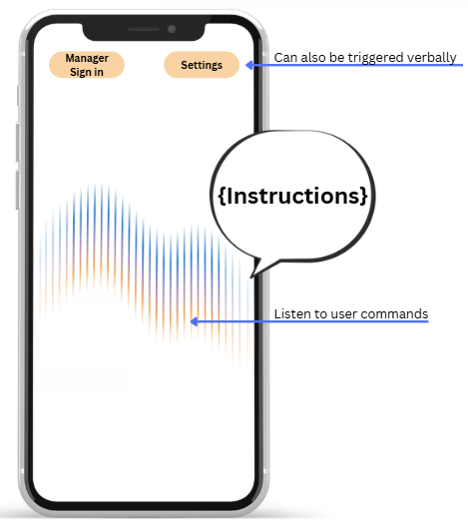
Scenario 2:
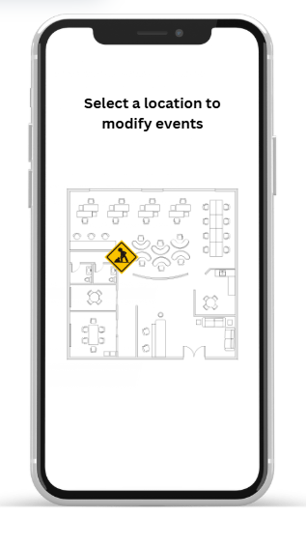
Lia is the building manager of IMAGINARY (building), and she knows a construction is going to take place right in front of the north elevator. To help blind students, she opens the Theia app and logs in to her certified account, and flags the location as “under construction.” Now, the Theia app automatically adjusts blind users' routes accordingly, avoiding the construction site.

Scenario 3:
Jerry has just finished class and wants to leave the room. The classroom is tightly packed with chairs and desks, and some students are still moving around. He opens Theia and says, "Take me to the classroom door." Using indoor mapping and visual sensing, Theia identifies the room layout and nearby obstacles. It generates a safe path and provides real-time spoken instructions. Following the step-by-step voice guidance, Jerry avoids obstacles and safely reaches the door.
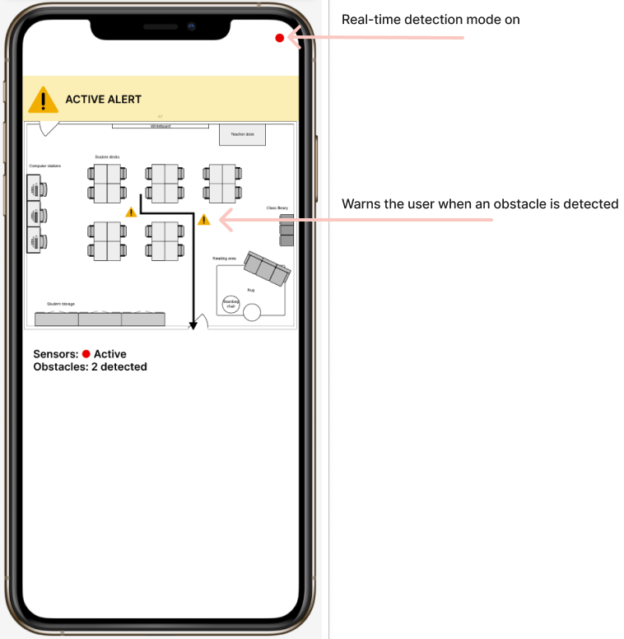
Scenario 4:
Tom trips and falls while walking inside a building. He drops his phone and cannot reach it. There is no one nearby to help him. The phone's motion sensors detect a fall. Theia asks "Are you okay?" and prompts Tom to say "I'm okay" or "Cancel the alert" to stop the emergency process. Tom doesn't respond. Theia counts down 30 seconds, then automatically sends an alert message and GPS location to his emergency contacts and 911.

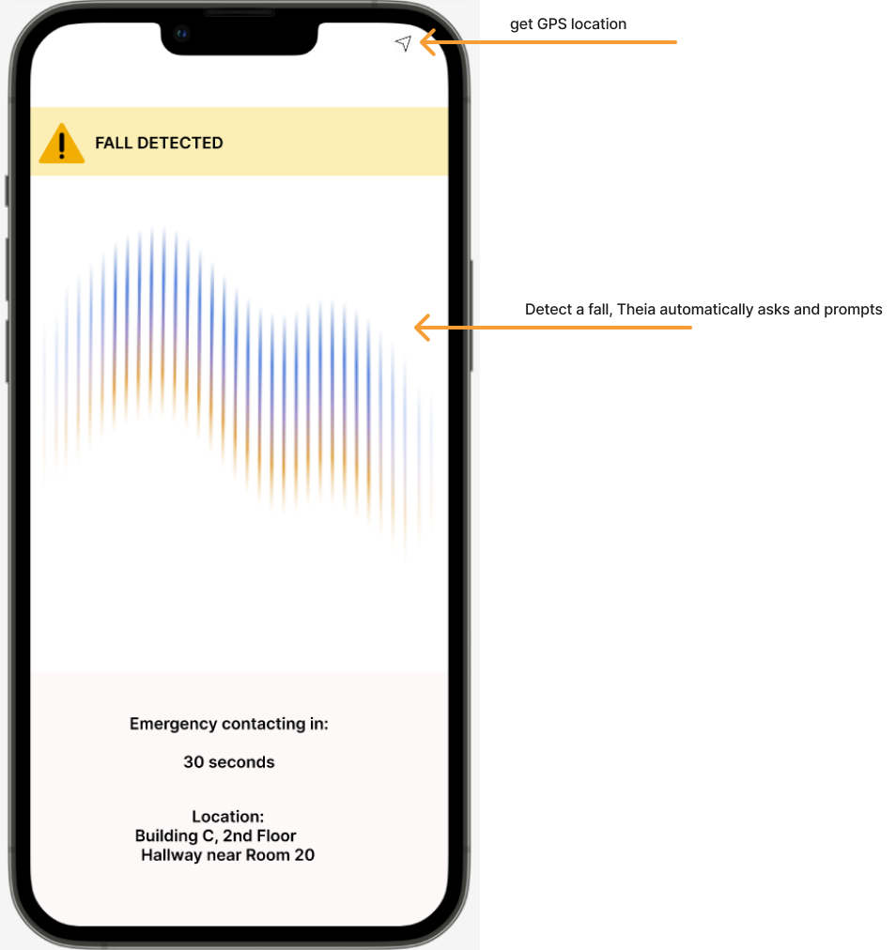

User Manual

References

Phase 1 Roles
Name | Tasks
Felix Zheng | 1.1, 1.2, 1.3, 2.1.DI3, 2.1.DI4, User manual, 3.1.3.2-3.1.3.4
Zirun Ye | W from section 3, Section 4 scenario 1 and 2.
Jinming Wang | 3.2.1, 3.2.2, 3.2.3(part)
Tong Shen | DI2, 2.2, 2.3
Ziming Fu | Section 4 scenario 3 and 4
Zijian Zhang | DI1, 1.4

Activities

Appendix I: Process Details

