英语（二）2018年4月历年真题

Life on the Farm

Life on a farm is always changing. New technologies and a rising interest in healthier and organic eating have had a huge impact on how farms do business. At the same time, a growing population has put more demands on farmers. They need to find ways to increase their production levels. The small family farms that used to produce most of the products have been largely replaced by factory farms. Small family farms that arc still operating are struggling to keep up.

Technology has made most aspects of farm life easier than it has ever been before. Bigger and more efficient equipment makes work such as plowing up fields and sowing the seeds easier. Such tasks used to take two or three times as long. These advances have allowed farmers to work faster and more efficiently than ever before.

In addition to newer technology, factory farms produce more products for less money than traditional farming would require.

Modem farm Life， despite the introduction of new technologies, has not changed much from what it has always been. Farmers still wake up early, and spend their days doing hard work. There are still animals to feed, cows to be milked, and fields to be plowed. Farm life still requires a lot of hard work and sacrifice.

The main change in modern farm life is in the way farms are run. It is common for even small farms to have several hired workers and even an animal manager. Family-nm farms are becoming rarer. Factory farms, with other larger farm corporations, are becoming the norm. A1though there are still many traditional family farms, they are quickly dying as modern practices change farm life forever.

1【单选】(总分1分)Factory farms now produce most of the products.

A True

B False

C Not Given

2【单选】(总分1分)Q:.Farmers prefer to grow healthy and organic food.

A True

B False

C Not Given

3【单选】(总分1分)Small family farms find it hard to survive.

A True

B False

C Not Given

4【单选】(总分1分)Plowing and sowing by machines are advances in modern farming.

A True

B False

C Not Given

5【单选】(总分1分)Modern farm products cost more than those from traditional farming.

A True

B False

C Not Given

6【单选】(总分1分)Most farmers cannot afford new machines.

A True

B False

C Not Given

7【单选】(总分1分)Modern farmers do not have to work hard.

A True

B False

C Not Given

8【单选】(总分1分)New technologies have not changed farm management.

A True

B False

C Not Given

9【单选】(总分1分)There are fewer and fewer family-nm farms now.

A True

B False

C Not Given

10【单选】(总分1分)Modem farms are hiring workers from cities.

A True

B False

C Not Given

Christmas Gift

Mary didn’t know what to send to her grandparents for Christmas. It was always hard to choose a good Christmas present for them. They didn’t need much, and it was hard for her to be creative every year.

One year, she sent them a big wooden elephant. It sat on the counter for a year, but then it disappeared, probably into a closet somewhere. Another year, she made handmade soaps with nice smells, but they probably weren’t any better than store-bought soaps. Last year, she sent lots of nice pictures of herself in frames, but grandparents’ house was small, and they couldn’t hang up very many.

This year, she decided on fruit. She lived where it was warm and there was lots of nice fruit. Her grandparents lived up north, where it colder and they couldn’t get fresh fruit all year, or at least not oranges and grapefruit. Fresh fruit was healthy for her grandparents, too.

Mary went to a fruit store and sampled the red oranges. She really liked them and bought a kilogram. Then she tried three kinds of grapefruit. The white ones were sour. The star grapefruit were interesting, but the dark red grapefruit were great. So she got a kilogram.

Mary carefully packed the fruit in a box to keep them safe and dry in case one got smashed and its juice got everywhere. Then she wrote the address on the box and mailed it from the store. She felt happy with what she bought.

A few days later, Mary got a phone call from her grandparents, thanking her for the lovely fruit. They said it was a healthy, tasty, and very thoughtful gift. Mary had never felt so good before.

11【单选】(总分2分)Mary was troubled because she___________.

A had no idea for a holiday gift

B w no creative in her work

C could not afford Christmas gifts

D found her grandma bard to please

12【单选】(总分2分)What did Mary send her grandparents last year?

A A wooden elephant.

B Handmade soaps.

C Her own pictures.

D A store-bought closet

13【单选】(总分2分)In se1ecting the gifts, Mary was ___________.

A excited

B impatient

C exhausted

D thoughtful

14【单选】(总分2分)Which of the following did Mary buy for her grandparents this year?

A Yellow oranges.

B Dark red grapefruit.

C White grapefruit.

D Star grapefruit

15【单选】(总分2分)Which of the following did Mary buy for her grandparents this year?

A loved her gift

B sent her a card

C wrote her a letter

D put her gift away

Team Work in Sports

① Teams that win in team spoils are often those that work well together. Learning to cooperate with others towards a common goal in sports is what builds character, friendship and important life skills for players.

② Working towards a common goal will keep the team firmly together. Entering into a new season in sports, you might only know a few of the players on your team. Some of the players may be people you do not like. But when your team decides to be the winner of the season, personal differences are often set aside for the common good of the team. By the end of the season, players who have fought through the whole season may become good friends, much like brothers.

③ For kids and young adults, team sports offer a way for them to get out and meet with friends. This can help them avoid spending too much time at home watching television and playing video games. Team work teaches people how to help each other and encourage each other. It can also give players a greater respect for one another and can build friendships that last a lifetime.

④ Team work in sports offers a way for people to compete for something together. It is important to know that winning is not everything in sports and healthy competition can be good for people. Working towards a goal can teach people the value of hard work, commitment and devotion. Team sports are a great way to learn these values.

⑤Team work in sports can help young people develop stronger communication skills. As every member must work for the same goal, they learn how to work with one another successfully.

Task 1

16. Paragraph ①:

17. Paragraph ②:

18. Paragraph ③:

19. Paragraph ④:

20. Paragraph ⑤:

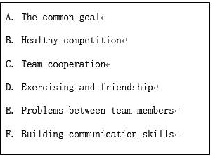

Task 2

21. Cooperation in team Sports helps build ___________.

22. When your team decides to win the season, you set aside________.

23. In team sports, kids learn to________.

24. In team sports, people learn the value of________.

1. A long-lasting friendship can be built_________.

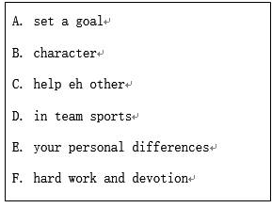

Homeschooling vs School

Many kids find it hard to concentrate in school. Classmates, bells, and even cheerful decorations in school can make it hard for some children to concentrate. 26

In some schools, conditions are bad for children’s safety and health.   27    Homeschooling parents can control their children’s environment to make sure It is safe and healthy.

When students sit in a classroom surrounded by classmates, under the tight control of adults, they find it very hard to function in a normal way. Homeschooling children don’t have to stay in the school.  28  They can interact with people in familiar situations, and they feel they can interact with people as adults.

School bullying (以强欺弱) is a serious problem.   29   Although schools are starling to deal with this problem, many kids ate still afraid of going to school. Homeschooling kids can choose who they associate with and walk away from an uncomfortable situation.

Schools are cutting field trips.    30   On the contrary, homeschooling can move outdoors, to the beach or the zoo. For homeschooling families, the whole world is a classroom. Learning takes place everywhere and it never ends.

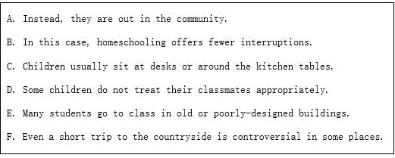

Planting Potatoes

When I was a boy had several gardens around our old house. The largest one of all was used just for growing potatoes.

I can still remember those potato planting days. All the family   31   helped. After my

Dad had   32   the soil, my Mom, brothers, and I went to work. It was my   33  to drop the little seed potatoes In the   34   while my Mom dropped handfuls of fertilizer beside them. My brothers then covered them all with the  35   turned earth.

For months   36   I would glance over at the garden while I played outside and wonder what was going on underneath the   37  . When the harvest time came I was amazed at the huge size of the potatoes my Dad _ 38   out of the soil. Those little seed potatoes had grown into big potatoes. They would be turned into meal after meal of   39  food. They would keep the   40   family well fed throughout the whole year. It truly was a miracle.

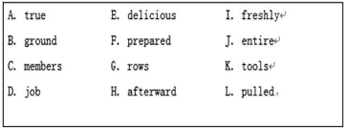

****Workplace English Learning****

English plays (play) an important role in the workplace. When  41 (use) correctly and appropriately, it will be   42  (help) in developing a career or a business. Some may need or want to study business English before they stall their   43  (career). Those who are already  44   (work) have the opportunity to see what they can and cannot do   45   (effective) with English In their current job.

A   46  (value)skill to have in business is how to negotiate. You need to know what you want, as ve1l as how to bargain and make concessions (让步). Being able to deal with a conflict and   47  (know) how to end negotiations can make a big   48  (different) to the outcome.

Workplace English learning will encourage   49  (profession) and efficient communication. It can better serve customers, business partners and   50  (supplier), and it will be a positive push for any business.

20【填空题】(总分30分)请根据所提供材料中的要求完成一篇100词左右的英文写作任务，将你的答案写在答题卡相应的位置上。假设你将举办一次周末小聚会，准备邀请你的英国朋友Tom参加。请给他写一封英文电子邮件，内容包括：活动主题：为Lucy举办生日晚会；时间、地点；询问Tom能否参加。请以Li ke署名。