Course Project: Classifying Weight Lifting Form

September 20, 2014

### Synopsis

This report is a course project which uses the *Weight Lifting Exercise Dataset* from [Human Activity Recognition](http://groupware.les.inf.puc-rio.br/har) website. A random forest model is used to classify weight lifting forms from wearable accelerometers input. The final model contains a total of 53 features with a 100% accuracy of prediction using the test dataset.

### Data Details

The data was collected from six young health participants. They were asked to perform one set of 10 repetitions of the Unilateral Dumbbell Biceps Curl in five different fashions: exactly according to the specification Class A, throwing the elbows to the front Class B, lifting the dumbbell only halfway Class C, lowering the dumbbell only halfway Class D and throwing the hips to the front Class E.

More information related to the data can be found used in the following research article: Velloso, E.; Bulling, A.; Gellersen, H.; Ugulino, W.; Fuks, H. [Qualitative Activity Recognition of Weight Lifting Exercises](http://groupware.les.inf.puc-rio.br/work.jsf?p1=11201). Proceedings of 4th International Conference in Cooperation with SIGCHI (Augmented Human '13) . Stuttgart, Germany: ACM SIGCHI, 2013.

### Data Processing

In order to load the data without the NA, !DIV/0, and empty string values, we treated the aforementioned three types of data as NA while loading the data.

library(RCurl)

Loading required package: bitops

library(caret)

Loading required package: lattice  
Loading required package: ggplot2

library(randomForest)

randomForest 4.6-10  
Type rfNews() to see new features/changes/bug fixes.

library(rpart.plot)

Loading required package: rpart

library(tree)  
  
# read in training data  
url1="https://d396qusza40orc.cloudfront.net/predmachlearn/pml-training.csv"  
x1 <- getURL(url1,ssl.verifypeer = FALSE)  
training <- read.csv(textConnection(x1), header = TRUE  
 , na.strings = c("NA", "#DIV/0!", "")   
 , quote ="\"")  
  
# read in testing data  
url2="https://d396qusza40orc.cloudfront.net/predmachlearn/pml-testing.csv"  
x2 <- getURL(url2,ssl.verifypeer = FALSE)  
testing <- read.csv(textConnection(x2), header = TRUE  
 , na.strings = c("NA", "#DIV/0!", "")   
 , quote ="\"")  
  
# record data access time  
dateDowloaded<-date()  
dput(dateDowloaded, "dateDownloaded.txt")

The training data is a 19622 by 160 data set and the testing data is a 20 by 160 data set.

dim(training)

## [1] 19622 160

dim(testing)

## [1] 20 160

We divide the training set into subtrain and subtest data set with a 70/30 split for fitting and testing the model.

inTrain <- createDataPartition(y=training$classe, p=0.7, list=FALSE)  
subtrain <- training[inTrain,]  
subtest <- training[-inTrain, ]

After using nafunc to check how many of the variables are missing the majority of their values (i.e. NA), we have found that a number of variables are mostly empty.

nafunc <- function(x) sum(is.na(x))  
sum_nas <- sapply(subtrain, nafunc) # number of rows in each col with NA

Since the variables with high number of NAs provide very little or no information, those variables are removed from the analysis. Using 90% NAs as the cutoff point, we removed 100 variables.

trainRows <- dim(subtrain)[1]  
few_nas <- !(sum_nas >= 0.9*trainRows) # TRUE = there are fewer NAs  
dim(subtrain)[2]-sum(few_nas) # variables to remove

## [1] 100

sum(few_nas) # variables to keep

## [1] 60

By visual inspection, we found some variables, such as the subject's name and timestamps, etc. would not have any significant impact on the outcome, thus those variables are also removed.

names(subtrain)[1:7]

## [1] "X" "user_name" "raw_timestamp_part_1"  
## [4] "raw_timestamp_part_2" "cvtd_timestamp" "new_window"   
## [7] "num_window"

useful <- c(rep(TRUE, times=length(subtrain)))  
useful[c(1,2,3,4,5,6,7)] <- FALSE   
  
keepvar <- useful & few_nas  
usefulVars <- sum(keepvar)  
  
subtrain <- subtrain[ ,keepvar]  
subtest <- subtest[ ,keepvar]

This leaves us with 53 columns in our data, including the predicted variable.

### Model Building

Since it is a classification problem to predict the exercise type, we will use [randomForest](http://www.stat.berkeley.edu/~breiman/RandomForests/cc_home.htm#workings) algorithm. Random Forests grows many classification trees. To classify a new object from an input vector, put the input vector down each of the trees in the forest. Each tree gives a classification, and we say the tree "votes" for that class. The forest chooses the classification having the most votes (over all the trees in the forest).

First, we tune randomForest for the optimal mtry parameter value with respect to *Out-of-Bag* error estimate.

set.seed(9988)  
rf_tune <- tuneRF(subtrain[,1:(length(subtrain)-1)], subtrain$classe  
 , doBest=FALSE  
 , trace=FALSE  
 , plot=FALSE  
 )  
mtry_tuned <- which.min(rf_tune)

The *out-of-Bag* error estimate is minimized at 5 variables. This estimate is used to create the random forest model.

set.seed(138)  
rf_fit <- randomForest(classe ~ . , data=subtrain  
 , mtry=mtry_tuned  
 , ntree=500  
 , importance=TRUE)  
rf_fit

##   
## Call:  
## randomForest(formula = classe ~ ., data = subtrain, mtry = mtry_tuned, ntree = 500, importance = TRUE)   
## Type of random forest: classification  
## Number of trees: 500  
## No. of variables tried at each split: 5  
##   
## OOB estimate of error rate: 0.5%  
## Confusion matrix:  
## A B C D E class.error  
## A 3905 0 0 0 1 0.000256  
## B 11 2645 2 0 0 0.004891  
## C 0 17 2375 4 0 0.008765  
## D 0 0 24 2226 2 0.011545  
## E 0 0 1 6 2518 0.002772

# error plot  
plot(rf_fit, main="Decrease in Model Error with Number of Trees")

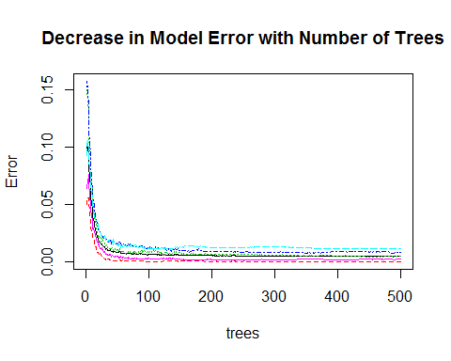

##### Figure 1: the model error decreases while the number of trees increases

The graph below shows the importance of variables in the fitted model.

varImpPlot(rf_fit, main = "Importance of Predictors in the Fit",   
 pch=19, col="blue",cex=0.75, sort=TRUE, type=1)

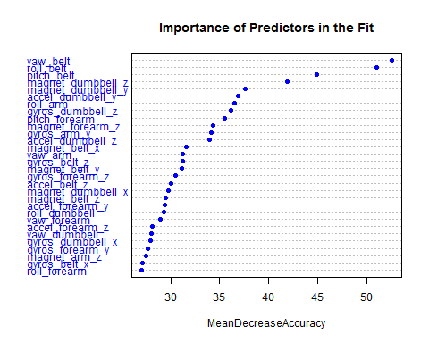

##### Figure 2: variable importance plot

### Cross-Validation

To validate the final model, we apply the model to the subset of the training data and compare the predicted classes to the actual classes.

pred <- predict(rf_fit,newdata=subtest)  
cm <- confusionMatrix(pred,subtest$classe)  
oos_err <- sum(!(pred==subtest$classe))/dim(subtest)[1]   
  
# estimated out of sample error  
oos_err

## [1] 0.007137

The confusion matrix shows that the model predicts each class with high precision. The estimated the out-of-sample error is 0.0071, or 0.7137%.

### Test Results

The model is applied to the test cases given with the 53 selected features/variables. The predictions from this test set were submitted for the assignment. The feedback upon submission indicated that the model has a 100% accuracy.

testing <- testing[ ,keepvar]  
pred2 <- predict(rf_fit,newdata=testing)  
  
### submission file script from course website   
pml_write_files = function(x){  
 n = length(x)  
 for(i in 1:n){  
 filename = paste0("problem_id_",i,".txt")  
 write.table(x[i],file=filename,quote=FALSE,row.names=FALSE,col.names=FALSE)  
 }  
}  
  
pml_write_files(pred2)