**Homework 5**

P8130 Fall 2022

Due: December 5, 2022 at midnight Eastern

**P8130 Guidelines for Submitting Homework**

• Your homework must be submitted through Courseworks. No email submissions!

• Only one PDF file should be submitted, including all derivations, graphs, output, and interpretations. When handwriting is allowed (this will be specified), scan the derivations and merge ALL PDF files (http: //www.pdfmerge.com/).

• You are encouraged to use R for calculations, but you must show all mathematical formulas and derivations. Please include the important parts of your R code in the PDF file but also submit your full, commented code as a separate R/RMD file.

• To best follow these guidelines, we suggest using Word (built in equation editor), R Markdown, Latex, or embedding a screenshot or scanned picture to compile your work.

DO NOT FORGET: You are encouraged to collaborate on homeworks, explain things to each other, and test each other’s knowledge. But Do NOT hand out answers to someone who has not done any work. Everyone ought to have ideas about the possible answers or at least some thoughts about how to probe the problem further. Write your own solutions!

State-of-Life-Predicting-Life-Expectancy-from-1970s-Census-Data

Xun Sun xs2569

2024-12-14

**Problem 1 (30 points)**

**R dataset state.x77 from library(faraway) contains information on 50 states from 1970s collected by US Census Bureau. The goal is to predict ‘life expectancy’ using a combination of remaining variables.**

library(tidyverse)

library(GGally)

library(patchwork)

library(gt)

library(leaps)

library(caret)

library(ggplot2)

library(dbplyr)

data.state <- as.data.frame(state.x77)|>   
 janitor::clean_names()   
head(data.state)

## population income illiteracy life_exp murder hs_grad frost area  
## Alabama 3615 3624 2.1 69.05 15.1 41.3 20 50708  
## Alaska 365 6315 1.5 69.31 11.3 66.7 152 566432  
## Arizona 2212 4530 1.8 70.55 7.8 58.1 15 113417  
## Arkansas 2110 3378 1.9 70.66 10.1 39.9 65 51945  
## California 21198 5114 1.1 71.71 10.3 62.6 20 156361  
## Colorado 2541 4884 0.7 72.06 6.8 63.9 166 103766

view(data.state)

1. Provide descriptive statistics for all variables of interest – no test required

summary(data.state)

## population income illiteracy life_exp   
## Min. : 365 Min. :3098 Min. :0.500 Min. :67.96   
## 1st Qu.: 1080 1st Qu.:3993 1st Qu.:0.625 1st Qu.:70.12   
## Median : 2838 Median :4519 Median :0.950 Median :70.67   
## Mean : 4246 Mean :4436 Mean :1.170 Mean :70.88   
## 3rd Qu.: 4968 3rd Qu.:4814 3rd Qu.:1.575 3rd Qu.:71.89   
## Max. :21198 Max. :6315 Max. :2.800 Max. :73.60   
## murder hs_grad frost area   
## Min. : 1.400 Min. :37.80 Min. : 0.00 Min. : 1049   
## 1st Qu.: 4.350 1st Qu.:48.05 1st Qu.: 66.25 1st Qu.: 36985   
## Median : 6.850 Median :53.25 Median :114.50 Median : 54277   
## Mean : 7.378 Mean :53.11 Mean :104.46 Mean : 70736   
## 3rd Qu.:10.675 3rd Qu.:59.15 3rd Qu.:139.75 3rd Qu.: 81163   
## Max. :15.100 Max. :67.30 Max. :188.00 Max. :566432

### ****Interpretation****

1. **Life Expectancy**: Ranges between 67.96 and 73.6 years with an average of 70.88.
2. **Population**: Highly variable, with a wide range (365 to 21,198).
3. **Income**: The average income is approximately $4,575, ranging from $3,098 to $6,315.
4. **Illiteracy**: Averages 1.17%, with some states showing higher illiteracy rates (up to 2.8%).
5. **Murder Rate**: The average murder rate is 7.38 per 100,000, with a large spread between states.
6. **HS Graduation Rate**: States have an average graduation rate of 53.11%.
7. **Frost**: Number of frost days varies greatly, with some states having no frost days.
8. **Area**: The size of states varies widely, reflecting geographic diversity.
9. Examine exploratory plots, e.g., scatter plots, histograms, boxplots to get a sense of the data and possible variable transformations.

data.state |>  
 relocate(`life_exp`) |>  
 ggpairs()

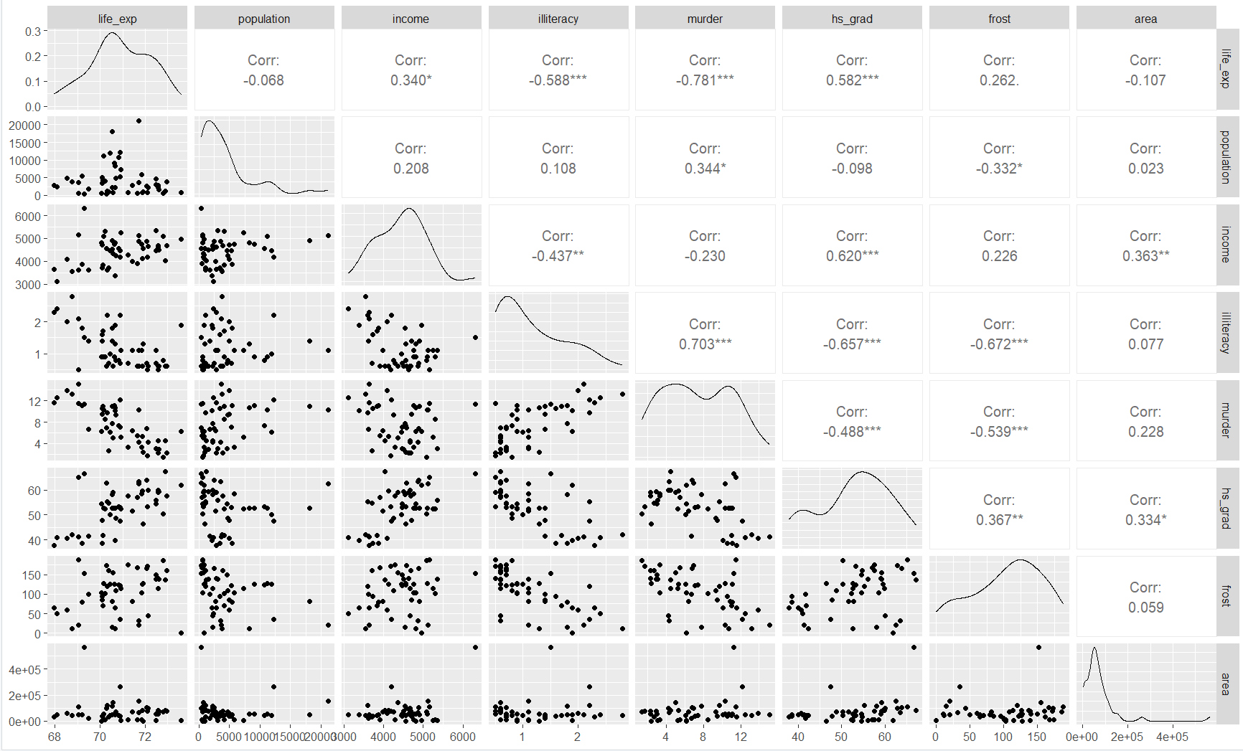

We can see that population, illiteracy and area are severely right skewed. Transforming these variables before making models can be helpful. This matrix of plots also shows the correlation between each variable. From this, we can see that life expectancy is moderately correlated with illiteracy, murder, and HS grad. Among Xs, murder is highly correlated with illiteracy.

## look for appropriate transformations

density_plot_population <-data.state |>  
 ggplot(aes(x = population)) +  
 geom_density()  
  
density_plot_logpopulation <-data.state |>  
 mutate(log_population = log(population)) |>  
 ggplot(aes(x = log_population)) + geom_density()  
  
density_plot_inver_population <-data.state |>  
 mutate(inver_population = 1/(population)) |>  
 ggplot(aes(x = inver_population)) + geom_density()  
  
  
density_plot_population + density_plot_logpopulation + density_plot_inver_population

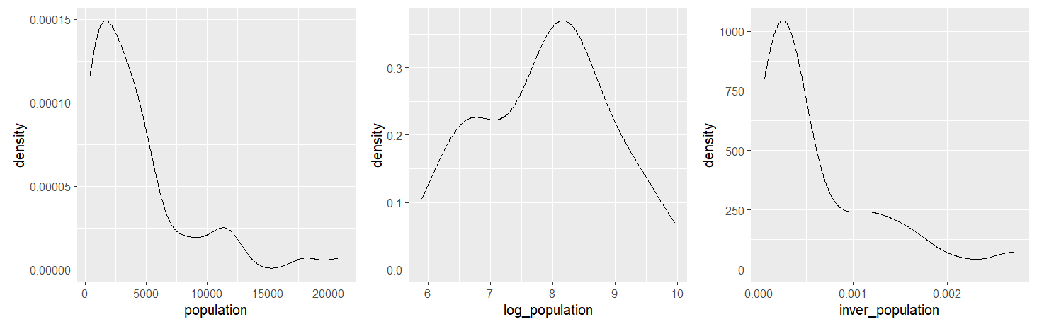

density_plot_area <- data.state |>  
 ggplot(aes(x = area)) +  
 geom_density()  
  
density_plot_logarea <- data.state |>  
 mutate(log_area = log(area)) |>  
 ggplot(aes(x = log_area)) + geom_density()  
  
density_plot_area + density_plot_logarea

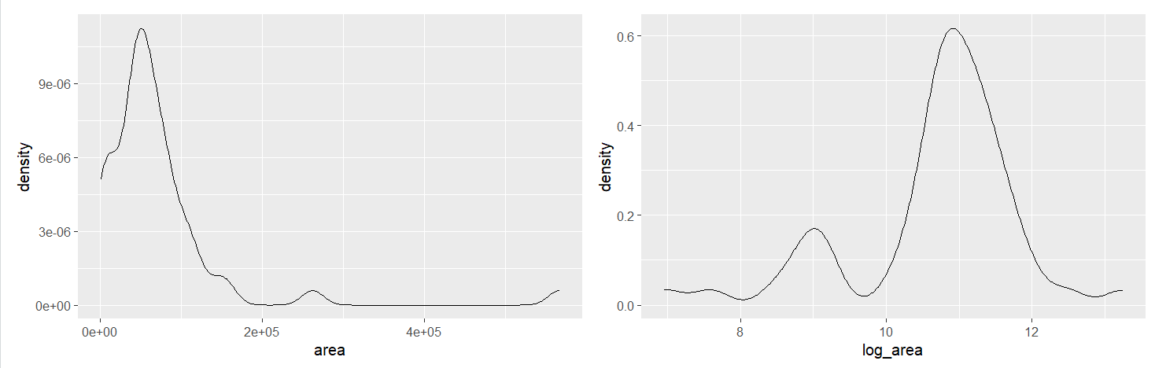

density_plot_illiteracy <- data.state |>  
 ggplot(aes(x = illiteracy)) +  
 geom_density()  
  
density_plot_logilliteracy <- data.state |>  
 mutate(log_illiteracy = log(illiteracy)) |>  
 ggplot(aes(x = log_illiteracy)) + geom_density()  
  
density_plot_illiteracy + density_plot_logilliteracy

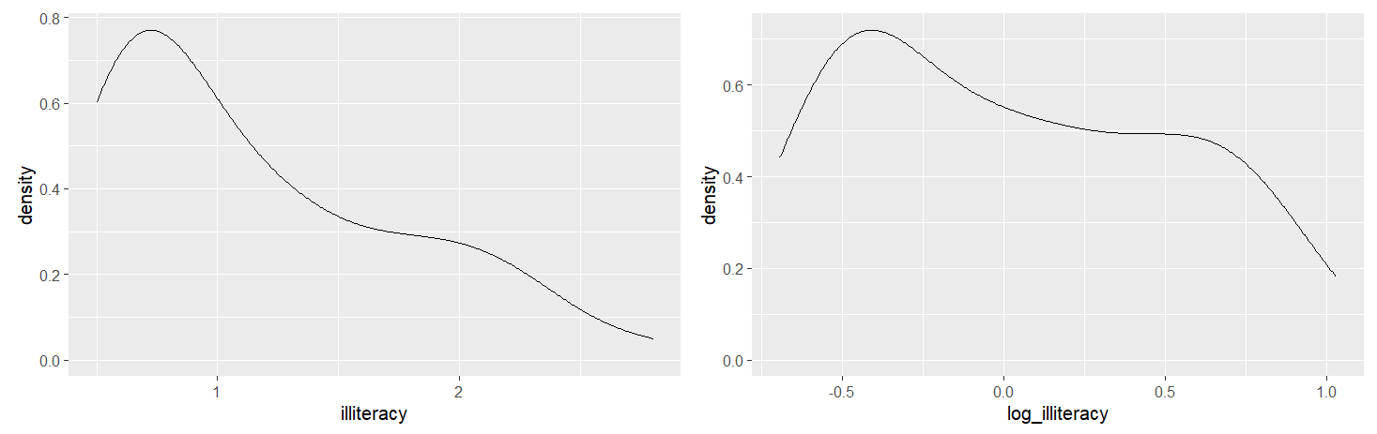

qq_population <- data.state |>  
 ggplot(aes(sample = population)) +  
 stat_qq() +  
 stat_qq_line() +  
 ggtitle("QQ Plot: Population")  
  
qq_log_population <- data.state |>  
 mutate(log_population = log(population)) |>  
 ggplot(aes(sample = log_population)) +  
 stat_qq() +  
 stat_qq_line() +  
 ggtitle("QQ Plot: Log Population")  
  
qq_inver_population <- data.state |>  
 mutate(inver_population = 1 / (population)) |>  
 ggplot(aes(sample = inver_population)) +  
 stat_qq() +  
 stat_qq_line() +  
 ggtitle("QQ Plot: Inverse Population")  
  
# QQ Plots for Area  
qq_area <- data.state |>  
 ggplot(aes(sample = area)) +  
 stat_qq() +  
 stat_qq_line() +  
 ggtitle("QQ Plot: Area")  
  
qq_log_area <- data.state |>  
 mutate(log_area = log(area)) |>  
 ggplot(aes(sample = log_area)) +  
 stat_qq() +  
 stat_qq_line() +  
 ggtitle("QQ Plot: Log Area")  
  
# QQ Plots for Illiteracy  
qq_illiteracy <- data.state |>  
 ggplot(aes(sample = illiteracy)) +  
 stat_qq() +  
 stat_qq_line() +  
 ggtitle("QQ Plot: Illiteracy")  
  
qq_log_illiteracy <- data.state |>  
 mutate(log_illiteracy = log(illiteracy)) |>  
 ggplot(aes(sample = log_illiteracy)) +  
 stat_qq() +  
 stat_qq_line() +  
 ggtitle("QQ Plot: Log Illiteracy")  
  
# Combine QQ Plots with Patchwork for Comparison  
library(patchwork)  
  
(qq_population | qq_log_population | qq_inver_population) /   
(qq_area | qq_log_area) /   
(qq_illiteracy | qq_log_illiteracy)

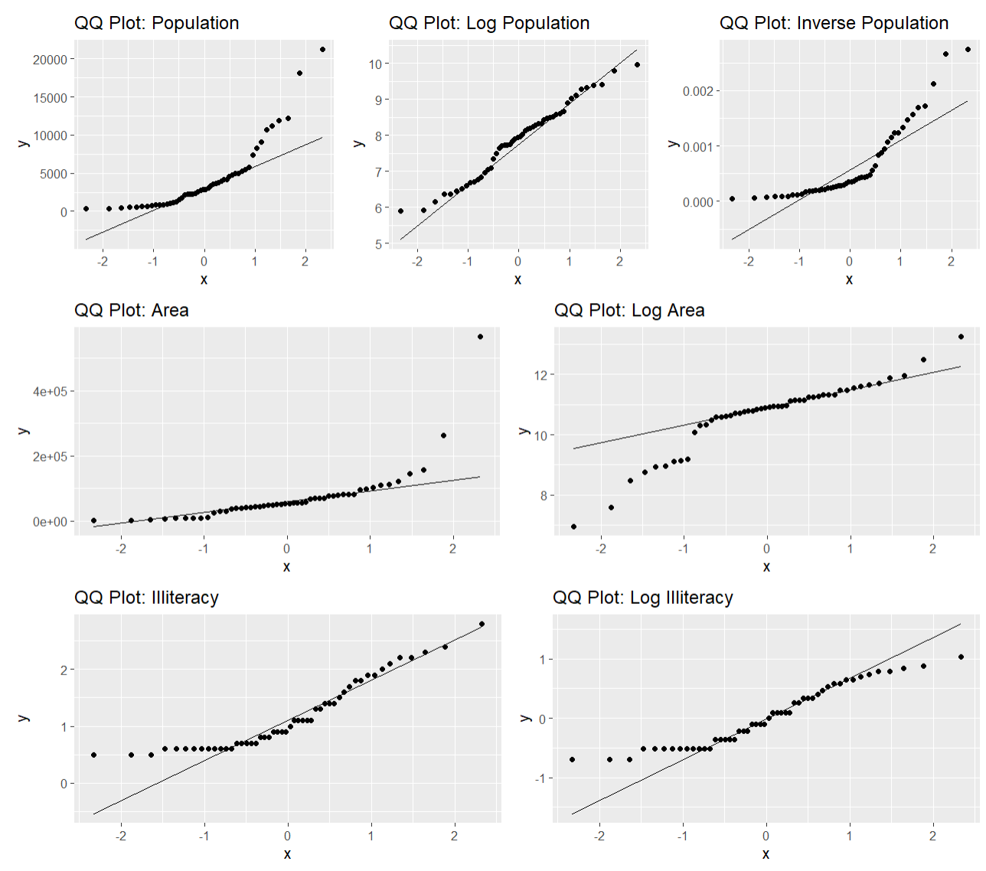

Based on the plots above, the log transformation effectively normalizes the Population variable, as evidenced by the density and QQ plots. However, for Area, the QQ plot shows no improvement after the log transformation, likely due to the presence of outliers identified in the scatter plot. Similarly, the QQ plot for Illiteracy does not improve after the log transformation, indicating it is not suitable for this variable. Therefore, we will use the log-transformed Population in our model, while retaining the raw Area and Illiteracy variables.

data.state <- data.state |>  
 mutate(log_Population = log(population)) |>  
 select(-population)  
view(data.state)

**c) Use automatic procedures to find a ‘best subset’ of the full model. Present the**

**results and comment on the following:**

•

# Define the response variable and dataset  
response <- "life_expectancy" # Replace with your actual response variable  
data <- data.state # Your dataset  
  
# Null model  
null_model <- lm(life_exp ~ 1, data = data)  
  
# Full model (all predictors)  
full_model <- lm(life_exp ~ ., data = data)

library(MASS)

library(olsrr)

# Forward Selection  
forward_aic <- stepAIC(null_model,   
 scope = list(lower = null_model, upper = full_model), direction = "forward")

## Start: AIC=30.44  
## life_exp ~ 1  
##   
## Df Sum of Sq RSS AIC  
## + murder 1 53.838 34.461 -14.609  
## + illiteracy 1 30.578 57.721 11.179  
## + hs_grad 1 29.931 58.368 11.737  
## + income 1 10.223 78.076 26.283  
## + frost 1 6.064 82.235 28.878  
## <none> 88.299 30.435  
## + log_Population 1 1.054 87.245 31.835  
## + area 1 1.017 87.282 31.856  
##   
## Step: AIC=-14.61  
## life_exp ~ murder  
##   
## Df Sum of Sq RSS AIC  
## + hs_grad 1 4.6910 29.770 -19.925  
## + frost 1 3.1346 31.327 -17.378  
## + log_Population 1 2.9854 31.476 -17.140  
## + income 1 2.4047 32.057 -16.226  
## <none> 34.461 -14.609  
## + area 1 0.4697 33.992 -13.295  
## + illiteracy 1 0.2732 34.188 -13.007  
##   
## Step: AIC=-19.93  
## life_exp ~ murder + hs_grad  
##   
## Df Sum of Sq RSS AIC  
## + log_Population 1 4.6350 25.135 -26.387  
## + frost 1 4.3987 25.372 -25.920  
## <none> 29.770 -19.925  
## + illiteracy 1 0.4419 29.328 -18.673  
## + area 1 0.2775 29.493 -18.394  
## + income 1 0.1022 29.668 -18.097  
##   
## Step: AIC=-26.39  
## life_exp ~ murder + hs_grad + log_Population  
##   
## Df Sum of Sq RSS AIC  
## + frost 1 2.21416 22.921 -28.998  
## + illiteracy 1 1.10754 24.028 -26.640  
## <none> 25.135 -26.387  
## + income 1 0.11819 25.017 -24.623  
## + area 1 0.00175 25.134 -24.391  
##   
## Step: AIC=-29  
## life_exp ~ murder + hs_grad + log_Population + frost  
##   
## Df Sum of Sq RSS AIC  
## <none> 22.921 -28.998  
## + illiteracy 1 0.051595 22.870 -27.111  
## + area 1 0.015956 22.905 -27.033  
## + income 1 0.010673 22.911 -27.021

# Summary of the selected model  
summary(forward_aic)

##   
## Call:  
## lm(formula = life_exp ~ murder + hs_grad + log_Population + frost,   
## data = data)  
##   
## Residuals:  
## Min 1Q Median 3Q Max   
## -1.41760 -0.43880 0.02539 0.52066 1.63048   
##   
## Coefficients:  
## Estimate Std. Error t value Pr(>|t|)   
## (Intercept) 68.720810 1.416828 48.503 < 2e-16 ***  
## murder -0.290016 0.035440 -8.183 1.87e-10 ***  
## hs_grad 0.054550 0.014758 3.696 0.000591 ***  
## log_Population 0.246836 0.112539 2.193 0.033491 *   
## frost -0.005174 0.002482 -2.085 0.042779 *   
## ---  
## Signif. codes: 0 '***' 0.001 '**' 0.01 '*' 0.05 '.' 0.1 ' ' 1  
##   
## Residual standard error: 0.7137 on 45 degrees of freedom  
## Multiple R-squared: 0.7404, Adjusted R-squared: 0.7173   
## F-statistic: 32.09 on 4 and 45 DF, p-value: 1.17e-12

n <- nrow(data.state)   
forward_bic <- step(null_model,   
 scope = list(lower = null_model, upper = full_model),   
 direction = "forward",   
 k = log(n))

## Start: AIC=32.35  
## life_exp ~ 1  
##   
## Df Sum of Sq RSS AIC  
## + murder 1 53.838 34.461 -10.785  
## + illiteracy 1 30.578 57.721 15.004  
## + hs_grad 1 29.931 58.368 15.561  
## + income 1 10.223 78.076 30.107  
## <none> 88.299 32.347  
## + frost 1 6.064 82.235 32.702  
## + log_Population 1 1.054 87.245 35.659  
## + area 1 1.017 87.282 35.680  
##   
## Step: AIC=-10.79  
## life_exp ~ murder  
##   
## Df Sum of Sq RSS AIC  
## + hs_grad 1 4.6910 29.770 -14.1894  
## + frost 1 3.1346 31.327 -11.6415  
## + log_Population 1 2.9854 31.476 -11.4039  
## <none> 34.461 -10.7852  
## + income 1 2.4047 32.057 -10.4900  
## + area 1 0.4697 33.992 -7.5593  
## + illiteracy 1 0.2732 34.188 -7.2712  
##   
## Step: AIC=-14.19  
## life_exp ~ murder + hs_grad  
##   
## Df Sum of Sq RSS AIC  
## + log_Population 1 4.6350 25.135 -18.739  
## + frost 1 4.3987 25.372 -18.271  
## <none> 29.770 -14.189  
## + illiteracy 1 0.4419 29.328 -11.025  
## + area 1 0.2775 29.493 -10.746  
## + income 1 0.1022 29.668 -10.449  
##

## Step: AIC=-18.74  
## life_exp ~ murder + hs_grad + log_Population  
##   
## Df Sum of Sq RSS AIC  
## + frost 1 2.21416 22.921 -19.438  
## <none> 25.135 -18.739  
## + illiteracy 1 1.10754 24.028 -17.080  
## + income 1 0.11819 25.017 -15.063  
## + area 1 0.00175 25.134 -14.831  
##   
## Step: AIC=-19.44  
## life_exp ~ murder + hs_grad + log_Population + frost  
##   
## Df Sum of Sq RSS AIC  
## <none> 22.921 -19.438  
## + illiteracy 1 0.051595 22.870 -15.639  
## + area 1 0.015956 22.905 -15.561  
## + income 1 0.010673 22.911 -15.549

Backward Selection

# Backward selection based on AIC  
backward_aic <- step(full_model,   
 direction = "backward",trace = TRUE)

## Start: AIC=-23.15  
## life_exp ~ income + illiteracy + murder + hs_grad + frost + area +   
## log_Population  
##   
## Df Sum of Sq RSS AIC  
## - area 1 0.0092 22.859 -25.134  
## - income 1 0.0159 22.866 -25.120  
## - illiteracy 1 0.0359 22.885 -25.076  
## <none> 22.850 -23.154  
## - frost 1 1.0933 23.943 -22.817  
## - log_Population 1 2.1947 25.044 -20.569  
## - hs_grad 1 3.1607 26.010 -18.677  
## - murder 1 23.6107 46.460 10.329  
##   
## Step: AIC=-25.13  
## life_exp ~ income + illiteracy + murder + hs_grad + frost + log_Population  
##   
## Df Sum of Sq RSS AIC  
## - income 1 0.0109 22.870 -27.111  
## - illiteracy 1 0.0518 22.911 -27.021  
## <none> 22.859 -25.134  
## - frost 1 1.1073 23.966 -24.769  
## - log_Population 1 2.1994 25.058 -22.541  
## - hs_grad 1 3.8468 26.706 -19.358  
## - murder 1 26.7410 49.600 11.598  
##   
## Step: AIC=-27.11  
## life_exp ~ illiteracy + murder + hs_grad + frost + log_Population  
##   
## Df Sum of Sq RSS AIC  
## - illiteracy 1 0.0516 22.921 -28.9980  
## <none> 22.870 -27.1107  
## - frost 1 1.1582 24.028 -26.6405  
## - log_Population 1 2.3302 25.200 -24.2594  
## - hs_grad 1 5.2719 28.141 -18.7389  
## - murder 1 26.9930 49.863 9.8624  
##   
## Step: AIC=-29  
## life_exp ~ murder + hs_grad + frost + log_Population  
##   
## Df Sum of Sq RSS AIC  
## <none> 22.921 -28.998  
## - frost 1 2.214 25.135 -26.387  
## - log_Population 1 2.450 25.372 -25.920  
## - hs_grad 1 6.959 29.881 -17.741  
## - murder 1 34.109 57.031 14.578

# Display summary of the final model  
summary(backward_aic)

##   
## Call:  
## lm(formula = life_exp ~ murder + hs_grad + frost + log_Population,   
## data = data)  
##   
## Residuals:  
## Min 1Q Median 3Q Max   
## -1.41760 -0.43880 0.02539 0.52066 1.63048   
##   
## Coefficients:  
## Estimate Std. Error t value Pr(>|t|)   
## (Intercept) 68.720810 1.416828 48.503 < 2e-16 ***  
## murder -0.290016 0.035440 -8.183 1.87e-10 ***  
## hs_grad 0.054550 0.014758 3.696 0.000591 ***  
## frost -0.005174 0.002482 -2.085 0.042779 *   
## log_Population 0.246836 0.112539 2.193 0.033491 *   
## ---  
## Signif. codes: 0 '***' 0.001 '**' 0.01 '*' 0.05 '.' 0.1 ' ' 1  
##   
## Residual standard error: 0.7137 on 45 degrees of freedom  
## Multiple R-squared: 0.7404, Adjusted R-squared: 0.7173   
## F-statistic: 32.09 on 4 and 45 DF, p-value: 1.17e-12

# Number of observations  
n <- nrow(data.state)  
  
# Backward selection based on BIC  
backward_bic <- step(full_model,   
 direction = "backward",   
 k = log(n),   
 trace = TRUE)

## Start: AIC=-7.86  
## life_exp ~ income + illiteracy + murder + hs_grad + frost + area +   
## log_Population  
##   
## Df Sum of Sq RSS AIC  
## - area 1 0.0092 22.859 -11.7503  
## - income 1 0.0159 22.866 -11.7355  
## - illiteracy 1 0.0359 22.885 -11.6919  
## - frost 1 1.0933 23.943 -9.4333  
## <none> 22.850 -7.8583  
## - log_Population 1 2.1947 25.044 -7.1846  
## - hs_grad 1 3.1607 26.010 -5.2923  
## - murder 1 23.6107 46.460 23.7129  
##   
## Step: AIC=-11.75  
## life_exp ~ income + illiteracy + murder + hs_grad + frost + log_Population  
##   
## Df Sum of Sq RSS AIC  
## - income 1 0.0109 22.870 -15.6385  
## - illiteracy 1 0.0518 22.911 -15.5491  
## - frost 1 1.1073 23.966 -13.2970  
## <none> 22.859 -11.7503  
## - log_Population 1 2.1994 25.058 -11.0691  
## - hs_grad 1 3.8468 26.706 -7.8855  
## - murder 1 26.7410 49.600 23.0703  
##   
## Step: AIC=-15.64  
## life_exp ~ illiteracy + murder + hs_grad + frost + log_Population  
##   
## Df Sum of Sq RSS AIC  
## - illiteracy 1 0.0516 22.921 -19.4379  
## - frost 1 1.1582 24.028 -17.0804  
## <none> 22.870 -15.6385  
## - log_Population 1 2.3302 25.200 -14.6993  
## - hs_grad 1 5.2719 28.141 -9.1788  
## - murder 1 26.9930 49.863 19.4225  
##   
## Step: AIC=-19.44  
## life_exp ~ murder + hs_grad + frost + log_Population  
##   
## Df Sum of Sq RSS AIC  
## <none> 22.921 -19.438  
## - frost 1 2.214 25.135 -18.739  
## - log_Population 1 2.450 25.372 -18.271  
## - hs_grad 1 6.959 29.881 -10.093  
## - murder 1 34.109 57.031 22.226

# Display summary of the final model  
summary(backward_bic)

##   
## Call:  
## lm(formula = life_exp ~ murder + hs_grad + frost + log_Population,   
## data = data)  
##   
## Residuals:  
## Min 1Q Median 3Q Max   
## -1.41760 -0.43880 0.02539 0.52066 1.63048   
##   
## Coefficients:  
## Estimate Std. Error t value Pr(>|t|)   
## (Intercept) 68.720810 1.416828 48.503 < 2e-16 ***  
## murder -0.290016 0.035440 -8.183 1.87e-10 ***  
## hs_grad 0.054550 0.014758 3.696 0.000591 ***  
## frost -0.005174 0.002482 -2.085 0.042779 *   
## log_Population 0.246836 0.112539 2.193 0.033491 *   
## ---  
## Signif. codes: 0 '***' 0.001 '**' 0.01 '*' 0.05 '.' 0.1 ' ' 1  
##   
## Residual standard error: 0.7137 on 45 degrees of freedom  
## Multiple R-squared: 0.7404, Adjusted R-squared: 0.7173   
## F-statistic: 32.09 on 4 and 45 DF, p-value: 1.17e-12

# Stepwise selection (both directions, default AIC)  
stepwise_aic <- step(full_model,   
 direction = "both",trace = TRUE)

## Start: AIC=-23.15  
## life_exp ~ income + illiteracy + murder + hs_grad + frost + area +   
## log_Population  
##   
## Df Sum of Sq RSS AIC  
## - area 1 0.0092 22.859 -25.134  
## - income 1 0.0159 22.866 -25.120  
## - illiteracy 1 0.0359 22.885 -25.076  
## <none> 22.850 -23.154  
## - frost 1 1.0933 23.943 -22.817  
## - log_Population 1 2.1947 25.044 -20.569  
## - hs_grad 1 3.1607 26.010 -18.677  
## - murder 1 23.6107 46.460 10.329  
##   
## Step: AIC=-25.13  
## life_exp ~ income + illiteracy + murder + hs_grad + frost + log_Population  
##   
## Df Sum of Sq RSS AIC  
## - income 1 0.0109 22.870 -27.111  
## - illiteracy 1 0.0518 22.911 -27.021  
## <none> 22.859 -25.134  
## - frost 1 1.1073 23.966 -24.769  
## + area 1 0.0092 22.850 -23.154  
## - log_Population 1 2.1994 25.058 -22.541  
## - hs_grad 1 3.8468 26.706 -19.358  
## - murder 1 26.7410 49.600 11.598  
##   
## Step: AIC=-27.11  
## life_exp ~ illiteracy + murder + hs_grad + frost + log_Population  
##   
## Df Sum of Sq RSS AIC  
## - illiteracy 1 0.0516 22.921 -28.9980  
## <none> 22.870 -27.1107  
## - frost 1 1.1582 24.028 -26.6405  
## + income 1 0.0109 22.859 -25.1344  
## + area 1 0.0041 22.866 -25.1197  
## - log_Population 1 2.3302 25.200 -24.2594  
## - hs_grad 1 5.2719 28.141 -18.7389  
## - murder 1 26.9930 49.863 9.8624  
##   
## Step: AIC=-29  
## life_exp ~ murder + hs_grad + frost + log_Population  
##   
## Df Sum of Sq RSS AIC  
## <none> 22.921 -28.998  
## + illiteracy 1 0.052 22.870 -27.111  
## + area 1 0.016 22.905 -27.033  
## + income 1 0.011 22.911 -27.021  
## - frost 1 2.214 25.135 -26.387  
## - log_Population 1 2.450 25.372 -25.920  
## - hs_grad 1 6.959 29.881 -17.741  
## - murder 1 34.109 57.031 14.578

# Summary of the final model  
summary(stepwise_aic)

##   
## Call:  
## lm(formula = life_exp ~ murder + hs_grad + frost + log_Population,   
## data = data)  
##   
## Residuals:  
## Min 1Q Median 3Q Max   
## -1.41760 -0.43880 0.02539 0.52066 1.63048   
##   
## Coefficients:  
## Estimate Std. Error t value Pr(>|t|)   
## (Intercept) 68.720810 1.416828 48.503 < 2e-16 ***  
## murder -0.290016 0.035440 -8.183 1.87e-10 ***  
## hs_grad 0.054550 0.014758 3.696 0.000591 ***  
## frost -0.005174 0.002482 -2.085 0.042779 *   
## log_Population 0.246836 0.112539 2.193 0.033491 *   
## ---  
## Signif. codes: 0 '***' 0.001 '**' 0.01 '*' 0.05 '.' 0.1 ' ' 1  
##   
## Residual standard error: 0.7137 on 45 degrees of freedom  
## Multiple R-squared: 0.7404, Adjusted R-squared: 0.7173   
## F-statistic: 32.09 on 4 and 45 DF, p-value: 1.17e-12

# Number of observations  
n <- nrow(data.state)  
  
# Stepwise selection (both directions, BIC)  
stepwise_bic <- step(full_model,   
 direction = "both",   
 k = log(n),trace = TRUE) # BIC penalty

## Start: AIC=-7.86  
## life_exp ~ income + illiteracy + murder + hs_grad + frost + area +   
## log_Population  
##   
## Df Sum of Sq RSS AIC  
## - area 1 0.0092 22.859 -11.7503  
## - income 1 0.0159 22.866 -11.7355  
## - illiteracy 1 0.0359 22.885 -11.6919  
## - frost 1 1.0933 23.943 -9.4333  
## <none> 22.850 -7.8583  
## - log_Population 1 2.1947 25.044 -7.1846  
## - hs_grad 1 3.1607 26.010 -5.2923  
## - murder 1 23.6107 46.460 23.7129  
##   
## Step: AIC=-11.75  
## life_exp ~ income + illiteracy + murder + hs_grad + frost + log_Population  
##   
## Df Sum of Sq RSS AIC  
## - income 1 0.0109 22.870 -15.6385  
## - illiteracy 1 0.0518 22.911 -15.5491  
## - frost 1 1.1073 23.966 -13.2970  
## <none> 22.859 -11.7503  
## - log_Population 1 2.1994 25.058 -11.0691  
## - hs_grad 1 3.8468 26.706 -7.8855  
## + area 1 0.0092 22.850 -7.8583  
## - murder 1 26.7410 49.600 23.0703  
##   
## Step: AIC=-15.64  
## life_exp ~ illiteracy + murder + hs_grad + frost + log_Population  
##   
## Df Sum of Sq RSS AIC  
## - illiteracy 1 0.0516 22.921 -19.4379  
## - frost 1 1.1582 24.028 -17.0804  
## <none> 22.870 -15.6385  
## - log_Population 1 2.3302 25.200 -14.6993  
## + income 1 0.0109 22.859 -11.7503  
## + area 1 0.0041 22.866 -11.7355  
## - hs_grad 1 5.2719 28.141 -9.1788  
## - murder 1 26.9930 49.863 19.4225  
##   
## Step: AIC=-19.44  
## life_exp ~ murder + hs_grad + frost + log_Population  
##   
## Df Sum of Sq RSS AIC  
## <none> 22.921 -19.438  
## - frost 1 2.214 25.135 -18.739  
## - log_Population 1 2.450 25.372 -18.271  
## + illiteracy 1 0.052 22.870 -15.639  
## + area 1 0.016 22.905 -15.561  
## + income 1 0.011 22.911 -15.549  
## - hs_grad 1 6.959 29.881 -10.093  
## - murder 1 34.109 57.031 22.226

# Summary of the final model  
summary(stepwise_bic)

##   
## Call:  
## lm(formula = life_exp ~ murder + hs_grad + frost + log_Population,   
## data = data)  
##   
## Residuals:  
## Min 1Q Median 3Q Max   
## -1.41760 -0.43880 0.02539 0.52066 1.63048   
##   
## Coefficients:  
## Estimate Std. Error t value Pr(>|t|)   
## (Intercept) 68.720810 1.416828 48.503 < 2e-16 ***  
## murder -0.290016 0.035440 -8.183 1.87e-10 ***  
## hs_grad 0.054550 0.014758 3.696 0.000591 ***  
## frost -0.005174 0.002482 -2.085 0.042779 *   
## log_Population 0.246836 0.112539 2.193 0.033491 *   
## ---  
## Signif. codes: 0 '***' 0.001 '**' 0.01 '*' 0.05 '.' 0.1 ' ' 1  
##   
## Residual standard error: 0.7137 on 45 degrees of freedom  
## Multiple R-squared: 0.7404, Adjusted R-squared: 0.7173   
## F-statistic: 32.09 on 4 and 45 DF, p-value: 1.17e-12

library(olsrr)  
  
# Perform stepwise selection based on p-values (default uses AIC)  
stepwise_model <- ols_step_both_p(full_model,   
 pent = 0.05, # Entry significance level  
 prem = 0.05) # Removal significance level  
  
# Print stepwise selection results  
print(stepwise_model)

##   
##   
## Stepwise Summary   
## ---------------------------------------------------------------------------------  
## Step Variable AIC SBC SBIC R2 Adj. R2   
## ---------------------------------------------------------------------------------  
## 0 Base Model 174.329 178.153 30.094 0.00000 0.00000   
## 1 murder (+) 129.285 135.021 -13.541 0.60972 0.60159   
## 2 hs_grad (+) 123.968 131.616 -18.458 0.66285 0.64850   
## 3 log_Population (+) 117.507 127.067 -23.743 0.71534 0.69677   
## 4 frost (+) 114.896 126.368 -25.200 0.74041 0.71734   
## ---------------------------------------------------------------------------------  
##   
## Final Model Output   
## ------------------  
##   
## Model Summary   
## ---------------------------------------------------------------  
## R 0.860 RMSE 0.677   
## R-Squared 0.740 MSE 0.458   
## Adj. R-Squared 0.717 Coef. Var 1.007   
## Pred R-Squared 0.659 AIC 114.896   
## MAE 0.571 SBC 126.368   
## ---------------------------------------------------------------  
## RMSE: Root Mean Square Error   
## MSE: Mean Square Error   
## MAE: Mean Absolute Error   
## AIC: Akaike Information Criteria   
## SBC: Schwarz Bayesian Criteria   
##   
## ANOVA   
## -------------------------------------------------------------------  
## Sum of   
## Squares DF Mean Square F Sig.   
## -------------------------------------------------------------------  
## Regression 65.378 4 16.344 32.088 0.0000   
## Residual 22.921 45 0.509   
## Total 88.299 49   
## -------------------------------------------------------------------  
##   
## Parameter Estimates   
## -------------------------------------------------------------------------------------------  
## model Beta Std. Error Std. Beta t Sig lower upper   
## -------------------------------------------------------------------------------------------  
## (Intercept) 68.721 1.417 48.503 0.000 65.867 71.574   
## murder -0.290 0.035 -0.798 -8.183 0.000 -0.361 -0.219   
## hs_grad 0.055 0.015 0.328 3.696 0.001 0.025 0.084   
## log_Population 0.247 0.113 0.192 2.193 0.033 0.020 0.474   
## frost -0.005 0.002 -0.200 -2.085 0.043 -0.010 0.000   
## -------------------------------------------------------------------------------------------

library(modelsummary)

modelsummary(list(stepwise_AIC_Model = stepwise_aic,stepwisw_BIC_Model = stepwise_bic,backward_AIC_Model = backward_aic, backward_BIC_Model = backward_aic,forkward_AIC_Model = forward_aic, forward_BIC_Model = forward_aic),   
 output = "markdown",   
 statistic = c("std.error", "p.value"))

|  | stepwise_AIC_Model | stepwisw_BIC_Model | backward_AIC_Model | backward_BIC_Model | forkward_AIC_Model | forward_BIC_Model |
| --- | --- | --- | --- | --- | --- | --- |
| (Intercept) | 68.721 | 68.721 | 68.721 | 68.721 | 68.721 | 68.721 |
|  | (1.417) | (1.417) | (1.417) | (1.417) | (1.417) | (1.417) |
|  | (<0.001) | (<0.001) | (<0.001) | (<0.001) | (<0.001) | (<0.001) |
| murder | -0.290 | -0.290 | -0.290 | -0.290 | -0.290 | -0.290 |
|  | (0.035) | (0.035) | (0.035) | (0.035) | (0.035) | (0.035) |
|  | (<0.001) | (<0.001) | (<0.001) | (<0.001) | (<0.001) | (<0.001) |
| hs_grad | 0.055 | 0.055 | 0.055 | 0.055 | 0.055 | 0.055 |
|  | (0.015) | (0.015) | (0.015) | (0.015) | (0.015) | (0.015) |
|  | (<0.001) | (<0.001) | (<0.001) | (<0.001) | (<0.001) | (<0.001) |
| frost | -0.005 | -0.005 | -0.005 | -0.005 | -0.005 | -0.005 |
|  | (0.002) | (0.002) | (0.002) | (0.002) | (0.002) | (0.002) |
|  | (0.043) | (0.043) | (0.043) | (0.043) | (0.043) | (0.043) |
| log_Population | 0.247 | 0.247 | 0.247 | 0.247 | 0.247 | 0.247 |
|  | (0.113) | (0.113) | (0.113) | (0.113) | (0.113) | (0.113) |
|  | (0.033) | (0.033) | (0.033) | (0.033) | (0.033) | (0.033) |
| Num.Obs. | 50 | 50 | 50 | 50 | 50 | 50 |
| R2 | 0.740 | 0.740 | 0.740 | 0.740 | 0.740 | 0.740 |
| R2 Adj. | 0.717 | 0.717 | 0.717 | 0.717 | 0.717 | 0.717 |
| AIC | 114.9 | 114.9 | 114.9 | 114.9 | 114.9 | 114.9 |
| BIC | 126.4 | 126.4 | 126.4 | 126.4 | 126.4 | 126.4 |
| Log.Lik. | -51.448 | -51.448 | -51.448 | -51.448 | -51.448 | -51.448 |
| RMSE | 0.68 | 0.68 | 0.68 | 0.68 | 0.68 | 0.68 |

• **Do the procedures generate the same model?**

**Yes!**

̂

Life Exp = 68.7 − 0.29 ⋅ Murder + 0.05 ⋅ HS Grad + 0.25 ⋅ log (Population) − 0.005 ⋅ Frost

• **Is there any variable a close call? What was your decision: keep or discard? Provide arguments for your choice. (Note: this question might have more or less relevance depending on the ‘subset’ you choose).**

### ****1. Evaluation of Variables****

#### **a. Key Variables Included**

From the final selected model, the included variables are:

* **murder**: Strongly significant with p<0.001p < 0.001p<0.001.
* **hs_grad**: Strongly significant with p<0.001p < 0.001p<0.001.
* **frost**: Marginally significant with p=0.043p = 0.043p=0.043.
* **log_Population**: Significant with p=0.033p = 0.033p=0.033.

#### **b. Potential Close Call:** frost

* **Significance**: The variable frost is only marginally significant (p=0.043) compared to the other variables, which have much lower ppp-values.
* **Effect Size**: The coefficient for frost (−0.005) is relatively small, suggesting its contribution to explaining life_exp may be limited.
* **Decision**: Despite being borderline significant, frost was retained because:
  1. **Contextual Relevance**: From a theoretical perspective, climatic factors like frost might impact life expectancy indirectly (e.g., through health or living conditions).
  2. **Model Fit**: Removing frost slightly reduces R2 and adjusted R2, indicating it adds some predictive power to the model.
  3. **Selection Consistency**: frost was selected consistently across all methods (forward, backward, stepwise).

#### **c. Variables Excluded Early**

* **illiteracy**: This variable was a strong contender early in the forward selection process (AIC=11.179), but its contribution was weaker compared to murder and hs_grad.
* **Decision**: Excluded, as adding it after murder did not improve the model fit significantly and would have introduced redundancy with hs_grad, which already captures aspects of education.

• **Is there any association between ‘Illiteracy’ and ‘HS graduation rate’?**

**Yes.**

**Does your ‘subset’ contain both?   
No.**

**d) Use criterion-based procedures to guide your selection of the best subset’. Summarize your results (tabular or graphical).**

all_submodel = regsubsets(life_exp ~., data = data.state)  
summary(all_submodel)

## Subset selection object  
## Call: regsubsets.formula(life_exp ~ ., data = data.state)  
## 7 Variables (and intercept)  
## Forced in Forced out  
## income FALSE FALSE  
## illiteracy FALSE FALSE  
## murder FALSE FALSE  
## hs_grad FALSE FALSE  
## frost FALSE FALSE  
## area FALSE FALSE  
## log_Population FALSE FALSE  
## 1 subsets of each size up to 7  
## Selection Algorithm: exhaustive  
## income illiteracy murder hs_grad frost area log_Population  
## 1 ( 1 ) " " " " "*" " " " " " " " "   
## 2 ( 1 ) " " " " "*" "*" " " " " " "   
## 3 ( 1 ) " " " " "*" "*" " " " " "*"   
## 4 ( 1 ) " " " " "*" "*" "*" " " "*"   
## 5 ( 1 ) " " "*" "*" "*" "*" " " "*"   
## 6 ( 1 ) "*" "*" "*" "*" "*" " " "*"   
## 7 ( 1 ) "*" "*" "*" "*" "*" "*" "*"

library(leaps)  
par(mfrow=c(1,2))  
plot(all_submodel, scale = "adjr2")   
  
plot(all_submodel, scale = "bic")

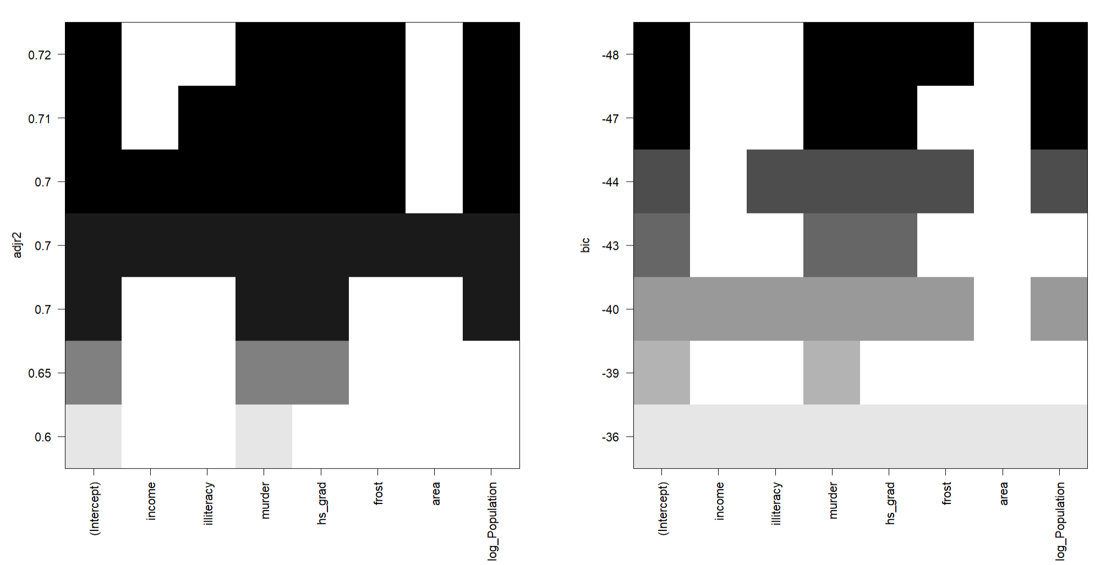

I used adjusted R2 and bic as the criterion, the selected model is the same,

̂

Life Exp = 68.7 − 0.29 ⋅ Murder + 0.05 ⋅ HS Grad + 0.25 ⋅ log (Population) − 0.005 ⋅ Frost

submodel_summary <- summary(all_submodel)  
  
print(submodel_summary$which)

## (Intercept) income illiteracy murder hs_grad frost area log_Population  
## 1 TRUE FALSE FALSE TRUE FALSE FALSE FALSE FALSE  
## 2 TRUE FALSE FALSE TRUE TRUE FALSE FALSE FALSE  
## 3 TRUE FALSE FALSE TRUE TRUE FALSE FALSE TRUE  
## 4 TRUE FALSE FALSE TRUE TRUE TRUE FALSE TRUE  
## 5 TRUE FALSE TRUE TRUE TRUE TRUE FALSE TRUE  
## 6 TRUE TRUE TRUE TRUE TRUE TRUE FALSE TRUE  
## 7 TRUE TRUE TRUE TRUE TRUE TRUE TRUE TRUE

sum1 = summary(all_submodel)  
par(mfrow=c(1,2))  
plot(1:7, sum1$cp, xlab = "No of parameters", ylab = "Cp Statistic")  
abline(0,1)  
plot(1:7, sum1$adjr2, xlab = "No of parameters", ylab = "Adj R2")

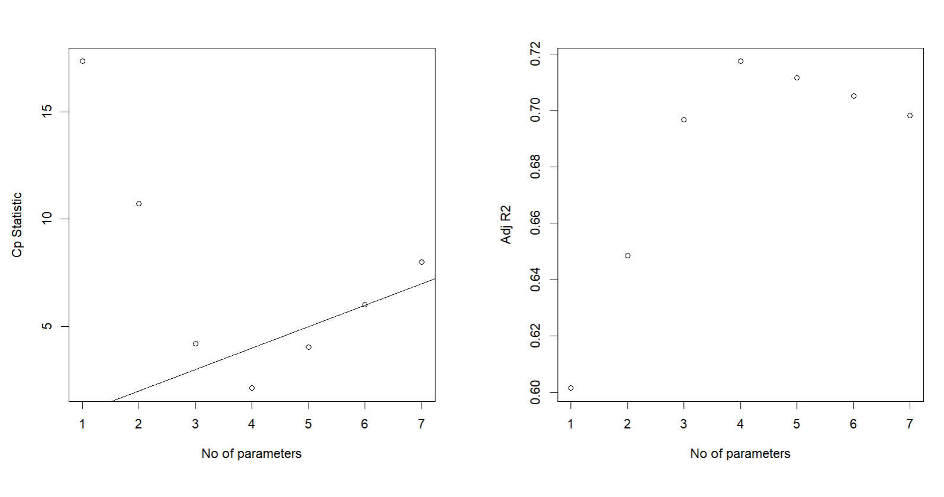

Then I compared Cp and adjusted R2 as the criterion, the selected model is not the same.   
  
**Mallows' Cp** is a measure of the goodness-of-fit of a model relative to its complexity. Ideally, the Cp statistic for a model should be close to the number of parameters (p) included in the model, as shown by the diagonal line in the plot. The model with 6 parameters had the Cp statistic well below or close to the diagonal line, indicating good fit relative to complexity.  
  
Adjusted R2 increases as the number of parameters increases, peaking at **4 parameters**. After 4 parameters, there is little to no improvement in Adjusted R2, indicating diminishing returns from adding more variables.

While the 6-parameter model slightly improves goodness-of-fit (as indicated by Mallows' Cp), the 4-parameter model strikes a better balance between performance, simplicity, and avoiding overfitting. This makes the 4-parameter model the final choice for your analysis.

̂

Life Exp = 68.7 − 0.29 ⋅ Murder + 0.05 ⋅ HS Grad + 0.25 ⋅ log (Population) − 0.005 ⋅ Frost

**e) Use the LASSO method to perform variable selection. Make sure you choose the “best lambda” to use and show how you determined this.**

library(glmnet)

# Convert predictors to a matrix (exclude the intercept)  
X <- model.matrix(life_exp ~ ., data = data.state)[, -1]  
  
# Response variable  
y <- data.state$life_exp  
  
# Fit LASSO model with cross-validation  
set.seed(123) # Set seed for reproducibility  
lasso_cv <- cv.glmnet(X, y, alpha = 1, nfolds = 10) # alpha = 1 for LASSO  
  
# Plot cross-validation results  
plot(lasso_cv)

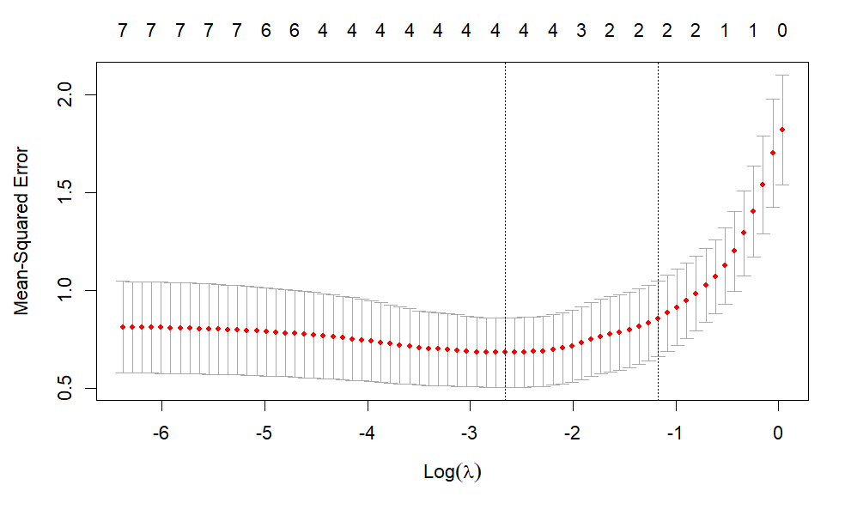

The x-axis represents log(𝜆), where 𝜆 is the regularization penalty parameter.  
The y-axis represents the mean-squared error (MSE) calculated during cross-validation.  
The red points correspond to the mean MSE for each 𝜆, and the vertical bars represent the standard error of the estimates.

# Best lambda based on minimum cross-validation error  
best_lambda <- lasso_cv$lambda.min  
  
# Lambda within 1 standard error of the minimum error  
lambda_1se <- lasso_cv$lambda.1se  
  
cat("Best lambda (minimum error):", best_lambda, "\n")

**## Best lambda (minimum error): 0.06987808**

cat("Best lambda (1-SE rule):", lambda_1se, "\n")

**## Best lambda (1-SE rule): 0.3096033**

# Fit the final LASSO model  
final_lasso <- glmnet(X, y, alpha = 1, lambda = best_lambda)  
  
# Extract coefficients as a matrix  
lasso_coefficients <- as.matrix(coef(final_lasso))  
  
# Get the row names of variables with non-zero coefficients  
selected_variables <- rownames(lasso_coefficients)[lasso_coefficients[, 1] != 0]  
  
# Print the selected variables  
print(selected_variables)

## [1] "(Intercept)" "murder" "hs_grad" "frost"   
## [5] "log_Population"

plot(lasso_cv$glmnet.fit, xvar = "lambda", label = TRUE)

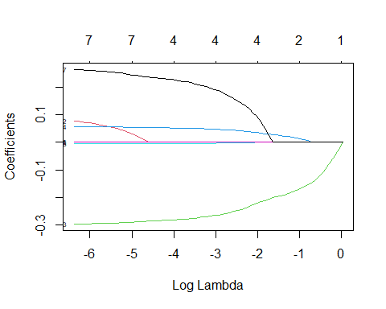

If the goal is to build a simpler model with fewer variables that still performs well,   
use 1se=0.3096033 with 2 parameters.  
If the primary focus is on minimizing prediction error and including all relevant variables, use min=0.06987808 with four parameters.  
I would choose **Best lambda (minimum error): 0.06987808**  with four parameters.

**f) Compare the ‘subsets’ from parts c, d, and e and recommend a ‘final’ model. Using this ‘final’ model do the following:**

• **Check the model assumptions.**

Since the stepwise, forward and backward selection techniques, the criterion techniques(except cp which indicate 6 parameters) and LASSO all chose the same model with 4 predictors, we recommend this as our final model.

̂

Life Exp = 68.7 − 0.29 ⋅ Murder + 0.05 ⋅ HS Grad + 0.25 ⋅ log (Population) − 0.005 ⋅ Frost

# Define the formula  
selected_formula <- life_exp ~ murder + hs_grad + frost + log_Population  
  
# Fit the regression model with selected variables  
selected_model <- lm(selected_formula, data = data.state)  
  
# Display the summary of the regression  
summary(selected_model)

##   
## Call:  
## lm(formula = selected_formula, data = data.state)  
##   
## Residuals:  
## Min 1Q Median 3Q Max   
## -1.41760 -0.43880 0.02539 0.52066 1.63048   
##   
## Coefficients:  
## Estimate Std. Error t value Pr(>|t|)   
## (Intercept) 68.720810 1.416828 48.503 < 2e-16 ***  
## murder -0.290016 0.035440 -8.183 1.87e-10 ***  
## hs_grad 0.054550 0.014758 3.696 0.000591 ***  
## frost -0.005174 0.002482 -2.085 0.042779 *   
## log_Population 0.246836 0.112539 2.193 0.033491 *   
## ---  
## Signif. codes: 0 '***' 0.001 '**' 0.01 '*' 0.05 '.' 0.1 ' ' 1  
##   
## Residual standard error: 0.7137 on 45 degrees of freedom  
## Multiple R-squared: 0.7404, Adjusted R-squared: 0.7173   
## F-statistic: 32.09 on 4 and 45 DF, p-value: 1.17e-12

par(mfrow = c(2,2))  
plot(selected_model)

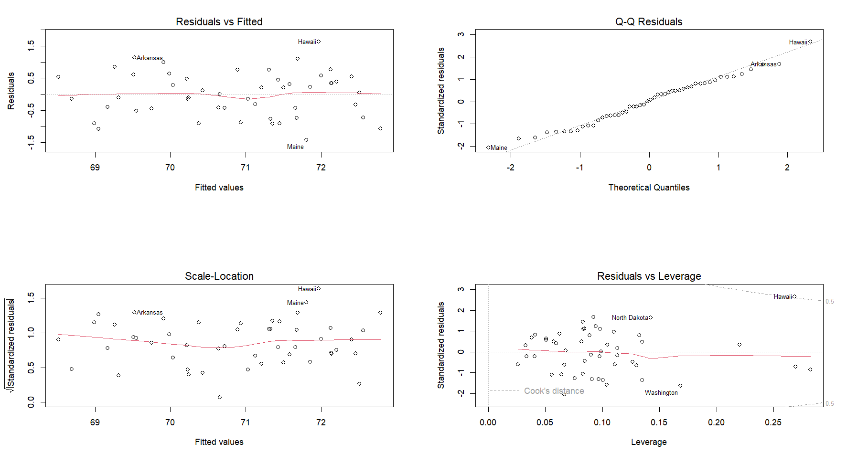

The diagnostic plots indicate that the model assumptions are partially satisfied but show some issues that need attention. The Residuals vs. Fitted plot suggests slight non-linearity, with outliers like Hawaii and Arkansas influencing the results. The Q-Q plot reveals deviations from normality, particularly at the tails, due to extreme residuals for these observations. The Scale-Location plot shows that homoscedasticity is largely satisfied, but again, outliers like Arkansas and Hawaii may be distorting the variance. The Residuals vs. Leverage plot identifies Hawaii as a highly influential observation with high leverage and a large residual, while North Dakota and Washington also display some influence. Overall, the model assumptions are reasonable but not perfect, and influential outliers should be further investigated. Potential solutions include applying robust regression methods, transforming variables to improve linearity and normality, or carefully addressing influential points to ensure model validity.

• **Test the model predictive ability using a 10-fold cross-validation (10 repeats).**

set.seed(111)  
  
train = trainControl(method = "cv", number = 10)  
  
model_10fold = train(selected_formula,  
data = data.state,  
trControl = train,  
method = 'lm',  
na.action = na.pass)  
  
model_10fold

## Linear Regression   
##   
## 50 samples  
## 4 predictor  
##   
## No pre-processing  
## Resampling: Cross-Validated (10 fold)   
## Summary of sample sizes: 44, 45, 45, 46, 44, 45, ...   
## Resampling results:  
##   
## RMSE Rsquared MAE   
## 0.7514293 0.7768153 0.6340191  
##   
## Tuning parameter 'intercept' was held constant at a value of TRUE

model_10fold$resample

## RMSE Rsquared MAE Resample  
## 1 0.7260482 0.5544736 0.5823172 Fold01  
## 2 0.6477251 0.8407706 0.6219278 Fold02  
## 3 0.6144612 0.8668420 0.5363928 Fold03  
## 4 0.6187864 0.8727852 0.5046897 Fold04  
## 5 0.7397143 0.8005523 0.6327371 Fold05  
## 6 0.7129359 0.9011760 0.6074712 Fold06  
## 7 0.8472056 0.6158807 0.6999753 Fold07  
## 8 0.4983759 0.8025908 0.4776243 Fold08  
## 9 0.9325622 0.6421142 0.8548502 Fold09  
## 10 1.1764783 0.8709673 0.8222052 Fold10

The results indicate an overall Root Mean Square Error (RMSE) of 0.7514, an R-squared value of 0.7768, and a Mean Absolute Error (MAE) of 0.6340, suggesting that the model explains approximately 77.7% of the variance in the data. The individual fold results show variability in performance, with RMSE ranging from 0.498 to 1.176 and R-squared ranging from 0.554 to 0.901, indicating that the model performs well overall but may be sensitive to certain subsets of the data. The relatively low RMSE and high R-squared values suggest the model has good predictive ability, though further refinement or investigation of influential points may improve consistency across folds.  
  
**G) In a paragraph, summarize your findings to address the primary question posed by the investigator (that has limited statistical knowledge).**The goal of this analysis was to identify key factors that influence life expectancy using census data. After applying rigorous statistical methods, including LASSO regression, subset selection, and cross-validation, the findings suggest that murder rate, high school graduation rate, frost days, and population (log-transformed) are significant predictors of life expectancy. These variables were consistently selected across different methods, highlighting their importance in explaining variations in life expectancy across states. The final model demonstrates good predictive performance, explaining approximately 77.7% of the variability in life expectancy, with a Root Mean Square Error (RMSE) of 0.751. While the model performs well overall, some influential data points (e.g., Hawaii and Arkansas) were identified, which may impact the results. Addressing these points through further investigation or model refinement could improve accuracy. Overall, the analysis provides a robust and interpretable model that identifies the most important factors influencing life expectancy, offering valuable insights for policymakers and stakeholders.

̂

Life Exp = 68.7 − 0.29 ⋅ Murder + 0.05 ⋅ HS Grad + 0.25 ⋅ log (Population) − 0.005 ⋅ Frost