🛡️ Microsoft Sentinel Step-By-Step

🛡️ Step 1 – Create a Log Analytics Workspace
Before activating Microsoft Sentinel, you need a Log Analytics Workspace.
📌 What is it?
A Log Analytics Workspace is a central repository in Azure where logs and telemetry from endpoints, cloud services, and other connected sources are stored. Microsoft Sentinel uses this workspace to analyze data, generate alerts, and visualize security events.
⚡ Why it’s important:
- It organizes all your security data in one place.
- It allows Sentinel to run queries, create alerts, and build dashboards.
- Every integration and detection rule will depend on this workspace.
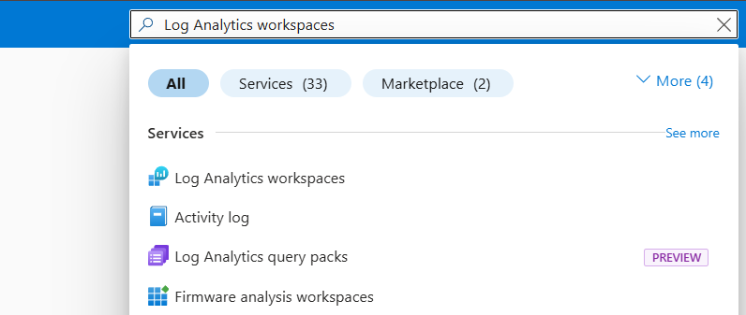
🖥️ Steps to create the workspace:
- Sign in to the Azure Portal.
- Navigate to Log Analytics Workspaces.
- Click + Create.
- Enter a descriptive workspace name, e.g., SOC-Lab-Workspace.
- Create or Select a Resource Group.
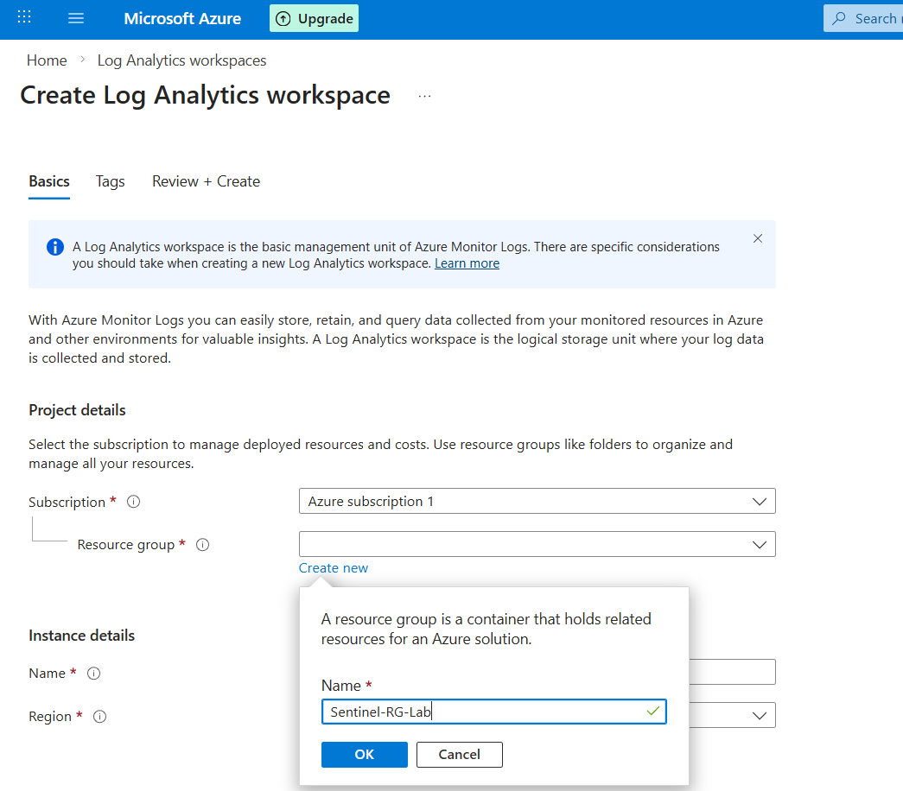

6.Review and Create.
✅ Now that the Log Analytics Workspace has been successfully created, it is ready to be used for Microsoft Sentinel onboarding and integration.
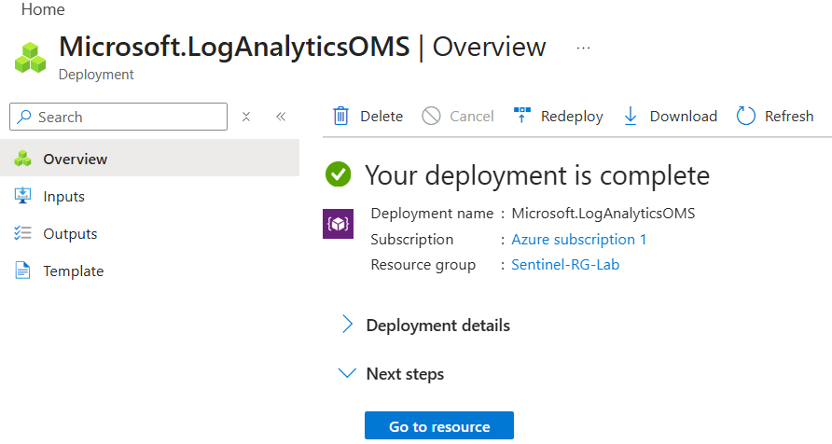

🚀 Step 2 – Enable Microsoft Sentinel
Once the Log Analytics Workspace is ready, you can activate Microsoft Sentinel. Sentinel will start collecting and analyzing security data from your workspace and connected sources.

🖥️ Steps to Enable Sentinel:
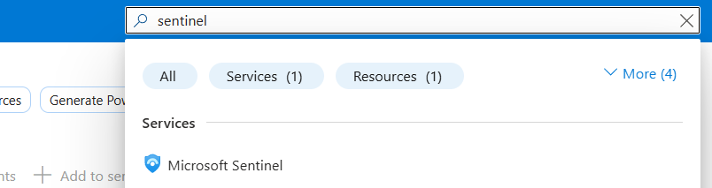
- Navigate to Microsoft Sentinel in the search bar.

- Click + Add to create a new Sentinel instance.
- Select the Log Analytics Workspace you created in Step 1
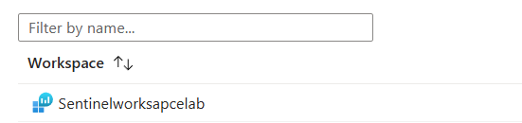
- Click Add to enable Microsoft Sentinel on this workspace.

⚡ What Happens Next:
- Sentinel will begin monitoring and preparing your workspace for data ingestion.
- You can now connect Microsoft Defender for Endpoint, Azure Activity Logs, and other data sources.
- After integration, you can create custom detection rules, alerts, and dashboards.
💡 Tip:
Wait a few minutes for Sentinel to fully activate before connecting data sources or creating rules. Check the workspace status in the portal to ensure it is “Active”.
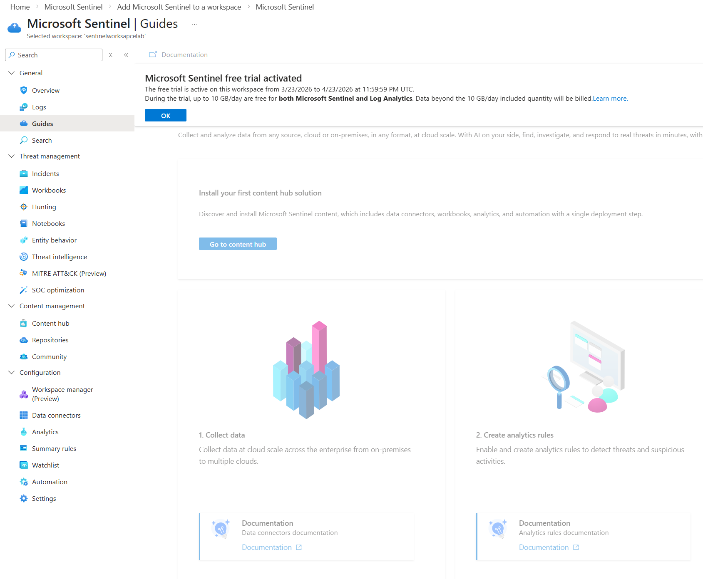

🔌 Step 3 – Connect Data Sources (Data Connectors)
Data Connectors are the bridges between Microsoft Sentinel and your data sources. They allow Sentinel to ingest logs and telemetry from multiple services, including Microsoft Defender for Endpoint, Azure services, and custom sources like Sysmon.
By connecting the right data sources, you can create rich, correlated alerts and build actionable dashboards.

🔄 Default Data Connectors in Sentinel
By default, Microsoft Defender for Endpoint, Office 365, Cloud Apps, Identity, and other Microsoft security services are already connected and actively sending data to Microsoft Sentinel once you onboard them.
-You can enhance the data collection by adding more connectors or custom logs (e.g., Sysmon via AMA).
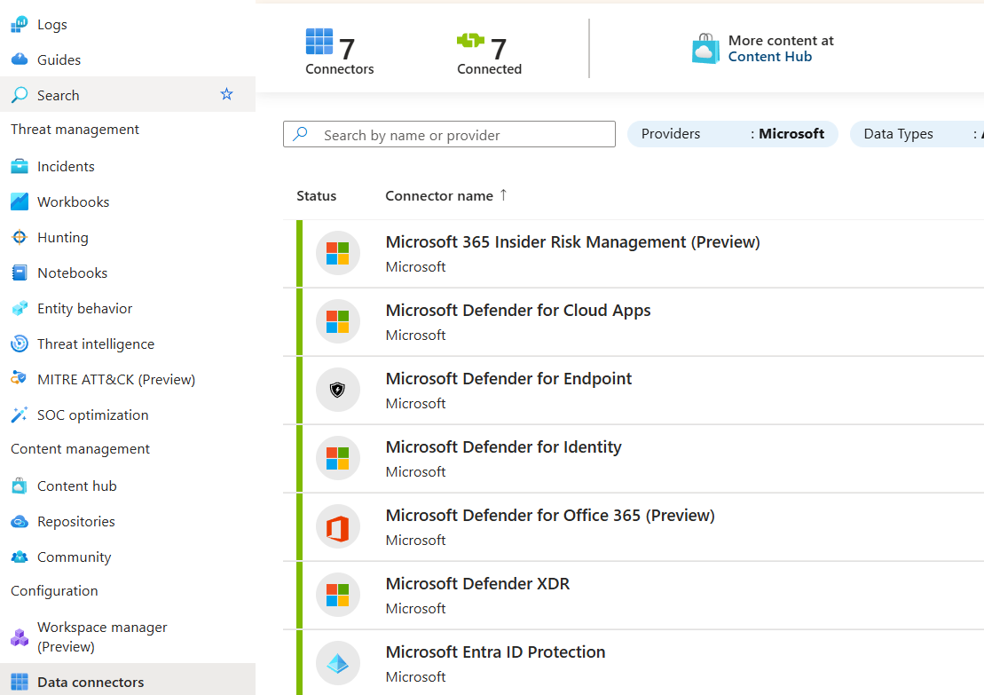

📚 More Data Connectors in the Content Hub
In the Content Hub of Microsoft Sentinel, you can find additional Data Connectors beyond the default ones. This allows you to expand your telemetry sources and gain more visibility across your environment.

🖥️ Example: Azure Activity Connector
- Purpose: Collects Azure subscription-level activity logs, including:
  - User sign-ins and administrative actions
  - Resource creation, modification, and deletion
  - Role assignments and policy changes
- Benefit: Enables Sentinel to detect suspicious or unauthorized activities in your Azure environment, such as unusual logins or configuration changes.
Tip:
Explore the Content Hub periodically—Microsoft frequently adds new connectors for services like Microsoft 365 Defender, Office 365, Teams, and third-party solutions. Connecting these sources enhances your lab environment and enables more advanced alerting and analysis.
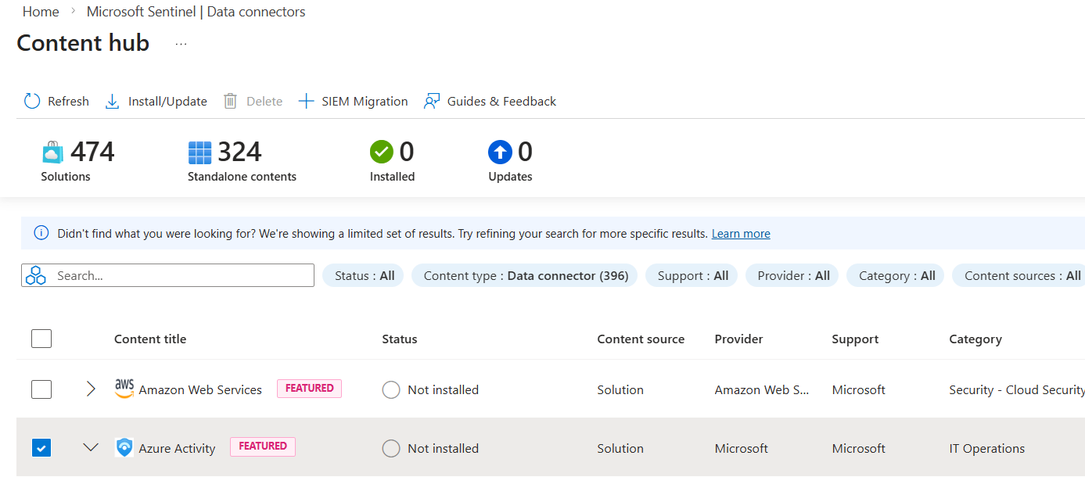
Many Data Connectors in Microsoft Sentinel come with pre-built templates for detection rules and dashboards.

🔹 Sysmon Logs Collection via AMA
Remember, before starting the lab, I have installed Sysmon on my Windows 11 VM. To retrieve these Sysmon logs in Microsoft Sentinel, I need to use a Data Connector that collects Windows Event Logs via the Azure Monitor Agent (AMA).
- AMA (Azure Monitor Agent) is the modern agent used to collect telemetry and logs from Windows and Linux machines and send them to a Log Analytics Workspace.
- Using AMA, the Sysmon logs from the VM will be ingested into Sentinel, allowing me to analyze detailed endpoint activity, create alerts, and correlate events with other data sources.
🔧 Using Windows Security Events via AMA Data Connectors
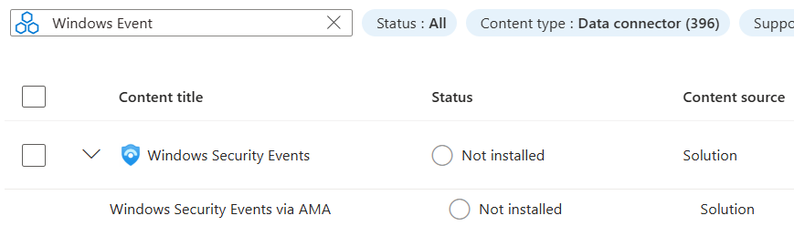
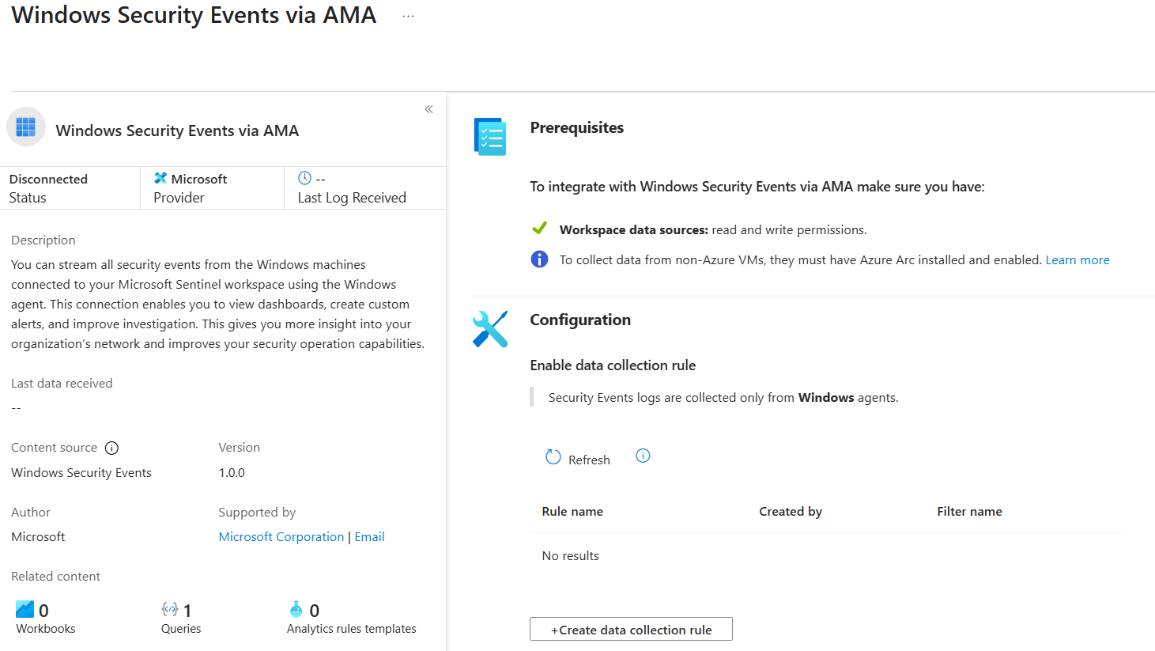

⚠️ Note – Data Connectors and Prerequisites
Each Data Connector in Microsoft Sentinel has prerequisites to function properly.
- In my lab, this includes:
  - Workspace integration – ensuring the Log Analytics Workspace has the proper permissions to receive data.
  - Azure Arc integration – enabling agents to communicate with the workspace and send logs correctly.

🥂 How Microsoft SIEM Solutions Work – Analogy
To better understand how Microsoft SIEM works, you can imagine it like serving a drink:
- Workspace → The waiter who serves the drink.
- Data Collection Rule (DCR) → The glass that defines what type of drink the customer will receive.
- Data Collection Endpoint (DCE) → The bottle containing the water or beverage.
- Data Connectors → The filter that ensures the drink is served correctly.
- Sentinel → The customer who enjoys the drink.
Whether the customer receives hot or cold water depends on what the waiter has in the bottle.
- If the workspace (waiter) and DCE (bottle) are correctly configured, the Sentinel (customer) will get the data exactly as needed.
- If either is misconfigured, the data may be incomplete, delayed, or unavailable.

🌐 Using Azure Arc to Install AMA on the VM
Now, we will use Azure Arc to install the Azure Monitor Agent (AMA) on the Windows 11 VM.

🔹 What is Azure Arc?
- Azure Arc is a Microsoft solution that allows you to manage and connect servers, VMs, and Kubernetes clusters outside of Azure (on-premises or other clouds) as if they were in Azure.
- It enables centralized management, policy enforcement, and agent deployment from the Azure Portal.

⚡ How it works in the lab:
- By connecting the VM to Azure Arc, we can deploy the AMA agent remotely via the Azure Portal.
- Once AMA is installed, it will send Sysmon custom logs (and other selected logs) to the Log Analytics Workspace.
- This simplifies the setup process and avoids manual agent installation.

Go to Azure Arc via Azure:
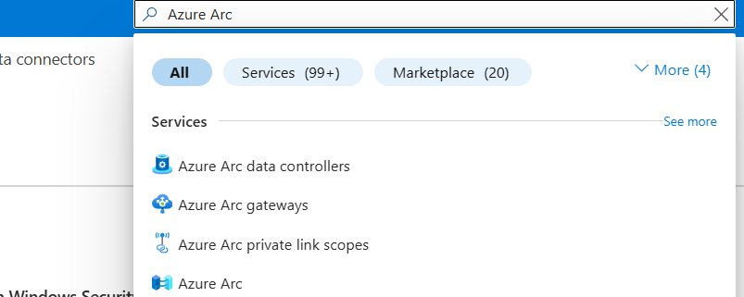
We need onboarding the VM.
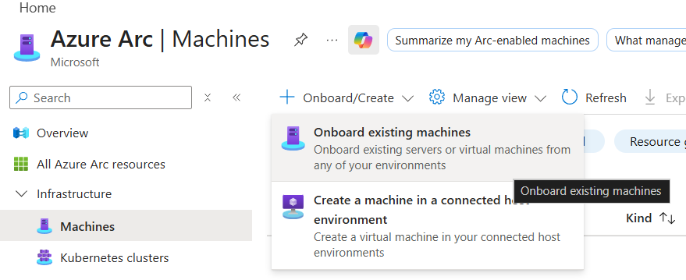
I will create a new Resource Group specifically for my Azure Arc registration. This simulates a real-world environment with better organization and separation from other resources.

🔹 Key Considerations
- Same region as Sentinel workspace – simplifies configuration and ensures low-latency communication.
- Public endpoint connectivity – the VM will communicate with Azure services over the internet.
- Manual machine authentication – the VM will be onboarded using a script, similar to the MDE onboarding process.

⚡ Lab Purpose
- By creating a dedicated RG for Arc, I can simulate a real enterprise environment, separating workloads and logs for clarity.
- The onboarding script ensures the VM is connected and authenticated properly, allowing the Azure Monitor Agent (AMA) to send Sysmon logs to the Log Analytics Workspace.
💡 Tip: Keep the same region for the Arc RG and Sentinel workspace to reduce latency
My Settings for my Onboarding machines with Azure Arc
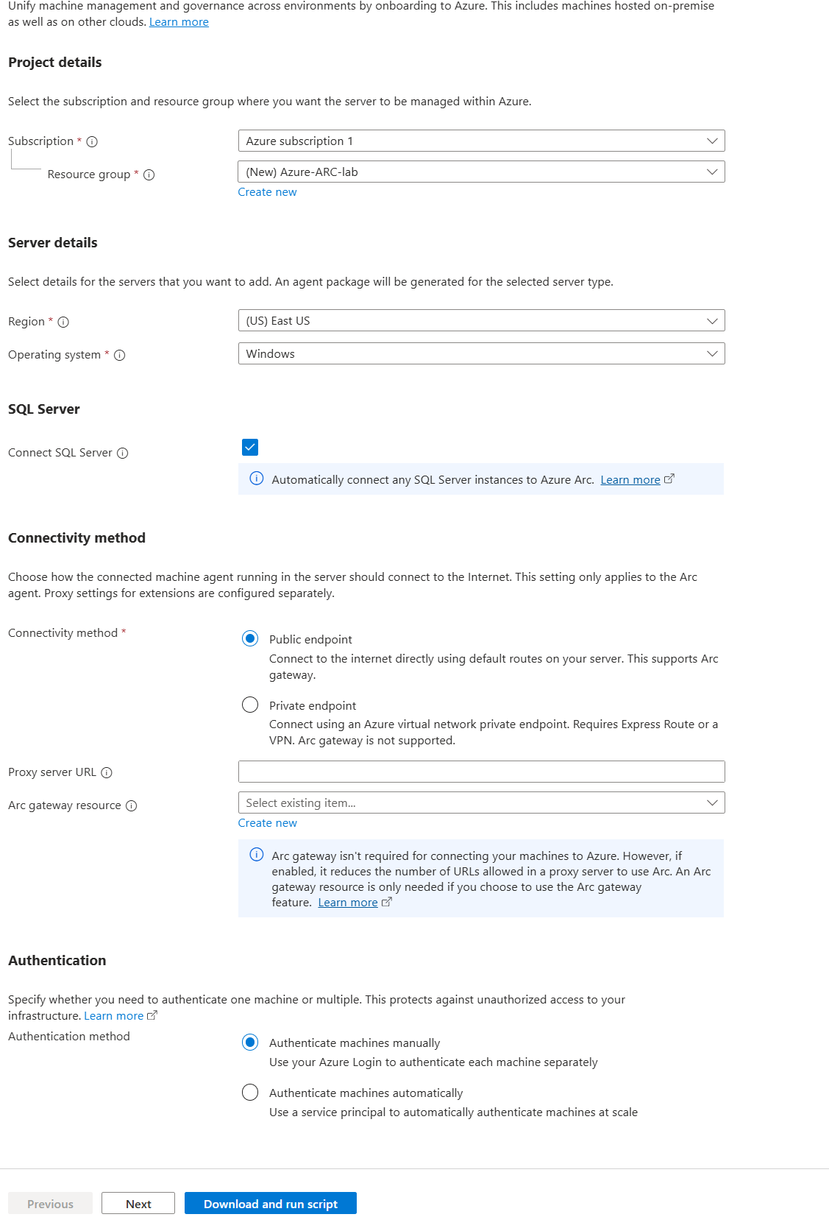

🛠️ Step – Run the Onboarding Script
1️⃣ Download or copy the script 💾
- For this lab, I will download the script provided for Azure Arc or AMA onboarding.
2️⃣ Run the script via PowerShell as Administrator 🖥️
- Open PowerShell with elevated privileges (Right-click → “Run as Administrator”).
- Running as admin avoids permission issues during onboarding.
⚠️ Important Note:
- Windows may block the script due to execution policy restrictions.
- Ensure you set the PowerShell Execution Policy to allow scripts:
Set-ExecutionPolicy RemoteSigned -Scope CurrentUser
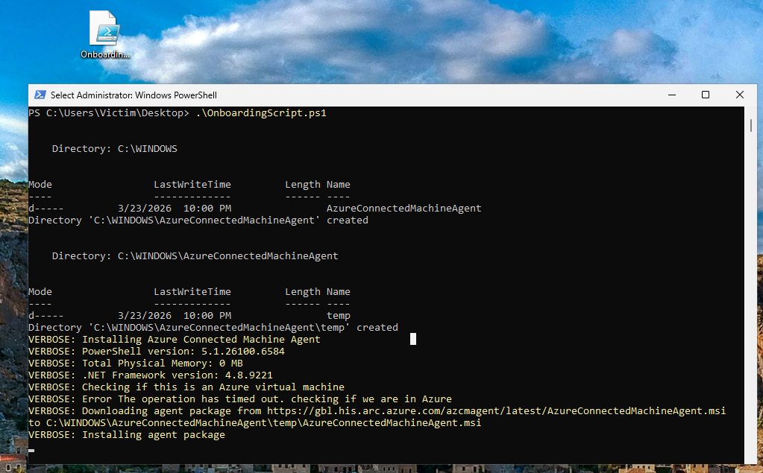
3️⃣ Finish the installation by logging in with a privileged account to authentication the instalation🔑
- To avoid RBAC-related issues, log in with an account that has full permissions (Global Administrator or equivalent role).
- This ensures the onboarding script completes successfully and that AMA can register the VM, collect logs, and send them to the Log Analytics Workspace.
⚠️ Important Notes:
- Using a limited account may cause permission errors during the onboarding process.
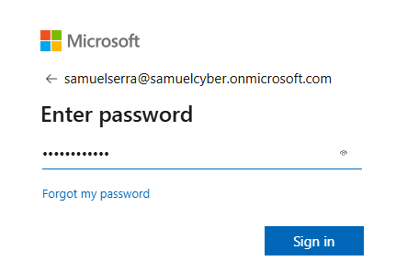

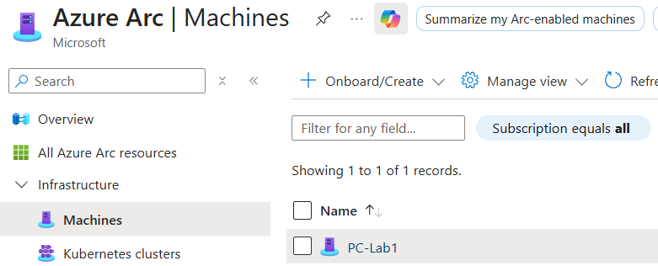
After that you can close the tab and check in Azure Arc the Machine

🛠️ Install AMA via VM Extensions
1️. Select the machine → Settings → Extensions ⚙️
2️. In the Extensions tab, you can:
- Download and install AMA for the VM.
- Enable other functions if needed.
💡 Tip:
- Make sure the extension shows “Provisioning succeeded” before moving on.
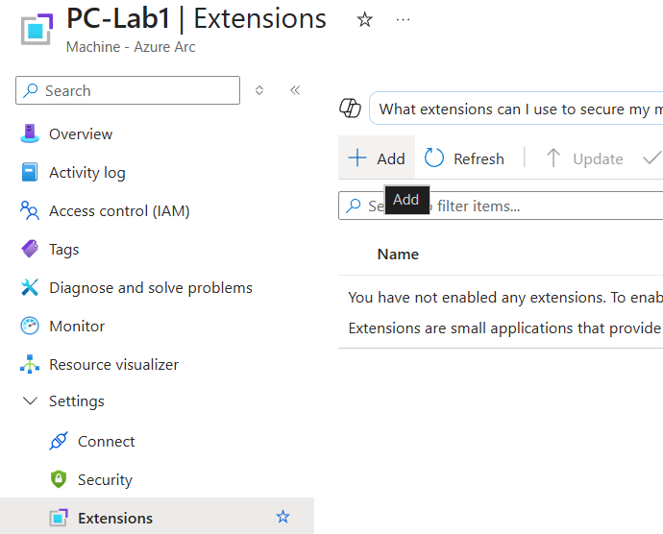

Select AMA (Azure Monitor Agent for Windows):
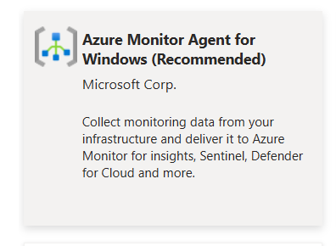



Then install – it’s quick and simple.
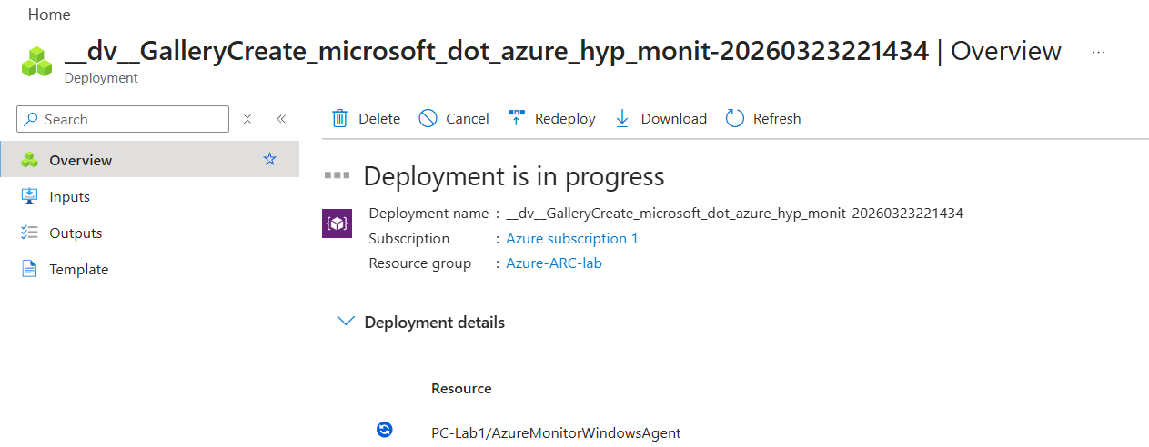

Confirm that AMA is installed and the status shows ‘Succeeded’.

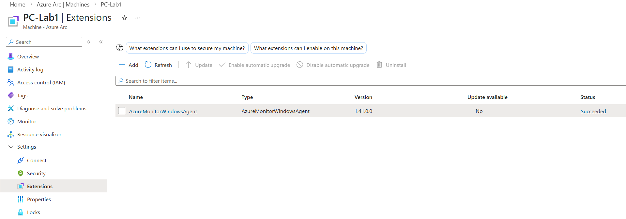
OK, now I have Azure Arc and AMA enabled on my VM.

---

⚙️ Configure DCE and DCR
Now it’s time to configure DCE and DCR to ingest logs from my VM into Microsoft Sentinel.
I will start by configuring the Data Collection Endpoint (DCE) in the Azure Monitor section.

🔹 What is Azure Monitor?
Azure Monitor is the service responsible for collecting, processing, and storing telemetry data from Azure resources and connected machines. It works as the central component that manages log ingestion, metrics, and monitoring configurations, including DCR and DCE.

🔹 What are DCE and DCR?

📡 Data Collection Endpoint (DCE)
The Data Collection Endpoint (DCE) defines where the data is sent.
- It acts as the ingestion endpoint used by the Azure Monitor Agent (AMA).
- It ensures logs are securely transmitted to the Log Analytics Workspace.
👉 Simple: DCE = destination of the data

📋 Data Collection Rule (DCR)
The Data Collection Rule (DCR) defines what data is collected and how it is processed.
- Specifies which logs to collect (e.g., Sysmon, Windows Security Events).
- Defines which machines (VMs) will send the data.
- Links to the DCE and workspace.
👉 Simple: DCR = what data to collect
--
On Azure Select “Monitor”
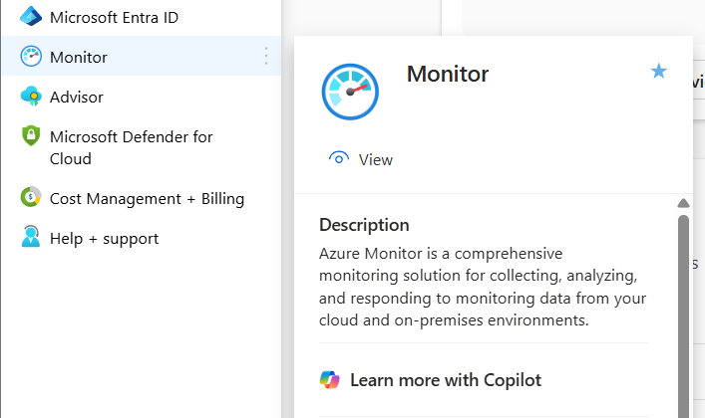

Go to Settings > Data Collection Endpoints

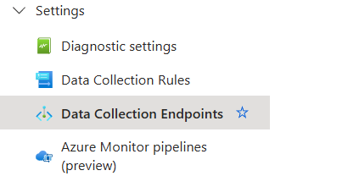

Click “Create”
For this lab, I will create a dedicated resource group to simulate a real environment and improve control and resource management.
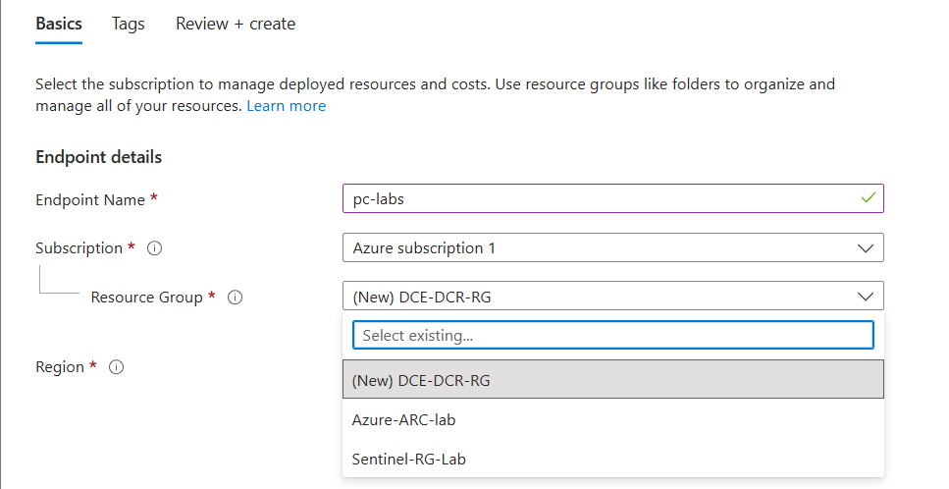
DCE created. Now I will create a DCR:
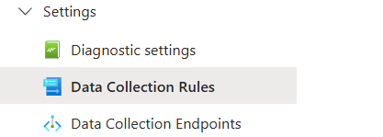

Click Create:

📋 Create a Data Collection Rule (DCR)
1️. Rule Name ✏️
- Give your DCR a descriptive name (e.g., dcr-sysmon-lab).
2️. Resource Group 🗂️
- Select the same RG you used for the DCE to keep things organized.
3️. Platform Type 💻
- Choose the target platform (e.g., Windows).
4️. Link DCE 🔗
- Connect this DCR to the DCE you created earlier.
- This ensures the logs collected from the VM are sent to the correct endpoint.
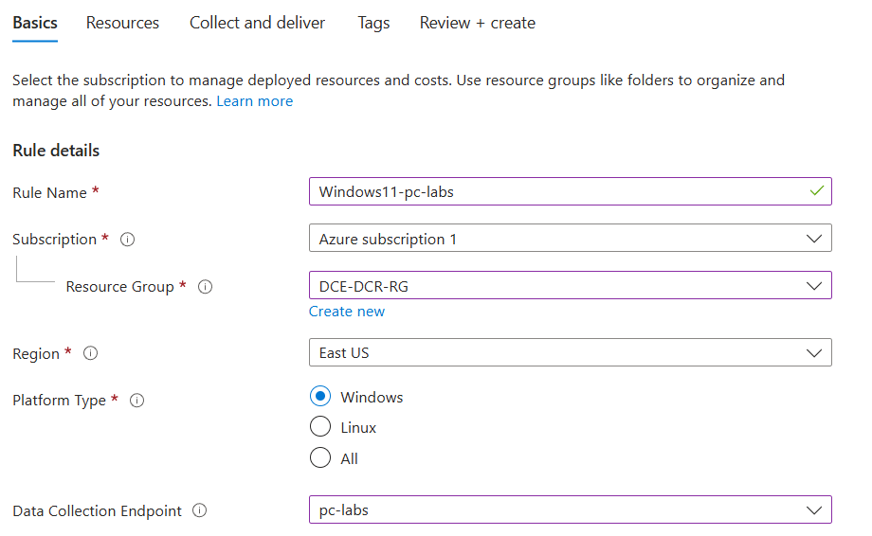

Next

🖥️ Resources Section in DCR
In the Resources section, you need to add your resource—in my case, my VM to collect data.
1️. Click on “Add resources” ➕
2️. Select the VM or other resources you want to collect data from.
💡 Tip:
- Only the selected resources will send logs to the DCE.
- If you have multiple VMs, you can select all the ones you want to monitor in this step.
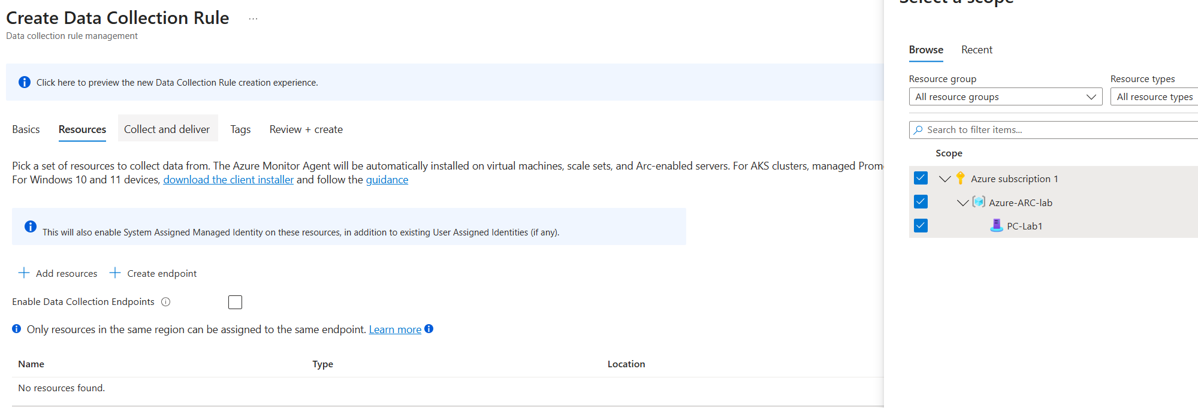

📦 Collect and Deliver Section
Next is the Collect and Deliver section. This is where you select the types of data sources you want to collect.
1️. Choose the log types (e.g., Sysmon, Windows Security Events).
2. Select how the data should be delivered to the DCE.
💡 Tip:
- This step defines what logs your VM will send.
- Make sure the selected logs match what you want to analyze in Sentinel.
Click add data source, and my case I will select Windows event Logs:
Remember, I already installed Sysmon on the VM to collect logs. In this section, I will choose Windows Event Logs, select Custom type, and enter the Sysmon path:
Microsoft-Windows-Sysmon/Operational
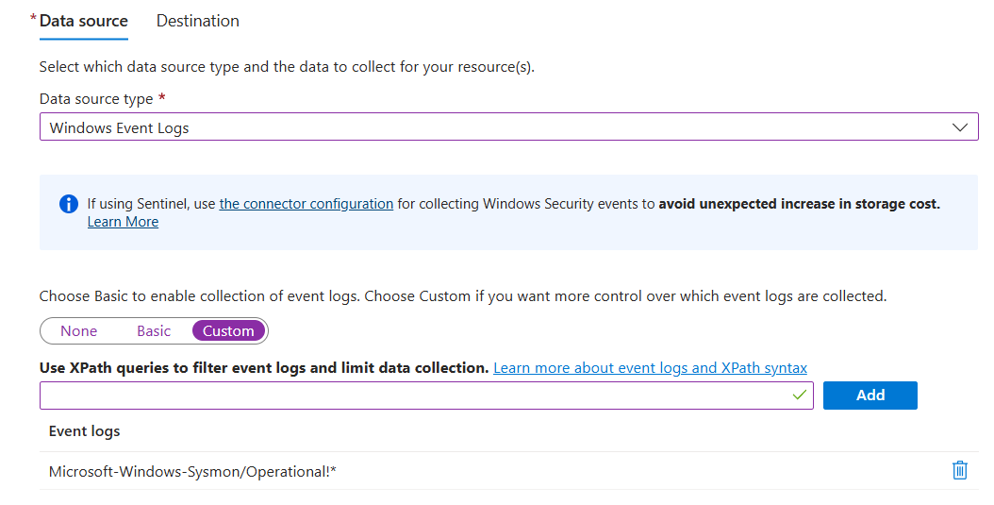
And select the destination. Remember, the destination is your Log Analytics Workspace, because the workspace is where all collected logs are stored, processed, and made available for Microsoft Sentinel to analyze and create alerts.
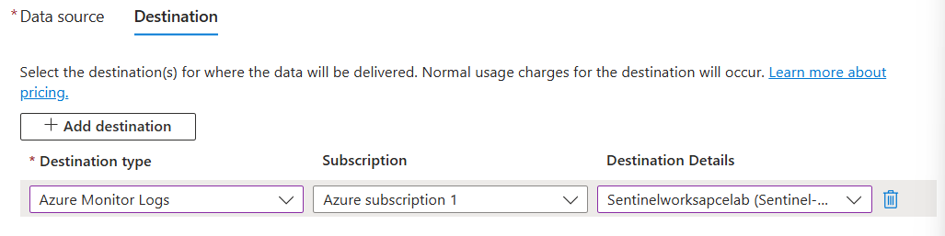
Review and Create.

Troubleshooting:
In some cases, the DCE doesn’t automatically link the VM. You need manual intervention to add the VM here for authorization
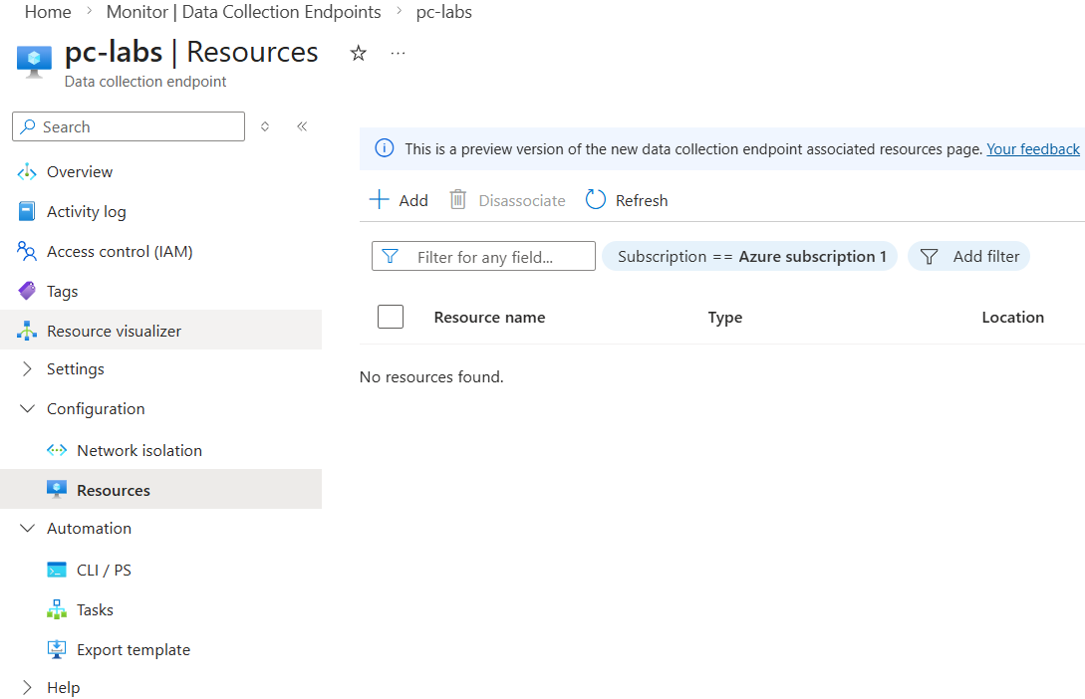

🔹 DCE and DCR – Quick Reminder
- DCE (Data Collection Endpoint) 🏁
  - Destination for logs
  - Defines where the data is sent (Log Analytics Workspace)
  - May require manual VM authorization in some cases
- DCR (Data Collection Rule) 📋
  - Defines what data to collect and from which resources (VMs)
  - Links the VM logs to a DCE for ingestion
💡 Simple analogy:
- VM → DCR → DCE → Workspace → Sentinel
- DCR = what & who
- DCE = where
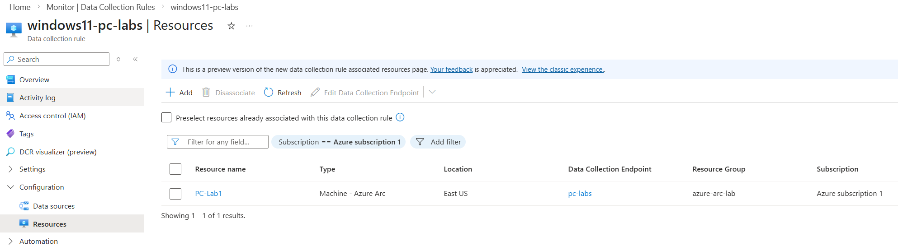
In this DCR section, there is a helpful tool to quickly identify any issues or misconfigurations.

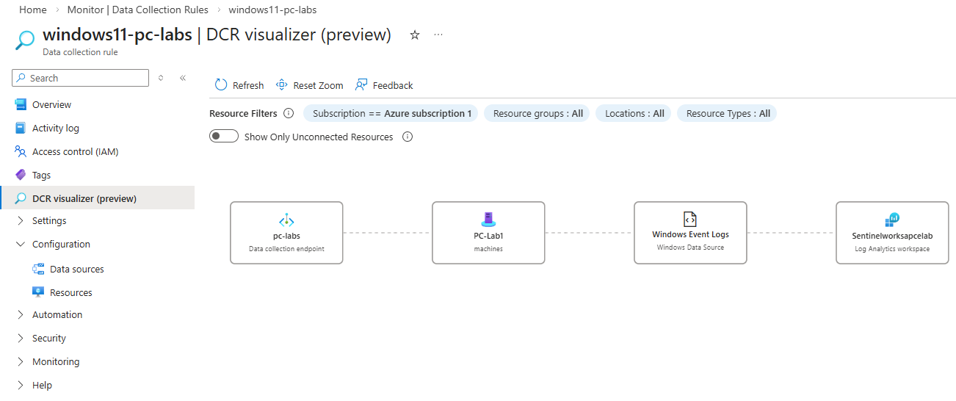

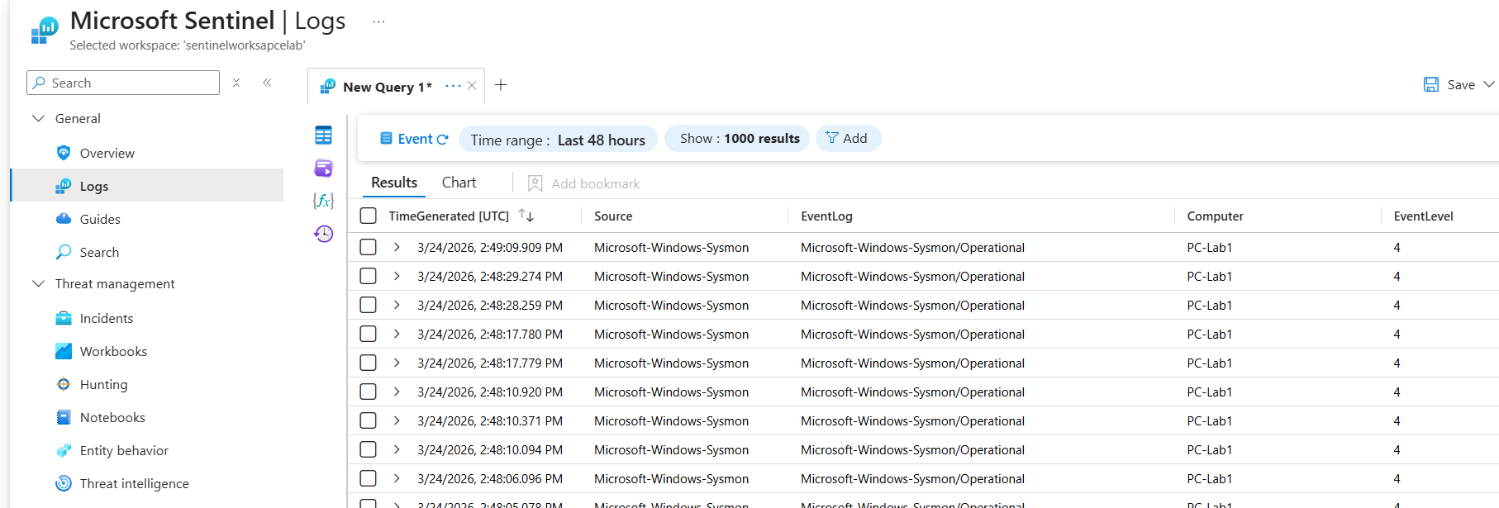
Now that the core environment is configured, feel free to add more logs to enrich your lab:
- Entra ID (Azure AD) Audit Logs 📝
  - Track user activities, sign-ins, and changes
  - Great for testing alerts and monitoring in Sentinel
- Azure Services Logs ☁️
  - Collect logs from Storage, VMs, App Services, etc.
  - Helps you explore more scenarios and test detection rules
💡 Tip:
- Sending additional logs is a great way to practice with Sentinel dashboards, alerts, and queries.
- The more data you have, the better you can simulate real-world detection and analysis.
For my lab, I will manually send audit logs to Sentinel just to have more logs to explore and play with.
