📧 Microsoft 365 E5 Trial & Azure Free Trial
Microsoft 365 E5 Trial

⚠️ Pre-Setup
Before starting, create a dedicated email account for the trials.

🔒 Best Practices
- 🔑 Use a strong password
- 🛡 Enable Multi-Factor Authentication (MFA) to simulate a real-world scenario
- 🖥 Treat the lab environment as production-level for proper security habits

Microsoft 365 E5 Trial:
https://www.microsoft.com/en-us/microsoft-365/enterprise/office-365-e5?activetab=pivot%3Aoverviewtab&market=pt

📝 Microsoft 365 E5 Trial – Step-by-Step

1️⃣ Start Trial
- Go to the Microsoft 365 E5 Trial page
- Click “Try for free”

⚠️ Reminder
- Use a dedicated email account for the trial

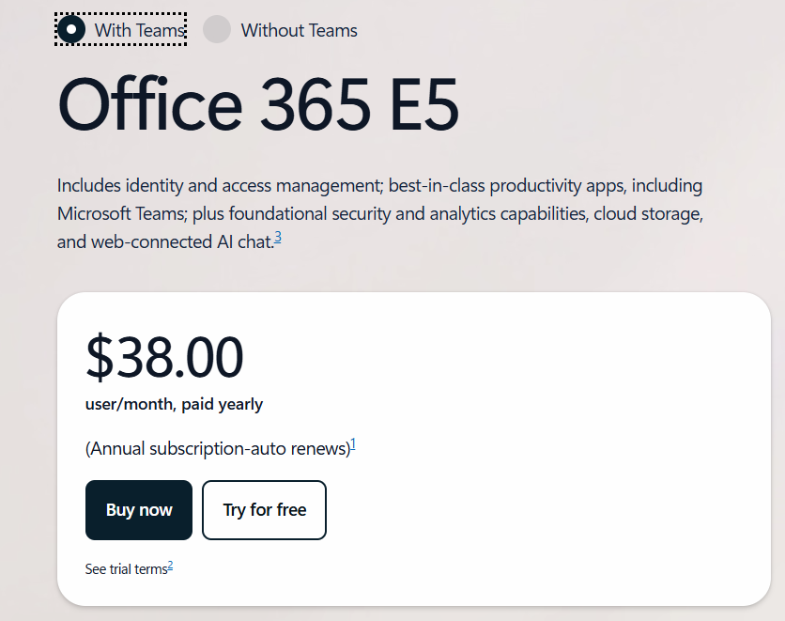

2️⃣ Choose Subscription Plan
- 💳 Select the monthly subscription plan
  - Allows easy cancellation
  - Provides better cost control
- 🖥 Recommended for learning environments and cybersecurity lab practice

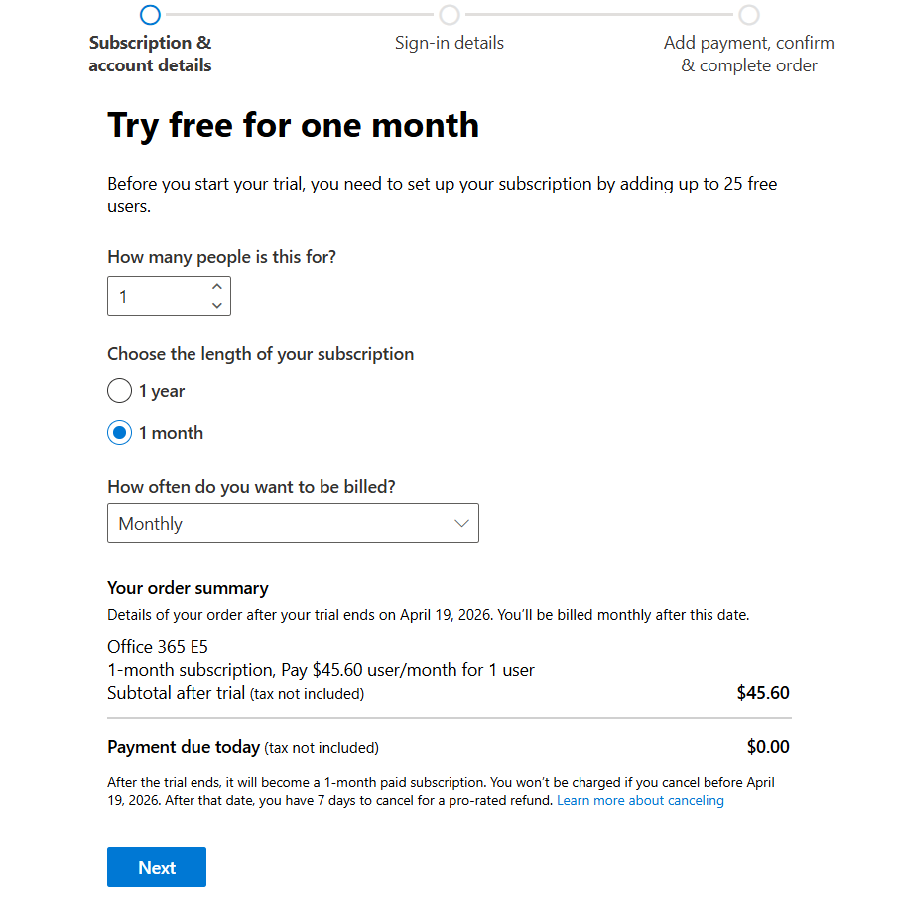
3️⃣ Confirm Email Address
- 📧 Verify your email address to activate the trial
- 🔒 Ensure you have access to the inbox for confirmation links
- 🛡 This step is required to complete the setup and enable all services

4️⃣ Enter Your Information
- 🖊 Fill in your details in the provided fields:
  - Name, phone number, job title, company, and department
- 🏢 You can customize the fields for lab or learning purposes to simulate a professional environment.
Example for a cybersecurity lab:
- 👤 Job Title: Cybersecurity Specialist
- 🏢 Company Name: SamCyber
- 👥 Company Size: 1 person
- 📞 Phone Number: Personal number (used for notifications only)
- 💡 Tip: Using realistic information enhances the lab experience and better simulates a professional scenario
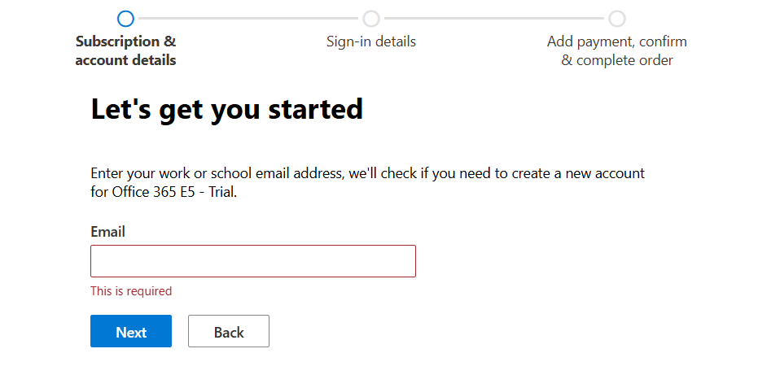

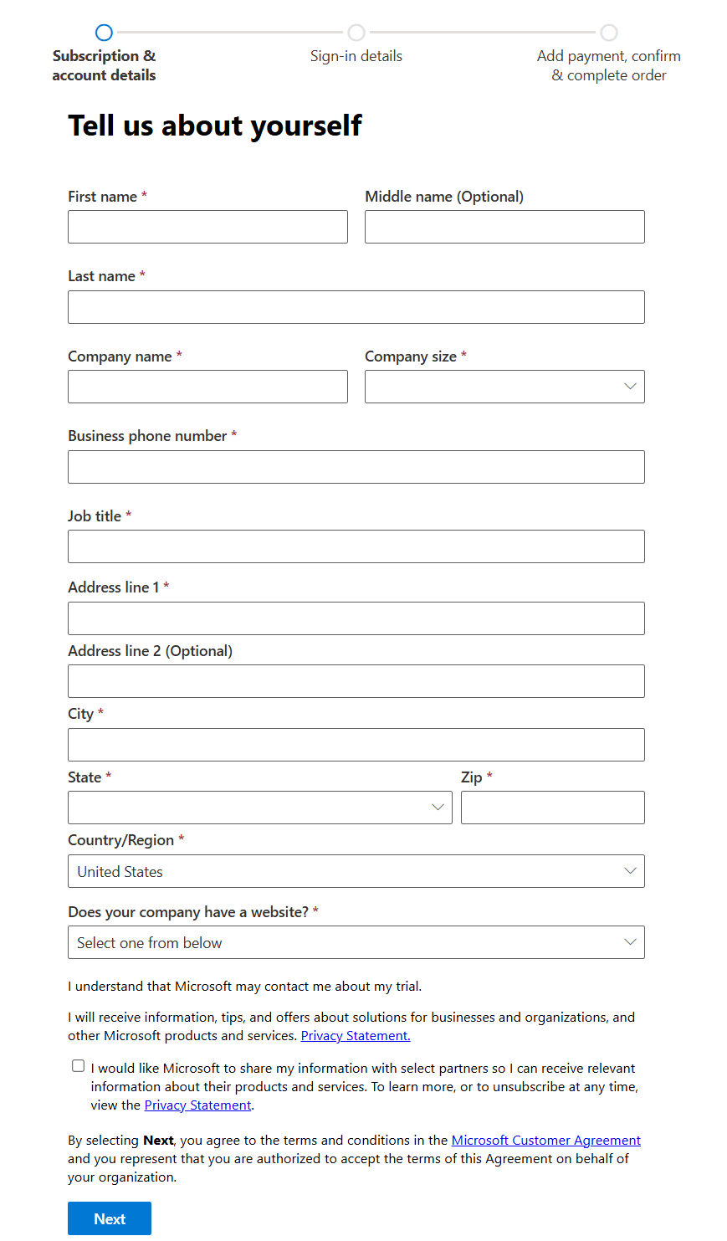

⚠️ Important Note
- 📝 Record all the information you enter:
  - Main user account, domain, password, company name, etc.
- 🔐 Keep it in a safe place
- 🖥 This information will be needed for:
  - Logging in
  - Receiving notifications
  - Performing lab exercises
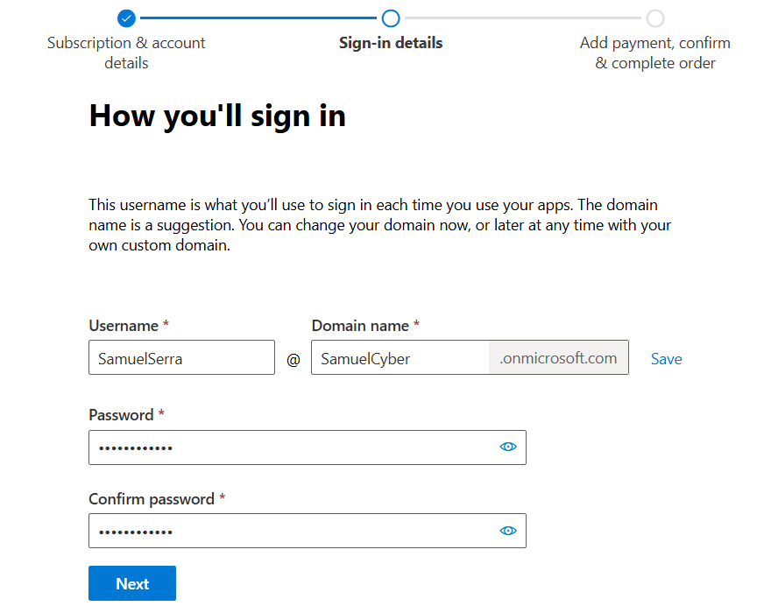

5️⃣ Add Payment Method
- 💳 Provide a valid credit card or virtual bank card to activate the trial subscription
- ✅ Review and confirm all details carefully
- 🛡 Used only for trial verification and subscription management
- ⚠️ No charges if you cancel before the trial ends

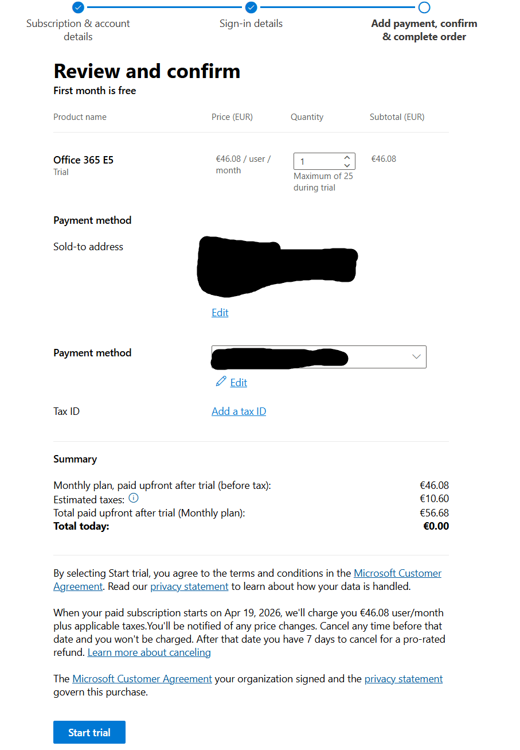

🔒 Enable Multi-Factor Authentication (MFA)
- 🛡 Enable MFA for your account to enhance security
- 📱 Recommended: Google Authenticator for managing one-time codes
- ✅ Provides a simple, secure, and lab-realistic experience
- ⚡ MFA simulates real-world cybersecurity best practices
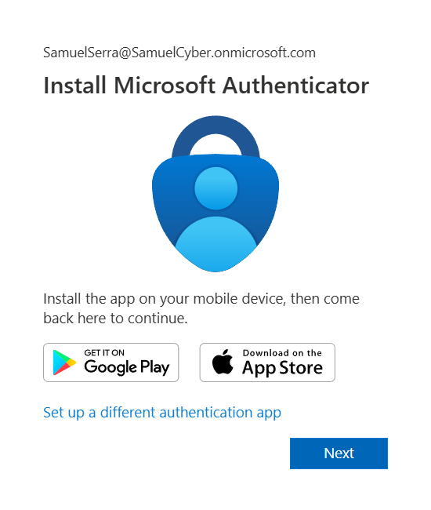

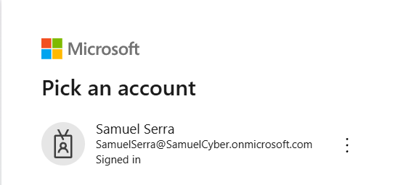

1º>2º

⚡ Access Microsoft 365 Admin Center
- 🖥 Ensure you have access to the Microsoft 365 Admin Center to actively manage and test the lab environment
- 🛒 Navigate to Marketplace → All Products
- 🔍 Search for Microsoft 365 E5
- ✅ Confirm that the trial subscription is correctly activated
- ⚠️ This step ensures all services are available for lab exercises and testing
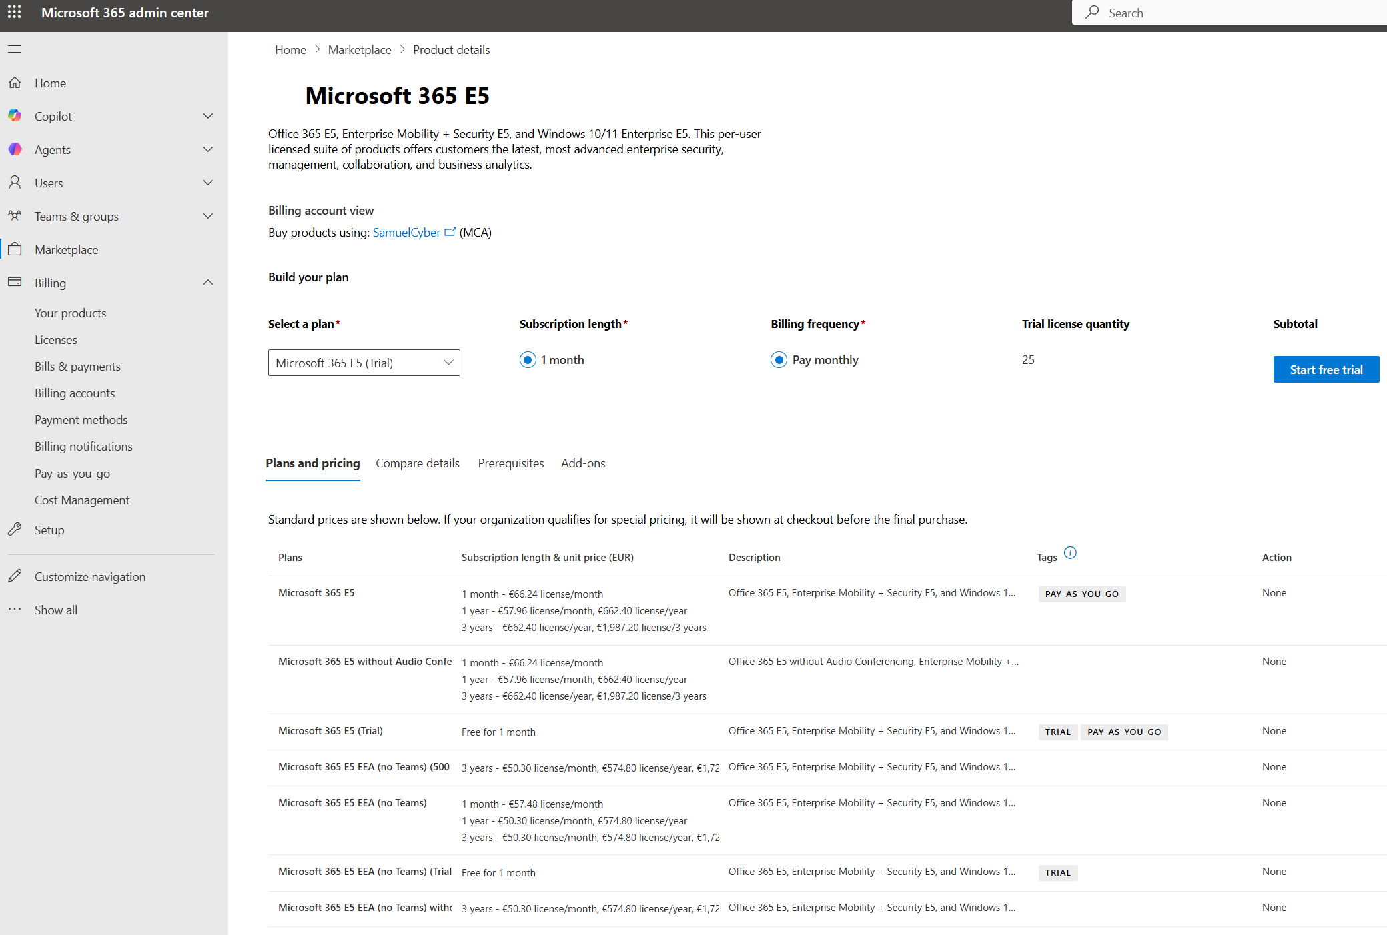
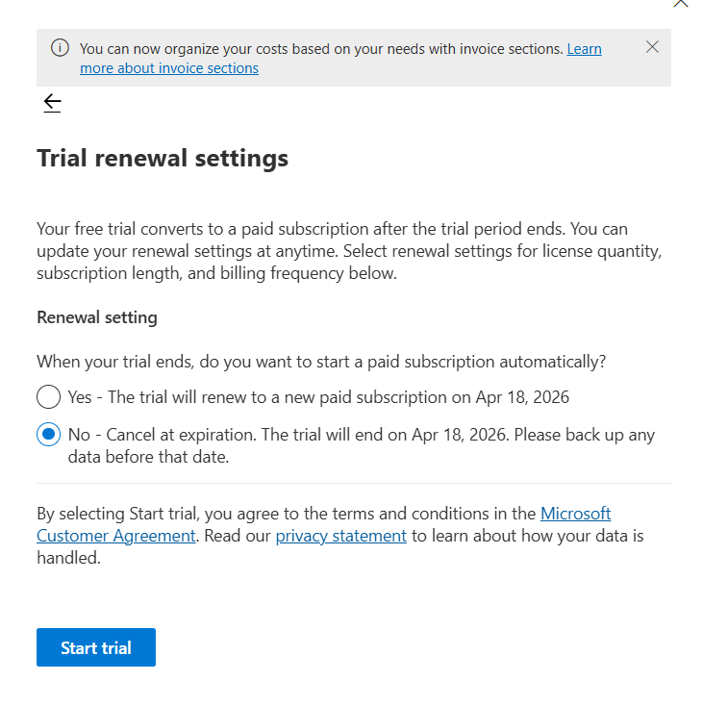
1º>2º

💼 Assign Licenses
- 🖥 Navigate to Billing → Licenses → Microsoft 365 E5 in the Admin Center
- 👤 Assign the license to your primary user account
- ✅ Ensures proper access and full functionality of all Microsoft 365 services for the lab
- ⚠️ Required for Defender services, data connectors, and lab exercises

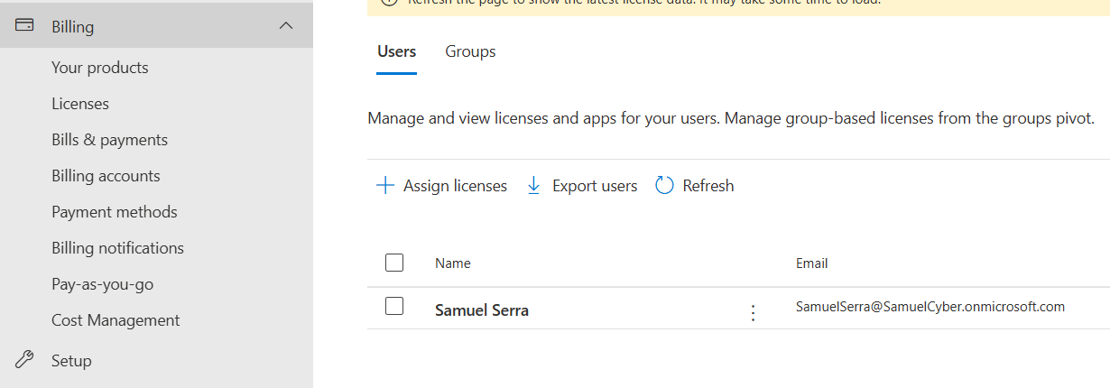

⏳ Important Note
- 🕒 Microsoft cloud solutions may take 5 minutes up to 24 hours to assign or activate certain products and licenses
- ✅ Ensure all previous steps are completed correctly
- ⚠️ Be patient and wait for the license assignment to process before continuing with lab exercises

🔍 Verify Microsoft Defender Data Connectors
At this stage, we will ensure all required data connectors in Microsoft Defender XDR are properly configured and actively ingesting telemetry.
This step is critical to guarantee full visibility across the environment.

🔐 Permissions Requirement
To configure Microsoft Defender, you need one of the following roles:
- Global Administrator – for lab/testing purposes
- Security Administrator – recommended for real environments

🧩 RBAC
Microsoft uses Role-Based Access Control (RBAC):
- Permissions are assigned based on roles
- Ensures users only have the access required for their responsibilities

⚠️ Note
- For lab environments, using Global Administrator is acceptable
- In real-world scenarios, it is not recommended due to the principle of least privilege
- ➡️ Always assign minimum permissions required (e.g., Security Administrator)

🖥 Navigate to Microsoft Defender Portal
- Go to: https://security.microsoft.com
- Menu: Settings → Data connectors
- Verify each service (Endpoint, Office 365, Identity, Cloud Apps) is Connected / Enabled
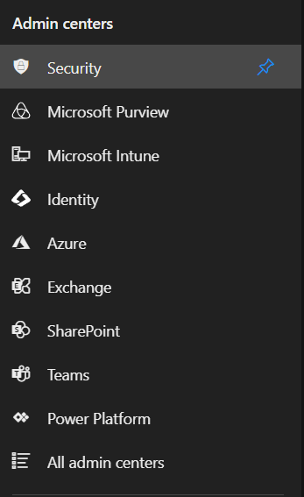

🔹 Check Data Connectors (Lab Only)
- Go to Microsoft Defender Portal → Settings → Data Connectors
- Verify that each connector is Enabled / Connected
- ⚠️ No data will appear yet if no VMs, AD sensors, emails, or cloud apps are generating telemetry
- ✅ This step only confirms activation, not data ingestion
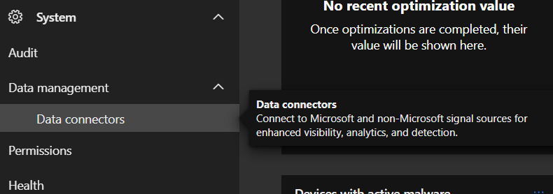

🔹 Confirm Microsoft Defender Suite (Lab Only)
- In some cases (like now), you may not see all Microsoft Defender Suite Data Connectors
- For lab purposes, you can confirm everything is okay by navigating to:
System → Settings → My Services
  - Ensure each service is available
  - Verify you can access Settings and Management for each service

🔐 Permissions & RBAC Notes
- Microsoft is RBAC-based in real environments
  - Each service requires role permissions assigned to a user or group
  - Without proper roles, only Global Administrator or Security Administrator can control all Defender XDR services
- 💡 Lab Tip:
  - You can create a user in Microsoft Entra ID (Azure AD)
  - Assign service-specific roles (e.g., Endpoint Admin, Email/Collaboration Admin, Cloud App Admin, Sentinel Contributor) instead of full Global Admin
  - Roles can be assigned directly in Microsoft Defender portal or via Entra ID depending on the service
- ⚠️ Principle of least privilege:
  - Assign users only the roles they need
  - Use Reader roles for monitoring-only access

💡 Important Note – Lab Realism
- 🖊 Be creative when setting up your lab
- 🏢 Imagine it as a real project or environment
- 🎯 Configure users, roles, and services based on your learning goals
- ✅ Helps simulate real-world scenarios and improves understanding of Microsoft Defender and RBAC

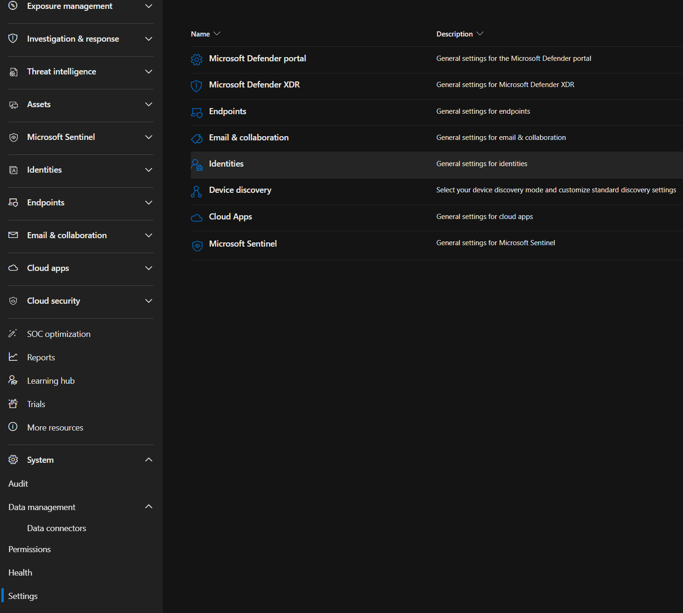

🔍 Review Each Service Setting
Instruction: Go into each service’s Settings and review the configurations to see what services are available.
Service | Settings Section | Notes
Microsoft Defender for Endpoint | Endpoints | Review security policies, device management, onboarding
Microsoft Defender for Office 365 | Email & Collaboration | Review email protection policies, Safe Links/Attachments, DLP
Microsoft Defender for Identity | Identity | Review sensors, alerts, identity protection settings
Microsoft Defender for Cloud Apps | Cloud Apps | Review connected apps, policies, alerts
Microsoft Sentinel | Sentinel | Review workbooks, rules, analytics, playbooks
Tips:
- ✅ Check both Settings and Management for each service
- ⚠️ For lab purposes, it’s fine if no telemetry is generated yet — this step is only to confirm service availability
- 💡 Use realistic configurations to simulate real-world environment

⏳ Service Settings Delay
- ⚠️ If a service setting is not available, you may need to wait some time
- 🕒 In some regions, it can take a few minutes up to several hours for the service to be fully ready
- 💡 This is normal and does not indicate an error
- ✅ Once available, you can review Settings and Management as planned

☁️ Azure Free Trial – Quick Steps
- 🖥 Go to Microsoft Azure
- 🔗 Click “Try Azure for free” → Azure Free Account
- 📧 Use the same account as Microsoft 365 E5
- 💳 Add a valid payment method
- 🔒 Enable MFA
- ✅ Click Next → Next until setup completes

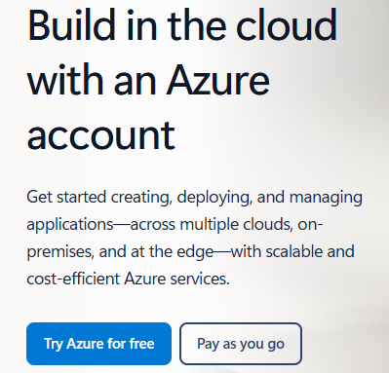

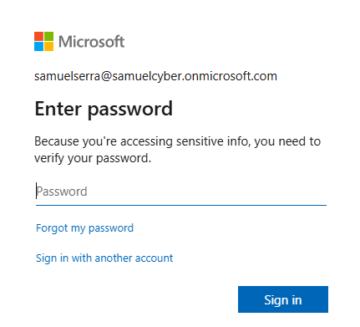

Easy steps:
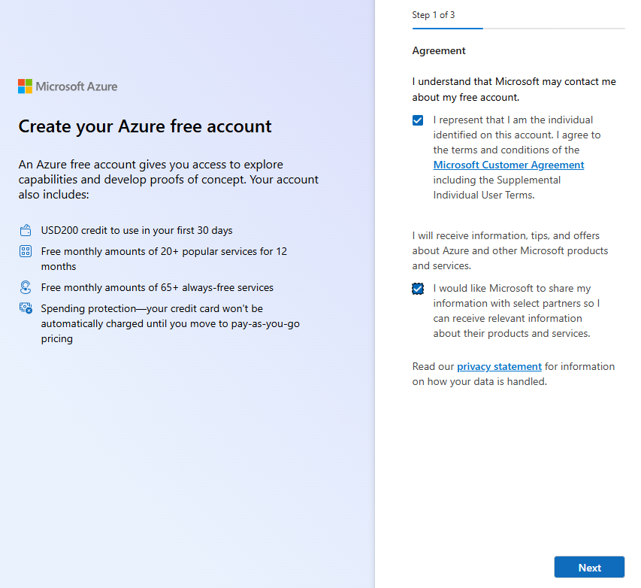
Just Next and Next.

☁️ Azure Cloud for Cyber Lab (Optional)
- ✅ Using the same account as Microsoft 365 E5, you can create an Azure Cloud environment for lab purposes
- 🔹 Required for some services:
  - Microsoft Sentinel (Cloud-based SIEM + SOAR)
  - Audit Logs, Sign-in / Sign-on Logs
  - Intune (for VM/device management in the cloud)
- ⚠️ Optional for lab-only testing:
  - Azure VMs are not strictly required if you can use on-premise VMs
  - Free tier credit may not cover normal VMs in some regions → real money required
- 💡 For lab purposes, using on-premise VMs works fine to test:
  - Defender for Endpoint
  - Policies and alerts
  - Simulated telemetry for testing and learning
- ✅ This approach allows you to practice cloud security, SIEM, and endpoint management without paying for Azure VMs
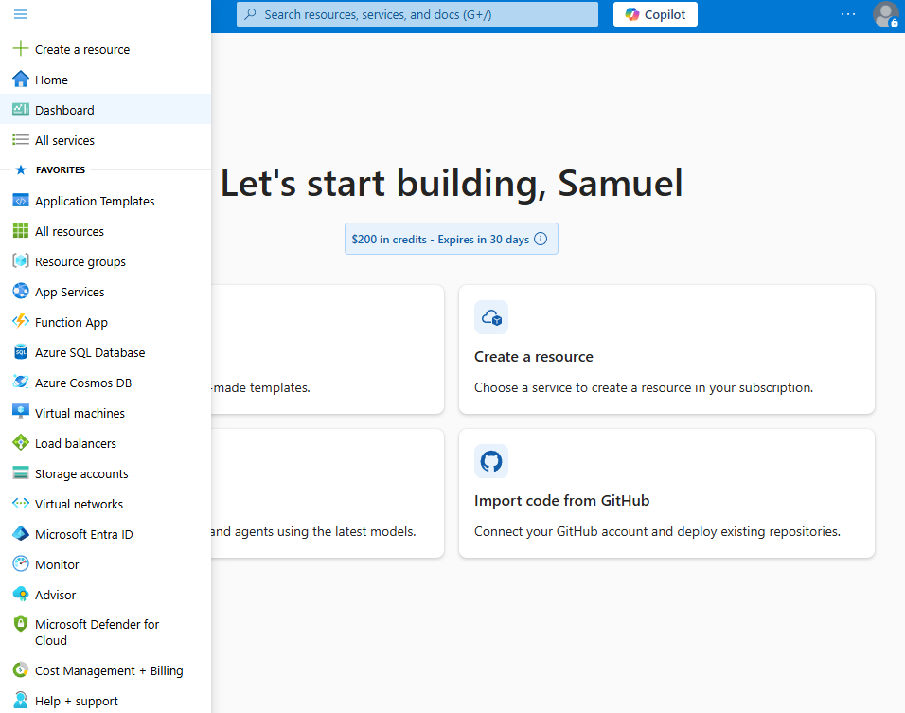

🙏 Thanks & Lab Note
- Thank you for following this guide!
- I hope it helps others get started with a Microsoft Cybersecurity lab.
- ⚡ Although it seems easy, beginners with zero experience in Microsoft Cybersecurity environments may encounter some setup challenges.
- 🎥 Many guides on YouTube or forums are outdated because Microsoft constantly updates its products, including service names, locations, and Azure vs. Defender portals.
- ✅ This guide aims to provide a current, practical, and easy-to-follow approach for lab purposes.

