Photosynthesis

* What is Photosynthesis ? And how does it work?

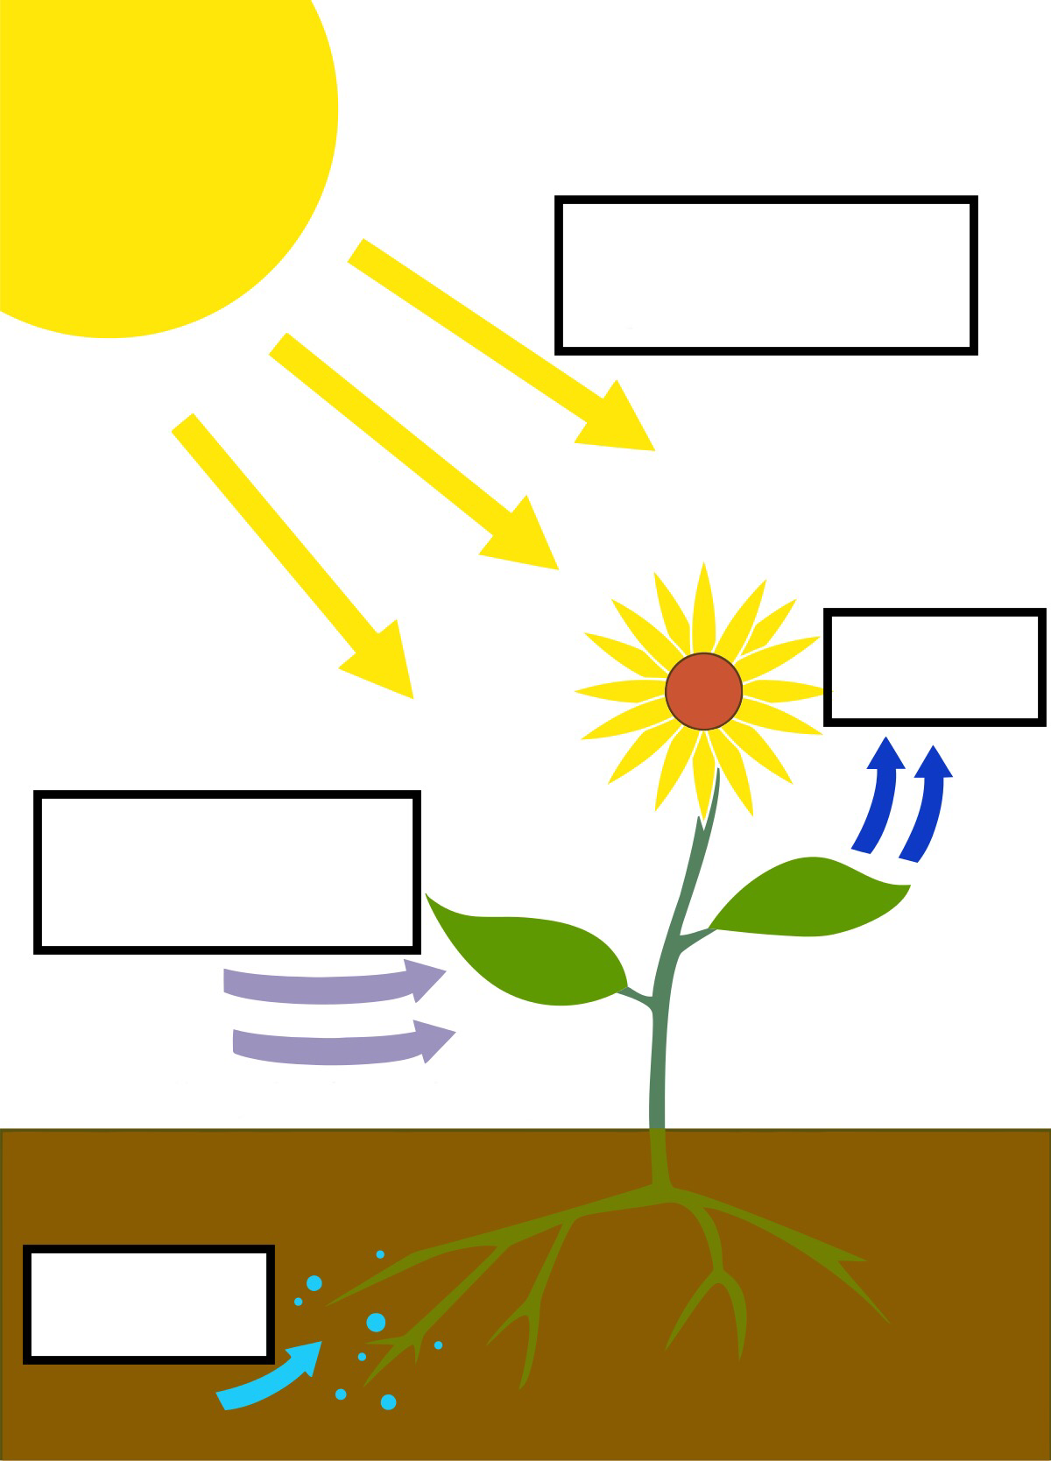Name