DOKUZ EYLUL UNIVERSITY
ENGINEERING FACULTY
DEPARTMENT OF COMPUTER ENGINEERING

CME1251 PROJECT BASED LEARNING – I I I
FINAL REPORT
PROJECT – I I I

CENG CHECKERS

by
Esma Beydili
Mustafa İzzet Yumuşak
Sefa Çelik

Lecturers
Assoc. Prof. Dr. Derya Birant
Dr. Meltem Yıldırım

IZMIR
05.01.2022

CHAPTER ONE
PROGRESS DESCRIPTION
We had started this project at 6 December by talking about what to do and we had decided what to do in that day. First week we created necessary variables, screen, and structures. Next week we did cursor moves, choosing piece, choosing target, and step operation for human.In the 3nd week, , we have done the steps the computer will play. In the 4nd week we did single jump operation for computer. and single jump operation and successive jump operations for human.In the final week we did double jump operation for computer and we finished coding our game.We prepared poster and presentation about our project. Finally, the goal of the game is to be the first player to move all 9 pieces across the board and into their own home area. Each player's home area is the opposing 3*3 area.

CHAPTER TWO
TASK SUMMARY

Completed Tasks
Creating the necessary variables, structures, screen designing.
Designing functions
For human: Cursor moves. choosing piece choosing target,step operation, single jump operation and successive jump operations.
For computer:Step operation,single jump operation and double jump operation.

Incomplete Tasks: Reasons and Explanation
There is no incompleted tasks left about the project.

Additional Improvements to the Project
Menu
Background and letter coloring

CHAPTER THREE
EXPLANATION of algorıthms

Screenshots
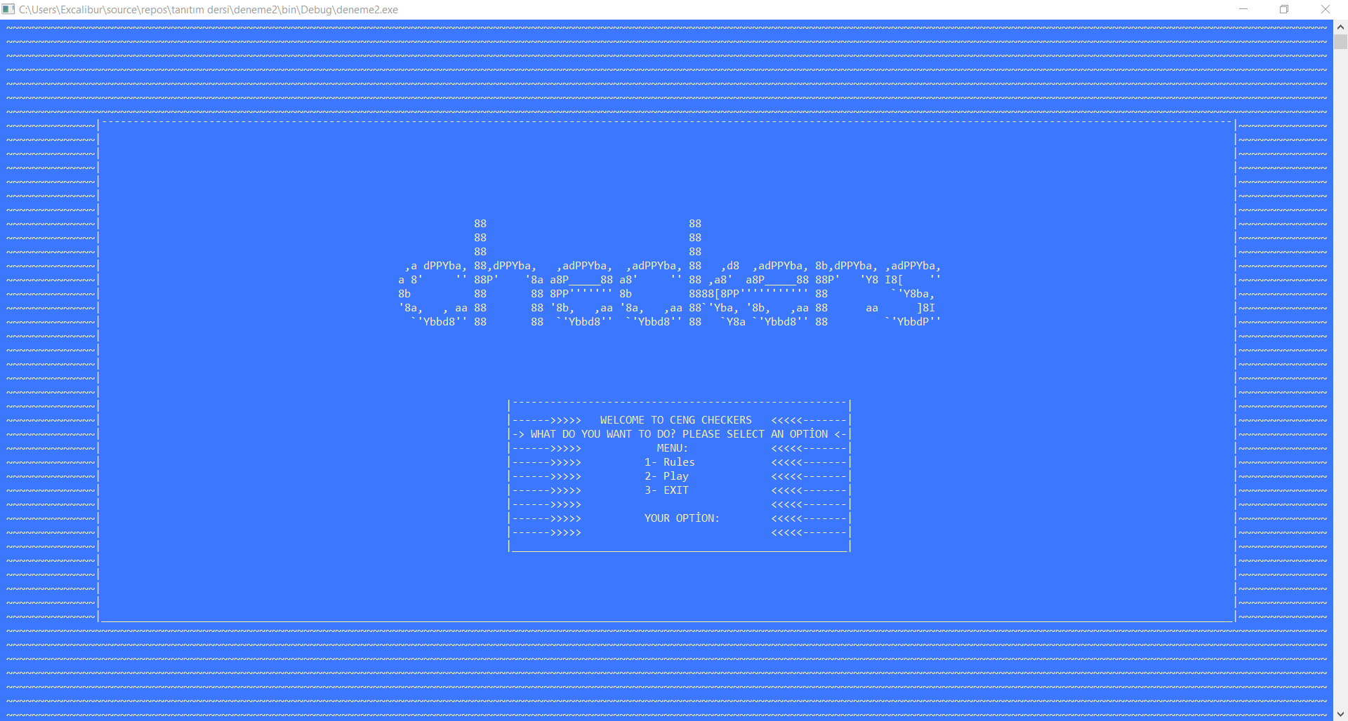
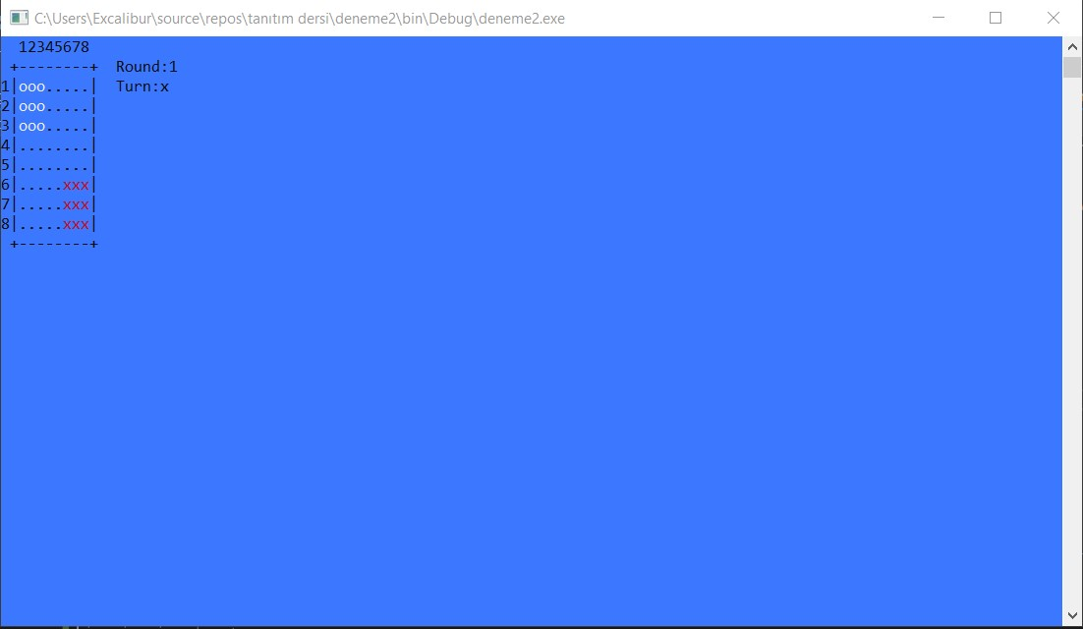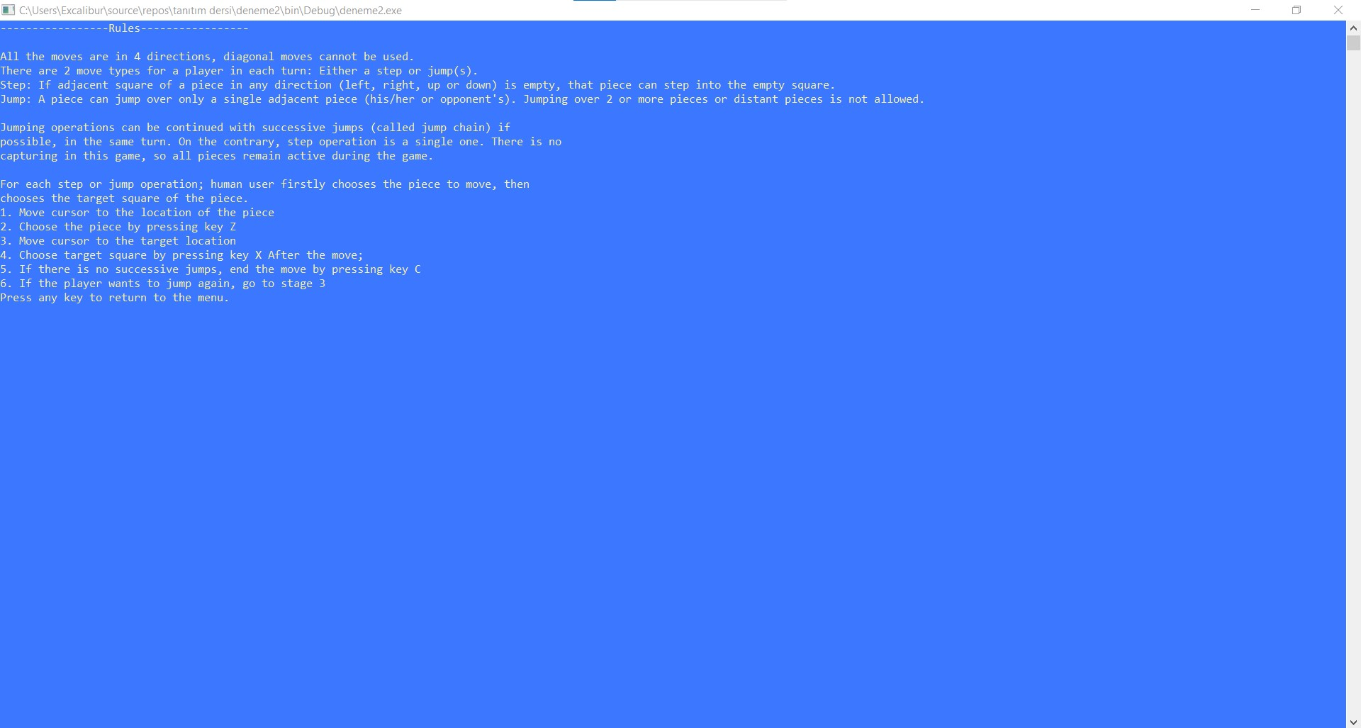

Functions
• Cmpjump: It takes 7 parameters one of them two dimensional array type of string and others 6 integers.This function makes jump operations for computer
• Counterforcomputer: It takes 1 parameter which is two dimensional array type of string.This function counter for the number of “o” for line 7
• Counterforcomputer6: It takes 1 parameter which is two dimensional array type of string.This function counter for the number of “o” for line 6
• Stepjump: It takes 5 parameters one of them two dimensional array type of string and others 4 integers.This function makes step and jump operations for human
• Winner: It takes 1 parameter which is type of string.This function fort he determining the winner.
• Writing: It takes 3 parameters one of them two dimensional array type of string and others 2 integers.This function for writing the array and structures to console.
• Menu: It takes no parameter.This function for writing the menu to console.
• Wincmptr: It takes 1 parameter which is two dimensional array type of string.This function for determining the winner it returns boolean value.
• Winhuman: It takes 1 parameter which is two dimensional array type of string.This function for determining the winner it returns boolean value.

Algorithms and Solution Strategies
If the user steps, we control it with a boolean value and prevent any possible movements. If the user jumps first, we only allow possible sucsessive jumps with another boolean value. We prevent it from stepping. With another boolean value, we prevented the game sequence from passing to the computer unless the user presses c. We kept a counter that calculates the “o” number so that there is no jam in the lower right corner of the screen. If there are 3 “o”, another “o” cannot be written on that row.

CHAPTER FOUR
PROBLEMS ENCOUNTERED
We had trouble getting together in the first week and we have overcome this problem in the following days..In the following weeks we also had problems with computer movements. There were jams at the bottom right of the screen and we overcame the problem by checking the number “o” in the row.

CHAPTER FIVE
conclusıon
There were a few things that we did not understand, so we asked to our supervisors various questions about the project in our lessons.We also tried to find solutions to the problems among ourselves by meeting online . Additionally we tried to finish our homework until the last day.We were determined to get together as a a team on online because we thought that everyone should have an idea about what we are working on. Thus, we have learned the subjects faster. Moreover that move has taught us to work as a group and strenghtened our communication link . Technically, we have learned how to use two dimensional array, procedures and functions in C#.

REFERENCES
- https://docs.microsoft.com/id-id/dotnet/csharp/methods
- https://www.w3schools.com/cs/cs_arrays.php
- https://www.w3schools.com/cs/cs_methods.php
- https://ascii.co.uk/art/checkers

AppendIx A
Poster/Web page of the Project
