DOKUZ EYLUL UNIVERSITY
ENGINEERING FACULTY
DEPARTMENT OF COMPUTER ENGINEERING

CME1252 PROJECT BASED LEARNING – II
FINAL REPORT
PROJECT – 3

COLUMNS

by
Sefa ÇELİK

Lecturers
Assc. Prof. Hilal Özcanhan
Fatih Dicle

IZMIR
5.27.2022

CHAPTER ONE
PROGRESS DESCRIPTION
In the first week, I prepared the menu and created the classes. In addition to these, I made the formation of cards and their random addition to the box. In the second week, I created the columns with SLL and added the first random 30 numbers to the columns and showed them on the screen. In the third week, I did the reading of the high score table, writing the new player to the high score txt and displaying them on the screen in order. In the fourth week, I momentarily moved the position between the columns with the colored background. In the fifth week, I managed to move between columns.

CHAPTER TWO
TASK SUMMARY

Completed Tasks
- Menu.
- Box definition.
- Creating the columns and adding the first 30 numbers to the columns.
- Reading and writing high score txt.
- Sequential display of high score table.
- Displaying the instant position during the game with the background color change.
- Ensuring transfers between columns during the game.
- Preparation of used array functions.
To summarize, except for the orderedAdd function in the SLL class of the code I posted, all the code belongs to me.

Incomplete Tasks: Reasons and Explanations
There are deficiencies caused by communication problems within the team and the indifference of the remaining members of the team. These are as listed below.
- Ensuring the conditional status at the time of transfer.
- Converting columns to MLL
- Card transfer from Box.
- Calculation of score.

Additional Improvements
- Menu and interface.
- A specified background formation.
- In-game coloring.

CHAPTER THREE
EXPLANATION of algorıthms

Screenshots
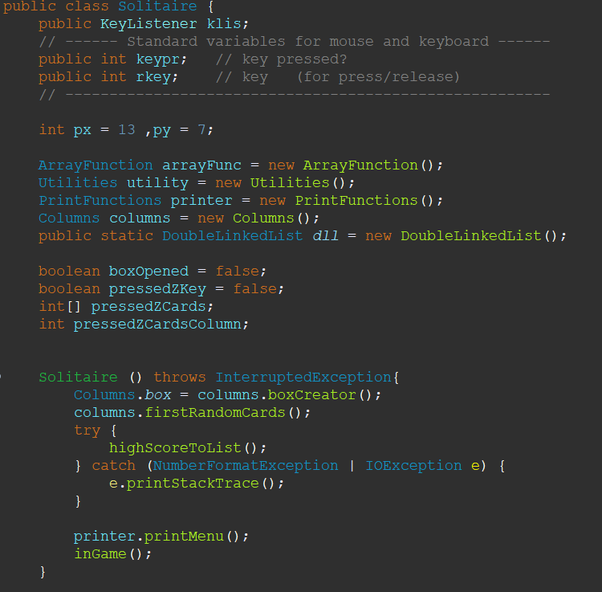
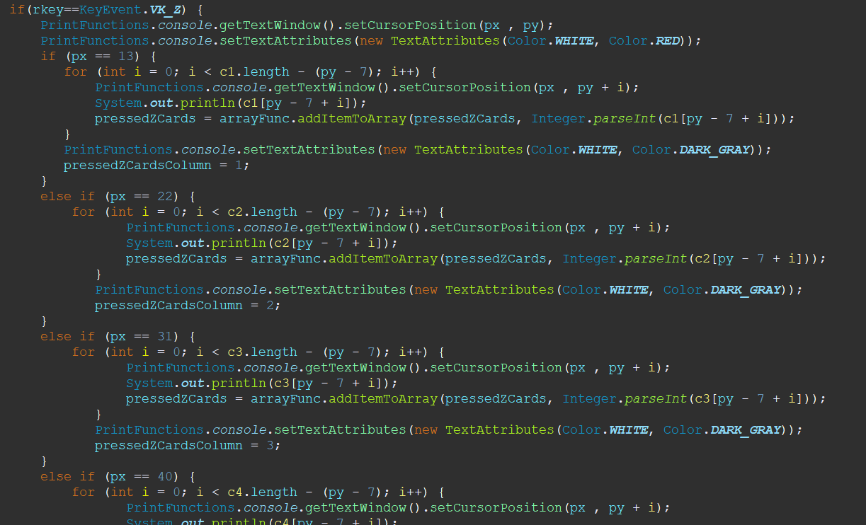
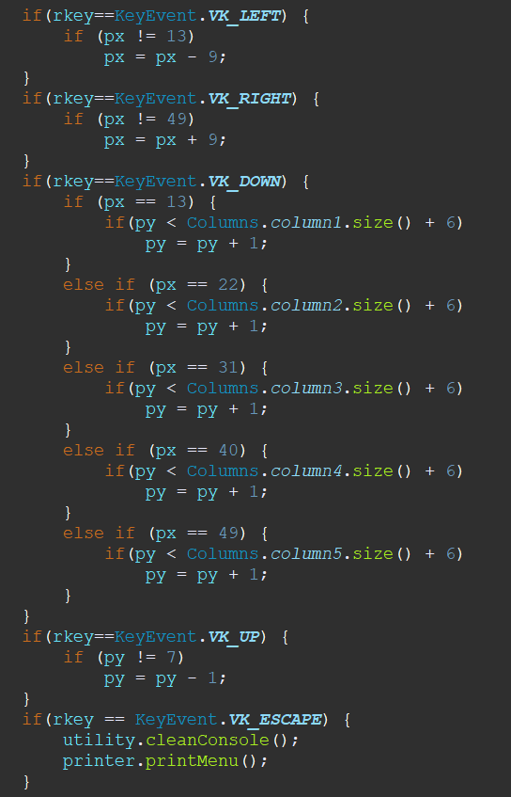
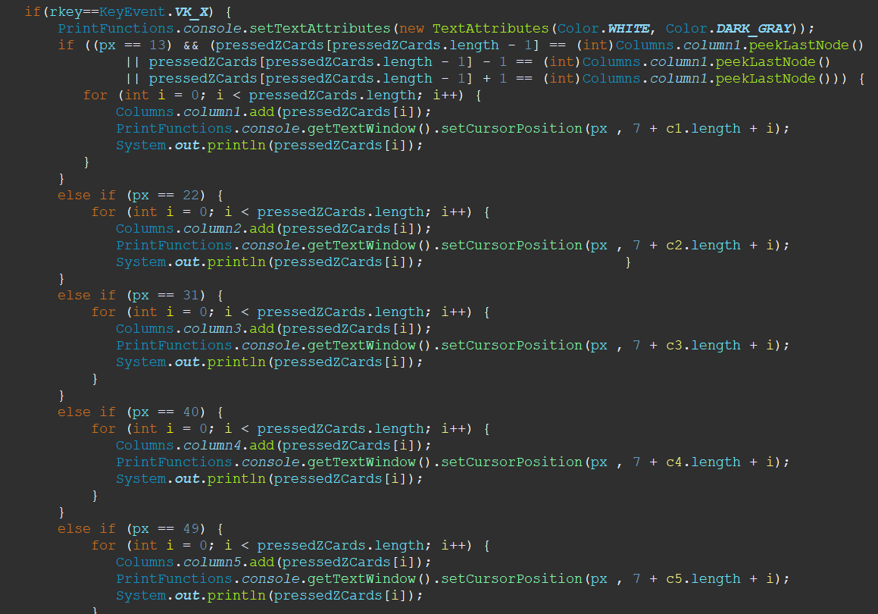
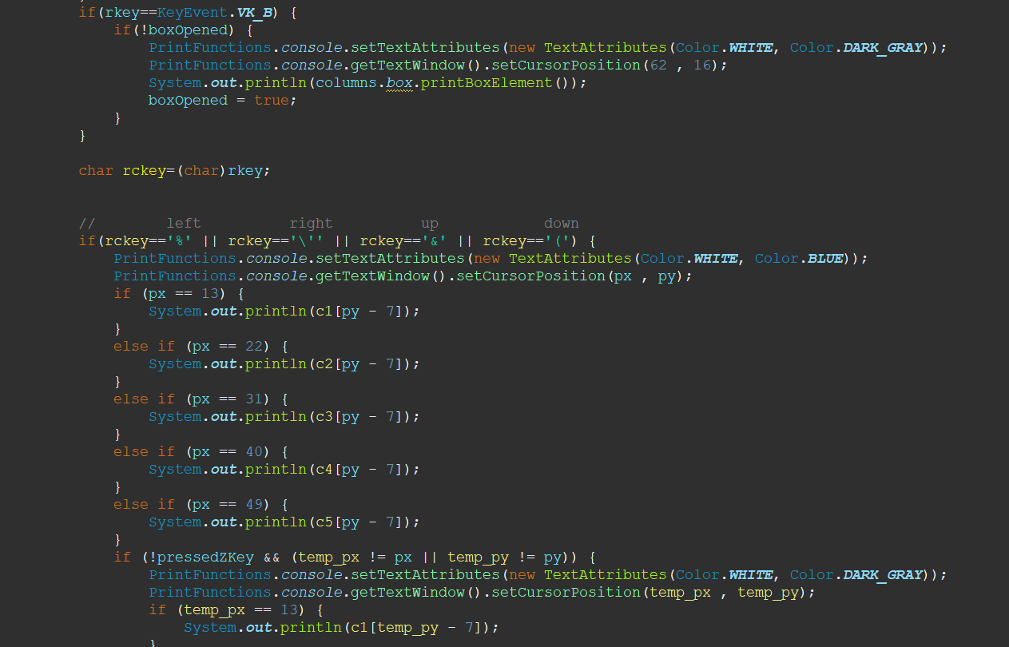
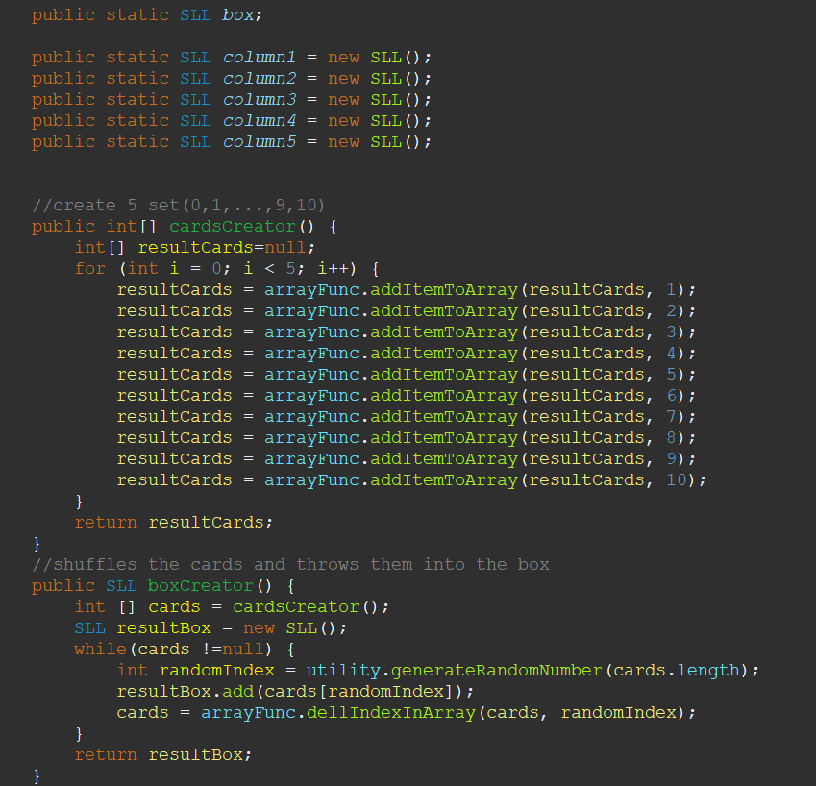
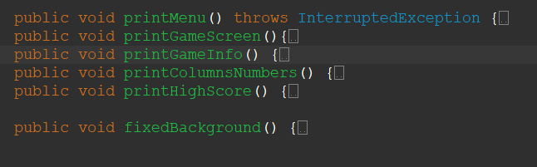

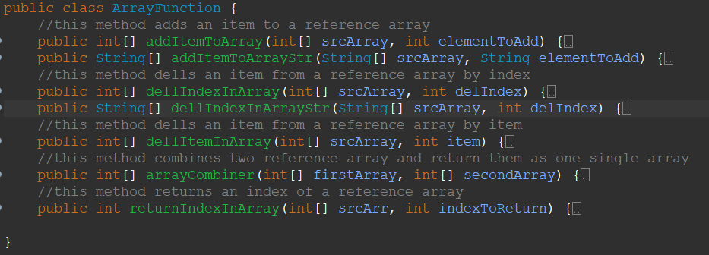

Functions
- printMenu();
- printGameScree();
- printColumnsNumber();
- printHighScore();
- fixedBackground();
- cardsCreator();
- boxCreator();
- firstRandomCards();
- inGame();
- highScoreToList();
- generetaRandomNumber();
- cleanConsole();
- addItemToArray();
- dellIndexInArray();
- dellItemInArray();
- arrayCombiner();
- returnIndexInArray();

Algorithms and Solution Strategies
While preparing the menu, I set up a structure consisting of a fixed title on a fixed background. There were general lines in this structure and the content changed according to its position in the menu. Then, to create the box, I first created an array of 5 sets of cards. I selected a random element from this array and transferred it to the box SLL. In this way, I created the box randomly. In the next step, I used SLL while creating the columns and I created 5 empty SLLs for 5 columns. After creating the columns, I pulled each of the 6 elements from the top of the box and assigned them to the columns. Later, I adjusted the movement part in the game and instantly changed the background of the element that I pulled from SLL, so we can see the position we are in instantly. Then, when Z is pressed in the transfer phase, I marked the position and all the column elements under it with a red background, and when x is pressed anywhere in another column we passed, all the elements marked with red are transferred to the other SLL, that is, the column and deleted from the end as much as the number of marked elements from the previous column. When B is pressed, the element at the top of the box is displayed.

CHAPTER FOUR
PROBLEMS ENCOUNTERED
In the first weeks, I said that I would deal with the menu and everyone got a task, but no one interacted and answered during the week. When we arrived the following week, no one had completed their mission. Afterwards, they didn't come to the classes because we were on vacation, and no one was working remotely or attending the meeting. I told you about this at the beginning of the third week. In the third week, one day before the control, someone threw a code, but the code he threw was the code of a part that was already completed. I understood from here that no one even took the codes I threw and opened them. When I said it had already been done, he said he didn't know, but everyone else in the group knew it was done and is in our conversations. I had completed everything up to the first code check day. They were going to make only the high score table, but since that was not done either, I completed it in the lesson and we passed the first code check completely. The next week, I said that I did the movement between the colons and the instant colorization of the background, and they said we will convert the columns to MLL and finish the transfer, but this was also not completed and they threw the incomplete code to the group 1 day before the presentation. That's why I dealt with the transfer on the last day, but I could not convert it to MLL. To summarize, there were big problems with my teammates.
In the code part, I had the most problems in printing to the screen and playing with slls instantly and editing the screen.

CHAPTER FIVE
conclusıon
As a result, I think eighty-five percent of the project has been completed. Although I had a bad experience as a team but I think I have improved myself in SLL, key reading and screen design.

REFERENCES

- Y. Daniel Liang, "Introduction to Java Programming", tenth edition. ISBN: 0133761312
- Bruce Eckel, "Thinking in Java", 4th ed, 2007.
- Java mother site : https://www.oracle.com/technetwork/java/index.html.
- Ken Arnold, James Gosling and David Holmes, "The Java Programming Language", 4th ed, 2005.
- Oracle Java Sstem documentation : https://docs.oracle.com/javase/7/docs/api/java/lang/System.html

