**ReWrighT: Wrist and Hand Rehabilitation Application**

**Using Leap Motion Controller**

by

Au, Daverick Kristian U.

Borjal, Gabriel Luis G.

Deloria, Ralph Lawrence P.

Demerey, Rheyvin Karl L.

Submitted in Partial Fulfillment of the Requirements for the Degree of

Bachelor of Science in Computer Science

at

FEU Institute of Technology

January 2019

Ms. Jennifer O. Contreras

Thesis Adviser

©2018 Au, Borjal, Deloria, and Demerey

All Rights Reserved

The author/s grant FEU Institute of Technology permission to reproduce and distribute the contents of this document in whole or in part

APPROVAL SHEET

The proposed project entitled “ReWrighT: Wrist and Hand Rehabilitation App Using Leap Motion Controller”, prepared and submitted by Au, Daverick Kristian U., Borjal, Gabriel Luis G., Deloria, Ralph Lawrence P., and Demerey, Rheyvin Karl L. in partial fulfilment of the

requirements for the degree of Bachelor of Science in Computer Science with specialization in Software Engineering is hereby recommended for oral defense.

Dr. HADJI TEJUCO

Project Mentor

MS. BEAU GRAY M. HABAL

Course Adviser

MS. ELISA V. MALASAGA MS. SHANETH AMBAT

Panel Member

Panel Member

Panel Chair

Accepted in partial fulfilment of the requirements for the degree of Bachelor of Science in

Bachelor of Science in Computer Science with specialization in Software Engineering. MS.

ELISA V. MALASAGA

Officer in Charge, CS Department

Date: __________________

APPROVAL SHEET......................................................................................................... iii

TABLE OF CONTENTS................................................................................................... iv

LIST OF TABLES..............................................................................................................vi

LIST OF FIGURES............................................................................................................vii

INTRODUCTION.................................................................................................................1

1.1. Background of the Study................................................................................... 3

1.2. Theoretical Framework of the Study..................................................................4

1.3. Conceptual Framework of the Study..................................................................6

1.4. Objectives of the Study.......................................................................................8

1.4.1. General Objective............................................................................................8

1.4.2. Specific Objective............................................................................................8

1.5. Scope and Limitations of the Study....................................................................9

1.6. Significance of the Study....................................................................................9

1.7. Definition of Terms...........................................................................................10

1.7.1. Technical........................................................................................................10

1.7.2. Operational.....................................................................................................12

REVIEW OF RELATED LITERATURE AND STUDIES.................................................14

2.1. Related Literature...................................................................................................

2.2. Related Studies.......................................................................................................

METHODOLOGY...............................................................................................................17

3.1. Type of Research...............................................................................................18

3.2. Project Design....................................................................................................18

3.3. Hardware and Software Specifications..............................................................23

3.4. Method in Developing the Software Product.....................................................23

3.5. Method in Evaluating the Software Product......................................................24

3.6. Data Gathering Procedure..................................................................................25

3.7. Respondents of the Study and Sampling Technique..........................................25

3.8. Statistical Treatment of Data..............................................................................25

BIBLIOGRAPHY.................................................................................................................26

APPENDICES.......................................................................................................................27

APPENDIX A....................................................................................................................

APPENDIX B....................................................................................................................

APPENDIX C....................................................................................................................

**List of Tables**

Table 3.1. Distribution of Respondents………………………………………………….32

**LIST OF FIGURES**

Fig 1.2 Extracted features………………………………………………………………10

Fig 1.3 Proposed additional feature vector for feature extraction………………………11

Figure 1.4. Modified Operational Process for Routine Checking. ……………………..12

Fig 1.5. Simple Dynamic Bayesian Network Framework with 3 variables…………….13

Fig 3.1. Use case Diagram of Patient user and Physical Therapist user

with the ReWrighT system………………........………………………………..25

Fig 3.2. Activity Diagram for View/ Do routine……………………………………….26

Fig 3.3. Class Diagram for Patient and Health Professional User classification……….27

Fig 3.4. Class Diagram of routine states………………………………………………..28

Fig 3.5. Sequence diagram for routineStart…………………………………………….29

Fig. 3.6. The Scrum process…………………………………………………………….30

Chapter 1

**INTRODUCTION**

A normal working hand is one of the most important features for independence in an individual’s life. The human dependence on fully functioning hands is highlighted most when these integral tools of the body are hindered in some way. According to Scott and Peckham (1995), losing hand functions results in compromises such as feeding and caring for oneself, and limiting oneself from one’s work, social, or family (as cited by Abolfathi, 2008). There are many injuries or conditions that can result in the loss of hand function. These include paralysis (from central or peripheral nerve injuries), swelling, joint stiffness, pain, burns, scarring or broken bones. For recovering individuals from such conditions, improvement in the healing process can be boosted by a therapy which is vigilant, appropriate and effective in turn restoring hand function (Hunter, Mackin, et al., 2002).

Prior to the prescription of appropriate therapy, comprehensive assessment of the hand condition is necessary. Furthermore, ongoing assessment in the course of the applied therapy can ensure the treatment will continue to be appropriate and provide optimal benefits to the patient According to Creek (2008), these assessments are needed for feedback, for discovery of lingering problems, for deciding whether to discharge the patient, and for coming up of a follow-up plan (as cited by Iconaru, 2014). In addition, during the recovery process, where no further improvements can be made to the hand, there are technologies available that can improve hand function.

According to the statistics from World Health Organization (WHO, 2017), the need for rehabilitation worldwide, especially in low- and middle-income countries, is greater and increasing. In southern Africa, studies show that only 26% receive the rehabilitation they need and is reflects to other low- and middle-income countries (as cited by WHO, 2019). In the Philippines, on the other hand, according to Marella, Devine, Armecin, Zayas, Marco, and Vaughn (2016), 2.1% and 2.7% of people in Quezon City and Ligao City, respectively, have difficulties in using their hands and fingers. Many of these patients of hand function cannot be provided prevention, diagnosis or treatment. In addition, unlike other diseases, hand impairment and function require sufficient patient’s exercise besides doctor’s treatment.

According to Liu, Zhang, Rau, Choe, and Gulrez (2015), exact motion exercise can profoundly help with patient’s rehabilitation. However, currently there is no other method than doctor’s judgment telling patients what to exercise and how they exercise, and patients only exercise their finger and thumb by repeatedly creating a fist or picking up small items in their time staying at home, without doctor’s instructions. Thus, there is a potential demand of designing a hand rehabilitation system to utilize patients’ time at home to exercise accurate motion training.

Gestures, as defined by Merriam-Webster dictionary, are actions made by part/s of the body, usually the limbs; and is used to express or emphasize an attitude, idea, or sentiment. Moreover, hand gestures are movements of the hand. As this study focuses on rehabilitations of the hand and wrist area, gesture recognition algorithms will be beneficial for such purposes as we can consider these as the state where the hand is in an exercise be it in a resting, open or close, or side to side position.

This study will feature the Leap Motion controller, which is a technology that introduces a new gesture and position tracking system with sub-millimeter accuracy. In contrast to standard multi-touch solutions, this above-surface sensor is discussed for use in realistic, stereo, and three-dimensional interaction systems, especially those concerning direct selection of stereoscopically displayed objects (Weichert, Bachmann, Rudak, & Fisseler, 2013). With this, it is evident that there is a need for a new modern approach for rehabilitation.

* 1. **Background of the Study**

One of the best routes to take when chronic pain is present is physical therapy. It helps the patient regain strength, mobility, as well as moving past the pain. Physical therapists create customized plans or programs based on the results of examining each patient. Each plan uses treatment techniques which aims to promote movement, reduce pain, restore function, and prevent disability. Variations of these plans or programs also prevent the occurrence of losing the ability to move (American Physical Therapy Association, 2016).

The complex structure of the wrist provides the possibility of adapting hand orientations according to the required task that, also, enables the hand to be ﬁrmly locked while interacting with the external environment in such a way as to transfer the force generated by the powerful forearm muscles for grasping objects or tools. The Wrist is a joint that consist of several carpal bones, movements of the carpal bones is facilitated by the shapes of the bones and links of ligaments. All these ligaments play a crucial role in stabilizing and guiding the motion of the carpal bones in a healthy wrist (Gordon Matthew Best, 2016). Furthermore, different wrist positions facilitate or hinder ﬁnger motion. According to Squeri and Masia (2014), movement occurs around two main axes and a combination of single rotations: ﬂexion or extension and abduction or adduction (also known as a radio-ulnar deviation). Furthermore, rotation around the forearm axis is not actively possible but is achieved through prono or supination of the radio-ulnar complex with some contribution by the shoulder in speciﬁc arm postures.

According to Liu, Zhang, Rau, Choe, and Gulrez (2015), the present medical care situation in China, most patients can only afford one or two treatments in hospitals per week, which is considerably incapable for rehabilitation. Improving the efﬁciency of patients’ self-exercise at home is a key method to reduce rehabilitation time and increase rehabilitation effect.

At the present, many modern health care centers and hospitals have computational systems oriented to the motor training and motor learning through both, fine and gross movement exercise. These focuses on accessibility and low-cost hardware in order to reduce costs throughout the rehabilitation process (Adrian Karashanov, Agata Manolova, & Nikolay Neshov, 2016)

Currently, according to Liu, et al (2015), the only option available is hand rehabilitation equipment that are either a wearable device or an interactive video game; wherein both have their own use case. Thus, when used by doctors for assistance, they could have several inherent drawbacks.

In response, the proponents came up with the Hand and Wrist Self-Rehabilitation Application using Leap motion, a tool that will help in the recovery and improvement of both coordination and mobility of a patient’s hand and wrist.

* 1. **Theoretical Framework of the Study**

Naidu and Ghotkar (2016) used a Leap Motion controller in order to track movements of the hands and fingers in 3-D digital format, the gestures mapped are in terms of feature points extracted and stored in a database. The distances between feature points were used as feature vectors. Using the Euclidean distance method on feature vectors of the current gesture captured and all stored gestures in the database, are calculated and compared in order to recognize gestures by the comparing of these vectors using four similarity measures namely Euclidean distance measure, Cosine similarity, Jaccard Similarity, and dice similarity.

Euclidean distance measure is the square root of the sum of squared difference between elements of two vectors and is only appropriate for data measured in the same scale. Jaccard similarity is defined as the ratio between the size of the intersection of two sets and the size of its union. Dice similarity measure equals twice the number of elements common to both sets divided by the sum of the number of elements in each set. Cosine similarity measure is the cosine angle of the inner space of two non-zero vectors. Both Jaccard and Dice similarity measures used were in terms of vector operations. Of the four similarity measures, only the cosine similarity measure is a judgment of orientation, not magnitude; and, the average accuracy of recognition this similarity measure achieved was the highest with 90% accuracy (Naidu & Ghotkar, 2016).

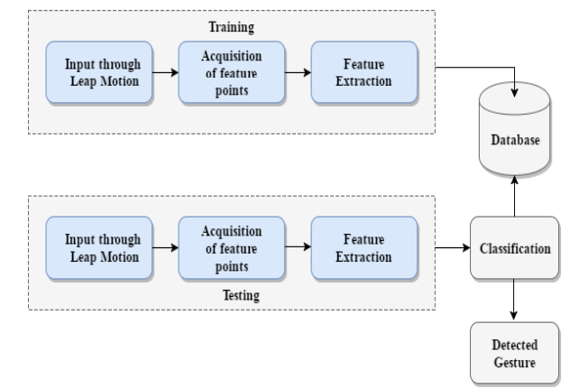

**Fig. 1.1 Flowchart of the Hand Gesture Recognition used by Naidu and Ghotkar (2016).**

Fig 1.1 shows the flowchart of gesture recognition used by Naidu and Ghotkar (2016). Training and testing of gestures have the same process of feature extraction by taking input from the leap motion controller, acquiring feature points, and then extracting them. Features extracted from training are then appended into the database. On the other hand, features extracted from testing are classified through the comparison of feature points stored in the database it corresponds to.

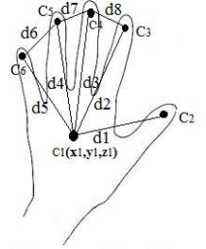

**Fig 1.2 Extracted features.**

Fig 1.2 shows the feature points to be extracted that are of interest. Each point $C_{i}$, where *i* goes from 1 to 6 for single hand and 1 to 12 for two-handed feature extraction, holds the position $(x_{i},y_{i},z_{i})$ of features of interest in the Euclidean space The feature vector ($C_{f}$) is formed by calculating the distances between these points using the Euclidean distance formula given by: $d_{i} = \sqrt{{(x_{i }- x_{i+1})}^{2}+{(y_{i }- y_{i+1})}^{2}+{(z_{i }- z_{i+1})}^{2}}$ where *i* goes from 1 to 8 for single hand and 1 to 16 for two-handed gestures.

For one-handed gestures: $C_{f}=\{d_{1},d_{2},d_{3},d_{4},d_{5},d_{6},d_{7},d_{8}\}$; and, for two-handed gestures: $C_{f}=\{d_{1},d_{2},d_{3},d_{4},d_{5},d_{6},d_{7},d_{8},d_{9},d_{10},d_{11},d_{12},d_{13},d_{14},d_{15},d_{16}\}$ For every gesture stored in the database ($C_{d}$), distances are calculated between the feature points at runtime.

The feature vector are compared for similarity with the cosine equation as followed: $S_{C}=\frac{C_{f}C_{d}}{\left|C_{f}\right||C_{d}|}$, where $S_{C}$ is the cosine similarity measure, $C_{f}$ is the feature vector to be compared, and $C_{d}$ is the feature vector stored in the database to be compared from.

* 1. **Conceptual Framework of the Study**

Gestures done by the wrist and hand will be considered as states where the said area is in relative to a repetition in an exercise routine. As such, in order to identify the state, gesture recognition of feature points in the Euclidean space through the identification of the cosine similarity measure as discussed in the previous section will be used. In order to boost performance of identifying states, a Bayesian Network Framework will be used to probabilistically determine the next state the system will compare the current state with in the database.

* + 1. **Pre-processing**

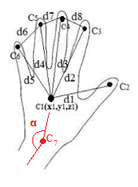

**Fig 1.3 Proposed additional feature vector for feature extraction.**

In fig 1.3, the position of the wrist will be extracted as well as the angle of deflection $(α)$ between the forearm and the center of the hand (palm) in the Euclidean space. This is in addition to the feature points discussed in fig 1.2 as to completely identify the state the hand and wrist area is in from the input.

* + 1. **Operational Processing**

According to Colgan (2014), the Leap Motion Controller uses three infrared LEDs and two cameras to detect movement. The interaction area is within 2.6 feet above by 2.6 feet wide by 2.6 feet deep in an inverted pyramid. Utilizing the two cameras to capture objects illuminated by the infrared LEDs the image data is streamed and processed by the Leap Motion Service taking the position and movements of the user’s hand/s (Chan, Halevi, and Memon, 2015). The data is separated as left and right cameras in grayscale stereo image near the infrared light spectrum. According to He (2014), the Leap Motion Service sends the data as part of frame objects as well as hands, tools, and gesture. However, due to the importance of protecting user privacy the Leap Motion Service only sends such data when a client application requests for it; from here on the bulk of the processing of data is in the hands of the application.

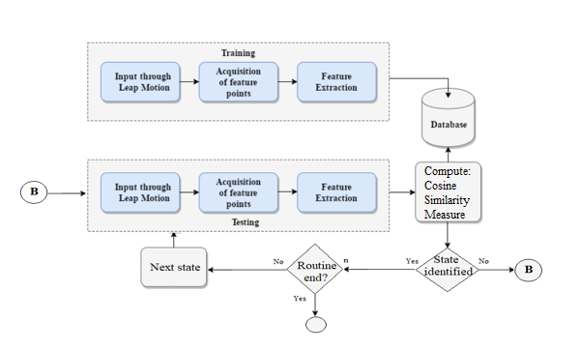

**Figure 1.4. Modified Operational Process for Routine Checking.**

Figure 1.4 shows the proposed flow of the routine checking of the application. Based from figure 1.1, the application will follow the pre-processing stages for both training and testing, namely input through leap motion, acquisition of feature points, and feature extraction; as we are considering gestures as states wherein the hand and wrist is in, identifying these states whether the hand and wrist is following the routine.

From the testing block, the feature vector extracted from the gesture will be compared with feature vectors stored in the database using the cosine similarity measure. The highest similarity index will be the state it is detected in. However, the process does not end with the detection of the state of the hand and wrist. The state must be identified as part or the next state of the routine as well. And since, a typical routine consists of many repetitions, the process continually goes back to input progressing into classification and identification until the user has reached the prescribed repetitions. However, in the case where the user or the application fails to accomplish or identify a repetition, respectively, the application goes back at the start of the testing block of taking input from the leap motion device.

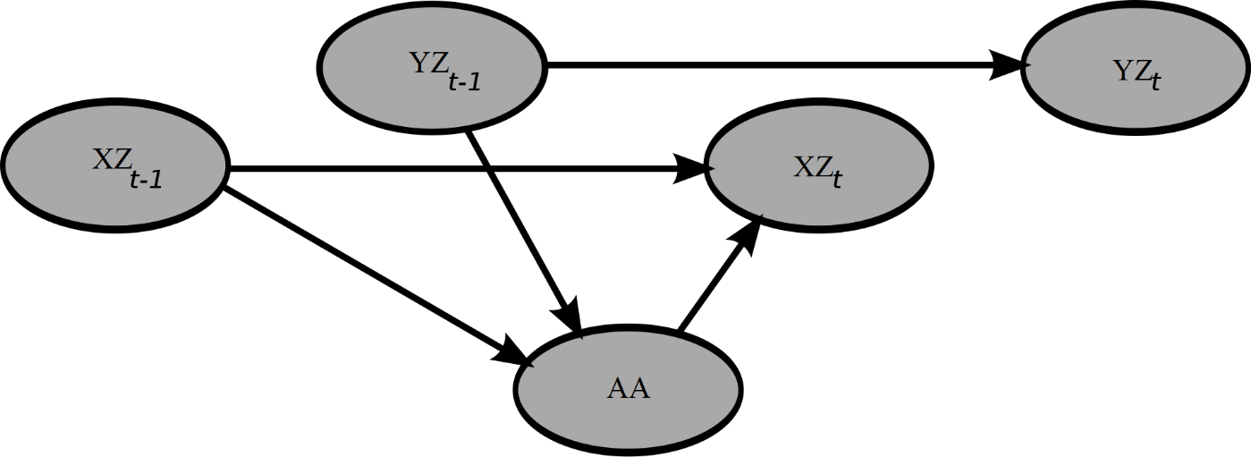

**Fig 1.5. Simple Dynamic Bayesian Network Framework with 3 variables.**

Fig 1.5 shows a simple Bayesian Network Framework with 3 variables. The variables XZ and YZ are the axis where the hand and wrist’ state is in; and AA is a completely different state (from open to closed hands). The probability of an event YZt occurring can be computed from internal regressor YZt-1 at any point in time. The same thing is applicable on other variables.

An open palm could transition into numerous states, in different axis, using the dynamic Bayesian network framework the application will be able to probabilistically determine which feature vector to compare with first by determining which state in the database has the highest probability to be next.

Accounting for the dynamic Bayesian network framework, the system will be able to monitor the end of a set and to later the repetitions done to the routine’s end.

* 1. **Objectives of the Study**
     1. **General Objective**

The general objective of this study is to create a tool that will provide guidelines in conducting self-rehabilitation exercises specifically for wrist and hand injuries and monitor the patient's progress without the need to consult a Licensed Physical therapist.

* + 1. **Specific Objectives**

Specifically, the study aims to achieve the following:

* To implement a gesture recognition algorithm making use of the Euclidean distance method and classifying them with the Cosine equation.
* To test whether the Euclidean method for gesture recognition is applicable on other applications that tracks movement of the hand such as exercising or training in real time.
* To test whether the addition of a simple implementation of a dynamic Bayesian network framework will increase gesture recognition performance as well as for the application of this paper.
  1. **Scope and Limitations of the Study**

Re:WrigHT is a software that can assist or help in the rehabilitation of patients with physical injuries in their wrists and hand even without the supervision of a medical professional. User will be given exercises to be followed by the patient, using leap motion sensor to be compared to a database of exercises which if not done correctly, the patient would not be able to continue to the next exercise if the user failed to follow the said exercise.

As per the Data privacy act of 2012, the system shall adhere to the principles of transparency, legitimate purpose, and proportionality in the collection, retention, and processing of personal information (Philippine Health Research Ethics Board, 2017). Users will be given the data privacy statement, specific to the purposes of the study prior to processing and processing of third party/s (National Privacy Commission, n.d) such as Licensed Physical Therapists; for which when they consent, their profile would connect with or help in diagnosis with patient users and licensed physical therapist users, respectively. Personal information of both users will remain confidential and to be used only for the purpose of this research.

The system may not be use as a substitute for actual or total rehabilitation, patience will be advice to still visit their therapist regularly. There will be cases that the system can or cannot be use with or without supervision of a professional base on the severity of the condition of the patient. This system is not advisable to be used by the patient without the supervision of a physical therapist.

* 1. **Significance of the Study**

Possible contribution of this research will provide a tool for treating and rehabilitating hand and wrist injuries as well as benefit patients, doctors, proponents, and future researchers.

**PROPONENTS.**The result will provide the proponents a better understanding of the Leap motion device, gesture algorithms, Bayesian network framework, as well as the incorporation of different programming languages to work in tandem; which they can use as they start to enter the industry.

**PATIENTS.** Patients will gain knowledge about self-rehabilitation exercises which can help them with their injuries in the said area. They will be able to manage their injuries by themselves with the use of the application.

**DOCTORS.** Health care professionals will be able to create hand and wrist rehabilitation routines that patients will be able to do by themselves freeing them to help other patients whose condition is worse and in need of attention, care, or help.

**FUTURE RESEARCHERS.** The future researchers will benefit as well as this research will provide them a better understanding of the Harris corner algorithm and gesture recognition algorithms making use of the Euclidean distance method and classifying them with the Euclidean, Cosine, Jaccard, and Dice equations.

* 1. **Definition of terms**
     1. **Technical**

**Bayesian Network** - a statistical model that is presented through a directed acyclic graph (DAG) where variables and their conditional dependencies are states found tin the said graph.

**Carpal bone** - are the eight small bones that make up the wrist (or carpus) that connects the hand to the forearm.

**Chronic pain** – is often defined as any pain lasting more than 12 weeks. Whereas acute pain is a normal sensation that alerts us to possible injury, chronic pain is very different.

**Cosine similarity measure** – uses the cosine angle of the inner product of space between two non-zero vectors. This similarity measure is a judgement of orientation not magnitude due to the nature of the cosine function.

**Database -** a collection of information that is organized so that it can be easily accessed, managed and updated.

**Disability** - a physical or mental condition that limits a person's movements, senses, or activities.

**Diagnosis** – the identification of the nature of an illness or other problem by examination of the symptoms.

**Edema** - Body parts swell from injury or inflammation. It can affect a small area or the entire body. Medications, pregnancy, infections, and many other medical problems can cause edema.

**Euclidean** - relating to or denoting the system of geometry based on the work of Euclid and corresponding to the geometry of ordinary experience.

**Facilitate** – make (an action or process) easy or easier.

**Hardware** - tools, machinery, and other durable equipment.

**Hand gestures** - actions made by part/s of the body, usually the limbs; and is used to express or emphasize an attitude, idea, or sentiment.

**Interactive** – allowing a two-way flow of information between a computer and a computer-user; responding to a user's input.

**Ligament** - a short band of tough, flexible fibrous connective tissue which connects two bones or cartilages or holds together a joint.

**Mobility** – the ability to move between different levels in society or employment

**Moto**r - something that produces or refers to motion.

**Paralysis -** the state of being unable to move or act.

**Physiatrist** - a medical Doctor of Osteopathic Medicine who specializes in Physical Medicine and Rehabilitation (also called PM&R physicians).

**Prescription** - a doctor’s written direction for the medicine that someone needs and how it is to be used, or the medicine itself.

**Radio-Ulnar deviation** - is a hand deformity in which the swelling of the metacarpophalangeal joints (the big knuckles at the base of the fingers) **causes** the fingers to become displaced, tending towards the little finger.

**Therapist -** a person trained in the use of physical methods, as exercises, heat treatments, etc., in treating or rehabilitating the sick or wounded or helping patients overcome physical defects.

**Therapy-** treatment to help a person get better from the effects of a disease or injury.

* + 1. **Operational**

**Feature point -** the distance computed from these points are used to classify gestures.

**Gesture** - a movement or position of the hand, arm, body, head, or face that is expressive of an idea, opinion, emotion, etc.

**Multi-touch sensor** - is technology that enables a surface (a trackpad or touchscreen) to recognize the presence of more than one point of contact with the surface.

**Rehabilitation** – the action of restoring someone to health or normal life through training and therapy after imprisonment, addiction, or illness.

**Supination** - rotation of the forearm and hand so that the palm faces forward or upward also a corresponding movement of the foot and leg in which the foot rolls outward with an elevated arch.

**Treatment** – the act or manner or an instance of treating someone or something

**Tracking** - the act or process of following something or someone

**Training** - the action of teaching a person or animal a particular skill or type of behavior.

Chapter 2

**REVIEW OF RELATED LITERATURE AND STUDIES**

* 1. **Related Literature**

Physical therapy benefits people of all ages as it has the capacity to treat different kinds of health problems. These people may need to relieve pain, increase mobility, prevent or recover from sports or recreational injury, prevent disability, and rehabilitate after major incidents like strokes, accidents, injuries, or surgeries; manage chronic diseases like diabetes, heart disease, or arthritis, and to adapt to artificial limbs and assistive devices such as canes or walkers. The best option to take when long-term pain (chronic pain) is being experienced in order to regain strength, mobility, as well as to move past the pain. Physical therapy treats pain, but it’s origin as well. Physical therapy sessions might include: Low-impact aerobic training, exercises on strengthening and pain relief, stretches, massages, Transcutaneous electrical nerve stimulation (TENS), and ultrasound (webMD, n.d.).

According to the American Physical Therapy Association (2016), physical therapists create customized plans or programs based from the results of examining each patient. Each plan uses treatment techniques that aim to promote movement, reduction of pain, restoration of function, and prevention of disability for the patients. Variations of these plans or programs also prevent the occurrence of losing the ability to move.

**2.2. Related Studies**

Based from theoretical and scientific findings of clinical applications, applications of physical therapy include restoring, maintaining, and promoting optimum physical functions. It involves diagnosing and managing dysfunction in movement; preventing onset, symptoms, and progression of the resulting impairment, limitation in functions, and disability due to disorders, conditions, diseases, or injuries (American Physical Therapy Association, 2016). Physical therapy also helps avoid expensive procedures that can be invasive such as surgery or imaging tests like MRIs, X-rays, and CT scans that are extensive (Athletico Physical Therapy, n.d). Surgeries demands so much on the body that leaves soreness, exhaustion, pain, and weakness to it. Which is why postoperative care plays a huge part to its recovery. Upon leaving the hospital and returning home, understanding that the over exertion of the body can lead to complications. Part of postoperative care is physiotherapy or physical therapy (Gulf Shore Private Home Care, 2015).

Athletes, competitive or recreational, suffers from damage in their upper extremities specifically on soft tissues, bones, ligaments, tendons, and nerves due to trauma or repetitive stress. Most susceptible are those that makes use of their arms for throwing, catching, or swinging (Rettig, 1998). The most common wrist-related injuries are sprains; injuries to the bone such as fractures in hand to wrist area, and dislocation of the PIP joint; and, injuries to the soft tissues and closed tendons (Beth Israel Deaconess Hospital, n.d.). Examples of rehab wrist exercises are resisted wrist extension, resisted wrist flexion, resisted radial deviation, resisted ulnar deviation, resisted forearm pronation, and resisted supination. Each of these rehab exercises helps specific problems concerning the wrist to forearm area and is recommended by the physiotherapist whichever works best for the patient’s need (My Health Alberta, n.d).

Several training methods have been developed to increase the skills of amateurs and residents in patient-free environments. One of these devices is called the box trainer. The box offers an enclosed space that simulates the surgical scenario, with realistic dimensions, access points and camera view. Motion analysis requires being able to track the movements of the laparoscopic instruments during performance of a task. Tracking technologies have traditionally relied on sensor-based systems, based on optical, electromagnetic or mechanic technologies. Nowadays, they are incorporated into different surgical systems for intraoperative navigation, robotic surgery and surgical training (box trainers, virtual reality simulators) (Oropesa, de Jong, Sánchez-González, Dankelman, & Gómez, 2016)

Traditionally, assessment of patients that need physical therapy and rehabilitation is based on a therapist’s observation and judgment. There are assessments methods such as Fugl-Meyer Assessment of Physical Performance relies heavily on visual assessment of the patient performing a standard task. This process needs a trained Physical Therapist to spend a lot of time with the patient. Yet, the assessment can be inaccurate for several reasons one of which is the subjectivity of these behavioral and clinical assessments. In the past few years sensors and computing technology that can be used for motion capture have advanced drastically; they have become more capable and affordable the hiring specialist for a one on one session (Hondori & Khademi, 2014).

Motion capture systems can record a human body’s kinematic data with high accuracy and reliability; also making analysis of the data faster, which also result in better clinical and behavioral assessment and efficient decision making and therapeutic relief for the patient. Vision based methods may track movements using either contrast-based or depth-based imaging. Color sensing system in RE may track a specific color marker attached to the patient’s body or held by their hand or track the patient’s skin color. On the other hand, systems which use depth imaging may use the skeletal tracking that devices such as Microsoft Kinect or Leap Motion Sensor provide. Depth-based systems may also use depth segmentation and computer vision algorithms to detect and track human body from the sequences of depth images (Hondori & Khademi, 2014).

Nowadays, the increasing research on human-computer interaction technologies breeds new set of input devices that changes interactivity. The new approach of human computer interfaces are more natural, built in communication between people and sensor-based input devices. The most common human-robot interaction in record is through a keyboard or a joystick, which in stated to the involvement of the robotic arm, that require a series composition and mode selection routines by pressing a series of button (International Symposium on Robotics, Verband der Elektrotechnik, Institute of Electrical and Electronics Engineers, & German Conference on Robotics, 2014).

The LMC offers the medical field a touchless interaction system that allows the medical staffs to interact directly with digital devices that visualize digital images in a sterile environment. In these circumstances, a usability evaluation study of a natural interaction system into the operating room conducted on the RISO system, (the acronym in English stands for “Image Recognition in Operating Room”) The interaction with the medical images would occur through the Leap Motion by the mean of nine gestures forming their database.

Chapter 3

**METHODOLOGY**

* 1. **Type of research**

Quantitative research is utilized because the researchers wanted a systematic and objective investigation of the phenomenon while applying statistical, mathematical, and numerical computations and analyzation of the data gathered from surveys. This type of research concentrates on gathering numerical data from the chosen sample to explain a certain phenomenon. If the data are properly analyzed by the researchers using the quantitative approach, the results will be accurate and reliable.

* 1. **Project Design**

**Use Case Diagram**

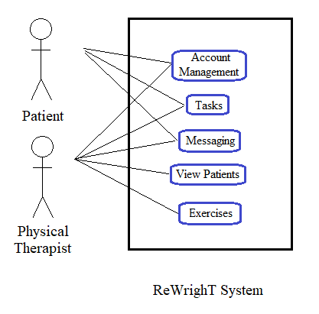

**Fig 3.1. Use case Diagram of Patient user and Physical Therapist user with the ReWrighT System.**

Fig 3.1 show the use case diagram of patients to the ReWrighT system under account management, they are able to create and modify their account, choose their registered physical therapist. Under tasks they can view announcements, exercises, progress reports, recovery status and do exercises al given by their assigned physical therapist. Under messaging they can view and send messages for urgent concerns that needs to be addressed by their respective physical therapists.

Fig 3.1 also shows that Physical therapist users have the same capabilities as a Patient user but with extended capabilities. The additional features such as under view patients, to be able to admit new patient, view patient records and schedule consultations. Under view patient records the therapist can select a specific patient and view the his/her record, view the patient progress, to create new and view existing routines, as well as to view and send messages to the selected patient. Under exercises, the therapist can then view existing exercises in the database, create or modify an existing exercise.

**Activity Diagram**

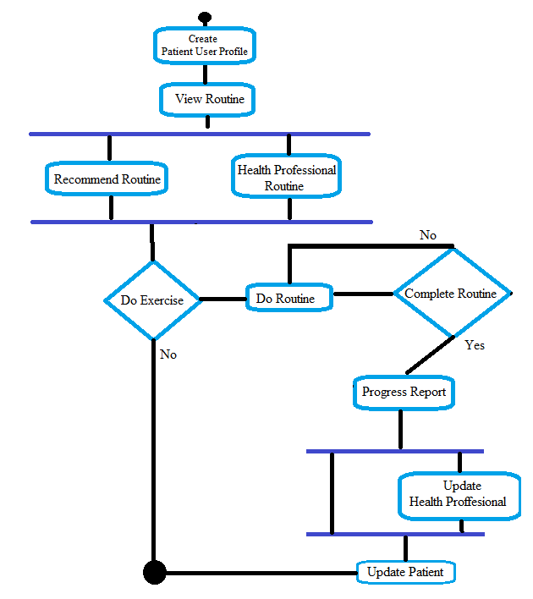

**Fig 3.2. Activity Diagram for View/ Do routine.**

Fig 3.2 shows the activity to be done by the patient user from creating a profile to viewing or executing routine. From the profile, whether the patient user wants a health professional to direct his/her recovery, he/she has the choice to do exercises and complete routines from the more generically recommended routine or routine provided by the connected health professional. Upon choosing, the patient user interacts with the system in testing as shown in Fig 1.4 from the input from the leap motion controller, identification of hand and wrist state, counting of repetitions, and, finally, to the end of repetition of routine. When the patient user has completed the routine, the health professional will receive a progress report automated by the system and, in turn, will trickle down to the patient for further recommendations.

**Class Diagram**

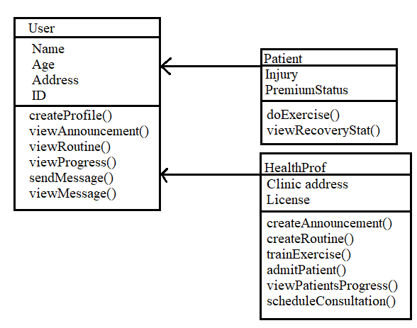

**Fig 3.3. Class Diagram for Patient and Health Professional User classification.**

In Fig 3.3., the patient and health professional users are subclasses of the user class having name, age, address, and ID as attributes. Both users are able to create their own profiles, view announcements, view routines, view progress, send messages, and view messages. Patient users can further elaborate their profile with their injury (condition) attribute. Premium status attribute enables them to avail premium services such as detailed reports, weekly consultations, and many more. In contrast, health professional users are able to extend their profile with the clinic address and medical license attribute.

In addition to the methods of a user, patient users are can do exercise and view recovery stat. Health professional users, on the other hand, can create announcements, create routines, train exercises, admit patients, viewing patient record, and schedule consultation.

Health professional users have more methods because the system relies on their knowledge and expertise in training and checking the system as well as the patient users.

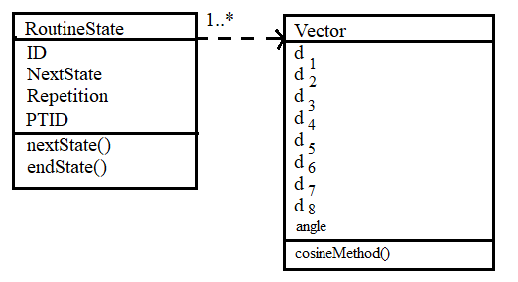

**Fig 3.4. Class Diagram of routine states.**

Fig 3.4 shows the class diagram of a RoutineState consisting of the ID, NextState, Repetition, and PTID. Its methods are nextState, which returns the vector to be expected by the system to be executed, and endState, that returns true when the routine has ended. Vector class consists of the Euclidean distances of the features extracted and stored in the database where di is the corresponding distance computed using Euclidean distance method on feature points extracted; *i* is equal to 8 for one-handed state and 16 for two-handed state. Vectors makes use of the cosineMethod to compute the similarity measure from comparing feature vector. It also shows the dependency of RoutineState to vectors as it consists of one or many Vectors.

RoutineState is the backbone of the dynamic Bayesian Network framework to be used by the ReWrighT system as it holds the next state to be expected by the system.

**Sequence Diagram**

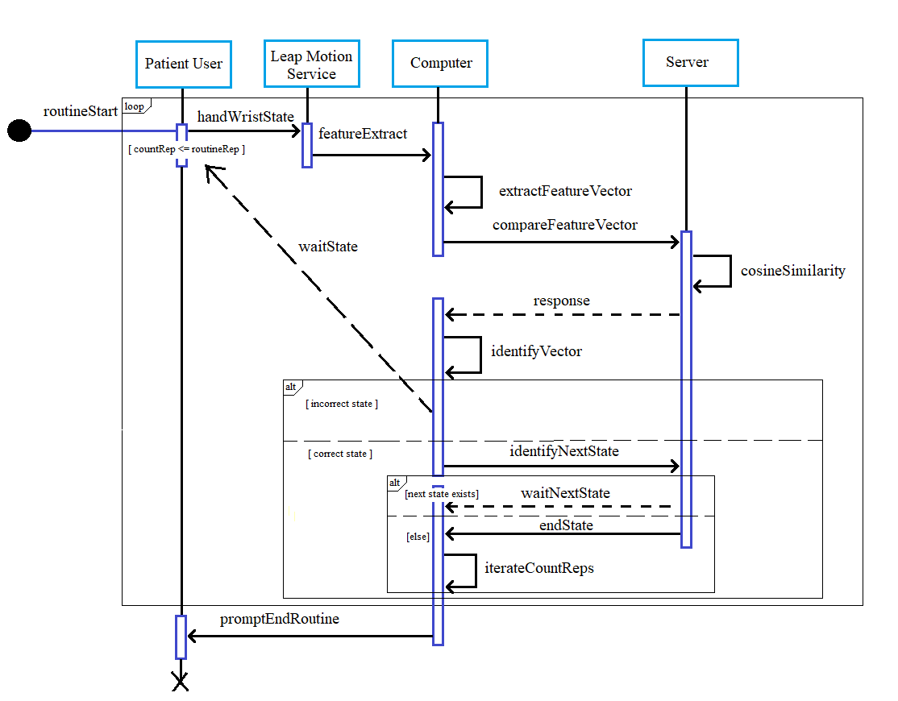

**Fig 3.5. Sequence diagram for routineStart.**

Fig 3.5 shows the sequence diagram for routineStart going through the patient user to the server. When the routine starts, the Patient user inputs the exercise with his/her wrist and hand through the Leap motion controller. The Leap motion Service then extracts the features the state the patient user’s wrist and hand is in. The computer transforms the features extracted into feature vector by computing for the Euclidean distances between them. The process compareFeatureVector sends the transformed vector to be compared by the server from existing training data through the cosineSimilarity process. Once the response is made, the computer identifies the whether the vector is part of the routine being done. In the event that the vector or state is not identified as part of the routine, the computer awaits for the handWristState from the Patient user. When the state is correct, the computer identifies the next state the server should expect in the session. The server then checks if there is another state to be expected. After which, the computer counts the repetition all while the server waits for the next state to be fed to it. Lastly, when the countReps has no longer satisfies the sequence’ condition where countReps must be less than or equal to routineRep.

* 1. **Hardware and Software Specifications**

As the study will make use of the leap motion controller on the hand and wrist area, this study is limited to the capabilities of the device as well as the aforementioned area.

* 1. **Method in Developing the Software Product**

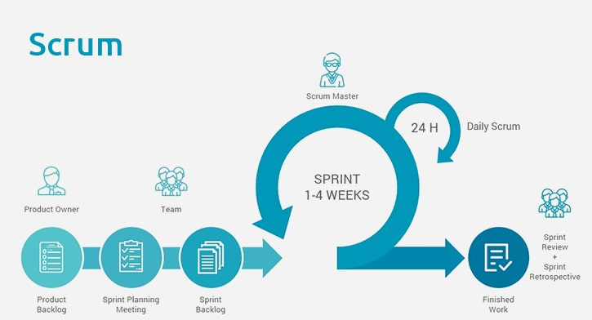

**Fig. 3.6. The Scrum process. n.d., Retrieved from https://www.peerbits.com/blog/agile-software-development.html**

Fig 3.6 shows the Scrum approach which is a general agile method that focuses on the management of iterative development rather than specific agile practices. Scrum begins with the requirements or a story specifying how features work and to be tested. Once the team understands and knows the expected outcome, they cycle through a set of sprints which provide small value quickly and consistently.

The initial phase (product backlog, sprint planning meeting) is an outline planning phase where general objectives and design of the software architecture are established. The starting point for planning is the product backlog, which is the list of work to be done on the project. This is followed by a series of sprint cycles, where each cycle develops an increment of the system where at the start of it key features are chosen and defined as well as the objective of a sprint (sprint backlog). Each sprints lasts one to four weeks with 24 hour sprints in between. The project closure phase wraps up the project, completes required documentation such as system help frames and user manuals and assesses the lessons learned from the project through sprint reviews and sprint retrospective.

The product owner is involved at the initial phase of the scrum process and at each end of a sprint. The team is involved with the product owner in the selection of key features after which is isolated throughout the sprint where communication is channeled through a scrum master. After the sprint, work is reviewed and presented to the product owner. Then the next sprint begins anew.

* 1. **Method in evaluating the software product**

**White Box Testing**

White Box Testing is a software testing method wherein the internal structure, design, and implementation of the software is tested and known by the tester. It is beyond the user interface because the testing involves the analysis of the internal structure of the system. White Box Testing is applied to three levels of testing: Unit Testing, Integration Testing, and System Testing. Unit Testing is used to test paths within a unit. Integration Testing is used to test paths between units. Lastly, System Testing is used to test paths between subsystems. However, White Box Testing is mainly applied to Unit Testing.

**Black Box Testing**

Black Box Testing is a software testing method wherein the internal structure, design, and implementation of the software is test but not known by the tester. The tests could either be functional or non-functional. Black Box Testing is used to find errors like incorrect or missing functions, errors in interface, errors in data structures or external database access, errors in behavior and performance, and errors in initialization and termination.

**Alpha Testing**

Alpha Testing, a type of acceptance testing, is a software testing method wherein the possible issues/bugs will be identified by internal employees before releasing the product to the public. Alpha Testing is conducted in a lab environment and performed at an internal organization.

**Beta Testing**

Beta Testing, or User Acceptance Testing, is a software testing method wherein the testing of the product is performed by “real users” in a “real environment”. The Beta version of the system is only released to limited number of users to get feedbacks about the quality of the product. Beta Testing reduces failure risks and increases the quality of the product.

* 1. **Data gathering procedure**

The researchers carefully studied possible information from the different resources taken from the internet, books, journals and, articles. Before coming up with their objectives, the researchers made sure that they were able to gather all the information that is needed to support their study.

After development, with consent, the researchers will ask Physical Therapists recommendations of patients with similar cases to test the system. Patients who consented will test the system’s performance with the guidance of the Physical Therapists who recommended them. The data gathered will be confidential unless consent has been given by the patients recommended.

* 1. **Respondents of the study and sampling technique**

The study will make use of a referral sampling technique asking permission to patients with similar cases from health professionals do as results would be objectively similar. The sample size was based on Fraenkel (1994) who suggested a minimum of 30 individuals. The study will be limited to the routines or exercises in the wrist and hand area.

**Table 3.1. Distribution of Respondents.**

|  |  |
| --- | --- |
| **Respondents** | **Number of Respondents** |
| Physical Therapists | 10 |
| Patients | 10 |
| Non-Patients | 10 |
| Expert on Leap Motion Projects | 3 |
| Computer Science Professors | 3 |

* 1. **Statistical Treatment of the Data**

As the sample size is of a manageable amount we as researchers used purposive sampling in which the non-probability sample to be used will be based on characteristics of a specific population with knowledgeable experts within. Likert scale for the treatment of data, as the respondents will only have to specify their level of agreement based on the treatment that they are receiving for the given time for the testing period of the system.

**BIBLIOGRAPHY**

Abolfathi, P. P. (2008). Development of an Instrumented and Powered Exoskeleton for the Rehabilitation of the Hand. University of Sydney. School of Aerospace, Mechanical and Mechatronic Engineering. Retrieved from http://hdl.handle.net/2123/3690

Ameur, S., Khalifa, A. B., & Bouhlel, M. S. (2016). A comprehensive leap motion database for hand gesture recognition. In 2016 7th International Conference on Sciences of Electronics, Technologies of Information and Telecommunications (SETIT) (pp. 514–519). Hammamet, Tunisia: IEEE. https://doi.org/10.1109/SETIT.2016.7939924

Brownlee, J. (2014). Introduction to Bayesian Networks with Jhonatan de Souza Oliveira. Retrieved from https://machinelearningmastery.com/introduction-to-bayesian-networks-with-jhonatan-de-souza-oliveira/

Campbell, D., Campbell, R., O’Connor, P., & Hawkes, R. (2013). Sports-related extensor carpi ulnaris pathology: a review of functional anatomy, sports injury and management. British Journal of Sports Medicine, 47(17), 1105–1111.

Chan, A., Halevi, T., Memon N. (2015). Leap Motion Controller for Authentication via Hand Geometry and Gestures. Springer International Publishing Switzerland 2015. T. Tryfonas and I. Askoxylakis (Eds.): HAS 2015, LNCS 9190, pp. 13–22, 2015. DOI: 10.1007/978-3-319-20376-8_2

Futfa, D. T., Goldfarb, C. A. (December 2012). Sports injuries of the wrist. Current Science Inc. Online ISSN: 1935-9748. Retrieved from https://doi.org/10.1007/s12178-012-9145-8

Fufa, D. T., & Goldfarb, C. A. (2013). Sports injuries of the wrist. Current Reviews in Musculoskeletal Medicine, 6(1), 35–40.

Gesture. (n.d.) In Merriam-Webster’s collegiate dictionary. Retrieved from https://www.merriam-webster.com/dictionary/gesture

He, J. (2014). Leap Motion: Image API now available for V2 Tracking Beta. Retrieved from http://blog.leapmotion.com/image-api-now-available-v2-tracking-beta/

Iconaru, E I (2014). Similarities and differences between evaluation protocols in physical therapy and occupational therapy – a case study. University of Pitesti, Str. Targu din Vale, Nr. 1, Pitesti, 110040, Romania. Retrieved from https://ac.els-cdn.com/S187704281400740X/1-s2.0-S187704281400740X-main.pdf?_tid=a4315c0a-b6d2-4909-8fdc-41d455deeaa8&acdnat=1552817711_54f0f30d425a20d52a96b50100f7e7ca

International Symposium on Robotics, Verband der Elektrotechnik, E., Informationstechnik, Institute of Electrical and Electronics Engineers, & German Conference on Robotics. (2014). ISR/Robotik 2014; 41st International Symposium on Robotics; Proceedings of: date 2-3 June 2014. Retrieved from http://ieeexplore.ieee.org/servlet/opac?punumber=6840099

Kamel Boulos, M. N., Brewer, A. C., Karimkhani, C., Buller, D. B., & Dellavalle, R. P. (2014). Mobile medical and health apps: state of the art, concerns, regulatory control and certification. Online Journal of Public Health Informatics, 5(3).

Liu, Z., Zhang, Y., Patrick Rau, P.-L., Choe, P., & Gulrez, T. (2015). Leap-Motion Based Online Interactive System for Hand Rehabilitation. In P. L. P. Rau (Ed.), Cross-Cultural Design Applications in Mobile Interaction, Education, Health, Transport and Cultural Heritage (Vol. 9181, pp. 338–347). Cham: Springer International Publishing.

Marella, M., Devine A., Armecin G. F., Zayas J., Marco M. J., Vaughan C. (2016). Rapid assessment of disability in the Philippines: understanding prevalence, well-being, and access to the community for people with disabilities to inform the W-DARE project. Retrieved from https://pophealthmetrics.biomedcentral.com/articles/10.1186/s12963-016-0096-y

Naidu, C., Ghotkar, A. (2016). Hand Gesture Recognition Using Leap Motion Controller. International Journal of Science and Research (IJSR), ISSN (Online): 2319-7064. Retrieved from https://pdfs.semanticscholar.org/44d9/7bc5fe16862a88935de31e231c53737a35d3.pdf?_ga=2.163750079.1605411892.1551619505-191580293.1551619505

Oropesa, I., de Jong, T. L., Sánchez-González, P., Dankelman, J., & Gómez, E. J. (2016). Feasibility of tracking laparoscopic instruments in a box trainer using a Leap Motion Controller. Measurement, 80, 115–124.

Pisuwala, U. (n.d.). A comprehensive guide on agile methods for modern software development. Retrieved from https://www.peerbits.com/blog/agile-software-development.html.

Rettig, A. C. (2004). Athletic Injuries of the Wrist and Hand: Part II: Overuse Injuries of the Wrist and Traumatic Injuries to the Hand. Sage journals Volume 32, Issue 1, pp. 262-273. Retrieved from https://doi.org/10.1177/0363546503261422

Taha, Z., Hassan, M. S. S., Yap, H. J., Yeo, W. K. (2016). Preliminary Investigation of an Innovative Digital Motion Analysis Device for Badminton Athlete Performance Evaluation. Procedia Engineering Volume 147, pp. 461-465. Retrieved from https://doi.org/10.1016/j.proeng.2016.06.341

Ventola, C. L. (2014). Mobile devices and apps for health care professionals: uses and benefits. P & T: A Peer-Reviewed Journal for Formulary Management, 39(5), 356–364.

World Health Organization (2017). Rehabilitation 2030 – a call for action. Retrieved from https://www.who.int/disabilities/care/KeyForHealth21stCentury.pdf?ua=1

Weichert, F., Bachmann, D., Rudak, B., & Fisseler, D. (2013). Analysis of the Accuracy and Robustness of the Leap Motion Controller. Sensors, 13(5), 6380–6393.

**APPENDICES**

**APPENDIX A**

**Approved Title**

**APPENDIX B**

**Communication Letters**

**APPENDIX C**

**Student Profile**

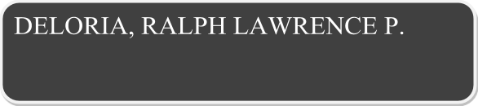

|  |  |  |  |  |  |  |  |  |  |  |  |  |
| --- | --- | --- | --- | --- | --- | --- | --- | --- | --- | --- | --- | --- |
| **CONTACT DETAILS** | | | | | | | | | | | | |
| **Telephone Nos.** | 02-5626915 | | | **Mobile No.** | | | | |  | | | |
| **Email Address** | rpdeloria@gmail.com | | | | | | | | | | | |
|  | | | | | | | | | | | | |
| **PERSONAL INFORMATION** | | | | | | | | | | | | |
| **Present Address** | 0966 Hanging Bridge st. lambakin marilao bulacan | | | | | | | | | | **Age** | 22 |
| **Date of Birth** | 03/01/1996 | | **Place of Birth:** | | Marilao | | | | | | **Sex** | M |
| **Citizenship** | Filipino | **Civil Status** | | Single | | **Height** | | | 182 cm | | **Weight** | 176 lbs |
| **Name of Father** | Rolando E. Deloria | | | | | **Occupation** | | | Consultant | | | |
| **Name of Mother** | Leonora P. Deloria | | | | | **Occupation** | | | Examiner | | | |
| **Languages/ Dialects Spoken** | Filipino, English | | | | | | | | | | | |
| **Person to be Notified In Case of Emergency** | | | | | | | | | | | | |
| **Name** | Rolando E. Deloria | | | | | | **Contact Nos.** | | | 09216410603 | | |
| **Address** | 0966 Hanging Bridge St. Lambakin Marilao Bulacan | | | | | | | | | | | |
|  |  | | | | | | | | | | | |
| **EDUCATION** | | | | | | | | | | | | |
| **TERTIARY** | | | | | | | | | | | | |
| **Name of School** | **FEU- Institute of Technology** | | | | | | | **Course** | | | BSCSSE | |
| **SECONDARY** | | | | | | | | | | | | |
| **Name of School** | **Team Mission Christian School** | | | | | | | **Year Graduated** | | | 2013 | |
| **PRIMARY** | | | | | | | | | | | | |
| **Name of School** | **Team Mission Christian School** | | | | | | | **Year Graduated** | | | 2009 | |
|  |  | | | | | | |  | | |  | |
| **SOFTWARE SKILLS** | | | | | | | | | | | | |
| * Adobe (Illustrator, Photoshop, Fireworks, Flash, After Effects) * Microsoft Office(Word, Powerpoint, Visio, Picture Manager) * Notepad/ Notepad++ * Oracle Database * Data Modeler | | | | | | | | | | | | |
| **ORGANIZATIONS** | | | | | | | | | | | | |
| * ACM | | | | | | | | | | | | |



|  |  |  |  |  |  |  |  |  |  |  |  |  |
| --- | --- | --- | --- | --- | --- | --- | --- | --- | --- | --- | --- | --- |
| **CONTACT DETAILS** | | | | | | | | | | | | |
| **Telephone Nos.** | 938-3460 | | | **Mobile No.** | | | | | 09278949690 | | | |
| **Email Address** | [gborjal01@gmail.com](mailto:gborjal01@gmail.com), ggborjal@up.edu.ph | | | | | | | | | | | |
|  | | | | | | | | | | | | |
| **PERSONAL INFORMATION** | | | | | | | | | | | | |
| **Present Address** | Blk. 4 Lot 1 Phase 1C Rambutan St. cor. Santol Drive, Palmera Homes, Quezon City | | | | | | | | | | **Age** | 26 |
| **Date of Birth** | 02/04/1993 | | **Place of Birth:** | | Quezon City | | | | | | **Sex** | M |
| **Citizenship** | Filipino | **Civil Status** | | Single | | **Height** | | | 5”4’ | | **Weight** |  |
| **Name of Father** | **Luis M. Borjal** | | | | | **Occupation** | | | **Pasor, Consultant, CPA** | | | |
| **Name of Mother** | **Wilhelmina Gatmaitan Borjal** | | | | | **Occupation** | | | **Dean, San Lorenzo** | | | |
| **Languages/ Dialects Spoken** | Filipino, English, Nihongo | | | | | | | | | | | |
| **Person to be Notified In Case of Emergency** | | | | | | | | | | | | |
| **Name** | **Luis M. Borjal** | | | | | | **Contact Nos.** | | | 09193515587 | | |
| **Address** |  | | | | | | | | | | | |
| **EDUCATION** | | | | | | | | | | | | |
| **TERTIARY** | | | | | | | | | | | | |
| **Name of School** | **University of the Philippines Los Banos FEU-Institute of Technology** | | | | | | | **Course** | | | **BSCS BSCSSE** | |
| **SECONDARY** | | | | | | | | | | | | |
| **Name of School** | **University of the Philippines Integrated School** | | | | | | | **Year Graduated** | | | **2010** | |
| **PRIMARY** | | | | | | | | | | | | |
| **Name of School** | **University of the Philippines Integrated School** | | | | | | | **Year Graduated** | | | **2006** | |
| **TECHNICAL SKILLS** | | | | | | | | | | | | |
| * **Programming Languages**: C/C#/C++ | Java | Perl | Assembly | .net Platform | R * **Scripting Languages**: PHP | JavaScript * **Markup and Style sheet Languages**: XHTML/HTML5 | CSS/CSS3 * **Database**: MySQL |PostgreSQL | Oracle SQL * **Operating Systems**: Windows XP/Vista/7/10 |Ubuntu * **Applications**: Microsoft SQL Server | Perforce | Microsoft Office | Adobe Photoshop * **Frameworks**: Laravel v5.1 | JQuery | Materialize CSS | | | | | | | | | | | | |
| **ORGANIZATIONS** | | | | | | | | | | | | |
| * UPLB Computer Science Society | | | | | | | | | | | | |



|  |  |  |  |  |  |  |  |  |  |  |  |  |
| --- | --- | --- | --- | --- | --- | --- | --- | --- | --- | --- | --- | --- |
| **CONTACT DETAILS** | | | | | | | | | | | | |
| **Telephone Nos.** |  | | | **Mobile No.** | | | | | 09358668067 | | | |
| **Email Address** | demereyrheyvinkarl@yahoo.com | | | | | | | | | | | |
| **PERSONAL INFORMATION** | | | | | | | | | | | | |
| **Present Address** | Sitio Sapang Bayu, Mandili, Candaba, Pampanga | | | | | | | | | | **Age** | 19 |
| **Date of Birth** | May 22,1999 | | **Place of Birth:** | | Davao City | | | | | | **Sex** | M |
| **Citizenship** | Filipino | **Civil Status** | | Single | | **Height** | | |  | | **Weight** |  |
| **Name of Father** | Ronald A. Demerey | | | | | **Occupation** | | | Freelance Photographer | | | |
| **Name of Mother** | Vilma L. Demerey | | | | | **Occupation** | | |  | | | |
| **Languages/ Dialects Spoken** | English and Tagalog | | | | | | | | | | | |
| **Person to be Notified In Case of Emergency** | | | | | | | | | | | | |
| **Name** | Vilma L. Demerey | | | | | | **Contact Nos.** | | | 09263953904 | | |
| **Address** | Sitio Sapang Bayu, Mandili, Candaba, Pampanga | | | | | | | | | | | |
| **EDUCATION** | | | | | | | | | | | | |
| **TERTIARY** | | | | | | | | | | | | |
| **Name of School** | FEU Institute of Technology | | | | | | | **Course** | | | BSCSSE | |
| **SECONDARY** | | | | | | | | | | | | |
| **Name of School** | The Nazarene Catholic School | | | | | | | **Year Graduated** | | | 2016 | |
| **PRIMARY** | | | | | | | | | | | | |
| **Name of School** | The Nazarene Catholic School | | | | | | | **Year Graduated** | | | 2012 | |
|  |  | | | | | | |  | | |  | |
| **SOFTWARE SKILLS** | | | | | | | | | | | | |
| * Adobe (Illustrator, Photoshop, Fireworks, Flash, After Effects) * Microsoft Office(Word, Powerpoint, Visio, Picture Manager) * Notepad/ Notepad++ * Oracle Database * Data Modeler | | | | | | | | | | | | |
| **ORGANIZATIONS** | | | | | | | | | | | | |
| * Artist Connection * Web.IT * YFC | | | | | | | | | | | | |



|  |  |  |  |  |  |  |  |  |  |  |  |  |
| --- | --- | --- | --- | --- | --- | --- | --- | --- | --- | --- | --- | --- |
| **CONTACT DETAILS** | | | | | | | | | | | | |
| **Telephone Nos.** | 099899 | | | **Mobile No.** | | | | | 09989927060 | | | |
| **Email Address** | au.dave@ymail.com | | | | | | | | | | | |
| **PERSONAL INFORMATION** | | | | | | | | | | | | |
| **Present Address** | Room 303, 670 Tomas Mapua St. Sta. Cruz Manila | | | | | | | | | | **Age** | 30 |
| **Date of Birth** | 12/21/1989 | | **Place of Birth:** | | Manila, Philippines | | | | | | **Sex** | M |
| **Citizenship** | F | **Civil Status** | | Single | | **Height** | | | 5’8” | | **Weight** | 81 |
| **Name of Father** | Dennis Au | | | | | **Occupation** | | | Engineer | | | |
| **Name of Mother** | Ellen Au | | | | | **Occupation** | | | Housewife | | | |
| **Languages/ Dialects Spoken** | Filipino, Mandarin | | | | | | | | | | | |
| **Person to be Notified In Case of Emergency** | | | | | | | | | | | | |
| **Name** | Ellen Au | | | | | | **Contact Nos.** | | |  | | |
| **Address** | 1507 Jose Abad Santos, Tondo Manila | | | | | | | | | | | |
| **EDUCATION** | | | | | | | | | | | | |
| **TERTIARY** | | | | | | | | | | | | |
| **Name of School** | **CHIANG KAI SHEK COLLEGE** | | | | | | | **Course** | | | BCSC | |
| **SECONDARY** | | | | | | | | | | | | |
| **Name of School** | **CHIANG KAI SHEK COLLEGE** | | | | | | | **Year Graduated** | | | 2008 | |
| **PRIMARY** | | | | | | | | | | | | |
| **Name of School** | **UNO HIGH SCHOOL/PHILIPPINE CULTURAL HIGH SCHOOL** | | | | | | | **Year Graduated** | | | 2002 | |
|  |  | | | | | | |  | | |  | |
| **SOFTWARE SKILLS** | | | | | | | | | | | | |
| * Microsoft Visual Basic * Microsoft Office (Word, Powerpoint, Visio, Picture Manager) * HTML/PHP * Oracle Database\SQL | | | | | | | | | | | | |
| **ORGANIZATIONS** | | | | | | | | | | | | |
| * ACM | | | | | | | | | | | | |