**INTI International College Penang School of Computing**

**3+0 Bachelor of Science (Hons) in Computer Science, in collaboration with Coventry University, UK**

# Coursework cover sheet

**Section A - To be completed by the student.**

|  |  |
| --- | --- |
| Full Name: SHARON TAN | |
| CU Student ID Number: 14007547 | |
| Semester: 2 | |
| Session:  **April 2023** | |
| Lecturer:  **Puteri Nursyawati Azzuri (puteri.azzuri@newinti.edu.my)** | |
| Module Code and Title:  **4067CEM Software Design** | |
| Assignment No. / Title:  **Continuous Assessment** | % of Module Mark:  **50** |
| Hand out Date:  **12 May 2023** | Due Date:  **Task 1: 04 June 2023, by 11.59pm.**  **Task 2: 07 July 2023, by 11.59pm**  **Task 3: 23 June 2023, by 11.59pm.**  **Task 4: 23 June 2023, by 11.59pm.**  **Task 5: 23 June 2023, by 11.59pm.** |
| Penalties: No late work will be accepted. If you are unable to submit coursework on time due  to extenuating circumstances, you may be eligible for an extension. Please consult the lecturer. | |
| Declaration: I/we the undersigned confirm that I/we have read and agree to abide by the University regulations on plagiarism and cheating and Faculty coursework policies and procedures. I/we confirm that this piece of work is my/our own. I/we consent to the appropriate storage of our work for plagiarism checking.  Signature(s): | |

# Section B - To be completed by the module leader

|  |  |  |
| --- | --- | --- |
| Intended learning outcomes assessed by this work:   1. Understand and apply appropriate concepts, tools, and techniques to each stage of the software development. 2. Understand and apply design patterns to software components in developing new software. 3. Demonstrate an understanding of project planning and working to agreed deadlines, along with professional, interpersonal skills and effective communication required for software production.   5. Demonstrate an awareness of, and ability to apply, social, professional, legal, and ethical standards as documented in relevant laws and professional codes of conduct such as that of  the Malaysian National Computer Confederation. | | |
| Marking scheme | Max | Mark |
| 1. User Story Mapping | 20 |  |
| 2. Setting up a GitHub |  |
| Repository | 10 |
| 3. Creating a Class diagram and |  |
| design pattern selection | 30 |
| 4. Creating a Prototype User |  |
| Interface and Usability Testing | 20 |
| 5. Discuss the ethical issue |  |
| related to the software | 20 |
| Total | 100 |  |

**Table of Contents**

|  |  |  |
| --- | --- | --- |
| No. | Title | Page |
| 1. | Introduction | 1 |
| 2. | Task 1 – User Story Mapping | 2 - 6 |
| 3. | References | 7 |
|  |  |  |
|  |  |  |

**Introduction**

This assessment is focused on designing a Student Business System for College. The term ‘business’ comes with different definitions. Based on Cambridge Dictionary, business means the commercial activities carried out by someone to earn profits by providing goods and services. On the other hand, it can also be defined as things or activities to do that are related to someone. In further research, it is found that the term ‘Student Business System’ is used by Australian National University and Swinburne University of Technology as a system providing administration and academic services for their students.

There are 5 tasks to be completed as for the design process. The assessment begins with the feedback collection from at least 10 real users for the features and functionalities of the system. Information collected is then interpreted to generate a user story mapping. A class diagram is then designed with the clarification of each class’s responsibilities. Based on that, a Unified Modelling Language (UML) diagram is created with a suitable design pattern. Now the process comes to the task of prototyping and followed by list out questions for usability testing. After all of the above tasks are done, an analysis needs to be carried out critically about the ethical issues of the system. Lastly, a GitHub repository is created to organize all the works and make sure not exceeding the due date.

Overall, this assessment is planned to create comprehensive designs for the Student Business System for College mainly based on the preferences of real users, the college students. For example, user story mapping, UML diagram as the class diagram and the prototype. The purpose of this system is to enhance the effectiveness of a college institution as well as improve student experiences.

**Task 1 – User Story Mapping**

**1.0 Data collection**

Google Forms is used in this assessment to collect the feedback of real users toward the Student Business System for College. The link is sent through conversations and extra information is given when the respondents meet any problems or questions when answering the survey forms. As a result, there are 15 responses with at least 10 different features hoped by them as a user. The survey form is closed after obtaining all the required information.

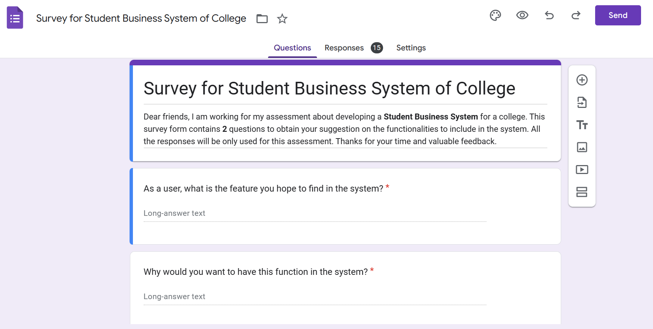

**1.1 Data Categorization**

As there are some similar responses in the survey forms for the features in question 1, hence Trello is used for better organization and categorization. The answers of question 1 are used as the list’s title and respective answers in question 2 are recorded in the card.

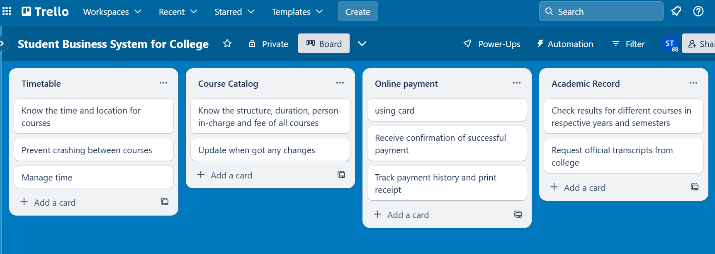

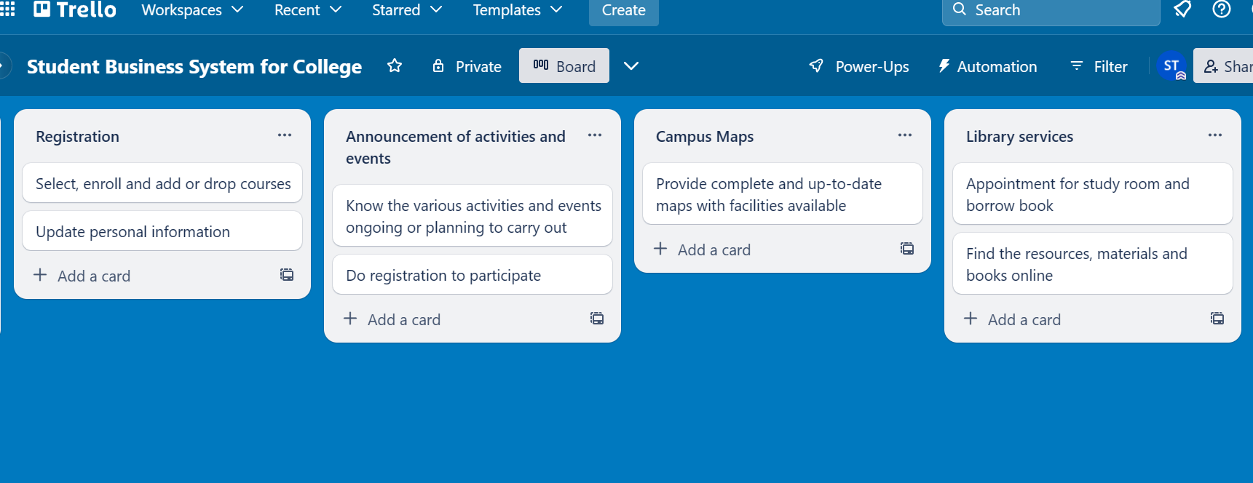

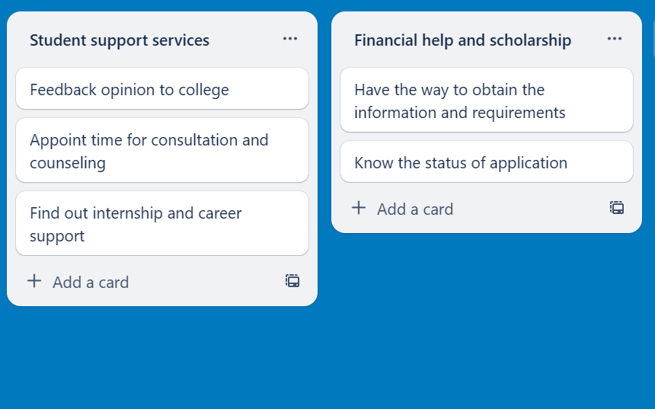

**1.2 User stories and Backlog**

Based on what has been done in Trello, 10 user stories and respective backlog are generated with small modifications for fluency. Basically, the different features in the title are used as the activities to be performed by users and the reasons for having these features in the card are the goals aimed to achieve.

User Stories

1. As a user, I want to look for my timetable so that I can know the time and location for courses, prevent crashing between courses and better time management.

2. As a user, I want to find out the course catalog so that I can know the structure, duration, person-in-charge and fee of all courses. Update is needed when there are any changes.

3. As a user, I want to pay the fees online by using cards so that I can easily track payment history and print receipts. I hope to receive confirmation after a successful payment.

4. As a user, I want to check my academic record so that I can access my results for different courses in specific years and semesters and also request official transcripts from college.

5. As a user, I want to do my registration so that I have the ability to select the courses to enroll, add or drop. I also hope that I can update my personal information.

6. As a user, I want to receive the announcements of activities and events so that I can participate by quickly registering for the various activities and events that are ongoing or planned to be carried out by college.

7. As a user, I want to access complete and up-to-date online campus maps so that I get familiar with campus faster. The maps should include all the facilities available as well.

8. As a user, I want to access library services online so that I can quickly find the resources, materials and books in the library. I hope there is also an appointment feature for a study room and borrowing book.

9. As a user, I want to easily access student support services so that I can provide feedback to college, schedule consultations or counseling sessions and also find information about internships and career opportunities.

10. As a user, I want to find out information about financial aids and scholarships so that I can obtain requirements for application and track the status of application.

Backlog

Goals:

1. Know the time and location for courses, prevent crashing between courses and better time management.

2. Know the structure, duration, person-in-charge and fee of all courses with updates when there are any changes.

3. Easily track payment history, print receipt and receive confirmation after a successful payment.

4. Access results for different courses in specific years and semesters and also request official transcripts from college.

5. Have ability to select the courses to enroll, add or drop and update personal information.

6. Participate by quickly registering for the various activities and events that are ongoing or planning to carry out by college.

7. Get familiar with campus faster with the maps including all the facilities available.

8. Quickly find the resources, materials and books in the library besides appointment for study room and borrowing book.

9. Provide feedback to college, schedule consultations or counseling sessions and also find information about internships and career opportunities.

10. Obtain requirements for application and track the status of application.

Activities:

1. Look for a timetable.

2. Find out the course catalog.

3. Pay fees online by using cards.

4. Check academic record.

5. Do registration.

6. Receive announcements of activities and events.

7. Access complete and up-to-date online campus maps.

8. Access library services online.

9. Easily access student support services.

10. Find out information about financial aids and scholarships.

Tasks:

1. Timetable page – Select year and semester

2. Catalog page – Select a course from the list

3. Payment page – Pay for selected courses

4. Academic page – Select year and semester

5. Log In – Personal information – Enrollment page – Select courses

6. Activities and Events page – Click on an activity or event

7. Maps page – Click on different blocks or floors

8. Library page

9. Student support services page

10. Financial Aids and Scholarships page – Select a financial aids or scholarship program

**1.3 User Story Mapping**

For the next step, Figma is utilized to create the user story mapping to provide a complete overview of the system. It included sections of person, goals, activities, tasks and releases. Each of the sections is represented using distinct colours of sticky notes. The arrangement of sticky notes is important to clarify the relationship between each other.

<https://www.figma.com/file/dtc90gPX9GJrDijUBtsA6x/Student-Business-System-for-College?type=whiteboard&node-id=0%3A1&t=nEPkMrroz4vzxCXg-1>

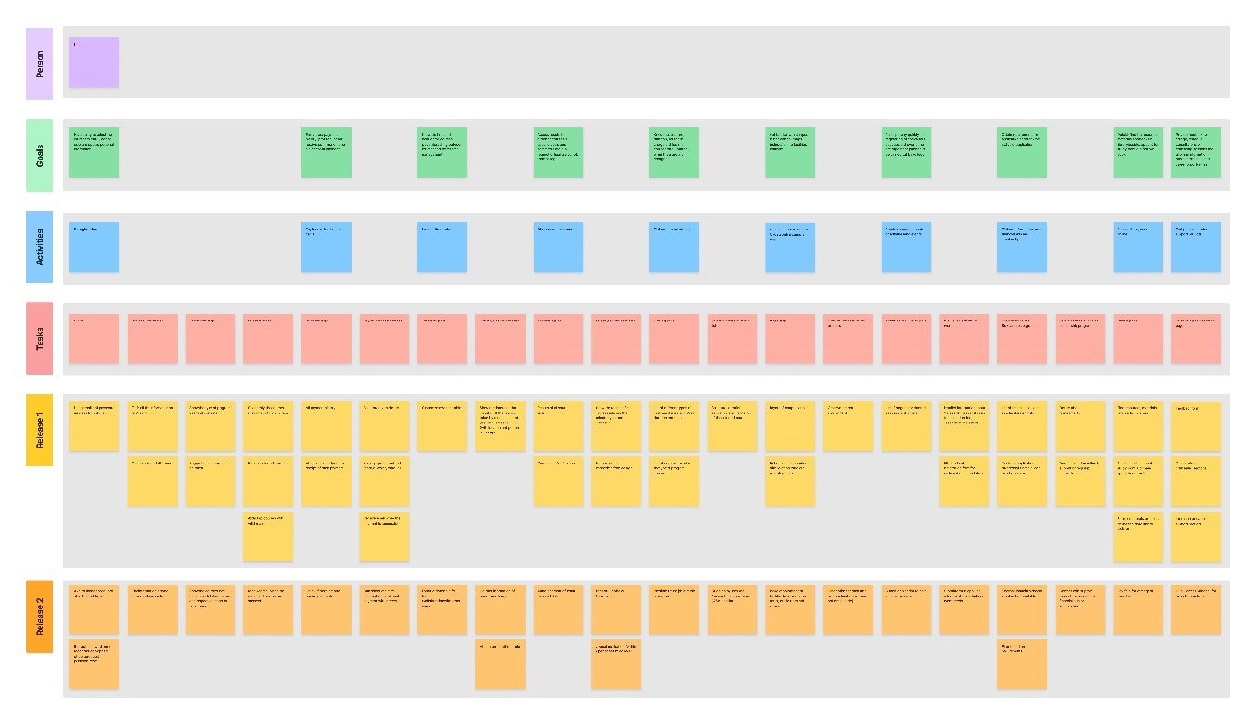

**References**

<https://dictionary.cambridge.org/dictionary/english/business>

<https://www.swinburne.edu.my/student-engagement/student-business-systems>

<https://services.anu.edu.au/business-units/division-of-student-administration/student-business-systems>