**Mini Crossword (0/5/18)  
  
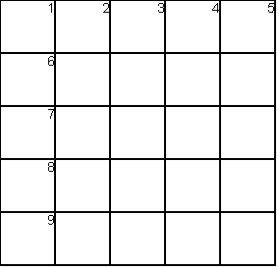**

|  |  |
| --- | --- |
| **ACROSS** | **DOWN** |
| 1. | 1. |
| 6. | 2. |
| 7. | 3. |
| 8. | 4. |
| 9. | 5. |