Supplementary Information

Coding club UoE Psychiatry

Shen X. et al.

## Introduction

### Reasons to quit using word for your supplementary materials

* It is often full of tables and figures.
* You probably can’t avoid redoing analysis.
* Really easy to track down if you’ve put the right versions of figures/tables in.
* It is cool. It makes me feel as if I’m a hacker.

### Let me guess your worries

* Will it take too long?
* Is it too hard to learn?

### Important things that are not covered in this documention

* Be familiar with rmarkdown.
* Organise analyses and results from the very beginning1,2. Make it structured and easy to extend.

## Preparation

### Files

* Reference for word style: .docx
* Citation: .bib and .csl
* Others: results, figures, etc.

### Main steps

* Create a basic word doc style
* Write the text and add citations
* Add tables and fingures

## Reference for word doc style

### Define output format in Yaml

An example:

---  
title: "Supplementary Information"  
subtitle: "Coding club UoE Psychiatry"  
author: "Shen X. et al."  
  
output:   
 word_document: # render into a docx file  
---

### Write an example rmarkdown file

Write a rmarkdown file with all levels of headings and text body. Render it into a docx file.

Open the docx file and edit the styles. Save the copy in a name, for example, ‘ref_style.docx’.

Step 1:

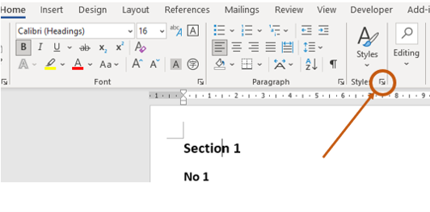

Step 2:

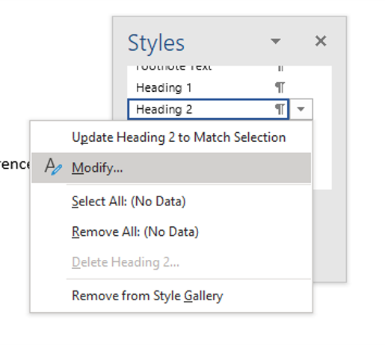

Step 3:

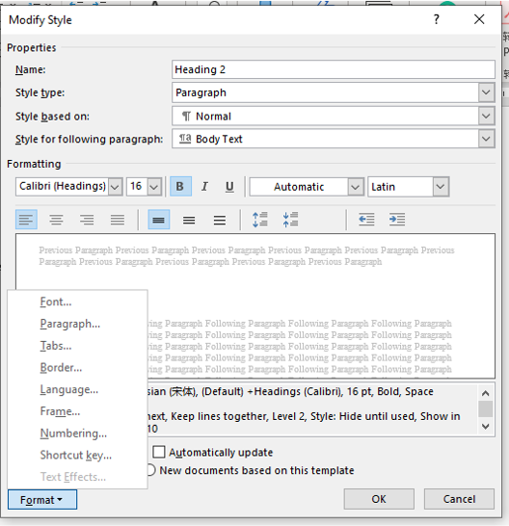

### Update reference file in Yaml

---  
title: "Supplementary Information"  
subtitle: "Coding club UoE Psychiatry"  
author: "Shen X. et al."  
  
output:   
 word_document: # render into a docx file  
 reference_docx: ref_style.docx # your reference file *  
---

## Add citation

[This video](https://www.youtube.com/watch?v=yk54_j3-4RM&lc=Ugy7Tdgx3VKewIzTngZ4AaABAg.9MvWztiBs3J9Mwg16gpER2) is helpful.

### Select citation style

Find and download the .csl for your chosen citation style from [here](https://github.com/citation-style-language/styles).

Update Yaml.

---  
title: "Supplementary Information"  
subtitle: "Coding club UoE Psychiatry"  
author: "Shen X. et al."  
  
output:   
 word_document: # render into a docx file  
 reference_docx: ref_style.docx # your reference file  
csl: nature.csl # citation style *  
---

### In-text citation

#### Add citations to the bibliography file

Create a plain text file named, for example, ‘bibliography.bib’.

Find doi, and put it in [the website](https://www.doi2bib.org/) to get bib text.

Copy and paste the bib text to ‘bibliography.bib’.

#### Add citations to the main text

Cite using ‘@keyword’ in text. The keyword can be found in the bib text.

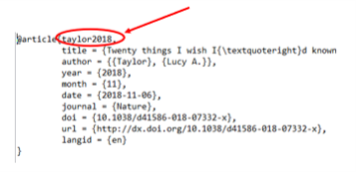

## Add tables and figures

Figures are straightforward. Often tables can’t be rendered well in a word file. I often use [‘flextable’.](https://ardata-fr.github.io/flextable-book/)

For example:

| **am** | **carb** | **gear** | **mpg** | **drat** |
| --- | --- | --- | --- | --- |
| 1 | 4 | 4 | 21.0 | **3.90** |
| 1 | 4 | 4 | 21.0 | **3.90** |
| 1 | 1 | 4 | 22.8 | **3.85** |
| 0 | 1 | 3 | 21.4 | 3.08 |
| 0 | 2 | 3 | 18.7 | 3.15 |
| 0 | 1 | 3 | 18.1 | 2.76 |

## References

1. Taylor, L. Twenty things i wish i’d known when i started my phd. *Nature* (2018) doi:[10.1038/d41586-018-07332-x](https://doi.org/10.1038/d41586-018-07332-x).

2. Veuthey, T. & Thompson, S. Why you need an agenda for meetings with your principal investigator. *Nature* **561**, 277–277 (2018).

##### 