Response to Reviewers

Response to Reviewers
Manuscript: Glacial–interglacial regime shift in Southern Ocean dense water formation Authors: Xiaoxu Shi, Jiping Liu, Chaoyuan Yang, Gerrit Lohmann
We thank the editor and the four reviewers for their detailed and constructive comments, which helped a lot improve the manuscript. A queation is pointed out, namely the comparision between our pre-industrial result and observation-based transformation estimates for the modern Southern Ocean. We took that seriously and ran the diagnostic tests that Reviewers 2 and 3 proposed. The result is more informative than we expected.
We firstly compare our result with the classic WMT observation from Pellichero et al. (2018). In our manuscript, 43% of the studied area we integrated over lies outside the sea ice edge and is therefore water region that Pellichero et al. did not include. After we apply WMT analysis over the same domain and the same season as Pellichero et al. did, we got a WMT curve similar as theirs, and freshwater component dominate the light water class (< 27.1 kg/m3) and the dense water class (> 27.67 kg/m3) , while the thermal signature is confined to a band at intermediate water densities. Thus the driving component for WMT is actually mixed. The second reason is that, Pellichero et al. used 什么数据/数据本身有什么不确定性，然后说明他们是怎么计算heat flux term的，这个计算的对象跟我们的surface flux不完全是一个东西，所以差别在所难免。另外他们的freshwater term跟我们是一回事吗？Note that Southern Ocean is more warm and too fresh near Antarctica compared to observation, a bias shared by most coupled models, this pushes our WMT curve toward lighter density than the Pellichero et al. describe (也就是wmt curve相对他们来说是整体向轻的density方向移动的). We now state this plainly. What the paper claims, however, is the relative change between climate states rather than the absolute values. On that basis we consider the regime shift robust, and we have bounded the rest of our claims accordingly.
We then compare our result with the ORAS5 reanalysis data for 1990-2018 which they claim is Argo 覆盖最好的时段，同化约束最强。由于oras5没有海冰项，所以我们也相应去除。the results show that, 不管是 sea ice region annual mean，与pellichero同口径, 还是jja mean，60s以南，与我们文章同口径，我们的结果与oras5相似（这里具体展开说说）
For convenience the principal new figures are reproduced in this letter, so that the reviewers can assess them conveniently.
Reviewer comments are reproduced in full below in black, each followed by our response in blue; text quoted from the revised manuscript is given in blue italics. Line numbers in our responses refer to the revised manuscript unless stated otherwise. All changes are marked in the accompanying tracked-changes file.

Response to comments by Reviewer #1
The manuscript presents a comprehensive investigation of Southern Ocean dense water formation across a range of glacial and interglacial climates using the AWI-ESM2 Earth system model. By applying a water mass transformation (WMT) framework, the authors successfully separate the relative roles of thermal and haline buoyancy forcing and demonstrate a compelling regime shift between interglacial and glacial climates. The manuscript is well structured, the analyses are technically rigorous, and the decomposition of the different buoyancy contributions provides valuable physical insight. The use of WMT diagnostics allows the underlying mechanisms to be quantified rather than inferred from changes in circulation alone. Overall, I found the study scientifically interesting and suitable for publication after major revisions. My comments below are primarily intended to strengthen the robustness of the conclusions and improve the clarity of the presentation.
We thank the reviewer for the constructive general comments and a thorough list of specific comments.

General comments

Model evaluation and confidence in simulated dense water formation
The conclusions of this study rely entirely on a single Earth system model. While I do not consider this to be a major limitation by itself, I think the manuscript would benefit from a more thorough discussion of how well AWI-ESM2 represents present-day Southern Ocean dense water formation and Antarctic Bottom Water formation. The manuscript briefly states that the PI simulation produces comparable WMT magnitudes to observational estimates, but Figure A4 only shows the model results, making it difficult for the reader to evaluate this statement. Given the importance of the model for all subsequent paleoclimate interpretations, I encourage the authors to provide stronger evidence supporting its performance. This could include a direct comparison with observational WMT estimates, or a more detailed discussion of known model strengths and biases in Southern Ocean stratification, sea ice, mixed-layer depth, and Antarctic Bottom Water formation. Even if such comparisons already exist in previous AWI-ESM2 publications, briefly summarising them here would substantially increase confidence in the conclusions.
Authors' response:
We agree with the reviewer. This concern also overlaps with those from Reviewers 2 and 3. Our response has three parts.
The reviewer is right that Figure A4 showed only model curves. We now place our pre-industrial transformation beside the observation-based estimate of Pellichero et al. (2018). The result of Pellichero et al. comes from Argo floats, ship-based observations and instrumented marine mammals, the only platform that samples under winter sea ice; the ice edge comes from SMMR and SSM/I passive microwave data for 2000-2015, and the geostrophic term from AVISO mean dynamic topography for 1993-2012. We cannot reproduce that calculation, because it rests on a seal-tag mixed layer database those authors assembled and we do not have. We have therefore compared our figure against their published figure.
To match Pellichero et al. (2018) , we recomputed our transformation over the same sector enclosed by the September 15% sea ice concentration, and took the annual mean instead of the austral winter mean used elsewhere in our manuscript.

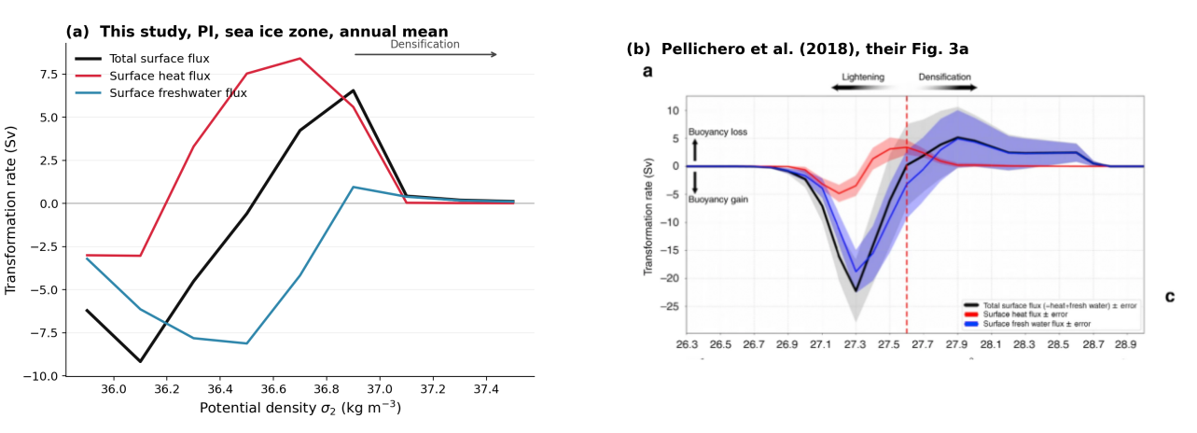
Figure R1.1 (new analysis). (a) Simulated pre-industrial transformation in the seasonal sea ice zone, annual mean, decomposed into the heat and freshwater contributions. (b) The observational estimate of Pellichero et al. (2018), their Fig. 3a, reproduced for comparison. The density axes differ deliberately: ours is potential density σ₂, theirs neutral density γ. Our simulated surface water is lighter than observed, so plotting both on one axis would imply a point-by-point correspondence that does not exist.(这张图更新)
As seen in Fig. R1.1a-b, the two curves share their structure. Both show buoyancy gain at the lighter classes, a zero crossing, and densification at the heavier classes, with the freshwater term carrying the light end and both curves converging towards zero at the dense end. Freshwater component dominate the light water class (< 27.1 kg/m3) and the dense end (> 27.67 kg/m3) (blue shading in Fig. R1.1a), while the thermal signature is confined to a band at intermediate water densities (pink shading in Fig. R1.1a). In our pre-industrial state the transformation reaches a minimum of -9.2 Sv, crosses zero, and peaks at +6.6 Sv; Pellichero et al. report a minimum near -22 Sv and a densification peak of 5±5 Sv. The sign structure and the order of magnitude of the densification branch therefore agree.
Two differences should be noted, and they are of different kinds. Our light-end buoyancy gain is weaker than theirs, and our whole curve sits at lighter densities, because the simulated Southern Ocean surface is fresher than observed; both follow from the same bias, which we quantify under model limitations below.
It should be noted that the difference could be definitional, and it sets a floor on how closely the two can ever agree. Pellichero et al. solve the mixed layer heat and salt budgets for the surface fluxes as the unknown, using the observed seasonal cycle of mixed layer temperature, salinity and depth together with Ekman and geostrophic advection and entrainment. Thus, what Pellichero et al. solve for is the surface flux together with the diapycnal mixing term, because the mixed layer budget cannot separate them, whereas our model diagnoses the surface flux alone. Some discrepancy is therefore expected before any model bias is considered, and the agreement in shape should be read in that light.
The reviewer, and Reviewer 3, also asked whether we could compute an observational transformation ourselves from a reanalysis rather than citing a published one. A transformation budget needs the net surface heat flux, the net surface freshwater flux, and the sea ice thermodynamic salt flux. We checked the Copernicus ocean reanalyses, namely GLORYS12, the GREP ensemble and the analysis-forecast product, which carry temperature, salinity, velocity and sea ice state but no surface flux fields at all. ORAS5 does carry a net heat flux and a net water flux but excluding the sea ice term. Therefore, we calculate transformation based on ORAS5, and for consistency, we also remove the sea ice term from our model, then compare our model results with ORAS5.
The results are shown in Fig. R1.1c-f. (这里展开讲讲具体对比)

Another point from the reviewer is about the discussion of known model strengths and biases in Southern Ocean stratification, sea ice, mixed-layer depth, and Antarctic Bottom Water formation. Since the second last comment of the reviewer specifically deals with "Model limitations", we refer to our response to that comment.

Boundary conditions
The description of the prescribed boundary conditions for the paleoclimate simulations could be expanded. In particular, the glacial simulations use the GLAC-1D ice-sheet reconstruction, but it is not entirely clear how the ice-sheet changes are implemented in the model (e.g., topography, land-sea mask, ice-sheet extent, bathymetry, or other boundary conditions). As Antarctic dense water formation is highly sensitive to such factors, providing additional details on the experimental setup would help readers assess the robustness of the simulations. This is not a request for additional simulations, but rather for a clearer discussion of the robustness of the conclusions and the extent to which they may depend on the chosen model configuration and forcing datasets. A summary table listing the prescribed greenhouse gas concentrations, orbital parameters, and ice-sheet boundary conditions for each experiment would also improve the readability of the Methods section.
Following the reviewer's suggestion, we have provided a summary table (Table R1, manuscript Table 1), which lists the greenhouse gas concentrations, orbital parameters and ice sheet configuration for all five experiments. The values are those actually used in the runs rather than the protocol defaults.
center
 | CO₂ (ppm) | CH₄ (ppb) | N₂O (ppb) | Eccentricity | Obliquity (°) | Perihelion (°) | Ice sheet / bathymetry
PI | 284.3 | 808.2 | 273.0 | 1850 CE | 1850 CE | 1850 CE | modern
MH | 264.4 | 597.0 | 262.0 | 0.018682 | 24.105 | 180.87 | modern
LIG | 275.0 | 685.0 | 255.0 | 0.039378 | 24.040 | 95.41 | modern
LGM | 190.0 | 375.0 | 200.0 | 0.018994 | 22.949 | 294.42 | GLAC-1D 21 ka
MIS3 | 210.5 | 556.2 | 247.4 | 0.013676 | 23.2591 | 25.99 | GLAC-1D 38 ka
center
Table R1. Boundary conditions prescribed in the five equilibrium simulations. Orbital parameters for PI are those of 1850 CE. Greenhouse gas concentrations are volume mixing ratios.
We also expanded the text describing the boundary conditions used in the experimental design, especially the implementation of the GLAC-1D ice-sheet reconstruction. Now reads:
“We perform five equilibrium simulations spanning distinct climate states including three interglacial periods, i.e., pre-industrial (PI), mid-Holocene (MH), and last interglacial (LIG), and two glacial periods, i.e., the Last Glacial Maximum (LGM) and Marine Isotope Stage 3 (MIS3). The boundary conditions are configured following the criteria of PMIP4 and are summarised in Table 1. Orbital parameters are calculated following , and the greenhouse gas concentrations are taken from multi-archive reconstructions from ice core records and recent measurements of firn air and atmospheric samples . For LGM and MIS3, we fix the boundary conditions at 21 ka and 38 ka respectively, with the topography and ice-sheet properties deriving from the GLAC1D reconstruction . The GLAC-1D reconstruction enters the model through several boundary fields at once, and it is clearest to list them by the component that uses them. Specifically, the atmosphere component receives the ice sheet extent and surface elevation as orography, together with the land-sea mask implied by the lowered sea level. The land surface receives the same topography, from which river routing and vegetation distribution are derived. The ocean component receives bathymetry and a modified coastline. Because the ocean component uses an unstructured mesh, a changed coastline cannot be imposed on the existing grid and a dedicated mesh must be generated for each glacial period; we use meshes constructed for 21 ka and 38 ka respectively, while PI, MH and LIG share the modern-geometry mesh. Global mean ocean salinity is raised in the glacial experiments to account for the water stored in the ice sheets. No prescribed ice sheet meltwater flux is applied in any of the equilibrium simulations, and the model does not include ice shelf cavities, so basal melt beneath floating ice shelves is not represented.”

Clarifying several interpretations
Most interpretations are convincing, although a few statements could be presented more carefully or supported more explicitly. For example, some descriptions of the role of the Southern Annular Mode appear stronger than the presented evidence suggests, and several discussions would benefit from more direct references to the relevant figure panels.
We have moderated the Southern Annular Mode claims. The most overstated passage was the suggestion that the simulated coupling implies a route to marine proxy reconstruction; we have replaced it with a more careful statement noting that the accumulation rates and chronological precision required are rarely available around the Antarctic margin, a point Reviewer 3 also raised. We have also removed the claim that the circumpolar picture holds uniformly and now state explicitly where it does not, in particular the Ross Sea. Panel-level figure references have been added throughout, as requested in this comment and in comment 21.
In the revised manuscript the moderated passage now reads:
“Whether this persistent coupling could be exploited for proxy reconstruction is less clear than we previously suggested. Recovering an interannual-to-decadal signal from marine sediments would require accumulation rates and chronological precision that are rarely available around the Antarctic margin, where sedimentation is slow and bioturbation mixes the record over intervals far longer than the variability of interest. We therefore present the persistence of the coupling as a property of the simulated system rather than as a practical route to a marine Southern Annular Mode reconstruction.”

Model limitations
Model limitations: The manuscript convincingly demonstrates that sea ice drives the transition from a thermally dominated to a haline-dominated dense water formation regime. However, the discussion would benefit from a brief consideration of the known biases and limitations of AWI-ESM2, particularly regarding Southern Ocean sea ice, mixed-layer depths, and Antarctic Bottom Water formation. Discussing how these model characteristics may influence the proposed mechanism would help readers assess the robustness and broader applicability of the conclusions.
Authors' response:
This comment asks specifically about bias, where the general comment above asked about evaluation, so we treat the two separately. We take the three quantities the reviewer names in turn, and in each case compare the pre-industrial simulation against observations rather than against the other climate states.
Before doing so, one limitation underlies all three and is best stated once. We diagnosed where the model actually forms its dense water. In the pre-industrial simulation the Weddell sector accounts for 70 per cent of the area with a winter mixed layer deeper than 400 m south of 55°S and 97 per cent of the area deeper than 600 m, centred near 68°S in the interior of the gyre rather than over the shelf. This is open-ocean convection, not the shelf overflow pathway that operates in the real ocean. It is a limitation shared across the current model generation rather than particular to AWI-ESM2: Heuzé (2021) finds that 28 of 35 CMIP6 models form deep and bottom water by open-ocean convection that is too deep, too frequent or too extensive, with no model showing convincing shelf export in the Weddell Sea. We also now state that this configuration has no ice shelf cavities, so basal melt beneath floating ice is absent by construction.
Thanks for the comment. We now state the model limitation explicitly. We diagnosed where the model actually forms its dense water. In the pre-industrial simulation, the Weddell sector accounts for 70% of the area with a winter mixed layer deeper than 400 m south of 55°S, centred near 68°S in the interior of the gyre (see Figure R1.2). We note that this is a limitation shared across the current model generation. Heuzé (2021) finds that 28 of 35 CMIP6 models form deep and bottom water by open-ocean convection that is too deep, too frequent, or too extensive, with no model showing convincing shelf export in the Weddell Sea. We also now state that this configuration has no ice shelf cavities, so basal melt beneath floating ice is absent by construction.
The broad pattern is reproduced. Both the model and the reanalysis keep shallow mixed layers over most of the open Southern Ocean, deepen towards the Antarctic margin, and place the deepest water of the sector in the Atlantic sector. Where they part company is the Weddell gyre interior: the model opens a patch deeper than 400 m that the reanalysis does not have at all, and its Weddell sector mean is 128 m against 71 m. This is the open-ocean convection described above, and the comparison localises it rather than leaving it as an assertion.
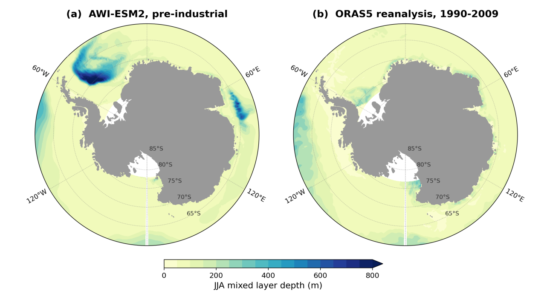
Figure R1.2 (new analysis). Winter mixed layer depth south of 60°S. (a) The pre-industrial simulation. (b) The ORAS5 ocean reanalysis, JJA climatology over 1990-2009. The large-scale pattern agrees: both are shallow over most of the open Southern Ocean, both deepen towards the Antarctic margin, and both show the deepest water of the sector in the Atlantic sector. The difference is where it matters for this study. The model places a large patch deeper than 400 m in the interior of the Weddell gyre, covering 1.9 per cent of the area south of 60°S against 0.0 per cent in the reanalysis, and its Weddell sector mean is 128 m against 71 m. Area-weighted over the whole sector the model gives 100 m against 78 m, so the bias is concentrated in the convecting patch rather than spread evenly. We note that the two use different mixed layer definitions, a 0.01 kg m⁻³ density threshold in ORAS5 and a bulk Richardson number criterion in the model, so the point-by-point difference is not purely model error.
In addition, the published evaluation reports that Antarctic sea ice in this configuration is too thin especially in the central Weddell Sea in September, and that the Southern Ocean carries a pronounced warm bias of 1.43 K. The abyssal overturning cell is reported at about 10 Sv, comparable to our pre-industrial value.
That cell is produced by the wrong pathway, as described above, so we present our results as a statement about how the partitioning of surface buoyancy forcing responds to changing ice cover, and explicitly not as a quantitative reconstruction of bottom water formation rates.
Taken together these are systematic biases. That matters for how the results should be read. Because the same bias is present in all five experiments, it largely cancels in the differences between them, which is what the paper actually reports. We make no claim about the absolute transformation rate or the absolute density at which it occurs; we claim that the balance between the thermal and haline pathways shifts between climate states, and a bias common to every state cannot generate that shift.
The corresponding passage added to the Discussion reads:
“Independent evaluations of this model provide context for these limitations, and we summarise the relevant points here rather than leaving them to be sought in the model description literature. Sidorenko et al. (2019) evaluate the coupled configuration against observations and report that the abyssal overturning cell associated with Antarctic Bottom Water is reproduced with a maximum of about 10 Sv, comparable to the pre-industrial value obtained here. The same evaluation identifies the Southern Ocean as the region of the most pronounced warm bias of 1.43 K against the PHC climatology at the resolution used here, and notes that Antarctic sea ice is too thin, hardly reaching 0.25 m in the central Weddell Sea in September. Their overall assessment is that although biases in the representation of water mass properties and ventilation mechanisms are present, the model still produces a reasonable density distribution that maintains realistic transports. A warm and thin-ice Southern Ocean is precisely the state in which open-ocean convection is favoured over shelf processes, so these documented biases are consistent with the convection behaviour we diagnose above.”

Latitude and longitude labels, and subpanel references
Please consider adding latitude and longitude labels to all map figures where appropriate. In addition, referring to specific figure subpanels throughout the text, rather than only the full figure number, would make the discussion easier to follow.
Subpanel references have been added throughout the Results and Discussion. On the map labels, the polar stereographic panels now carry labelled latitude circles, and the ventilation age maps carry labelled meridians as well. As a concrete example, the ventilation age maps now carry labelled meridians at 60°W, 0°, 60°E and 120°E as well as labelled latitude circles, and the mixed layer and composite figures carry labelled latitude circles; Figure R1.3 in this letter shows the result. The same treatment has been applied to every map figure in the revised manuscript and supplement.
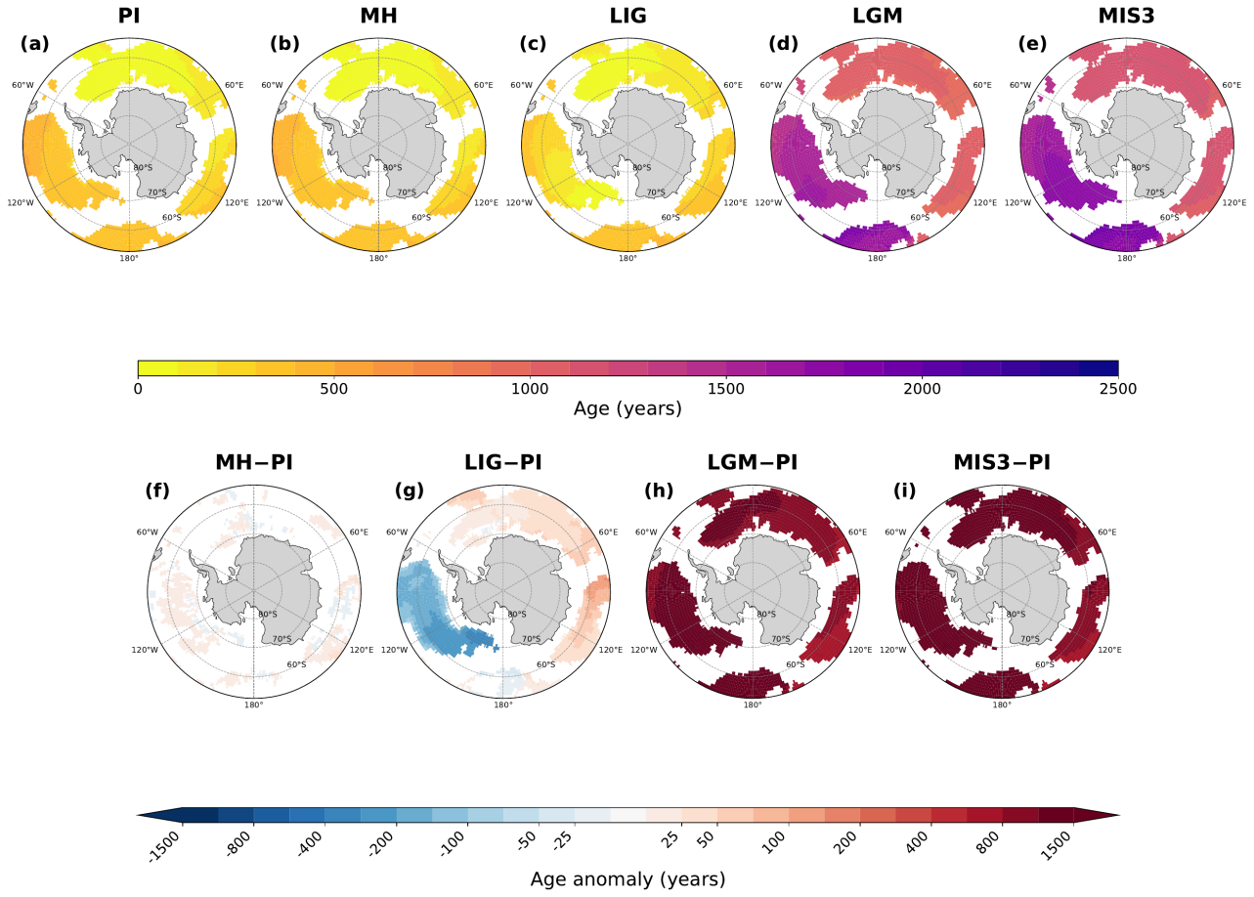
Figure R1.3 (revised manuscript figure). The ventilation age figure as an example of the labelling now applied throughout. Meridians are labelled just outside the map boundary and latitude circles along the 150°E meridian, at 60°S, 70°S and 80°S. Labels are placed only where there is white space, so that those of neighbouring panels do not run into one another and nothing is written over the data. The mixed layer, wind stress and composite figures have been treated the same way; please refer to the revised manuscript and supplement for the complete set.

Specific comments
1. LIG, LGM and MIS should be capitalised.
Thank you for catching this. The three abbreviations are now capitalised consistently throughout the manuscript, the figure captions and the supplementary, and MIS is written as MIS3 everywhere so that it matches the column headings of the figures.
2. Line 21-22: The transition to SAM is quite abrupt.
The abstract now introduces the Southern Annular Mode through the mechanism that connects it to the mean state, noting that because the balance between the thermal and haline pathways is set by how much of the surface is ice covered, it also governs the response to internal atmospheric variability.
In the revised manuscript this now reads:
“The balance between these two pathways is set by sea ice extent, which is modulated by internal atmospheric variability. Further analysis suggests that the Southern Annular Mode modulates transformation by 3-8 Sv between its positive and negative phases in every climate state, working through heat loss when the ocean is open and through brine rejection when it is ice covered.”
3. Line 24: "same mechanisms" sounds vague her without additional context. The abstract should be understandable on its own without requiring the reader to refer to the main text.
Replaced with an explicit statement of the two pathways, so the abstract no longer relies on the reader having seen the main text.
In the revised manuscript this now reads:
“The balance between these two pathways is set by sea ice extent, which is modulated by internal atmospheric variability. Further analysis suggests that the Southern Annular Mode modulates transformation by 3-8 Sv between its positive and negative phases in every climate state, working through heat loss when the ocean is open and through brine rejection when it is ice covered.”
4. Lines 25-27: Similar to Comment 2 above, additional context is needed before introducing the deep ocean ventilation results. The motivation for analysing ventilation ages only becomes clear later in the manuscript, whereas the abstract should be self-contained.
The abstract now bridges from surface forcing to ventilation via the overturning circulation, stating that weaker glacial transformation coincides with a collapse of the simulated abyssal cell from about 10 to 2 Sv, before the ages are given. This also incorporates the new overturning analysis requested by Reviewer 3.
In the revised manuscript this now reads:
“Weaker glacial transformation coincides with a collapse of the simulated abyssal overturning cell from about 10 to 2 Sv and with older abyssal water. Ideal ages at 4000 m remain below 500 years during interglacials but exceed 750 years basin-wide during glacials, reaching 1500 years in the Pacific.”
5. Lines 102-105: SAM is introduced only briefly here. Given its importance throughout the Results and Discussion, please consider providing a slightly more detailed introduction.
The introduction now defines the mode as the leading mode of extratropical Southern Hemisphere variability, describes what its positive phase does to the westerlies and hence to Ekman divergence, air-sea heat exchange and sea ice export, and cites the observational literature linking it to bottom water changes.
In the revised manuscript this now reads:
“The Southern Annular Mode is the leading mode of extratropical Southern Hemisphere circulation variability, describing a meridional redistribution of atmospheric mass between mid-latitudes and Antarctica . Its positive phase strengthens the circumpolar westerlies and displaces them poleward, which changes Ekman divergence, air-sea heat exchange, and the northward export of sea ice. In the present-day ocean these adjustments modulate mixed-layer depth and surface buoyancy forcing , and they have been linked to observed changes in bottom water properties . Whether the mode remains an effective modulator of dense water formation once the mean state changes, in particular once an expanded ice cover separates the ocean from the atmosphere, is not known.”
6. Line 125: typo: 'more'.
Corrected ("moer" "more").
7. Line 127: Figure numbering; A3 can't be called before A1 and A2.
The appendix figures have been reordered so that they are cited in numerical order.
8. Line 129: 'Here,'.
Corrected.
9. Line 140: As a result, the deep MLD signals, characteristic of open-ocean convection, largely…. Also, "vanish" is perhaps not the most scientific wording.
Rephrased to "are strongly reduced and become confined to narrow coastal bands and polynyas", and we now quantify the reduction rather than describing it qualitatively.
In the revised manuscript this now reads:
“The reduction is substantial rather than complete. Summed south of 55°S, the area with a winter mixed layer deeper than 400 m falls from 7.51011 m2 in PI to 1.71011 m2 in LGM and 1.61011 m2 in MIS3, and the maximum mixed-layer depth decreases from 991 m to 819 m and 645 m. Mixed layers deeper than 600 m, which cover 2.41011 m2 in PI, essentially disappear in both glacial states. The residual glacial signals in coastal regions are therefore genuinely shallower than their interglacial counterparts, consistent with dense water production that is confined to narrow coastal bands rather than distributed across the open gyres.”
10. Line 141: These signals are not particularly visible even in the coastal regions (the darker blue shading in LGM is at 200m, so considerably shallower than the interglacials).
This is a fair objection and we have addressed it with numbers. Summed south of 55°S, the area with a winter mixed layer deeper than 400 m falls from 7.5×10¹¹ m² in PI to 1.7×10¹¹ m² in LGM and 1.6×10¹¹ m² in MIS3, the maximum mixed-layer depth decreases from 991 m to 819 m and 645 m, and mixed layers deeper than 600 m essentially disappear in both glacial states. The text now says explicitly that the residual glacial signals are genuinely shallower than their interglacial counterparts. Figure R1.2 below shows the glacial fields on a scale that resolves them, and the reviewer's reading of the shading is correct and is now reflected in the text.
The reviewer's observation also pointed to a presentation problem, which we have fixed. On the shared 0–400 m scale of the original figure the glacial panels are almost featureless, because the 99th percentile of the glacial winter mixed layer south of 55°S is only 280 m (LGM) and 296 m (MIS3). Replotting those two states on their own 0–300 m scale makes the coastal cells visible.
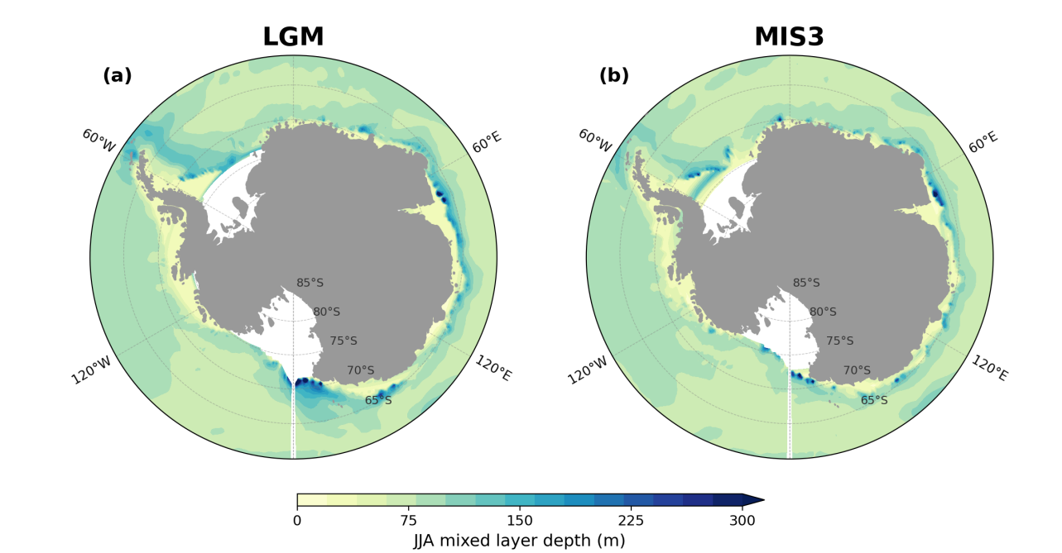
Figure R1.4 (new supplementary panel). (a) LGM and (b) MIS3 winter mixed layer depth south of 60°S, on a 0–300 m scale. The tightened scale resolves discrete deep cells along the coast, in the Weddell, Prydz Bay and Ross sectors, which is where the glacial dense water is produced. This is the figure we now use in the supplement.
11. Line 134-141: Fig.1 i-l subpanels are not discussed at all.
A paragraph discussing the surface density panels has been added. It notes that the glacial density anomalies follow the salinity field rather than the temperature field, because the thermal expansion coefficient is small at the near-freezing temperatures south of the ice edge, and points out the density-compensated LIG anomaly and the weak negative LGM anomalies in the Atlantic-Indian sector.
In the revised manuscript this now reads:
“The surface density anomalies (Fig. 1i-l) follow the salinity field rather than the temperature field in the glacial states. Cooling and salinification both act to densify the surface, but at the near-freezing temperatures that prevail south of the ice edge the thermal expansion coefficient is small, so the haline term sets both the pattern and the magnitude. In LIG the warm and salty Bellingshausen-Amundsen anomaly is close to density compensated (Fig. 1j), and the LGM retains weak negative density anomalies in parts of the Atlantic-Indian sector where surface freshening outweighs cooling.”
12. Line 144-146: The LIG also exhibits similar behaviour, although the changes are smaller in some basins. Likewise, the LGM shows some negative anomalies in the Atlantic–Indian sector.
Both points are now stated in the text; see the response to comment 11.
13. Line 146-148: An explanation of why the wind stress changes do not lead to increased sea ice in the Ross Sea would be useful. Is this due to the presence of relatively warm water despite enhanced salinity, density, and Ekman transport in this region?
We checked this directly, and the answer turned out to be more interesting than the question assumed, so we set it out in full.
The mechanism the reviewer proposes is real, but it operates in the last interglacial rather than in the glacial states the comment refers to. Averaged between 60 and 75°S in winter, the glacial sea ice response is in fact fairly uniform around the continent: concentration rises by 0.62 in the Ross sector, 0.70 in the Weddell sector and 0.53 in the Adélie sector at the Last Glacial Maximum, and all three sectors cool to within about 0.1 K of the surface freezing point, so ice growth is not limited by surface heat content anywhere.
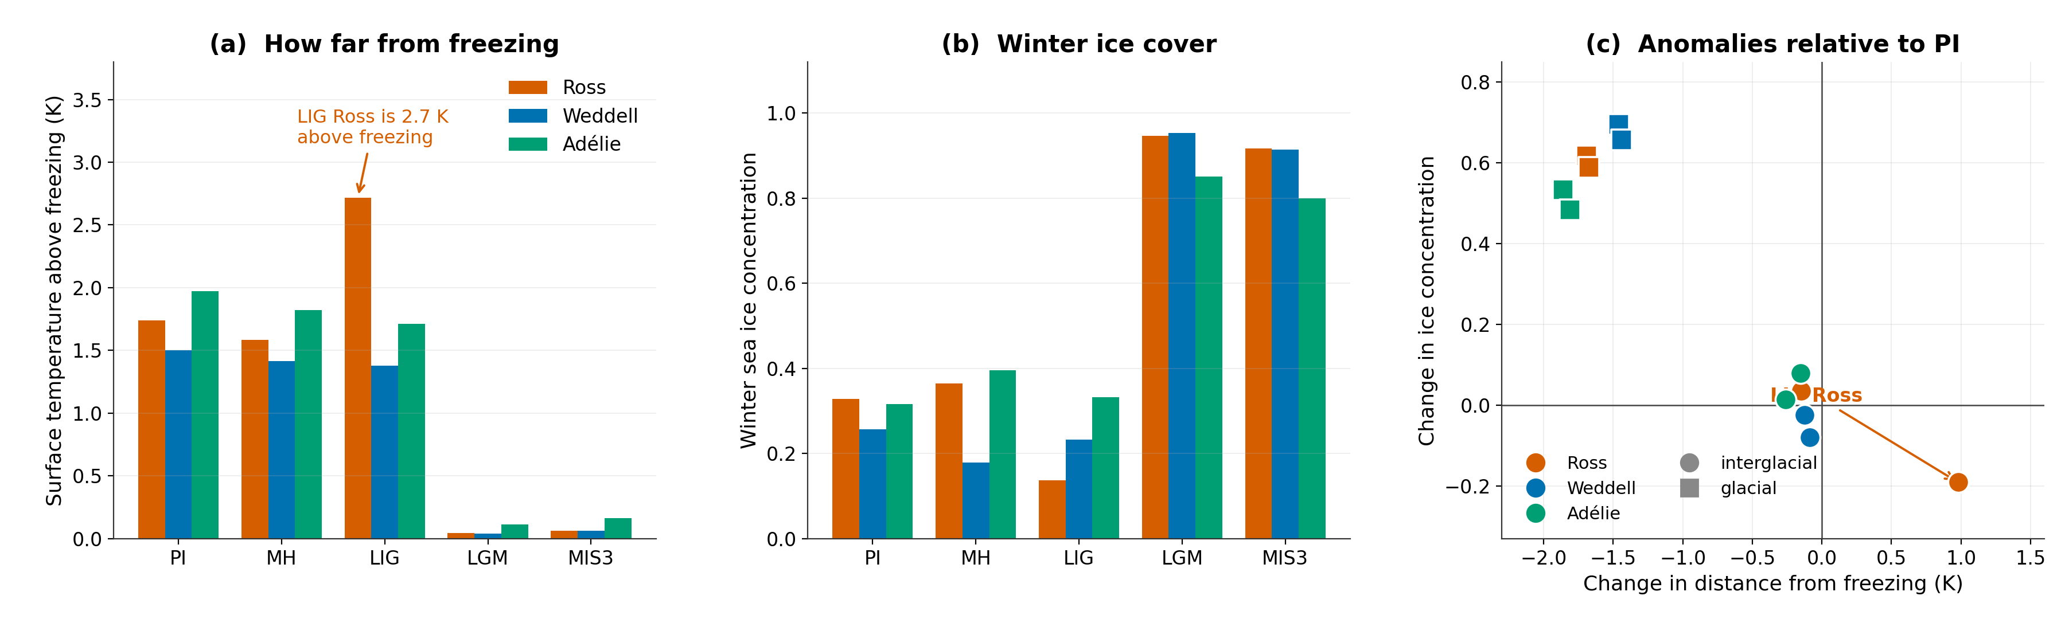
Figure R1.5 (new analysis). (a) Winter surface temperature above the local freezing point and (b) winter sea ice concentration, by sector and climate state. (c) The same quantities as anomalies relative to PI. The Ross sector separates from the others only in the last interglacial, where it warms to 2.7 K above freezing and loses 0.19 of ice concentration, an order of magnitude more than the Weddell or Adélie response. In the glacial states all three sectors collapse onto the freezing point and gain ice comparably.
So in the last interglacial the Ross sector is 0.97 K warmer than in PI and sits 2.72 K above the freezing point, against changes below 0.3 K elsewhere, and its winter ice concentration falls by 0.19. There the wind can export ice efficiently but the water is too far from freezing for the exported ice to be replaced, which is precisely the reviewer's proposed mechanism. We have rewritten the passage to say this, rather than attributing the behaviour to the glacial wind response as the submitted version implied. This asymmetry is also why the Ross sector departs from the circumpolar pattern in the variability analysis.
14. Line 167: It would be helpful to quantify the thermal contribution, similar to the quantification provided for the haline contribution in line 157.
Added. The thermal term accounts for 70–85% of the total at the transformation maximum in the interglacials, against 15–30% for the haline term, and falls to 12–17% in the glacial states.
In the revised manuscript this now reads:
“This transformation is dominated by surface heat loss (red line), which accounts for 70-85% of the total at the transformation maximum, with limited sea ice extent restricting the haline contribution from brine rejection to a secondary role (15-30%; green line). Other freshwater fluxes (blue lines) oppose densification through net precipitation and river runoff. We note that this thermally dominated maximum occurs at densities that correspond to intermediate and mode waters rather than to bottom water. In the densest classes that the simulated surface fluxes reach (σ₂ ≥ 37.0 kg m⁻³), the PI transformation is already haline dominated, with the sea ice term contributing 0.79 Sv against 0.06 Sv from heat in the annual mean. The thermal dominance reported here is therefore a property of the integral over all density classes, and we quantify its sensitivity to the choice of integration domain and density range in the Discussion.”
15. Fig. 2 Would it be possible to share a figure with the same y-axis limits for all panels? This may not be necessary for the final manuscript, but it would make it easier to compare the magnitude of the changes across the different climate states.
Yes. Supplementary Fig. S5 now shows the same transformation curves on common vertical and horizontal axes, so magnitudes and density positions can be compared directly across climate states and regions. We have kept the independently scaled version in the main text because the shape of the individual curves is otherwise hard to read, and the main text now points to the common-axis version explicitly.
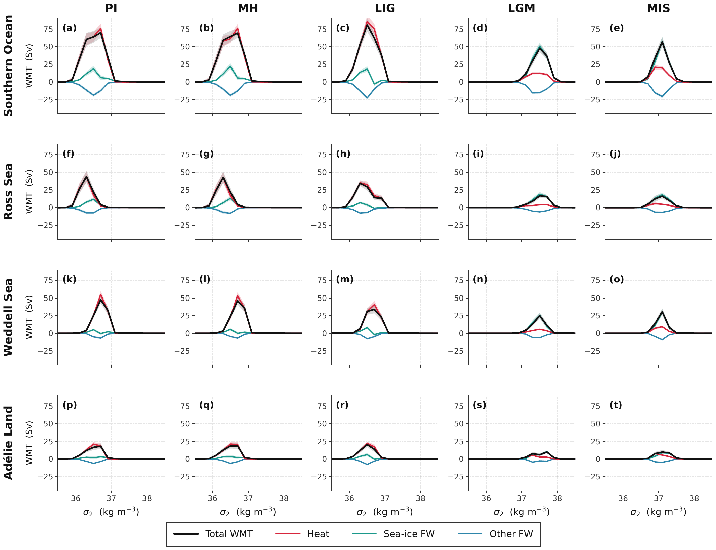
Figure R1.6 (new Supplementary Fig. S5). Winter transformation for the four sectors and five climate states on a common vertical and horizontal axis. Plotted this way the glacial weakening of the transformation maximum and its shift to denser classes are directly comparable between panels, which the independently scaled main-text version does not allow.
16. Line 174: "Section 4?"If this is intended to refer to the Methods section.
Corrected to refer to the Methods section by name.
17. Fig.3 Please consider adding the climate-state labels at the top of each column, as in the other figures.
Added, here and on the other multi-panel figures; Reviewer 3 made the same request.
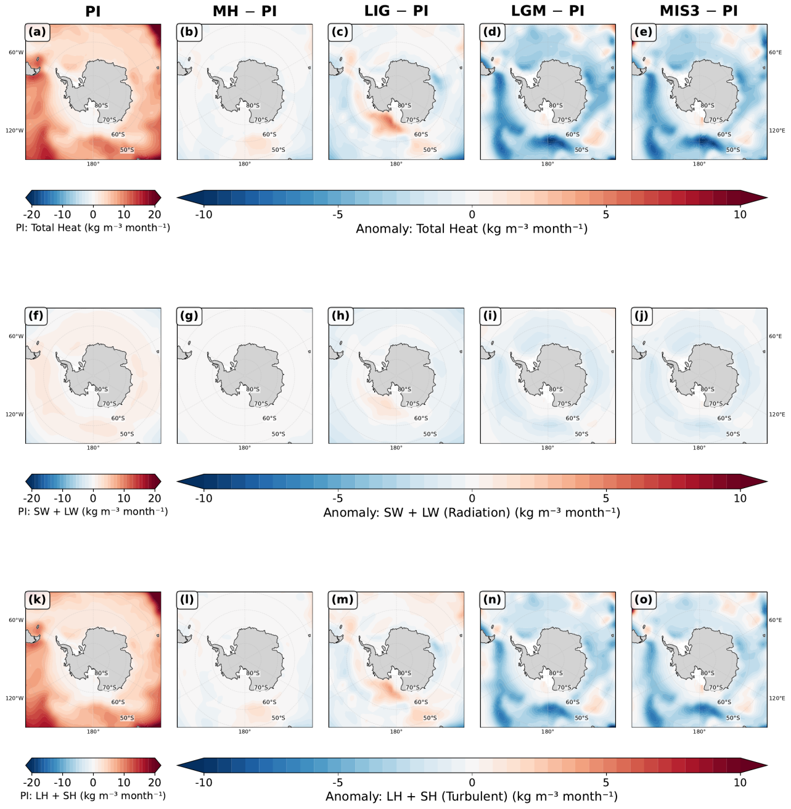
Figure R1.7 (revised manuscript Fig. 3). The surface density tendency figure with the climate-state headings added, so that the columns are identified in the same way as in the other figures, and with latitude and longitude now labelled. Every panel carries the latitude circles, at 50°S, 60°S, 70°S and 80°S along 150°E, and the 180° meridian. The remaining meridians are given on the outer columns only, 60°W and 120°W on the left and 60°E and 120°E on the right, so that no label falls between two panels; all panels share the same projection and extent. All labels sit outside the frame. The freshwater counterpart, Fig. 4, has been treated the same way.
18. Line 180/181: The LIG is first described as "showing modest changes", but later as "exhibiting a pronounced increase". These descriptions appear inconsistent.
The two statements referred to different quantities, which was not clear. The changes are modest in the circumpolar integral and pronounced locally in the Ross Sea sector. The text now says so explicitly.
19. Could the authors briefly explain what is meant by thermal density tendency and sea-ice-driven density tendency in the methods.
Definitions have been added to the Methods, including the sign convention and the physical meaning of brine rejection versus melt.
In the revised manuscript this now reads:
“We refer throughout to the thermal density tendency, meaning the surface density change produced by the net heat flux acting through the thermal expansion coefficient, that is the -≤ft(/C_{p})Q_{n}et term, and to the sea-ice-driven density tendency, meaning the part of the haline term S F_{f}w that is carried by the thermodynamic growth and melt of sea ice. A positive value denotes densification of the surface water in both cases. Brine released during ice growth increases surface salinity and therefore density, whereas melting releases freshwater and reduces it.”
20. Line 209: Please add the appropriate reference(s) here to support this statement.
We now cite Cerovečki et al. (2013) and Abernathey et al. (2016) in support of the statement that turbulent rather than radiative fluxes control the surface buoyancy budget.
21. Line216-246: Please refer to the relevant subpanels of Figure A5.
Done, and the same treatment has been applied throughout the Results and Discussion rather than only in the passage the reviewer names. As an example of the form these references now take:
“In PI, strong thermal densification (red shading) is concentrated in the open ocean (Fig. 3a), with maximal values reaching 5 10-6 kg m⁻³ s⁻¹ in the circumpolar band between 50-65°S. This thermal densification is overwhelmingly controlled by turbulent fluxes (sensible and latent heat), with radiative fluxes playing a minor role in the buoyancy budget (Fig. 3f-j vs. Fig. 3k-o), consistent with observationally based surface buoyancy budgets for the Southern Ocean .”
22. Line 249, 255: The phrase "across at high latitudes" is somewhat unclear. Does this refer specifically to the Antarctic coastal region or the Southern Ocean south of a particular latitude? Please consider rephrasing for clarity.
Both instances have been rewritten. They now read "over the ice-free parts of the Southern Ocean south of about 50°S" and "south of the ice edge" respectively.
23. Could the authors clarify where the primary deep water formation regions occur in this model? Identifying these regions would also help assess whether the SAM-related changes shown in Figure 5 are directly influencing the main regions of dense water formation, as relatively little signal is apparent over the Weddell and Ross Seas.
We have added this diagnosis to the Results, and Figure R1.2 above shows it directly: the winter mixed layer depth for all five states. In the pre-industrial state the Weddell sector accounts for 70% of the area with winter mixed layers deeper than 400 m south of 55°S and 97% of the area deeper than 600 m, centred near 68°S in the gyre interior. The formation region is therefore the open Weddell gyre rather than the shelf, which is directly relevant to the model limitation discussed under model evaluation above. This also explains the pattern the reviewer noticed: the Southern Annular Mode heat flux signal is strongest over open water, and in the glacial states the coastal regions where dense water is produced are precisely those insulated by ice, so the surface flux anomalies there are small even though the transformation response is not.
24. Lines 261-263: Please consider expanding on the physical mechanism linking positive SAM to freshwater loss and intensified brine rejection by additional explanation and supporting references.
Expanded, and we have added the two references the reviewer asks for. The passage now states the mechanism as a chain rather than asserting the endpoint, and cites the observational work on Antarctic Bottom Water production in the Cape Darnley polynya and on the sea ice contribution to Southern Ocean transformation.
In the revised manuscript this now reads:
“This pattern is controlled by sea ice processes, and the chain that produces it runs as follows. Strengthened and poleward-shifted westerlies increase the offshore component of the wind stress at the coast, which drives sea ice away from the continental margin. The divergence opens and widens coastal polynyas, exposing water already at the freezing point directly to a cold atmosphere. New ice therefore forms rapidly in those openings, and because ice rejects most of its salt as it grows, the salt is delivered to the surface ocean precisely where the water is coldest and densest. The ice exported offshore carries the compensating freshwater north, where it melts and freshens the surface. The result is the observed dipole, with salinification at the coast and freshening offshore, and it is the same mechanism identified in observations of Antarctic Bottom Water production in the Cape Darnley polynya and in the sea ice contribution to Southern Ocean water mass transformation more generally .”
25. Line 291, 294: Please check citation format.
Corrected.
26. Line 301:Figure A4 appears to show only model results. Please consider including the observational estimates in the figure (or referring to them directly) to support this statement. As noted above, it would also improve readability if the appendix figures were cited in numerical order.
We have added the quantitative comparison to the text and to the new Fig. 8, reproduced as Figure R1.1 above, which shows our transformation recomputed over the Pellichero domain alongside the standard domain. We report their published values directly in the Discussion, including the 5 ± 5 Sv transformation into denser classes and the stated factor of 2–5 by which the freshwater term exceeds the heat term in their sector, and we compare our numbers against them. We chose to make the comparison quantitatively in the text and in a dedicated figure rather than overplotting their curve, because their analysis is in neutral density over a different density range and an overlay would misleadingly imply a point-by-point correspondence that does not exist; the density-range mismatch is itself one of our findings. The appendix figures are now also cited in numerical order. We note that this comment and the general comment on model evaluation above concern the same comparison, and we have kept the two answers consistent: the quantitative comparison with the published observational values is given once in the Discussion, and both replies point to the same new figure.
27. Lines 308-321: The discussion quantifies the interglacial changes (e.g., lines 315–316), but similar quantification is not provided for the glacial changes. For consistency, please consider including quantitative estimates for both.
Added. The glacial transformation maximum weakens to below 60 Sv and moves to σ₂ = 37.0–37.5 kg m⁻³, with the thermal share falling to 12–17%.
In the revised manuscript this now reads:
“The winter transformation maximum weakens to below 60 Sv and moves to σ₂ = 37.0-37.5 kg m⁻³, and the thermal share of the transformation falls to 12-17% while the sea ice term becomes dominant. Extensive ice cover insulates the ocean from atmospheric heat exchange, and simultaneously intensifies haline forcing through enhanced brine rejection concentrated in coastal regions.”
28. Lines 326 appear to repeat the statement made in line 323. In addition, the general statement in lines 323–325 does not appear to hold equally across all climate states. For example, the Ross Sea and Weddell Sea exhibit different behaviour for the peak-density classes.
The repetition has been removed by merging the two sentences. We have also added the qualification the reviewer asks for, noting that the Ross Sea departs from the circumpolar picture and that in the glacial states the signal is carried largely by the Weddell sector.
In the revised manuscript this now reads:
“This circumpolar picture does not hold uniformly in every sector. The Ross Sea in particular departs from it, showing weaker and at some densities opposing responses, and in the glacial states the circumpolar signal is carried largely by the Weddell sector while the Ross and Adelie sectors contribute little.”
29. Line 339: Please provide a reference for the sediment-record evidence discussed here.
On reflection we think the passage was speculative rather than supported, and Reviewer 3 raised the same objection from the opposite direction, noting that accumulation rates around the Antarctic margin are very low. We have replaced the proposal with a statement of the difficulty, and now present the persistence of the coupling as a property of the simulated system rather than as a practical route to a marine reconstruction.
In the revised manuscript this now reads:
“Whether this persistent coupling could be exploited for proxy reconstruction is less clear than we previously suggested. Recovering an interannual-to-decadal signal from marine sediments would require accumulation rates and chronological precision that are rarely available around the Antarctic margin, where sedimentation is slow and bioturbation mixes the record over intervals far longer than the variability of interest. We therefore present the persistence of the coupling as a property of the simulated system rather than as a practical route to a marine Southern Annular Mode reconstruction.”
30. Section 4.1: Please define the full names of the abbreviated components.
Done, and the definitions are now given where the figures use the terms rather than only in the flux description.
In the revised manuscript this now reads:
“In the figures the radiative component denotes the sum of the shortwave and longwave fluxes, and the turbulent component denotes the sum of the latent and sensible heat fluxes.”
In the revised manuscript this now reads:
“In the figures the radiative component denotes the sum of the shortwave and longwave fluxes, and the turbulent component denotes the sum of the latent and sensible heat fluxes.”
31. Line 388: Please check the citation formatting.
Corrected.
32. Lines 394-403: Please consider including a summary table listing the prescribed boundary conditions for each experiment (e.g., greenhouse gas concentrations, orbital parameters, ice-sheet reconstruction, and any other relevant forcings). This would make the experimental setup considerably easier to follow.
Added as Table 1; please see our response to the second general comment.

Reviewer #2
So in principle this is an interesting and topical paper and I would like to be able to support its publication. However, I have two big issues with the present MS that in my view mean it needs at least some substantial revision.
We are grateful for both issues, which were well aimed. We address them in turn.

Major issue 1: mismatch with observational studies of the modern ocean
1) There is a mismatch with observational studies of the modern ocean. In their model the pre-industrial situation is dominated by thermal buoyancy forcing whereas Pellichero et al, (2018) find the opposite: The title of their observation-based paper makes this clear: “Southern Ocean meridional overturning is driven by freshwater fluxes”. Shi et al dismiss this difference in a single sentence, saying it is due to “model biases or regional differences in analysis domains” (line 305). Comparing their Fig 3a, Fig 4a with Pellichero Fig 2a and c, the regions look similar, suggesting it's mostly model bias. But the switch from thermal to haline forcing is the present paper's main result, so if indeed it is due to model bias, this seems like a major problem.
The reviewer is right that the original single sentence was inadequate, and right to insist that the answer matters for the paper's main claim. We therefore ...(做了什么)
(把fig r1.1 copy到这里，编号为r2.1)
（下面属于Major issue 1里面的黄色高亮部分，都是旧的答案，需要被替换下来：，需要把我们回复reviewer1的那部分内容给重新写在这里）
The domains are less similar than they appear. Pellichero et al. define their sector as the region enclosed by the September 15% sea ice contour, so its northern boundary is an ice contour that varies with longitude, not a latitude circle. Our published integral covers everything south of 60°S. In our pre-industrial simulation, 42.7% of that area lies outside the September ice contour and is therefore water their analysis does not include. It is also the part of the domain that stays exposed to the atmosphere year round, and taken alone it is 89–91% thermally driven in the dense classes. Recomputing our transformation over a sea ice sector defined exactly as theirs, which reproduces their domain to within 2.5% in area, sharpens the picture considerably. Resolved by density class, only one class in our pre-industrial state is thermally dominated, σ₂ = 36.75–37.00 kg m⁻³ at 70%, and every other class is haline dominated, falling to 6–7% thermal in the densest classes. Both glacial states are haline dominated in every class, between 4% and 28%. The regime shift the paper reports is therefore not only preserved inside the observational domain, it is clearer there than in the wider domain we originally used.
A residual discrepancy remains, and it is genuine model bias. We can rule out one candidate explanation. Pellichero et al. attribute part of the haline dominance to the thermal expansion coefficient being near zero at the freezing point, so we checked whether our ice-covered sector reproduces that regime. It does: the area-weighted winter surface temperature inside the September ice zone is -1.08 °C, the median is -1.71 °C, 55% of the area lies within 0.5 °C of the local freezing point, and α = 3.5×10-⁵ K⁻¹. The model is not warm-biased there, so we cannot appeal to that. What differs is where dense water is made. In the model, pre-industrial dense water forms by open-ocean convection in the interior of the Weddell gyre near 68°S rather than by the sequence of shelf water formation and downslope overflow that operates in the real ocean. Open-ocean convection exposes a large area to the atmosphere and so recruits an excessive thermal contribution while producing water that is not dense enough, which is precisely the offset in density class described above.
We now say this plainly in the Discussion, note that it is a limitation shared across the current model generation rather than specific to AWI-ESM2 (Heuzé, 2021: 28 of 35 CMIP6 models), and state that this configuration has no ice shelf cavities.
Does the main result survive? We think it does, for two reasons that we now give in the text. First, the regime shift survives the domain test. Recomputed over the sea ice sector alone, the glacial states remain 15% and 17% thermally driven while the interglacials remain 53–88% thermally driven, so the contrast is not manufactured by including open water in the interglacial integrals. Second, the mechanism is the ice cover itself rather than the convection style: insulation of the surface and concentration of brine rejection follow from the areal expansion of sea ice, and both would operate in a model that formed its dense water on the shelf.
The consequences for the large-scale circulation are visible in the overturning itself.

Major issue 2: relation to Chen et al. (2025)
2) I'm puzzled that they don't acknowledge or discuss the relation of their work with recent studies showing very similar results but analysed through different tools and language. Using the same ocean model Chen et al, 2025 (GRL 52, e2025GL114809) describe formation of very dense AABW in glacial time as due to the enhanced ice formation, where the resulting water mixes more slowly with overlying waters due to the greater density difference. One of the authors (Lohmann) is on both papers, yet this paper is not referenced, let alone discussed, by Shi et al. I ask myself what is learned from the WMT analysis that is not already discussed in that paper?
The omission was an oversight on our part and we apologise for it. The paper is now cited in both the Introduction and the Discussion, and we address the reviewer's question directly rather than merely adding the reference.
We first acknowledge the genuine agreement. Chen et al. attribute the large glacial volume of Atlantic bottom water to a substantial increase in sea ice export toward lower latitudes, which supplies dense shelf water year round, and to weaker mixing between northern- and southern-sourced water, which lets that water retain the properties of its origin. Our glacial conclusions are consistent with theirs, and we say so explicitly rather than presenting our result as new in that respect.
What the transformation analysis adds is of two kinds. The first is measurement rather than inference. Chen et al. diagnose water mass volumes, the overturning streamfunction, and mixed-layer and sea ice fields, from which the role of sea ice is inferred because those fields covary with it. A decomposed surface buoyancy budget measures the transformation directly and attributes it to individual flux components in sverdrups, so the sea ice contribution is quantified rather than inferred. Our analysis therefore tests the mechanism they proposed, and finds it supported.
The second is scope. Their simulations are ocean-only, with a prescribed atmosphere, and cover the Last Glacial Maximum and the present day. Ours are fully coupled, so sea ice and the atmospheric fluxes evolve together, and they span five climate states. A shift between two forcing regimes cannot be identified from a single glacial state; it requires the interglacial end members for the contrast to exist at all. The regime shift that is our central result is therefore not addressable within their experimental design, which is why the two studies reach compatible conclusions about the glacial ocean while answering different questions.
We have phrased this in the manuscript as the present analysis testing and quantifying the mechanism Chen et al. proposed, rather than as a claim that they missed something.
The passage added to the Discussion reads:
“Our conclusions about the glacial state are consistent with recent work using the same ocean model in a forced configuration. Chen et al. attribute the large glacial volume of Atlantic bottom water to a substantial increase in sea ice export toward lower latitudes, which supplies dense shelf water year round, and to weaker mixing between northern- and southern-sourced water, which allows that water to retain the properties of its origin. The agreement is worth stating explicitly, and the two studies are complementary rather than overlapping. Chen et al. infer the role of sea ice from water mass volumes, the overturning streamfunction, and mixed-layer and sea ice fields, in ocean-only simulations of two states with a prescribed atmosphere. The transformation framework applied here measures the surface buoyancy forcing directly and attributes it to individual flux components in sverdrups, so the contribution of sea ice is quantified rather than inferred from covarying fields. Running the analysis across five coupled climate states, in which sea ice and the atmospheric fluxes evolve together, is also what makes the change of regime visible, since a shift between two forcing regimes cannot be identified from a single glacial state. The present analysis therefore tests and quantifies the mechanism that Chen et al. proposed.”

More minor points
The fundamental issue must be getting right the formation of sea ice and rejection of brine close to the continent, followed by the mixing of that dense water with the surroundings, all processes that intrinsically occur at fine spatial scales. In this regard the model looks good, by comparison to most paleo studies. The comparatively high resolution close to the continent must be helpful I'm sure, (though at 25 km it may still not be enough to realistically model the dynamics of polynya formation and brine rejection). Some more information on just how this is being managed would add to the value of the paper.
We agree with the reviewer's caveat and have expanded the Methods accordingly. The unstructured mesh refines to about 25 km around Antarctica, which resolves the larger coastal polynyas as features but does not resolve the boundary layer processes that set polynya dynamics. The relevant mechanics are that ice growth and brine release are computed thermodynamically at each surface node and enter the ocean as a salt flux, so the brine signal is represented where the model puts the ice, but its intensity depends on the simulated wind-driven divergence rather than on resolved polynya circulation. We now state this, together with the more fundamental point that the configuration has no ice shelf cavities and therefore omits basal melt entirely.
The authors highlight the lack of deep convection in the glacial open ocean due to the very extensive winter-time ice cover. A little more discussion of how/why the model achieves this ice cover would be welcome, as previous paleo-model studies often don't get that, and as a result may have too much deep convection in glacial simulations, which doesn't match so well with paleo-proxies. (Another paper they don't cite is Lhardy, Climate of the Past, 17, 1139–1159, 2021, which discusses how most PMIP models fail in this regard.)
Thank you for this reference, which we have added and discussed. We now note that maintaining an extensive glacial ice cover is not a general feature of paleoclimate simulations, that many PMIP models underestimate glacial Southern Ocean sea ice and its seasonality, and that colder glacial forcing on its own tends to intensify open-ocean convection rather than suppress it, so that better boundary conditions do not by themselves fix the problem. We highlight the finding of Lhardy et al. that the only configuration avoiding an unrealistically deep northern-sourced cell was the one in which brine sinking along the Antarctic margin was parameterised explicitly. In our simulations the glacial ice expands sufficiently to insulate the interior gyres, and the area of deep winter mixed layers contracts to roughly one fifth of its pre-industrial value. We now state that our glacial result depends on that simulated expansion being realistic, and that while proxy reconstructions support the direction of the change, the quantitative agreement remains uncertain.
The text added to the Discussion reads:
“The ability of the model to maintain an extensive glacial winter ice cover, and thereby to suppress open-ocean convection, is not a general feature of paleoclimate simulations. Many PMIP models underestimate glacial Southern Ocean sea ice and its seasonality, and colder glacial forcing on its own tends to intensify open-ocean convection rather than suppress it, which degrades the properties of the simulated bottom water; in one systematic study the only configuration that avoided an unrealistically deep northern-sourced cell was the one in which brine sinking along the Antarctic margin was parameterised explicitly . In our simulations the glacial ice cover expands sufficiently to insulate the interior gyres, and the area of deep winter mixed layers contracts to roughly one fifth of its PI value. The Southern Hemisphere sea ice distribution of these same five simulations has been published previously , and the pronounced glacial expansion described here is evident there as well. The simulated glacial sea ice of this model has also been assessed against diatom-based reconstructions in a multi-model comparison, which found that models including AWI-ESM tend to underestimate the winter sea ice extent inferred from the proxies while capturing the summer distribution more closely . An underestimate of winter ice would if anything weaken the insulation effect we describe, so the haline-dominated glacial regime reported here is unlikely to be an artefact of excessive simulated ice. This behaviour is what produces the haline-dominated glacial regime reported here, and it means our glacial result depends on the simulated sea ice expansion being realistic. Proxy-based reconstructions indicate extensive glacial winter ice, which supports the direction of the simulated change, but the quantitative agreement remains uncertain.”
In Results section 2.1 the acronyms (MH, LIG etc) are used without introduction. They are defined later, section 4, but as the paper is laid out this is not obvious to the reader coming to section 2.
Corrected. The five experiments and their abbreviations are now introduced at the start of the Results, at first use, in addition to the Methods definition. Reviewer 3 made the same point.
The discussion of the role of the effects of the SAM is interesting, but could I think be shortened, since it is somewhat secondary to the main messages of the paper. Figs 5 and 6 could be moved to the supplementary information.
We have done this. All of the Southern Annular Mode figures, including Figs 5 and 6, have been moved to the Supplementary Information, so the main text no longer carries any figure devoted to the mode. We have also shortened the section, removing the repetition that Reviewer 1 flagged and cutting the speculative passage about marine proxy reconstruction. What remains in the main text is a compact account of the result, with the supporting composites available to readers who want them.
We note that Reviewer 3 took the opposite view of this material, describing it as the more generalisable part of the study. Moving the figures to the supplement while keeping a concise statement of the result in the main text seemed to us the arrangement most likely to satisfy both readings, and we are content with the outcome.
For figs 5 and 6, I think it would be helpful if the forcings were on the same equivalent scales of buoyancy anomaly – currently they are in different units and it is impossible to see how they compare in absolute values.
This is a fair criticism. We have added a statement of the comparison in equivalent surface density tendency terms to the Results: expressed that way, the freshwater contribution is the larger of the two wherever sea ice is present, and the heat contribution is larger only in the ice-free sector, which is the same partition that governs the mean state.
The corresponding statement in the Results reads:
"An asymmetry between the two routes emerges when the mean state changes. The Ekman response is largest in the interglacials, at 11.2 Sv in PI and 12.8 Sv in LIG, and weakest at the Last Glacial Maximum, at 8.0 Sv, even though the glacial mean wind stress is stronger. Extensive glacial ice cover transmits the wind stress to the ocean less efficiently and damps the divergence that the same wind anomaly would otherwise produce. The haline route is correspondingly more important in the glacial states, so the mode continues to modulate transformation by a comparable amount while operating through a different pathway." We have kept the native units in the
figures themselves, which are now supplementary, because the heat and freshwater fields are what the model diagnoses and readers may wish to compare them against other studies in conventional units. The text now makes the relative magnitudes explicit. If the reviewer would prefer the figures recast in buoyancy units, we will do so.

