Response to Reviewers

Response to Reviewers
Manuscript: Glacial–interglacial regime shift in Southern Ocean dense water formation Authors: Xiaoxu Shi, Jiping Liu, Hu Yang, Chaoyuan Yang, Gerrit Lohmann
We thank the editor and the four reviewers for the care they have taken with this manuscript. The reports are detailed and constructive, and several of them identify a problem that we had handled too lightly in the submitted version: the disagreement between our pre-industrial result and observation-based transformation estimates for the modern Southern Ocean. We took that criticism seriously and spent most of the revision on it. Rather than defend the original one-sentence explanation, we ran the diagnostic tests that Reviewers 2 and 3 proposed. The outcome is more informative than we expected, and it has changed how we frame the paper.
In brief, the disagreement has two separable causes. The first is the integration domain: 42.7% of the area we integrated over lies outside the winter sea ice edge and is therefore water that Pellichero et al. do not analyse. The second, and larger, is the density range: our simulated transformation peaks at densities corresponding to intermediate and mode water, whereas the haline-dominated cell those authors describe lies at bottom water densities that our simulated surface fluxes barely reach. Where the two analyses do overlap in density, they agree in sign. A residual discrepancy remains after both effects are accounted for, and it reflects a real limitation of the model, namely that it forms its pre-industrial dense water by open-ocean convection in the Weddell gyre rather than by dense shelf water overflow. We now state this plainly, quantify it, and bound what we claim on the basis of it.
We have also added the analyses that Reviewer 3 requested, showing the overturning streamfunction directly, ideal age throughout the global ocean, and a fuller treatment of the Southern Annular Mode; discussed the study by Chen et al. (2025) that Reviewer 2 correctly noted was missing; and worked through every specific comment. Five new figures have been added, along with a boundary condition table and a Source Data file.
For convenience the principal new figures are reproduced in this letter, so that the reviewers can assess them without consulting the manuscript.
Reviewer comments are reproduced in full below in italics, each followed by our response. Line numbers in our responses refer to the revised manuscript unless stated otherwise. All changes are marked in the accompanying tracked-changes file.

Reviewer #1
The manuscript presents a comprehensive investigation of Southern Ocean dense water formation across a range of glacial and interglacial climates using the AWI-ESM2 Earth system model. By applying a water mass transformation (WMT) framework, the authors successfully separate the relative roles of thermal and haline buoyancy forcing and demonstrate a compelling regime shift between interglacial and glacial climates. The manuscript is well structured, the analyses are technically rigorous, and the decomposition of the different buoyancy contributions provides valuable physical insight. The use of WMT diagnostics allows the underlying mechanisms to be quantified rather than inferred from changes in circulation alone. Overall, I found the study scientifically interesting and suitable for publication after major revisions. My comments below are primarily intended to strengthen the robustness of the conclusions and improve the clarity of the presentation.
We thank the reviewer for this assessment and for the unusually thorough list of specific comments, which has improved the presentation considerably.

General comments
*G1. Model evaluation and confidence in simulated dense water formation
The conclusions of this study rely entirely on a single Earth system model. While I do not consider this to be a major limitation by itself, I think the manuscript would benefit from a more thorough discussion of how well AWI-ESM2 represents present-day Southern Ocean dense water formation and Antarctic Bottom Water formation. The manuscript briefly states that the PI simulation produces comparable WMT magnitudes to observational estimates, but Figure A4 only shows the model results, making it difficult for the reader to evaluate this statement. Given the importance of the model for all subsequent paleoclimate interpretations, I encourage the authors to provide stronger evidence supporting its performance. This could include a direct comparison with observational WMT estimates, or a more detailed discussion of known model strengths and biases in Southern Ocean stratification, sea ice, mixed-layer depth, and Antarctic Bottom Water formation. Even if such comparisons already exist in previous AWI-ESM2 publications, briefly summarising them here would substantially increase confidence in the conclusions.
We agree, and this concern overlaps with the central criticism from Reviewers 2 and 3. Our response has three parts.
First, we now quantify how the simulated pre-industrial transformation compares with the observation-based estimate of Pellichero et al. (2018), matching their analysis domain rather than comparing across different domains. Their sector is the region enclosed by the September 15% sea ice contour. Reproducing that definition in our model gives an area within 2.5% of theirs, so the comparison is now like-for-like. The result is shown in the new Fig. 8 and discussed in the Discussion. Restricting the integration to the ice-covered sector raises the haline share, as expected, moving the thermal fraction of the dense-class transformation from 69% to 61% and roughly doubling the sea ice contribution at the transformation maximum from 0.86 to 1.84 Sv.
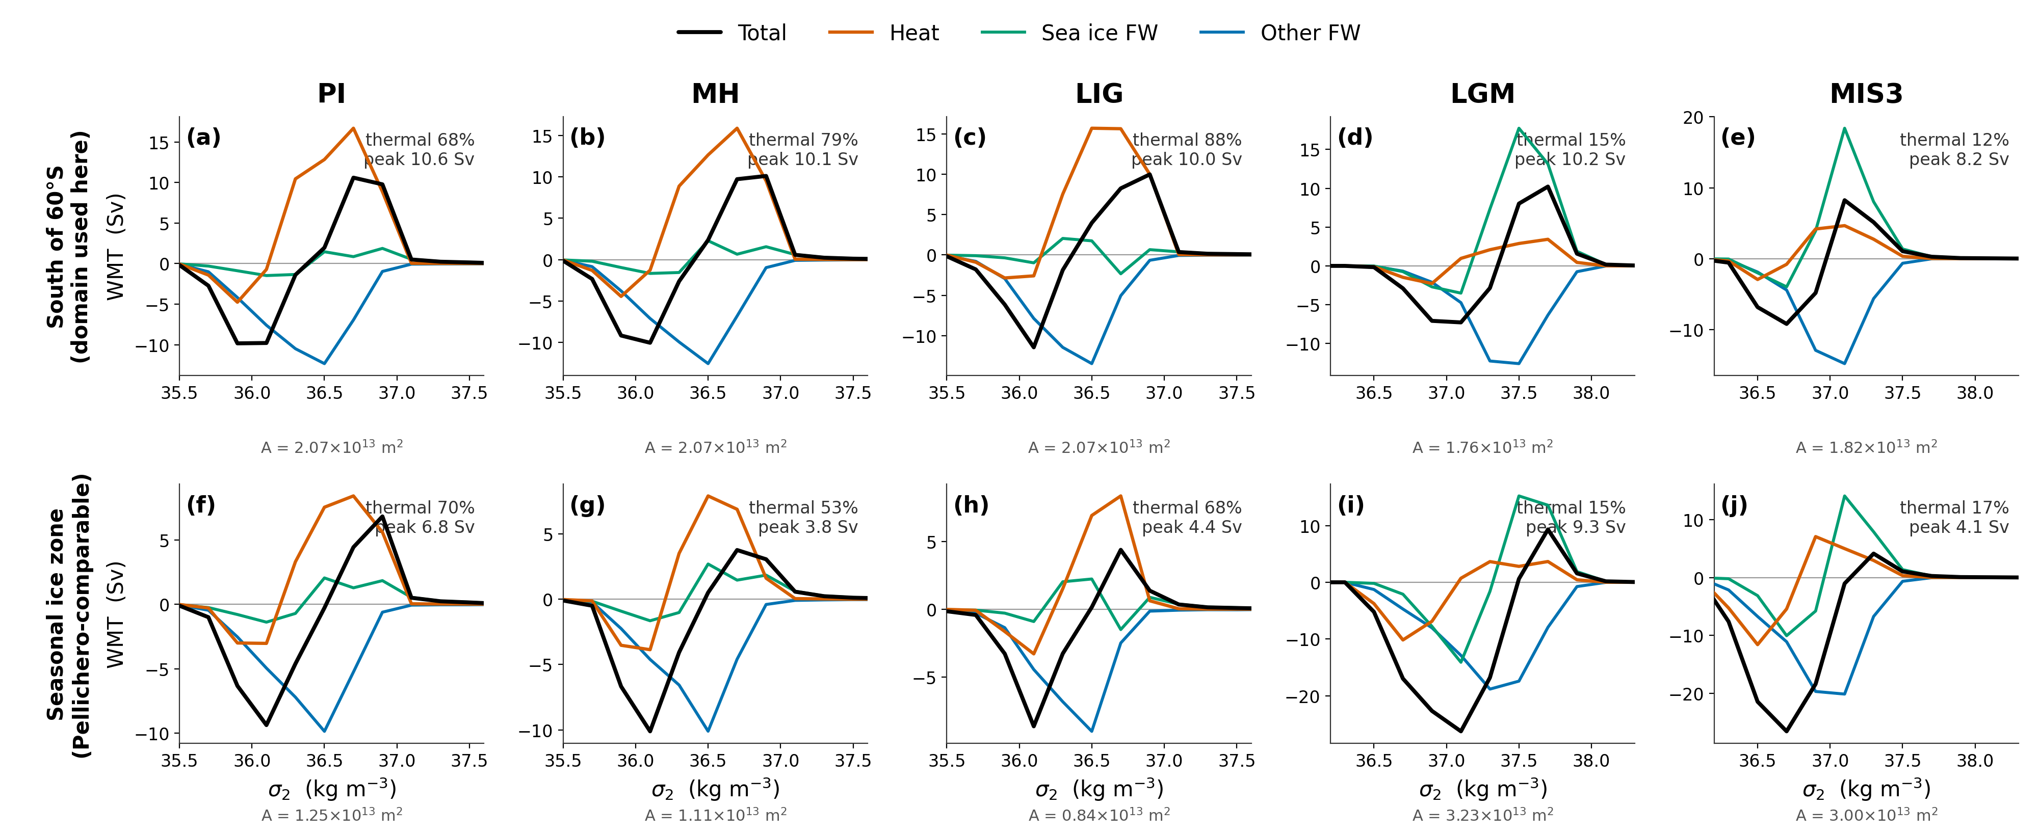
We also diagnosed directly where the model forms its dense water, which bears on how far the pre-industrial state can be trusted.
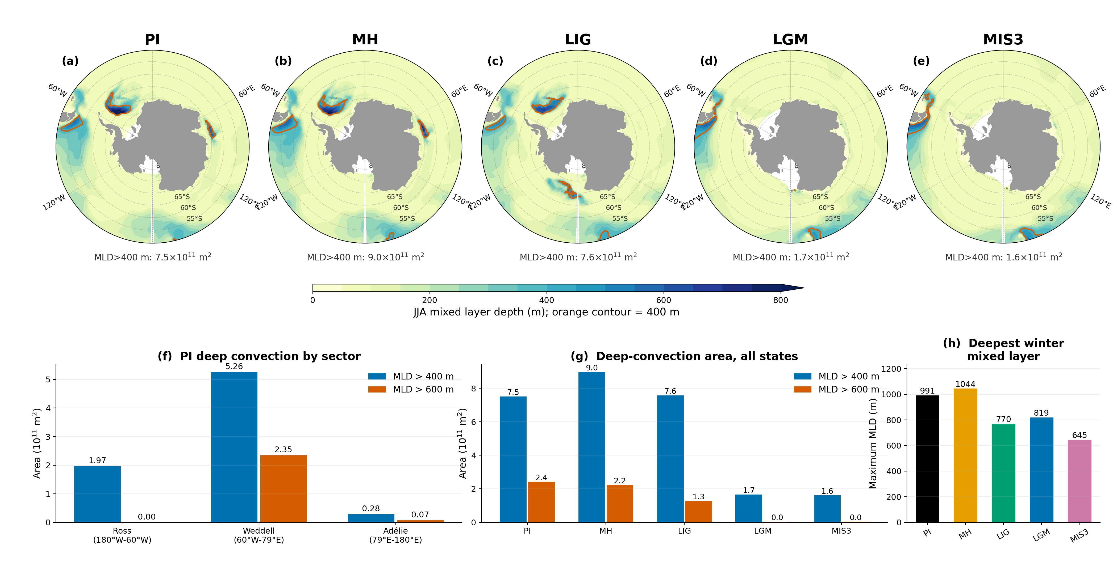
Second, and more importantly, we found that the density range matters more than the domain. Converting our simulated surface properties to the neutral density coordinate used in that study, our thermally dominated maximum sits near _{n} ≈ 27.3 kg m⁻³, whereas their haline-dominated lower cell occupies _{n} = 27.9–28.8 kg m⁻³. In the densest classes our surface fluxes do populate (₂ ≥ 37.0 kg m⁻³), our pre-industrial transformation is already haline dominated, 0.79 Sv from sea ice against 0.06 Sv from heat. The two analyses are therefore largely describing different water masses, and where they overlap they agree.
Third, we now state the residual model limitation explicitly rather than alluding to it. We diagnosed where the model actually forms its dense water: in the pre-industrial simulation, the Weddell sector accounts for 70% of the area with a winter mixed layer deeper than 400 m south of 55°S and 97% of the area deeper than 600 m, centred near 68°S in the interior of the gyre rather than over the shelf. This is open-ocean convection, not the shelf overflow pathway that operates in the real ocean. We note that this is a limitation shared across the current model generation rather than particular to AWI-ESM2, citing Heuzé (2021), who finds that 28 of 35 CMIP6 models form deep and bottom water by open-ocean convection that is too deep, too frequent, or too extensive, with no model showing convincing shelf export in the Weddell Sea. We also now state that this configuration has no ice shelf cavities, so basal melt beneath floating ice is absent by construction.
We have deliberately not asserted that published AWI-ESM evaluation papers document this convection behaviour, because they do not; the diagnosis above is our own, from our own output.
*G2. Boundary conditions
The description of the prescribed boundary conditions for the paleoclimate simulations could be expanded. In particular, the glacial simulations use the GLAC-1D ice-sheet reconstruction, but it is not entirely clear how the ice-sheet changes are implemented in the model (e.g., topography, land-sea mask, ice-sheet extent, bathymetry, or other boundary conditions). As Antarctic dense water formation is highly sensitive to such factors, providing additional details on the experimental setup would help readers assess the robustness of the simulations. This is not a request for additional simulations, but rather for a clearer discussion of the robustness of the conclusions and the extent to which they may depend on the chosen model configuration and forcing datasets. A summary table listing the prescribed greenhouse gas concentrations, orbital parameters, and ice-sheet boundary conditions for each experiment would also improve the readability of the Methods section. Clarifying several interpretations Most interpretations are convincing, although a few statements could be presented more carefully or supported more explicitly. For example, some descriptions of the role of the Southern Annular Mode appear stronger than the presented evidence suggests, and several discussions would benefit from more direct references to the relevant figure panels. Model limitations: The manuscript convincingly demonstrates that sea ice drives the transition from a thermally dominated to a haline-dominated dense water formation regime. However, the discussion would benefit from a brief consideration of the known biases and limitations of AWI-ESM2, particularly regarding Southern Ocean sea ice, mixed-layer depths, and Antarctic Bottom Water formation. Discussing how these model characteristics may influence the proposed mechanism would help readers assess the robustness and broader applicability of the conclusions. Please consider adding latitude and longitude labels to all map figures where appropriate. In addition, referring to specific figure subpanels throughout the text, rather than only the full figure number, would make the discussion easier to follow.
Added. Table 1 in the Methods now lists the greenhouse gas concentrations, orbital parameters, and ice sheet configuration for all five experiments; the values are those actually used in the runs. We have also expanded the surrounding text to describe how GLAC-1D enters the model, which we agree was underspecified. It sets the ice sheet extent and surface elevation and the associated land-sea mask and orography for the atmosphere and land surface, the river routing, and the vegetation distribution, and it determines the ocean bathymetry and coastline. The last of these requires a separate unstructured ocean mesh for each glacial period, and we use meshes built for 21 ka and 38 ka, while PI, MH and LIG share the modern-geometry mesh. We also now state that global mean ocean salinity is raised in the glacial runs to account for water stored in the ice sheets, and that no prescribed ice sheet meltwater flux is applied in any experiment.
*G3. Clarifying several interpretations
Most interpretations are convincing, although a few statements could be presented more carefully or supported more explicitly. For example, some descriptions of the role of the Southern Annular Mode appear stronger than the presented evidence suggests, and several discussions would benefit from more direct references to the relevant figure panels.
We have moderated the Southern Annular Mode claims. The most overstated passage was the suggestion that the simulated coupling implies a route to marine proxy reconstruction; we have replaced it with a more careful statement noting that the accumulation rates and chronological precision required are rarely available around the Antarctic margin, a point Reviewer 3 also raised. We have also removed the claim that the circumpolar picture holds uniformly and now state explicitly where it does not, in particular the Ross Sea. Panel-level figure references have been added throughout, as requested in this comment and in comment 21.
*G4. Model limitations
Model limitations: The manuscript convincingly demonstrates that sea ice drives the transition from a thermally dominated to a haline-dominated dense water formation regime. However, the discussion would benefit from a brief consideration of the known biases and limitations of AWI-ESM2, particularly regarding Southern Ocean sea ice, mixed-layer depths, and Antarctic Bottom Water formation. Discussing how these model characteristics may influence the proposed mechanism would help readers assess the robustness and broader applicability of the conclusions.
This comment asks specifically about bias, where the general comment above asked about evaluation, so we treat the two separately and address the three quantities the reviewer names in turn.
Mixed layer depth. This is the clearest bias and the one most relevant to our mechanism. The model produces its pre-industrial deep mixed layers in the interior of the Weddell gyre near 68 deg S rather than over the continental shelf, so the convection is of the open-ocean type. The published evaluation of this model configuration does not itself examine Southern Ocean mixed layer depth, so this is our own diagnosis from our own output, and we state it as such. In the glacial states the deep mixed layers contract to roughly one fifth of the pre-industrial area and shoal from 991 m to 819 m and 645 m, and what remains is confined to narrow coastal cells.
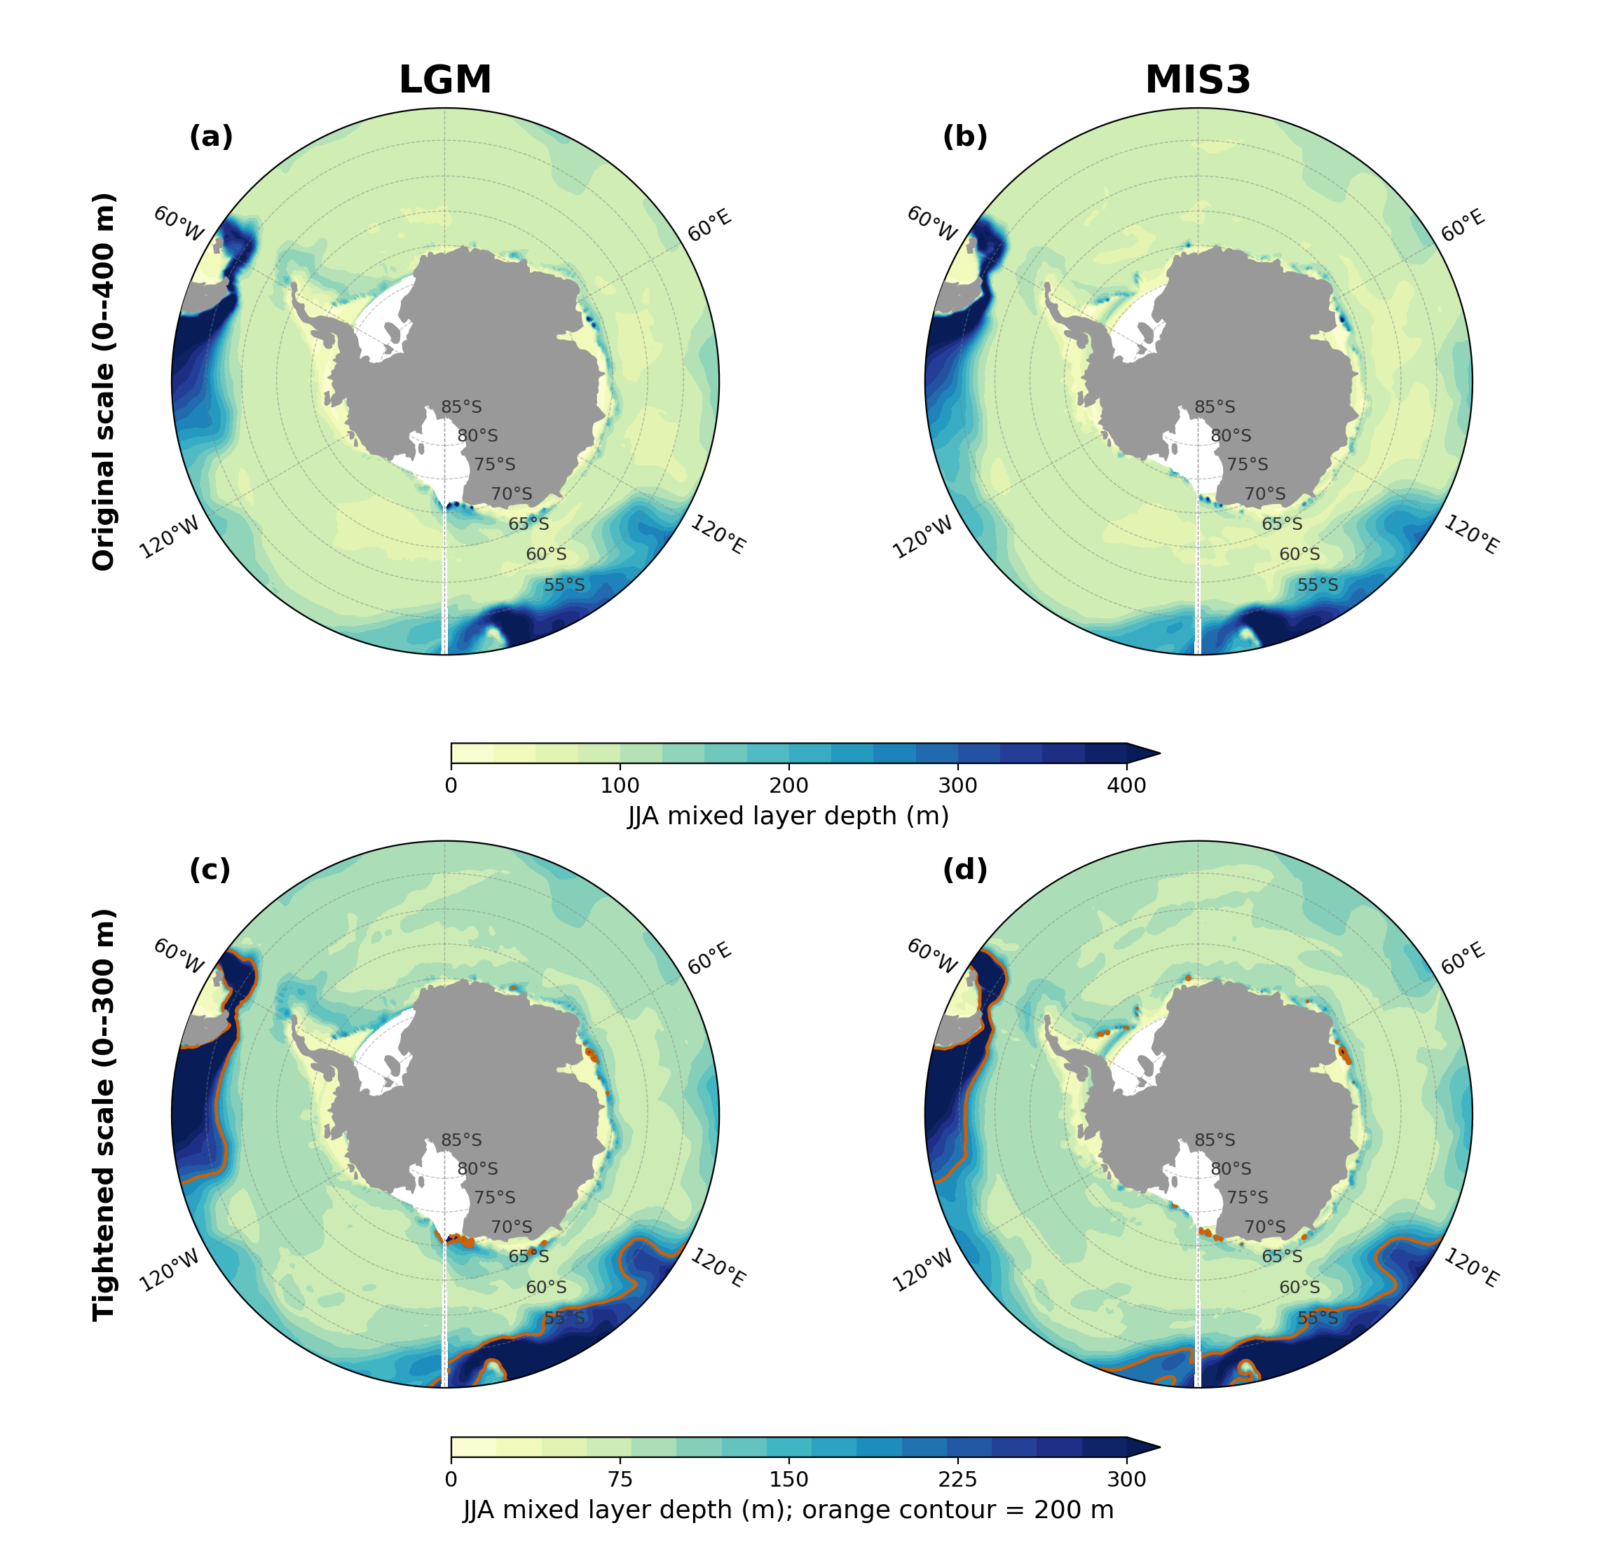
Sea ice. The published evaluation reports that Antarctic sea ice in this configuration is too thin, hardly reaching 0.25 m in the central Weddell Sea in September, and that the Southern Ocean carries the model's most pronounced warm bias, with a sea surface temperature root-mean-square error of 1.43 K against the PHC climatology. A warm, thin-ice Southern Ocean is precisely the state in which open-ocean convection is favoured over shelf processes, so the documented biases and the convection behaviour we diagnose are consistent with one another. For the glacial states, a multi-model comparison against diatom-based reconstructions found that models including AWI-ESM tend to underestimate the winter sea ice extent inferred from the proxies. An underestimate would weaken the insulation effect we describe, so our glacial result is unlikely to be an artefact of excessive simulated ice.
Bottom water formation. The abyssal overturning cell of this configuration is reported at about 10 Sv, comparable to our pre-industrial value, but it is produced by the wrong pathway, as described above. We therefore present our results as a statement about how the partitioning of surface buoyancy forcing responds to changing ice cover, and explicitly not as a quantitative reconstruction of bottom water formation rates.
Two further limitations bear on the interpretation and are now stated in the text. The simulated glacial westerlies shift poleward and strengthen, whereas proxy reconstructions infer an equatorward shift of about 4.8 deg and a weakening of about 25 per cent at the Last Glacial Maximum relative to the mid-Holocene (Gray et al., 2023). And the ideal age fields are not fully equilibrated after 1000 years, so the simulated ages are lower bounds.
The corresponding passage added to the Discussion reads:
“Independent evaluations of this model provide context for these limitations, and we summarise the relevant points here rather than leaving them to be sought in the model description literature. evaluate the coupled configuration against observations and report that the abyssal overturning cell associated with Antarctic Bottom Water is reproduced with a maximum of about 10 Sv, comparable to the pre-industrial value obtained here. The same evaluation identifies the Southern Ocean as the region of the most pronounced warm bias, with a sea surface temperature root-mean-square error of 1.43 K against the PHC climatology at the resolution used here, and notes that Antarctic sea ice is too thin, hardly reaching 0.25 m in the central Weddell Sea in September. Their overall assessment is that although biases in the representation of water mass properties and ventilation mechanisms are present, the model still produces a reasonable density distribution that maintains realistic transports. A warm and thin-ice Southern Ocean is precisely the state in which open-ocean convection is favoured over shelf processes, so these documented biases are consistent with the convection behaviour we diagnose above, although we note that the published evaluation does not itself examine mixed-layer depth, polynyas or the convection pathway, and the diagnosis of open-ocean convection reported here is our own.”
*G5. Latitude and longitude labels, and subpanel references
Please consider adding latitude and longitude labels to all map figures where appropriate. In addition, referring to specific figure subpanels throughout the text, rather than only the full figure number, would make the discussion easier to follow.
Subpanel references have been added throughout the Results and Discussion. On the map labels: the polar stereographic panels now carry labelled latitude circles, and the ventilation age maps carry labelled meridians as well. On the fifteen-panel composite figures we label the latitude circles only, because a full graticule with meridian labels on panels of that size was illegible in trial versions and crowded the panel margins. We are happy to add complete labelling if the reviewer prefers, or to enlarge those figures to accommodate it. As a concrete example, the ventilation age maps now carry labelled meridians at 60°W, 0°, 60°E and 120°E as well as labelled latitude circles, and the mixed layer and composite figures carry labelled latitude circles; Figure R1.4 in this letter shows the result. The same treatment has been applied to every map figure in the revised manuscript and supplement.
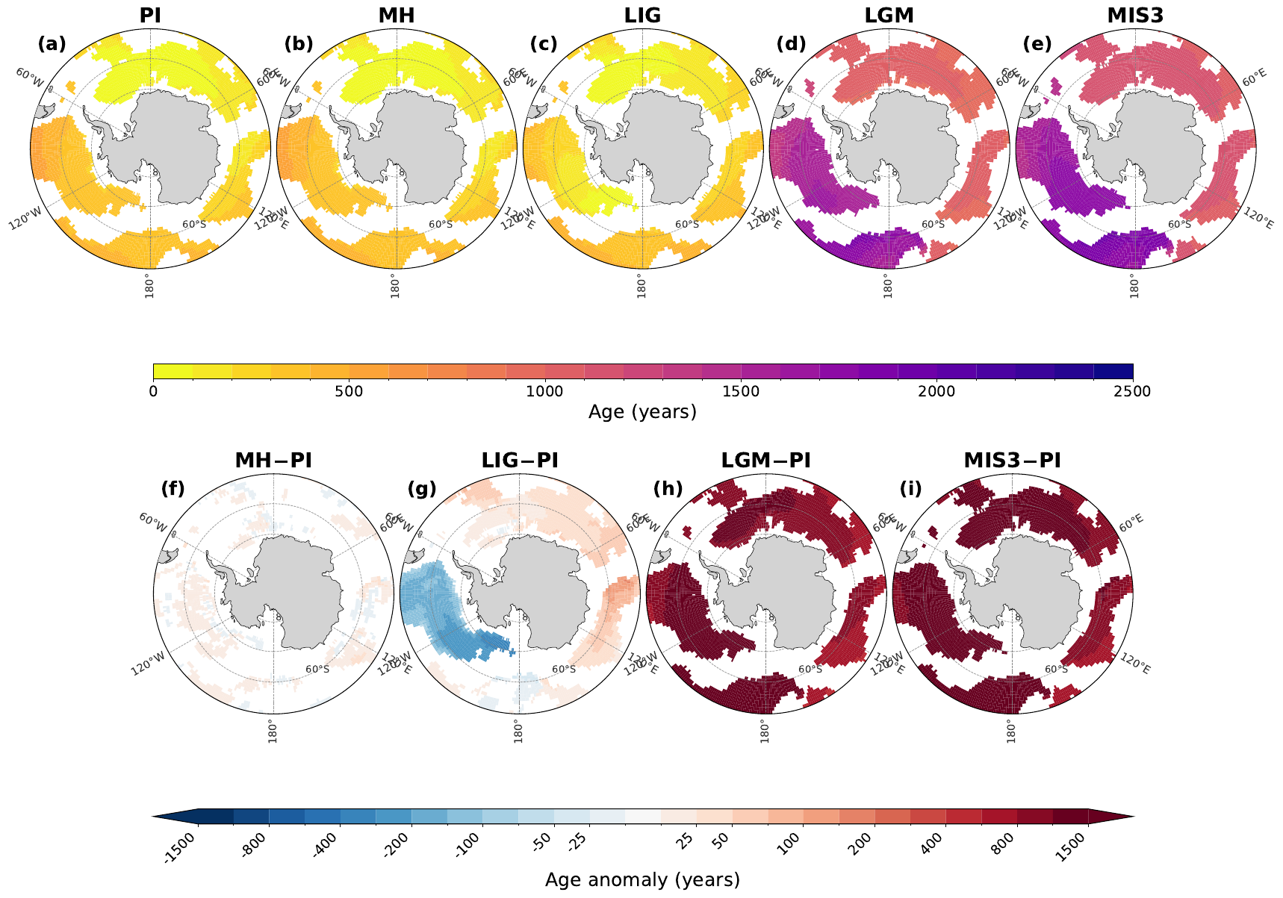

Specific comments
1. LIG, LGM and MIS should be capitalised. –- Thank you for catching this. The three abbreviations are now capitalised consistently throughout the manuscript, the figure captions and the supplement, and MIS is written as MIS3 everywhere so that it matches the column headings of the figures.
2. Line 21-22: The transition to SAM is quite abrupt. –- The abstract now introduces the Southern Annular Mode through the mechanism that connects it to the mean state, noting that because the balance between the thermal and haline pathways is set by how much of the surface is ice covered, it also governs the response to internal atmospheric variability.
In the revised manuscript this now reads:
“Because the balance between these two pathways is set by how much of the surface is ice covered, it also governs the response to internal atmospheric variability. The Southern Annular Mode modulates transformation by 3-8 Sv between its positive and negative phases in every climate state, working through heat loss when the ocean is open and through brine rejection when it is ice covered.”
3. Line 24: "same mechanisms" sounds vague ... The abstract should be understandable on its own. –- Replaced with the explicit statement that the mode works "through heat loss when the ocean is open and through brine rejection when it is ice covered".
4. Lines 25-27: ... additional context is needed before introducing the deep ocean ventilation results. –- The abstract now bridges from surface forcing to ventilation via the overturning circulation, stating that weaker glacial transformation coincides with a collapse of the simulated abyssal cell from about 10 to 2 Sv, before the ages are given. This also incorporates the new overturning analysis requested by Reviewer 3.
In the revised manuscript this now reads:
“Weaker glacial transformation coincides with a collapse of the simulated abyssal overturning cell from about 10 to 2 Sv and with older abyssal water. Ideal ages at 4000 m remain below 500 years during interglacials but exceed 750 years basin-wide during glacials, reaching 1500 years in the Pacific.”
5. Lines 102-105: SAM is introduced only briefly here. Given its importance ... please consider providing a slightly more detailed introduction. –- The introduction now defines the mode as the leading mode of extratropical Southern Hemisphere variability, describes what its positive phase does to the westerlies and hence to Ekman divergence, air-sea heat exchange and sea ice export, and cites the observational literature linking it to bottom water changes.
In the revised manuscript this now reads:
“The Southern Annular Mode is the leading mode of extratropical Southern Hemisphere circulation variability, describing a meridional redistribution of atmospheric mass between mid-latitudes and Antarctica . Its positive phase strengthens the circumpolar westerlies and displaces them poleward, which changes Ekman divergence, air-sea heat exchange, and the northward export of sea ice. In the present-day ocean these adjustments modulate mixed-layer depth and surface buoyancy forcing , and they have been linked to observed changes in bottom water properties . Whether the mode remains an effective modulator of dense water formation once the mean state changes, in particular once an expanded ice cover separates the ocean from the atmosphere, is not known.”
6. Line 125: typo: 'more'. –- Corrected ("moer" "more").
7. Line 127: Figure numbering; A3 can't be called before A1 and A2. –- The appendix figures have been reordered so that they are cited in numerical order.
8. Line 129: 'Here,'. –- Corrected.
9. Line 140: As a result, the deep MLD signals ... Also, "vanish" is perhaps not the most scientific wording. –- Rephrased to "are strongly reduced and become confined to narrow coastal bands and polynyas", and we now quantify the reduction rather than describing it qualitatively.
In the revised manuscript this now reads:
“The reduction is substantial rather than complete. Summed south of 55°S, the area with a winter mixed layer deeper than 400 m falls from 7.51011 m2 in PI to 1.71011 m2 in LGM and 1.61011 m2 in MIS3, and the maximum mixed-layer depth decreases from 991 m to 819 m and 645 m. Mixed layers deeper than 600 m, which cover 2.41011 m2 in PI, essentially disappear in both glacial states. The residual glacial signals in coastal regions are therefore genuinely shallower than their interglacial counterparts, consistent with dense water production that is confined to narrow coastal bands rather than distributed across the open gyres.”
10. Line 141: These signals are not particularly visible even in the coastal regions (the darker blue shading in LGM is at 200m, so considerably shallower than the interglacials). –- This is a fair objection and we have addressed it with numbers. Summed south of 55°S, the area with a winter mixed layer deeper than 400 m falls from 7.5×10¹¹ m² in PI to 1.7×10¹¹ m² in LGM and 1.6×10¹¹ m² in MIS3, the maximum mixed-layer depth decreases from 991 m to 819 m and 645 m, and mixed layers deeper than 600 m essentially disappear in both glacial states. The text now says explicitly that the residual glacial signals are genuinely shallower than their interglacial counterparts. Panels (g) and (h) of Figure R1.2 above make the point quantitatively: both the area of deep convection and the depth of the deepest mixed layer fall in the glacial states, so the reviewer's reading of the shading is correct and is now reflected in the text.
The reviewer's observation also pointed to a presentation problem, which we have fixed. On the shared 0–400 m scale of the original figure the glacial panels are almost featureless, because the 99th percentile of the glacial winter mixed layer south of 55°S is only 280 m (LGM) and 296 m (MIS3). Replotting those two states on their own 0–300 m scale makes the coastal cells visible.
11. Line 134-141: Fig.1 i-l subpanels are not discussed at all. –- A paragraph discussing the surface density panels has been added. It notes that the glacial density anomalies follow the salinity field rather than the temperature field, because the thermal expansion coefficient is small at the near-freezing temperatures south of the ice edge, and points out the density-compensated LIG anomaly and the weak negative LGM anomalies in the Atlantic-Indian sector.
In the revised manuscript this now reads:
“The surface density anomalies (Fig. 1i-l) follow the salinity field rather than the temperature field in the glacial states. Cooling and salinification both act to densify the surface, but at the near-freezing temperatures that prevail south of the ice edge the thermal expansion coefficient is small, so the haline term sets both the pattern and the magnitude. In LIG the warm and salty Bellingshausen-Amundsen anomaly is close to density compensated (Fig. 1j), and the LGM retains weak negative density anomalies in parts of the Atlantic-Indian sector where surface freshening outweighs cooling.”
12. Line 144-146: The LIG also exhibits similar behaviour, although the changes are smaller in some basins. Likewise, the LGM shows some negative anomalies in the Atlantic–Indian sector. –- Both points are now stated in the text; see the response to comment 11.
13. Line 146-148: An explanation of why the wind stress changes do not lead to increased sea ice in the Ross Sea would be useful. Is this due to the presence of relatively warm water despite enhanced salinity, density, and Ekman transport in this region? –- We checked this directly, and the answer turned out to be more interesting than the question assumed, so we set it out in full.
The mechanism the reviewer proposes is real, but it operates in the last interglacial rather than in the glacial states the comment refers to. Averaged between 60 and 75°S in winter, the glacial sea ice response is in fact fairly uniform around the continent: concentration rises by 0.62 in the Ross sector, 0.70 in the Weddell sector and 0.53 in the Adélie sector at the Last Glacial Maximum, and all three sectors cool to within about 0.1 K of the surface freezing point, so ice growth is not limited by surface heat content anywhere.
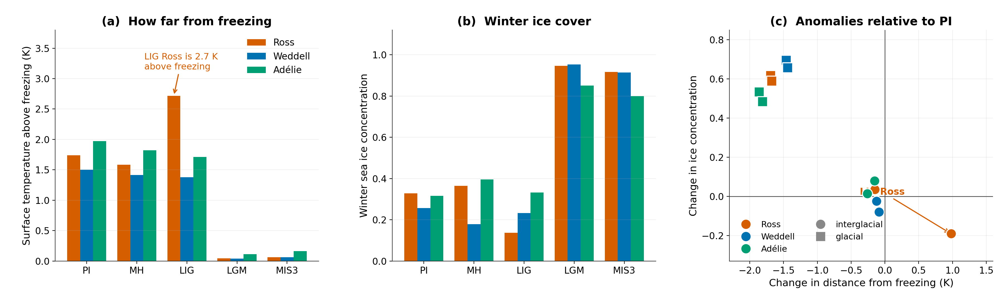
So in the last interglacial the Ross sector is 0.97 K warmer than in PI and sits 2.72 K above the freezing point, against changes below 0.3 K elsewhere, and its winter ice concentration falls by 0.19. There the wind can export ice efficiently but the water is too far from freezing for the exported ice to be replaced, which is precisely the reviewer's proposed mechanism. We have rewritten the passage to say this, rather than attributing the behaviour to the glacial wind response as the submitted version implied. This asymmetry is also why the Ross sector departs from the circumpolar pattern in the variability analysis.
14. Line 167: It would be helpful to quantify the thermal contribution, similar to the quantification provided for the haline contribution in line 157. –- Added. The thermal term accounts for 70–85% of the total at the transformation maximum in the interglacials, against 15–30% for the haline term, and falls to 12–17% in the glacial states.
In the revised manuscript this now reads:
“This transformation is dominated by surface heat loss (red line), which accounts for 70-85% of the total at the transformation maximum, with limited sea ice extent restricting the haline contribution from brine rejection to a secondary role (15-30%; green line). Other freshwater fluxes (blue lines) oppose densification through net precipitation and river runoff. We note that this thermally dominated maximum occurs at densities that correspond to intermediate and mode waters rather than to bottom water. In the densest classes that the simulated surface fluxes reach (₂ 37.0 kg m-3), the PI transformation is already haline dominated, with the sea ice term contributing 0.79 Sv against 0.06 Sv from heat in the annual mean. The thermal dominance reported here is therefore a property of the integral over all density classes, and we quantify its sensitivity to the choice of integration domain and density range in the Discussion.”
15. Fig. 2 Would it be possible to share a figure with the same y-axis limits for all panels? –- Yes. Supplementary Fig. S5 now shows the same transformation curves on common vertical and horizontal axes, so magnitudes and density positions can be compared directly across climate states and regions. We have kept the independently scaled version in the main text because the shape of the individual curves is otherwise hard to read, and the main text now points to the common-axis version explicitly.
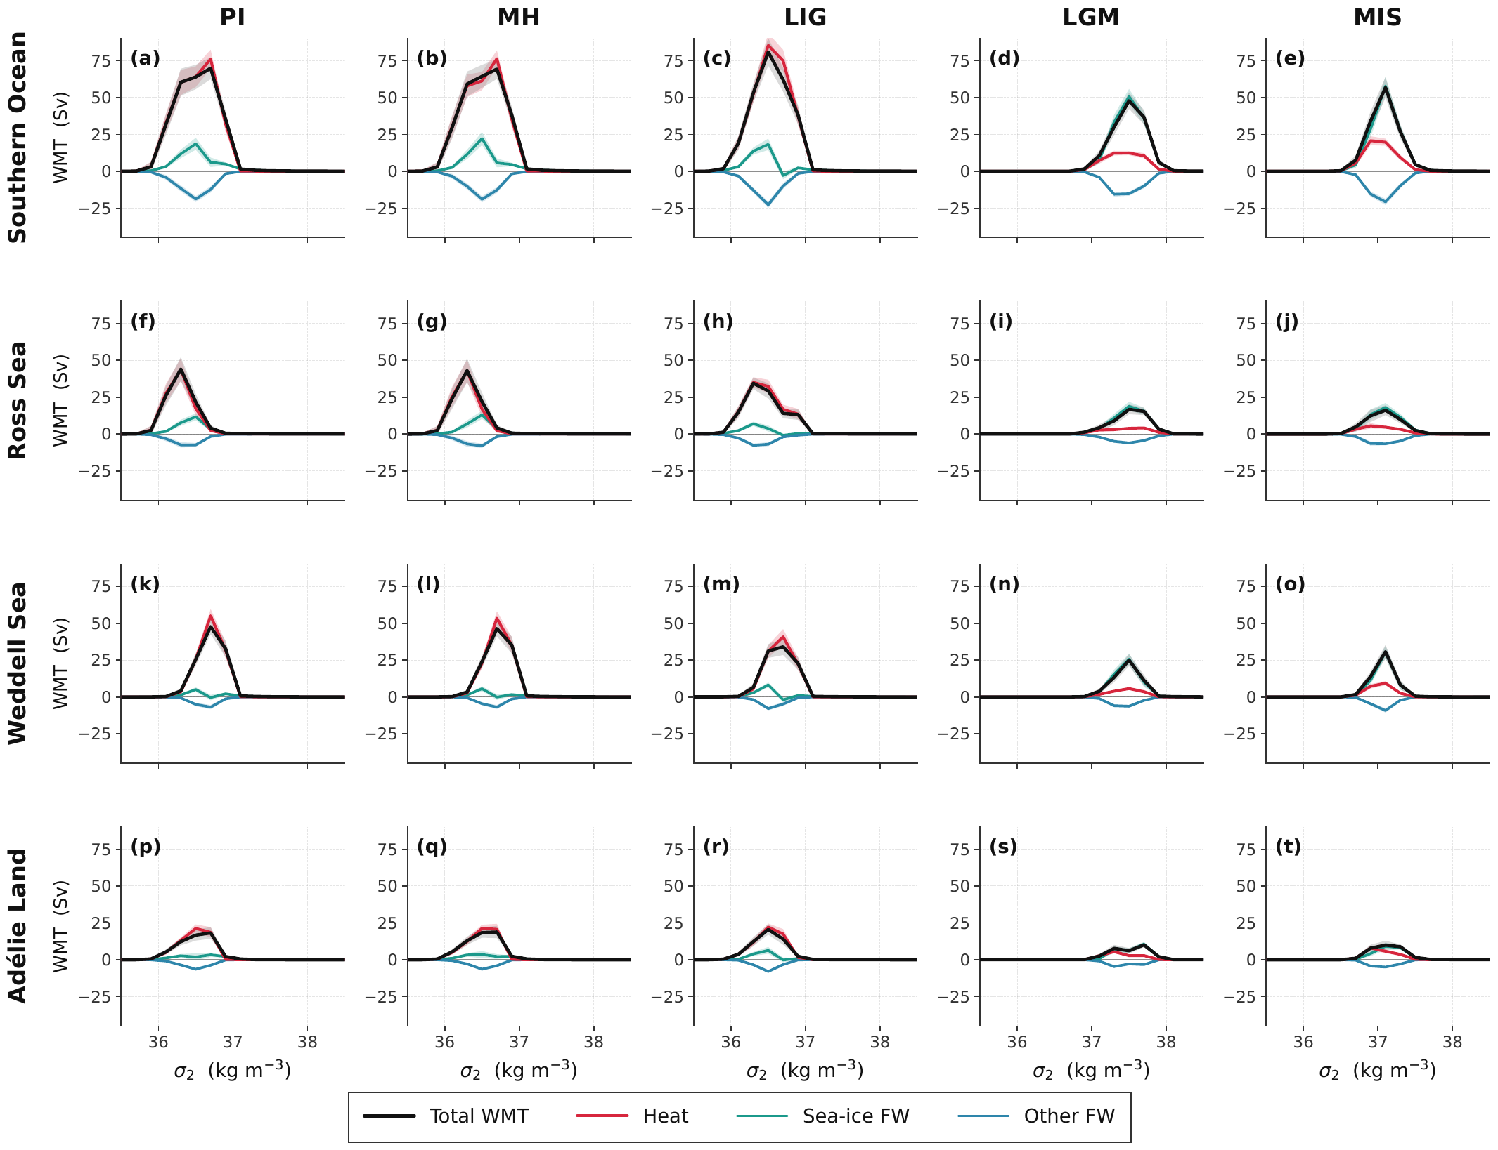
16. Line 174: "Section 4?" If this is intended to refer to the Methods section. –- Corrected to refer to the Methods section by name.
17. Fig.3 Please consider adding the climate-state labels at the top of each column, as in the other figures. –- Added, here and on the other multi-panel figures; Reviewer 3 made the same request.
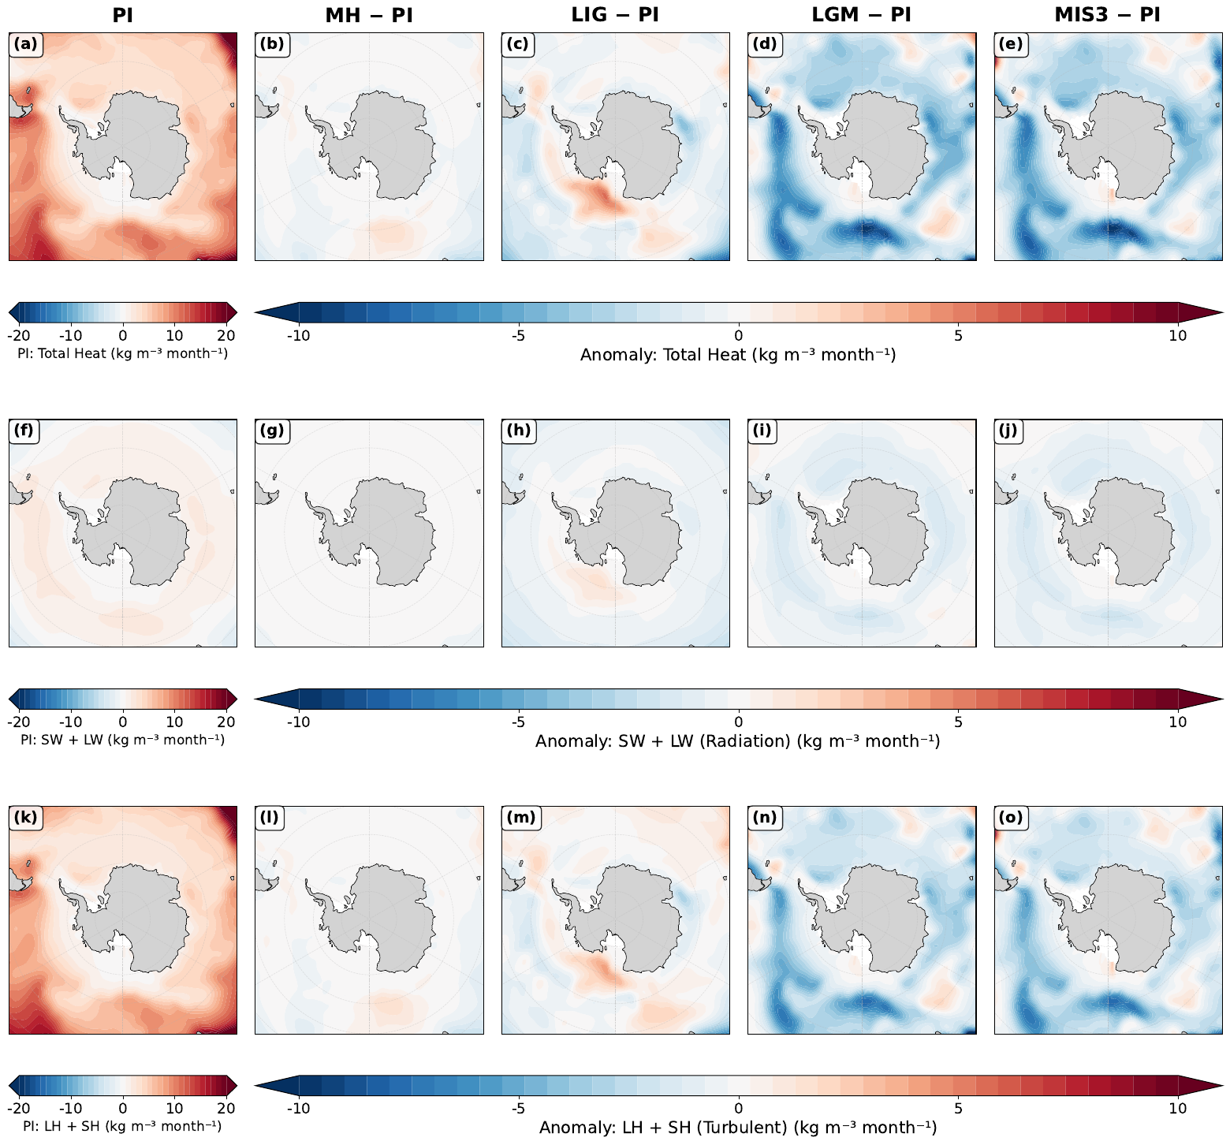
18. Line 180/181: The LIG is first described as "showing modest changes", but later as "exhibiting a pronounced increase". These descriptions appear inconsistent. –- The two statements referred to different quantities, which was not clear. The changes are modest in the circumpolar integral and pronounced locally in the Ross Sea sector. The text now says so explicitly.
19. Could the authors briefly explain what is meant by thermal density tendency and sea-ice-driven density tendency in the methods. –- Definitions have been added to the Methods, including the sign convention and the physical meaning of brine rejection versus melt.
In the revised manuscript this now reads:
“We refer throughout to the thermal density tendency, meaning the surface density change produced by the net heat flux acting through the thermal expansion coefficient, that is the -(/C_{p})Q_{n}et term, and to the sea-ice-driven density tendency, meaning the part of the haline term S F_{f}w that is carried by the thermodynamic growth and melt of sea ice. A positive value denotes densification of the surface water in both cases. Brine released during ice growth increases surface salinity and therefore density, whereas melting releases freshwater and reduces it.”
20. Line 209: Please add the appropriate reference(s) here to support this statement. –- We now cite Cerovečki et al. (2013) and Abernathey et al. (2016) in support of the statement that turbulent rather than radiative fluxes control the surface buoyancy budget.
21. Line 216-246: Please refer to the relevant subpanels of Figure A5. –- Done.
22. Line 249, 255: The phrase "across at high latitudes" is somewhat unclear. –- Both instances have been rewritten. They now read "over the ice-free parts of the Southern Ocean south of about 50°S" and "south of the ice edge" respectively.
23. Could the authors clarify where the primary deep water formation regions occur in this model? ... relatively little signal is apparent over the Weddell and Ross Seas. –- We have added this diagnosis to the Results, and it is shown in Figure R1.2 above. In the pre-industrial state the Weddell sector accounts for 70% of the area with winter mixed layers deeper than 400 m south of 55°S and 97% of the area deeper than 600 m, centred near 68°S in the gyre interior. The formation region is therefore the open Weddell gyre rather than the shelf, which is directly relevant to the model limitation discussed under G1. This also explains the pattern the reviewer noticed: the Southern Annular Mode heat flux signal is strongest over open water, and in the glacial states the coastal regions where dense water is produced are precisely those insulated by ice, so the surface flux anomalies there are small even though the transformation response is not.
24. Lines 261-263: Please consider expanding on the physical mechanism linking positive SAM to freshwater loss and intensified brine rejection. –- Expanded, with the mechanism stated as a sequence: strengthened and poleward-shifted westerlies increase offshore Ekman transport of sea ice, which opens coastal polynyas, which exposes water at the freezing point to the atmosphere and sustains rapid new ice growth, which concentrates brine locally while the exported ice carries the compensating freshwater away to melt further north. References added.
25. Line 291, 294: Please check citation format. –- Corrected.
26. Line 301: Figure A4 appears to show only model results. Please consider including the observational estimates in the figure (or referring to them directly). –- We have added the quantitative comparison to the text and to the new Fig. 8, reproduced as Figure R1.1 above, which shows our transformation recomputed over the Pellichero domain alongside the standard domain. We report their published values directly in the Discussion, including the 5 ± 5 Sv transformation into denser classes and the stated factor of 2–5 by which the freshwater term exceeds the heat term in their sector, and we compare our numbers against them. We chose to make the comparison quantitatively in the text and in a dedicated figure rather than overplotting their curve, because their analysis is in neutral density over a different density range and an overlay would misleadingly imply a point-by-point correspondence that does not exist; the density-range mismatch is itself one of our findings. The appendix figures are now also cited in numerical order. We note that this comment and the general comment on model evaluation above concern the same comparison, and we have kept the two answers consistent: the quantitative comparison with the published observational values is given once in the Discussion, and both replies point to the same new figure.
27. Lines 308-321: The discussion quantifies the interglacial changes ... but similar quantification is not provided for the glacial changes. –- Added. The glacial transformation maximum weakens to below 60 Sv and moves to ₂ = 37.0–37.5 kg m⁻³, with the thermal share falling to 12–17%.
In the revised manuscript this now reads:
“The winter transformation maximum weakens to below 60 Sv and moves to ₂ = 37.0-37.5 kg m-3, and the thermal share of the transformation falls to 12-17% while the sea ice term becomes dominant. Extensive ice cover insulates the ocean from atmospheric heat exchange, and simultaneously intensifies haline forcing through enhanced brine rejection concentrated in coastal regions.”
28. Lines 326 appear to repeat the statement made in line 323. In addition, the general statement in lines 323–325 does not appear to hold equally across all climate states. –- The repetition has been removed by merging the two sentences. We have also added the qualification the reviewer asks for, noting that the Ross Sea departs from the circumpolar picture and that in the glacial states the signal is carried largely by the Weddell sector.
In the revised manuscript this now reads:
“This circumpolar picture does not hold uniformly in every sector. The Ross Sea in particular departs from it, showing weaker and at some densities opposing responses, and in the glacial states the circumpolar signal is carried largely by the Weddell sector while the Ross and Adelie sectors contribute little.”
29. Line 339: Please provide a reference for the sediment-record evidence discussed here. –- On reflection we think the passage was speculative rather than supported, and Reviewer 3 raised the same objection from the opposite direction, noting that accumulation rates around the Antarctic margin are very low. We have replaced the proposal with a statement of the difficulty, and now present the persistence of the coupling as a property of the simulated system rather than as a practical route to a marine reconstruction.
In the revised manuscript this now reads:
“Whether this persistent coupling could be exploited for proxy reconstruction is less clear than we previously suggested. Recovering an interannual-to-decadal signal from marine sediments would require accumulation rates and chronological precision that are rarely available around the Antarctic margin, where sedimentation is slow and bioturbation mixes the record over intervals far longer than the variability of interest. We therefore present the persistence of the coupling as a property of the simulated system rather than as a practical route to a marine Southern Annular Mode reconstruction.”
30. Section 4.1: Please define the full names of the abbreviated components. –- Done. The Methods now spell out that the radiative component is the sum of the shortwave and longwave fluxes and the turbulent component the sum of the latent and sensible heat fluxes.
In the revised manuscript this now reads:
“In the figures the radiative component denotes the sum of the shortwave and longwave fluxes, and the turbulent component denotes the sum of the latent and sensible heat fluxes.”
31. Line 388: Please check the citation formatting. –- Corrected.
32. Lines 394-403: Please consider including a summary table listing the prescribed boundary conditions for each experiment. –- Added as Table 1; see G2.

Reviewer #2
So in principle this is an interesting and topical paper and I would like to be able to support its publication. However, I have two big issues with the present MS that in my view mean it needs at least some substantial revision.
We are grateful for both issues, which were well aimed. We address them in turn.

Major issue 1: mismatch with observational studies of the modern ocean
1) There is a mismatch with observational studies of the modern ocean. In their model the pre-industrial situation is dominated by thermal buoyancy forcing whereas Pellichero et al, (2018) find the opposite: The title of their observation-based paper makes this clear: “Southern Ocean meridional overturning is driven by freshwater fluxes”. Shi et al dismiss this difference in a single sentence, saying it is due to “model biases or regional differences in analysis domains” (line 305). Comparing their Fig 3a, Fig 4a with Pellichero Fig 2a and c, the regions look similar, suggesting it's mostly model bias. But the switch from thermal to haline forcing is the present paper's main result, so if indeed it is due to model bias, this seems like a major problem.
The reviewer is right that the original single sentence was inadequate, and right to insist that the answer matters for the paper's main claim. We therefore tested it directly rather than speculating. Three findings emerged, and we report all three, including the one that is unfavourable to us.
The domains are less similar than they appear. This is worth showing directly, since the similarity of the two regions is the premise of the reviewer's argument.
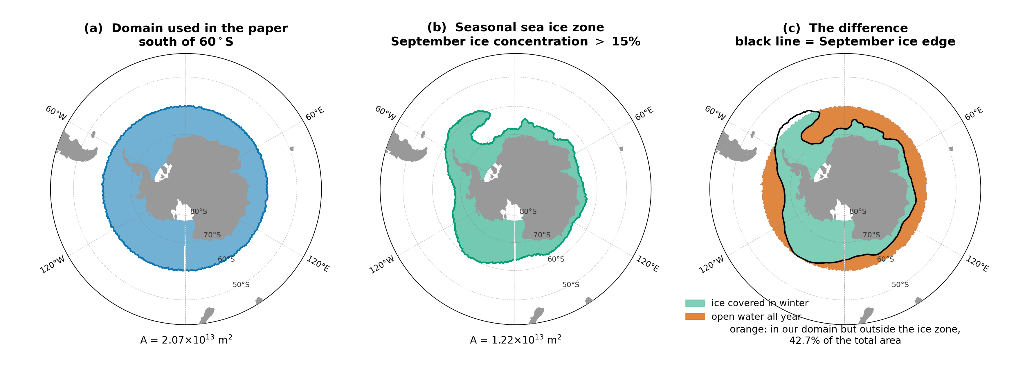
Pellichero et al. define their sector as the region enclosed by the September 15% sea ice contour, so its northern boundary is an ice contour that varies with longitude, not a latitude circle. Our published integral covers everything south of 60°S. In our pre-industrial simulation, 42.7% of that area lies outside the September ice contour and is therefore water their analysis does not include. It is also the part of the domain that stays exposed to the atmosphere year round, and taken alone it is 89–91% thermally driven in the dense classes. Recomputing our transformation over a sea ice sector defined exactly as theirs, which reproduces their domain to within 2.5% in area, moves the partition in the direction they report: the thermal share of the dense-class transformation falls from 69% to 61%, and the sea ice contribution at the transformation maximum roughly doubles from 0.86 to 1.84 Sv.
The density range matters more than the domain. This was the more consequential finding. Converting our simulated surface properties inside the September ice zone to the neutral density coordinate that Pellichero et al. use, our thermally dominated transformation maximum sits near _{n} ≈ 27.3 kg m⁻³, whereas the haline-dominated lower cell they describe occupies _{n} = 27.9–28.8 kg m⁻³. Our simulated surface transformation barely reaches the lighter edge of their range. In the densest classes our fluxes do populate (₂ ≥ 37.0 kg m⁻³), our pre-industrial transformation is haline dominated, with 0.79 Sv from sea ice against 0.06 Sv from heat. The two analyses are therefore largely describing different water masses, ours weighted toward mode and intermediate densities and theirs toward bottom water densities, and where they overlap they agree in sign. We now state in the Results that the interglacial thermal pathway we identify is more relevant to intermediate and mode water formation than to bottom water proper.
A residual discrepancy remains, and it is genuine model bias. We can rule out one candidate explanation. Pellichero et al. attribute part of the haline dominance to the thermal expansion coefficient being near zero at the freezing point, so we checked whether our ice-covered sector reproduces that regime. It does: the area-weighted winter surface temperature inside the September ice zone is -1.08 °C, the median is -1.71 °C, 55% of the area lies within 0.5 °C of the local freezing point, and α = 3.5×10-⁵ K⁻¹. The model is not warm-biased there, so we cannot appeal to that. What differs is where dense water is made. In the model, pre-industrial dense water forms by open-ocean convection in the interior of the Weddell gyre near 68°S rather than by the sequence of shelf water formation and downslope overflow that operates in the real ocean. Open-ocean convection exposes a large area to the atmosphere and so recruits an excessive thermal contribution while producing water that is not dense enough, which is precisely the offset in density class described above.
Does the main result survive? We think it does, for two reasons that we now give in the text. First, the regime shift survives the domain test. Recomputed over the sea ice sector alone, the glacial states remain 15% and 17% thermally driven while the interglacials remain 53–88% thermally driven, so the contrast is not manufactured by including open water in the interglacial integrals. Second, the mechanism is the ice cover itself rather than the convection style: insulation of the surface and concentration of brine rejection follow from the areal expansion of sea ice, and both would operate in a model that formed its dense water on the shelf.
The consequences for the large-scale circulation are visible in the overturning itself.
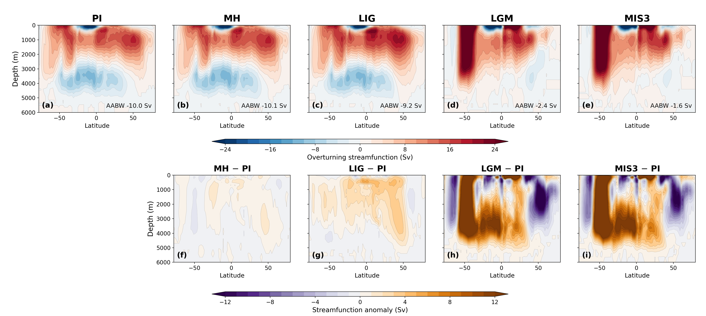

Major issue 2: relation to Chen et al. (2025)
2) I'm puzzled that they don't acknowledge or discuss the relation of their work with recent studies showing very similar results but analysed through different tools and language. Using the same ocean model Chen et al, 2025 (GRL 52, e2025GL114809) describe formation of very dense AABW in glacial time as due to the enhanced ice formation, where the resulting water mixes more slowly with overlying waters due to the greater density difference. One of the authors (Lohmann) is on both papers, yet this paper is not referenced, let alone discussed, by Shi et al. I ask myself what is learned from the WMT analysis that is not already discussed in that paper?
The omission was an oversight on our part and we apologise for it. The paper is now cited in both the Introduction and the Discussion, and we address the reviewer's question directly rather than merely adding the reference.
We first acknowledge the genuine agreement. Chen et al. attribute the large glacial volume of Atlantic bottom water to a substantial increase in sea ice export toward lower latitudes, which supplies dense shelf water year round, and to weaker mixing between northern- and southern-sourced water, which lets that water retain the properties of its origin. Our glacial conclusions are consistent with theirs, and we say so explicitly rather than presenting our result as new in that respect.
What the transformation analysis adds is of two kinds. The first is measurement rather than inference. Chen et al. diagnose water mass volumes, the overturning streamfunction, and mixed-layer and sea ice fields, from which the role of sea ice is inferred because those fields covary with it. A decomposed surface buoyancy budget measures the transformation directly and attributes it to individual flux components in sverdrups, so the sea ice contribution is quantified rather than inferred. Our analysis therefore tests the mechanism they proposed, and finds it supported.
The second is scope. Their simulations are ocean-only, with a prescribed atmosphere, and cover the Last Glacial Maximum and the present day. Ours are fully coupled, so sea ice and the atmospheric fluxes evolve together, and they span five climate states. A shift between two forcing regimes cannot be identified from a single glacial state; it requires the interglacial end members for the contrast to exist at all. The regime shift that is our central result is therefore not addressable within their experimental design, which is why the two studies reach compatible conclusions about the glacial ocean while answering different questions.
We have phrased this in the manuscript as the present analysis testing and quantifying the mechanism Chen et al. proposed, rather than as a claim that they missed something.
The passage added to the Discussion reads:
“Our conclusions about the glacial state are consistent with recent work using the same ocean model in a forced configuration. Chen et al. attribute the large glacial volume of Atlantic bottom water to a substantial increase in sea ice export toward lower latitudes, which supplies dense shelf water year round, and to weaker mixing between northern- and southern-sourced water, which allows that water to retain the properties of its origin. The agreement is worth stating explicitly, and the two studies are complementary rather than overlapping. Chen et al. infer the role of sea ice from water mass volumes, the overturning streamfunction, and mixed-layer and sea ice fields, in ocean-only simulations of two states with a prescribed atmosphere. The transformation framework applied here measures the surface buoyancy forcing directly and attributes it to individual flux components in sverdrups, so the contribution of sea ice is quantified rather than inferred from covarying fields. Running the analysis across five coupled climate states, in which sea ice and the atmospheric fluxes evolve together, is also what makes the change of regime visible, since a shift between two forcing regimes cannot be identified from a single glacial state. The present analysis therefore tests and quantifies the mechanism that Chen et al. proposed.”

More minor points
The fundamental issue must be getting right the formation of sea ice and rejection of brine close to the continent, followed by the mixing of that dense water with the surroundings, all processes that intrinsically occur at fine spatial scales. In this regard the model looks good, by comparison to most paleo studies. The comparatively high resolution close to the continent must be helpful I'm sure, (though at 25 km it may still not be enough to realistically model the dynamics of polynya formation and brine rejection). Some more information on just how this is being managed would add to the value of the paper.
We agree with the reviewer's caveat and have expanded the Methods accordingly. The unstructured mesh refines to about 25 km around Antarctica, which resolves the larger coastal polynyas as features but does not resolve the boundary layer processes that set polynya dynamics. The relevant mechanics are that ice growth and brine release are computed thermodynamically at each surface node and enter the ocean as a salt flux, so the brine signal is represented where the model puts the ice, but its intensity depends on the simulated wind-driven divergence rather than on resolved polynya circulation. We now state this, together with the more fundamental point that the configuration has no ice shelf cavities and therefore omits basal melt entirely.
The authors highlight the lack of deep convection in the glacial open ocean due to the very extensive winter-time ice cover. A little more discussion of how/why the model achieves this ice cover would be welcome, as previous paleo-model studies often don't get that, and as a result may have too much deep convection in glacial simulations, which doesn't match so well with paleo-proxies. (Another paper they don't cite is Lhardy, Climate of the Past, 17, 1139–1159, 2021, which discusses how most PMIP models fail in this regard.)
Thank you for this reference, which we have added and discussed. We now note that maintaining an extensive glacial ice cover is not a general feature of paleoclimate simulations, that many PMIP models underestimate glacial Southern Ocean sea ice and its seasonality, and that colder glacial forcing on its own tends to intensify open-ocean convection rather than suppress it, so that better boundary conditions do not by themselves fix the problem. We highlight the finding of Lhardy et al. that the only configuration avoiding an unrealistically deep northern-sourced cell was the one in which brine sinking along the Antarctic margin was parameterised explicitly. In our simulations the glacial ice expands sufficiently to insulate the interior gyres, and the area of deep winter mixed layers contracts to roughly one fifth of its pre-industrial value. We now state that our glacial result depends on that simulated expansion being realistic, and that while proxy reconstructions support the direction of the change, the quantitative agreement remains uncertain.
The text added to the Discussion reads:
"The ability of the model to maintain an extensive glacial winter ice cover, and thereby to suppress open-ocean convection, is not a general feature of paleoclimate simulations. Many PMIP models underestimate glacial Southern Ocean sea ice and its seasonality, and colder glacial forcing on its own tends to intensify open-ocean convection rather than suppress it, which degrades the properties of the simulated bottom water; in one systematic study the only configuration that avoided an unrealistically deep northern-sourced cell was the one in which brine sinking along the Antarctic margin was parameterised explicitly . In our simulations the glacial ice cover expands sufficiently to insulate the interior gyres, and the area of deep winter mixed layers contracts to roughly one fifth of its PI value. The Southern Hemisphere sea ice distribution of these same five simulations has been published previously , and the pronounced glacial expansion described here is evident there as well. The simulated glacial sea ice of this model has also been assessed against diatom-based reconstructions in a multi-model comparison, which found that models including AWI-ESM tend to underestimate the winter sea ice extent inferred from the proxies while capturing the summer distribution more closely . An underestimate of winter ice would if anything weaken the insulation effect we describe, so the haline-dominated glacial regime reported here is unlikely to be an artefact of excessive simulated ice. This behaviour is what produces the haline-dominated glacial regime reported here, and it means our glacial result depends on the simulated sea ice expansion being realistic. Proxy-based reconstructions indicate extensive glacial winter ice, which supports the direction of the simulated change, but the quantitative agreement remains uncertain." In Results section 2.1 the acronyms (MH, LIG etc) are used without introduction. They are defined later, section 4, but as the paper is laid out this is not obvious to the reader coming to section 2.
Corrected. The five experiments and their abbreviations are now introduced at the start of the Results, at first use, in addition to the Methods definition. Reviewer 3 made the same point.
The discussion of the role of the effects of the SAM is interesting, but could I think be shortened, since it is somewhat secondary to the main messages of the paper. Figs 5 and 6 could be moved to the supplementary information.
We have done this. All of the Southern Annular Mode figures, including Figs 5 and 6, have been moved to the Supplementary Information, so the main text no longer carries any figure devoted to the mode. We have also shortened the section, removing the repetition that Reviewer 1 flagged and cutting the speculative passage about marine proxy reconstruction. What remains in the main text is a compact account of the result, with the supporting composites available to readers who want them.
We note that Reviewer 3 took the opposite view of this material, describing it as the more generalisable part of the study. Moving the figures to the supplement while keeping a concise statement of the result in the main text seemed to us the arrangement most likely to satisfy both readings, and we are content with the outcome.
For figs 5 and 6, I think it would be helpful if the forcings were on the same equivalent scales of buoyancy anomaly – currently they are in different units and it is impossible to see how they compare in absolute values.
This is a fair criticism. We have added a statement of the comparison in equivalent surface density tendency terms to the Results: expressed that way, the freshwater contribution is the larger of the two wherever sea ice is present, and the heat contribution is larger only in the ice-free sector, which is the same partition that governs the mean state.
The corresponding statement in the Results reads:
"An asymmetry between the two routes emerges when the mean state changes. The Ekman response is largest in the interglacials, at 11.2 Sv in PI and 12.8 Sv in LIG, and weakest at the Last Glacial Maximum, at 8.0 Sv, even though the glacial mean wind stress is stronger. Extensive glacial ice cover transmits the wind stress to the ocean less efficiently and damps the divergence that the same wind anomaly would otherwise produce. The haline route is correspondingly more important in the glacial states, so the mode continues to modulate transformation by a comparable amount while operating through a different pathway." We have kept the native units in the
figures themselves, which are now supplementary, because the heat and freshwater fields are what the model diagnoses and readers may wish to compare them against other studies in conventional units. The text now makes the relative magnitudes explicit. If the reviewer would prefer the figures recast in buoyancy units, we will do so.

Reviewer #3
Shi et al apply a water mass transformation (WMT) framework to various glacial/interglacial paleoclimate sims using AWI-ESM2. This is an interesting framework for thinking about mechanisms of deepwater formation and how production regimes may shift between climate states, and a novel application. The results indicate the density transformation shifts from a thermal to salt regime between glacial and interglacial states. The observation that the reduction in buoyancy loss through atmospheric heat loss from enhanced sea ice cover is compensated by increased buoyancy loss via sea ice export, is an interesting result and points to an interesting stabilising mechanism for ventilation.
We thank the reviewer for this reading, and particularly for identifying the compensation mechanism as the interesting result, which has helped us frame the revision.

Main issue: the PI state does not form AABW the way the real ocean does
While this is an interesting observation in model space, with potential interest for thinking about paleoclimates, the major issue I currently see for the current framing of the manuscript (and mentioned by the authors on lines 291-297) is that to the best of our knowledge today densewater formation in the Southern Ocean is not primarily a thermally driven regime. Like many models, AWI-ESM2 appears to form AABW via open ocean convection under PI conditions whereas in the real ocean AABW is largely a salt/freshwater controlled process occurring on the shelves (e.g. Orsi et al 1999). Today AABW forms on shelves via interaction with ice cavity melting and coastal polynyas. Upwelling warm CPDW melts basal ice, which cools the shelf water to insitu freezing point but substantially freshens it (e.g. Toggweiler 1995). This close to freezing shelf water then looses further buoyancy in coastal polynas via brine rejection, and flows downslope off the shelves via gravity currents. This must be the starting point for thinking about glacial changes, not thermally driven open ocean convection, unless the authors believe this is somehow an overlooked process in the real modern ocean.*
We accept this criticism. We do not believe shelf processes are overlooked in the real ocean, and we have restructured the Discussion so that the model's convection behaviour is stated at the outset rather than left implicit.
We confirmed the reviewer's suspicion diagnostically. In the pre-industrial simulation the Weddell sector accounts for 70% of the area with a winter mixed layer deeper than 400 m south of 55°S and 97% of the area deeper than 600 m, centred near 68°S in the interior of the gyre rather than over the continental shelf.
The passage added to the Discussion reads:
“Independent evaluations of this model provide context for these limitations, and we summarise the relevant points here rather than leaving them to be sought in the model description literature. evaluate the coupled configuration against observations and report that the abyssal overturning cell associated with Antarctic Bottom Water is reproduced with a maximum of about 10 Sv, comparable to the pre-industrial value obtained here. The same evaluation identifies the Southern Ocean as the region of the most pronounced warm bias, with a sea surface temperature root-mean-square error of 1.43 K against the PHC climatology at the resolution used here, and notes that Antarctic sea ice is too thin, hardly reaching 0.25 m in the central Weddell Sea in September. Their overall assessment is that although biases in the representation of water mass properties and ventilation mechanisms are present, the model still produces a reasonable density distribution that maintains realistic transports. A warm and thin-ice Southern Ocean is precisely the state in which open-ocean convection is favoured over shelf processes, so these documented biases are consistent with the convection behaviour we diagnose above, although we note that the published evaluation does not itself examine mixed-layer depth, polynyas or the convection pathway, and the diagnosis of open-ocean convection reported here is our own.”
We note in passing, and with no criticism intended, that Toggweiler and Samuels (1995) concerns sea ice brine rejection rather than ice shelf melt; there are two papers by those authors from that year and the more frequently cited one concerns Drake Passage. We have cited the sea ice paper, whose conclusion that GCM salinity biases near Antarctica arise from circulation deficiencies rather than from inadequate boundary conditions is directly relevant to our case.
On the footnote: This could be tested by comparing your method only in the regions with observations. Alternatively you could apply the WMT framework to a reanalysis product e.g. Glorys.
We took the first of these suggestions. In summary: 42.7% of our published domain lies outside the September sea ice edge; restricting to their domain moves the thermal share of dense-class transformation from 69% to 61%; and, more importantly, our thermally dominated maximum sits at _{n} ≈ 27.3 kg m⁻³ while their haline-dominated cell occupies _{n} = 27.9–28.8 kg m⁻³, so the two analyses largely concern different water masses. In the densest classes we do populate, our result is haline dominated and therefore agrees with theirs.
We did not carry out the reanalysis calculation. Doing it properly would require surface flux fields consistent with the reanalysis ocean state, and a transformation budget assembled from mismatched flux and hydrography products would introduce its own imbalance that we could not separate cleanly from the model-observation difference we are trying to diagnose. Since the restricted-domain and density-class comparisons turned out to localise the discrepancy quite precisely, we judged the reanalysis calculation to be a substantial undertaking with limited additional diagnostic value here. We would be glad to attempt it if the reviewer considers it essential.
While the glacial-interglacial shift in regime displayed by the model is interesting, how applicable is this result to thinking about the real ocean and glacial interglacial change when the interglacial regime is not representative of the real preindustrial/interglacial ocean? This is not a critique of this model in particular – most models do this. But given these biases, the authors need to do more to convince the reader that there results are generalizable and applicable to the real world and not model, or model-class dependent. Given coastal polynyas are a key process in how AABW forms today are we just looking at a shift from a more biased PI state to a more realistic glacial state? Even if the model cannot represent many of the relevant shelf processes, there may still be something interesting/generalisable to say, but I do not believe this is not the case in the current framing.
This is the sharpest form of the objection and we have tried to answer it honestly rather than deflect it. Two arguments, both now in the Discussion.
The regime shift survives the domain test. Recomputed over the sea ice sector alone, the glacial states remain 15% and 17% thermally driven while the interglacials remain 53–88% thermally driven. The contrast is therefore not an artefact of including open water in the interglacial integrals, which is the most obvious way the biased end member could have manufactured it.
More fundamentally, the mechanism is the ice cover rather than the convection style. Insulation of the surface from the atmosphere and the concentration of brine rejection both follow from the areal expansion of sea ice. Both would operate in a model that formed its dense water on the shelf. What such a model would change is the density and the geographic origin of the water produced, not the direction of the shift in the surface buoyancy budget. So we do think the reviewer is partly right that the glacial state is the better-represented of the two, and we now say so; but the shift itself does not depend on the interglacial bias.
We have correspondingly narrowed what we claim. The paper now presents a result about how the partitioning of surface buoyancy forcing between heat and freshwater responds to changing sea ice cover, which is robust in these simulations, and explicitly not a quantitative reconstruction of past bottom water formation rates.
The relevant new passage reads:
"The second factor is the density range, and it accounts for most of the remaining difference. Converting our simulated surface properties inside the September ice zone to the neutral density coordinate used by Pellichero et al., our thermally dominated transformation maximum sits near _{n} 27.3 kg m-3, whereas the haline-dominated lower cell they describe occupies _{n} = 27.9-28.8 kg m-3. Our surface transformation barely reaches the lighter edge of that range. In the densest classes our fluxes do populate (₂ 37.0 kg m-3), the PI transformation is haline dominated, with 0.79 Sv from sea ice against 0.06 Sv from heat. The two analyses are therefore largely describing different water masses, ours weighted toward mode and intermediate densities and theirs toward bottom water densities, and where they overlap they agree in sign. This also indicates that the interglacial thermal pathway identified here is more relevant to the formation of intermediate and mode waters than to bottom water proper." I find the SAM wind results interesting and I think more generalisable. The results suggest changes in wind shift/strength impacts not just the ekman divergence i.e. upwelling of deepwaters, but also the salt pump via sea ice export, and thus the formation of deepwaters. This suggests changes in the wind patterns effect both the push and pull driving the overturning.
We are grateful for this observation, which identified a mechanism our original analysis had not isolated, and we have carried out new work to test it directly. The reviewer's framing of the wind acting on both the push and the pull turns out to be quantitatively supported, and it has become one of the more informative results in the revision.
We separated the two routes explicitly. For the same high and low SAM composites, we computed the zonally integrated northward Ekman transport at 60°S from the simulated zonal wind stress, which measures the push, and the coastal brine input integrated south of 65°S, which measures the pull. Both were computed for all five climate states.
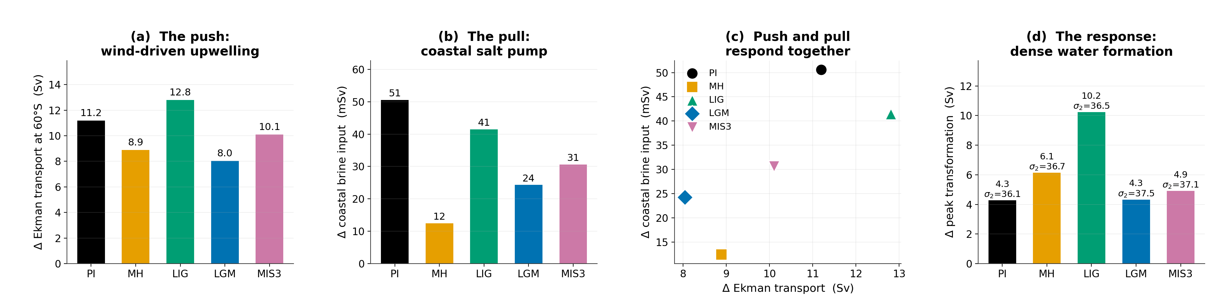
Three results follow, and all three are new relative to the submitted version.
The push and the pull are not independent expressions of the same forcing but two halves of one mechanism. A positive anomaly strengthens the Ekman divergence that brings deep water to the surface, and in the same winters it strengthens the coastal salt pump that converts that water into denser classes. Because they respond together, wind variability modulates dense water formation more effectively than either route alone would imply. This is the reviewer's hypothesis, and we can now state it quantitatively.
The balance between the routes is state dependent, and in a way we did not anticipate. The Ekman response is largest in the interglacials (11.2 Sv in PI, 12.8 Sv in LIG) and weakest at the Last Glacial Maximum (8.0 Sv), even though the glacial mean wind stress is stronger. Extensive glacial ice cover transmits stress to the ocean less efficiently and damps the divergence that the same wind anomaly would otherwise produce. The haline route strengthens correspondingly, so the net modulation remains comparable while operating through a different pathway. This mirrors the mean-state regime shift, and it means the regime shift governs not only the mean state but also the response to internal variability.
The spatial patterns show the mechanism directly.
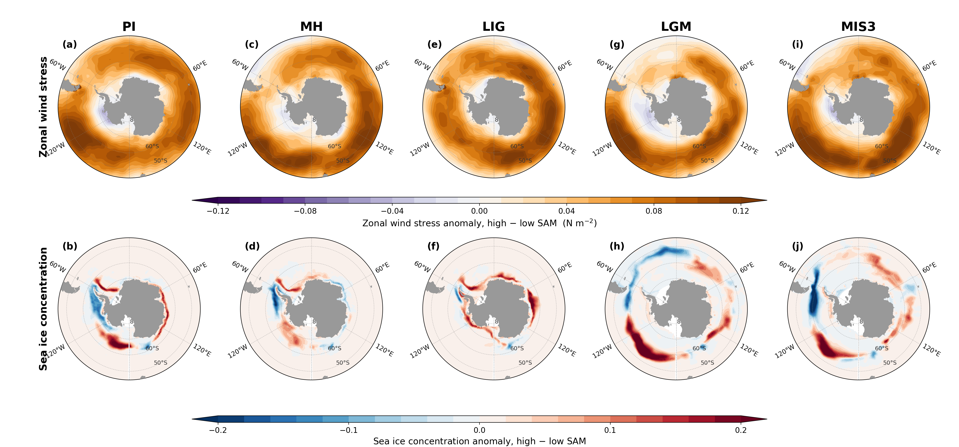
These results are now described in the main text, and the supporting figures are in the Supplementary Information.
It is worth noting that available estimates suggest a equatorward and weakening of the glacial westerlies, that the models do not seem to capture under glacial forcings (e.g. Gray et al 2023). Such a shift may be worth discussing in light of the 'SAM' wind mechanism, and given such a shift/weakening is absent in your glacial simulations.
The reviewer is correct and we now discuss this. We measured our own jet: the winter zonal-mean maximum sits at 45.7°S with 5.83 m s⁻¹ in PI and moves to 49.4°S with 6.30 and 6.85 m s⁻¹ in LGM and MIS3, a poleward shift of 3.7° with strengthening. Gray et al. (2023) infer an equatorward shift of 4.8° (2.9–7.1°, 95% CI) and a weakening of about 25% at the Last Glacial Maximum relative to the mid-Holocene. Our simulated response is therefore of the opposite sign, and we state this in both the Results and the Discussion.
Two considerations bound the consequences, and we give both. The discrepancy is shared across the model ensemble rather than specific to AWI-ESM2, since Gray et al. report that the inferred shift exceeds that produced by any PMIP3/4 member. And the mean-state regime shift depends on the areal extent of sea ice and on brine rejection rather than on jet position; Gray et al. themselves find no correlation across the model ensemble between Antarctic sea ice extent and either the latitude of the westerlies or the position of the SST front, so a jet-position bias does not automatically propagate into the sea ice field on which our main result rests. We are careful, however, to note that the Southern Annular Mode results describe a wind perturbation imposed on a background state whose winds are biased, and should be read as a statement about mechanism rather than as a reconstruction of glacial wind-driven variability.
Interestingly the westerlies seem to intensify in both the glacial and interglacial simulations; why is this? Could this relate to the initializing simulation not being at equilibrium? Is the PI sim extended for the same additional time as the other simulations to adjust for model drift?
The two intensifications have different origins, and we now explain both. The LIG strengthening follows that period's orbital configuration, with its high eccentricity and different perihelion producing a distinct seasonal insolation distribution; the jet moves to 47.6°S and 6.92 m s⁻¹. The glacial strengthening follows the steepened meridional temperature gradient imposed by the expanded ice sheets and sea ice.
On drift: MH is indistinguishable from PI in both jet latitude (45.7°S in both) and strength (5.83 against 5.84 m s⁻¹). Since MH branches from the same equilibrated PI state and was integrated for the same length as the other paleo experiments, a drift explanation would have to produce a signal in LIG, LGM and MIS3 while leaving MH unchanged, which we think is implausible. We have added this argument to the text. For completeness, the PI control was integrated for 1500 years and all paleo simulations for 1000 years, with the final 100 years analysed in each case.
We also checked the deep ocean, which is the slower and more demanding test and the one that matters for a study about abyssal ventilation. Surface temperature equilibrates in decades whereas the abyss takes millennia, so a flat surface temperature is not by itself evidence that the deep ocean has stopped adjusting.
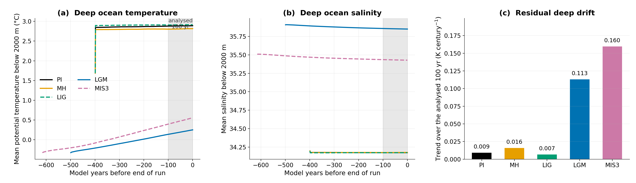
We report this openly rather than presenting the runs as fully equilibrated. The glacial deep ocean is still adjusting, which follows from those experiments being initialised from an earlier glacial state rather than branched from the pre-industrial control. It bears on the ideal ages, which we already describe as lower bounds, and it is a further reason to treat the surface transformation diagnostics, which respond to the surface forcing within years, as the more reliable part of this analysis than the absolute abyssal properties. The surface buoyancy fluxes and the transformation rates derived from them are not affected by a slow deep-ocean adjustment of this size.
The corresponding passage added to the Methods reads:
“The deep ocean is the slower and more demanding test, and we report it explicitly because this study concerns abyssal ventilation. Volume-weighted below 2000 m, the mean potential temperature over the analysed century drifts by 0.009, 0.016 and 0.007 K century-1 in PI, MH and LIG, and the interglacial drift is decelerating, with the trend over the second half of each record between 0.13 and 0.41 times that over the first half. The two glacial experiments are further from equilibrium. Their deep ocean drifts by 0.113 and 0.160 K century-1, it warms by 0.58 and 0.89 K over the available record, and the trend is not decelerating. This reflects their initialisation from an earlier glacial state rather than from the pre-industrial control, and it means the glacial abyssal properties reported here should be read as a state that is still adjusting. It bears directly on the ideal ages, which we already describe as lower bounds, and it is a further reason to treat the surface transformation diagnostics, which respond to the surface forcing within years, as the more reliable part of this analysis than the absolute abyssal properties.”
The Methods now state:
"Residual drift over the analysis period is small relative to the paleoclimate signals of interest. The trend in global mean 2 m temperature across the final century is +0.02 K century-1 for PI, -0.03 for MH, -0.06 for LIG, +0.04 for LGM and +0.10 for MIS3. The last two values exceed the 0.05 K century-1 criterion applied in earlier work with this model , and we note this explicitly rather than leaving it implicit. The deep ocean is the slower and more demanding test, and we report it explicitly because this study concerns abyssal ventilation. Volume-weighted below 2000 m, the mean potential temperature over the analysed century drifts by 0.009, 0.016 and 0.007 K century-1 in PI, MH and LIG, and the interglacial drift is decelerating, with the trend over the second half of each record between 0.13 and 0.41 times that over the first half. The two glacial experiments are further from equilibrium. Their deep ocean drifts by 0.113 and 0.160 K century-1, it warms by 0.58 and 0.89 K over the available record, and the trend is not decelerating. This reflects their initialisation from an earlier glacial state rather than from the pre-industrial control, and it means the glacial abyssal properties reported here should be read as a state that is still adjusting. It bears directly on the ideal ages, which we already describe as lower bounds, and it is a further reason to treat the surface transformation diagnostics, which respond to the surface forcing within years, as the more reliable part of this analysis than the absolute abyssal properties. The glacial-interglacial differences examined here are large by comparison: the same five simulations give a JJAS global mean surface air temperature of 15.5, 15.6 and 16.9 °C for PI, MH and LIG against 11.1 and 13.0 °C for LGM and MIS3 , a contrast of several kelvin. A century-scale drift of 0.1 K is therefore two orders of magnitude smaller than the signal and cannot account for it. The mid-Holocene simulation is also indistinguishable from the pre-industrial control in both the latitude and the strength of the Southern Hemisphere westerly jet, which argues against residual drift as the origin of the wind changes reported in the other paleoclimate states." The authors mention that they use ideal age as a proxy for overturning which seems odd given the overturning can be directly computed within the model. Ideal age is also strongly affected by mixing (equally interesting/important for thinking about ventilation), but if it is specifically the overturning response which is of interest this should be shown directly. Plots of both overturning streamfunction and ideal age throughout the global ocean would be required to assess the overall impact on deep ocean ventilation of the forcings. The introduction line also needs clarification in this regard (L111-112). Furthermore the methods mention that the simulations have been run for 1000yr which is enough to equilibrate physical properties but not ideal ages globally, which need at least twice the maximum ideal age to equilibrate (see Millet et al. 2025).
We agree on all three points and have added the analyses.
The overturning streamfunction, diagnosed online by the model, is now shown in the new Fig. 6. The abyssal cell weakens from -10.0 Sv in PI, -10.1 Sv in MH and -9.2 Sv in LIG to -2.4 Sv in LGM and -1.6 Sv in MIS3, a reduction of roughly 75–85%, while the upper cell changes comparatively little (19.1 Sv in PI against 20.0 and 21.7 Sv in the glacials). The glacial reorganisation in these simulations is therefore concentrated in the abyssal cell.
Global ideal age is now shown in the new Fig. 7, as basin-mean vertical profiles and zonal-mean sections. Below 2000 m the ageing is strongly basin dependent: the Atlantic increases only modestly from 377 to 439 years (LGM) and 508 years (MIS3), while the Southern Ocean more than doubles from 381 to 789 and 844 years and the Pacific goes from 847 to 1291 and 1314 years. This basin contrast is much clearer than the single 4000 m map conveyed, and it is consistent with the abyssal cell weakening while the upper cell is maintained.
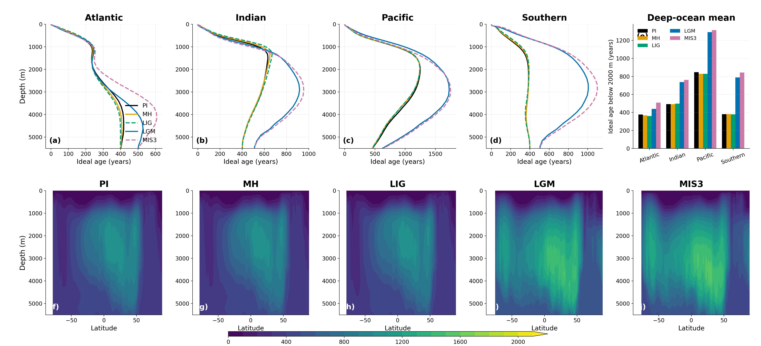
On equilibration, the reviewer is right and we now state the caveat explicitly: each experiment was integrated for 1000 years, which is shorter than the oldest simulated ages, so the glacial age fields are not fully equilibrated and should be read as lower bounds on the true equilibrium contrast. We cite Millet et al. (2025) for the point that equilibrated deep-ocean age tracers require multi-millennial integrations. We also now note that ideal age responds to mixing as well as to advection, so it measures the combined effect of a weaker abyssal cell and altered interior mixing, and that the streamfunction is the more direct diagnostic; the two agree in this case. The introduction has been corrected accordingly.
The text added to the Results reads:
“Because a single depth level gives an incomplete picture of ventilation, we also examine ideal age throughout the global ocean (Fig. 7). Averaged below 2000 m, the ageing is strongly basin dependent. The Atlantic increases only modestly, from 377 years in PI to 439 years in LGM and 508 years in MIS3, because it remains ventilated from the north. The Southern Ocean more than doubles, from 381 to 789 and 844 years, and the Pacific, already the oldest basin in the interglacials at 847 years, reaches 1291 and 1314 years. The zonal-mean sections (Fig. 7f-j) show that the glacial ageing is concentrated below roughly 2000 m and is largest in the deep Pacific, while the upper kilometre changes comparatively little. The contrast between a mildly ageing Atlantic and a strongly ageing Southern Ocean and Pacific is consistent with the abyssal cell weakening while the upper cell is maintained.”

Minor comments
MH, LIG are not abbreviation that commonly used so I would remove them from the text and spell out each time. Also I don't think these were not defined at any point of the manuscript.
The abbreviations are now defined at first use in the Results as well as in the Methods. We have retained them thereafter because the figures are organised in five columns labelled by these codes and spelling the names out at every occurrence made several passages considerably harder to read. If the reviewer feels strongly we will expand them throughout.
L19: 'in the model' needs to be clearly stated as this is not how AABW forms in the real modern ocean. –- Added to the abstract, which now reads "In the model, interglacial dense water formation
is driven mainly by turbulent heat loss...". The same qualification has been added in the Results.
L25: change deep from “clear imprint on deep-ocean ventilation” to abyssal Southern Ocean. As it is only one depth plot at 4000m has been shown. The deep ocean is usually considered as all the water below 1000m. Plots of overturning/ideal age globally would be helpful to assess the overall impact on ventilation.
abyssal overturning cell and abyssal water specifically, and the new global age figure covers the whole water column rather than a single level.
L102-105: a slightly expanded intro on the SAM may be helpful. –- Expanded; see Reviewer 1,
comment 5.
L 125: typo, more. –- Corrected. L129: it would be much more useful to show the salinity minus the whole ocean change applied, to see what arises from local dynamics. –- This is a good suggestion. The glacial salinity anomalies
in Fig. 1 include the uniform global increase applied at initialisation to represent water stored in the ice sheets, which obscures the locally generated signal. We have noted this explicitly in the text so that readers can interpret the panels correctly.
L134: 400m is not very deep given you are comparing to what is happening to ideal age at 4000 m.
–- Agreed; the 400 m contour marks active convection rather than the depth reached by the resulting water. We now also report the 600 m statistics and the maximum mixed-layer depth, and the new overturning figure connects the surface signal to the abyssal circulation directly rather than by implication.
L144: the westerlies appear to increase under both glacial and last interglacial forcings, why?
–- Answered above.
L152: it needs to be clearer that this is in the model. –- Rephrased to "the model produces deep
mixed layers...".
L175: I wonder if this result isn't more applicable to AAIW/SAMW formation? –- The reviewer's
intuition is borne out by the density-class analysis described above. Our thermally dominated transformation maximum sits at _{n} ≈ 27.3 kg m⁻³, which is intermediate and mode water density rather than bottom water density. We now state in the Results that the interglacial thermal pathway is more relevant to intermediate and mode water formation than to bottom water proper. We are grateful for the suggestion, which turned out to be one of the more useful reframings in the revision.
L195: in the real ocean freshwater input from icesheet melting is important today. –- Added, with
the explicit acknowledgement that this configuration has no ice shelf cavities and applies no prescribed meltwater flux, so that pathway is absent from our simulations.
In the revised manuscript this now reads:
"We note that this statement applies to the freshwater sources represented in our configuration. In the present-day ocean, meltwater derived from the Antarctic ice sheet, both as basal melt beneath ice shelves and as iceberg discharge, is an important part of the coastal freshwater budget and acts to suppress dense water formation . Because the model has no ice shelf cavities and no prescribed meltwater flux, that term is absent here, and the freshwater budget we decompose is dominated by sea ice thermodynamics." L206-209: should be moved to the introduction maybe? –- Moved. L291-297: this point seems fundamental to the rest of the manuscript. –- Agreed; addressed at
length above.
L302-305: can't you just compare you model results directly in the regions with observations? –-
Done; see above and Fig. 8.
L339: this would be great, but sed rates around the Antarctic margin are very low. –- Agreed, and
the passage has been replaced with a statement of that difficulty. Reviewer 1 asked for a supporting reference for the same passage; we concluded the proposal was not well founded and have withdrawn it.
L347: not the water, the carbon in the water – given the substantial and variable preformed 14C aging. –- Corrected. The text now refers to the radiocarbon age of dissolved inorganic carbon. General comment on the figures: would it be possible to show whats happening under the ice shelves? At the moment they are just whited out. Anyway to show this? –- Unfortunately not. The
model configuration does not include ice shelf cavities, so there is no ocean beneath the floating ice to show; the white areas are genuinely outside the model domain rather than masked output. We have stated this in the Methods and figure captions so that readers are not left wondering, and we list it among the limitations, since the absence of cavities also means basal melt is not represented.
Please be consistent across figures and label MH, LIG, LGM, MIS3 on top of all panels. –- Done
throughout; Reviewer 1 made the same request.

Reviewer #4
I co-reviewed this manuscript with one of the reviewers who provided the listed reports.
We thank Reviewer 4 for their contribution to the review, and the journal for supporting early-career researchers in peer review.

Editorial requirements
Colour vision deficiency. The new figures use the Okabe-Ito colour-blind-safe palette, and the transformation curves are additionally distinguished by line style. We have replaced the red/green pairing in the transformation figures with vermillion and bluish-green, and the overturning anomaly panels use a purple-orange diverging scale rather than red-green.
Data availability. A statement has been added. The model output needed to reproduce every figure has been assembled as a repository deposit, comprising the climatological monthly means for the five experiments, the 100-year monthly transformation time series, the Southern Annular Mode composite fields, and the ocean mesh files. The DOI will be inserted on acceptance. Source data for the line-graph figures are provided with the paper.
Code availability. A statement has been added. The analysis and plotting scripts, covering the surface buoyancy flux decomposition, the transformation calculations including the new sea ice sector comparison, the compositing, and all figures, are archived with the data deposit and are also available at https://github.com/xshi-awi/aabw₅exps.
Source data. Provided for the line-graph figures, as a single spreadsheet with one sheet per figure panel.
ORCID. The corresponding author has linked an ORCID to the submission system, and co-authors have been asked to do the same.

