# Entities & Attributes

### USER

* Email: the email of the user
* Password: hashed password of the user

### ADMIN

* Email: the email of the admin
* Password: hashed password of the admin

### WORD

* Id: primary key for each word
* Persian: Persian equivalent of the word
* English: English equivalent of the word
* Pro: pronunciation of the word
* Exp: an practical example that the English equivalent of the word is used on

# Relations

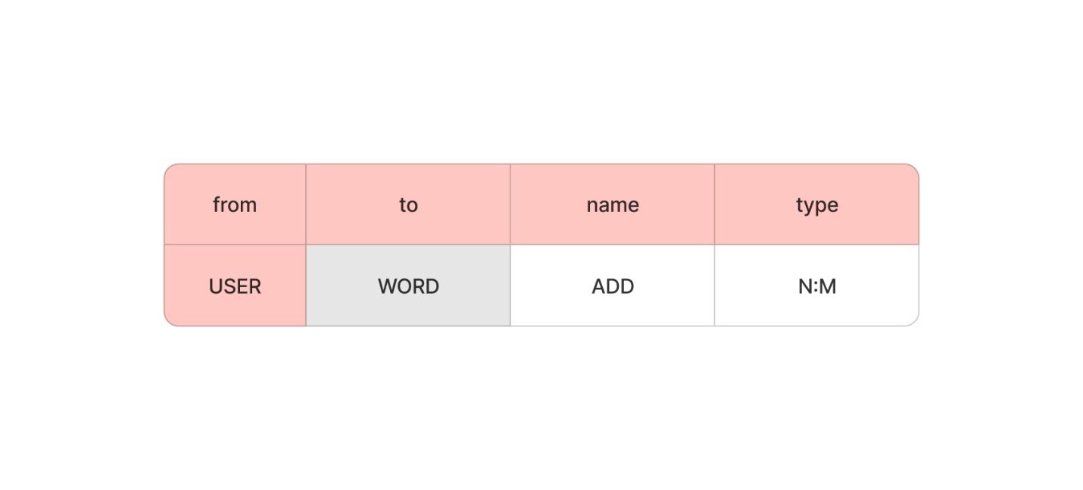

# ERD

