

Requirement Documentation

Version 1.0.0

Vocab system

Parisa Ebrahemian

Shayan Ahmadi

# Stakeholders & Actors

## User

The User is an individual who interacts with the system to manage their English-to-Persian vocabulary. They can log in, register, and recover their password if needed. Once logged in, they can add, update, delete, and search for words in English or Persian.

## Admin

The admin is a system manager responsible for overseeing the application's overall operation. They have access to advanced reporting tools, including performance statistics for all users. The admin ensures the system is functioning efficiently and securely, addressing any issues that arise.

# Requirement Use Cases

## User triggers:

### Login

### Register

### Recover pass

### Search

### Add word

### Update word

### Delete word

## Admin triggers:

### Performance report

# Analysis Use Cases

## User triggers:

### Login

### Register

### Recover pass

### Search

### AUD

### Add word

### Update word

### Delete word

## Admin triggers:

### Performance report

# Business Modeling

## Requirement Use Case Diagram

### User

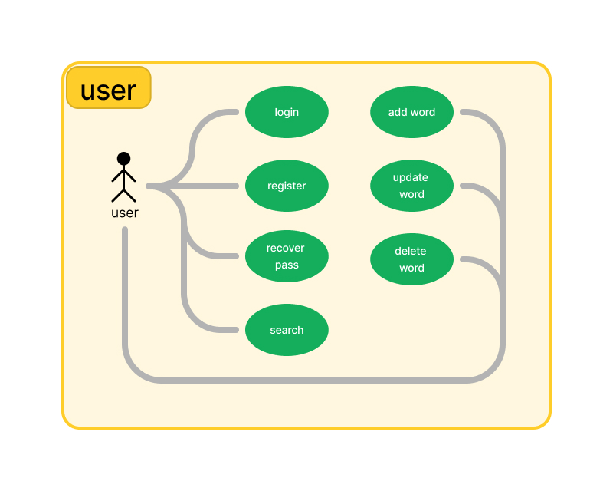

### Admin

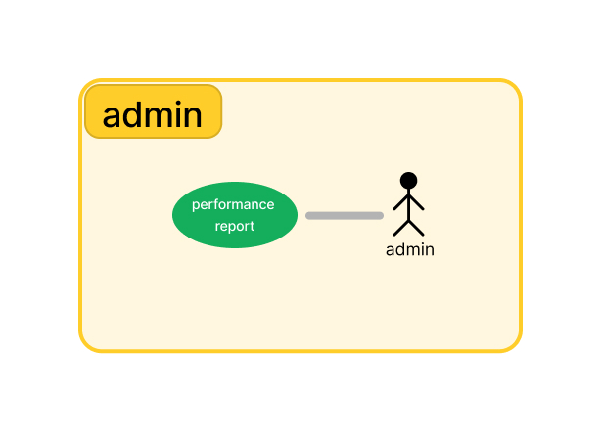

## Requirement Use Case Diagram

### User

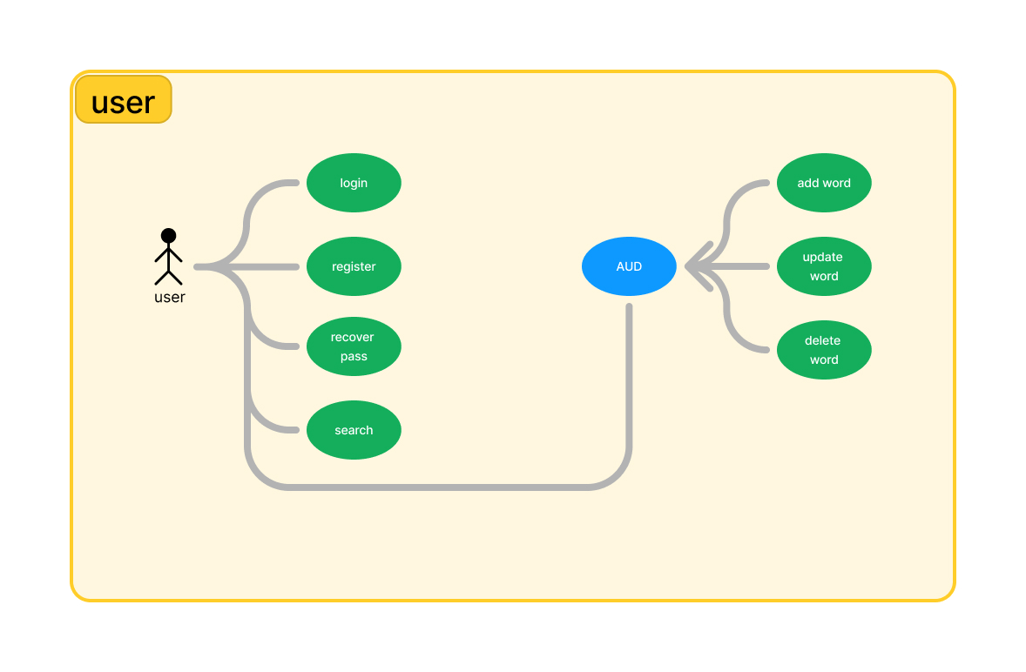

### Admin

