DSC 650 Weeks 11/12 – Final
Data Pipeline – NBA CSV Data
Xhoi Shyti
Sunday March 2, 2025

Data Pipeline Overview and Walkthrough

This report presents an overview and discussion of the data pipeline designed to ingest, move, and query NBA data originating from https://www.nba.com/stats. The initial steps in the pipeline are handled using Nifi – consider the below screenshot showing the Nifi processor group.

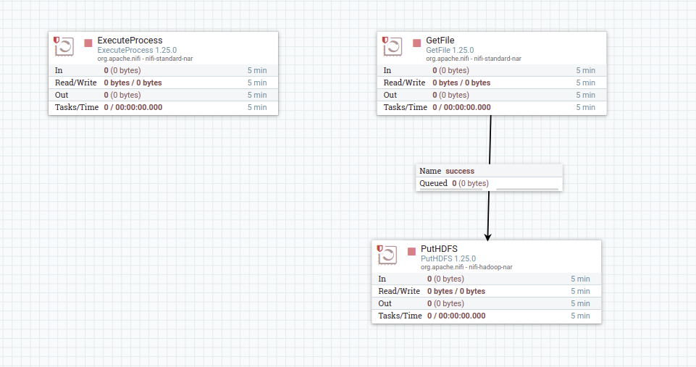
The first step in the pipeline is the ExecuteProcessor that executes a python script which makes several API calls to https://www.nba.com/stats, each corresponding to a particular NBA season.

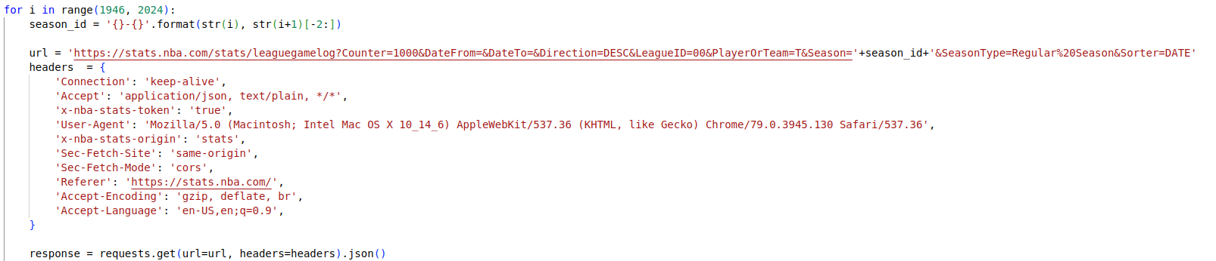
The loop iterates over valid NBA seasons, and a unique request URL is generated given the season. Using the headers listed, the python request library method ‘requests.get()’ calls the API and converts the response to JSON.

Then, additional processing logic converts the JSON to CSV format and outputs this. The result is a unique data file for each nba season. Finally, the script accumulates all of the separate CSV files into one single CSV. The below screenshot shows the details of the processing required.

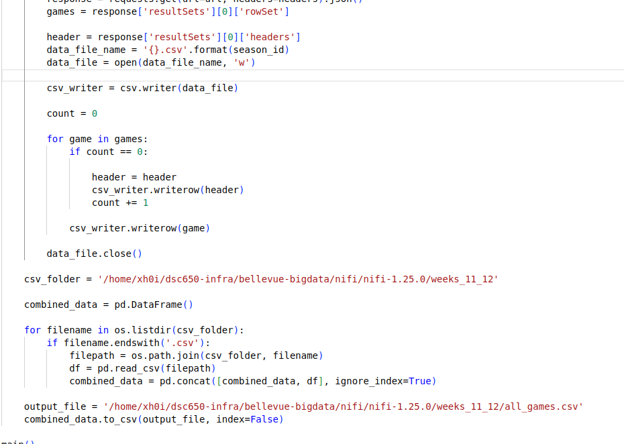
Notice that the output path of this is the dsc650-infra remote instance. Since Nifi is to execute this script, it must output to the remote instance itself.

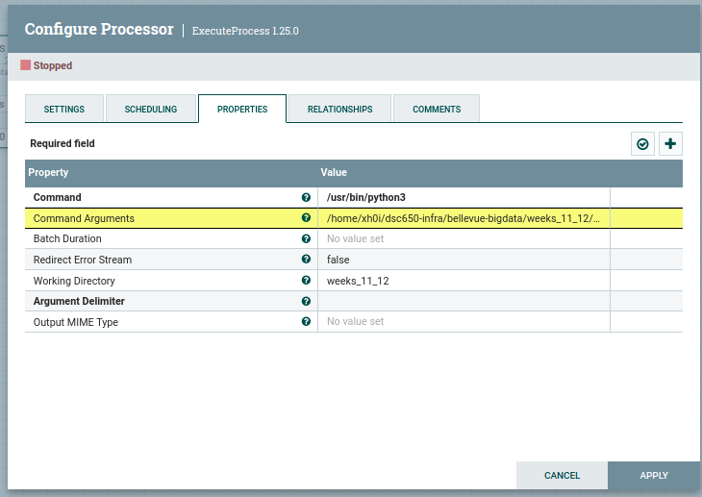
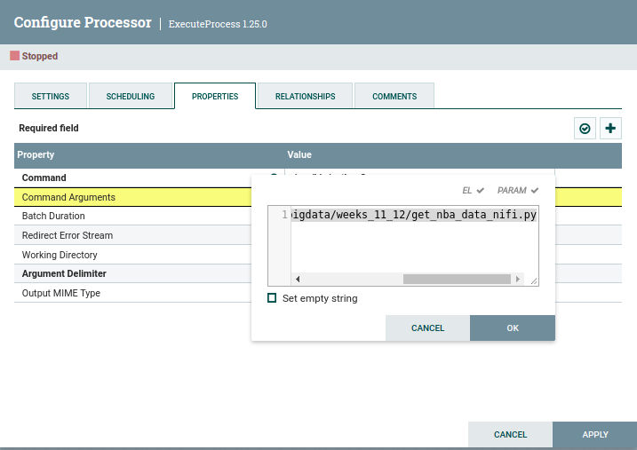
The properties were configured to enable this processor to execute the python script and output to weeks_11_12 directory.

The next step in the Nifi flow is the GetFile processor. This processor simply reads the CSV output and moves it.

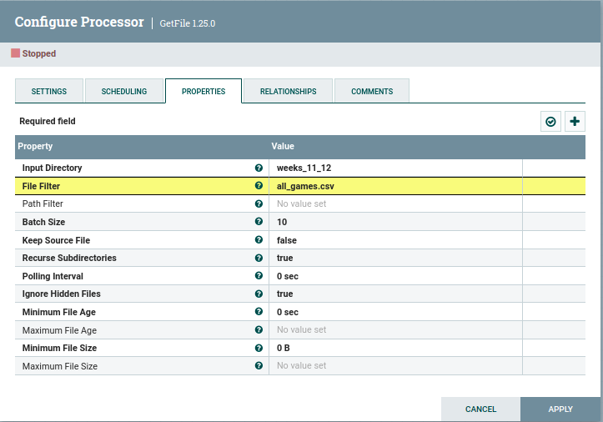
Notice that the input directory matches the directory configured in the Execute Processor. Without this, the reader will not find the matching filter: “all_games.csv”.

Next, the PutHDFS processor takes the data moved by GetFile and transfers it to HDFS.

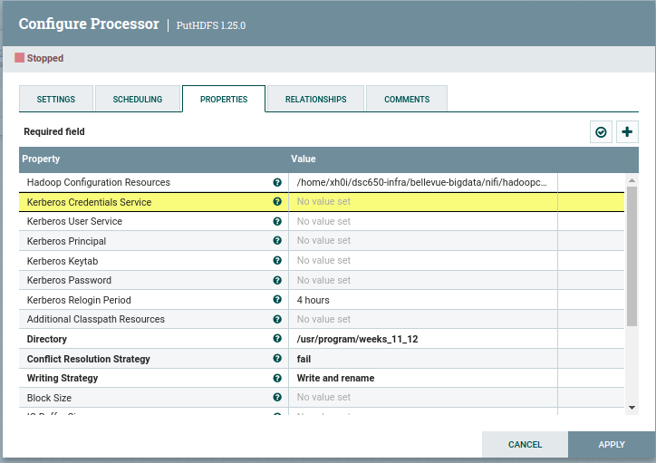
For that configuration, the Hadoop Configuration Resources must match that which is given in the nifi config itself in the remote instance. The directory points to the hdfs directory where the data is supposed to be transfered.

The below screenshot shows a successful search query using pyspark on hdfs.

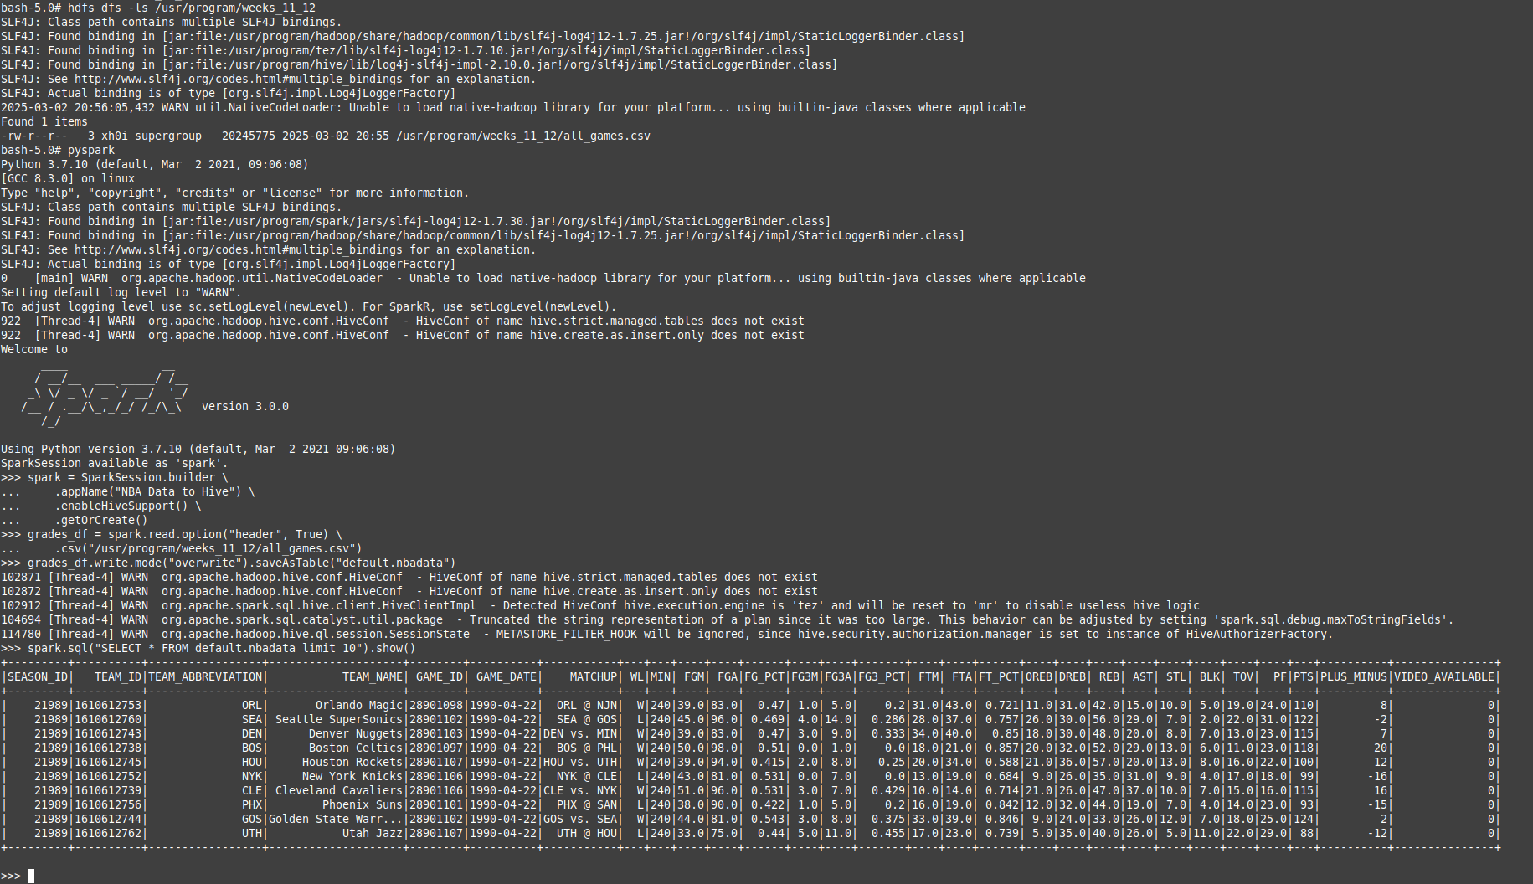
Challenges Faced

Finding the correct processor to execute the python script took some research, and the pip tool had to be installed on the remote instance, as well as the pandas library after that.

There was some trial and error to cofigure the GetFile processor, as it was not immediately obvious that the directories should match.

There was additional trial and error the PutHDFS processor, since the first attempts were, once again, pointing to the wrong directory.

Several times the remote instance itself had to be restarted since the shell would freeze – likely due to the fact that Nifi was kept running and that, by itself, is very resource intensive for the remote instance.

Conclusion

This data pipeline effectively integrates Apache NiFi, HDFS, Hive, and Spark to facilitate seamless data ingestion, storage, and analysis. By leveraging NiFi, data is efficiently ingested from https://www.nba.com/stats and loaded into HDFS. The integration with Hive enables structured querying and metadata management, providing a structured framework for data organization. Finally, Apache Spark is used to execute high-performance queries and transformations, allowing for advanced analytics and data processing.
This end-to-end workflow ensures an automated, scalable, and efficient data processing pipeline, making it well-suited for big data applications. The combination of these technologies enhances data accessibility, performance, and analytical capabilities, supporting informed decision-making and real-time insights.

