Thursday Renju Class in 5lin.

- 教育訓練組 對 ○助教
Opening i12.

Every Thursday, during 9.30 p.m. – 11.00 p.m. several renju fans gather in 5lin classroom to take part in weekly renju class. In that class we study renju openings, we try to learn to understand the essence of each opening, therefore we always try to explain about each variant as much as possible. We also give homework for our students in the end of each class. However, 1.5 hours is not long time, so we do not always study every possible move in openings.
As there are many renju players who do not have time to join renju class in 5lin at Thursdays, as there are many renju players playing other sites (Acer, BBS, etc.), as there are many people without Internet access, therefore we decided to publish the 5lin class materials in this magazine so that everybody can read them.
My greatest thanks to 奕學 who is always kindly assisting the class under the name 助教 ! ^_^
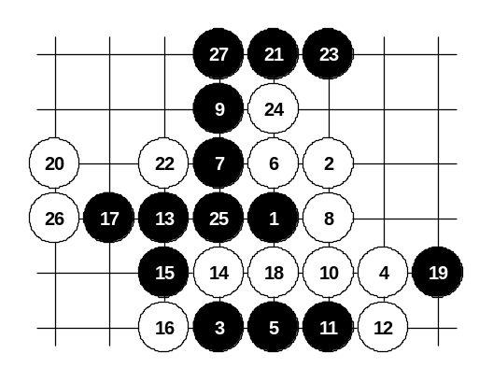
Sep 25 21:07
The 4th move is not difficult question for black. The simple 5th choices are 5-5 and 5-6.
On the diagram there is the answer that students suggested for last week homework "how to win after 12th move".

Sep 25 15:37
We shall continue with other 4th moves ^^ everyone ready?
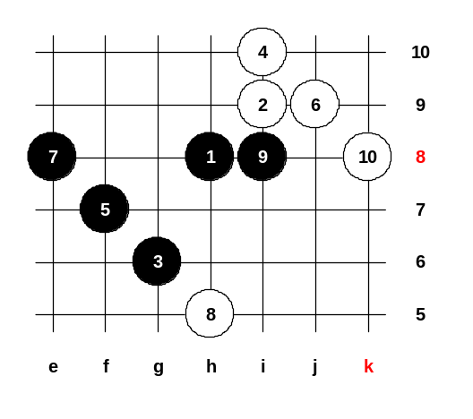
4-i10. Ha, this is tricky 4th move. Any one knows 5th moves?
5-g9 is right. 5-f7 seems logical, but is loss...
The right move is 5-e8.
I will explain the difference between f7 and e8
We will play f7 move here first.
6-j9! Usually, such defense pattern is good for black, but this time, while black played e8, the white stone appeared at h5, and the h5 stone connects with k8, so here white wins quite easily.

Sep 25 15:45
Now, I will show you 5-e8, try to notice the difference here! 5-e8 and white answers same 6-j9. And now, white has not enough power to attack, so the black will win with move 7-i8.
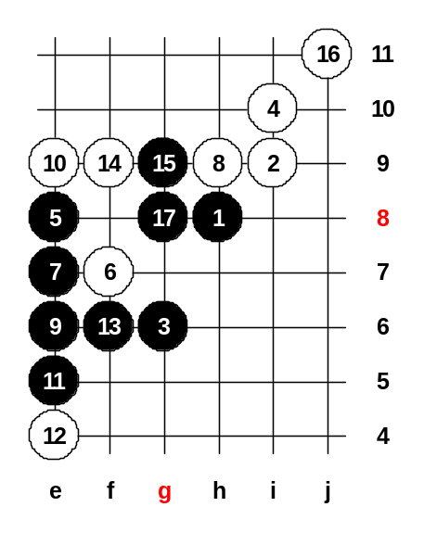

Sep 25 16:00
Lets change the 6th move.
After 10th move black has win! But how !?
11-f6 is wrong because of 3x3 threat at g8.
11-g7 is immediate loss by 3x3.
But black has got wonderful idea - e5, f6 !! and 3x3 danger is disappeared because one 3 will become 4x4…
After white plays f9 and j11, black moves g8 – it is legal move because have only one 3, the other 3 is pseudo-three. As g8 is legal move, so black wins here ^_^
Remember, it is important to play the four at e5 in right time!

Slee : Sep 26 01:01
TO:ando
Re Game 457334, would you please comment on Discuss 58,post by LA on 19-Jul-98, said if 8-E6, seems Black not easy to win?! How Black can win if 8-E6? Thanks in advance here. :-)
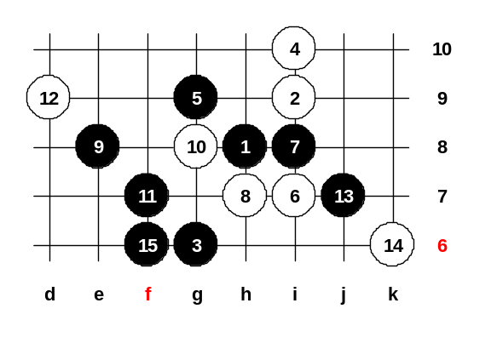

Sep 25 16:08
Now, we will study 5-g9.
Who can guess the 9th move here? ^_^
9-e8 ! Black is stretching out, white must g8.
12-d9.
Here comes the most difficult move - j7 !
Black couldn't play 13-f6 too early because white was almost going to attack.
14-k6.
After j7 and k6 stones black can finally play desired f6 power-move and black wins!
Your homework: please find black’s win if white plays 14-f6.

Sep 25 21:12
Actually, the homework is very easy. I just wanted you to understand that white cannot avoid black taking that F6 point. If white self takes F6 point, black wins easily. So, F6 belongs to black.

Sep 25 21:30
Additional comments:
Lets check some other white stops too. Another 8th move (8-g8):
8-g8, 9-h7....
If 10-j9 then 11-h6, 12-h5, 13-e6, 14-f6, 15-e7.
If 10-f5 then 11-h9....... (if 12-h10 then 13-g10, 14-j7, 15-f9), (if 12-h6 then 13-f11, 14-g10, 15-f10).

Sep 25 21:35
What if 6-h10?
Don't lose your head! ^^
7-i7, 8-f10, 9-g10... and even though white has the activity, it is all controlled by black and so black is about to win soon!

Sep 25 21:45
If 6-f10... then one good idea seems to be: 7-g8, 8-g10, 9-h10, 10-i8, 11-i7 (!!!) and black seems to win! ^^
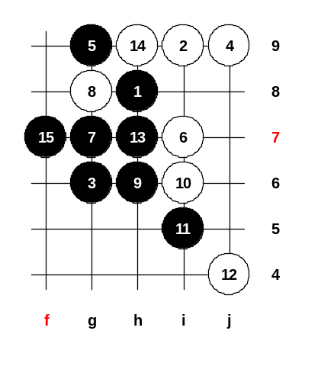

Sep 30 22:09
Today we will study two 4th moves in i12 opening.
If you learn all 4th moves in this opening, you will become good expert of i12 opening.
First 4-j9.
Black must play 5-g9 and 5-h9. I don’t see any other choices. I tried to find the other 5th moves for black, but I couldn't.
5-g9 first. 5-g9 is quite easy for black, no trouble at all. After 5-g9 white best move is certainly 6-i7.
After seeing those 6 moves, it reminds me i11 opening similar pattern. So I will use this knowledge and turn into i11 opening variant: 7-g7! 8-g8, 9-h6 win!!!

Sep 30 22:11
Do you recognize the i11 opening position?
It often happens that one opening leads to another opening after some moves and the win becomes familiar. Any 10 here is hopeless.
Ok, we try 10-i6. And you please tell how black wins. Give me ideas ^_^
Yes, 11-i5 is right!
12-j4. Now what?
All your suggested moves are good enough to win :)
But we always try to win in shortest way as possible. 13-H7 is the shortest win!
Because of f8, h10 VCF, white must block upside. 15-f7 - black made double threat!! Black wins!

Sep 30 23:24
So, 5-h9 now!
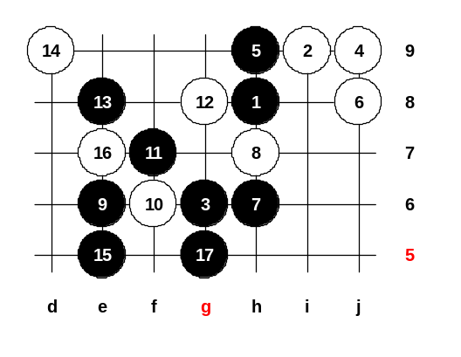
I tried to find any good 6th move here, but so hard. The most interesting move seems to be 6-j8. And now, please give me ideas for 7th move ^_^
Lets see if your ideas are same as my ideas. ^^
Ok, somebody say h6. Any other ideas?
K7 is also interesting ^^
H7 is maybe not that good because then white plays h6 and black power is getting weaker.
Do you want to know my idea?
My idea is same as somebody already said: h6
So, who thought h6, thinks same way as me. :)
If 8-h10 then 9-k7 and black is very powerful below. So, we try 8-h7 now.
Any ideas for black attack? Yes, e6 is good!!
10-i6 is useless because black easily wins on the left: 11-f7.
Lets try 10-f6 now. Black attacks directly! 12 middle is best.
17-g5 this is sure win!

Sep 30 23:44
For zxzxz:
If 18-h5 then one way to win is: 19-e3, 20-f4, 21-g4, 22-g3, 23-f5 and then black wins by VCF. Another win is: 19-f4, 20-e3, 21-d6, 22-g3, 24-d5, easy win.
Other win ways begin in same first moves, but may end differently.

zxzxz : Oct 1 00:03
Thank you ando.
But i think the shortest 17-h5, 19-g5, 21-g4, 23-e3, 25-e2.

Sep 30 23:27
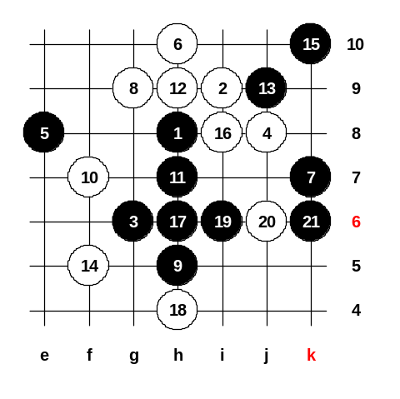
4-j8 now.
Now, after 4-j8, the 5th moves are f7 and e8, remember them!
5-f7 is easy black win, so we will not spend time on looking this. So, lets look 5-e8!
6-h10 is the best white move! 7-k7 is necessary.
And here white can have two interesting moves: 8-g9 and 8-i10.
Today we have time for look 8-g9, also we will look 8-i10 next time.
Since the white is so powerful, black must begin direct attack.
10-f7. 11-h7!! White must block upside. 14-f5, white makes VCF threat! 15-k10 is important, because otherwise black can fall into 3x3 trap at f8. Now, black h6 and i6 are possible. White must play 20-j6.
21-k6 !! Black win!! It is a beautiful position! ^^

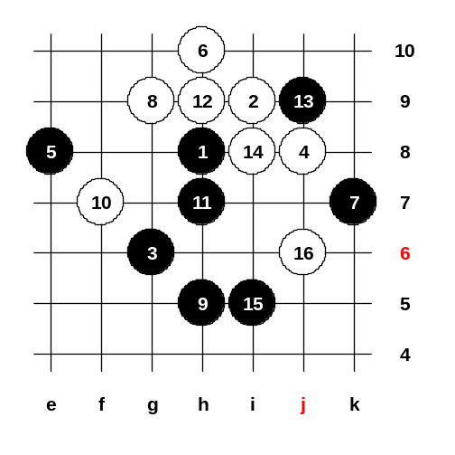
Sep 30 23:21
14-i8. Here is homework for you!
How does black win?
I tell you, this is not easy! ^_^
I add 2 more stones. 17-i5 and 18-j6.
And your duty is to find sure black win here!!
Good luck in your home study! ^__^
See you on next Thursday! ^_^ Bye!

Tiger_Wolf : Sep 30 23:29
17-j5, 18-k5, 19-i6 win.
17-j5, 18-g5, 19-k4, 20-e9, 22-k8, 23-i2 win.

悟棋生 : Sep 30 23:59
17-j5, 18-k5, 19-f8, 20-e9, 21-f9, 22-g7, 23-g10, 24-d7, 25-g5, 27-h4, 29-i3, 31-i6.
17-j5, 18-g5, 19-i6, 20-k4, 21-h6, 23-g7.
偶也不知對不對喔!!

Slee : Oct 3 23:44
a1)J5(K5)-F6(H4)-G5(F5)-G8(E9-I6)-D6(E6)〉G7-D4-D8-D7#
a2)J5(K5)-F6(H4)-G5(F5)-G8(E9-any)〉D8-E7 or I6-G4
a3)J5(K5)-F6(H6)-G5(F5)-G8(F12-F9-I6)〉G7-E5-E7-H4
a4)J5(K5)-F6(H6)-G5(F5)-G8(F9-any)〉D8 or I6-G4
a5)J5(K5)-F6(others)-H6 or H4-G5
b1)J5(G5)-K4(E9-K8)-J7(M8-G7)〉L7-L5#
b2)J5(G5)-K4(E9-K8)-J7(others)〉K5-K3-H6 or K5-K6-L7#
b3)J5(G5)-K4(E9-others)-J7〉I6

教育訓練組 : Oct 4 00:04
Tiger_Wolf’s solution is wrong because after 17-j5, 18-k5, 19-i6 white will play 20-e9, 21-f9, 22-g8 and white wins.
But, about 18-g5, Tiger_Wolf shows nice win! ^^

okokok : Oct 4 00:35
17-h6, 18-h4, 19-k5, 20-j5, 21-k3, 22-j7, 23-i7, 25-k4, 27-k8.

Slee : Oct 4 00:50
TO:okokok
After 21-K3, then white 22-G7, Black cannot win!!

okokok : Oct 4 00:53
To:Slee
22-g7, 23-j4 then...

Slee : Oct 4 00:56
TO:okokok
22-G7, then white can VCF G11-G8, black must stop it.

okokok : Oct 4 01:01
To:Slee這樣子的話就可以接受了...:-)

ciman : Oct 4 01:51
I am using another PC now, therefore I cannot see Chinese names right now. So, the person who discussed at Sep 30 23:59, seems to give correct answer. Congratulations!
^_^
ciman : Oct 4 01:53
Slee's answer is also very original - seems to be correct answer, too. Congratulations! ^_^

ciman : Oct 4 01:54
okokok answer is wrong, but I see that Slee already explained him/her that.

奕學 : Oct 6 23:16
17-j5, 18-k5, 19-g7 - double threat.
If: 20-f9, 21-e9, 22-g8 then black VCF.
If 22-g5, 23-i6, then 25-j7 win.

Slee : Oct 7 00:17
To:奕學. Seems your answer not correct?!
After 19-G7, white can win by F9-F8. Am I right?

Oct 7 23:50
I remind you the 5th moves: f7 and e8. Lets look the last week homework first.
So, do you all know the win here? I am waiting your answers :)
17-j5 is right, 17-f5 is wrong. Ok, how is win after 18-k5?
I have seen at least two different ways to win here. Dreamlink says 19-i6. Lets look.
White plays 20-e9 !! (it is necessary move)
And now?
Dreamlink says 22-h6, 24-e6.
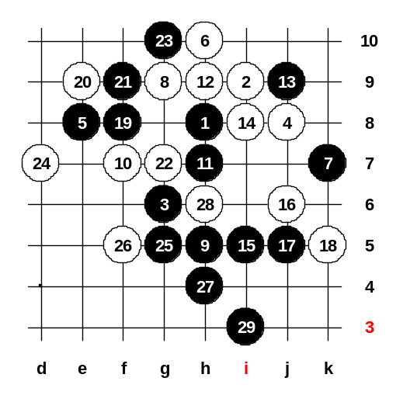
Black attack failed, so 19-i6 was mistake.
We move back now and try other way.
Mirageled says 19-i3. Lets look.
What can white do?
Jianway says 20-f9 and 22-f8, but it doesn’t block the black's VCF.
Mirageled says 20-f9 and 22-f6 but black wins.
Lets move back to 20. 20-f5 is better move. Now it seems that black has problems. Therefore, 19-i3 may be not correct.
Here are 2 good moves: 19-f8 and 19-f6. Both will give black win :-)
19-f8, white must 20-e9, 22-g7. 23-g10 is good move! White must stop below, otherwise black VCF.
Apple suggests 25-k8. But not good because white can play 26-i10 (cut!).
Here is right way: 25-g5, 27-h4, 29-i3. This is the homework answer. ^^
Anyone has questions about it? If no questions, then we close the diagram and continue with new board. If black does not play 23-g10 then white can attack towards black 4x4 using g11 and g10 fours.

Oct 7 23:52
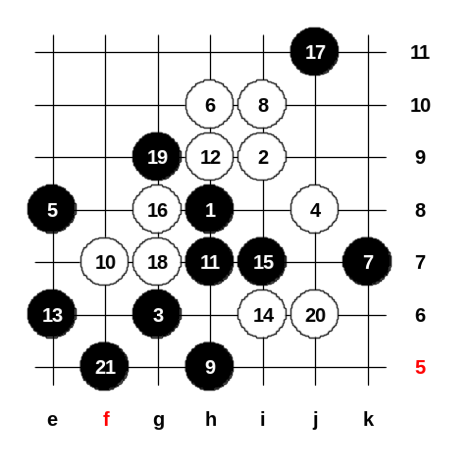
We study another 8th move now. Here it is easy to remember, because 9th move is same. The 10th must be in the middle of course. Now, black seems to have two choices, 11-h6 or 11-h7. Which one is right?
O, we try h7.
12-h9.
Can black play 13-g8 or cannot?
No, cannot. White wins easy.
So, must be 13-e6.
Black threat is 4x3 at h6, so white must stop it.
The best idea is to play 14-i6, it will give VCF threat for white.
So, black must play 15-i7. Now, white must play 16-g8 and 18-g7.
Lets look why white cannot move 16-j7. 17-i8 is black win!! :-)
So we move back and change 16.
16-g8, 18-g7. Now white has VCF threat again! So, black needs 19-g9!
Now, white cannot put 20-f10 because of black VCF below. Therefore must 20-j6.
21-f5, black win finally! ^__^
I will give you homework. HOMEWORK QUESTION:
Who will win after 11-h6? Black or white? And how is win?
If you find answer, write it to game discussion.

談笑生 : Oct 7 23:52
11-h6, 12-h9, 13-e6, 14-i6, 15-g8, 16-i8, 18-j7, 19-f6.d8.h4.g5.

談笑生 : Oct 8 00:00
最後不速g5訴e7才對

Slee : Oct 12 22:12
Black can win as below if 11-H6: H6(H9)-E6(I6)-G8(F8)-H7(H4)-G7
Black stops White's VCF and win by VCF F6-E5.

