Thursday Renju Class in 5lin.

- 教育訓練組 對 ○助教
Opening i12.

Every Thursday, during 9.30 p.m. – 11.00 p.m. several renju fans gather in 5lin classroom to take part in weekly renju class. In that class we study renju openings, we try to learn to understand the essence of each opening, therefore we always try to explain about each variant as much as possible. We also give homework for our students in the end of each class. However, 1.5 hours is not long time, so we do not always study every possible move in openings.
As there are many renju players who do not have time to join renju class in 5lin at Thursdays, as there are many renju players playing other sites (Acer, BBS, etc.), as there are many people without Internet access, therefore we decided to publish the 5lin class materials in this magazine so that everybody can read them.
My greatest thanks to 奕學 who is always kindly assisting the class under the name 助教 ! ^_^

Oct 14 23:23
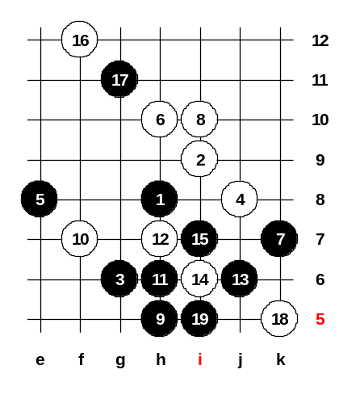
Today we continue our study in i12 opening.
First of all, lets see the last week homework.
My question to you was: who will win, black or white?
So, I want to hear your answers. Say black or white.
Please everybody see 461132 and we will together look at last week homework.
Here, I asked you last week a question. Who will win after 11-h6? Now, I am waiting your opinion. Who wins? Is here anybody who thinks that white wins?
OK, lets see together ^_^
White 12-h9.
13-e6 is necessary! 14-i6, and now comes the key-move: 15-g8 and black seems to win. There is no way to defend here. The best try is 16-i8 and 18-j7 but after that black has VCF. Can you all see it? ^_^ So, we can see that black wins after 11-h6.
But, famous Russian renju book "Click of Stones" says after 11-h6 white wins. If 16-f8 then same 17th is win. 17-i7. So, we proved that the Russian book is wrong. ^_*
Now mirageled asks, why 12-h7? Lets look. 13-j6 seems good enough ^^
Ok, we close diagram now, the win is easy here.

Oct 14 23:25
And now, we will study the most important 4th move in this opening ^_^
This is the most popular 4th move. Although it is very strong for black, some players like to play it as white. One Russian player A.Mihailov thinks that it is quite good for white. But I think black should win about 95% here. Here are 3 different 5th moves.
The strongest move is 5-g9 (100%). The second best is 5-j9 (95%) and the third choice is 5-i8 (about 50%). We will study the two best 5th moves here.

Oct 14 23:26
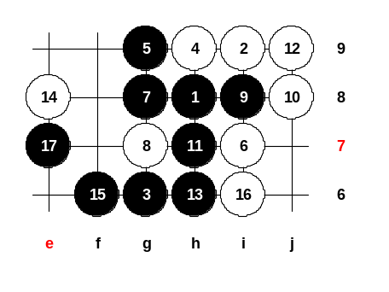
First we look at 5-g9. 6-i7.
Show me win steps! Here is straight win! It is quite a standard attacking pattern. Similar kind of attack may appear in many openings.
7-g8, 8-g7, 9-i8, 10-f8, 11-h7, 12-j9, 13-i6, 14-j5, 15-h6, 16-L9, 17-k9, 18-j6, 19-j8, 20-k8, 21-g4.
Here is win, so, we can move back now and see 10-j8.
11-h7, 12-j9, 13-h6!
White must stop black's VCF, so 14-e8. Easy win comes now. Do you have any questions? If 14-f8 then 15 and 17 are same! ^_^ Any more questions?

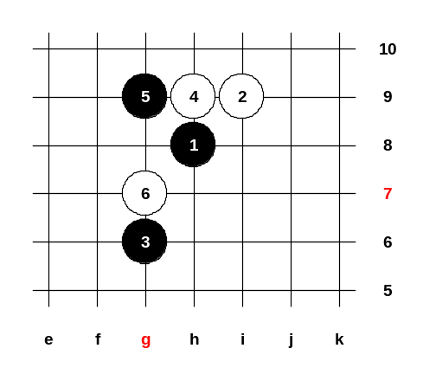
Oct 14 23:09
Your homework is: "Please find a good way for black attack!"
And next week we will see, who found the best idea for black attack.
How to play after 6th move?
Anybody have questions?
Thank you all for joining the class today. See you next week ^_^

Oct 24 21:11
It is time to begin our weekly lesson! ^_^ Welcome everyone who joined!
We shall begin with last week homework. You had to find some good way for black attack. I am waiting your ideas.

Oct 24 21:12
I see people suggest e8 or f7. But, no matter if 7-e8 or 7-f7, white will play 8-i7 and black attack is hard. Now, mirageled suggests 7-i7, this is good move.
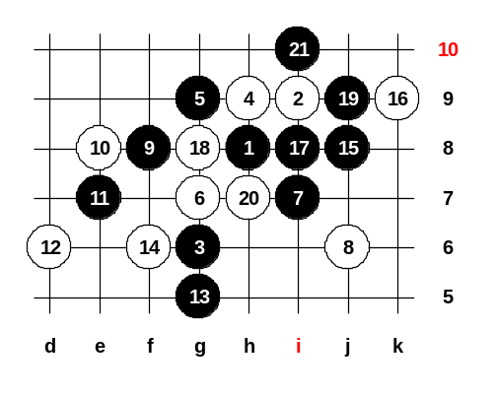
So, i7 is called preparation move. 8-j6 is necessary. And now black can attack on the left side much easier.
Give me ideas!
Yes, f8 looks strong for black. Also f7 and e8 look good for black now. So, which move shall we try? f7, f8 or e8?
f8. White’s best block is 10-e8. Now, where is black attack? Hmm.. not easy...
Ok, we try e7. and then? White stops 12-d6. And where is black next move? 13-g5 looks good! ^_^ White should not let black to move f6 next, so white must play f6 now (important point). Now, the diagonal line e10_f9_g8 becomes dangerous, also the line i10_j9_k8 looks dangerous. Please tell me how can black win using i10_j9_k8 idea? Ok, mirageled say 15-j8. Right!
16-k9. Here comes the win. This was one example way how to attack in such position.
I am sure there are lots of way for black attack here. I hope you learned some ideas from this example. We shall close this diagram and we open new board for study another 5th move.

Oct 24 21:14
5-j9 is another strong 5th move for black! We shall study it now. Here are so many 6th moves. That makes our study harder. So lets look them shortly. Which 6th move shall we look first? OK, 6-i8. It is the most common 6th move. Be careful, here can black play only one 7th move. Do you know the 7th move?
Right. i7 is the only choice! If 7-j7 then 8-10 and white wins.
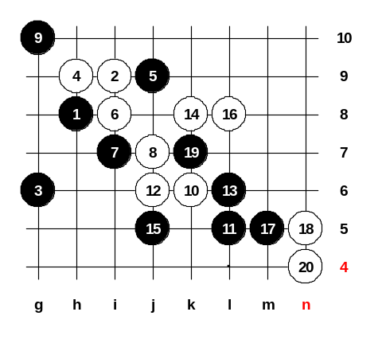
I don’t know why book says i7 is "best". i7 is the only move. "Best" can only say when there are many possible choices. But here is just one. If 7-i10 then 8-j7, 9-k6 and 10-g11 white win!!! So, book is wrong to say "best". If 7-j7 then 8-i10, 9-i11, 10g8, 11-..., 12-f9.. Must say "the only possible move".
Ok, we can continue? Shall we continue looking 7-i7?
Ok, here are two choices for white: 8-j6 or 8-j7. Other white choices lose fast.
Lets look at 8-j7 now. 9-g10 - necessary! As I said before, this opening is 95% black win. Very powerful, but not easy to prove sure win everywhere. Now, black looks strong on the left side, so white must try something active. Therefore the book suggests 10-k6, 12-j6. Lets try it now.
If you don't know the right 13th move here, you may be in danger, because here can only be one right 13th. The other 13th moves will give white win.
Does anyone of you know the correct 13th move here? i6?? now? impossible! white will win! Yes, 13-L6 is right. White may try to continue to attack, hoping that black will make a mistake. For example 14-k8.
And now again, black has only one choice. Where is it? Somebody says k5. Any other ideas? Don't trust the books too much, sometimes book may be wrong. ^_*
Anyway, 15-j5 is the only move indeed.
White attack is stopped. And now, black is very powerful below and left side.
Ok, we study 16-L8. Lets try something... 17-L3. We play 19-m5. 20-k5. 21-k7.
Ok, only wants 18-n5. We try it. 19-k7. Ok, 20-n4.

We leave it as a HOMEWORK. Find black next moves here.
Maybe there is sure win for black here, maybe it takes longer time to win later on the left side.

Oct 28 23:12
We shall see the last week homework. Last week there was a big argument about the homework position. First we will look homework. Here was the question, how should black play next? I know it is hard to find the good idea. But here is one idea that leads to black powerful attack on the left side. Last week only said it is good for white.
21-g8 is wrong because 22-L9 is white win. Any other ideas?
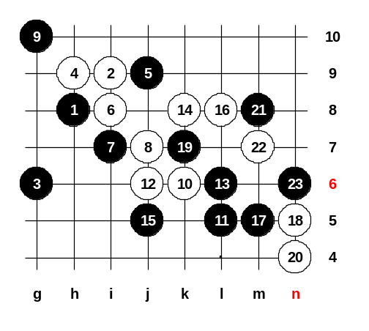
If none of you have ideas, then I will show the idea myself.
i6? no. because after i6 white will attack with n6, etc.
If m7 or n8, then L9 is white win again.
If g7 then L9 is win. Ok, I explain more exactly:
If m7 then white plays m8, n8, L9, ok?
If black plays 21-n8 then 22-m7. L3, I have tried this move, but no success. I suggest 21-M8! What white can do now? And now, black stopped white activity. And black self has activity on right side and below. When white tries to stop black activity now then black easily wins on the LEFT side which is very powerful. Indeed, white best move now is m7. And here comes black natural answer n6 ! This is what I analyzed last week. Now white is in big trouble. All the lower and left side is full of black stones. Nobody can defend here. Everybody agrees or somebody still has question?
Shall we continue study 5-j9 or begin with 5-i7? Ok, we take a quick look at 5-i7, no problem.
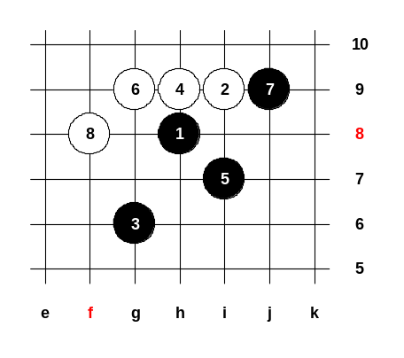

Oct 28 23:19
5-i7 is very bad move.
Japanese stopped using this move very long time ago. 5-i7, 6-g9!
Now black 7-j9, ok. And beautiful white move 8-f8!!! And white will win. Black activity is useless.
White controls black's activity.

Oct 28 23:21
Now, lets go back to 5-j9. We try same 6th move as before but we change the 8th move. This time we play 8-j6. In old times people played 9-j7, but it is not so good. After 9-j7 there will be equal game. Therefore 9-h5 is a good move! But if you decide to use 9-h5 then you must have more knowledge, otherwise white will trick you. Two years ago somebody used this pattern against me. I was black. I couldn't remember black win and I lost by 62nd move. So, please study this win carefully.

I will show you the position where I made a mistake 2 years ago. 10-j7 is the only move for white. In case of other 10th moves black will win quickly. 11-k6.
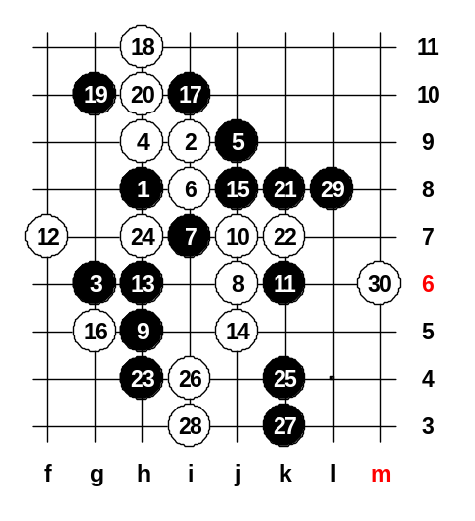
Now, white has two choices: 12-f7 or 12-j5. My opponent played 12-f7 two years ago.
So lets try this variant now. After 13-h6, black is very active. According to the old books, white had tried 14-i10 but it is hopeless because black stops with 15-e6! Therefore, people used 14-j5 more often. We shall look at 14-j5 now.
15-j8, 16-g5, 17-i10...

Even though white was able to defend the left side, now the right side becomes dangerous. 18-h11 is necessary, otherwise black will have winning power above.
19-g10 is a beautiful idea. With this move black stopped all white activity and as black is active above, white needs to waste one move for defense above, too: 20-h11.
Black does not attack on the left side now because there is no power for attack. When g10 point is still open, then white activity will bother black.
Now, 20-h11. In old times, Japanese played 21-k4, but after 22-k3 white was able to defend. So, in old times Japanese didn't know how black should win. But some years ago, Russian players found a nice win here: 21-k8 !!
It was about 7 years ago. 22-k7. If 22-k9 then 23-k4, and win.
This was the moment where I made a mistake 2 years ago: I played 23-L8 but it was mistake, the right moves were 23-h4 and 25-k4. I was silly I didn't remember the right moves at that time, so I made mistake with 23-L8. So, now you can all remember the right way to win. Then you do not fail as I failed 2 years ago in one game.
Now, 26-i4. 27-k3!! 28-i3. All those moves are necessary. And now finally L8 !!
You see, 29-L8 is the key move. In my old game I forgot the right sequence of moves, I played 23-L8 and lost. The difference is:
If 23-L8 then white can play 24-L7 and defend alright. But now, thanks to the extra stones in lower side, after 29-L8 white cannot move to L7 because of black immediate win m7. So, white must put 30-m6 now. Now, black has sure win.
Your HOMEWORK is to find it. If you find it, you may write it to the game discussion. If any of you felt difficult to follow the class speed, then you can come back again and read the discussions under the boards. You may read them slowly again and as many times you wish. ^_^
Thank you all, the class is over for today! Good night ^_^
One moment. I want make the homework harder. We move 30-j4 and 32-m6.
Ok, we can close the diagram now ^^

mirageled : Oct 29 00:21
33-L6?

ando : Oct 30 20:04
If 33-L6, then white stops 34-K5.

鎮國cck : Nov 2 07:13
haha......L6 is cute.........^_^ If White stops 34-K5 and then.....Black just put 35-N6,
White 36 just only stops K9, Black 37-L4, and VCF....^^

ando : Nov 2 20:05
haha, yes, very good answer, CCK ^__^

