Over-rewriting in Chinese Gender-Inclusive Rewriting
A Case Analysis of Eleven Failure Scenarios
Case Analysis v3.0 · English edition

1 Background and scope
Over a longer period I tested, observed and compared four Chinese systems — Qwen, DeepSeek, GLM and Kimi — on gender-inclusive rewriting. The systems differ from one another in how they behave on the same input, but that work was not written up at the time. This document is the retrospective record: I selected typical examples from it and analysed them as representative cases.
The document collects eleven cases of over-rewriting: the system alters a gender expression that should have been left in place, and in doing so damages the sentence. Its purpose is to characterise the types of failure. It is not a frequency estimate and not a cross-model comparison; all eleven examples shown here come from DeepSeek, so that the failure types are not confounded with system differences.
Method: web chat interface, one fixed prompt (Appendix A), each sentence submitted once, unedited screenshots retained. The sentences are constructed rather than sampled from a corpus, since the aim is to isolate specific linguistic functions.
Each case records the same fields: system, function category, source sentence, model output, triggering span, operation, failure type, severity, gate violated, analysis, and provenance. Operation, failure type, severity and gate are the analytic layer added on top of the raw observations; they turn a general note of "meaning was lost" into categories that can be counted and argued about.
Entries marked "Added in v2.0" or "disputed" are my own additions or objections and are still open — they are listed in §6.5.

2 How to read the Chinese examples
Five properties of Chinese are doing the work in these cases. They are worth stating in advance, because several of the failures are not visible in the English translations.
— Pronouns are marked for sex in writing only. 她 ("she") and 他 ("he") are pronounced identically (tā) and differ only in the written character. The written distinction therefore carries a disambiguation load that speech does not — see C03, where it is the sole cue resolving the anaphora.
— Kinship terms are differentiated by lineage as well as sex. 外公 is specifically the mother's father; there is no neutral term at that node, so a "neutral" rewrite has to invent a disjunctive phrase (C02).
— Gender is marked morphologically by a prefix on the noun (女 "female" + N). The same surface pattern can be a redundant marker, part of an institutional proper name (C09), or the grouping variable of a study (C08). Surface form does not identify the function.
— Zero anaphora is fully grammatical. Deleting a pronoun is therefore sometimes a harmless operation (C04) and sometimes destructive — which is why pronoun deletion cannot be evaluated as a single rule.
— TA (Latin letters) is an emerging written gender-neutral pronoun, used by the systems as a substitute for 她/他. It is not yet neutral in register.

3 Overview of the eleven cases
ID | Function category | Operation applied | Failure type | Sev.
C01 | Semantic core · relationship term | Hypernym substitution | Referential precision loss | S2
C02 | Semantic core · kinship term | Hypernym substitution | Referential precision loss + breakdown of naturalness | S2
C03 | Reference · coreference with a sentence-internal antecedent | Pronoun substitution | Added ambiguity | S2
C04 | Reference · definite anaphora | Pronoun deletion | Disputed (no substantive loss) | S3
C05 | Reference · bare nominal description | Hypernym substitution | Referential precision loss | S2
C06 | Reference · indefinite first mention | Modifier deletion + de-personalising substitution | Referential precision loss | S2
C07 | Historical representativeness · 'first' | Modifier deletion | Factual error | S1
C08 | Statistical / medical variable · epidemiology | Propositional abstraction | Factual error (finding no longer reproducible) | S1
C09 | Institutional category / proper name · competition division | Modifier deletion | Proper-name reference error | S1
C10 | Quotation and reported speech · embedded function | Propositional abstraction | Quotation distortion | S1
C11 | Gender metadiscourse · propositional discussion of a phenomenon | Propositional abstraction | Quotation distortion (the object of study disappears) | S1

Severity distribution: S1 five cases (truth value of the sentence changed, or quoted material altered); S2 five cases (referential precision lost or ambiguity introduced); S3 one case (disputed, no substantive loss).

4 Severity levels and acceptance gates
Level | Criterion | Failure types at this level
S1 | The truth value of the proposition changes, or material inside quotation marks — quoted or metalinguistically mentioned — is altered | Factual error; proper-name reference error; quotation distortion
S2 | The proposition still holds, but referential precision is lost or a new ambiguity is created | Referential precision loss; added ambiguity; breakdown of naturalness
S3 | No substantive loss; stylistic difference only, or the judgement is disputed | Disputed

The four gates below are the acceptance conditions a rewrite has to pass. They operate in parallel: failing any one of them sends the sentence back unchanged.
Gate | Rejection condition
Information preservation | The referential, factual or research information carried by the source cannot be recovered from the output
No added ambiguity | The output introduces an ambiguity that the source did not have
Naturalness | The output is not something a native speaker would produce
Minimal edit | The edit goes beyond what is required and touches material that must not be altered, such as the inside of a quotation

5 Cases

C01 Semantic core · relationship term
System | DeepSeek (web chat)
Source (zh) | 我女朋友跟我打电话说她明天会过来。
Source (en) | My girlfriend called me and said she would come over tomorrow.
Model output (zh) | 我伴侣跟我打电话说她明天会过来。
Model output (en) | My partner called me and said she would come over tomorrow.
Triggering span | 女朋友 nǚpéngyou 'girlfriend'
Operation | Hypernym substitution
Failure type | Referential precision loss
Severity | S2
Gate violated | Information preservation / Naturalness
Analysis | '女朋友' encodes both the relationship type (dating) and the partner's sex. Replacing it with '伴侣' ('partner', normally used of a long-term or marital partner) changes the relationship type and drops the sex. The edit is also internally inconsistent: the pronoun '她' ('she') later in the same sentence is left untouched, so the output still marks sex — evidence that the system edits spans locally without re-checking the sentence.
Provenance | Original document
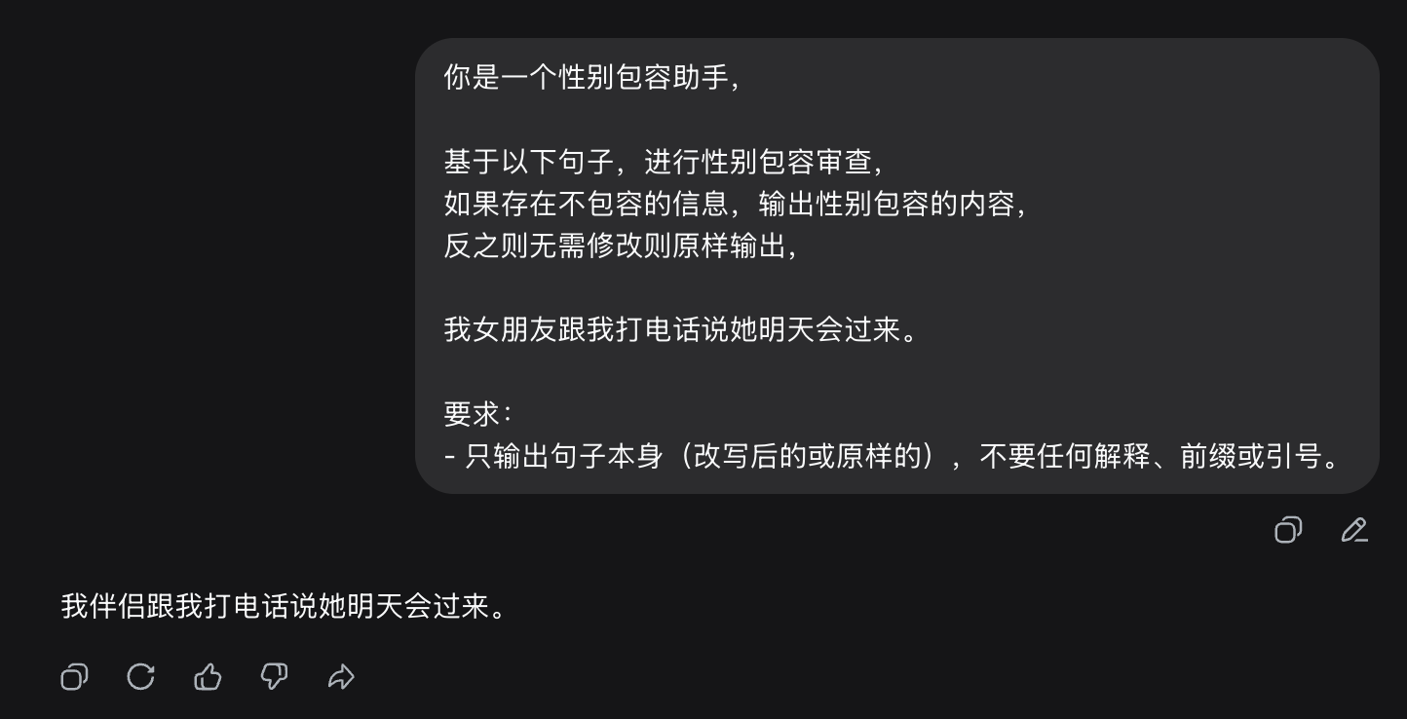
Figure 1 — C01: unedited screenshot of the model output (Chinese interface; the prompt, input and output are transcribed and translated in the table above).

C02 Semantic core · kinship term
System | DeepSeek (web chat)
Source (zh) | 小明的外公今天下午会去接他放学。
Source (en) | Xiao Ming's maternal grandfather will pick him up from school this afternoon.
Model output (zh) | 小明的外祖父母之一今天下午会去接他放学。
Model output (en) | One of Xiao Ming's maternal grandparents will pick him up from school this afternoon.
Triggering span | 外公 wàigōng 'maternal grandfather'
Operation | Hypernym substitution
Failure type | Referential precision loss + breakdown of naturalness
Severity | S2
Gate violated | Information preservation / Naturalness
Analysis | Chinese kinship terminology is differentiated by lineage as well as by sex: '外公' specifies the maternal line and the male grandparent, and there is no neutral term at that node. The system's workaround, '外祖父母之一' ('one of the maternal grandparents'), is a disjunctive description no native speaker would use to refer to a known individual. Both precision and naturalness fail at once.
Provenance | Original document
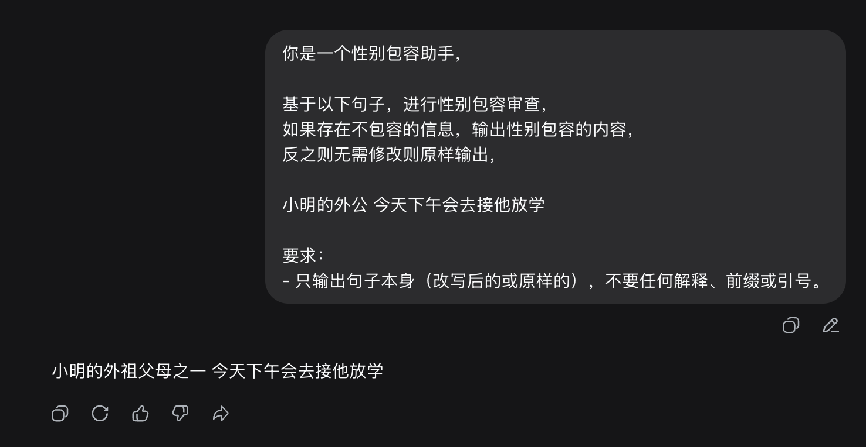
Figure 2 — C02: unedited screenshot of the model output (Chinese interface; the prompt, input and output are transcribed and translated in the table above).

C03 Reference · coreference with a sentence-internal antecedent
System | DeepSeek (web chat)
Source (zh) | 张阿姨把钥匙交给李叔叔后，她就先回家了。
Source (en) | After Aunt Zhang handed the keys to Uncle Li, she went home first.
Model output (zh) | 张阿姨把钥匙交给李叔叔后，TA就先回家了。
Model output (en) | After Aunt Zhang handed the keys to Uncle Li, TA went home first.
Triggering span | 她 tā 'she'
Operation | Pronoun substitution
Failure type | Added ambiguity
Severity | S2
Gate violated | No added ambiguity
Analysis | There are two candidate antecedents, one female and one male, and the written pronoun is the only cue that resolves the anaphora. Substituting the neutral form 'TA' leaves the reference undetermined. Note the direction of failure: this case adds an ambiguity that the source did not have, rather than deleting information — the two failure modes need to be scored separately.
Provenance | Original document
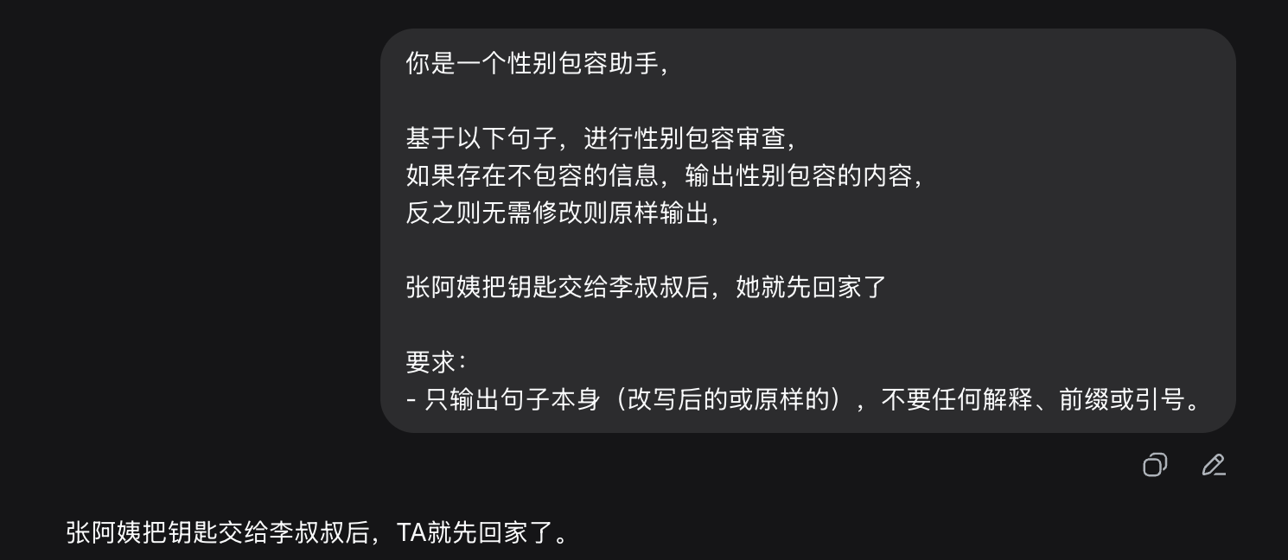
Figure 3 — C03: unedited screenshot of the model output (Chinese interface; the prompt, input and output are transcribed and translated in the table above).

C04 Reference · definite anaphora (labelled 'indefinite first mention' in the source document — see analysis)
System | DeepSeek (web chat)
Source (zh) | 王敏工作很努力，她每天晚上都持续加班到10点以后。
Source (en) | Wang Min works very hard; she stays at the office past 10 pm every night.
Model output (zh) | 王敏工作很努力，每天晚上都持续加班到10点以后。
Model output (en) | Wang Min works very hard; [she] stays at the office past 10 pm every night.
Triggering span | 她 tā 'she'
Operation | Pronoun deletion
Failure type | Disputed (no substantive loss)
Severity | S3
Gate violated | —
Analysis | Chinese permits zero anaphora, and the antecedent here is a unique proper name, so the output remains natural and unambiguous. This is the weakest case in the set. The source document's label ('indefinite first mention') also does not match the example, since 王敏 is a definite proper name; the genuine indefinite first mention is C06. Recommendation: downgrade or replace. Retained here pending adjudication.
Provenance | Original document (disputed)
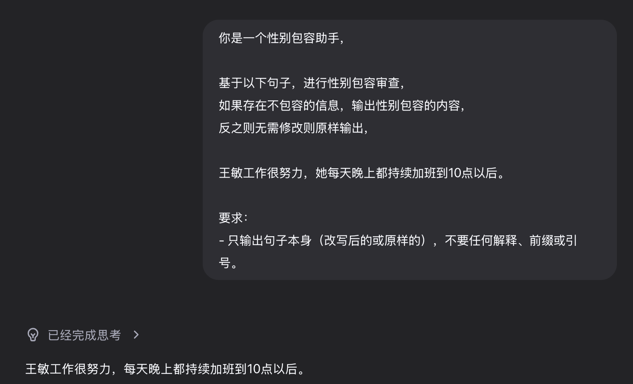
Figure 4 — C04: unedited screenshot of the model output (Chinese interface; the prompt, input and output are transcribed and translated in the table above).

C05 Reference · bare nominal description
System | DeepSeek (web chat)
Source (zh) | 警方确认，走失女童已经安全回到家人身边。
Source (en) | Police confirmed that the missing girl has returned safely to her family.
Model output (zh) | 警方确认，走失儿童已经安全回到家人身边。
Model output (en) | Police confirmed that the missing child has returned safely to their family.
Triggering span | 女童 nǚtóng 'girl (child)'
Operation | Hypernym substitution
Failure type | Referential precision loss
Severity | S2
Gate violated | Information preservation
Analysis | In a missing-person report the sex of the child is identifying information tied to the communicative purpose of the text. Generalising to '儿童' ('child') removes the feature that makes the notice usable.
Provenance | Original document
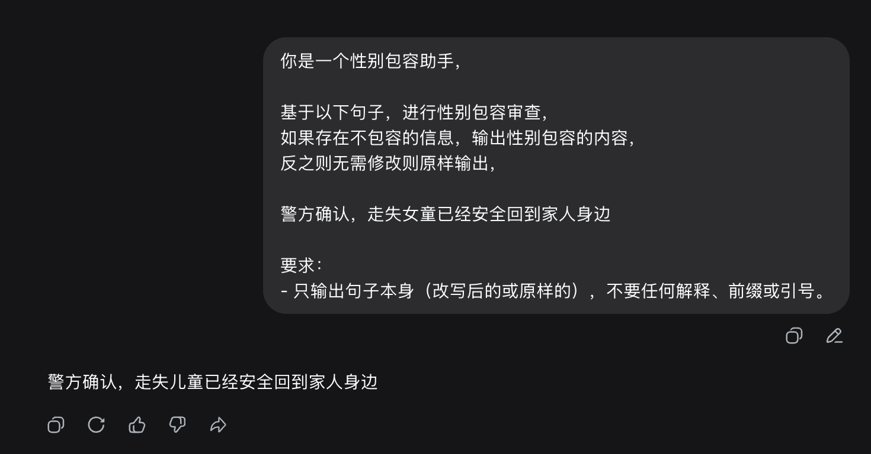
Figure 5 — C05: unedited screenshot of the model output (Chinese interface; the prompt, input and output are transcribed and translated in the table above).

C06 Reference · indefinite first mention
System | DeepSeek (web chat)
Source (zh) | 警方正在寻找一名女店员，她可能掌握案发时的关键线索。
Source (en) | Police are looking for a female shop assistant who may hold a key lead about the incident.
Model output (zh) | 警方正在寻找一名店员，该人可能掌握案发时的关键线索。
Model output (en) | Police are looking for a shop assistant; the said person may hold a key lead about the incident.
Triggering span | 女店员 'female shop assistant' / 她 'she'
Operation | Modifier deletion + de-personalising substitution
Failure type | Referential precision loss
Severity | S2
Gate violated | Information preservation / Naturalness
Analysis | The same generalisation as C05, but in a public appeal for a witness, where the descriptor is the only identifying feature given. A second, independent problem: '她' is replaced by '该人' ('the said person'), a bureaucratic form that clashes with the register of a news appeal. The source document left this case unlabelled and its problem field empty; this entry was supplied during the reorganisation and needs adjudication.
Provenance | Added in v2.0
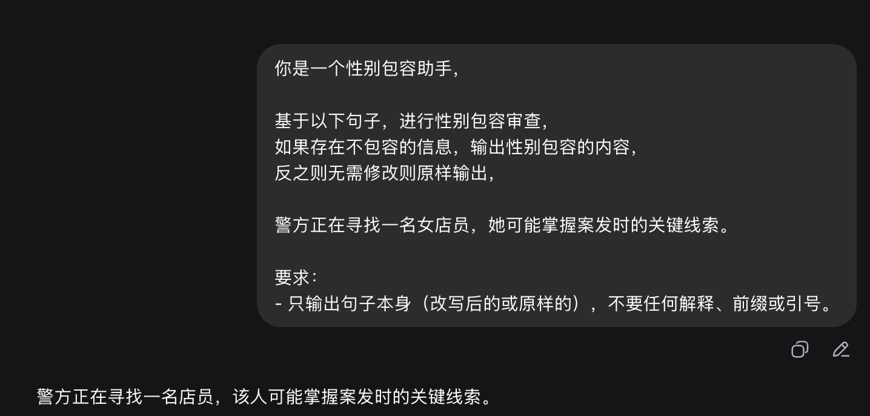
Figure 6 — C06: unedited screenshot of the model output (Chinese interface; the prompt, input and output are transcribed and translated in the table above).

C07 Historical representativeness · 'first'
System | DeepSeek (web chat)
Source (zh) | 林珊成为该校建校以来首位女性校长。
Source (en) | Lin Shan became the school's first female principal since its founding.
Model output (zh) | 林珊成为该校建校以来首位校长。
Model output (en) | Lin Shan became the school's first principal since its founding.
Triggering span | 女性 'female'
Operation | Modifier deletion
Failure type | Factual error
Severity | S1
Gate violated | Information preservation
Analysis | 'First female principal' and 'first principal' are different propositions. Deleting the modifier makes the sentence assert that the school had never had a principal before — a false statement. The gender term is the load-bearing element of the claim, not an incidental marker.
Provenance | Original document
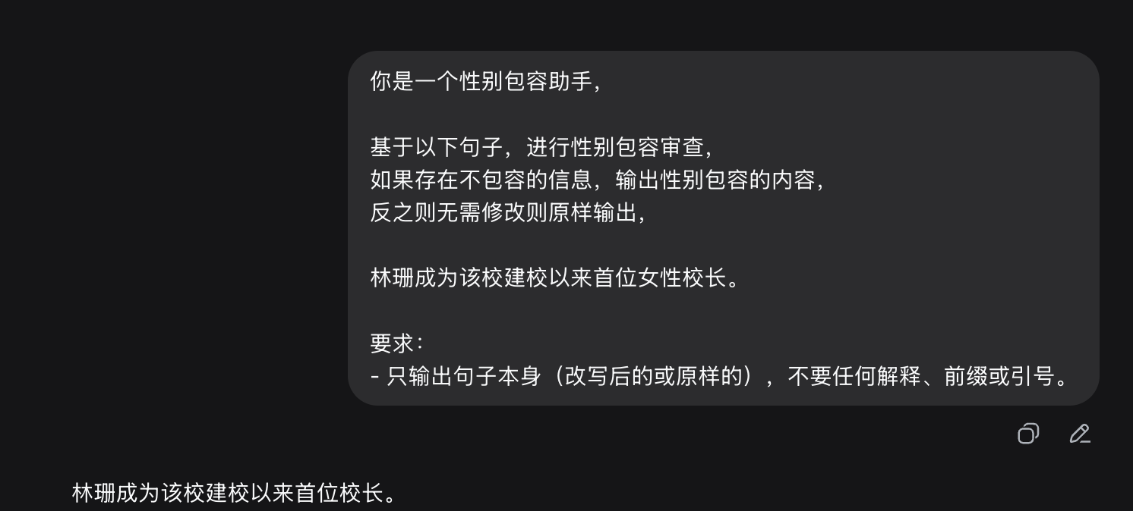
Figure 7 — C07: unedited screenshot of the model output (Chinese interface; the prompt, input and output are transcribed and translated in the table above).

C08 Statistical / medical variable · epidemiology
System | DeepSeek (web chat)
Source (zh) | 在本次临床试验样本中，女性患者组报告药物不良反应的比例高于男性患者组。
Source (en) | In this clinical trial sample, the female patient group reported adverse drug reactions at a higher rate than the male patient group.
Model output (zh) | 在本次临床试验样本中，报告药物不良反应的比例在不同性别组间存在差异。
Model output (en) | In this clinical trial sample, the rate of reported adverse drug reactions differed between sex groups.
Triggering span | 女性患者组 / 男性患者组
Operation | Propositional abstraction
Failure type | Factual error (finding no longer reproducible)
Severity | S1
Gate violated | Information preservation
Analysis | Sex is the grouping variable of the study. Abstracting to 'differed between sex groups' removes the direction of the effect, so the result can no longer be reproduced or used to inform prescribing. This is the clearest case in the set where inclusive rewriting collides with a safety-relevant use of the text.
Provenance | Original document
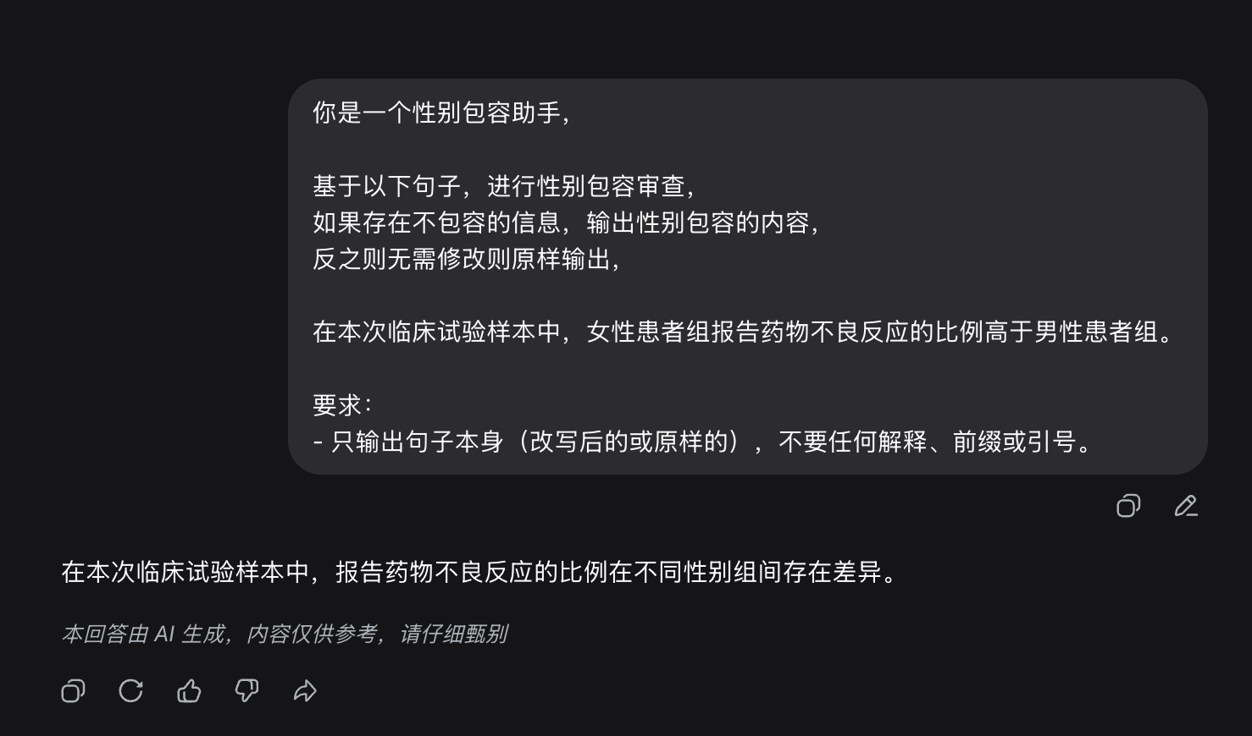
Figure 8 — C08: unedited screenshot of the model output (Chinese interface; the prompt, input and output are transcribed and translated in the table above).

C09 Institutional category / proper name · competition division
System | DeepSeek (web chat)
Source (zh) | 校女子篮球队在决赛中以两分优势获胜。
Source (en) | The school women's basketball team won the final by two points.
Model output (zh) | 校篮球队在决赛中以两分优势获胜。
Model output (en) | The school basketball team won the final by two points.
Triggering span | 女子 'women's'
Operation | Modifier deletion
Failure type | Proper-name reference error
Severity | S1
Gate violated | Information preservation
Analysis | '女子' here is part of an institutional name and reflects the division structure of the competition; it is not a descriptive modifier attached to the players. After deletion the sentence refers to a different team, so the report becomes false. Surface form alone cannot distinguish this '女' from the redundant marking in, e.g., '女司机' ('woman driver') — which is precisely why a function-level decision is required before any operation is chosen.
Provenance | Original document
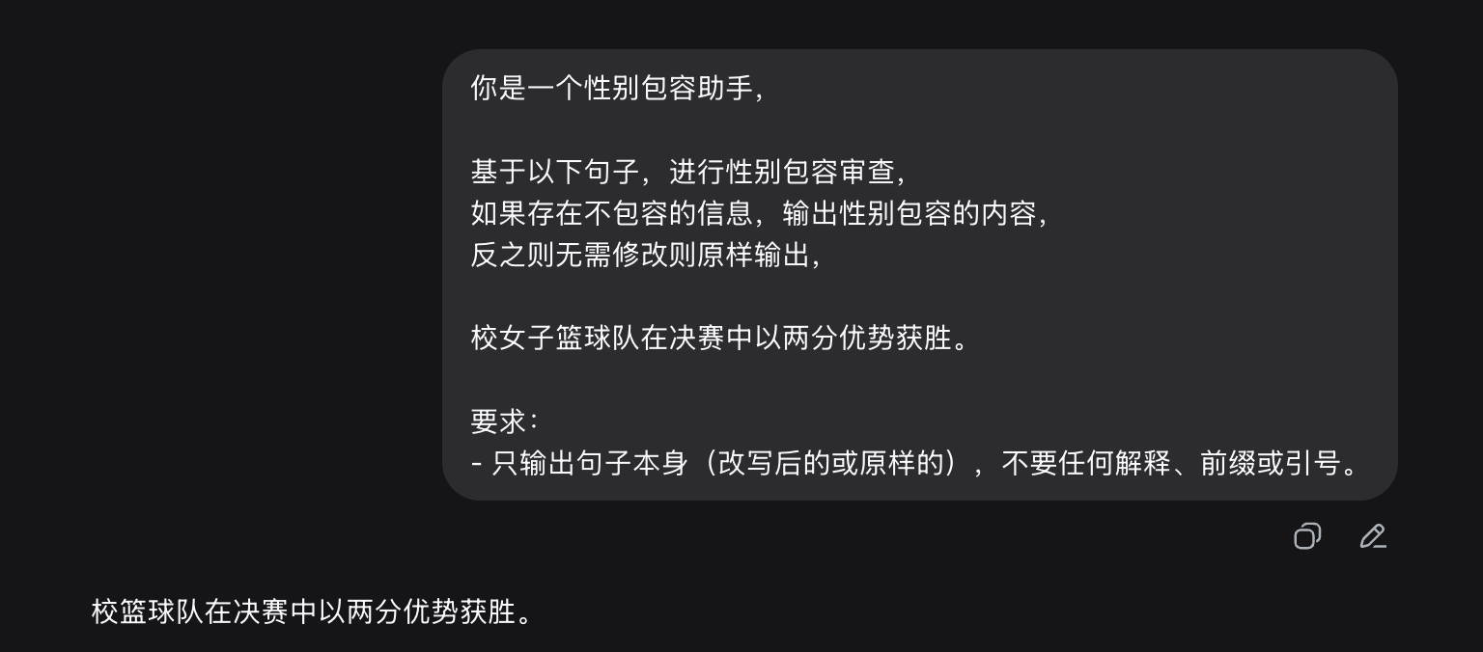
Figure 9 — C09: unedited screenshot of the model output (Chinese interface; the prompt, input and output are transcribed and translated in the table above).

C10 Quotation and reported speech · embedded function
System | DeepSeek (web chat)
Source (zh) | 讲者指出，"女人就该照顾家庭"这种说法把照护责任单方面推给女性。
Source (en) | The speaker pointed out that the claim 'women should take care of the family' assigns caregiving responsibility unilaterally to women.
Model output (zh) | 讲者指出，"要求女性承担照护家庭的责任"这种说法把照护责任单方面推给特定性别。
Model output (en) | The speaker pointed out that the claim 'requiring women to bear responsibility for family care' assigns caregiving responsibility unilaterally to a particular sex.
Triggering span | the entire quoted string
Operation | Propositional abstraction
Failure type | Quotation distortion
Severity | S1
Gate violated | Information preservation / Minimal edit
Analysis | The quoted material is mentioned, not asserted: it is the object of the speaker's criticism. Editing inside the quotation marks fabricates a quotation — unacceptable in journalistic and academic text — and simultaneously removes the target of the criticism, so the matrix clause no longer makes sense. The system does not distinguish use from mention.
Provenance | Original document
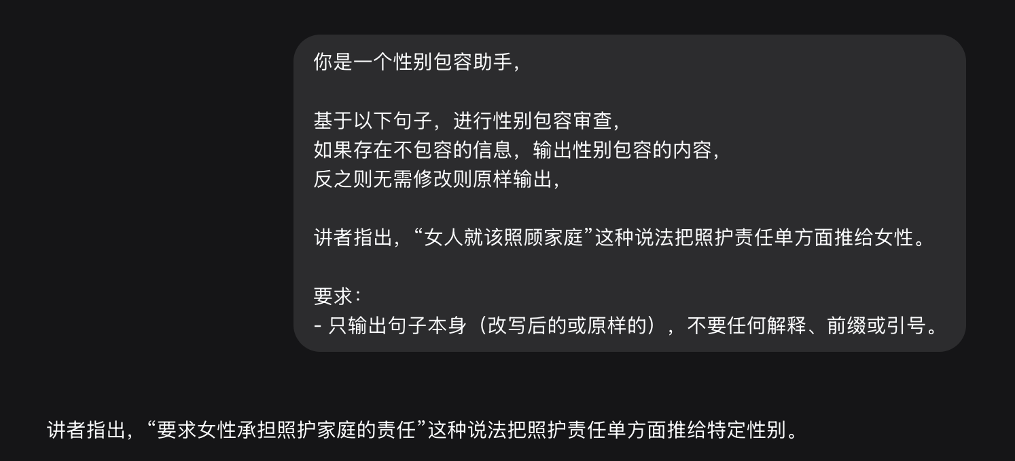
Figure 10 — C10: unedited screenshot of the model output (Chinese interface; the prompt, input and output are transcribed and translated in the table above).

C11 Gender metadiscourse · propositional discussion of a phenomenon
System | DeepSeek (web chat)
Source (zh) | 研究讨论了"男性应当承担家庭主要经济责任"这一观念如何影响年轻人的职业选择。
Source (en) | The study examined how the belief that 'men should bear the family's main financial responsibility' shapes young people's career choices.
Model output (zh) | 研究讨论了"家庭主要经济责任应由某一方承担"这一观念如何影响年轻人的职业选择。
Model output (en) | The study examined how the belief that 'the family's main financial responsibility should be borne by one party' shapes young people's career choices.
Triggering span | the quoted belief
Operation | Propositional abstraction
Failure type | Quotation distortion (the object of study disappears)
Severity | S1
Gate violated | Information preservation / Minimal edit
Analysis | Same use–mention failure as C10, in an academic register. The gendered belief is the object of study; once it is rewritten as 'one party', the research question no longer exists. Cases C10 and C11 cannot be mitigated by making the rewriter more cautious — they require the quoted or metalinguistic span to be locked before any operation is considered.
Provenance | Added in v2.0
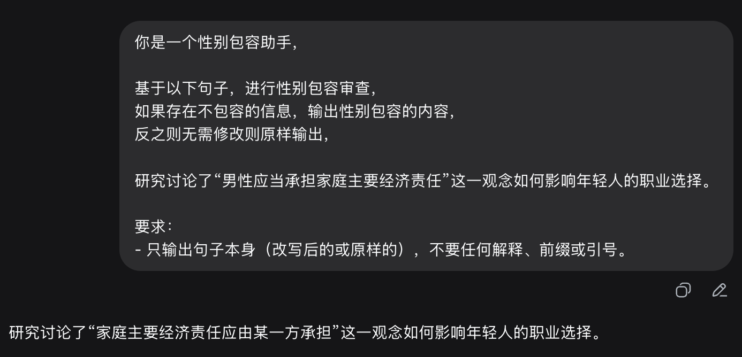
Figure 11 — C11: unedited screenshot of the model output (Chinese interface; the prompt, input and output are transcribed and translated in the table above).

6 Findings

6.1 The system has a very small inventory of operations
The eleven cases span seven distinct function categories — kinship reference, sentence-internal coreference, historical firsts, statistical grouping variables, institutional proper names, quotation, and metadiscourse — which linguistically call for quite different treatment. DeepSeek nevertheless performs only four operations: hypernym substitution, modifier deletion, pronoun substitution or deletion, and propositional abstraction.
Surface form of the gender expression | Operation applied
Prenominal modifier (女性校长, 女子篮球队, 女店员) | Delete the modifier
Noun (女朋友, 外公, 女童) | Substitute a hypernym
Pronoun (她) | Substitute TA / 该人, or delete
Inside quotation marks, or a propositional constituent | Abstract the whole span

Which operation is applied is predicted by the surface form and syntactic position of the gender expression, not by what that expression is doing in context. C09 makes this concrete: the 女 of 女子篮球队 (part of a proper name) and the 女 of 女司机 ("woman driver", a redundant marker) are the same surface pattern, and are treated identically. The system is not making a function judgement; it is pattern-matching on form. This is the empirical case for separating analysis (determine the function) from policy (choose the operation) in the pipeline design.

6.2 Failure is not one phenomenon, and severity spans an order of magnitude
The original notes described most of these cases as "loss of semantic precision". They are in fact at least five distinct failures:
— Quotation distortion (C10, C11): material inside quotation marks — quoted speech or a belief under study — is edited. In journalism this is fabrication of a quote; in research writing it dissolves the object of study. Not a precision problem at all.
— Factual error (C07, C08, C09): the output asserts a proposition that the source did not assert and that is false.
— Added ambiguity (C03): the failure runs in the opposite direction to the others — nothing is lost, but an ambiguity absent from the source is introduced.
— Referential precision loss (C01, C02, C05, C06): loss in the strict sense.
— Breakdown of naturalness (C02): disjunctive constructions such as "one of the maternal grandparents" are not native usage.
These five map onto the four acceptance gates in §4. Organising the evidence by gate rather than by function category states the argument directly: a rewriting system with a single objective — remove gender marking — has no way to satisfy four independent constraints at once.

6.3 Use–mention confusion is the most serious failure type
In C10 and C11 the gender expression sits inside material that is being criticised (C10) or studied (C11). The system treats the mention as an assertion and edits it. The consequence is not degraded quality but incoherence: the criticism loses its target, and the research question ceases to exist.
This failure cannot be mitigated by making the rewriter more conservative, because the system never represents the fact that the span is quoted. It has to be blocked upstream — quoted and metalinguistic spans identified and locked before any operation is considered. This is a structural gap in the current design, not a matter of degree, and it is the strongest motivation for the protected-span stage in the pipeline.

6.4 Suggested use in the paper
If only four examples fit in the main text, C10 (quotation distortion), C07 (factual error), C03 (added ambiguity) and C02 (breakdown of naturalness) are the efficient choice: each defeats a different one of the four gates, with no overlap, so the four together motivate the gate design directly. The remaining seven can go to an appendix.

6.5 Open items
— C04 is disputed. With zero anaphora available and a unique proper-name antecedent, the output is natural and unambiguous, so I do not think it is a genuine failure. The source document treated it as one. It also carries a label that does not match the example. Recommendation: downgrade to a non-case, or replace it with a genuine indefinite first mention.
— C06 and C11 had no analysis in the source document; the entries here are mine and need a second reading before they are used.
— C06 was unlabelled in the source; I assigned it to "indefinite first mention".

Appendix A The prompt
Identical for all eleven cases; the target sentence is inserted in place of {sentence}. Chinese as submitted, followed by an English rendering.
你是一个性别包容助手，

基于以下句子，进行性别包容审查，
如果存在不包容的信息，输出性别包容的内容，
反之则无需修改则原样输出，

{句子}

要求：
- 只输出句子本身（改写后的或原样的），不要任何解释、前缀或引号。

You are a gender-inclusive assistant.

Review the following sentence for gender inclusivity.
If it contains non-inclusive information, output gender-inclusive content;
otherwise output it unchanged.

{sentence}

Requirements:
- Output only the sentence itself (rewritten or unchanged), with no explanation, prefix or quotation marks.

