Superstore Sales Analysis Report
Author: Hongyang Song
Generated by Python + MySQL
2026-07-19

Executive Summary
Dataset Overview
• Total Orders: 4922
• Total Customers: 793
• Total Products: 1849
• Total Sales: $2,261,536.78
• Average Sales: $230.77
• Maximum Sales: $22,638.48
• Minimum Sales: $0.44
• Best Category: Technology
• Best Region: West

Business Overview
This report analyzes the Superstore sales dataset stored in MySQL. The dataset contains sales transactions from different regions, customer segments and product categories.
The dataset includes 9,800 sales records, 4,922 unique orders, 793 customers and 1,849 products.
Total sales reached $2,261,536.78. The highest-selling category is Technology, while the best-performing region is West.

Figure 1. Monthly Sales Trend
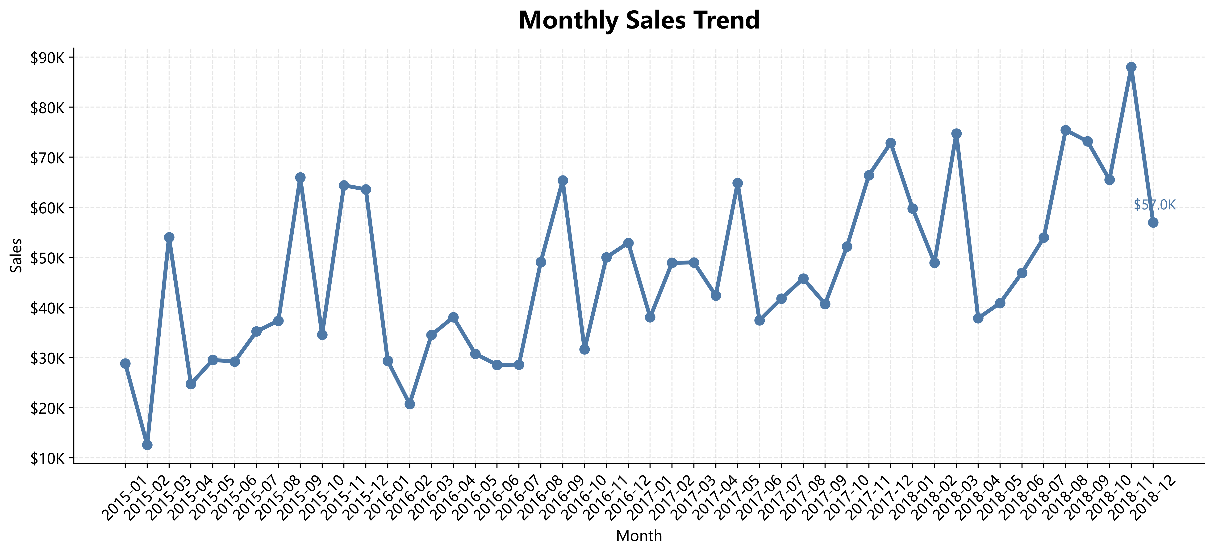
The monthly sales trend illustrates how sales changed over time. This chart helps identify seasonal patterns and business growth.

Figure 2. Sales by Category
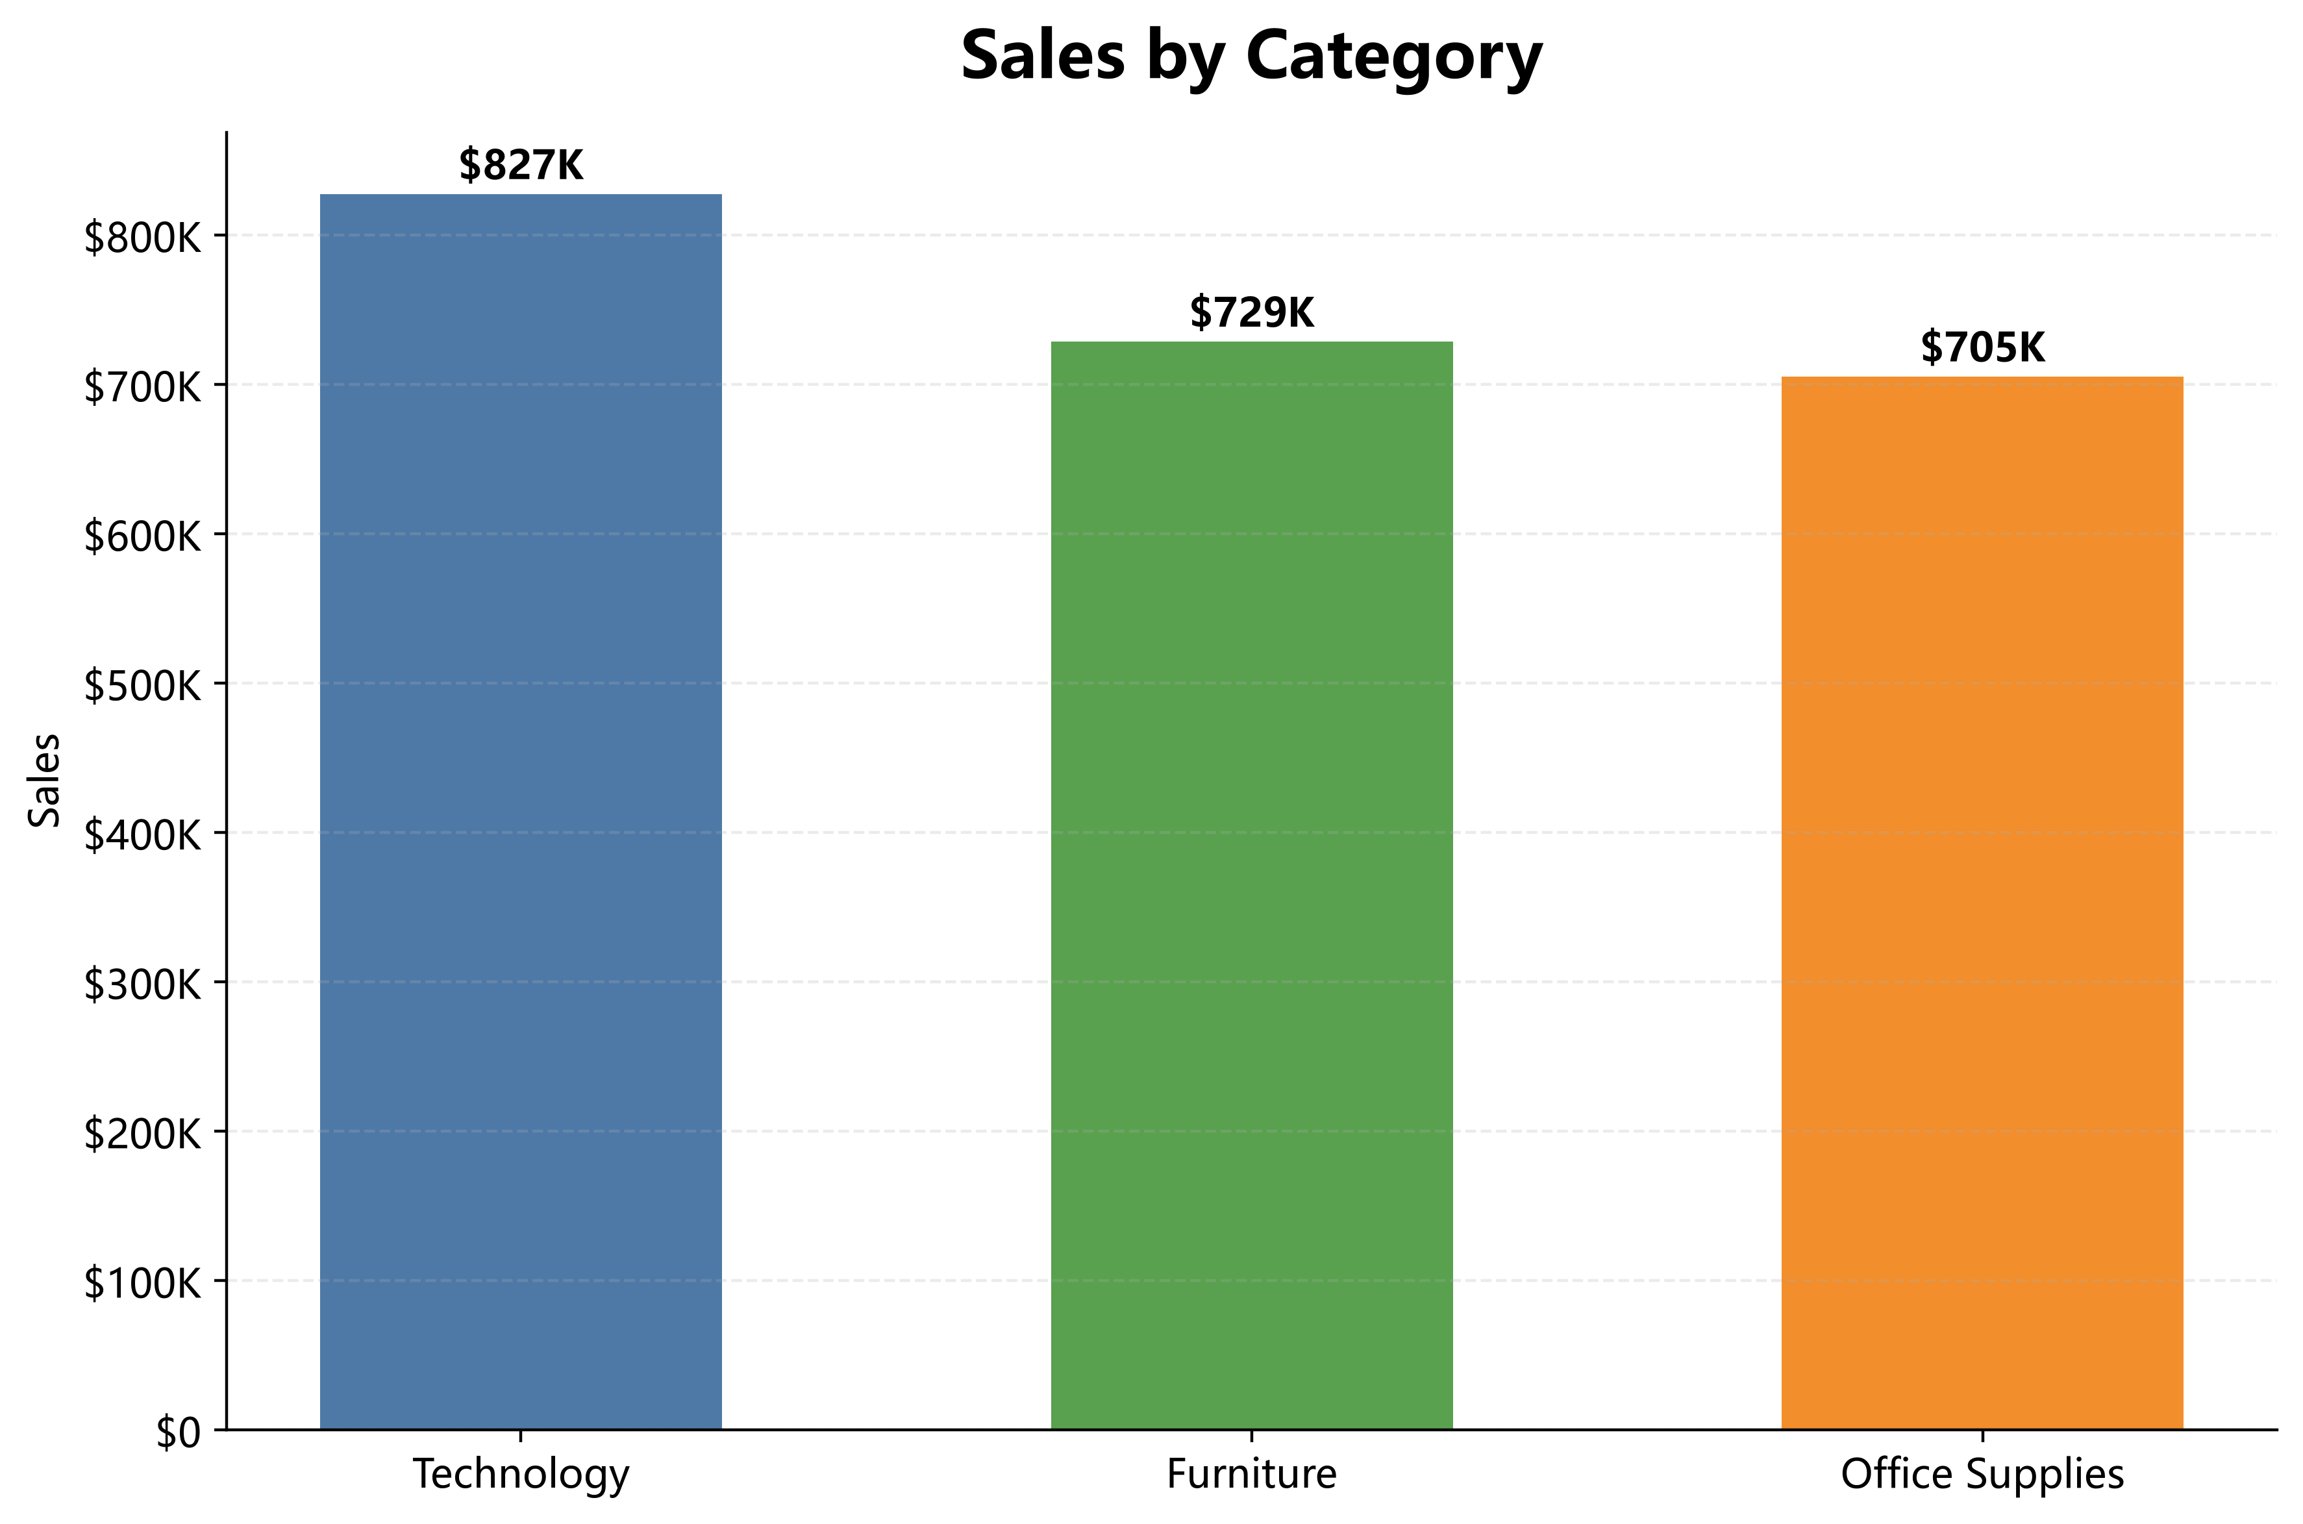
Technology generates the highest sales among all product categories, followed by Furniture and Office Supplies.

Figure 3. Sales by Region
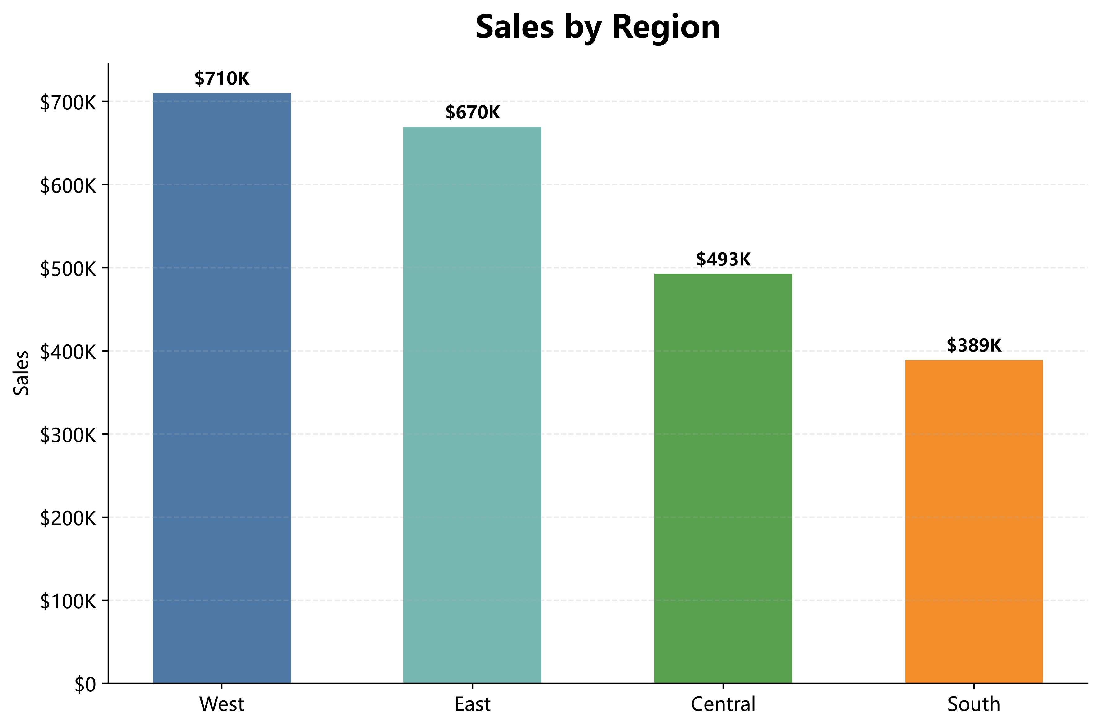
The regional sales comparison indicates that the West region contributes the highest revenue, while the South region records the lowest sales.

Figure 4. Sales by Customer Segment
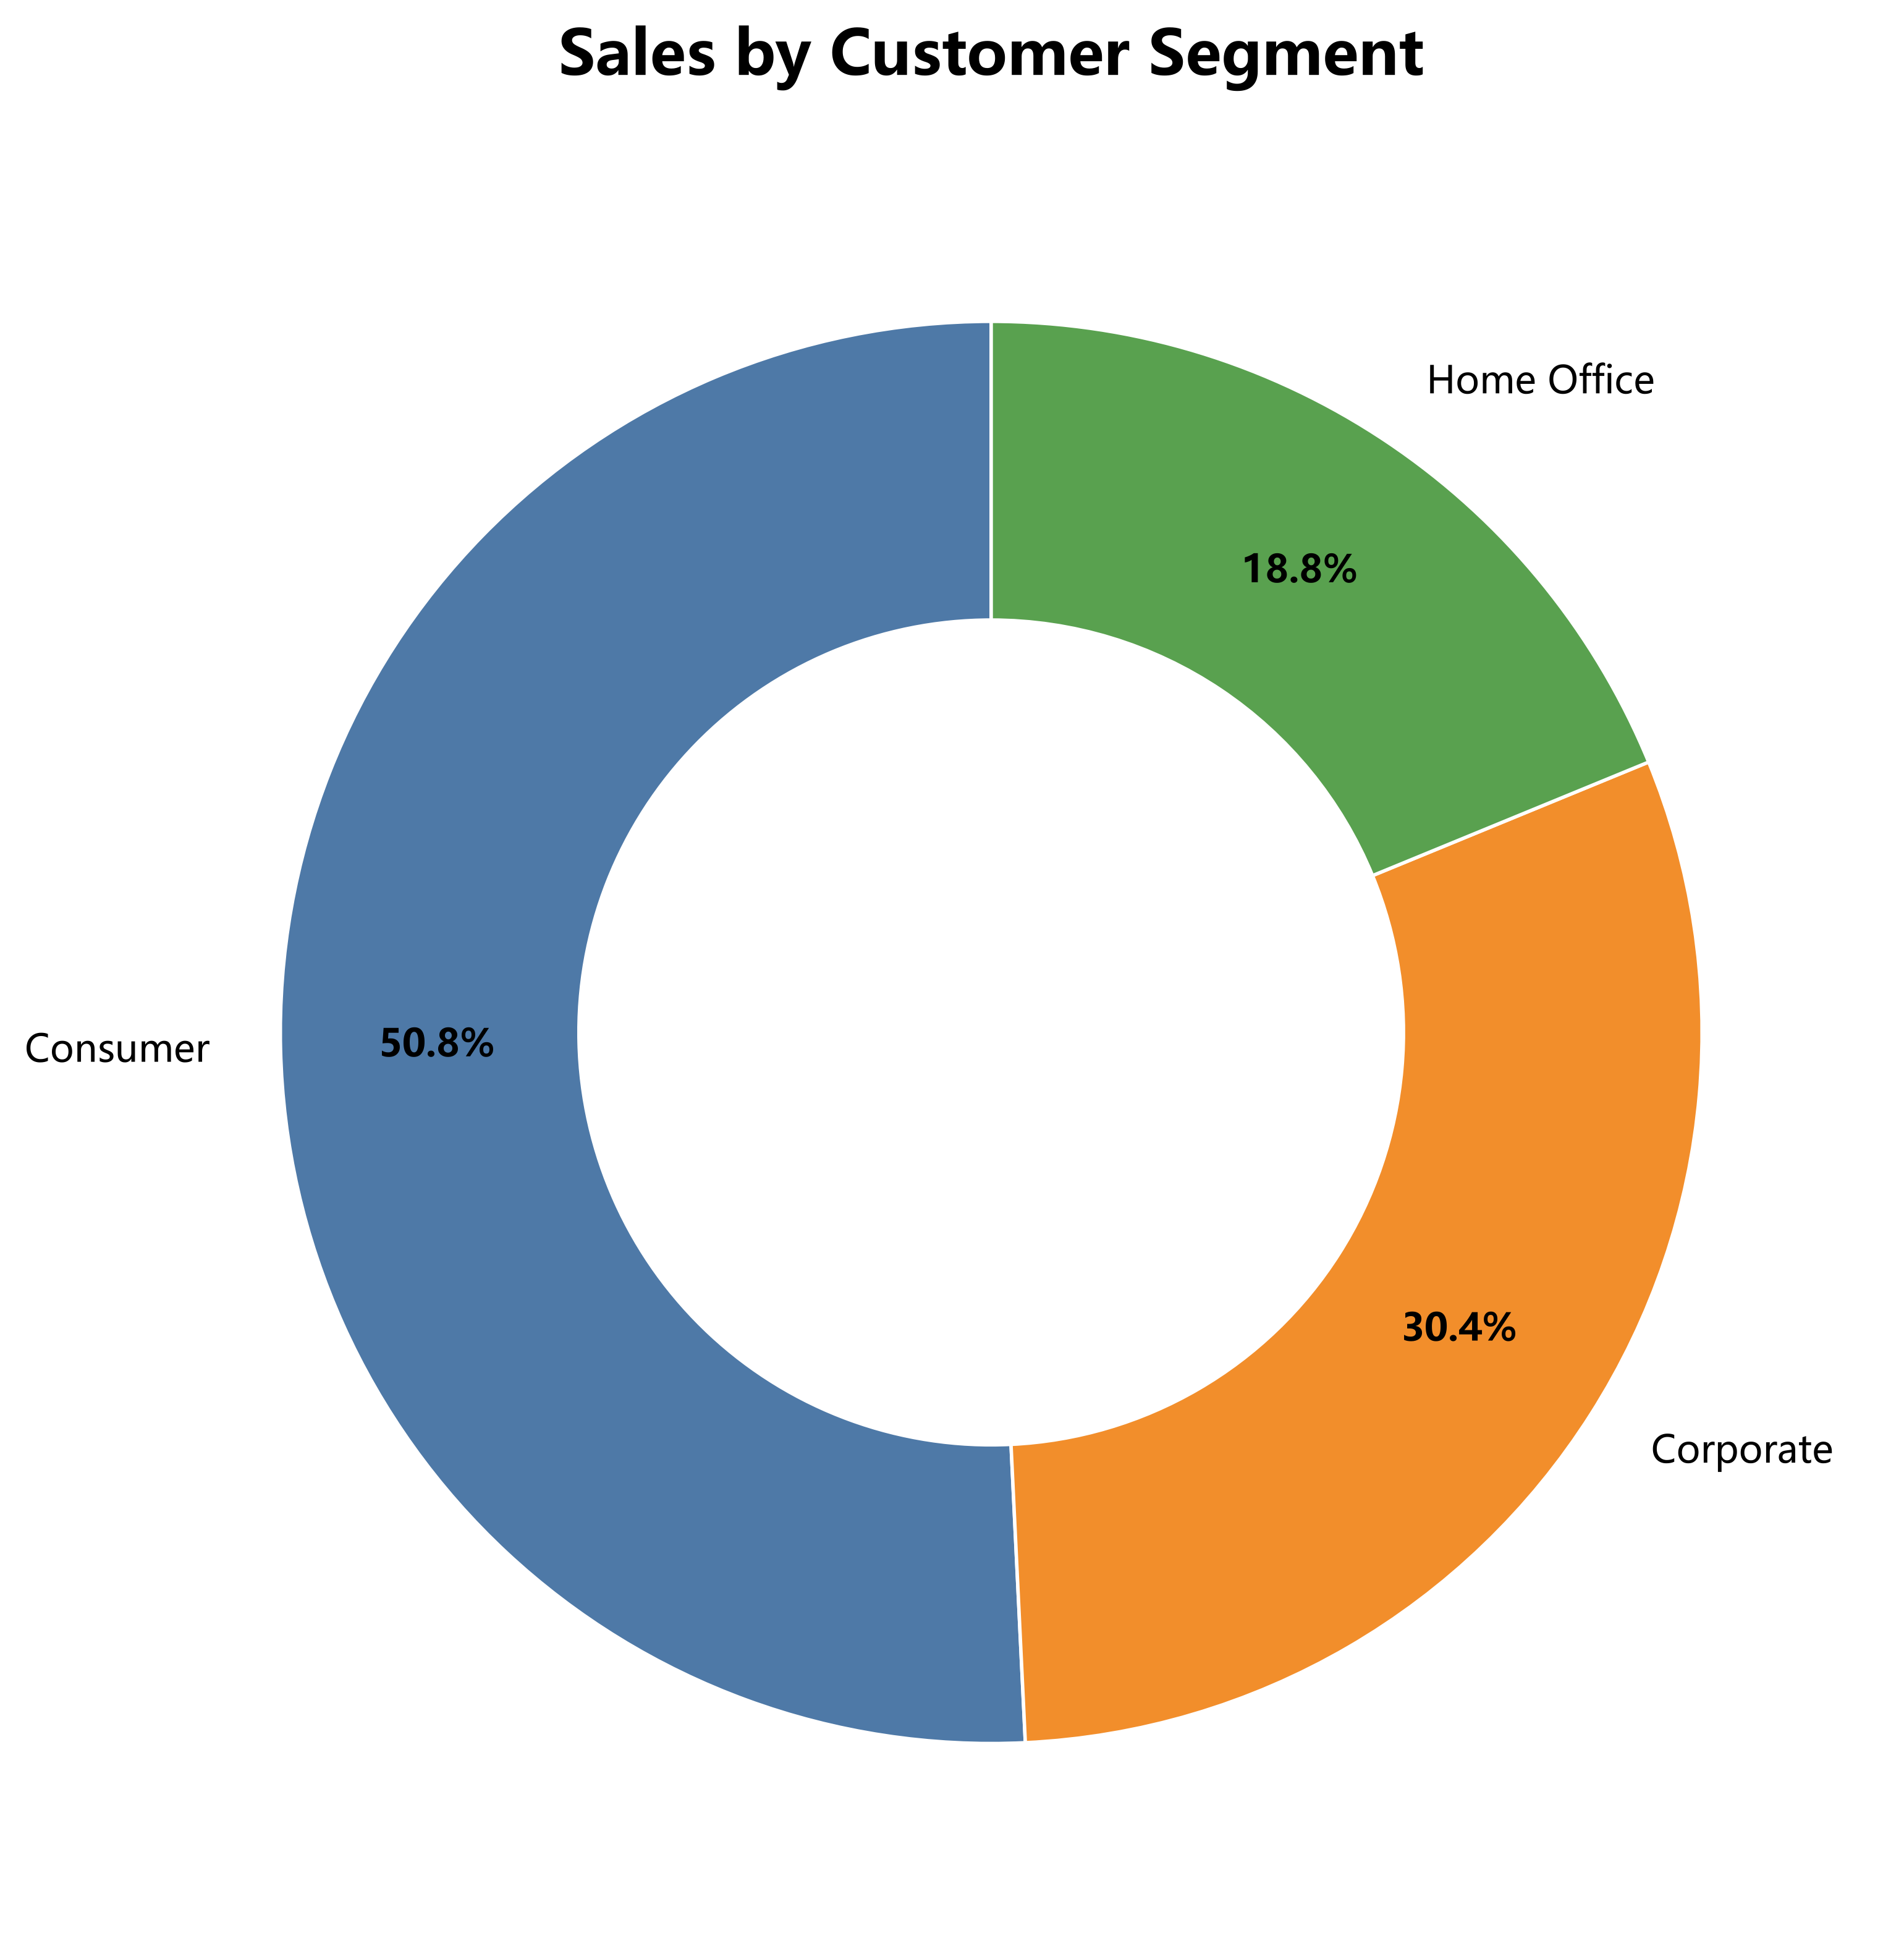
Consumer customers contribute the largest share of total sales, followed by Corporate and Home Office customers. This indicates that individual consumers remain the primary revenue source.

Figure 5. Top 10 Products
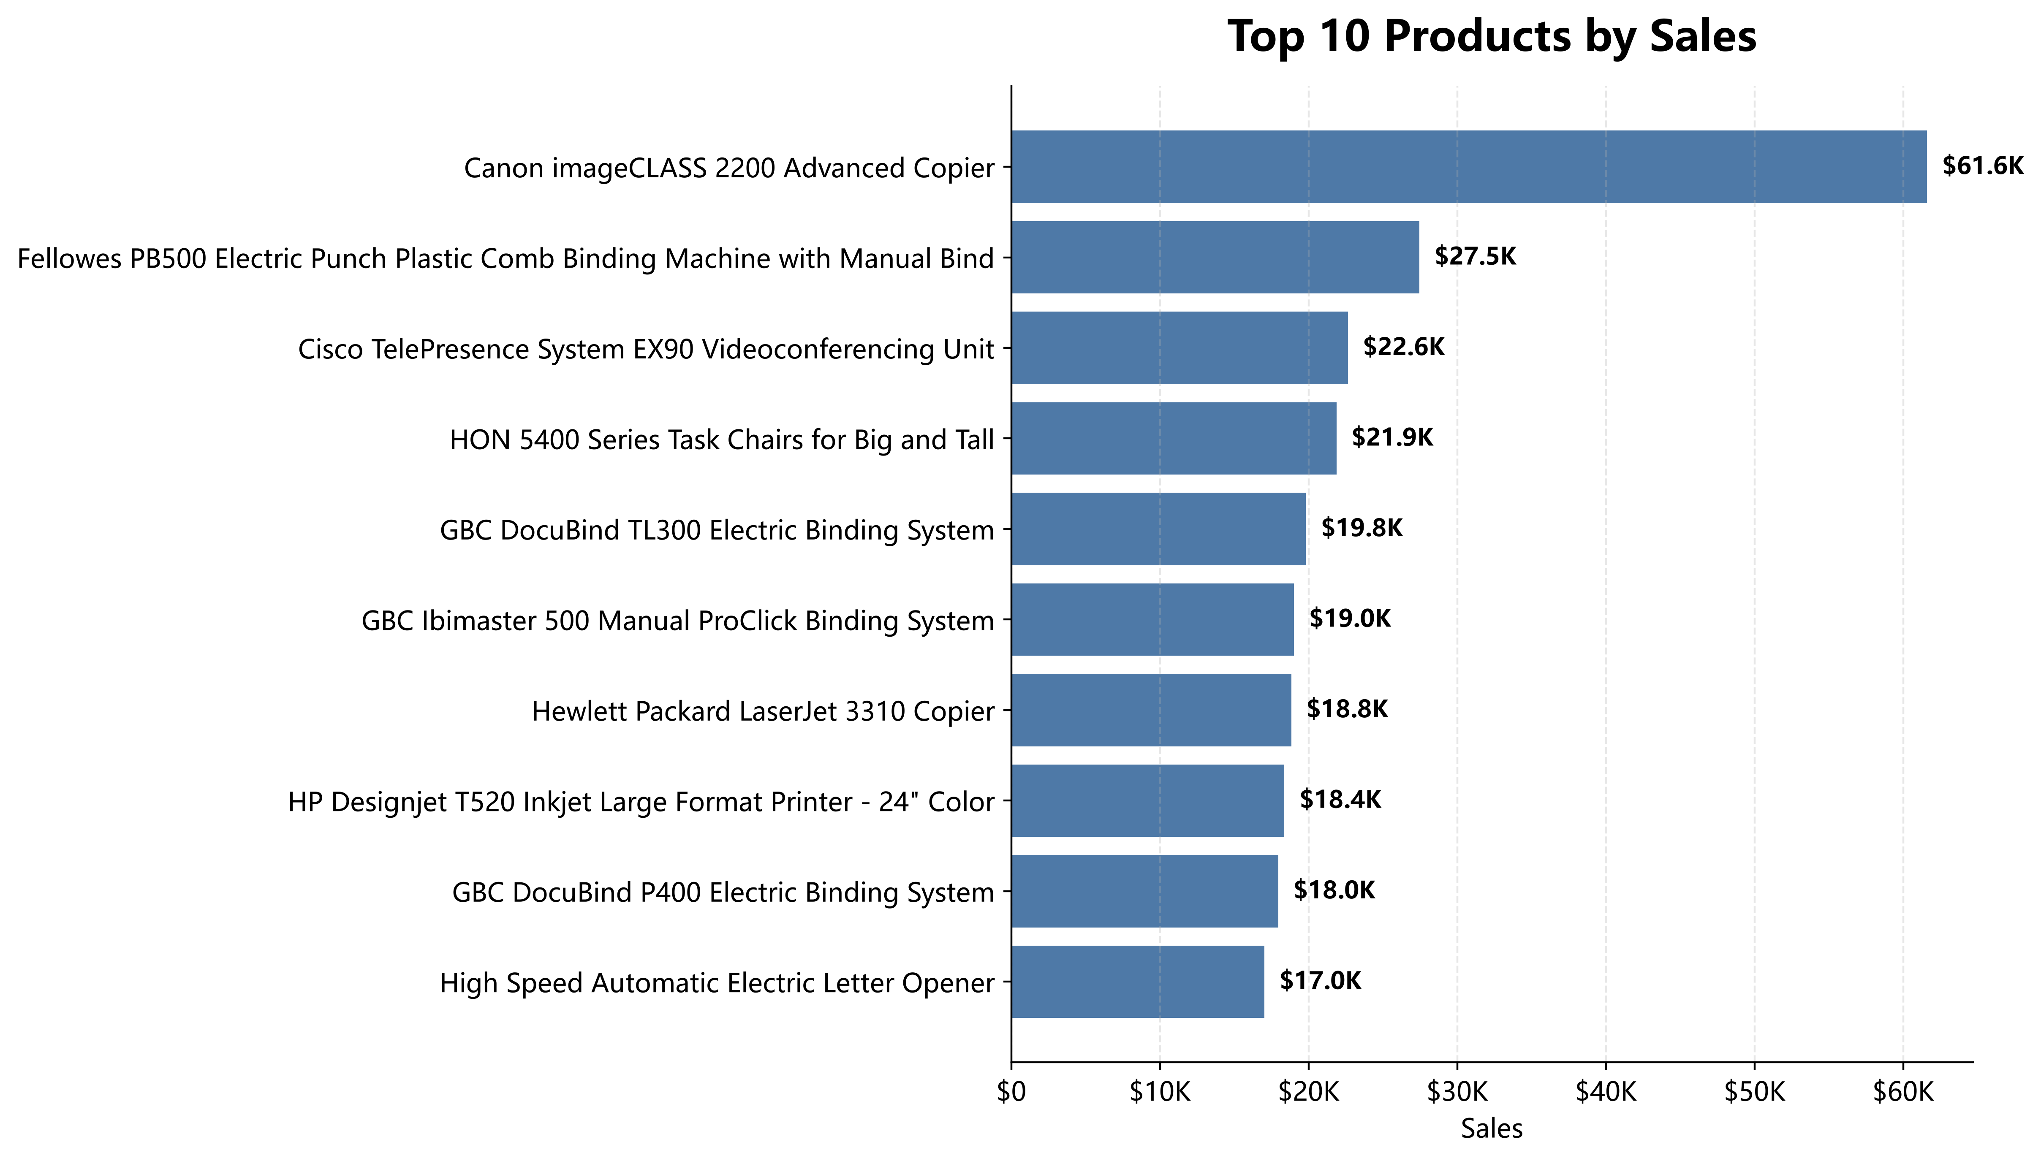
The Top 10 products generate a significant proportion of total revenue. High-value products have a major impact on business performance.

Figure 6. Sales Distribution
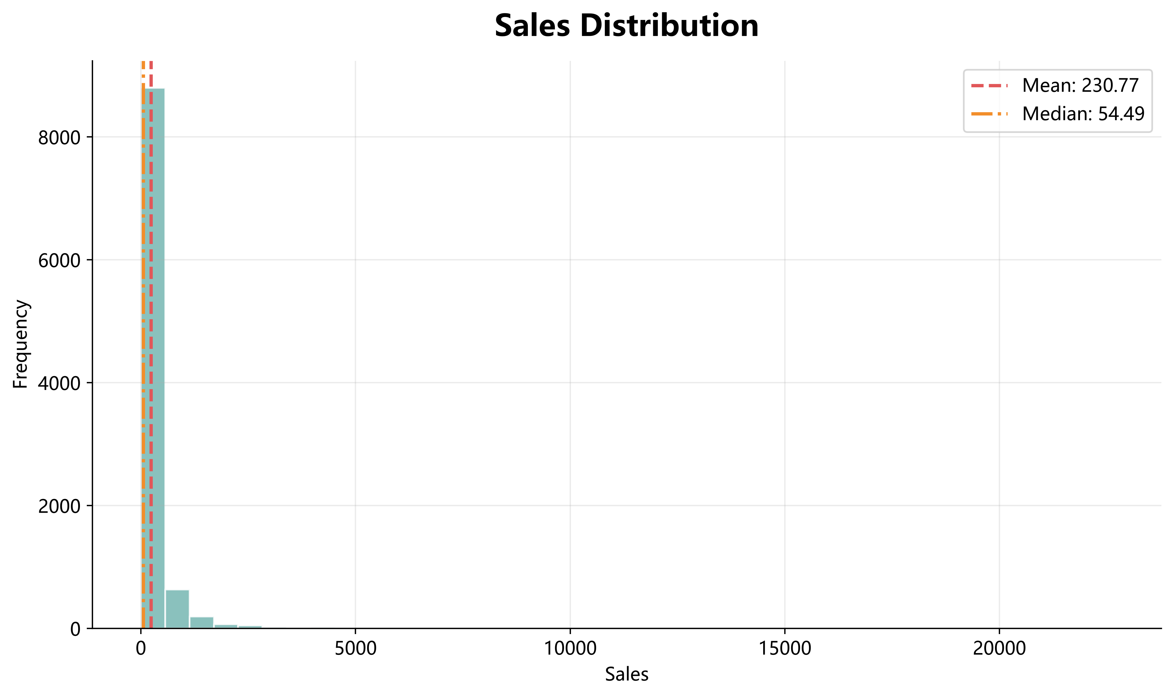
The sales distribution is right-skewed, indicating that most transactions are relatively small while a small number of orders contribute very high sales.

Conclusion
Key Findings
• Total sales reached $2,261,536.78, demonstrating strong overall business performance.
• Technology is the best-performing product category.
• West generates the highest regional revenue.
• Consumer customers contribute the largest proportion of sales.
• Sales are highly concentrated in a small number of high-value products.
• The sales distribution shows a typical long-tail pattern.
• Future marketing efforts should focus on high-value products, customer retention, and regional optimization.

