Supplementary Material
Return-aware proximal policy optimization with pointer attention for multi-resource mountain-road unmanned aerial vehicle inspection planning

S1. Frozen protocol and reproducibility scope
This supplement reports secondary diagnostics, additional baseline views, failure-mode summaries, all learning curves, and the post-hoc operational composite. It does not change the confirmatory safe priority-weighted coverage outcome, map-level independent unit, or v3.2.14 protocol. The source result file contains 21,648 records, the final audit passed, and ppo_mlp is absent.
Table S1. Frozen audit facts.
Item | Frozen value | Claim boundary
Learning checkpoints | 35 paper models | Seven variants × five seeds
Paper training episodes | 105,000 | Historical excluded work not used
Unseen procedural maps | 24 | Independent map-level test units
Geographic DSM regions | 8 | Simulation transfer only
Final route records | 21,648 | No manuscript rerun
Hierarchical bootstrap | 10,000 replicates | Outer unit is map

S2. Performance profiles and solver diagnostics
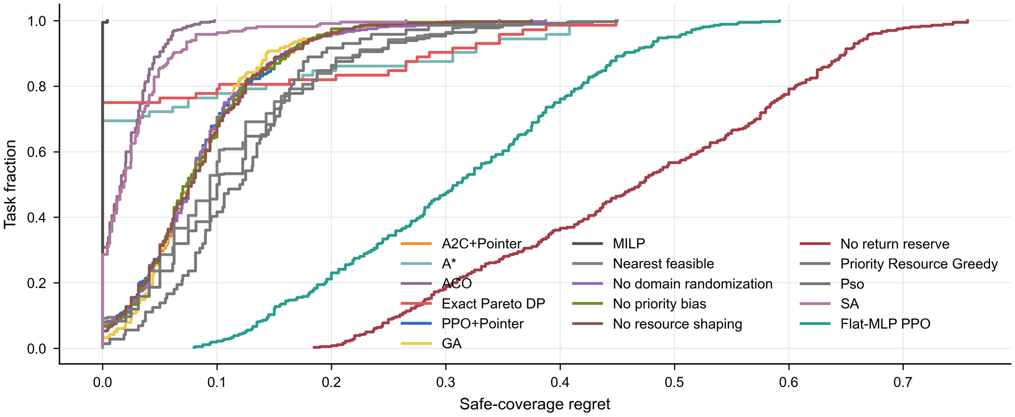
Fig. S1. Performance profiles based on regret from the safe priority-weighted coverage leader for each task.
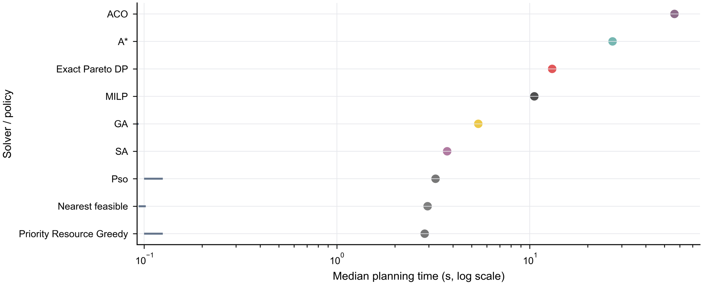
Fig. S2. Oracle regret and online computation. Horizontal intervals show the frozen regret range; planning time is logarithmic.

S3. Scenario-stratified and failure-mode results
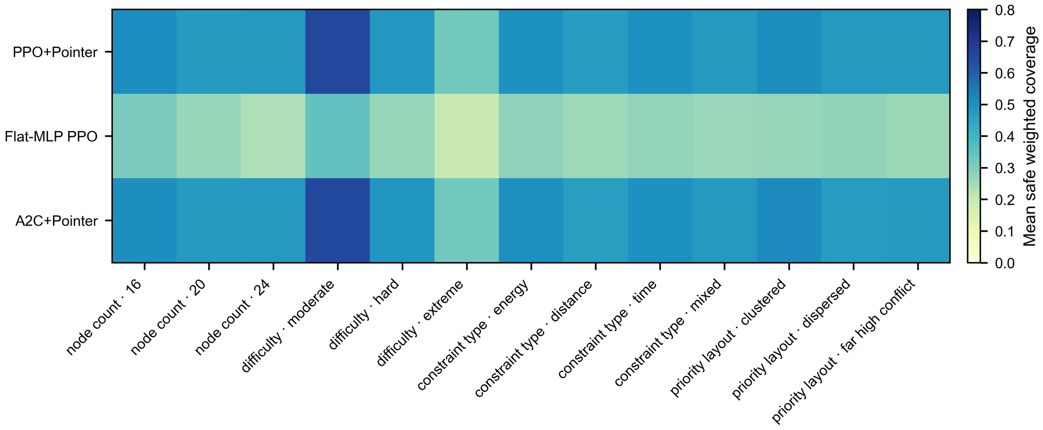
Fig. S3. Scenario-stratified safe priority-weighted coverage across node count, terrain, wind, and resource factors.
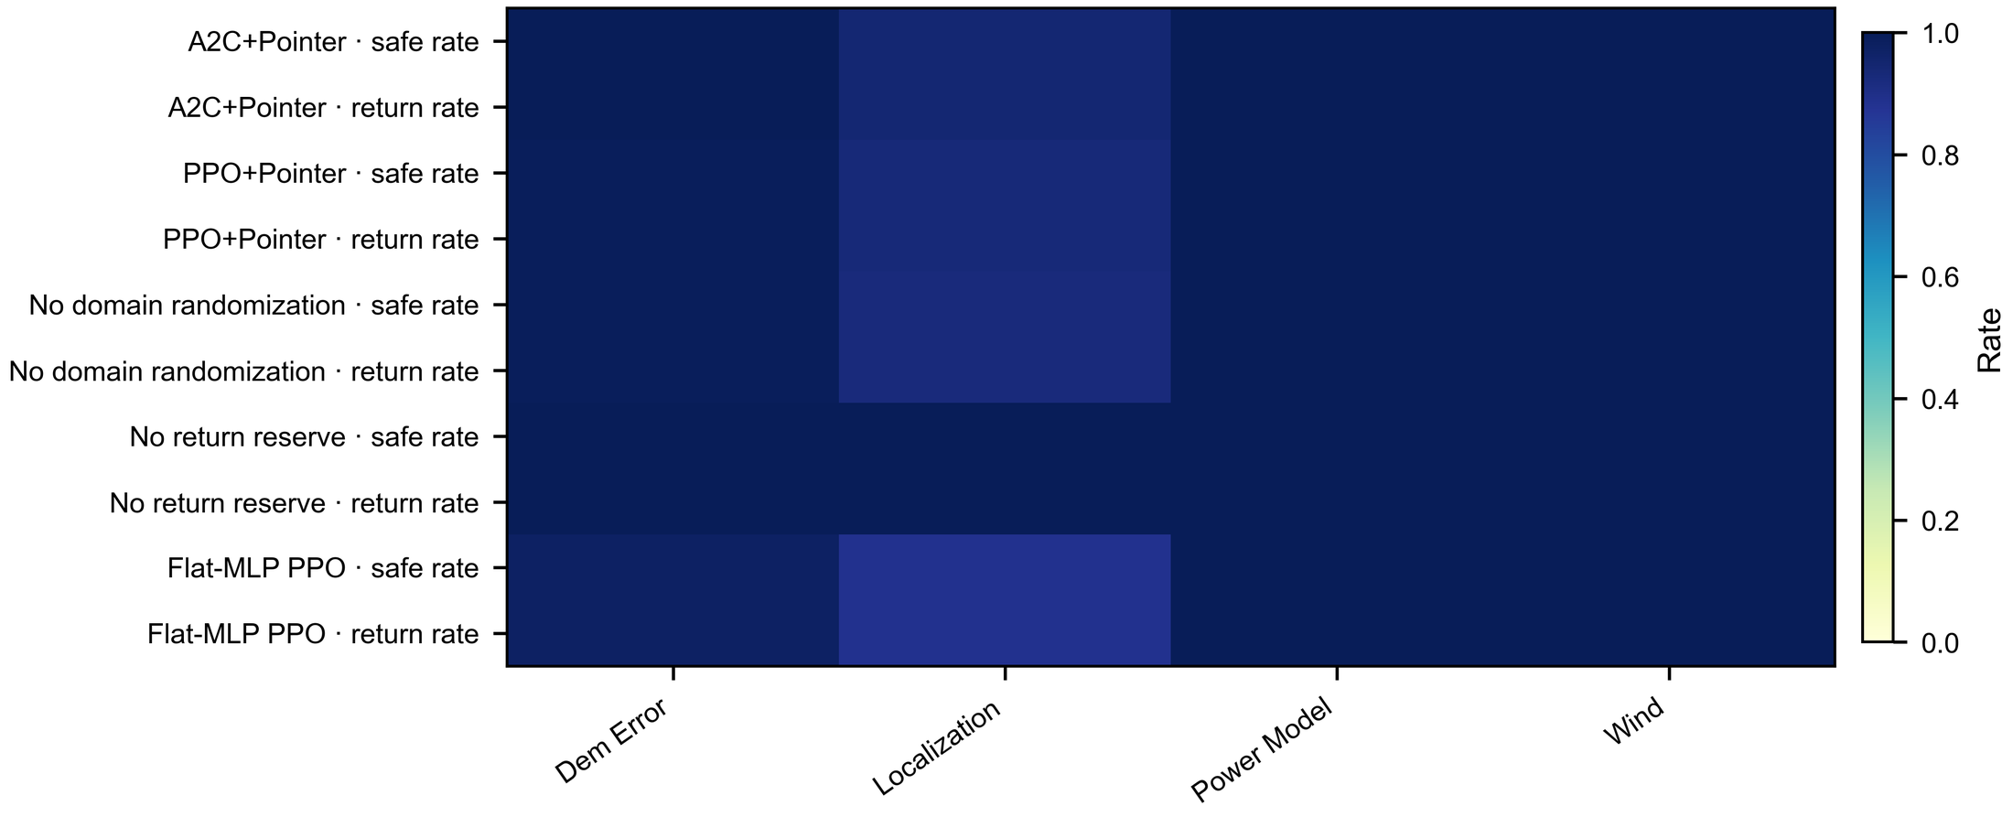
Fig. S4. Safety and return outcomes across robustness families and perturbation conditions.

S4. All-model training evidence
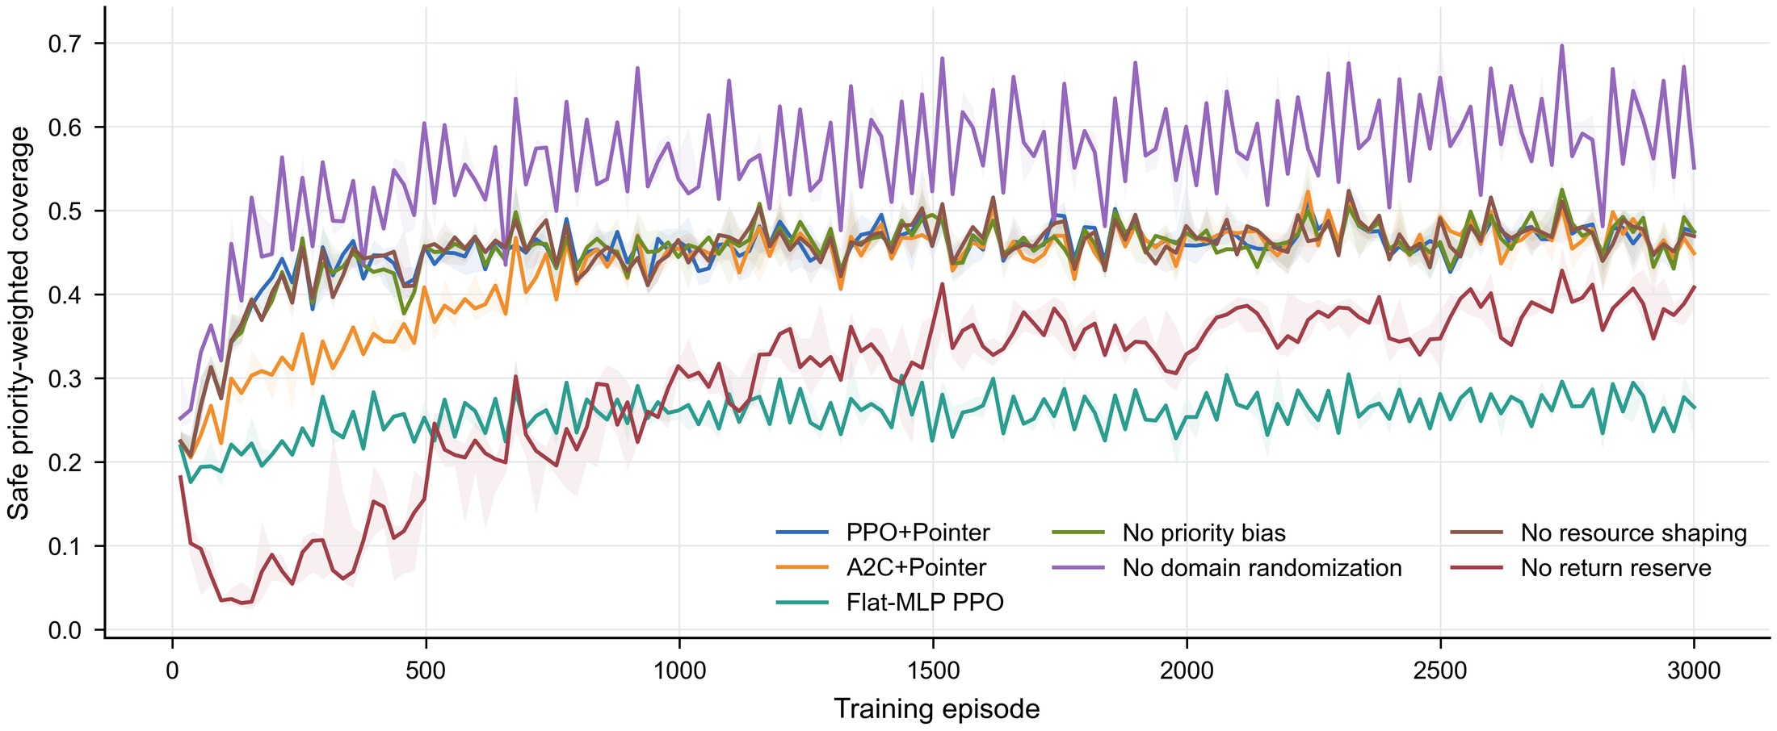
Fig. S5. Training trajectories for all seven learning variants under the frozen 3,000-episode protocol.

S5. Post-hoc operational summary and sensitivity
The seven-dimensional operational score combines D1–D7 after the confirmatory analyses. The arithmetic scores are 76.66 for PPO+Pointer, 74.55 for A2C+Pointer, and 54.47 for Flat-MLP PPO. A 10,000-replicate hierarchical bootstrap gives a mean PPO-minus-A2C difference of 1.99 points (95% interval 0.78–3.21; probability positive 1.00). This score is descriptive: its weights, operational floor, and normalisation do not replace safe priority-weighted coverage, and no individual D4, D6, or D7 contrast remained significant after Holm adjustment in its post-hoc family.
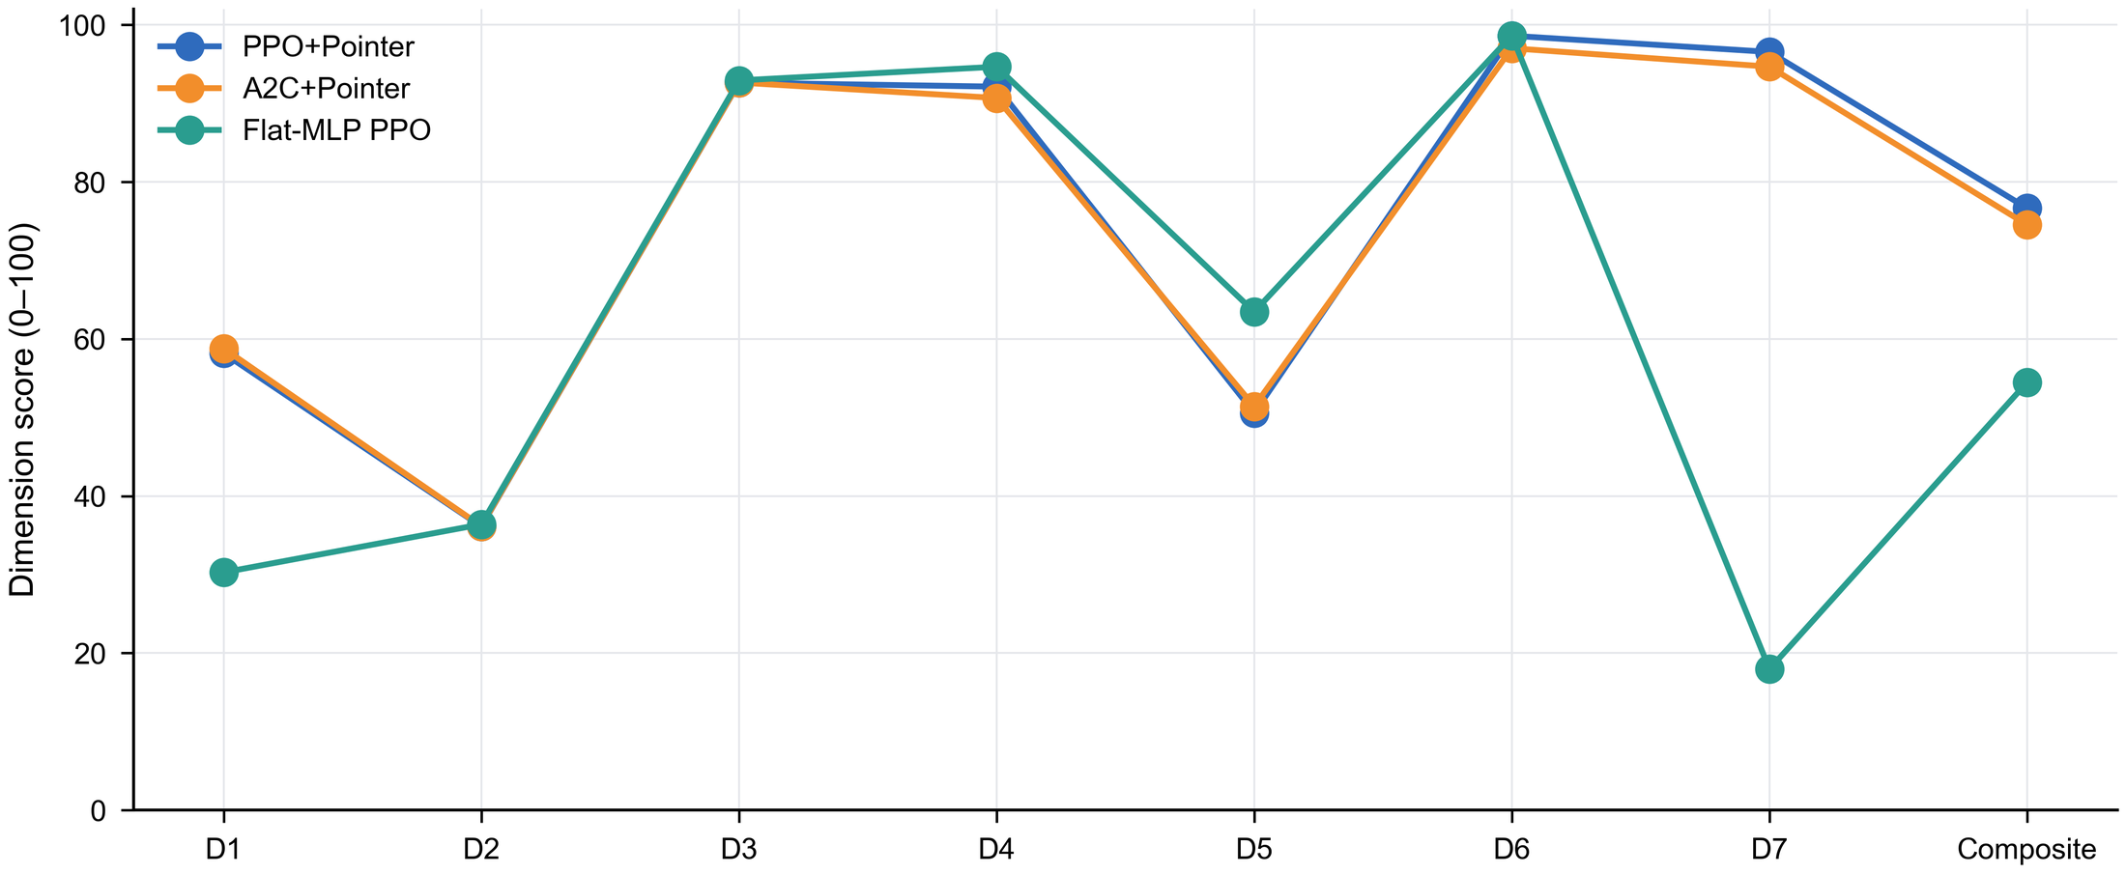
Fig. S6. Seven-dimensional operational evidence profile. The 100-point aggregate is post-hoc and not a confirmatory champion metric.
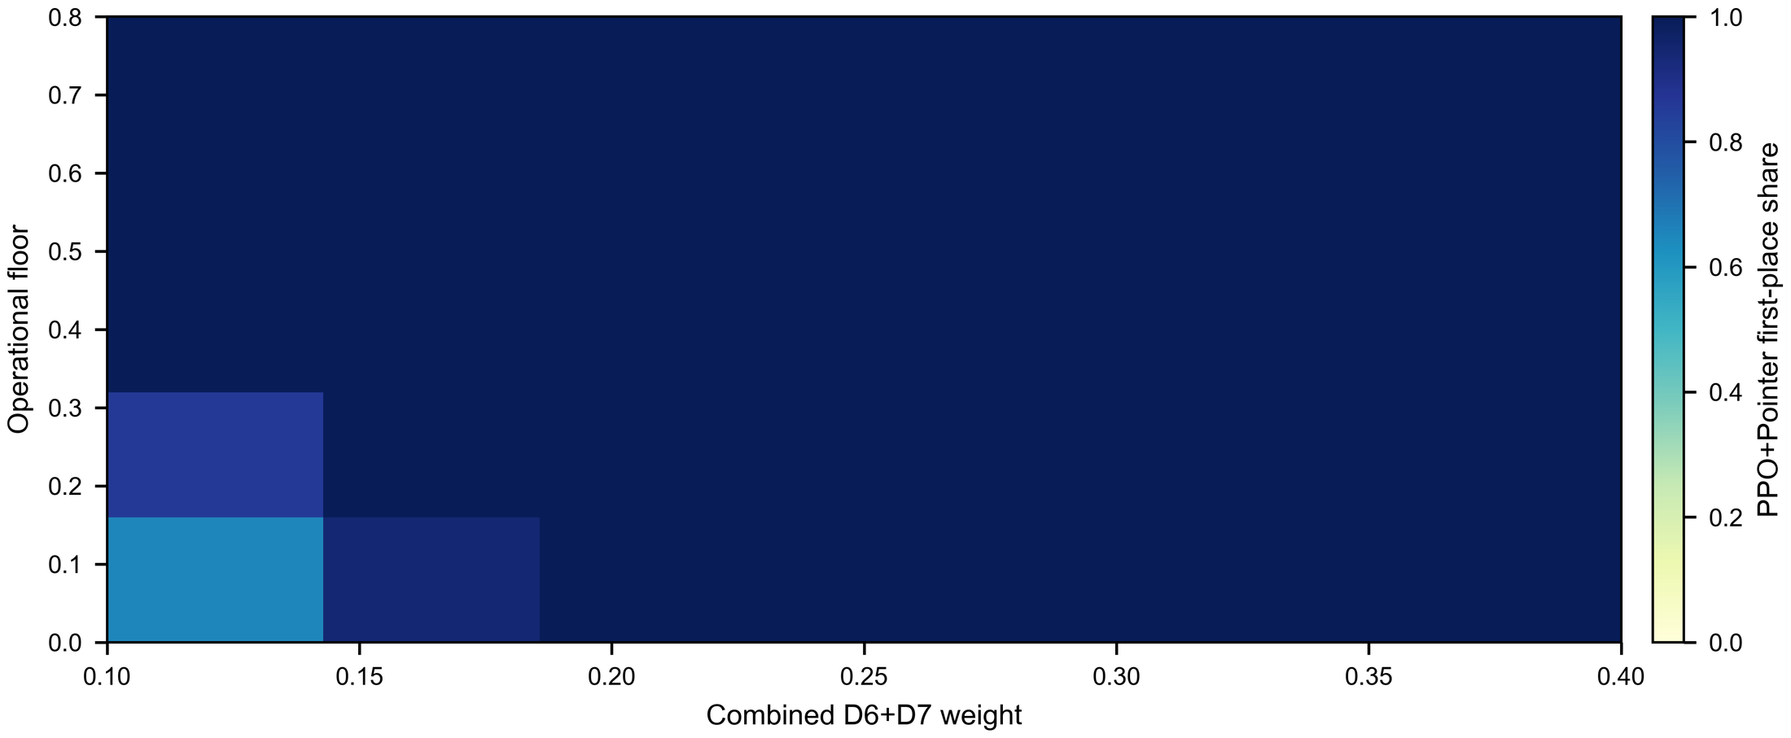
Fig. S7. Sensitivity of PPO+Pointer ranking to the operational floor and combined D6+D7 training weight.

S6. Representative unseen synthetic route
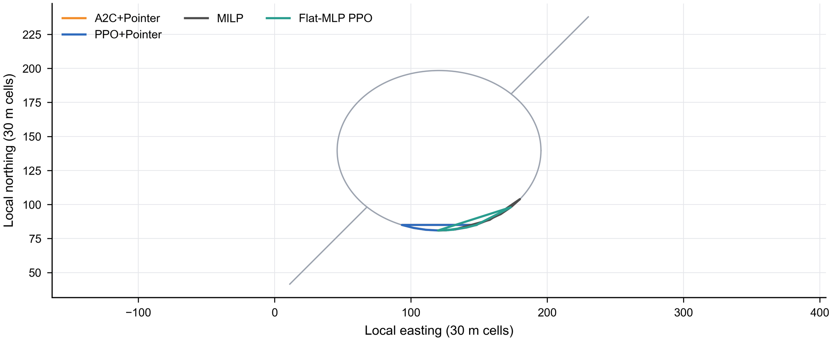
Fig. S8. Representative fixed unseen synthetic task with road context, inspection priorities, and comparator routes.

S7. Additional claim boundaries
- The geographic evidence is DSM-based simulation, not flight validation.
- All node counts were observed during training; scale extrapolation is untested.
- The ablations do not isolate energy, distance, time, and dynamics submasks separately.
- The aircraft and wind models are engineering proxies, not certified digital twins.
- Classical solver status and runtime must be interpreted jointly with route quality.
- The 100-point score is a post-hoc summary and is not used in the abstract or primary conclusion.

