Supplementary material

S1. Frozen protocol identity and audit trail
The supplementary package refers only to protocol v3.2.14. The formal result file contains exactly 21,648 unique rows and the route directories contain 21,648 corresponding route records. The frozen protocol SHA-256 is c0ac70fb8fac32bd60afe602b24d8534d9329e531ea381d9a73bf4237c9fbc58; the final result SHA-256 is 4b620c21566c2e33c875f6bea2017b741b02a7d30d70aa50add60a6d06214a2c. The excluded historical attention-containing prototype is absent from the paper-eligible model set. The formal set contains 35 learning models (seven variants × five seeds) and 105,000 paper-eligible training episodes.
Table S1. Formal evaluation families
Family | Result rows | Independent maps | Role
Unseen synthetic learning models | 7,560 | 24 | Main and ablation evaluation
Unseen synthetic main baselines | 3,888 | 24 | Main traditional comparison
Unseen synthetic supplementary baselines | 504 | stratified subset | A*, particle swarm and Pareto dynamic programming
Digital-surface-model learning models | 5,040 | 8 | Geographic simulation transfer
Digital-surface-model representative baselines | 1,152 | 8 | Traditional comparison
Known domain shift | 1,008 | 8 | Planner observes shifted truth
Hidden model/perception mismatch | 2,496 | 8 | Planner and execution truth differ
Total | 21,648 | — | Frozen audited evidence

S2. Learning models and ablations
Table S2. Model definitions
Model label | Policy architecture | Update | Removed component
PPO–Pointer | Priority encoder + Pointer actor | PPO | None
A2C–Pointer | Priority encoder + Pointer actor | A2C | PPO repeated clipped update
Flat-MLP PPO | Fixed 24-node slots + depot slot | PPO | Pointer, attention and node encoder
No priority bias | Pointer | PPO | Explicit additive priority bias only
No domain randomization | Pointer | PPO | Parameter randomization; multi-map training retained
No resource shaping | Pointer | PPO | Secondary incremental resource term
No return reserve | Pointer | PPO | Policy-visible projected return reserve

All models used seeds 42–46 and 3,000 episodes per seed. The complete PPO configuration used a 128-dimensional candidate representation, four attention heads, priority-bias coefficient 0.5, learning rate 10^−4, clipping ratio 0.2, discount 0.99, generalized-advantage parameter 0.95, five epochs per update, minibatches of at most 128 transitions, value coefficient 0.5, gradient norm cap 1.0 and entropy coefficient annealed from 0.02 to 0.002. These values are implementation identities, not post-hoc tuned manuscript parameters.

S3. Observation and feasibility definitions
Each candidate token had 15 features: relative x, y and z position; normalized priority; visited and depot flags; outgoing distance, energy and time fractions; projected return distance, energy and time fractions; and three normalized outgoing-wind components. The vehicle vector had 14 features: position relative to the depot, previous direction, remaining energy, distance and time fractions, ordinary and priority-weighted coverage, and the local three-component wind vector.
The legal set was the conjunction of visit, energy, distance, time and dynamics masks. For an inspection candidate, resource checks included the outgoing segment, service requirement and projected return segment. The no-return-reserve ablation relaxed only the policy-visible reserve. The simulator retained the full execution check and marked a newly exposed but actually infeasible proposal as stranded without executing the segment. The experiment therefore measures a planning-safety mechanism in simulation and not physical hazard exposure.

S4. Map/task factorial design
Procedural training, validation and unseen-test splits contained 72/12/24 maps and 648/108/216 tasks. Each map supported factorial variation over 16, 20 and 24 nodes; moderate, hard and extreme difficulty; energy, distance, time and mixed constraints; and multiple priority layouts. Because all three node counts entered training, size-stratified results are within the trained range.
Eight Copernicus DEM GLO-30 digital-surface-model assets defined the geographic simulation set. Each map used two deterministic road/launch contexts and 144 total tasks. The digital surface model is a terrain input to the simulator. No flight, sensing or inspection-image data were collected.

S5. Map-level primary results
Table S3. Safe weighted coverage by map
Family | Algorithm | n maps | Mean | Median | Q1 | Q3
Synthetic | PPO–Pointer | 24 | 0.4858 | 0.4829 | 0.4683 | 0.5042
Synthetic | A2C–Pointer | 24 | 0.4850 | 0.4846 | 0.4700 | 0.4991
Synthetic | Flat-MLP PPO | 24 | 0.2686 | 0.2713 | 0.2536 | 0.2835
Synthetic | ACO | 24 | 0.5525 | 0.5543 | 0.5370 | 0.5663
Synthetic | SA | 24 | 0.5436 | 0.5458 | 0.5295 | 0.5601
Synthetic | MILP | 24 | 0.5711 | 0.5726 | 0.5560 | 0.5852
DSM | PPO–Pointer | 8 | 0.5024 | 0.5006 | 0.4960 | 0.5086
DSM | A2C–Pointer | 8 | 0.5025 | 0.4975 | 0.4920 | 0.5100
DSM | Flat-MLP PPO | 8 | 0.2658 | 0.2706 | 0.2561 | 0.2730
DSM | ACO | 8 | 0.5599 | 0.5603 | 0.5482 | 0.5649
DSM | MILP | 8 | 0.5829 | 0.5850 | 0.5783 | 0.5888

Table S4. Selected paired comparisons against PPO–Pointer
Family | Comparator | Mean difference | 95% bootstrap interval | Holm p | Interpretation
Synthetic main | Flat-MLP PPO | 0.2172 | 0.1958 to 0.2393 | 9.54 × 10^−7 | PPO–Pointer higher
Synthetic main | A2C–Pointer | 0.0008 | −0.0057 to 0.0069 | 0.845 | No detected difference; not equivalence
Synthetic main | ACO | −0.0667 | −0.0814 to −0.0534 | 9.54 × 10^−7 | ACO higher
Synthetic main | SA | −0.0578 | −0.0729 to −0.0432 | 9.54 × 10^−7 | SA higher
Synthetic main | MILP | −0.0853 | −0.0999 to −0.0722 | 9.54 × 10^−7 | MILP higher
DSM main | Flat-MLP PPO | 0.2366 | 0.2123 to 0.2618 | 0.0469 | PPO–Pointer higher
DSM main | A2C–Pointer | −0.00001 | −0.0090 to 0.0090 | 0.742 | No detected difference; not equivalence
DSM main | ACO | −0.0575 | −0.0706 to −0.0456 | 0.0469 | ACO higher
DSM main | MILP | −0.0805 | −0.0956 to −0.0658 | 0.0469 | MILP higher

S6. Ablation tests
Table S5. Complete-model minus ablation differences
Family | Ablation | Mean difference | 95% bootstrap interval | Holm p
Synthetic | No priority bias | 0.0010 | −0.0066 to 0.0087 | 1.000
Synthetic | No domain randomization | 0.0012 | −0.0071 to 0.0095 | 1.000
Synthetic | No resource shaping | 0.0018 | −0.0050 to 0.0083 | 0.506
Synthetic | No return reserve | 0.3725 | 0.3434 to 0.4018 | 4.77 × 10^−7
DSM | No priority bias | −0.0006 | −0.0097 to 0.0085 | 1.000
DSM | No domain randomization | 0.0009 | −0.0088 to 0.0121 | 1.000
DSM | No resource shaping | 0.0001 | −0.0083 to 0.0082 | 1.000
DSM | No return reserve | 0.3904 | 0.3563 to 0.4245 | 0.0313
Hidden mismatch | No return reserve | 0.3174 | 0.2460 to 0.4042 | 0.0391

The first three ablations show limited average evidence for the primary endpoint. Their non-significant differences are not equivalence tests. The last rows apply only to the composite return-aware mechanism.

S7. Training-aware post-hoc analysis
The complete PPO–Pointer model had normalized D6 training stability of 0.9860 and D7 sample efficiency of 0.9654. A2C–Pointer had 0.9701 and 0.9466. In paired seed-level tests, the D6 and D7 complete-minus-A2C mean differences were 0.0159 and 0.0187; both Holm-adjusted p values were 0.125 with five seeds. The dimensions therefore provide directional and descriptive training evidence, not separately confirmed superiority at α = 0.05.
An operational 100-point arithmetic summary assigned 76.656 to PPO–Pointer, 74.547 to A2C–Pointer and 54.467 to Flat-MLP PPO under its selected normalization and weights. A map-outer hierarchical bootstrap estimated a PPO-minus-A2C score difference of 1.986 points (95% interval 0.784–3.206; 10,000 resamples). This score was designed after results were available, combines heterogeneous dimensions and changes under weighting/normalization choices. It is a diagnostic summary only and does not replace safe weighted coverage.

S8. Traditional-planner status and computation
Mean synthetic planning times were 1.168 s for PPO–Pointer, 3.832 s for simulated annealing, 20.807 s for mixed-integer programming and 76.701 s for ant-colony optimization. Times refer to the frozen hardware, software and implementation. Mixed-integer records retain termination status, incumbent objective, dual bound and gap. A time-limited feasible incumbent is not described as proven optimal.

S9. Supplementary figure register
- Figure S1: performance profile across the full algorithm set.
- Figure S2: quality–online-time Pareto display.
- Figure S3: oracle regret and computational cost.
- Figure S4: complete five-seed training curves.
- Figure S5: post-hoc score and weight sensitivity.
- Figure S6: ablation effects by map.
- Figure S7: robustness failures and termination patterns.
- Figure S8: representative route atlas across digital-surface-model maps.
- Figure V1: three-dimensional route illustration; non-inferential.
- Figure V2: outcome-flow illustration; non-inferential.

S10. Reproducibility and redistribution notes
The reproducibility package provides the frozen protocol, analysis protocol, task/evaluation matrix, final results, statistics, source data, environment description, model metadata, file hashes and rerun commands. Openly redistributable references are included only where licence status permits. Publisher or school-access papers are supplied as DOI/publisher links rather than copied PDFs. Copernicus raw assets are handled separately: the package records the product, region identifiers, attribution and reconstruction procedure and does not assume that local raw files can be redistributed without checking the current access terms.

S11. Author verification items
[AUTHOR INPUT REQUIRED: permanent repository DOI or URL.]
[AUTHOR INPUT REQUIRED: confirm Copernicus region identifiers that may be published.]
[AUTHOR INPUT REQUIRED: verify the generative-AI disclosure and all author-side declarations.]

Supplementary figures
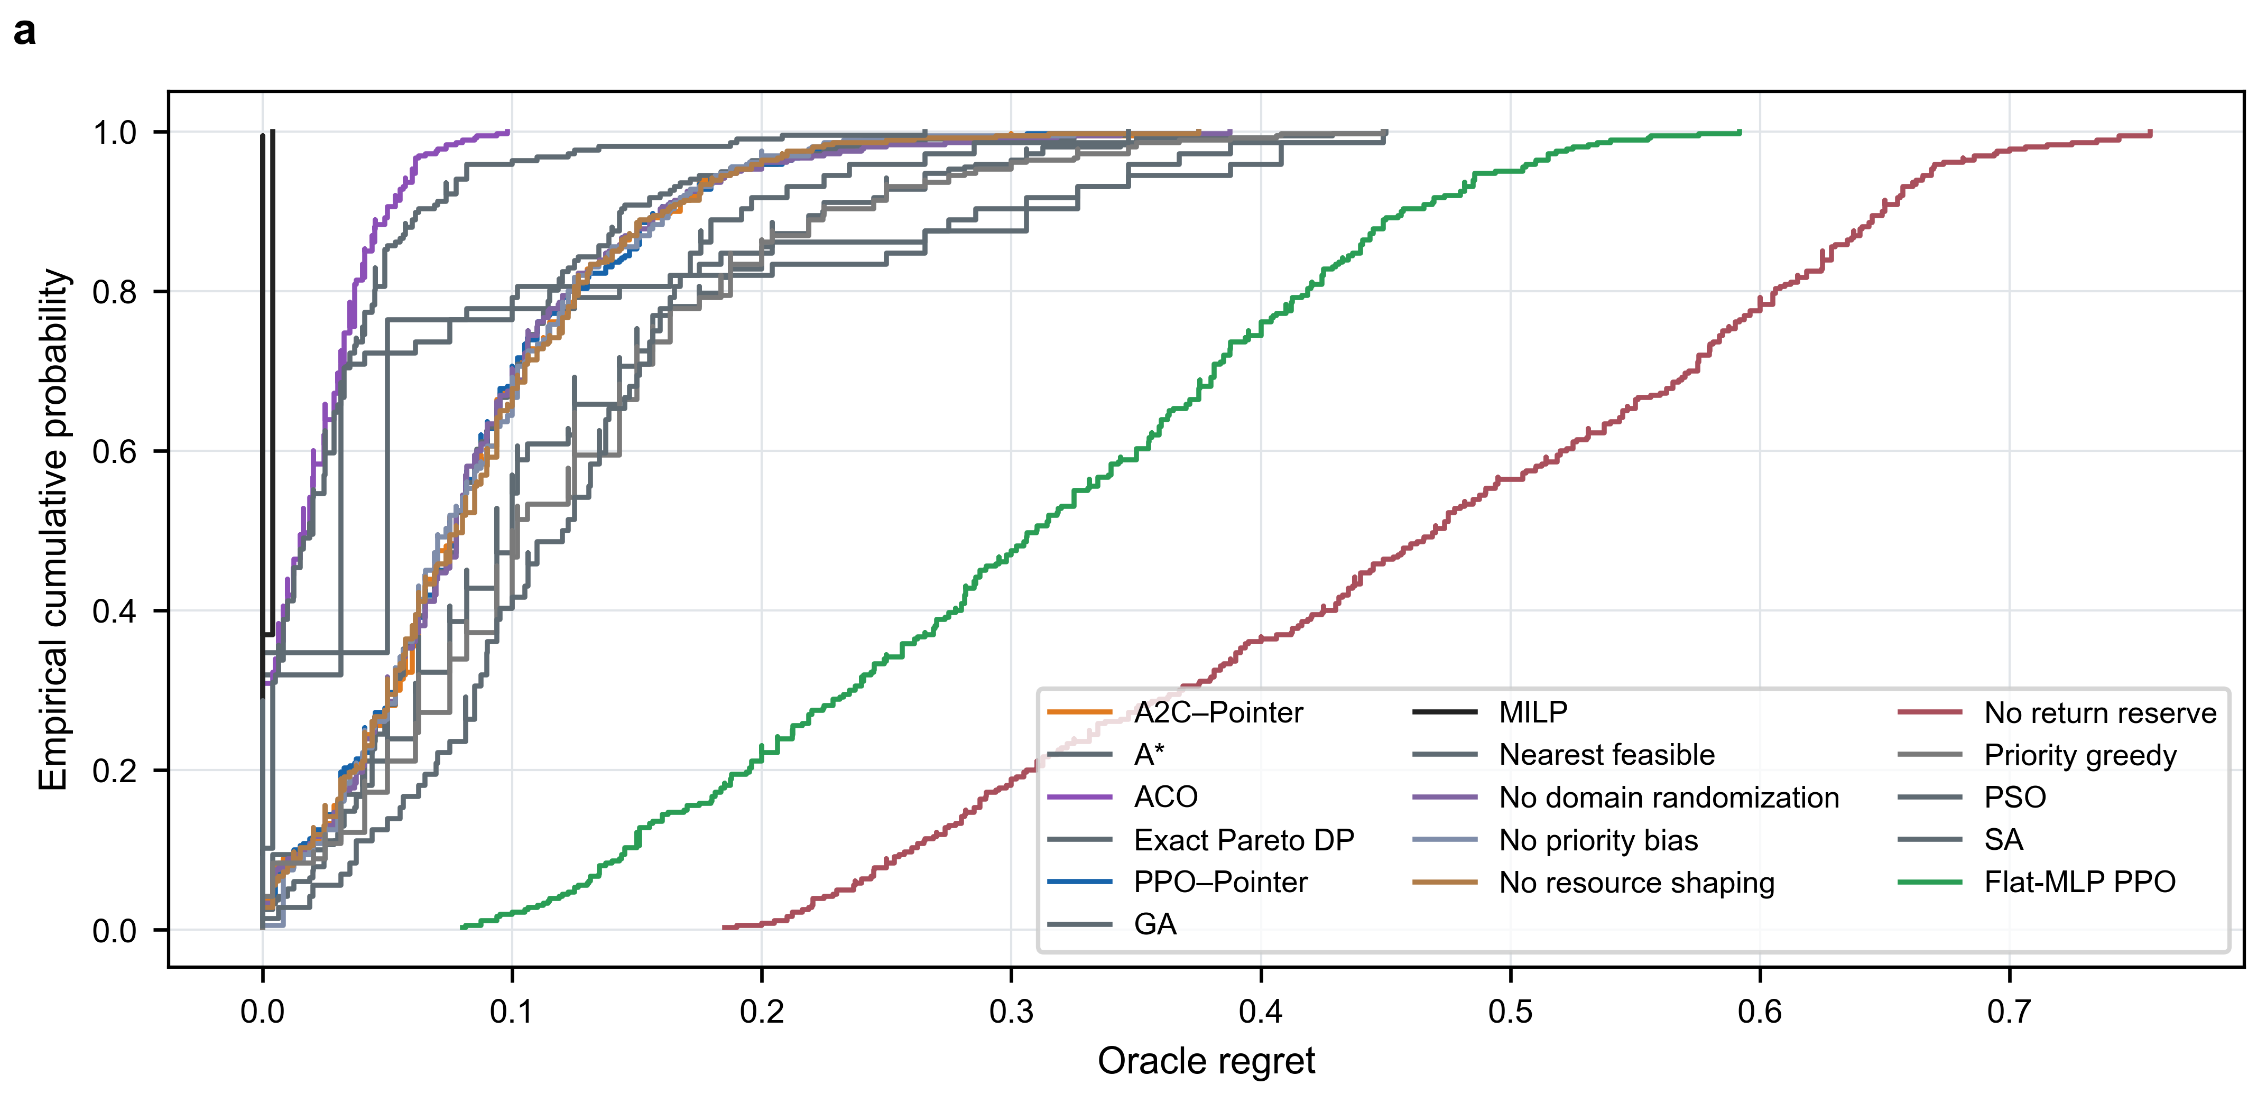
Figure S1. Regret performance profile for all frozen algorithms. Each curve is an empirical cumulative distribution over the stated task set; the panel is descriptive and does not change the map-level inferential unit.
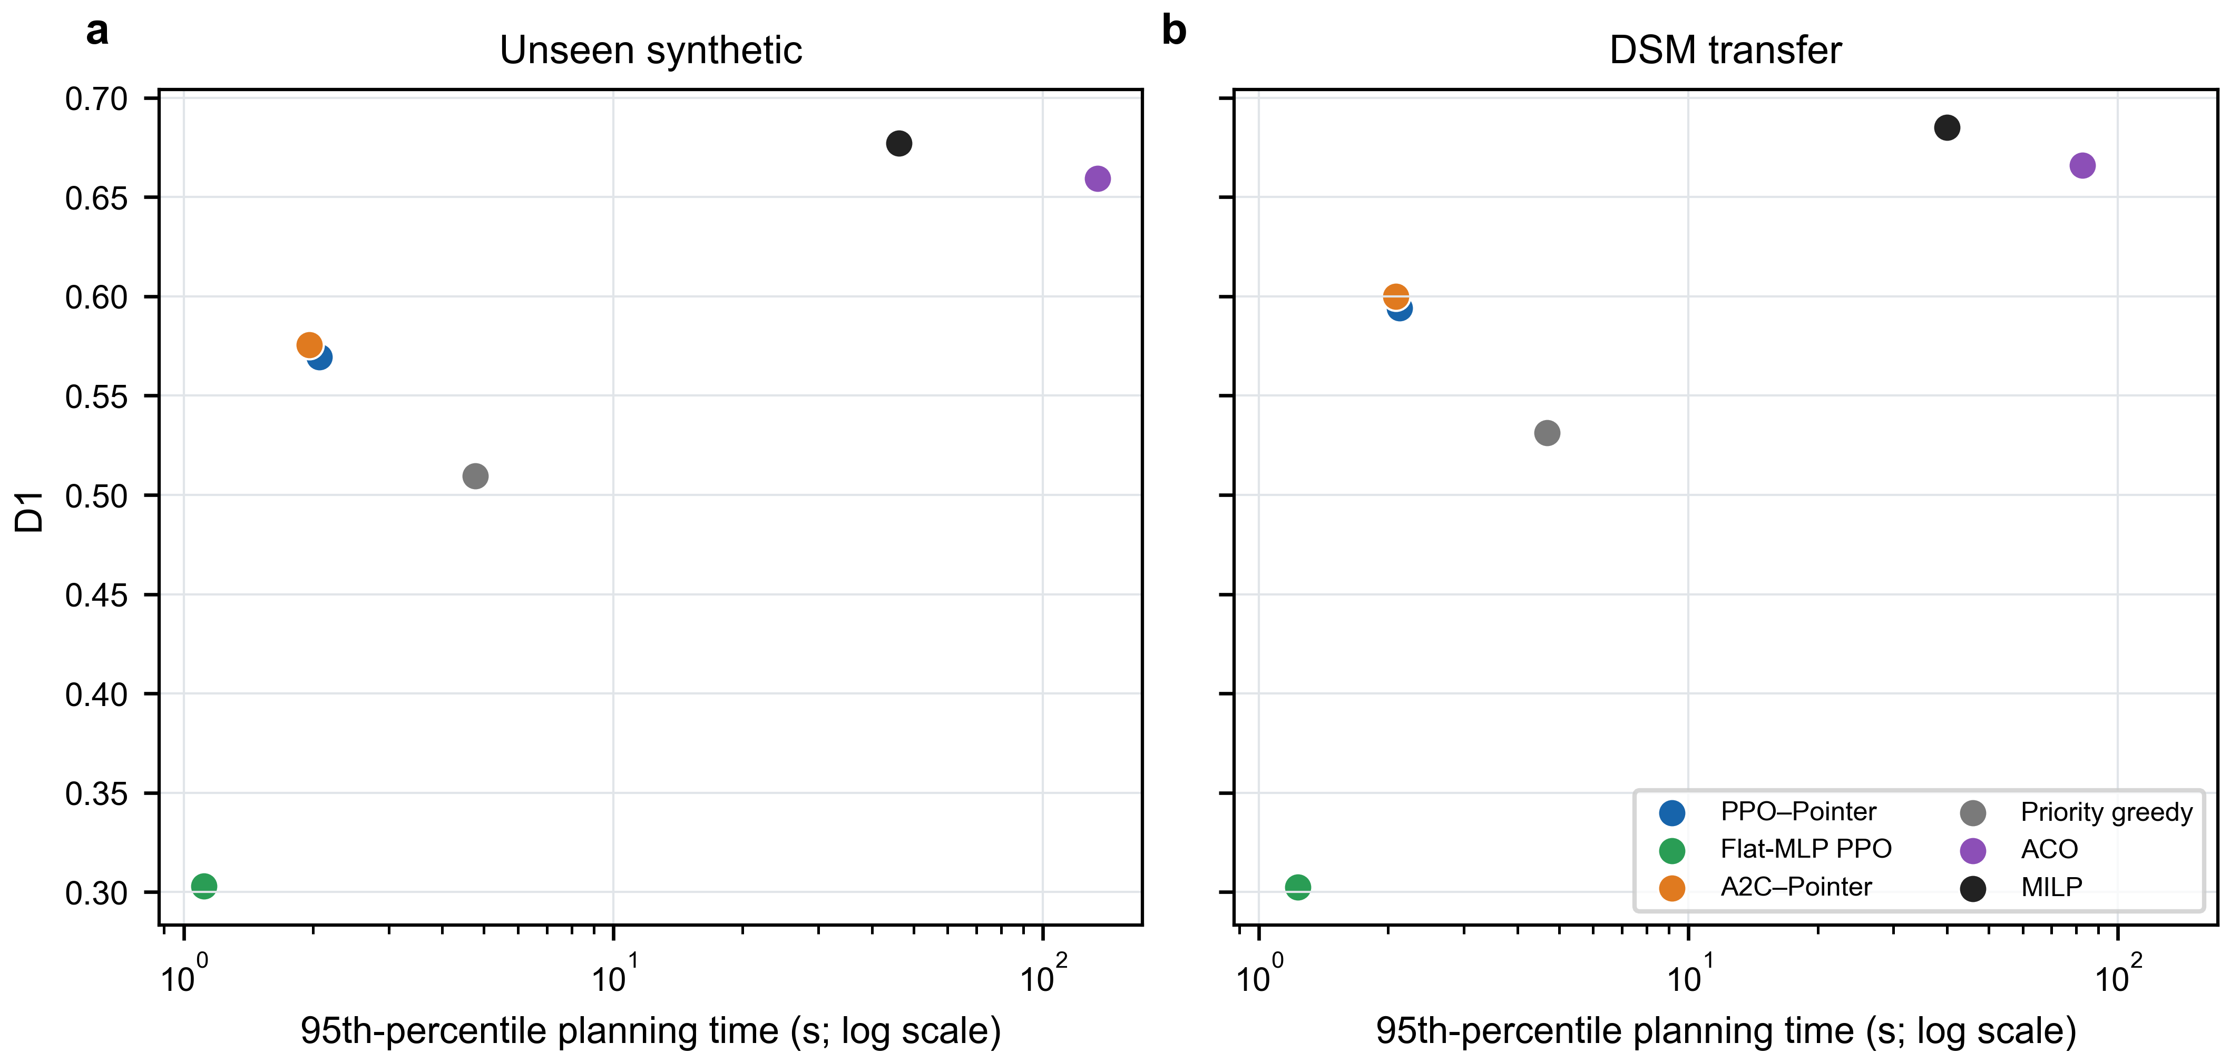
Figure S2. Coverage–time trade-off on synthetic and DSM tasks using D1 and the protocol-specific 95th-percentile planning time.
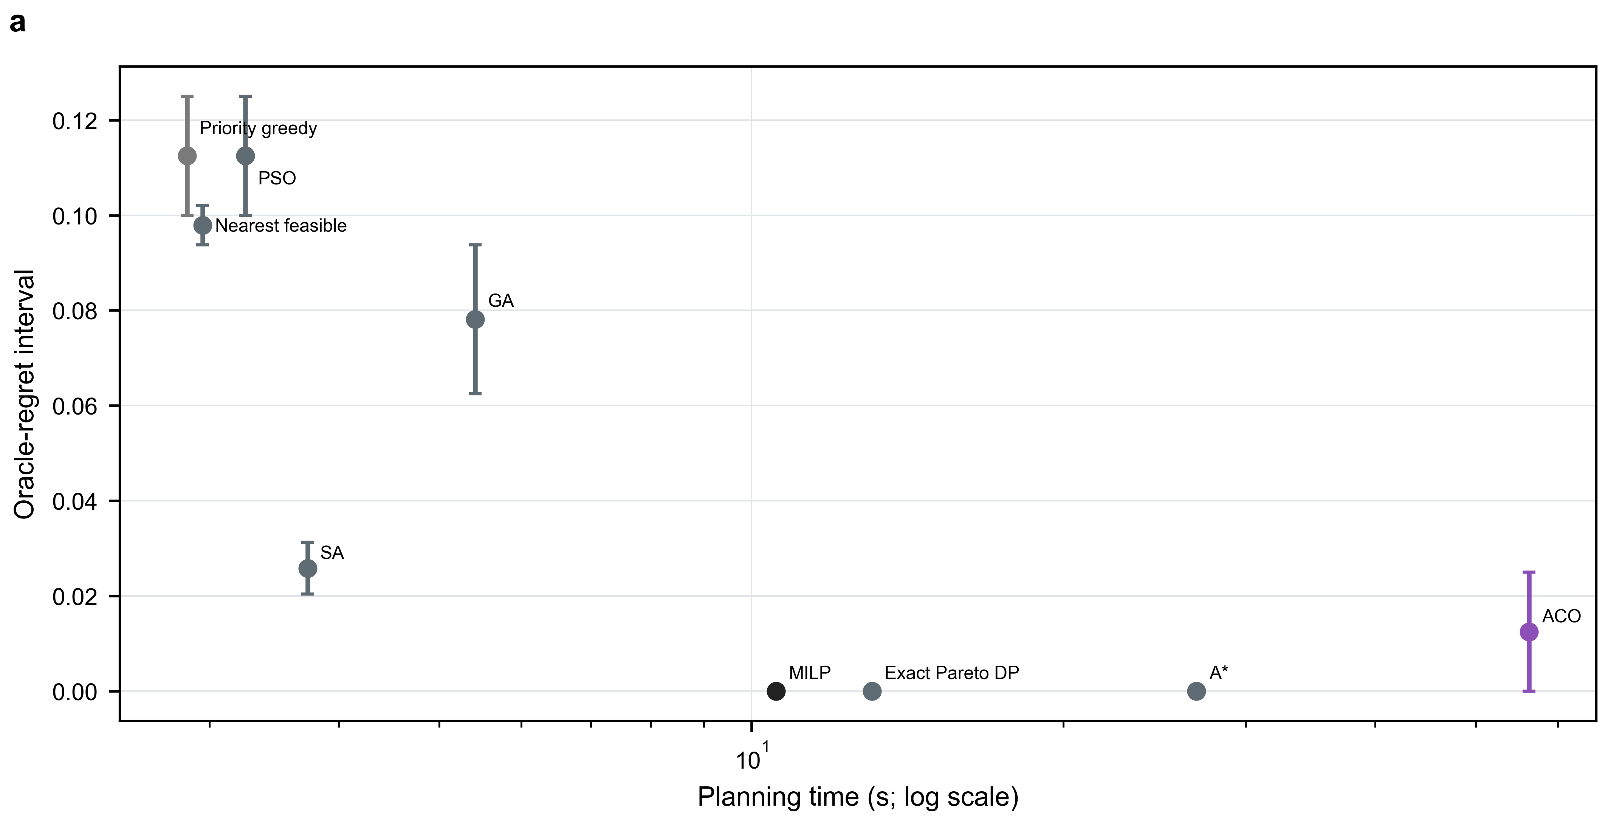
Figure S3. Traditional-planner oracle-regret intervals versus planning time. Solver status and certification share must be read together with these values.
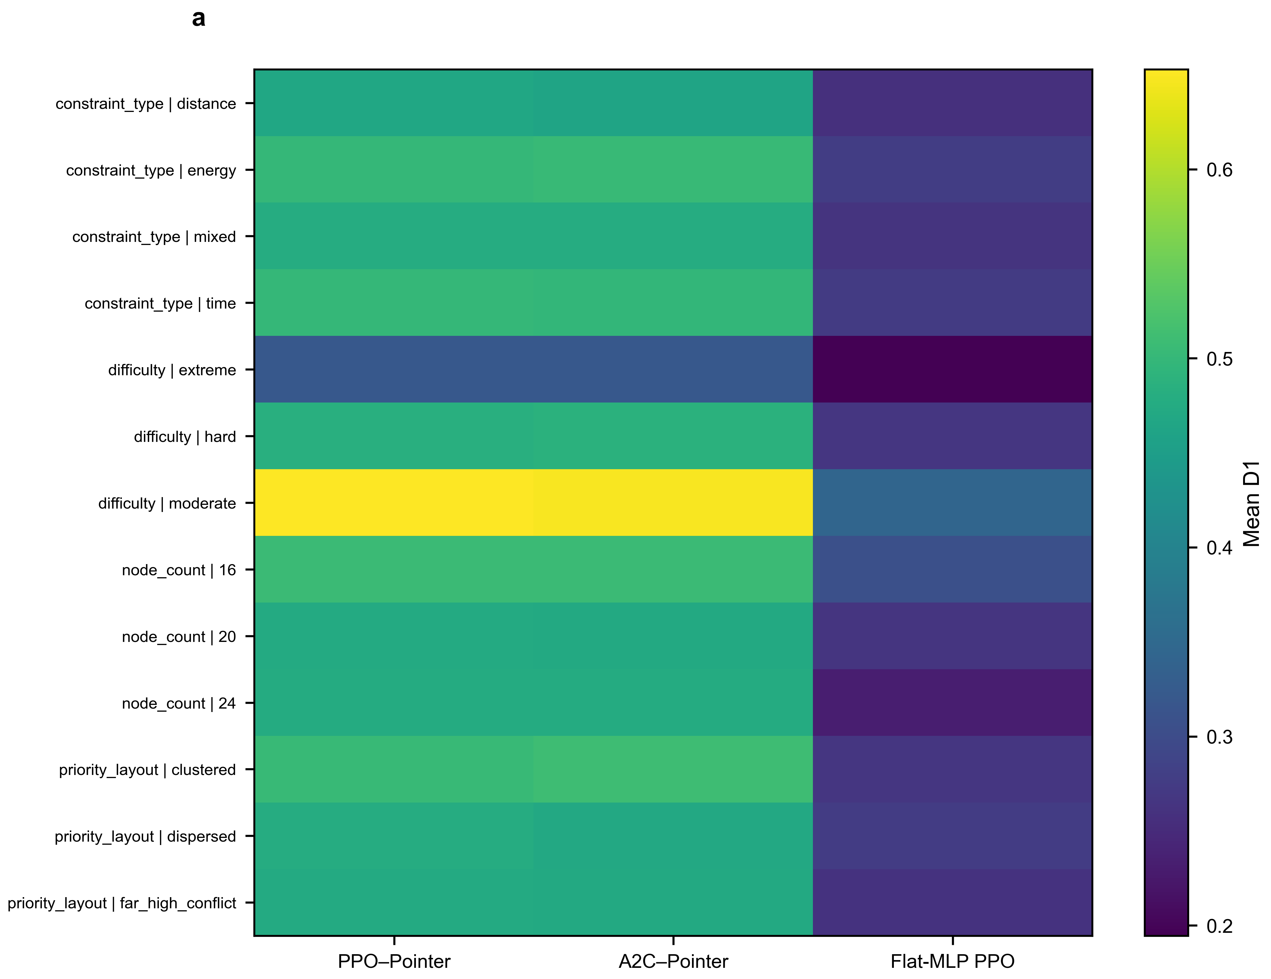
Figure S4. Scenario-stratified mean D1 for the three principal learning models. Scenario cells are descriptive strata, not independent replication units.
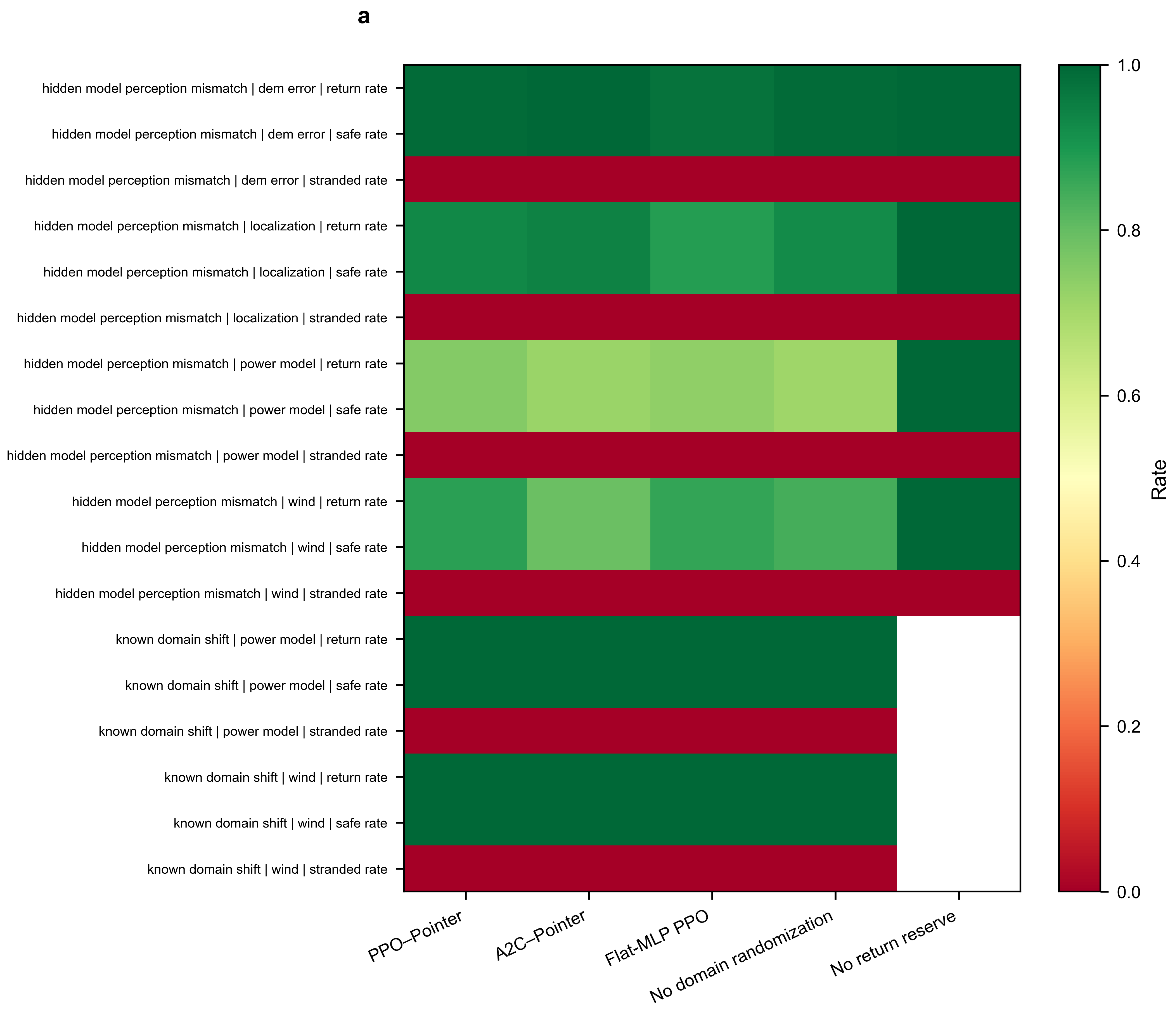
Figure S5. Robustness and failure-mode rates under known shifts and hidden mismatch. Values are frozen task aggregates; safe and return rates are not flight-certification evidence.
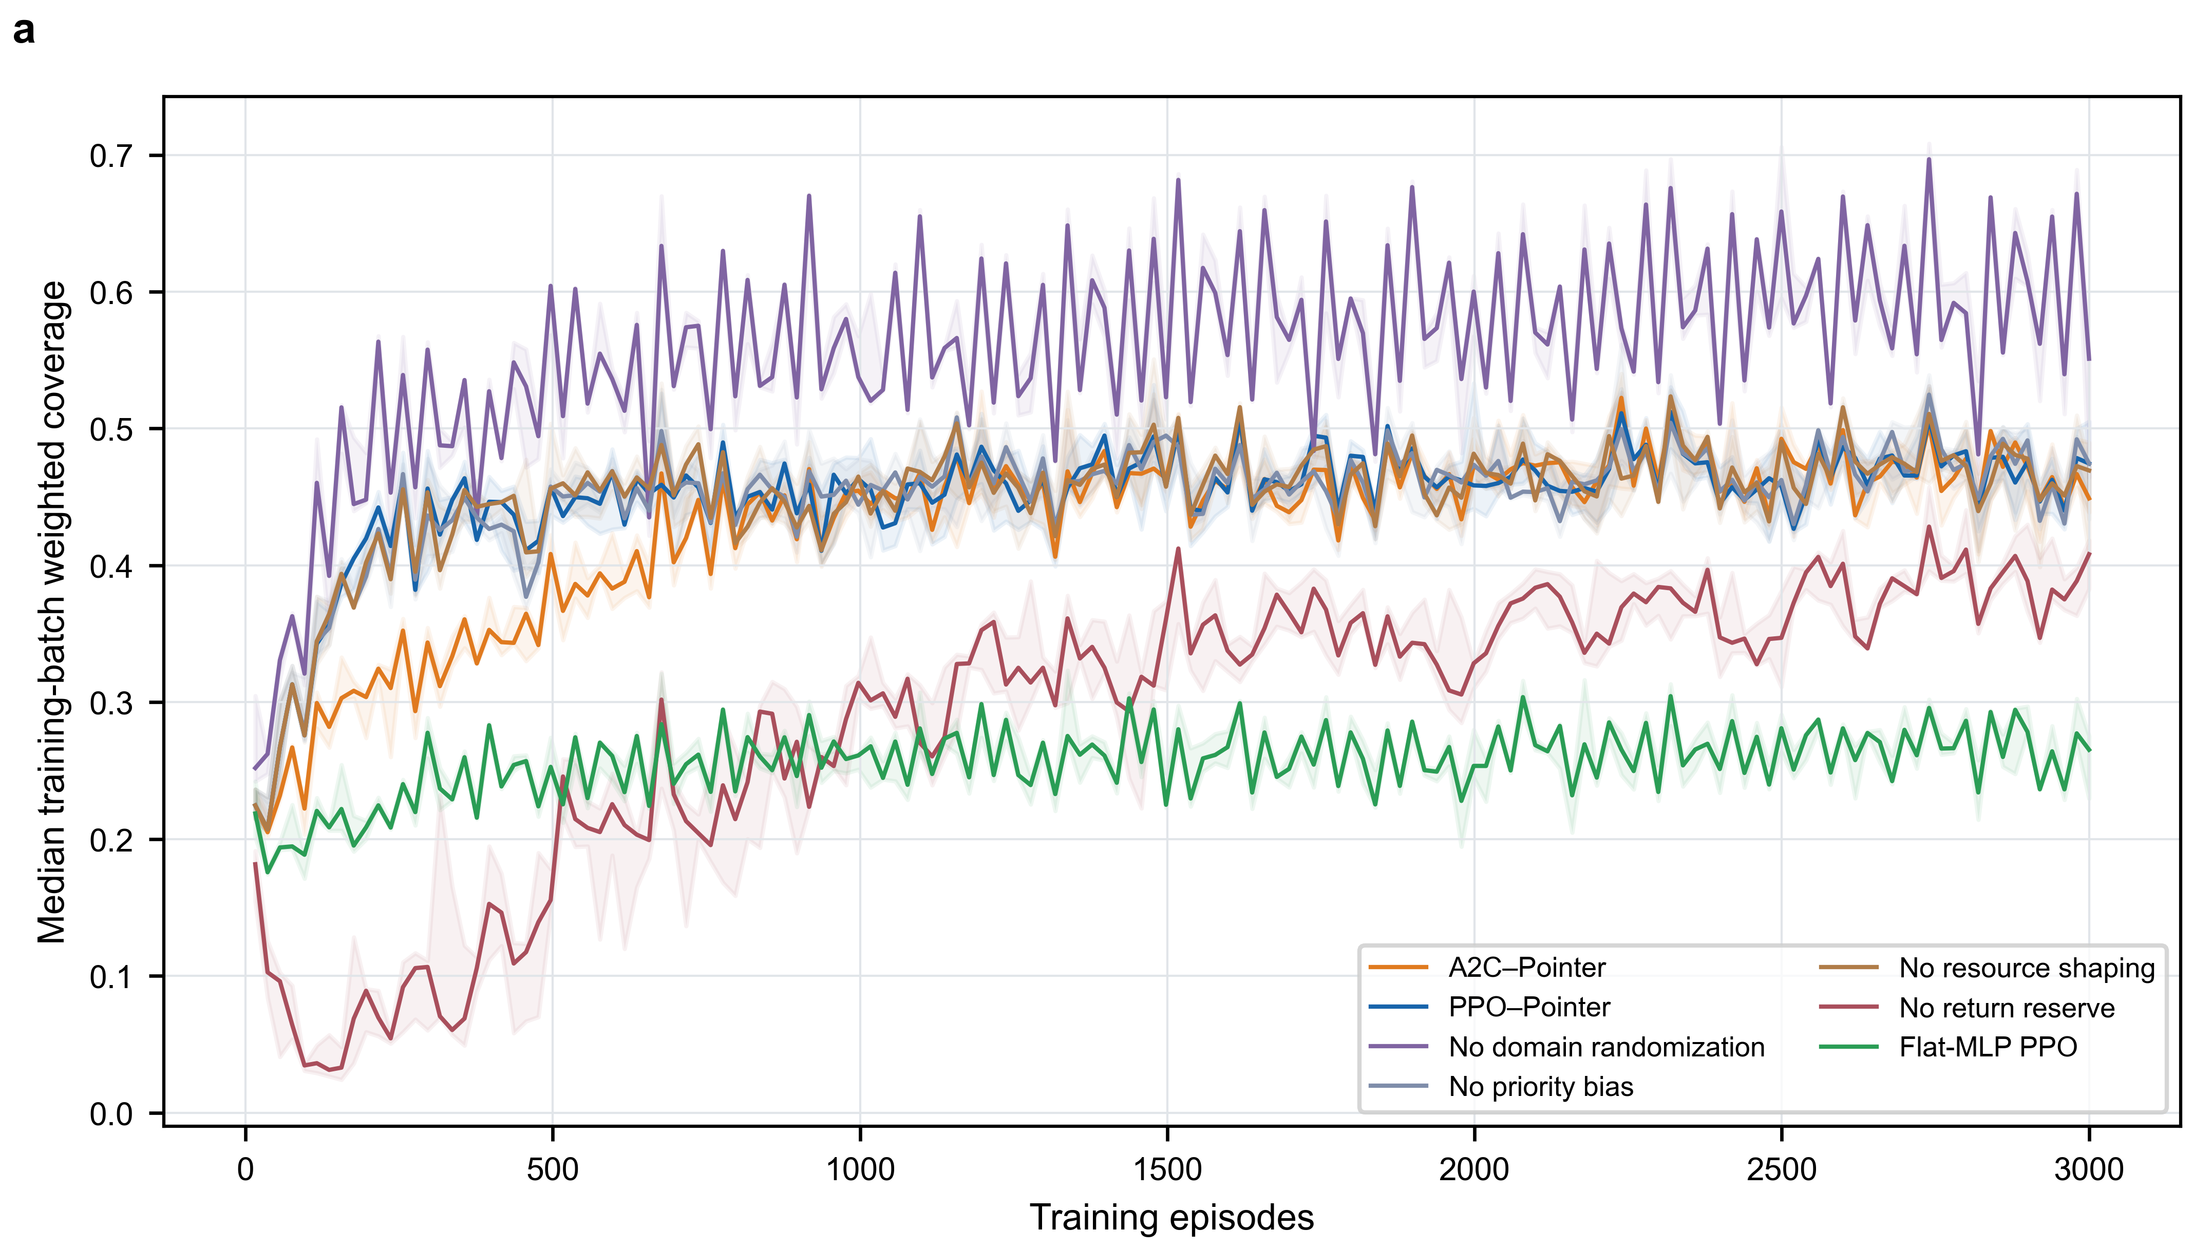
Figure S6. Training trajectories for the seven paper-eligible learning variants. Curves summarize five seeds per model over 3,000 episodes.
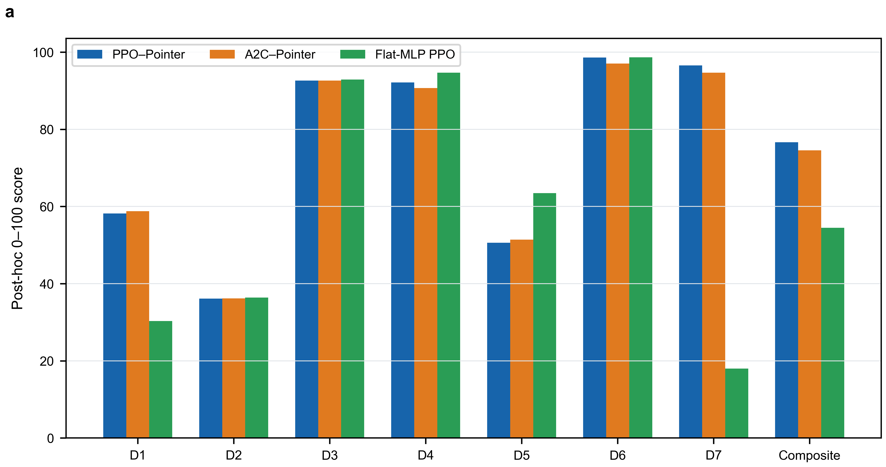
Figure S7. Seven normalized dimensions and the post-hoc 100-point composite. This score is exploratory, weight-dependent and is not the confirmatory endpoint.
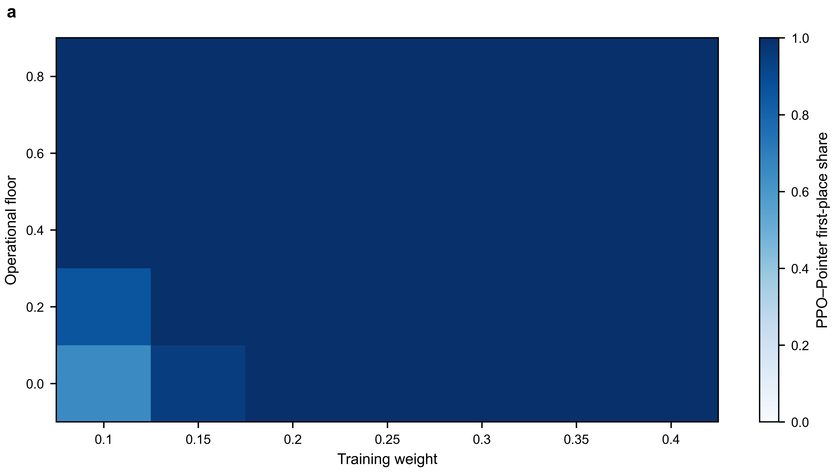
Figure S8. Joint sensitivity of the first-place share to training weight and operational floor in the post-hoc composite analysis.
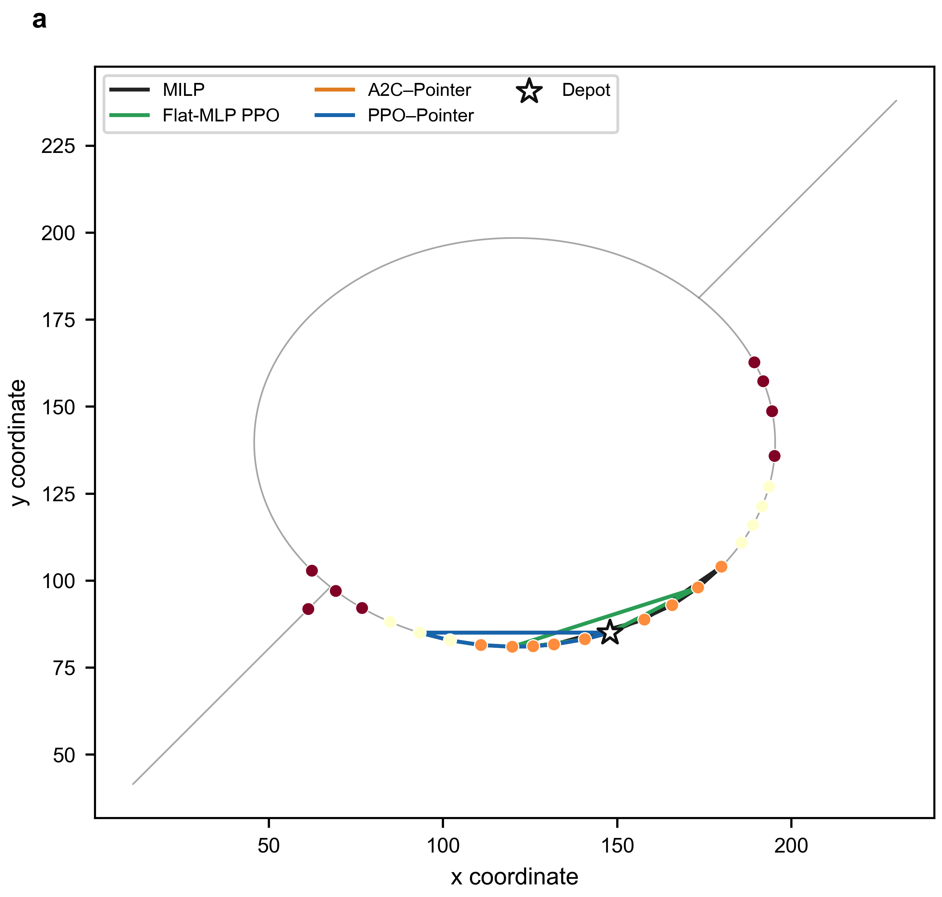
Figure S9. Representative routes on one fixed synthetic task. The panel is illustrative and not used for statistical inference.
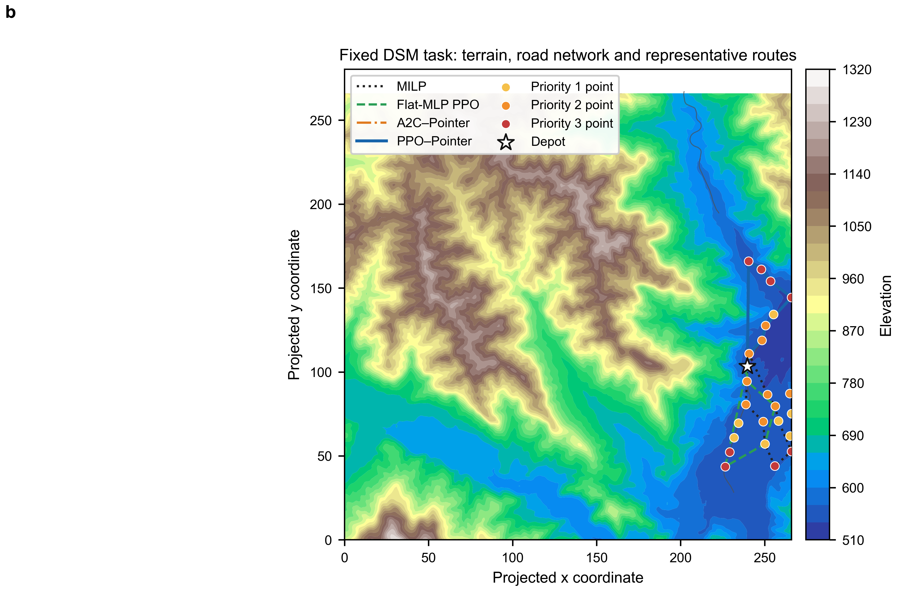
Figure S10. Representative routes on one fixed DSM task with elevation and road context. This is a zero-shot simulation-transfer illustration, not field validation.

