Task Description

## **Task 1**

Build a website with below functions using vue-cli.

1. An admin console page with below layout

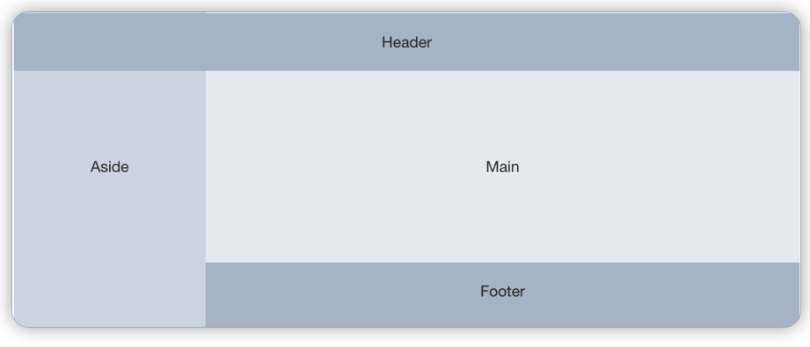

1. Add two entries in the left menu

* Dashboard (the default active item)
* List

1. Add business logic to above pages

Dashboard

* Display simple text in Main section

List

* Implement Create/Read/Update/Delete functions

1. Create button on the top, with ability to open a dialog to insert data

2. A table with all inserted data displayed

3. Each data record has ‘Edit’, ‘Delete’ buttons Click ‘Edit’ -> Dialog popup with editable function, support save data and cancel edit function Click ‘Delete’ -> Delete current record

4. Permission control

We have ['user.list', 'user.list.add', 'user.list.delete', 'user.list.update] permissions

1. All users have ‘user.list’ permission.

2. Only users with target privilege can toggle the Create/Edit/Delete button, otherwise these buttons will be hidden.

## **Task 2**

Design and build a gis monitoring system using Arcgis, Echarts

1. Click the province, display different charts of selected province
2. Hover on the province, show a popup, display the province basic information
3. Use Mock.js and Axios to mock the request

