**Current layout for the game (will update as more progress is made)**

The size of the frame is 420 by 460 (width x length)

The size of the border in the frame is 401 by 401

The size of each square in the grid is 20 by 20

* The images used for the student and the professor will also be sized 20 by 20 to fit each grid square
* Images currently being used (can be changed later if graphics wants)

 

The color scheme for the game is the Brooklyn College colors (Burgundy/Yellow or Gold)

There is a start screen, pressing any key will start the game

There is a border for the maze, the maze itself, display of lives, and score

* The image currently in use for the start screen is temporary and can be changed later

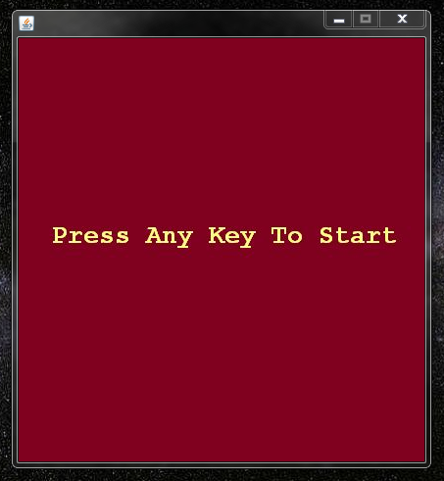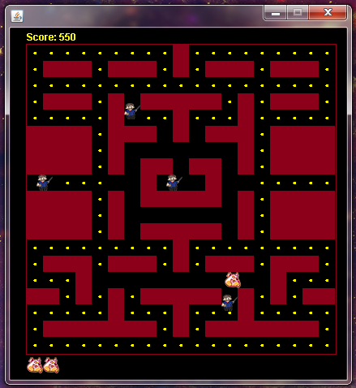

* The maze is made of rectangles drawn in the grid (burgundy color)
* A drawn grid will be included to help understand the placement of the elements and the maze

There is also a winner screen, and a game over screen, pressing any key will return to the start screen

Once the player has collided with the professor three times, then the game is lost

* The screen then transitions into the game over screen

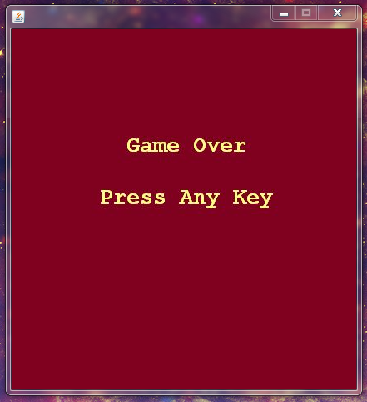

If a player has consumed 173 pellets before losing their three lives, then the game is won

* The screen then transitions into the winner screen

