|  |  |
| --- | --- |
| **Course signature** | TesterRemoteCz8 |
| **Team members names and surnames** | **Radek Jurášek, Dominika Šuhajdová, Alena Kalinska, Zita Selecká** |
| **Project title** | Final Project |
| **Link to repository** |  |
| **Project description** (with listed, used technologies, testing plan) | For the final project, we tested the website https://petstore.octoperf.com/. We started by familiarizing ourselves with the test page and subsequently proposed several test cases. We used Chrome and Safari as a test environment.  We divided test cases into 5 basic parts: Registration and login, Menu and catalog, search functionality, Shopping cart/Ordering/Payment, Check Home Page behavior for returning customers.  Each of us focused on a different test case.  We recorded individual test cases in testrail. We executed the test cases and we set up the status per step (passed/failed). The bugs encountered were linked to the test cases and we established the severity for each one.  To conclude the project we created a report which describes the entire project.  You will find bellow the conclusion report. |

**Final Project**

1. **General info:**

**Name project: Final Project**

**Version: Version 1.2**

**Epic: Group I**

**Environment: Google Chrome 105.0.5195.102, Google Chrome 105.0.5195.127 and Safari 15.6 on Windows 10**

**Cycle Summary: Groups I - V Requirements Test Cycle**

**Folders based on Stories:**

* **Registration and login**
* **Menu and catalog**
* **Search functionality**
* **Shopping cart, ordering and payment**
* **Check homepage behavior for returning customers**

1. **Test Metrics for Final Project**

**In the period 11.09.2022-19.09.2022 were executed 43 test cases, 21 (49%) were passed, 19 (44%) were failed, 3 (7%ň were bolecked.**

**The highest number of test cases executed were on 17.09.2022 - 21 passed, 3 blocked and 19 failed.**

**There is no unscheduled test case(s), all of 43 test cases from Version 1.2 were done.**

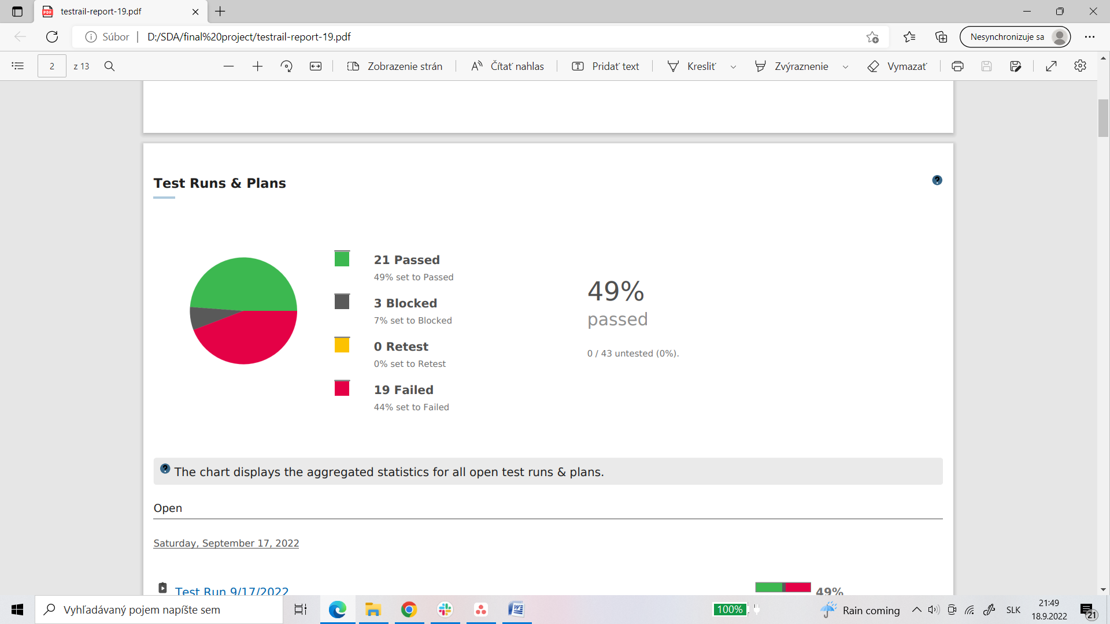

**Graph of results of all test cases.**

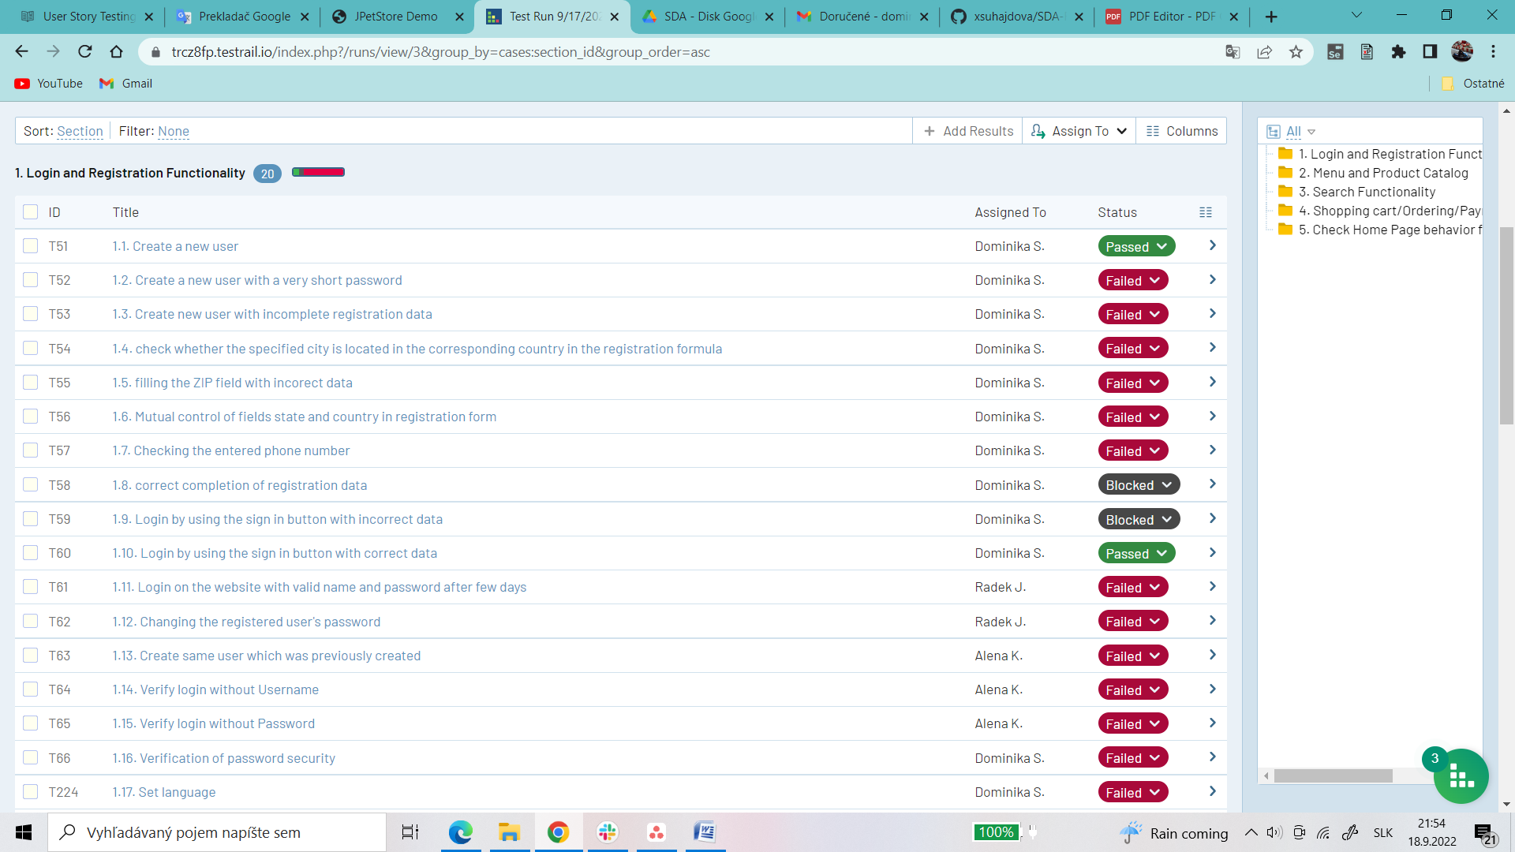

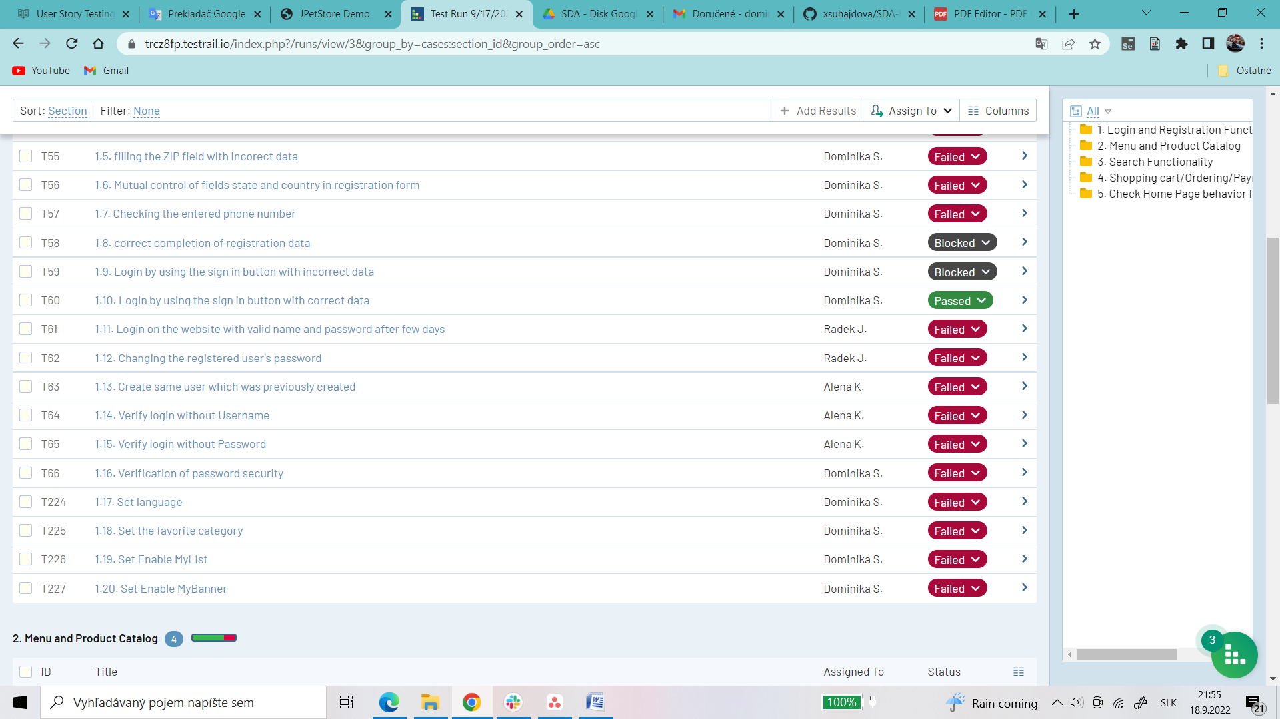

**From the first part Login and registration we have 20 test cases, 2 (10%) passed, 2 (10%) blocked and 16 (80%) failed.**

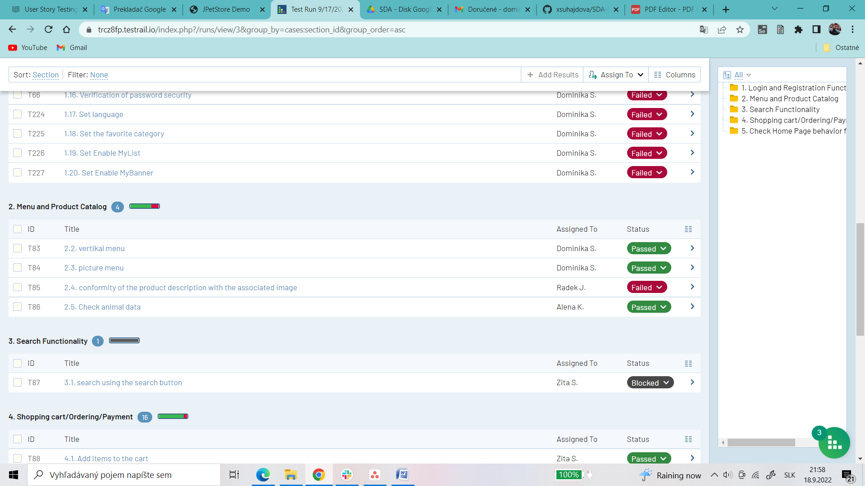

**From second part we have 4 test cases, 3 (75%) passed and 1 (25%) failed.**

**From third part we have only one test case and it is blocked.**

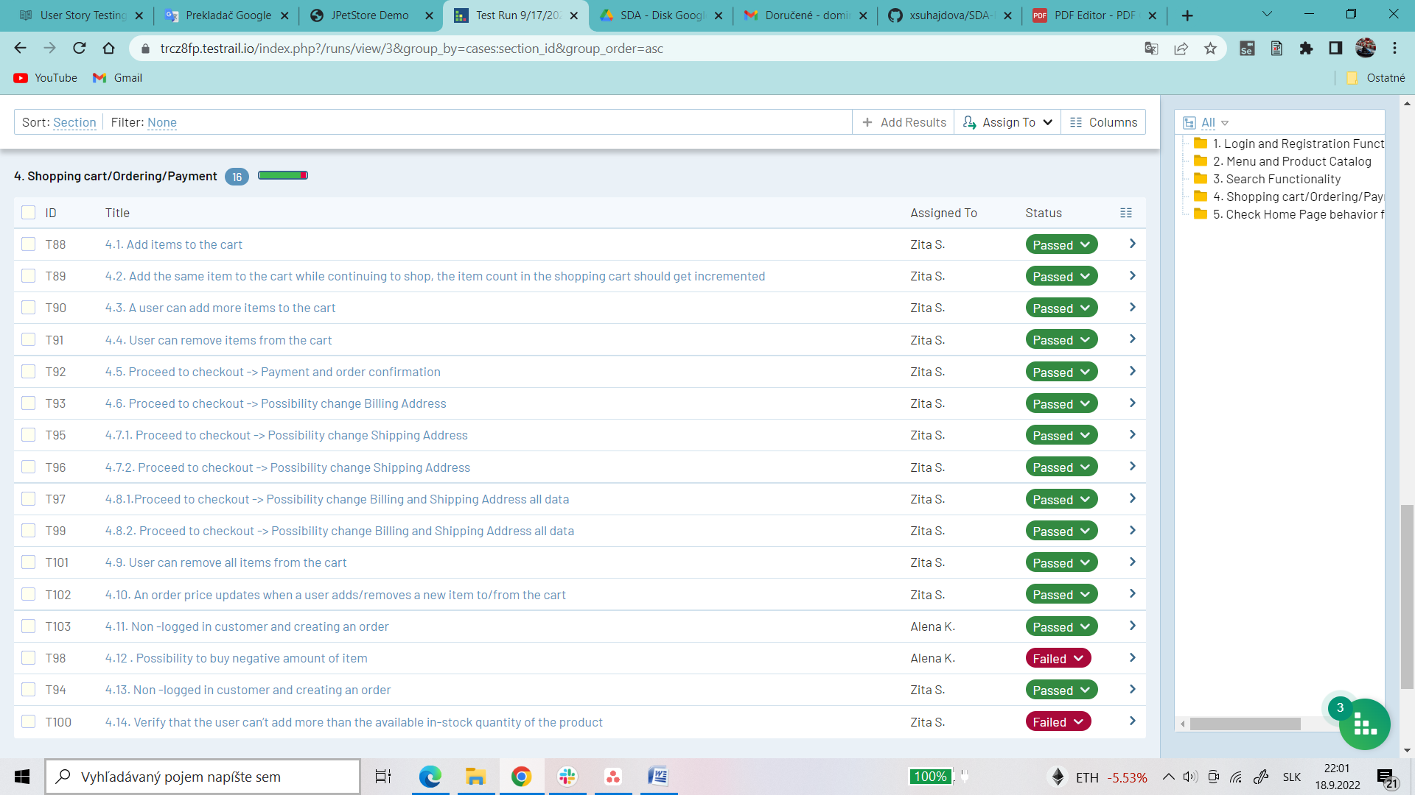

**From fourth part we have 16 test cases, 14 (88%) passed and 2 (13%) failed.**

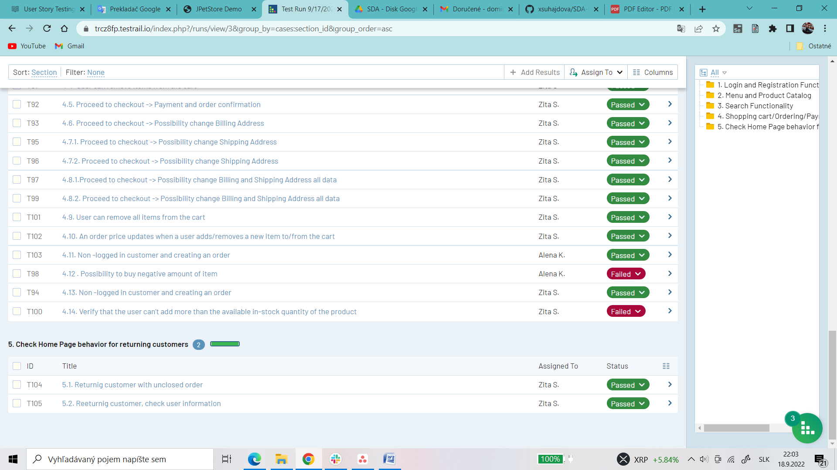

**In the last part we have only 2 test cases and both of them are passed.**