F74066195 林煒博

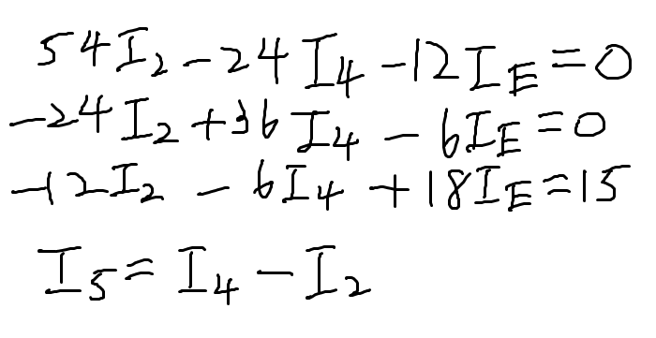Prob1:

(1)

(2) Gauss elimination, 圖中I的方向為正

Prob2:

1. Euler’s method, h = 10^-6, 向右為正
2. f = 1 / T

Prob3:

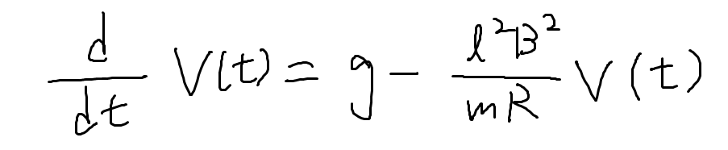 (a)

(b) Euler’s method, h = 10^-6, 向下為正

(c) t越大，越接近終端速度

Prob4:

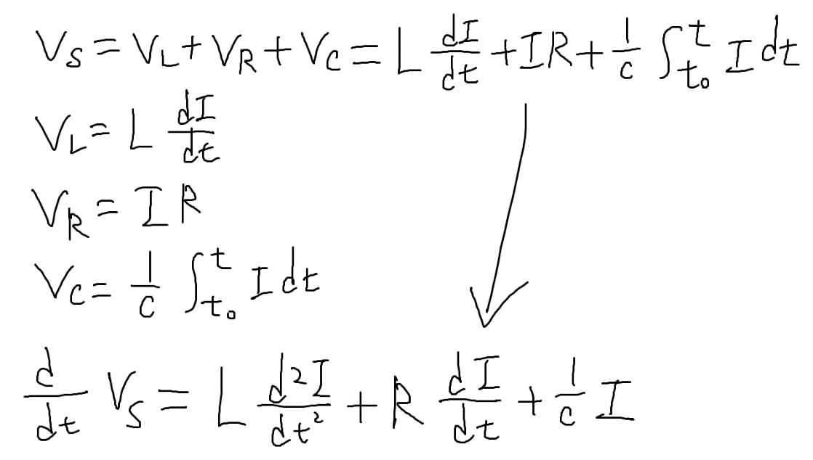(a)

(b) Euler’s method, h = 10^-6

(c) Euler’s method, h = 10^-6

(d) Euler’s method, h = 10^-6

大約花2.2秒跑完