Mandarin-Speaking Children’s Interpretation and Expression of Actions and Results: Evidence From Resultative Verb Compounds and Monomorphemic V1s

Abstract
Mandarin resultative verb compounds (RVCs), such as chuī-miè “blow-extinguished,” entail the result named by the second verb, whereas their monomorphemic first verbs (V1s), such as chuī “blow,” only suggest it. This study examined how Mandarin-speaking 4- and 5-year-olds and adults interpret and describe events in which an action does or does not bring about a target result. The materials comprised pairs of actions performed on the same object with the same target result, which differed in how strongly the action was associated with the result, as verified by adult ratings of result likelihood and action typicality. In a yes–no judgment task (N = 104), all age groups rejected RVC descriptions of zero-result events and accepted V1 descriptions of these events more often, although children accepted V1 descriptions less often than adults. In all groups, V1 descriptions of zero-result events were accepted less often when the V1 named an action more strongly associated with the result. This association effect did not differ credibly between children and adults, and children’s lower acceptance held for both stronger- and weaker-association V1s. In an elicited-production task (N = 104), all groups produced fewer RVCs and mentioned the result less often for zero-result events, and children produced fewer RVCs than adults mainly because they mentioned the result less often. The findings suggest that what a V1 conveys about a result depends on the relation between the named action and the result, for children as for adults.
Keywords: resultative verb compounds, Mandarin Chinese, event culmination, action–result association, verb semantics, comprehension and production

Mandarin-Speaking Children’s Interpretation and Expression of Actions and Results: Evidence From Resultative Verb Compounds and Monomorphemic V1s
Describing an event involves identifying what someone did and whether that action brought about a particular result. Someone can squeeze a lychee without getting it open, or wipe a mirror without getting it clean. To talk about such events, children must learn what different expressions commit a speaker to with respect to the result, and which information to express when they describe an event themselves.
Mandarin resultative verb compounds (RVCs) and their monomorphemic first verbs make this learning problem especially visible. An RVC combines two verbal components: The first (V1) expresses an action, and the second (V2) expresses the resulting state of the affected entity (Li & Thompson, 1981; Sybesma, 1999). The RVC in (1a) thus states both that she peeled the lychee and that the lychee came open, whereas the V1 alone in (1b) expresses the action but does not itself express that resulting state.
(1) a. Tā bāo-kāi-le lìzhī.
she peel-open-PERF lychee
“She peeled the lychee open.”
b. Tā bāo-le lìzhī.
she peel-PERF lychee
“She peeled the lychee.”
For many Mandarin monomorphemic verbs, the result is not entailed. Tai (1984) observed that shā “kill” can be used of an event in which the victim did not die, whereas the corresponding RVC shā-sǐ “kill-dead” cannot, and Talmy (1991, 2000) identified verbs of this kind, whose result is implied but can be cancelled, as a major type in Mandarin. As (2a) shows, the result of a monomorphemic V1 can be explicitly denied, whereas denying the result of the corresponding RVC, as in (2b), is contradictory. A listener who hears a V1 description may nevertheless infer that the result was attained, that is, that the event culminated. Because this culmination inference is not entailed, it can be cancelled by further information (J. Liu et al., 2026). RVCs and their V1s therefore differ in whether the result is entailed or only inferred, and this difference becomes observable when an action is performed but its result is not attained.
(2) a. Tā xiū-le diànnǎo, dàn méi xiū-hǎo.
he fix-PERF computer but NEG fix-good
“He fixed the computer, but it is still not working.”
b. #Tā xiū-hǎo-le diànnǎo, dàn méi xiū-hǎo.
he fix-good-PERF computer but NEG fix-good
“#He fixed the computer so that it worked, but it is still not working.”
Can Mandarin-speaking children distinguish RVCs from their V1s in this respect? Children produce RVCs early, although their command of RVC event structure develops gradually (Chen, 2008; Deng, 2019), and by around 5 years of age they treat RVCs as requiring the result in comprehension (J. Liu et al., 2026). Their interpretation of the corresponding V1s, however, is less adult-like: Children have difficulty unpacking the meanings of the individual verbs in RVCs (Chen, 2017) and judge V1 descriptions of events without the result more strictly than adults do (J. Liu et al., 2026). This pattern raises the question of how children interpret monomorphemic V1s, and it cannot be answered by contrasting V1s with RVCs alone, because adults’ result-related interpretations also vary across monomorphemic verbs (Chen, 2018). Whether a child accepts a V1 description of an unattained result may therefore depend on which V1 is used and on how the action it names is related to the result in question.
The present study examines Mandarin-speaking 4- and 5-year-olds’ interpretation and production of RVCs and monomorphemic V1s, with adults tested as a reference group. It compares RVC and V1 descriptions of events in which a target result is either attained or not, and it compares pairs of V1s that take the same object and combine with the same V2 but were selected to differ in how strongly the actions they denote are associated with that result. To verify and characterize this difference, adults rated each V1–object expression for result likelihood, how likely the target result is to follow the action, and action typicality, how typical the action is as a means of achieving that result. We first review what constrains the combination of V1 and V2 in RVCs, then explain why existing classifications of monomorphemic V1s leave the relation between an action and a particular result underspecified and how the present study characterizes it. We then review children’s comprehension and production of RVCs and V1s and present the research questions and predictions.

V1–V2 Combination in Mandarin RVCs
Prior work on RVCs bears on two properties of V1 that are relevant here: which V1s can enter RVCs and what constrains their combination with V2.
First, the V1 of an RVC is not restricted to transitive activity verbs. Huang (2006), for example, analyzes resultatives with unergative V1s, in which V2 may predicate a result of the subject or of an object that V1 does not itself select (e.g., kū-shī shǒupà “cry-wet handkerchief”). RVCs thus vary in which participant undergoes the result and in whether that participant is an argument of V1. The present study is restricted to agentive transitive RVCs in which V1 selects the object and V2 predicates a resulting state of that object, so that across materials the same participant is acted on by V1 and undergoes the result expressed by V2.
Second, V1–V2 combination is constrained by the relation between the two components. Li (1990, 1995) derives the argument structure of V–V compounds from the thematic properties of V1 and V2 and from the interaction of thematic and causative hierarchies. Han (2021) analyzes V1–V2 sentences as describing a force exerted by one entity on another: V1 names the action through which the force is realized, and V2 names the result state of the affected entity. On this view, a compound depends on how a particular action relates to a particular result rather than on the class of V1 alone. The same V1 can thus combine with different V2s and the same V2 with different V1s: tī “kick” forms both tī-dǎo “kick-fallen” and tī-kāi “kick-open,” and miè “extinguished” follows both chuī “blow” and pū “beat.” These combinations are not equally conventional, however. By conventional we mean how established an RVC is as an expression, that is, how commonly speakers use it: chuī-miè “blow-extinguished” is a common expression, whereas huī-miè “wave-extinguished” is hardly ever used. If whether a compound is possible depends on how the action relates to the result, how conventional it is may depend on this relation as well: An action that is a natural means of bringing about a result is likely to be described often with the corresponding RVC. The two are nonetheless distinct, because conventionality concerns the expression, whereas the relation concerns the event. Existing accounts do not specify what makes a given action a more or less natural means of bringing about a given result. The next section addresses this relation.

Monomorphemic V1s: Classification and Action–Result Association
What a V1 conveys about a result on its own has been characterized in ways that do not align. Mandarin monomorphemic verbs such as shā “kill” and guān “close” have been analyzed as activity verbs that do not encode the result (Tai, 1984), as implied-fulfillment verbs whose result is implicated but cancellable (Talmy, 1991, 2000), and as causative verbs that nevertheless allow zero-change construals (Martin et al., 2020, 2026). Kou and Hohenstein (2022) distinguish four fulfillment types, from verbs that leave the result unspecified to verbs that entail it, and propose diagnostics for assigning English and Mandarin verbs to them. Monomorphemic verbs have also been divided into strong and weak types according to their compatibility with preverbal time-span adverbials (Martin et al., 2020, 2026). This diagnostic, however, is binary, and it tracks whether a result construal of the verb phrase is available, which the object and the context can supply; it therefore does not grade how strongly a verb implies a result. The V1s in the present materials were originally selected as strong and weak with this diagnostic, but the present study characterizes them by adult ratings instead (see Materials). Chen (2018), using adult ratings, found instead that the acceptability of cancelling the result varies along a cline across verbs, and J. Liu et al. (2026) showed that such cancellation also depends on context, such as the presence of hǎojǐcì “several times.” These accounts differ in their criteria and in where they draw boundaries, but they share one feature: Result strength is treated as a property of the verb.
This verb-level characterization is a limitation for studying how a V1 description is interpreted for a particular event. A comprehension task presents a V1 with a particular object and asks about a particular result, and, as the combination facts show, the relation between the action named by a V1 and a result depends on the result in question: Kicking is a reliable way of knocking over a bottle but a less reliable way of opening a door. Work on sentence processing likewise shows that comprehenders’ expectations about events depend on the combination of a verb with its arguments rather than on the verb alone (Bicknell et al., 2010; McRae & Matsuki, 2009). Previous child studies have described differences among V1s in terms of the strength of the result inference without measuring the particular action–result relation depicted. The present study does not propose a new classification of V1s. Instead, it characterizes the actions named by the selected V1–object expressions by their association with a specified target result.
We refer to the relation between the action named by a V1 and a target result as action–result association. Little prior work addresses what makes an action more or less strongly associated with a particular result, so the present study characterizes this relation empirically rather than deriving it from a theory. Adults rated each V1–object expression for result likelihood, how likely the target result is to follow the action, and action typicality, how typical the action is as a means of achieving that result. The two ratings approach the relation from the action and from the result, respectively: Blowing on a candle, for example, is both likely to put it out and a typical way of doing so, whereas waving at it is neither. Both ratings concern the relation between an action and a result in the event, not how conventional the corresponding RVC is. They are used jointly to verify and characterize the contrast between the paired V1s (see Materials), and the study does not attempt to separate their contributions. Neither rating measures lexical entailment or children’s own knowledge; both are adult reference measures of the relations between the selected actions and their target results.

Children’s Comprehension of RVCs and V1s
Children need to learn that an RVC describes an action that brings about the result expressed by V2, and that the corresponding V1 can describe the action even when that result is absent. Comprehension studies examine this by showing events with or without the result and asking children to judge perfective sentences containing an RVC or its V1. Mandarin-speaking children show early sensitivity to the association between the perfective marker -le and telic verbs (Li & Bowerman, 1998).
For RVCs, this knowledge is largely in place by around 4 to 5 years of age. Chen (2017) tested children with mean ages of 2;6, 3;6, 4;6, and 6;1 and found that the two older groups, like adults, rejected RVCs when the result was not attained, whereas the two younger groups sometimes accepted them. Similarly, J. Liu et al. (2026) found that 3-year-olds accepted non-culminating interpretations of both RVCs and monomorphemic causative verbs, whereas 5-year-olds rejected them for RVCs.
For V1s, development is slower. In Chen’s (2017) study, adults always accepted a V1 when the action was performed without the result, but children in all age groups, including 6-year-olds, often rejected it, as if the V1, like the RVC, entailed the result. J. Liu et al. (2026) likewise found that 5-year-olds rejected monomorphemic causative verbs in such events more often than adults did, although the adverbial hǎojǐcì “several times” increased acceptance in all age groups. Children’s rejections also varied across verbs. In Chen’s (2017) study, guān “close” and zhāi “pick” were accepted less often than the six other V1s tested, and in an adult rating study reported in the same paper, these two verbs were also the least acceptable with a clause cancelling the result. Chen attributed children’s verb differences to sensitivity to the strength of the state-change implicature.
These findings indicate that by 4 to 5 years of age children distinguish V1s from RVCs, in that they do not require the result for V1 descriptions as consistently as for RVC descriptions, but that their judgments of V1 descriptions remain stricter than adults’. Two questions remain open, and the present study addresses both. First, it is not well established whether 4-year-olds already make this distinction: Chen (2017) tested a single group of 10 children around this age, and J. Liu et al. (2026) tested 3- and 5-year-olds. The present study therefore compares RVC and V1 descriptions in 4- and 5-year-olds. Second, it is unclear what the variation in children’s V1 judgments depends on. J. Liu et al. (2026) showed that acceptance depends on the sentence, increasing with hǎojǐcì “several times,” and found that children, unlike adults, were not influenced by whether the agent was in control of the event. Chen (2017) found differences among verbs, but each verb was presented with a different object and result (e.g., closing a door, picking an apple), so these differences could not be separated from differences in the depicted action–result relations. Neither study varied how strongly the action is associated with the result while holding the object and the result constant. The present study does so by comparing V1s that name actions on the same object with the same target result but differ in their association with that result. If children’s judgments depend on this association, they should reject V1 descriptions of zero-result events more often for the stronger-association V1 than for its weaker-association partner.

Children’s Production of RVCs and V1s
Being able to form an RVC provides a resource for describing events but does not determine which information a speaker will express. Children produce RVCs from early on (Chen, 2008; Deng, 2019), although their command of RVC event structure develops gradually (Deng, 2019), and in elicitation tasks they produce infixed forms that indicate knowledge of the compounds’ internal structure (Hsu et al., 2019; X. Liu & Ji, 2023). These findings establish that the components are available, but production research has largely asked whether and when children form RVCs. It has not compared descriptions of matched events in which the same action does or does not attain its result, which is the comparison needed to see how result realization shapes what children say.
Production complements comprehension. Whereas comprehension shows how children evaluate descriptions supplied to them, production shows which information they choose to express when no description is supplied, and result realization is what makes this choice informative. When the result occurs, a speaker may describe it with an RVC, mention only the action or only the result, or express the action and the result in separate predicates. When it does not, a speaker may describe only the action or mention the result in order to deny it, as in méi bāo-kāi “did not peel open,” which itself contains an RVC. RVC use and mention of the result therefore do not coincide: A child may produce fewer RVCs because the result is left unmentioned or because it is expressed in another form. Distinguishing these possibilities addresses RQ3, which asks how result realization relates to the forms children select and to whether they mention the result. Responses that affirm an absent result are also recorded, since a child who infers that the result has occurred may describe a zero-result event as if the result had been attained.

The Present Study
The study comprises a comprehension experiment and an elicited-production experiment with independent samples of 4-year-olds, 5-year-olds, and adults. Both use the same 40 videos: 10 pairs of actions, each pair sharing an object and a target result, with each action filmed in a full-result and a zero-result version. Each pair was constructed so that one action was expected to be more strongly associated with the target result than the other (e.g., chuī “blow” vs. huī “wave” a candle, with the target result miè “extinguished”). After the child data had been collected, adult ratings of result likelihood and action typicality were obtained to verify and characterize this contrast. In eight pairs, the expected stronger-association expression received reliably higher ratings on both dimensions; these pairs, comprising eight stronger-association and eight weaker-association V1s, form the materials for the analyses of Experiment 1. The two remaining pairs, in which the typicality difference was reversed or neither difference was reliable, are excluded from these analyses (see Pair Selection).
Experiment 1 tests children’s interpretation of RVC and V1 descriptions in a yes–no judgment task, in which acceptance serves as the measure of interpretation. It asks two questions:
RQ1. Do children, like adults, interpret V1 and RVC descriptions differently with respect to the target result, as indexed by whether acceptance of the two forms differs between full-result and zero-result events, and does this differ between 4- and 5-year-olds?
RQ2. Within pairs matched for object and target result, do children interpret stronger- and weaker-association V1s differently, as indexed by whether acceptance of V1 descriptions differs between them, particularly in zero-result events, and does this difference differ between children and adults?
RVC descriptions are expected to be accepted for full-result and rejected for zero-result events, although children may accept some RVC descriptions of zero-result events (J. Liu et al., 2026). V1 descriptions are expected to be accepted less often in zero-result than in full-result events, but this difference should be smaller than for RVCs. Because children judge V1 descriptions of zero-result events more strictly than adults (Chen, 2017; J. Liu et al., 2026), the difference between the two forms is expected to be smaller in children than in adults. In zero-result events, stronger-association V1s are expected to be accepted less often than their weaker-association partners in all age groups, with a smaller difference in full-result events, and children are expected to accept V1 descriptions of zero-result events less often than adults regardless of association (Chen, 2017; J. Liu et al., 2026). No directional prediction is made about whether the association effect differs between children and adults. An initial analysis of the child data with all 10 pairs and the original Strong/Weak coding showed effects of both association and age group on V1 acceptance in zero-result events but no interaction between them (see Pair Selection).
Experiment 2 examines how children describe the same events in an open-ended video-description task. It asks one question:
RQ3. Does realization of the target result affect how children describe an event, as indexed by (a) whether they include an RVC and (b) among responses without an RVC, whether they express the action only, the target result only, or both in separate predicates?
Whether a mentioned target result is affirmed or negated is coded separately. Full-result events are expected to elicit more RVCs than zero-result events, because an absent result is expressed only if the speaker chooses to deny it. No directional predictions are made for (b) or for differences between age groups. The adult ratings are not used as predictors in Experiment 2: They were collected for specified V1–object expressions, whereas the production task supplies no expression and the videos were not rated on these dimensions.
Because the two experiments use independent samples and different response demands, they provide complementary evidence about how children interpret and express actions and results, but they do not test a within-child relation between comprehension and production, and comparisons across tasks remain descriptive.

Materials
Both experiments used the same video materials. The materials were characterized in three ways: whether the videos elicited the intended V1s, how adults rated the relation between each action and its target result, and how often the corresponding RVCs occur in a corpus. Throughout, we distinguish the depicted events from the expressions used to describe them. An action is what the actor does in a video (e.g., blowing on a candle), and the target result is the change in the object that the action may or may not bring about (the candle going out). A V1 is the monomorphemic verb that names the action (chuī “blow”), V2 is the verb or adjective that names the target result (miè “extinguished”), and the RVC combines the two (chuī-miè “blow-extinguished”). Action–result association is a property of the relation between an action and a result; the adult ratings were collected for V1–object expressions, which name the action and the object it is performed on. For brevity, a stronger-association V1 is the V1 of the expression whose action adults rated as more strongly associated with the target result, and a weaker-association V1 is the V1 of its partner.

Action Pairs and Videos
The materials comprise 10 pairs of actions (Table 1). The two actions in each pair are performed on the same object and can bring about the same target result, but they were expected to differ in how strongly they are associated with that result: Peeling and squeezing a lychee can both get it open, and blowing on and waving at a candle can both put it out. Each action is named by a different V1, and both V1s combine with the same V2. Each pair therefore corresponds to two V1–object expressions (e.g., bāo lìzhī “peel (the) lychee” and niē lìzhī “squeeze (the) lychee”) and two RVCs (bāo-kāi “peel-open” and niē-kāi “squeeze-open”). The 20 expressions thus comprise 10 expected stronger-association expressions and their 10 expected weaker-association partners.
When the materials were designed, the V1s were classified as Strong and Weak V1s, following Martin et al. (2020, 2026). On this classification, Strong V1s, such as xǐ “wash,” strongly imply a change of state in the object, whereas Weak V1s, such as mō “pet,” at best weakly imply one. The two classes are distinguished by a single diagnostic: Only Strong V1s are compatible with a preverbal time-span adverbial, as in yì fēnzhōng xǐ-le yì shuāng wàzi “washed a pair of socks in one minute” versus *yì fēnzhōng mō-le yì zhī māo “petted a cat in one minute.” Some V1s in the present materials were taken from Martin et al. (2020), and the others were selected with this diagnostic. We no longer use this classification, for three reasons. First, the diagnostic is binary, whereas the property it was meant to capture, the strength with which a V1 implies a result, is a matter of degree. Second, the diagnostic tracks whether a result construal of the verb phrase is available, which the object and the context can supply, rather than a fixed property of the V1: Several of the Weak V1s in the present materials are also compatible with the adverbial when combined with a suitable object, as in yì fēnzhōng tuī-le yí ge xiāngzi “pushed a box in one minute,” and the same holds for chōng “rinse” and chuí “hammer.” Third, the Strong V1s grouped verbs that name an action directed at a specific result, such as bāo “peel,” sī “tear,” and cā “wipe,” with verbs that name a manner of action compatible with many results, such as tī “kick” and chuī “blow,” and the diagnostic provides no independent reason to group them together. Because the diagnostic characterizes verbs rather than the relation between an action and a particular result, the present study characterizes the pairs by adult ratings of each action’s association with its target result, described below. The labels stronger-association and weaker-association refer to these ratings, not to the original classification.
Table 1
Action Pairs, Adult Ratings, and Corpus Frequency of the Corresponding RVCs
Pair | Object | Target result (V2) | V1 | RVC | Likelihood  M (SD) | Typicality  M (SD) | CCL  documents
1 | lìzhī  “lychee” | kāi  “open” | bāo  “peel” | bāo-kāi | 93.40 (12.50) | 6.65 (0.81) | 1,700
1 | lìzhī  “lychee” | kāi  “open” | niē  “squeeze” | niē-kāi | 64.50 (26.97) | 3.40 (1.60) | 28
2 | dèngzi  “stool” | fān  “overturned” | xiān  “flip” | xiān-fān | 83.60 (21.36) | 6.40 (0.94) | 1,780
2 | dèngzi  “stool” | fān  “overturned” | pāi  “slap” | pāi-fān | 15.70 (18.63) | 1.80 (0.89) | 11
3 | shǒuzhǐ  “finger” | wān  “bent” | bāi  “twist” | bāi-wān | 63.20 (31.57) | 5.95 (1.05) | 130ᵇ
3 | shǒuzhǐ  “finger” | wān  “bent” | àn  “press” | àn-wān | 27.70 (28.15) | 3.05 (1.57) | 1
4ᵉ | zhǐ  “paper” | kāi  “open” | sī  “tear” | sī-kāi | 86.65 (17.12) | 6.50 (0.95) | 2,810
4ᵉ | zhǐ  “paper” | kāi  “open” | chě  “pull” | chě-kāi | 50.40 (18.28) | 3.00 (1.30) | 840ᵈ
5 | làzhú  “candle” | miè  “extinguished” | chuī  “blow” | chuī-miè | 76.25 (17.39) | 6.65 (0.75) | 770
5 | làzhú  “candle” | miè  “extinguished” | huī  “wave” | huī-miè | 40.45 (22.25) | 2.70 (1.30) | 0
6 | píngzi  “bottle” | dǎo  “fallen” | tī  “kick” | tī-dǎo | 88.05 (12.70) | 5.75 (1.02) | 480
6 | píngzi  “bottle” | dǎo  “fallen” | tuī  “push” | tuī-dǎo | 56.65 (26.29) | 4.45 (1.64) | 5,750ᶜ
7ᵃ | Xiǎo Wáng  “a person” | xǐng  “awake” | qiā  “pinch” | qiā-xǐng | 70.30 (20.83) | 5.05 (1.54) | 7
7ᵃ | Xiǎo Wáng  “a person” | xǐng  “awake” | jiào  “call” | jiào-xǐng | 55.95 (20.78) | 6.05 (1.15) | 4,560
8ᵃ | shǒuzhǎng  “palm” | hóng  “red” | tú  “paint” | tú-hóng | 66.30 (30.68) | 4.70 (2.25) | 110
8ᵃ | shǒuzhǎng  “palm” | hóng  “red” | náo  “scratch” | náo-hóng | 49.90 (25.37) | 4.25 (1.55) | 1
9 | jìngzi  “mirror” | gānjìng  “clean” | cā  “wipe” | cā-gānjìng | 77.15 (19.68) | 6.65 (0.75) | 1,840
9 | jìngzi  “mirror” | gānjìng  “clean” | chōng  “rinse” | chōng-gānjìng | 43.20 (21.14) | 2.95 (1.67) | 310
10ᵉ | hétao  “walnut” | kāi  “open” | jiā  “clamp” | jiā-kāi | 72.30 (27.01) | 6.20 (1.11) | 21
10ᵉ | hétao  “walnut” | kāi  “open” | chuí  “hammer” | chuí-kāi | 42.15 (26.52) | 4.35 (1.81) | 1
Note. Likelihood was rated on a scale from 0 to 100 and typicality on a scale from 1 to 7 (n = 20 raters). In each pair, the first row is the expected stronger-association expression. CCL documents are numbers of documents in the CCL corpus containing the RVC in its resultative use. Counts of 100 or more are estimates (raw document count × proportion of resultative uses in a checked sample), rounded to the nearest 10; counts below 100 are based on checking all matches (see text). ᵃ Excluded from the analyses of Experiment 1 (see Pair Selection); the stronger/weaker labels follow the original design. ᵇ Mostly figurative uses. ᶜ Includes many abstract uses. ᵈ Includes idiomatic uses such as chě-kāi sǎngzi “pull-open throat,” “raise one’s voice.” ᵉ The rating items for this pair used zhuài “drag” instead of chě and the target result pò “torn” (Pair 4) or suì “smashed” (Pair 10) instead of kāi “open.”
Each of the 20 actions was filmed in a full-result and a zero-result version, yielding 40 critical videos (5.0–25.0 s, M = 11.4 s). In the full-result version, the action brings about the target result (e.g., the lychee is peeled open); in the zero-result version, the actor performs the same action, but the object is left perceptibly unchanged (e.g., the lychee remains closed). The two versions differ only in this outcome. Each video began and ended with the actor still for 1 s. Eight filler videos showed actions without an affected object (e.g., squatting, shaking one’s head). Figure 1 shows stills from the four videos of one pair.
Figure 1
Stills From the Full-Result and Zero-Result Videos of Pair 2
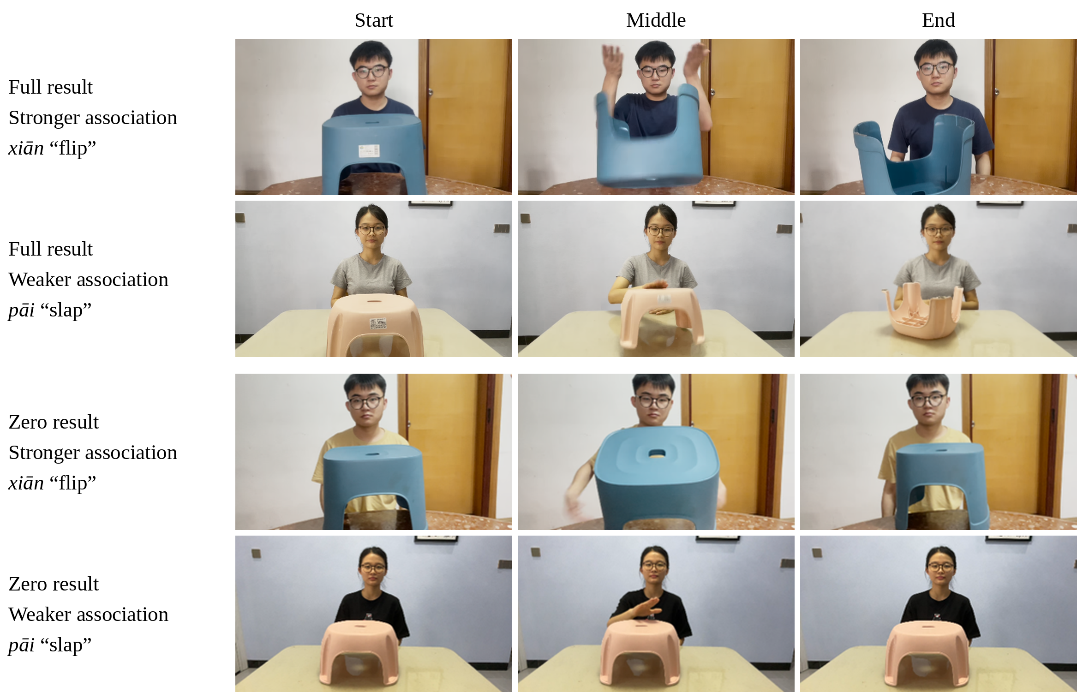
Note. The actor flips (xiān) or slaps (pāi) a stool; the target result is fān “overturned.” Stills show the start, middle, and end of each video.

Verb–Video Correspondence
Because each expression was paired with its own video, the comparison between the two members of a pair is also a comparison between two videos. A norming study therefore assessed whether each video elicited the intended V1. Sixteen adults (20–24 years, M = 22.4; 13 female) watched the 20 zero-result videos with the final 30% removed, so that their descriptions would focus on the action rather than the outcome. Each participant saw either the 10 videos of the stronger-association actions or the 10 videos of the weaker-association actions and described each in a full sentence. If the intended V1 did not appear, the participant was asked for another description; if it still did not appear after two attempts, the participant rated how natural the intended V1 was as a description of the action (1 = very unnatural, 5 = very natural). The intended V1 appeared in 62% of first descriptions and in 72% of all descriptions; when it did not appear, it was rated as natural (M = 4.32, SD = 0.79, range = 2.67–5). Item-level values are given in Table A1 in the Appendix. These item-level values are used as a covariate in a sensitivity analysis of Experiment 1.

Adult Ratings of Result Likelihood and Action Typicality
Twenty native speakers of Mandarin (21–35 years, M = 28.2; 9 female) completed an online questionnaire of about 5 min, in which they rated each of the 20 V1–object expressions in two separate blocks. After a consent statement and questions about their language background (native language, frequency of Mandarin use, and English proficiency), they were told that the questions had no correct answers and were asked to respond on the basis of their everyday experience and first intuition. In the likelihood block, each item presented a perfective sentence containing the V1–object expression, followed by a question about the target result, for example, Xiǎo Lǐ sī-le zhǐ “Xiao Li tore the paper. How likely do you think it is that the paper ended up torn?” The instructions asked participants to judge, on the basis of the sentence and their everyday experience, how likely it was that the stated result eventually occurred. They typed a number from 0 to 100, where 0 was labeled cannot happen and 100 will certainly happen. In the typicality block, the instructions stated that each item first named a result that someone wanted to achieve and then an action that could be used to achieve it, and asked participants to rate how typical the action was as a way of achieving that result, for example, “Suppose Xiao Li wants to break the walnut. How typical is jiā hétao ‘clamping the walnut’ as a way of doing this?” Responses were given on a 7-point scale whose endpoints were labeled 1 (very atypical) and 7 (very typical); the intermediate points were numbered but not labeled. The likelihood items thus presented each expression in the same perfective form as the V1 questions of Experiment 1. Because the ratings were collected for sentences naming the expressions, they characterize the action–result relation that each expression describes, not the particular videos.
Four lists were constructed, and five raters completed each list. In all lists, the 20 likelihood items preceded the 20 typicality items. Within each block, the 10 stronger-association expressions and the 10 weaker-association expressions were presented in separate halves, with the pairs in the same order in both halves, so that the two members of each pair were always separated by nine other items. The stronger-association expressions came first in Lists 1 and 3, and the weaker-association expressions came first in Lists 2 and 4. Four different pair orders were used, two for Lists 1 and 2 and two for Lists 3 and 4, and the two blocks of each list used different orders. Because the likelihood block always came first, the typicality judgments may have been influenced by the preceding likelihood judgments. All raters completed all items, and no ratings were excluded. The ratings were collected after the child data had been collected and initially analyzed with the original Strong/Weak coding; the raters did not take part in the child experiments and received no information about children’s responses.
For each rater and pair, we computed the difference between the ratings of the two expressions (expected stronger- minus expected weaker-association expression) and modeled these differences with crossed random intercepts for raters and pairs, estimated by restricted maximum likelihood. Because there were only 10 pairs, we report 95% confidence intervals from a bootstrap that resampled both raters and pairs, and exact p values from a randomization test that exchanged the two expression labels within pairs across all 2¹⁰ assignments. Across the 10 pairs, the expected stronger-association expressions received higher likelihood ratings (mean difference = 33.06 points, 95% CI [21.74, 44.70], p = .003) and higher typicality ratings (mean difference = 2.45 points, 95% CI [1.25, 3.59], p = .007). The pair-level differences in the two ratings were correlated, r = .79, permutation p = .005. Mean ratings for each expression are shown in Table 1.

Pair Selection
A pair was retained for the analyses of Experiment 1 if the expected stronger-association expression received reliably higher ratings than its partner on both scales, as assessed by a within-rater label-exchange test for each pair (p < .05, uncorrected). Eight pairs met this criterion. Two did not. In Pair 7 (qiā “pinch” vs. jiào “call” a person, with the target result xǐng “awake”), the likelihood difference was in the expected direction, but the typicality difference was reversed (−1.00 points, 95% CI [−1.70, −0.30]). In Pair 8 (tú “paint” vs. náo “scratch” a palm, with the target result hóng “red”), neither difference was reliable (likelihood: 16.40 points, 95% CI [−1.00, 33.40]; typicality: 0.45 points, 95% CI [−0.90, 1.85]). Because action–result association is defined by the two ratings jointly, the actions in these pairs cannot be classified as stronger- or weaker-association actions. The two pairs remained in the experimental lists, so all participants saw all 10 pairs, but their trials are excluded from the analyses of Experiment 1. The original design included all 10 pairs, and an initial analysis of the child data used all of them with the original Strong/Weak coding. The adult ratings were collected, and Pairs 7 and 8 excluded, after that analysis. The exclusion criterion refers only to the rating data, not to children’s responses, but because both steps followed an inspection of the child data, analyses with all 10 pairs are reported alongside the main analyses of Experiment 1 (see Sensitivity Analyses).
In the eight retained pairs, the stronger-association expressions had a mean likelihood rating of 80.08 and a mean typicality rating of 6.34, compared with 42.59 and 3.21 for their weaker-association partners. Within pairs, the likelihood difference ranged from 28.90 to 67.90 points and the typicality difference from 1.30 to 4.60 points. The pair-level tests used for selection are exploratory and uncorrected for multiple comparisons. They identify pairs in which the two ratings agree; they do not establish lexical classes of V1s.

Corpus Frequency of the Corresponding RVCs
We also examined how conventional each RVC is. As noted in the Introduction, whether a V1 and a V2 combine depends on how the action named by V1 relates to the result named by V2. If the two actions in a pair differ in their association with the target result, this difference should also be reflected in the language, such that the RVC formed with the stronger-association V1 is the more conventional one. Corpus frequency thus provides a check on the contrast between the paired V1s that does not rely on the adult ratings, although conventionality concerns the RVC as an expression rather than the action–result relation itself. We therefore searched the modern Chinese section of the CCL corpus (Zhan et al., 2019) for each of the 20 RVCs. The corpus reports the number of documents in which a string occurs rather than the number of tokens, and string matching also returns sequences in which the two characters belong to different words (e.g., zhǐhuī | mièhuǒ “command | fire-fighting” for huī-miè). All matches for the less frequent RVCs were therefore checked by hand. For the more frequent RVCs, matches were segmented automatically to check for word boundaries before V1 and after V2, and 10–12 matches per RVC were checked by hand; for tú-hóng “paint-red,” a sample of 60 matches was checked. Figurative and idiomatic uses (e.g., chě-kāi sǎngzi “pull-open throat,” “raise one’s voice”) were counted, because they also indicate that the combination is conventional. For the RVCs checked by sampling, the number of documents was estimated by multiplying the raw document count by the proportion of checked matches that were resultative uses; for the other RVCs, all matches were checked. Document counts are shown in Table 1.
In seven of the eight retained pairs, the RVC formed with the stronger-association V1 occurred in more documents than the RVC formed with its weaker-association partner, in most pairs by more than an order of magnitude. The exception was Pair 6, in which tuī-dǎo “push-fallen” (5,750 documents) was far more frequent than tī-dǎo “kick-fallen” (480), largely because of abstract uses such as tuīdǎo chónglái “tear down and start over.” The pattern does not reflect the frequency of the V1s themselves: As single words, several weaker-association V1s (e.g., pāi “slap,” àn “press,” tuī “push,” chōng “rinse”) are more frequent than their stronger-association partners (Speer, 2022). Most weaker-association RVCs were attested, although rarely; only huī-miè “wave-extinguished” was unattested in its resultative use. The corpus data thus indicate that the RVCs formed with stronger-association V1s are more conventional, not that those formed with weaker-association V1s are unacceptable. Because the CCL corpus consists mainly of written texts, the counts do not describe children’s input. RVC frequency is reported to characterize the materials and is not entered into the analyses.

Experiment 1: Comprehension

Method

Participants
Participants were 32 four-year-olds (14 female; 4;0–4;10, M = 4;7), 32 five-year-olds (15 female; 5;0–5;11, M = 5;5), and 40 adults (18 female; 18;4–37;3 years, M = 23.1). Children were recruited from two kindergartens in Hunan Province, China, and adults from a university in Beijing. All participants were native speakers of Mandarin with no reported language or intellectual impairments. Guardians and adult participants gave written informed consent under a protocol approved by the university’s institutional review board. Children received a book as a gift, and adults received 10 RMB. Sample size was set before data collection at 32 children per age group, following previous studies of Mandarin verb comprehension (Chen, 2017; J. Liu, 2018).

Design and Materials
On each trial, participants watched one critical video and answered a perfective yes–no question about it. The question contained either the RVC or the V1, with the object as a bare noun, as in (3).
(3) a. Tā bāo-le lìzhī ma?
she peel-PERF lychee Q
“Did she peel (the) lychee?”
b. Tā bāo-kāi-le lìzhī ma?
she peel-open-PERF lychee Q
“Did she peel (the) lychee open?”
Form (RVC vs. V1) and Action–Result Association (Stronger vs. Weaker) were manipulated between participants, and Result Realization (Full vs. Zero) within participants. Eight lists crossed four event lists with the two forms. Each event list contained one action from each of the 10 pairs, either all stronger-association or all weaker-association actions, with five videos in their full-result and five in their zero-result version; across the two event lists with the same actions, each video appeared once in each version. Each list also contained eight filler videos (one practice and seven test trials), whose questions either matched or did not match the depicted action, to balance “yes” and “no” answers. Participants were randomly assigned to lists. In the eight retained pairs, each participant judged eight critical trials, and across lists each retained video appeared equally often in its full-result and zero-result version.
With about four children per age group and five adults per list, the V1 descriptions of the stronger-association actions, like those of the weaker-association actions, were judged by eight children per age group and 10 adults, and each V1 description in a given result condition by about four children per age group. Comparisons between stronger- and weaker-association V1s are therefore largely between participants, and item-level estimates are imprecise.

Procedure
Children were tested individually in a quiet room in their kindergarten. After each video, they heard the question and answered orally, and an experimenter recorded the response. If a child reported not having seen the video clearly or did not answer, the video was played once more. Adults were tested online in Gorilla (Anwyl-Irvine et al., 2020); they received oral instructions from an experimenter and selected their answers themselves. Each session began with one practice trial. Acceptance was coded 1 and rejection 0.

Analysis Plan
Trial-level acceptance is modeled with Bayesian logistic mixed-effects models in brms (Bürkner, 2017) in R (R Core Team, 2024). Bayesian estimation was chosen because near-ceiling acceptance in full-result events and in some adult conditions produces quasi-separation, and frequentist models with the required interaction structure did not converge on these data. Factors are sum-coded. Fixed effects have Normal(0, 1.5) priors, standard deviations Exponential(1) priors, and correlations LKJ(2) priors. Convergence is assessed by R̂ < 1.01 and adequate effective sample sizes. We report posterior medians, 95% credible intervals, and predicted acceptance probabilities, and, for directional predictions, the posterior probability that the effect has the predicted sign. Because precision in designs with few stimuli depends mainly on the number of stimuli (Westfall et al., 2014), an interval that includes both zero and sizable effects is treated as inconclusive rather than as evidence of no difference.

RVC and V1 Descriptions
The first model addresses RQ1. It includes Form (RVC vs. V1), Result Realization (Full vs. Zero), Age Group (4-year-olds, 5-year-olds, adults), and their interactions; V1 trials with stronger- and weaker-association V1s are pooled. Random effects are intercepts for participants, items (a V1–object expression and its RVC), and pairs; a by-participant slope for Result Realization; and by-item slopes for Form, Result Realization, and Age Group. The focal contrasts are the full–zero difference in acceptance for each form in each age group and the difference between these two differences (Form × Result Realization), which indicates whether Result Realization affects acceptance of the two forms differently. Comparing this interaction between children and adults and between 4- and 5-year-olds addresses the age questions in RQ1.

Stronger- and Weaker-Association V1s
The second model addresses RQ2 and uses V1 trials only. It includes Action–Result Association (Stronger vs. Weaker), Result Realization, Age Group, and their interactions. Random effects are intercepts for participants, items, and pairs; a by-participant slope for Result Realization; by-item slopes for Result Realization and Age Group; and a by-pair slope for Action–Result Association, which allows the difference between the two V1s of a pair to vary across pairs. The focal estimates are (a) the difference in acceptance between stronger- and weaker-association V1s in zero-result events in each age group (hereafter, the association effect); (b) the Action–Result Association × Result Realization interaction, which assesses whether the association effect is larger in zero-result than in full-result events; and (c) the Action–Result Association × Age Group interaction in zero-result events, which assesses whether the association effect differs between children and adults. Because adult acceptance in zero-result events may approach ceiling, this interaction is reported both on the log-odds scale and as differences in predicted acceptance probability.

Sensitivity Analyses
Three analyses assess whether the conclusions depend on the materials: (a) refitting both models with all 10 pairs, with the actions of Pairs 7 and 8 classified as stronger- or weaker-association as in the original design; (b) adding the item-level verb–video correspondence values as a covariate; and (c) refitting the models with each pair left out in turn. Because Pairs 7 and 8 were excluded after an initial analysis of the child data (see Pair Selection), analysis (a) is reported alongside the main results, and any conclusion that differs between the eight-pair and 10-pair analyses is stated. Frequentist refits are reported where they converge. These analyses are not used to select a preferred subset of items. Acceptance of each V1 and RVC description is also reported by Result Realization and Age Group, to show whether the association effect is carried by most pairs or by a few.

Results
Accuracy on filler trials was 100% for adults, 97% for 4-year-olds, and 95% for 5-year-olds, and no participant was excluded. The data comprise 1,040 critical responses, of which 832 belong to the eight retained pairs (416 RVC and 416 V1 trials). All models converged (R̂ ≤ 1.005; at most one divergent transition per model). Below, raw percentages are reported together with model-predicted acceptance (posterior medians with 95% credible intervals [CrIs], population-level predictions). Because the model predictions set item and participant effects to zero, they can differ from the raw percentages when acceptance varies strongly across items.

RVC and V1 Descriptions
Figure 2 shows acceptance by form, result realization, and age group. In full-result events, both forms were accepted at high rates in all groups (RVC descriptions: 92%–94%; V1 descriptions: 97%–100%). In zero-result events, RVC descriptions were rarely accepted (4-year-olds: 19%; 5-year-olds: 11%; adults: 1%), whereas V1 descriptions were accepted more often (55%, 58%, and 83%, respectively).
Figure 2
Acceptance of RVC and V1 Descriptions by Result Realization and Age Group (Experiment 1)
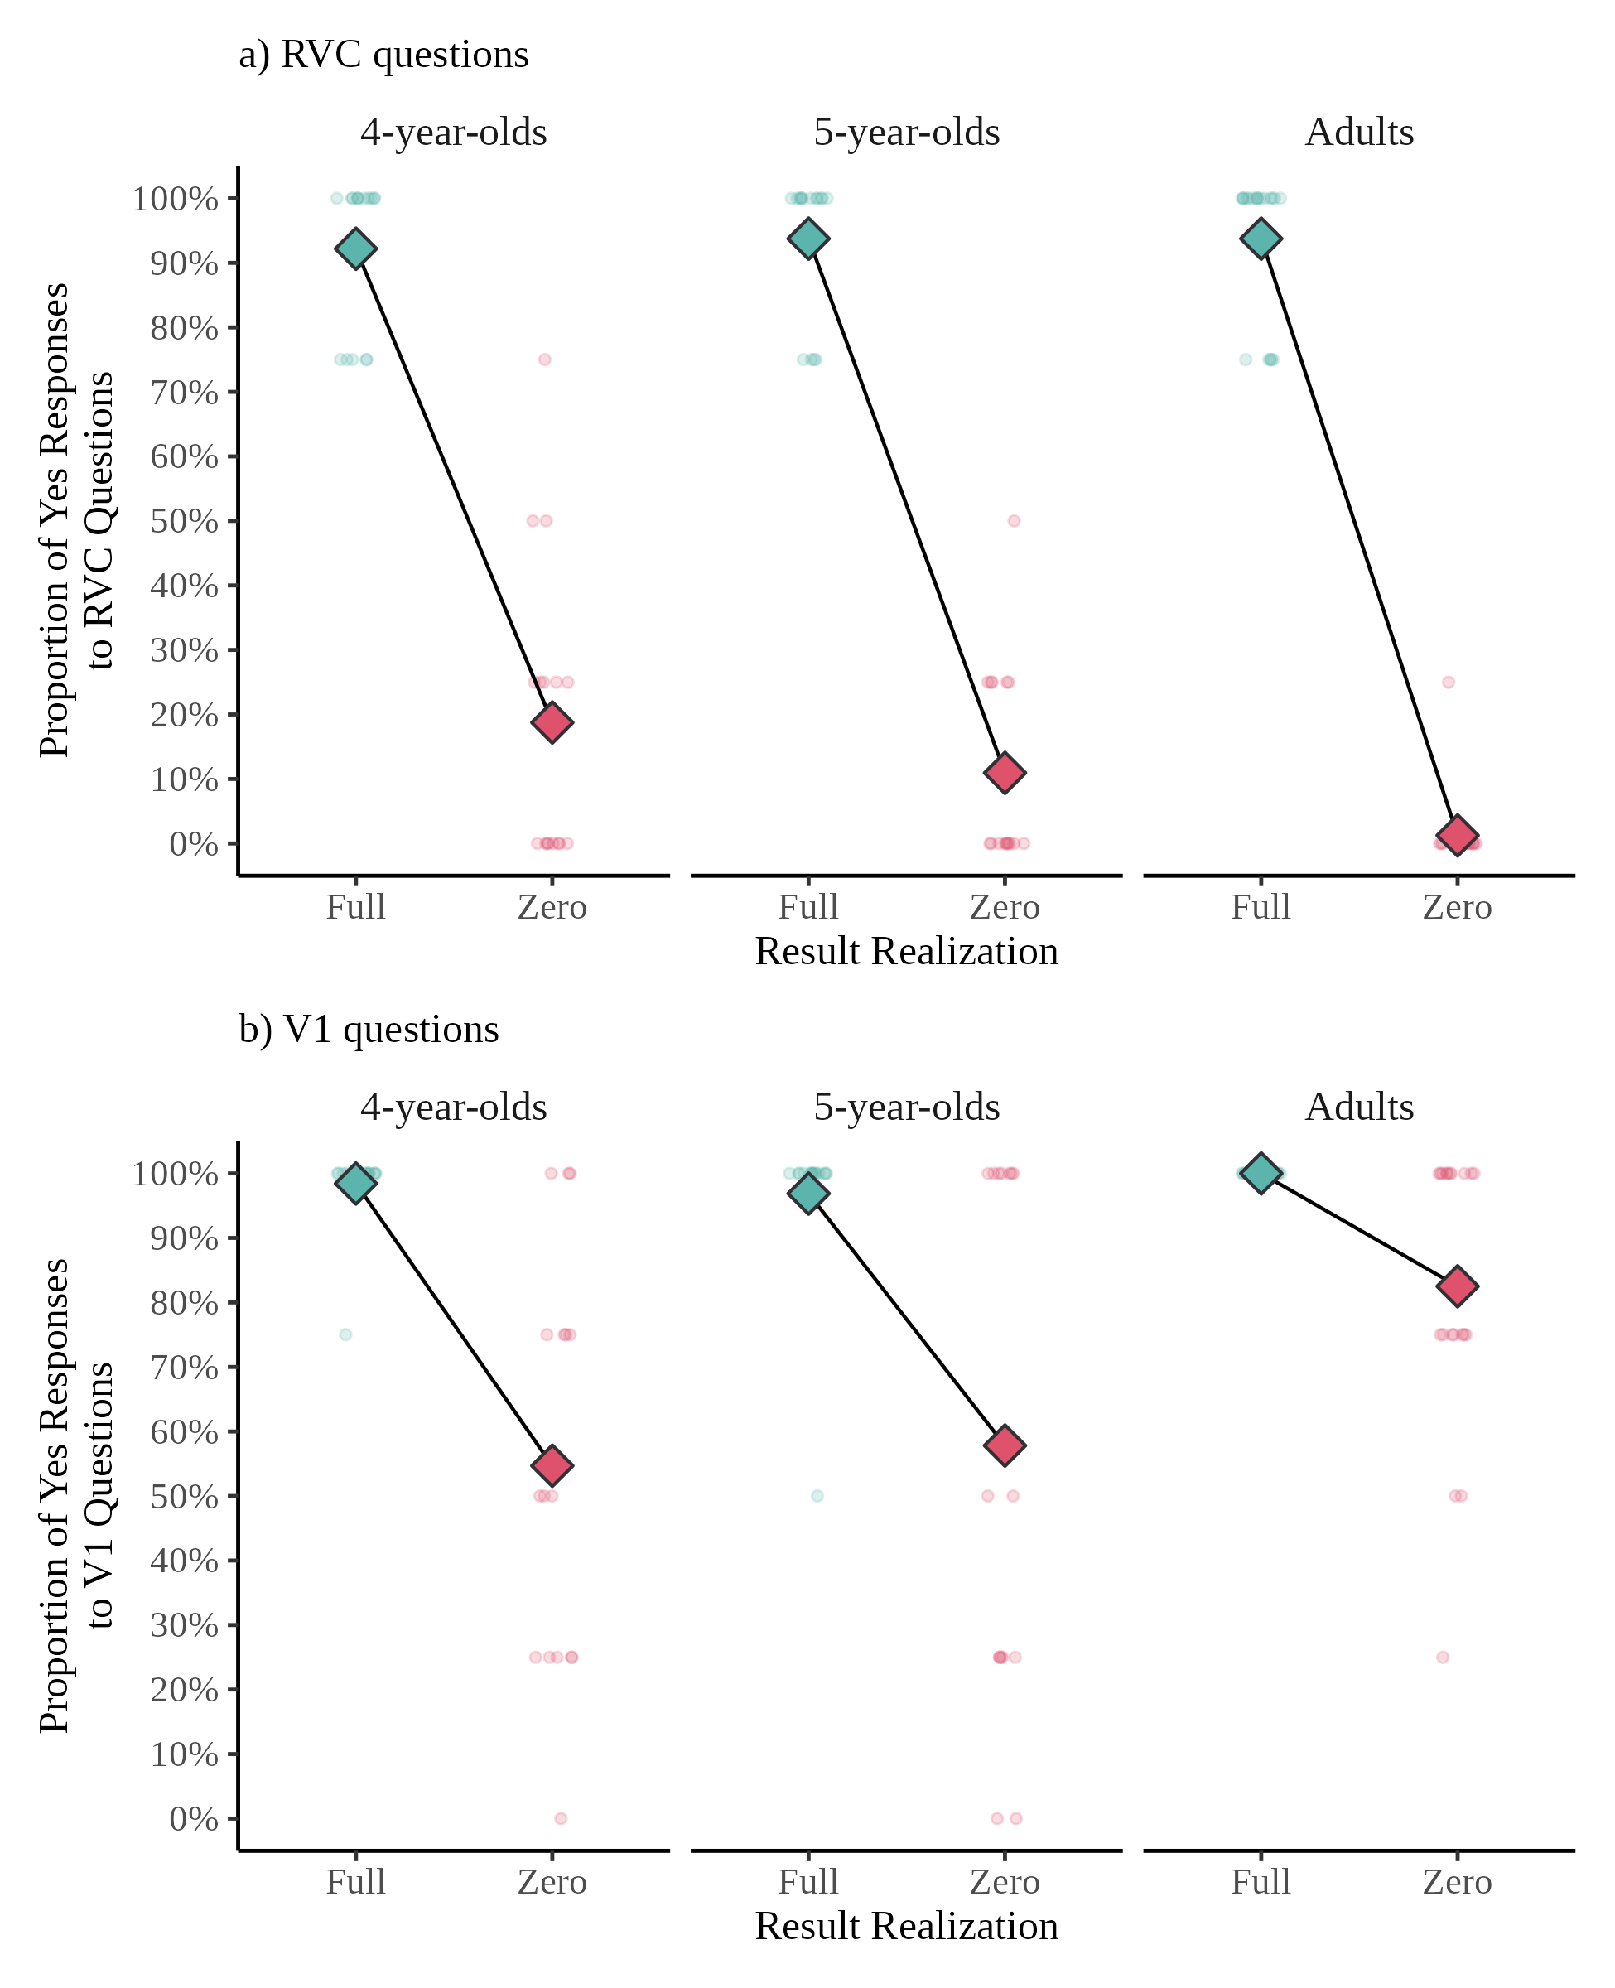
Note. Eight retained pairs. Small points show proportions for individual participants, and diamonds show group means.
In the model, the full–zero difference in predicted acceptance was large for RVC descriptions in all groups (4-year-olds: 0.89, 95% CrI [0.69, 0.97]; 5-year-olds: 0.94 [0.82, 0.99]; adults: 0.98 [0.90, 1.00]) and smaller for V1 descriptions (0.41 [0.12, 0.77], 0.33 [0.08, 0.69], and 0.04 [0.00, 0.19], respectively). On the probability scale, the difference between these two differences was positive in each group (4-year-olds: 0.46 [0.12, 0.75]; 5-year-olds: 0.60 [0.24, 0.85]; adults: 0.93 [0.77, 0.98]). On the log-odds scale, the Form × Result Realization interaction was probably positive for 5-year-olds (2.70 [−0.36, 5.74], posterior probability of a positive effect, p(> 0) = .96) and adults (6.31 [−0.28, 11.83], p(> 0) = .97), although both intervals include zero, and uncertain for 4-year-olds (0.53 [−2.90, 3.42], p(> 0) = .63). The interaction was smaller in children than in adults (difference in log-odds: −4.69 [−10.65, 2.15], p(< 0) = .92), and somewhat larger in 5- than in 4-year-olds (2.20 [−1.73, 6.39], p(> 0) = .86); both comparisons have wide intervals.
The age differences were located mainly in zero-result events. Children accepted V1 descriptions of zero-result events less often than adults (difference in predicted acceptance: 0.33 [0.11, 0.62], p(> 0) > .99) and accepted RVC descriptions of these events slightly more often (0.05 [0.01, 0.17], p(> 0) > .99). Thus, by 4 years of age, children rejected RVC descriptions of zero-result events in most cases and accepted V1 descriptions of these events more often than RVC descriptions, but less often than adults did.

Stronger- and Weaker-Association V1s
Figure 3 shows acceptance of V1 descriptions by association, result realization, and age group. In full-result events, V1 descriptions were accepted almost always (94%–100%). In zero-result events, descriptions with stronger-association V1s were accepted less often than descriptions with weaker-association V1s in every group (4-year-olds: 31% vs. 78%; 5-year-olds: 41% vs. 75%; adults: 68% vs. 98%).
Figure 3
Acceptance of V1 Descriptions by Action–Result Association, Result Realization, and Age Group (Experiment 1)
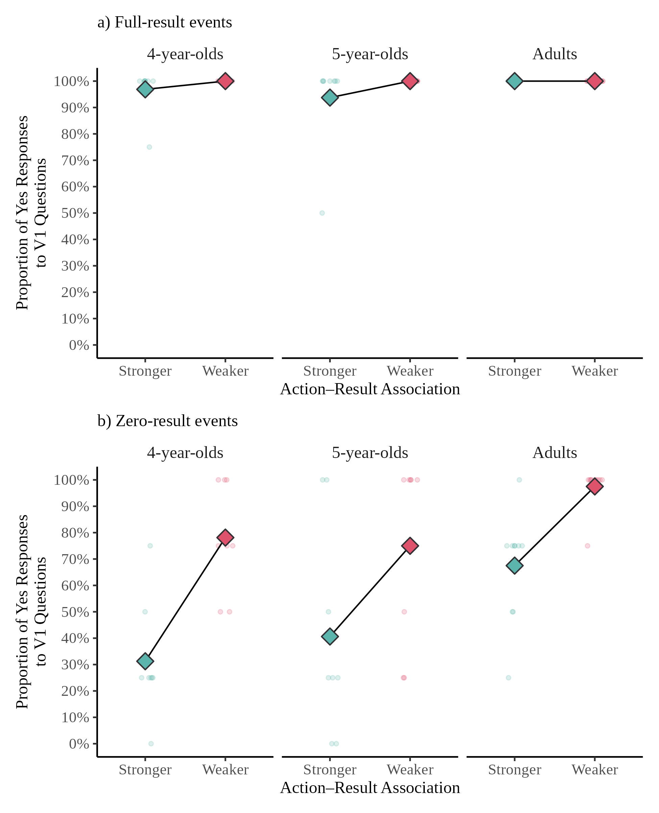
Note. Eight retained pairs. Small points show proportions for individual participants, and diamonds show group means.
In the model, the association effect in zero-result events was positive in all three groups, with intervals excluding zero for 4-year-olds and adults and only marginally including it for 5-year-olds (difference in log-odds, weaker minus stronger: 4-year-olds: 3.94 [0.46, 7.95], p(> 0) = .99; 5-year-olds: 2.87 [−0.49, 6.48], p(> 0) = .96; adults: 4.55 [0.69, 9.21], p(> 0) = .99; averaged over groups: 3.80 [1.12, 6.84], p(> 0) > .99). In full-result events, the association effect was negligible (differences in predicted acceptance ≤ 0.01). The Action–Result Association × Result Realization interaction was positive in all groups but uncertain because acceptance was at ceiling in full-result events (log-odds: 1.49 [−5.39, 8.04], −0.13 [−6.75, 5.75], and 4.46 [−3.54, 12.64]).
The association effect did not differ credibly between children and adults. On the log-odds scale, the effect was, if anything, smaller in children (difference: −1.13 [−5.57, 2.91], p(> 0) = .29); on the probability scale, it was larger in children (0.31 [−0.30, 0.73], p(> 0) = .86), because adults’ acceptance of weaker-association V1s was close to ceiling. Both intervals include zero and sizable effects in either direction, so the comparison is inconclusive. The effect also did not differ between 4- and 5-year-olds (−1.05 [−5.23, 2.80]). Children accepted V1 descriptions of zero-result events less often than adults for both stronger-association V1s (difference in predicted acceptance: 0.47 [0.02, 0.82], p(> 0) = .98) and weaker-association V1s (0.12 [0.01, 0.55], p(> 0) = .99). Children and adults were thus both sensitive to action–result association, and children’s stricter judgments held regardless of association.

Sensitivity Analyses and Item-Level Acceptance
With all 10 pairs, the conclusions were unchanged, except that the Form × Result Realization interaction in 5-year-olds was now clearly positive. The Form × Result Realization interaction on the log-odds scale was 1.05 [−1.47, 3.49] for 4-year-olds (p(> 0) = .79), 4.01 [1.62, 6.47] for 5-year-olds (p(> 0) > .99), and 4.78 [−1.79, 9.36] for adults (p(> 0) = .93). The association effect in zero-result events was 4.05 [1.27, 7.34] for 4-year-olds (p(> 0) > .99), 2.71 [−0.08, 5.77] for 5-year-olds (p(> 0) = .97), and 4.83 [1.67, 8.67] for adults (p(> 0) > .99), and it again did not differ credibly between children and adults (log-odds: −1.41 [−5.26, 1.90]; probability: 0.27 [−0.16, 0.61]).
When each of the eight retained pairs was left out in turn, the association effect in zero-result events, averaged over age groups, ranged from 3.23 to 4.25 on the log-odds scale, and its 95% CrI excluded zero in every refit (p(> 0) ≥ .99). The Action–Result Association × Age Group comparison remained inconclusive in every refit (children minus adults, log-odds: −2.58 to −0.55; probability: 0.19 to 0.36; all intervals including zero). Frequentist models with the full interaction structure produced unstable estimates because of near-ceiling acceptance in full-result events, as anticipated in the Analysis Plan. A frequentist model restricted to V1 descriptions of zero-result events, with random intercepts for participants and items, showed effects of action–result association, χ²(1) = 6.21, p = .013, and age group, χ²(2) = 9.76, p = .008, but no interaction, χ²(2) = 0.68, p = .71. Adding the item-level verb–video correspondence values (Table A1, proportion of all descriptions containing the intended V1, centered) and their interaction with Result Realization as covariates did not change the conclusions. The covariate effects were small and uncertain (Model 1: 0.20 [−1.67, 2.08]; Model 2: −0.13 [−2.42, 2.21]). The Form × Result Realization interaction was 0.49 [−2.93, 3.45] for 4-year-olds, 2.70 [−0.45, 5.73] for 5-year-olds, and 6.38 [−0.21, 11.90] for adults, and the association effect in zero-result events, averaged over age groups, was 3.86 [1.13, 6.88], p(> 0) > .99, with no credible difference between children and adults (log-odds: −1.16 [−5.58, 2.96]; probability: 0.32 [−0.29, 0.72]).
Figure 4 shows acceptance of V1 descriptions in zero-result events for each pair. In seven of the eight pairs, the stronger-association V1 was accepted less often than its weaker-association partner by children, and in six of the eight pairs by adults; the remaining adult pairs were at ceiling for both V1s (Pair 2) or for both groups (Pair 9). The association effect was thus carried by most pairs rather than by one or two. Pair 9 (cā “wipe” vs. chōng “rinse” a mirror) behaved differently from the other pairs: Both V1s were accepted in all zero-result trials, and children also accepted the RVC descriptions of the zero-result videos in 50%–75% of trials. In the videos of this pair, the stain on the mirror was a small red spot in one corner and was not very conspicuous, so participants may not have noticed that it remained in the zero-result videos; one child explained a rejection by saying that only one side of the mirror had been wiped. Acceptance of the RVC descriptions in zero-result events was otherwise low for every pair (children: 0%–38%; adults: 0%).
Figure 4
Acceptance of V1 Descriptions in Zero-Result Events for Each Pair (Experiment 1)
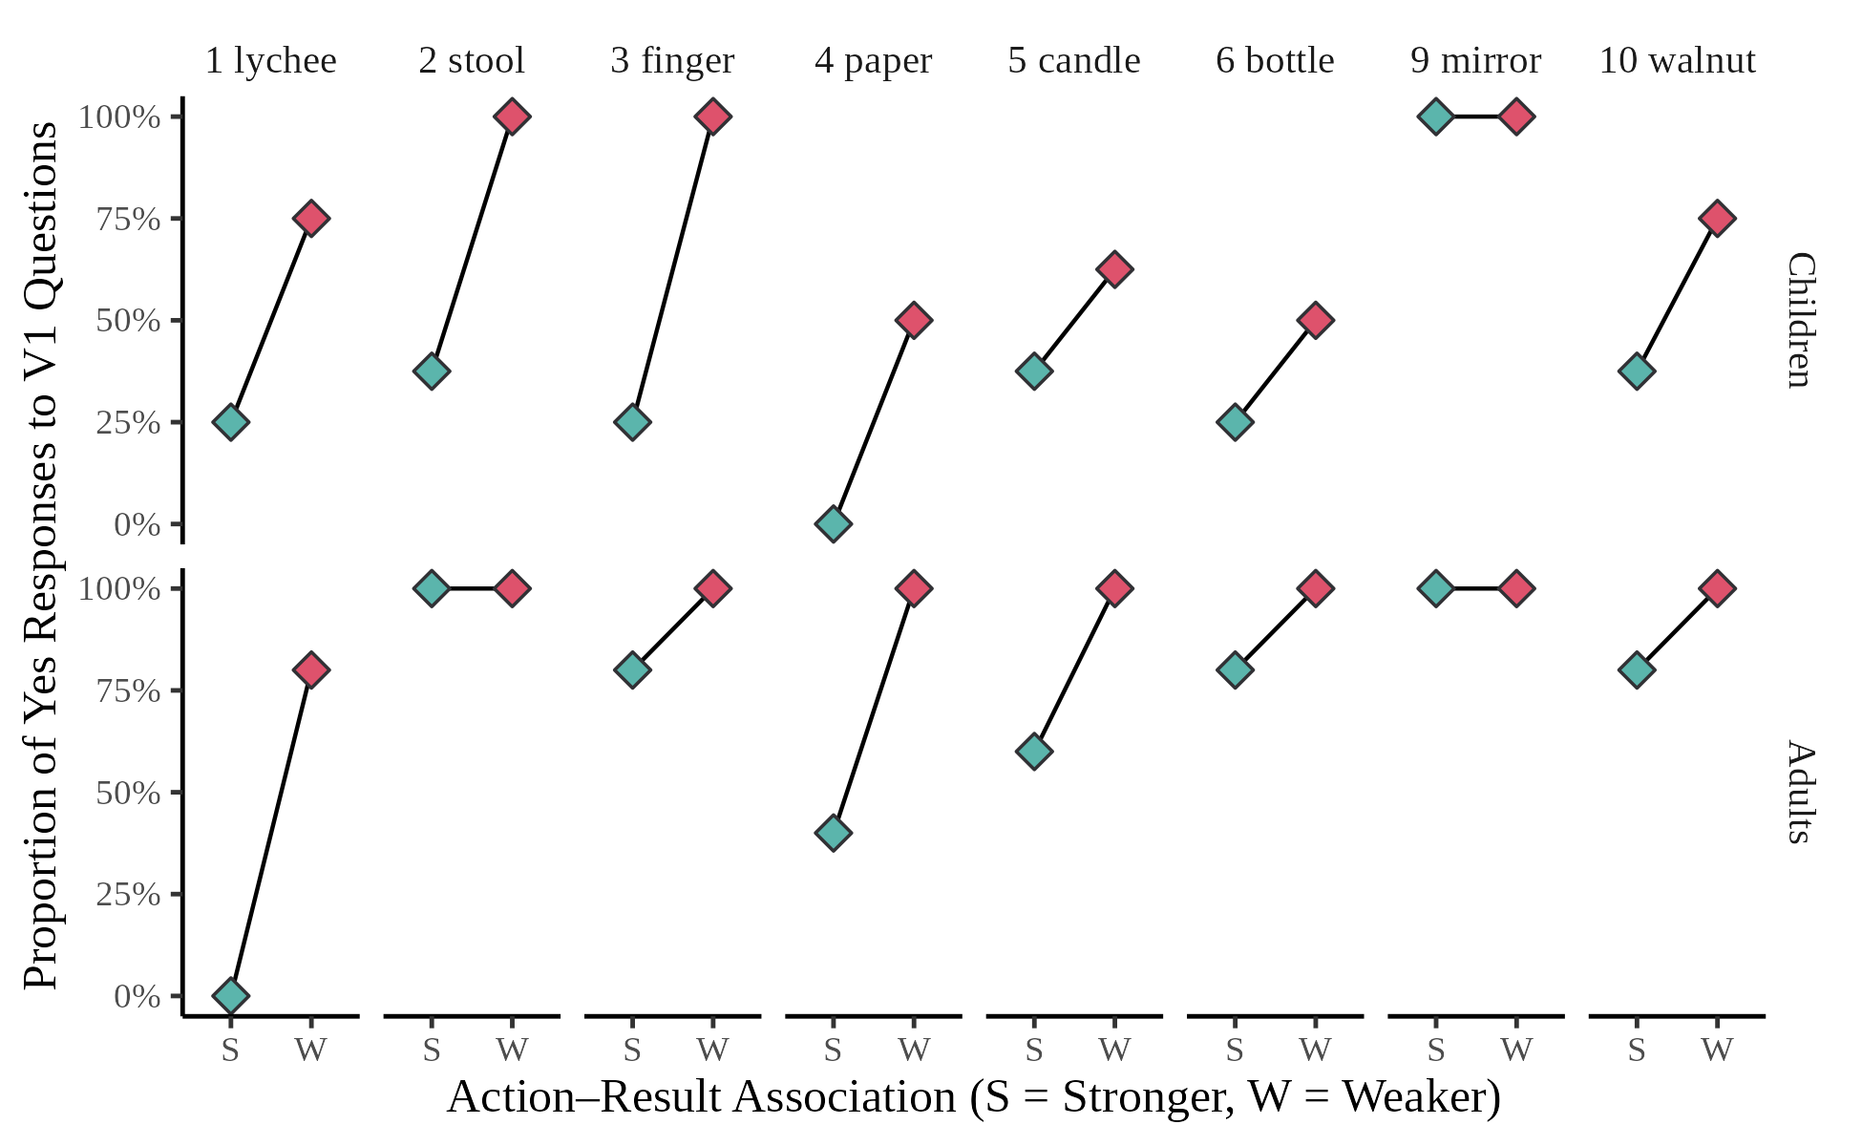
Note. Diamonds show proportions for each V1 description. Children are pooled across the two age groups (eight children per V1 description); five adults per V1 description. Pair 9 is discussed in the text.

Experiment 2: Production

Method

Participants
A new sample of 32 four-year-olds (14 female; 4;0–4;11, M = 4;4), 32 five-year-olds (18 female; 5;0–5;11, M = 5;5), and 40 adults (29 female; 20.8–33.8 years, M = 24.3) was recruited from the same populations as in Experiment 1, with the same consent procedure and compensation.

Materials and Procedure
The 40 critical videos were divided into four lists. Each list contained either the 10 stronger-association or the 10 weaker-association actions, five in their full-result and five in their zero-result version, together with the eight filler videos (one practice and seven test trials). Four further lists presented the same videos in reverse order, yielding eight lists. Participants were randomly assigned to lists, watched each video, and were asked to describe what happened. [指导语原文] Children responded orally, and an experimenter transcribed their responses; adults typed their descriptions online. Because response modality differed between children and adults, child–adult differences are interpreted with caution.
All 10 pairs are included in the analyses of Experiment 2, because these analyses compare result conditions and do not require the actions to be classified as stronger- or weaker-association. Analyses restricted to the eight retained pairs are reported as a sensitivity check.

Coding
The coding unit is the complete response to a video, including information expressed across clauses. Responses were recoded from the transcripts for the present analyses. Trials without a recorded response are excluded and reported. In the present draft, responses were coded with item-specific lists of V1s, V2s, and equivalent result expressions, together with rules for negation and attempt verbs (e.g., shìtú “try”). [规则编码初稿：需人工逐条核对，并由第二编码者独立编码 20% 的回答后报告一致性]
Form. Each response is coded for whether it contains an RVC, affirmed or negated (e.g., bāo-kāi-le “peeled open”; méi bāo-kāi “did not peel open”). Responses without an RVC contain only monomorphemic predicates, which may name the action (e.g., bāo “peel”) or the result (e.g., miè-le “went out”). Serial-verb responses are retained and coded in the same way.
Information. Each response is also coded for whether it mentions the action and whether it mentions the target result. The action is coded as mentioned when any verb describes the depicted action; whether this verb is the intended V1 is recorded separately, and general verbs such as nòng “do, handle” are coded as mentioning the action without specifying it. The target result is coded as mentioned when the response contains the V2 or an expression listed as equivalent for that item in the coding manual, whether the result is affirmed or denied. Only explicitly expressed information is coded: A bǎ construction with a monomorphemic verb (e.g., bǎ làzhú chuī-le “BA candle blow-PERF”) is coded as mentioning the action only. Whether a mentioned result is affirmed or denied is recorded, so that responses affirming the target result in a zero-result event can be identified.
Response categories. Combining the two codes, each response is assigned to one of five categories: action only, target result only, action and target result in an RVC, action and target result in separate predicates, or neither. The RVC and action-only categories correspond to the RVC and V1 descriptions judged in Experiment 1.

Analysis Plan
Two binary outcomes are modeled with the Bayesian specification of Experiment 1: whether a response contains an RVC and whether it mentions the target result. Each model includes Result Realization, Age Group, and their interaction, with random intercepts for participants, items (the videos of one action), and pairs; a by-participant slope for Result Realization; and by-item slopes for Result Realization and Age Group. Because negated RVCs are counted as RVCs, the first outcome concerns the form of the description regardless of whether the result is affirmed or denied. Because every RVC mentions both the action and the target result, the two outcomes overlap by design; comparing them shows whether fewer RVCs in zero-result events reflect fewer mentions of the result or a shift to other ways of mentioning it. Among responses without an RVC, the proportions of action-only, result-only, and separate-predicate responses are reported by Result Realization and Age Group descriptively, because several cells contain few responses. Responses that affirm the target result in zero-result events are counted by age group. The two models are also refitted with the eight retained pairs. The adult ratings are not used in these analyses.

Results
Ten child trials (seven from 4-year-olds and three from 5-year-olds) had no recorded response and are excluded, leaving 1,030 responses (4-year-olds: 313; 5-year-olds: 317; adults: 400). Both models converged (R̂ ≤ 1.003, no divergent transitions). Figure 5 shows the proportions of responses that contained an RVC and that mentioned the target result, and Table 2 shows the distribution of response categories.
Figure 5
Proportion of Responses Containing an RVC and of Responses Mentioning the Target Result (Experiment 2)
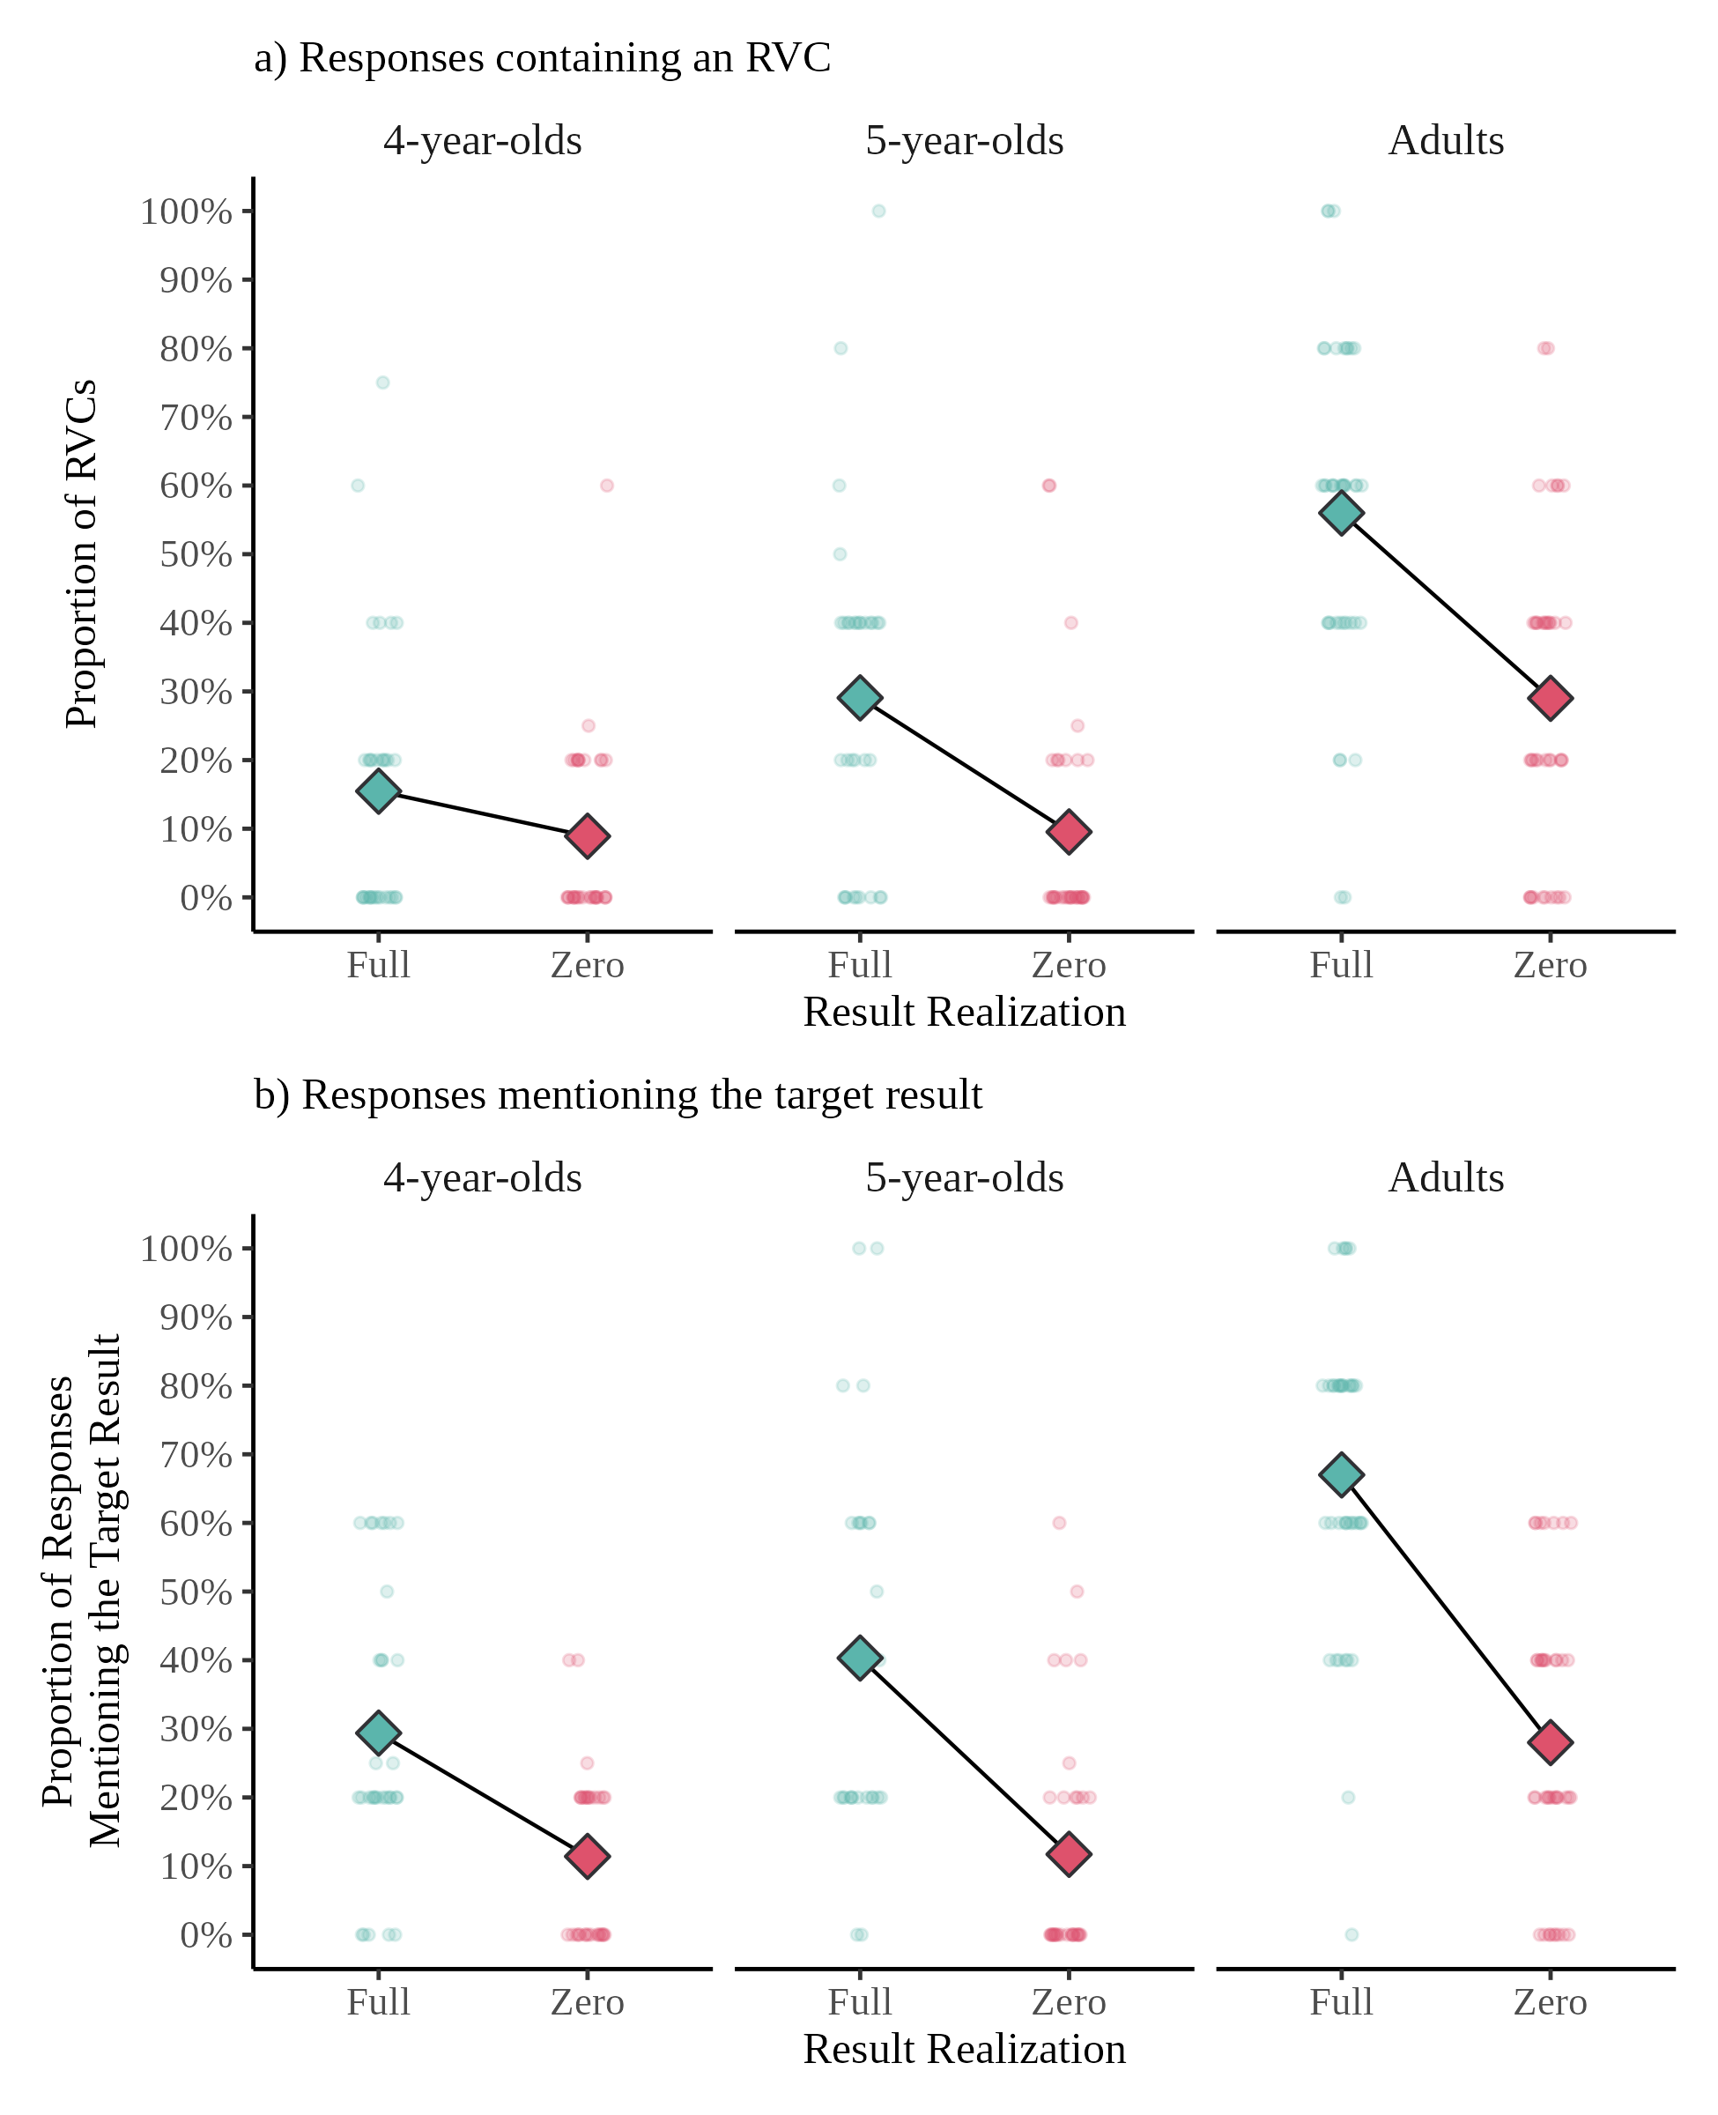
Note. All 10 pairs. Small points show proportions for individual participants, and diamonds show group means.

RVC Use
Responses contained an RVC more often for full-result than for zero-result events in all groups (4-year-olds: 15% vs. 9%; 5-year-olds: 29% vs. 10%; adults: 56% vs. 29%). In the model, this difference was credible for 5-year-olds (log-odds: 1.92, 95% CrI [0.82, 3.13], p(> 0) > .99) and adults (1.87 [0.97, 2.84], p(> 0) > .99) but uncertain for 4-year-olds (0.81 [−0.37, 2.01], p(> 0) = .92), who produced few RVCs in either condition. On the log-odds scale, the effect of result realization did not differ credibly between children and adults (−0.50 [−1.57, 0.54]). Adults produced RVCs more often than children (difference in predicted proportion, averaged over result conditions: 0.30 [0.15, 0.46]), and 5-year-olds slightly more often than 4-year-olds (0.06 [0.00, 0.17]). RVCs in zero-result events usually appeared in negated or potential forms (e.g., méi zá-kāi “did not smash open”; qiāo bù kāi “knock-cannot-open”) or, in adults, as the object of an attempt verb (e.g., shìtú sī-kāi “tried to tear open”).

Mention of the Target Result
The target result was mentioned more often for full-result than for zero-result events in all groups (4-year-olds: 29% vs. 12%; 5-year-olds: 40% vs. 11%; adults: 67% vs. 28%). The difference was credible in each group (log-odds: 1.43 [0.28, 2.67], p(> 0) = .99; 2.32 [1.20, 3.59], p(> 0) > .99; and 2.74 [1.65, 3.87], p(> 0) > .99, respectively), and it tended to be smaller in children than in adults (−0.84 [−1.75, 0.03]). Adults mentioned the target result more often than children (0.27 [0.15, 0.39]). In zero-result events, adults who mentioned the target result usually denied it (20% of zero-result responses) or presented it as the actor’s goal (7%); children denied it in 8% of zero-result responses. Responses affirming the target result in a zero-result event were rare (4-year-olds: 5 responses, 3%; 5-year-olds: 6, 4%; adults: 2, 1%).

Response Categories
Among responses without an RVC (Table 2), action-only responses predominated in all groups and in both result conditions (67%–90%). In full-result events, children’s descriptions more often named the action alone than adults’ (all responses: 62% and 53% vs. 31%), whereas responses expressing the action and the target result in separate predicates (e.g., huīwǔ-le jǐ xià, làzhú miè le “waved it a few times, and the candle went out”) made up 13%–14% of children’s and 26% of adults’ responses without an RVC. Responses mentioning only the target result were rare (0%–6%). Thus, children did not express the target result in separate predicates or without the action more often than adults; their lower RVC use went together with less frequent mention of the result. In zero-result events, separate-predicate and result-only responses were rare in all groups (≤ 5% of responses without an RVC). Because several cells contain few responses, these proportions are reported descriptively.
Table 2
Response Categories by Result Realization and Age Group in Experiment 2 (Percentages of Responses)
Age group | Result | n | RVC | Separate predicates | Result only | Action only | Neither
4-year-olds | Full | 157 | 13 | 11 | 5 | 62 | 8
 | Zero | 156 | 7 | 1 | 4 | 78 | 11
5-year-olds | Full | 159 | 26 | 10 | 4 | 53 | 7
 | Zero | 158 | 7 | 2 | 3 | 80 | 8
Adults | Full | 200 | 54 | 12 | 2 | 31 | 2
 | Zero | 200 | 26 | 2 | 0 | 67 | 5
Note. RVC = action and target result expressed in an RVC, affirmed or negated. Responses containing an RVC that did not express the target result (e.g., an RVC with a different result) are classified by the remaining information; therefore, the RVC column can be lower than the proportion of responses containing an RVC reported in the text. All 10 pairs are included.
Restricting the analyses to the eight retained pairs did not change these patterns (RVC use, full minus zero, log-odds: 4-year-olds: 0.62 [−0.61, 1.90]; 5-year-olds: 1.81 [0.66, 3.06]; adults: 2.01 [1.00, 3.08]). Descriptively, in zero-result events RVCs were produced somewhat more often for stronger- than for weaker-association actions (4-year-olds: 12% vs. 6%; 5-year-olds: 12% vs. 6%; adults: 33% vs. 25%), mostly in negated or attempt constructions; this comparison was not planned and is not modeled. [产出编码为依据逐项关键词表的规则编码初稿，待人工核对和第二编码者编码后更新以上数值]

General Discussion
The study asks three questions about how Mandarin-speaking 4- and 5-year-olds interpret and describe events in which an action does or does not bring about a target result. First, do children evaluate RVC and V1 descriptions differently with respect to the result, and do 4-year-olds already do so? Second, with the object and the result held constant, do children judge V1 descriptions differently depending on how strongly the named action is associated with the result? Third, how does the realization of the result shape which forms children use and whether they mention the result in their own descriptions?
Three main findings emerged. First, 4-year-olds, 5-year-olds, and adults all rejected RVC descriptions of zero-result events and accepted V1 descriptions of these events more often, although children accepted V1 descriptions less often than adults. Second, within pairs matched for object and target result, all three groups accepted V1 descriptions of zero-result events less often when the V1 named an action more strongly associated with the target result; the size of this association effect did not differ credibly between children and adults, and children’s lower acceptance held for both stronger- and weaker-association V1s. Third, in their own descriptions, children and adults produced fewer RVCs and mentioned the target result less often for zero-result than for full-result events, and children produced fewer RVCs than adults mainly because they mentioned the result less often, not because they expressed it in other forms.

RVC and V1 Descriptions
The larger effect of result realization on RVC than on V1 descriptions shows that children treat a result expressed by V2 differently from a result that is only associated with the action named by V1. This replicates the distinction found in 5-year-olds (J. Liu et al., 2026) and in a small group of children around 4;6 (Chen, 2017), and it extends it to a larger sample of 4-year-olds. On the probability scale, the difference between the two forms was present in all three groups. On the log-odds scale, the Form × Result Realization interaction was probably positive in 5-year-olds and adults (clearly so in 5-year-olds when all 10 pairs were included) but uncertain in 4-year-olds, and 4-year-olds accepted RVC descriptions of zero-result events somewhat more often (19%) than 5-year-olds (11%) and adults (1%). The distinction is therefore in place by 4 years of age for the events tested here, but it is less sharp at 4 than at 5, both because 4-year-olds occasionally accept RVC descriptions of unattained results and because they reject many V1 descriptions of these events. As noted in the Introduction, this conclusion concerns the selected RVCs and events, not RVC semantics or telicity in general.
Children accepted V1 descriptions of zero-result events less often than adults (55% and 58% vs. 83%), replicating the finding that children judge V1 descriptions of events without the result more strictly than adults do (Chen, 2017; J. Liu et al., 2026). Their stricter judgments did not make the two forms equivalent, however: Even 4-year-olds accepted V1 descriptions of zero-result events far more often than RVC descriptions. Children thus do not treat V1s as entailing the result in the way RVCs do; rather, a V1 description of an unattained result is acceptable to them in fewer cases than to adults.

Action–Result Association and V1 Descriptions
Children and adults rejected V1 descriptions of zero-result events more often when the V1 named an action strongly associated with the target result. Because the object and the target result were constant within pairs, this association effect cannot be attributed to differences between objects or results, which was not possible in previous studies in which each V1 was presented with a different object and result (Chen, 2017). The effect was carried by most pairs rather than by one or two, and it was found with all 10 pairs and with each pair left out in turn. For both children and adults, then, what a V1 description conveys about a result depends on how the named action relates to that result. In adults, this is consistent with the cline in the acceptability of result cancellation across verbs (Chen, 2018) and with evidence that comprehenders’ expectations about events depend on the combination of a verb with its arguments (Bicknell et al., 2010; McRae & Matsuki, 2009). In children, it shows that the variation among V1s that Chen (2017) attributed to the strength of the state-change implicature can be found when the event is held constant and only the action varies.
Why action–result association matters is not settled by previous work. Accounts of monomorphemic verbs hold that a verb can imply a result without entailing it and that the strength of the implication varies, whether across verbs (Chen, 2018) or across fulfillment types (Kou & Hohenstein, 2022, 2024), but they do not specify what that strength depends on. The two ratings point to two possibilities. Result likelihood bears on the culmination inference: The more likely the result is to follow the action, the stronger the expectation that the event culminated, and the less acceptable a V1 description may seem when the result is absent. Action typicality bears on what counts as a good instance of the action. The actions that achieve a given result can be viewed as a goal-derived category, in which typicality reflects how well members serve the goal and how often they are encountered as members (Barsalou, 1985); because children are reluctant to extend familiar verbs beyond typical instances of the actions they name (Ma et al., 2021), a failed attempt at a typical means may make a V1 description less acceptable. The two dimensions usually go together but need not coincide (Kim & Murphy, 2011). These possibilities are offered as interpretations of the association effect, not as hypotheses the study was designed to test.
The association effect did not differ credibly between children and adults, and children accepted V1 descriptions of zero-result events less often than adults for both stronger- and weaker-association V1s. This pattern matches the predictions and the initial analysis with the original Strong/Weak coding. The comparison between children and adults was inconclusive rather than null, however: The effect was, if anything, smaller in children on the log-odds scale and larger in children on the probability scale, because adults accepted weaker-association V1s almost always, and the intervals on both scales were wide. With this caveat, the results suggest that children are sensitive to action–result association in the same way as adults and that their stricter judgments do not arise only for V1s that name strongly associated actions. Children’s lower acceptance then reflects a more general difference in how they evaluate V1 descriptions of failed attempts. Three explanations of this difference cannot be separated by the binary task: Children may find it harder than adults to set aside an inference that the result occurred, may reject a true description as inadequate because it leaves an expected result unaddressed, or may judge a failed attempt to be a poor instance of the action. Because children tend to be more tolerant than adults of underinformative descriptions in binary judgment tasks (Katsos & Bishop, 2011), the second explanation would require that a description that leaves the result unaddressed is perceived as more than underinformative when an attempt has failed. The production data, discussed below, bear on these explanations.
Because the stronger- and weaker-association expressions differ in both rated likelihood and rated typicality, the study cannot determine which dimension, or what the two share, underlies the association effect; the two ratings diverged only in Pair 7, which was excluded. The contrast between stronger- and weaker-association expressions also goes together with a difference in the conventionality of the corresponding RVCs. A child who often hears chuī-miè “blow-extinguished” may come to expect a candle to go out after chuī “blow,” so familiarity with the RVC offers an alternative account of the association effect. This account is not incompatible with the association account, because an action that reliably brings about a result is also likely to be described often with the corresponding RVC, but the present materials cannot separate the two. Pair 6 offers a small hint, because the RVC with the weaker-association V1, tuī-dǎo “push-fallen,” was far more frequent than tī-dǎo “kick-fallen”; children nevertheless accepted tī “kick” less often than tuī “push” in zero-result events, as the ratings predict. A single pair cannot decide between the accounts, and the frequency of tuī-dǎo reflects mainly abstract uses.

Form and Information in Production
Comparing RVC use with mention of the target result separates the forms speakers used from the information they expressed. All groups mentioned the target result less often for zero-result than for full-result events, and 5-year-olds and adults also produced fewer RVCs; 4-year-olds produced few RVCs in either condition. RVC use and mention of the target result declined together, and in zero-result events responses that mentioned the result in another form, in a separate predicate or without the action, were rare. Speakers describing a failed attempt thus tended to leave the result unmentioned rather than express it in another form. When adults mentioned the result in a zero-result event, they usually denied it (e.g., méi zá-kāi “did not smash open”) or presented it as the actor’s goal (e.g., shìtú sī-kāi “tried to tear open”), so their RVCs in zero-result events typically appeared in negated, potential, or attempt constructions. Children rarely mentioned the result in zero-result events, and when they did, they mostly denied it, often with potential forms such as qiāo bù kāi “knock-cannot-open.” Responses affirming the target result in a zero-result event were rare in all groups (1%–4% of zero-result responses), so children did not describe an unattained result as attained.
Children produced fewer RVCs than adults in both result conditions. In full-result events, children’s descriptions more often named the action alone, and children did not express the result in separate predicates or without the action more often than adults. Children’s lower RVC use therefore reflects less frequent mention of the target result rather than a different way of packaging it. This is consistent with evidence that children can form RVCs (Chen, 2008; Deng, 2019; Hsu et al., 2019) but shows that, in an open-ended task, they often do not express the result even when it is attained. RVC frequency alone therefore underestimates what children know about RVCs, and comparing RVC use with mention of the result is needed to interpret it. Because children responded orally and adults in writing, part of this difference may reflect response modality; adults’ written descriptions were on average more than twice as long as children’s oral descriptions (15 vs. 6 characters).
The two experiments also present an asymmetry at the group level. In production, children described most zero-result events with action-only responses, that is, with the kind of V1 description they rejected in about 40% of comprehension trials. If children judged V1 descriptions of failed attempts to be false because the V1 entails the result, they should avoid such descriptions in production as well. That they produced them freely suggests that their rejections in comprehension do not reflect a lexical entailment but how they evaluate a description supplied to them, for example as leaving an expected result unaddressed or as describing a poor instance of the action. This interpretation is tentative, because comprehension and production were tested in independent samples and the tasks differ in their demands: An open-ended description task allows a speaker to describe the action without committing to the result, whereas a yes–no question requires a decision about a description that may be taken to bear on the result. A within-participant comparison of comprehension and production would test the interpretation directly.

Limitations and Future Directions
Several limitations follow from the design and from the materials. First, the yes–no task cannot distinguish a judgment that a V1 description is false from a judgment that it is true but inadequate; a graded or ternary response format (Katsos & Bishop, 2011) or a cancellation task would be needed to separate them. Second, each V1 appears with a single object and result, so the data cannot show that the same V1 conveys more or less about a result depending on the result in question; presenting the same V1 with different objects and results, such as tī “kick” with a bottle and with a door, would test this directly. Third, likelihood, typicality, and RVC conventionality covary across the retained pairs. Separating them would require pairs in which they diverge, as in the excluded Pair 7, with the two ratings collected from different raters; in the present study, the same raters always gave the likelihood ratings first. Fourth, with eight pairs and with stronger- and weaker-association V1s judged by different participants, each association effect rests on few items and small groups, and item-level estimates are descriptive; in addition, the ratings were collected and two pairs excluded after an initial analysis of the same children’s data. The eight-pair results agreed with the 10-pair analyses, but the association effect needs to be replicated with a new sample of children, and the comparison of the effect between children and adults requires larger samples. Fifth, the ratings describe expressions rather than videos, and the videos did not always elicit the intended V1; for Pairs 4 and 10, the rating items differed slightly in wording from the experimental items; and in Pair 9, the stain on the mirror was small, so the zero-result videos may not have shown clearly that the mirror remained unclean. Sixth, the production data were coded with item-specific criteria that will be checked by a second coder. [人工核对与第二编码者完成后修改此句] Finally, children and adults were tested in different modalities, and comprehension and production were tested in independent samples.

Conclusion
Mandarin-speaking 4- and 5-year-olds distinguish RVCs from their monomorphemic V1s with respect to the target result: Like adults, they reject RVC descriptions of events in which the result is not attained and accept V1 descriptions of these events more often, although less often than adults do. Their acceptance of V1 descriptions also depends on the relation between the named action and the result. When the object and the target result are held constant, children and adults alike are less willing to accept a V1 description of a failed attempt if the action is strongly associated with the result, and children’s stricter judgments hold for strongly and weakly associated actions alike. In their own descriptions, children rarely express an unattained result and often leave an attained result unmentioned, so that their lower use of RVCs reflects which information they express rather than how they package it. What a monomorphemic verb conveys about a result, for children as for adults, is thus best characterized not as a fixed property of the verb but as a property of the relation between the action it names and the result in question.

References
Anwyl-Irvine, A. L., Massonnié, J., Flitton, A., Kirkham, N., & Evershed, J. K. (2020). Gorilla in our midst: An online behavioral experiment builder. Behavior Research Methods, 52(1), 388–407. https://doi.org/10.3758/s13428-019-01237-x
Barsalou, L. W. (1985). Ideals, central tendency, and frequency of instantiation as determinants of graded structure in categories. Journal of Experimental Psychology: Learning, Memory, and Cognition, 11(4), 629–654. https://doi.org/10.1037/0278-7393.11.1-4.629
Bicknell, K., Elman, J. L., Hare, M., McRae, K., & Kutas, M. (2010). Effects of event knowledge in processing verbal arguments. Journal of Memory and Language, 63(4), 489–505. https://doi.org/10.1016/j.jml.2010.08.004
Bürkner, P.-C. (2017). brms: An R package for Bayesian multilevel models using Stan. Journal of Statistical Software, 80(1), 1–28. https://doi.org/10.18637/jss.v080.i01
Chen, J. (2008). The acquisition of verb compounding in Mandarin Chinese [Doctoral dissertation, Vrije Universiteit Amsterdam]. LOT.
Chen, J. (2017). When transparency doesn’t mean ease: Learning the meaning of resultative verb compounds in Mandarin Chinese. Journal of Child Language, 44(3), 695–718. https://doi.org/10.1017/S0305000916000192
Chen, J. (2018). “He killed a chicken, but it didn’t die”: An empirical study of the lexicalization of state change in Mandarin monomorphemic verbs. Chinese Language and Discourse, 9(2), 136–161. https://doi.org/10.1075/cld.17007.che
Deng, X. (2019). The acquisition of resultative verb compounds in Mandarin Chinese. Journal of Chinese Linguistics, 47(1), 42–81. https://doi.org/10.1353/jcl.2019.0002
Han, P. (2021). Reanalyzing Mandarin V1–V2 resultative constructions—A force-theoretic approach. Canadian Journal of Linguistics/Revue canadienne de linguistique, 66(2), 191–222. https://doi.org/10.1017/cnj.2021.11
Hsu, N., Rispoli, M., & Hadley, P. A. (2019). Mastering the grammar of complex events: Evidence from Mandarin resultative verb compounds. Language Learning and Development, 15(3), 255–277. https://doi.org/10.1080/15475441.2019.1590204
Huang, C.-T. J. (2006). Resultatives and unaccusatives: A parametric view. Bulletin of the Chinese Linguistic Society of Japan, 2006(253), 1–43. https://doi.org/10.7131/chuugokugogaku.2006.1
Katsos, N., & Bishop, D. V. M. (2011). Pragmatic tolerance: Implications for the acquisition of informativeness and implicature. Cognition, 120(1), 67–81. https://doi.org/10.1016/j.cognition.2011.02.015
Kim, S., & Murphy, G. L. (2011). Ideals and category typicality. Journal of Experimental Psychology: Learning, Memory, and Cognition, 37(5), 1092–1112. https://doi.org/10.1037/a0023916
Kou, X., & Hohenstein, J. (2022). Fulfillment types in Realization events: Definition, distinctions, and diagnostics. Lingua, 269, Article 103204. https://doi.org/10.1016/j.lingua.2021.103204
Kou, X., & Hohenstein, J. (2024). Manner, result, and intention: Implications for event typology from a cognitive account of verb semantics based on fulfilment types. Language and Cognition, 16(4), 1053–1078. https://doi.org/10.1017/langcog.2023.72
Li, C. N., & Thompson, S. A. (1981). Mandarin Chinese: A functional reference grammar. University of California Press.
Li, P., & Bowerman, M. (1998). The acquisition of lexical and grammatical aspect in Chinese. First Language, 18(54), 311–350. https://doi.org/10.1177/014272379801805404
Li, Y. (1990). On V-V compounds in Chinese. Natural Language & Linguistic Theory, 8(2), 177–207. https://doi.org/10.1007/BF00208523
Li, Y. (1995). The thematic hierarchy and causativity. Natural Language & Linguistic Theory, 13(2), 255–282. https://doi.org/10.1007/BF00992783
Liu, J. (2018). (Non-culminating) accomplishments in child and adult Mandarin [Doctoral dissertation, Université de Nantes].
Liu, J., van Hout, A., & Demirdache, H. (2026). Mandarin children’s acquisition of event culmination. Languages, 11(9), Article 190. https://doi.org/10.3390/languages11090190
Ma, W., Golinkoff, R. M., Song, L., & Hirsh-Pasek, K. (2021). Using verb extension to gauge children’s verb meaning construals: The case of Chinese. Frontiers in Psychology, 11, Article 572198. https://doi.org/10.3389/fpsyg.2020.572198
Martin, F., Sun, H., Liu, J., & Demirdache, H. (2020). On the zero-change construal of causative simple verbs in Mandarin Chinese. In P. Liu, E. Sjovall, X. Sun, P. Berezovskaya, & V. Hohaus (Eds.), Proceedings of TripleA 7. Universität Tübingen.
Martin, F., Sun, H., Liu, J., & Demirdache, H. (2026). Zero-change construals as a probe into event structure: Mandarin Chinese simple verbs and their anticausative vs. antiagentive alternants [Preprint]. ResearchGate.
McRae, K., & Matsuki, K. (2009). People use their knowledge of common events to understand language, and do so as quickly as possible. Language and Linguistics Compass, 3(6), 1417–1429. https://doi.org/10.1111/j.1749-818X.2009.00174.x
R Core Team. (2024). R: A language and environment for statistical computing. R Foundation for Statistical Computing. https://www.R-project.org/
Speer, R. (2022). wordfreq (Version 3.0) [Computer software]. Zenodo. https://doi.org/10.5281/zenodo.7199437
Sybesma, R. (1999). The Mandarin VP. Kluwer Academic.
Tai, J. H.-Y. (1984). Verbs and times in Chinese: Vendler’s four categories. In D. Testen, V. Mishra, & J. Drogo (Eds.), Papers from the parasession on lexical semantics (pp. 289–296). Chicago Linguistic Society.
Talmy, L. (1991). Path to realization: A typology of event conflation. Proceedings of the Annual Meeting of the Berkeley Linguistics Society, 17, 480–519. https://doi.org/10.3765/bls.v17i0.1620
Talmy, L. (2000). Toward a cognitive semantics: Vol. 2. Typology and process in concept structuring. MIT Press.
Westfall, J., Kenny, D. A., & Judd, C. M. (2014). Statistical power and optimal design in experiments in which samples of participants respond to samples of stimuli. Journal of Experimental Psychology: General, 143(5), 2020–2045. https://doi.org/10.1037/xge0000014
Zhan, W., Guo, R., Chang, B., Chen, Y., & Chen, L. (2019). The building of the CCL corpus: Its design and implementation. Corpus Linguistics, 6(1), 71–86.

Appendix
Table A1
Proportion of Descriptions Containing the Intended V1 in the Verb–Video Correspondence Norming
Pair | Stronger-association V1 | First | All | Weaker-association V1 | First | All
1 | bāo | 1.00 | 1.00 | niē | 0.25 | 0.44
2 | xiān | 0.12 | 0.18 | pāi | 1.00 | 1.00
3 | bāi | 0.88 | 0.88 | àn | 0.62 | 0.55
4 | sī | 1.00 | 1.00 | chě | 0.38 | 0.33
5 | chuī | 1.00 | 1.00 | huī | 0.50 | 0.50
6 | tī | 0.75 | 0.70 | tuī | 1.00 | 1.00
7ᵃ | qiā | 0.62 | 0.80 | jiào | 1.00 | 1.00
8ᵃ | tú | 0.88 | 0.89 | náo | 1.00 | 1.00
9 | cā | 1.00 | 1.00 | chōng | 0.55 | 0.73
10 | jiā | 0.62 | 0.64 | chuí | 0.38 | 0.36
Note. First = proportion of participants whose first description contained the intended V1; All = proportion of all descriptions, including those given on request, that contained the intended V1 (n = 8 participants per video). The All values are used as the covariate in the sensitivity analysis of Experiment 1. ᵃ Excluded from the analyses of Experiment 1.

The study concerns culmination, whether the result expressed by V2 is attained in the depicted event, rather than telicity, the presence of an inherent endpoint in the event structure of a predicate; a telic predicate may still permit non-culminating uses (Martin, 2019; see J. Liu, 2018, for Mandarin). Throughout, the target result is the result expressed by V2 in the paired RVC; target does not imply that the result is intended or expected. In full-result events the target result is visibly attained; in zero-result events the action is performed but the target result is not attained.

