Full-Stack PHP Developer (Short Resume)

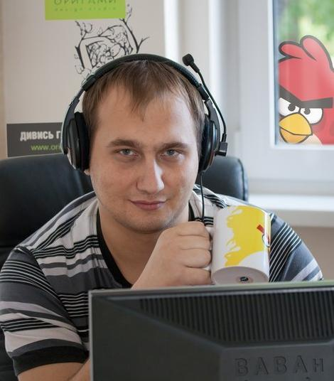
Full Name: Batrakov Volodymyr
Location: Zhytomyr, Ukraine (Strictly Remote)
Email: xxtarantulzz@gmail.com
Telegram: @xtarantulz
LinkedIn: https://www.linkedin.com/in/xtarantulz/
Employment type: Full-time, Remote
Desired Position: Senior Full-Stack Web Engineer / Architect (PHP, Yii2, Laravel, Node.js)

Objective:
Securing a long-term remote position as a Senior Full-Stack Engineer to design scalable system architectures, develop high-load web systems, optimize database performance, and build efficient backend solutions (PHP/Node.js).

Languages:
- Ukrainian - fluent
- English - Intermediate (B1): technical documentation, work communication, APIs and development workflow
- Russian - fluent
Education:
- Master’s Degree in Informatics and Applied Mathematics, Zhytomyr Ivan Franko State University.
- Additionally, I completed a 6-month corporate English course at an IT company to improve technical and professional communication in English.

Experience:
- PHP Developer at Origami design studio from 04.2011 to 03.2016 (http://origami.ua/)
- PHP Backend & REST API Developer at Grapps from 04.2016 to 10.2017 (https://grapps.io/)
- PHP Backend & REST API Developer at SeoTm from 11.2017 to 11.2019 (https://www.seotm.com/)
- Full-Stack & REST API Developer (remote) from 11.2019 to 08.2022 (https://oda.ztmbk.gov.ua)
- Full-Stack Web Developer at Solid Solutions from 09.2022 to 04.2024 (https://solid-sl.com/)
- Full-Stack & REST API Developer (remote) from 04.2024 (payment systems project) - confidential / not subject to disclosure

Skills:
- Platforms: Windows, Linux
- Frameworks: Yii2 (10 years), Laravel (2 years)
- CMS (not currently used): Drupal (4 years), Joomla (4 years), Magento (1 year), OpenCart (0.5 year), WordPress
- Backend / Server: PHP (10 years), MySQL (10 years), REST API, Node.js (2 years)
- Frontend: HTML5, CSS3, JavaScript, jQuery, Bootstrap, AJAX, WebRTC, Socket.IO, React
- DevOps / Infrastructure: Docker, Nginx, Apache, CI/CD (GitLab CI), Linux server administration, Crontab, Cloudflare
- Caching: Redis, Memcached, database caching, HTTP caching, file caching
- API / Integrations: OAuth 2.0, Google APIs, Firebase API, Telegram Bot API, Twilio API, SendGrid API, Discord API, Facebook Graph API, DataForSEO API, Nova Poshta API
- Payment Systems: LiqPay, PayPal, Stripe, Tranzilla, Payoneer, FLEXIFY API, MIFINITY API, SHEEPY API, PAYADMIT API
- Tools: Git, Composer, NPM, PhpStorm, Postman, DBeaver, Docker, Open Server, XAMPP, Chrome DevTools, FileZilla, PuTTY
- Architecture & Approaches: MVC, RESTful API design, Microservices, Monolith, Design Patterns, SOLID, DRY / KISS
- Testing: PHPUnit, API testing, functional testing, manual QA, Postman collections
- Image Processing: GD, ImageMagick, upload/crop/resize API, WebP optimization, lazy loading images
- Task Management: Jira, Redmine, Notion, Trello, Worksection
- Control Panels: cPanel, ISPmanager, DirectAdmin, VestaCP
- AI in Development: AI-assisted development (3+ years), ChatGPT, Gemini, Codex (JetBrains AI), Claude (basic usage)

Portfolio:

- http://my-print.com.ua/
- https://magnum-hotel.com/
- https://chayka.org.ua/
- https://avesauto.ua/
- https://zorrov.com/
- https://www.prime-group.com.ua/
- https://reputationbook.org/
- oda.ztmbk.gov.ua (laravel, rest-api, backend and frontend)
- seoptimer.com (yii2, rest-api, backend and frontend, google api, stripe, socials api)
- tuberanker.com (yii2, rest-api, backend and frontend, youtube api)
- localranking.com (yii2, rest-api, backend and frontend, google api, stripe)
Portfolio and Profiles:
- GitHub Resume: https://xtarantulz.github.io/resume/
- Weblancer: https://www.weblancer.net/users/xtarantulz/ (some portfolio items were removed due to project age or NDA)
- LinkedIn: https://www.linkedin.com/in/xtarantulz/ (includes “Projects” section)
- GitHub: https://github.com/xtarantulz (some code, modules, and pet projects are publicly available, including a demo e-commerce project on Yii2 created before using AI: https://github.com/xtarantulz/shop-yii2)
- Additionally, there are personal pet projects (real products with practical business logic; some have active users and are used in real scenarios). Details and examples can be provided during the interview.
Short description of work experience over the years:

From February 2011 to February 2016, I worked at a design studio developing websites of varying complexity. I used popular CMS platforms such as Drupal, Joomla, WordPress, and Magento.
Projects: DS Origami, Magnum Hotel, Cofedgio, Prime Group, Irish Pub, Mila Nytych, Fitness Mania,
S. Stvardovska, Avtozvuk, Stop Transit, Avesauto, AvdTrade, Ostrovit, Zorrov, My-print, Marian, Donich.

After that, until November 2017, I worked in a company serving international clients.
- A project similar to Telegram for Android and iOS users in Europe. I used Yii2 for administration and Node.js for real-time messaging using Socket.IO and Firebase.
- A project for cyclists traveling in the mountains in Italy, including an admin panel and web application built with Yii2 and REST API development.
- A project for Israeli tow truck drivers, similar to a taxi app but with an auction system for tow truck owners. My contribution included Yii2 admin panel, web application, and REST API development.

Later, I joined an IT company working with both local and international clients on website development and promotion projects.
- A project similar to rabota.ua but focused on dentists in the UK. I developed the backend, admin panel, and REST API using Yii2.
- A multimedia monitor network in minibuses built with Yii2, Node.js, and Android, including real-time device management and features such as video display, battery status, and scheduling.
- A coffee point-of-sale network built with Laravel and React Native, allowing owners to manage categories, products, sales, inventory, staff, and suppliers. I developed backend, admin panel, and REST API.
- An Amazon USA warehouse-related system built with Yii2, including backend, admin panel, and REST API for 1C synchronization.

Then I worked remotely until 2022 on projects related to Ukrainian cadastral maps and logistics using Google Maps. One project focused on informational aspects where regional administrations uploaded land-related contracts, while another focused on route optimization between multiple points for efficient delivery planning.
From 2022 to 2024, I worked in an IT company on SEO, Google Business, and YouTube channel audit projects. Website and business forecasting were also part of my responsibilities. I worked in a team of 8 developers.
From 2024 to April 2026, I worked as a Full-Stack and REST API Developer in a payment systems company. I was responsible for backend/frontend development, REST API, payment service integrations, and infrastructure support. Some project and client information is under NDA.

