Full-Stack PHP Developer (Short Resume)

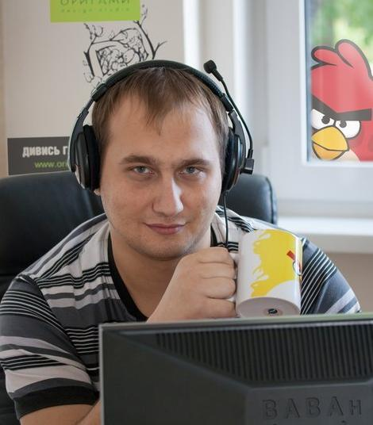
Full Name: Batrakov Volodymyr
Location: Zhytomyr, Ukraine (Strictly Remote)
Email: xxtarantulzz@gmail.com
Telegram: @xtarantulz
LinkedIn: https://www.linkedin.com/in/xtarantulz/
Employment type: Full-time, Remote
Desired Position: Senior Full-Stack Web Engineer / Architect (PHP, Yii2, Laravel, Node.js)

Objective:
To obtain the opportunity to develop my talents as a web developer and application developer, as well as to use a creative approach in creating video and music. I am looking for a team that values innovation and openness to new ideas, where I can continuously grow and improve my skills in a professional environment.

Languages:
- Ukrainian - fluent
- English - Intermediate (B1): technical documentation, work communication, APIs and development workflow
- Russian - fluent
Education:
- Master’s Degree in Informatics and Applied Mathematics, Zhytomyr Ivan Franko State University.
- Additionally, I completed a 6-month corporate English course at an IT company to improve technical and professional communication in English.

Experience:
- Fullstack PHP (CMS) Developer at Origami design studio from 02.2011 to 02.2016 (http://origami.ua/)
- Fullstack Web Developer at Grapps from 04.2016 to 11.2017 (https://grapps.io/)
- Fullstack Web Developer at SeoTm from 12.2017 to 12.2019 (https://www.seotm.com/)
- Fullstack Yii2 Developer (remote) at the State GeoCadastre from 01.2020 to 07.2022 (https://oda.ztmbk.gov.ua)
- Fullstack Web Developer at Solid Solutions from 09.2022 to 04.2024 (https://solid-sl.com/)
- Fullstack Web Developer (remote) from 04.2024 (payment systems project) - confidential / not subject to disclosure

Skills:
- Platforms: Windows, Linux
- Frameworks: Yii2 (10 years), Laravel (2 years)
- CMS (not currently used): Drupal (4 years), Joomla (4 years), Magento (1 year), OpenCart (0.5 year), WordPress
- Backend / Server: PHP (10 years), MySQL (10 years), REST API, Node.js (2 years)
- Frontend: HTML5, CSS3, JavaScript, jQuery, Bootstrap, AJAX, WebRTC, Socket.IO, React
- DevOps / Infrastructure: Docker, Nginx, Apache, CI/CD (GitLab CI), Linux server administration, Crontab, Cloudflare
- Caching: Redis, Memcached, database caching, HTTP caching, file caching
- API / Integrations: OAuth 2.0, Google APIs, Firebase API, Telegram Bot API, Twilio API, SendGrid API, Discord API, Facebook Graph API, DataForSEO API, Nova Poshta API
- Payment Systems: LiqPay, PayPal, Stripe, Tranzilla, Payoneer, FLEXIFY API, MIFINITY API, SHEEPY API, PAYADMIT API
- Tools: Git, Composer, NPM, PhpStorm, Postman, DBeaver, Docker, Open Server, XAMPP, Chrome DevTools, FileZilla, PuTTY
- Architecture & Approaches: MVC, RESTful API design, Microservices, Monolith, Design Patterns, SOLID, DRY / KISS
- Testing: PHPUnit, API testing, functional testing, manual QA, Postman collections
- Image Processing: GD, ImageMagick, upload/crop/resize API, WebP optimization, lazy loading images
- Task Management: Jira, Redmine, Notion, Trello, Worksection
- Control Panels: cPanel, ISPmanager, DirectAdmin, VestaCP
- AI in Development: AI-assisted development (3+ years), ChatGPT, Gemini, Codex (JetBrains AI), Claude (basic usage)

Portfolio:

- http://my-print.com.ua/
- https://magnum-hotel.com/
- https://chayka.org.ua/
- https://avesauto.ua/
- https://zorrov.com/
- https://www.prime-group.com.ua/
- https://reputationbook.org/
- oda.ztmbk.gov.ua
- seoptimer.com
- tuberanker.com
- localranking.com
Portfolio and Profiles:
- GitHub Resume: https://xtarantulz.github.io/resume/
- Weblancer: https://www.weblancer.net/users/xtarantulz/ (some portfolio items were removed due to project age or NDA)
- LinkedIn: https://www.linkedin.com/in/xtarantulz/ (includes “Projects” section)
- GitHub: https://github.com/xtarantulz (some code, modules, and pet projects are publicly available, including a demo e-commerce project on Yii2 created before using AI: https://github.com/xtarantulz/shop-yii2)
- Additionally, there are personal pet projects (real products with practical business logic; some have active users and are used in real scenarios). Details and examples can be provided during the interview.
Short description of work experience over the years:
From February 2011 to February 2016, I worked at a design studio developing websites of varying complexity. I used popular CMS platforms such as Drupal, Joomla, WordPress, and Magento.
Projects: DS Origami, Magnum Hotel, Cofedgio, Prime Group, Irish Pub, Mila Nytych, Fitness Mania, S. Stvardovska, Avtozvuk, Stop Transit, Avesauto, AvdTrade, Ostrovit, Zorrov, My-Print, Marian and Donich.
After that, from April 2016 to November 2017, I worked at a company that collaborated with international clients.
- A project similar to Telegram for Android and iOS users in Europe. I used Yii2 for the admin panel and Node.js (Socket.IO, Firebase) for real-time messaging.
- A platform for cyclists traveling mountain routes in Italy. I developed the admin panel, a Yii2 web application, and a REST API.
- A project for Israeli tow truck drivers, similar to a ride-hailing auction service. I built the admin panel, Yii2 web application, and REST API.
From December 2017 to December 2019, I worked at an IT company focused on developing and promoting websites for Ukrainian and international clients.
- A job search platform for dentists in the UK (similar to rabota.ua). I developed the backend, admin panel, and REST API using Yii2.
- A fleet management system for minibuses with screen monitoring using Yii2, Node.js, and Android, including remote device control.
- A coffee shop chain management system built with Yii2 and React Native. I implemented the backend, admin panel, and REST API for managing products, sales, staff, inventory, and suppliers.
- An Amazon warehouse automation system built with Yii2, including data synchronization with 1C via REST API.
From January 2020 to July 2022, I worked remotely on projects related to Ukrainian cadastral mapping and logistics based on Google Maps. One project focused on land contracts and cadastral data management, while another involved optimizing multi-point routing for efficient delivery operations.
From August 2022 to April 2024, I worked at an IT company on projects in the SEO and analytics domain, including Google Business Profile, YouTube auditing, and website analytics. I also worked on predicting website and business performance. I was part of a team of eight developers.
From April 2024 to April 2026, I worked as a Fullstack and REST API developer in a payments systems company. My responsibilities included backend/frontend development, REST API integration, payment service integrations, and infrastructure support. Some project and client details are confidential under NDA.

