wget https://github.com/etcd-io/etcd/releases/download/v3.4.4/etcd-v3.4.4-linux-amd64.tar.gz

tar -xzvf etcd-v3.4.4-linux-amd64.tar.gz

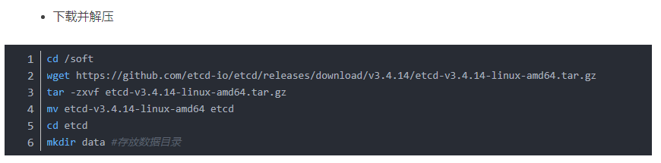

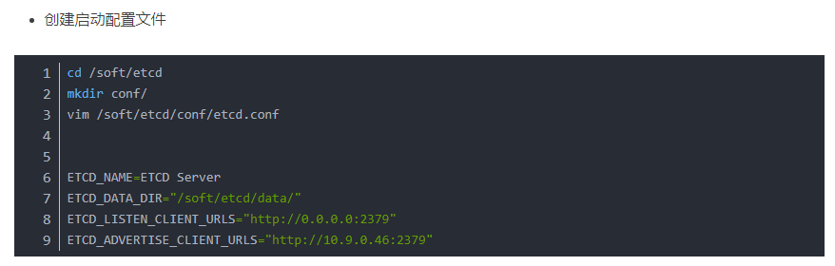

ETCD_NAME=ETCD Server

ETCD_DATA_DIR=/soft/etcd-v3.4.4-linux-amd64/data

ETCD_LISTEN_CLIENT_URLS=”http://0.0.0.0:2379”

ETCD_ADVERTISE_CLIENT_URLS=”http://192.168.1.128:2379”

vi /lib/systemd/system/etcd.service

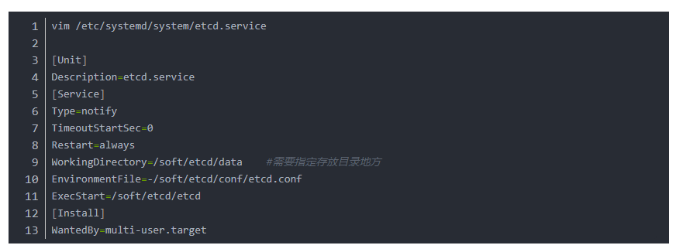

[Unit]

Description=Etcd Server

[Service]

Type=notify

TimeoutStartSec=0

WorkingDirectory=/soft/etcd-v3.4.4-linux-amd64/data

EnvironmentFile=/soft/etcd-v3.4.4-linux-amd64/conf/etcd.conf

# set GOMAXPROCS to number of processors

ExecStart=/soft/etcd-v3.4.4-linux-amd64/etcd

Restart=always

[Install]

WantedBy=multi-user.target

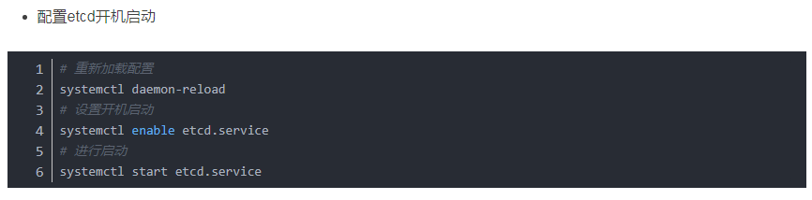

Systemctl daemon-reload

Systemctl enable etcd.service

Systemctl start etcd.service